2022 Mid-Year Report November 28, 2021

Resistance of Soybean Cultivars and Germplasm to Soybean Cyst Nematode

PI: Guiping Yan, Ph.D.
Collaborators: Greg LaPlante, Drs. Carrie Miranda, Sam Markell, and Berlin Nelson

Objectives of the research

- Evaluate 80 soybean cultivars, germplasm and breeding lines for their resistance reactions to two prevalent SCN populations detected in North Dakota.
- Evaluate 20 soybean cultivars, germplasm and breeding lines for their resistance reactions to SDS detected in North Dakota.
Completed work

Forty-seven soybean seed samples (commercial cultivars) obtained from growers were tested against HG type 0, and 44 seed samples from growers were assessed against HG type 2.5.7. Fourteen breeding lines from the soybean breeding program at NDSU were tested with HG type 0. A total of 149 early maturity soybean accessions originated from different countries (South Korea, North Korea, Canada, China, Japan, Russia, Ukraine, Vietnam, and United States) were screened against the HG type 2.5.7. These soybean accessions were acquired from the USDA-ARS Soybean Germplasm Collection in Illinois. The soybean cultivar Barnes from North Dakota was included as a susceptible check. Two common SCN populations, HG type 2.5.7. and HG type 0 were collected from two soybean fields in Traill and Richland counties, ND.

Pre-germinated seeds from each of the soybean cultivars and lines and the susceptible check were planted in small cone-tainers each containing 100 cc of sterilized sandy soil in four replicates. Each plant was inoculated with 2,000 eggs of each of SCN HG type 2.5.7 and SCN HG type 0. The plants were kept in a growth chamber maintained at a constant temperature of 27º C with a daylight period of 16 hours (Figure 1). After 35 days of growth, SCN white females (cysts) from plant roots and soil in each cone-tainer were extracted and then counted under a microscope. The mean number of white females produced on the roots of each cultivar and line was used for calculating the female index (FI) by comparing with the susceptible check Barnes using the formula (FI = mean no. of white females produced on a tested line/mean no. of white females in the susceptible check x 100%). Resistance response of each of the lines was categorized based on the female index and the resistance rating system described by Schmitt and Shannon (1992) (resistant: FI < 10%; moderately resistant: FI = 10-30%; moderately susceptible: FI = 31-60%; susceptible: FI > 60%).

The inoculum for SDS resistance evaluation was provided by Dr. Berlin Nelson. Fungal isolate of Fusarium virguliforme was sub-cultured in eleven petri plates with autoclaved PDA media (Figure 1). The inoculated petri plates were covered by lid and wrapped by parafilm tape before incubation. Plugs of actively growing fungal hyphae will be used to inoculate sorghum seeds. The sorghum seeds were provided by Dr. Marisol Berti (NDSU) upon request. The original SDS isolate was kept in daylight to enhance conidia production. The original isolate of F. virguliforme was also cryopreserved in 50% glycerol solution at -80°C for future use. Twenty soybean germplasm lines showing least susceptibility to both SCN populations were selected and will be tested with the fungal pathogen.

Preliminary results

Out of the 47 soybean seed samples obtained from growers tested for SCN HG type 0, 13% of them showed resistant reaction, 19% had moderately resistant reaction, 45% had moderately susceptible reaction, and 23% of them had susceptible reaction. Out of the 44 soybean seed samples from growers tested for SCN HG type 2.5.7, 9% of them showed resistant reaction, 11% of them showed moderately resistant reaction, 30% had moderately susceptible reaction, and 50% had susceptible reaction (Figure 2).

Among the 14 breeding lines obtained from the NDSU soybean breeding program tested for SCN HG type 0, one of them showed resistant reaction, eight of them had moderately resistant reaction, and five of them had moderately susceptible reaction based on the resistance classification described by Schmitt and Shannon (1992).

Out of the 149 soybean germplasm lines from the USDA-ARS Soybean Germplasm Collection tested for SCN HG type 2.5.7, 13 accessions were resistant, 17 accessions were moderately resistant, 81 accessions were moderately susceptible, and 38 accessions were susceptible. Out of the 13 resistant accessions, three originated from China, four from Canada, four from Japan, one from North Korea, and one from Ukraine. These results have been summarized and presented in a manuscript which is now being published in the journal, Plant Health Progress.

Work to be completed

During the rest of the funding cycle, 20 soybean germplasm lines from the USDA-ARS Soybean Germplasm Collection, which showed least susceptibility to SCN, will be tested with the fungal pathogen (F. virguliforme) to determine the levels of resistance or susceptibility to SDS. Twenty-five new soybean seed samples obtained from growers will be tested with both SCN populations, HG type 0 and HG type 2.5.7, upon request. An experiment with 20 soybean lines showing resistant or moderately resistant to HG type 2.5.7 in our previous experiment is being conducted to confirm their resistance reactions. These lines will be tested with another SCN population HG type 0 to further confirm their resistance reactions and to select soybean lines with high resistance to both HG type 0 and 2.5.7. The majority of screened soybean cultivars and lines in our experiments were not resistant to SCN. The valuable resistant soybean lines identified in this study have the potential to be used in breeding SCN-resistant cultivars. The information obtained from this research will be useful to identity resistance genes for developing soybean cultivars with improved genetic resistance to SCN.

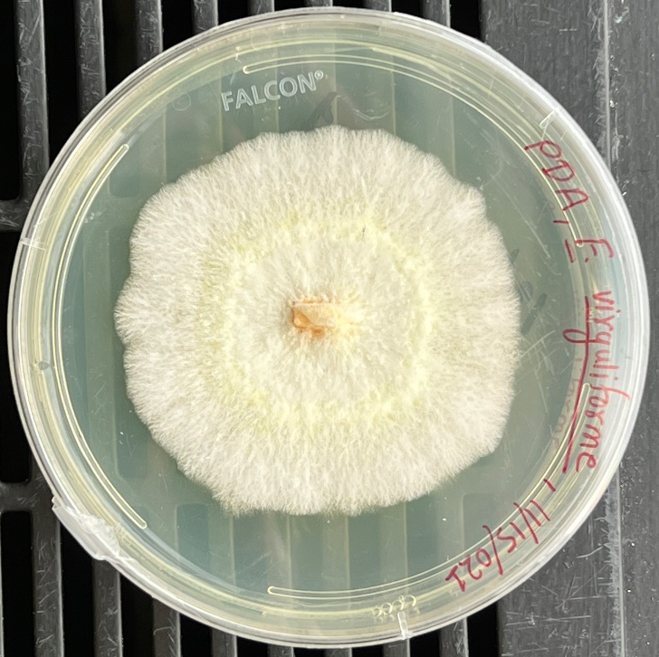
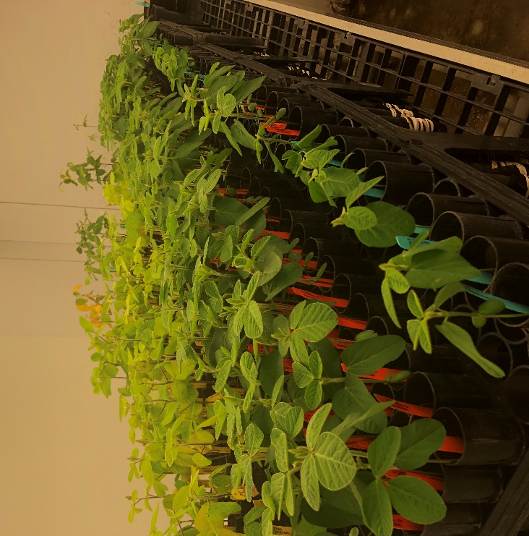
Figure 1. The picture on the left showing soybean plants grown in the growth chamber maintained at 27 °C for SCN resistance evaluation; and the picture on the right showing the pure fungal culture used as inoculum for SDS resistance evaluation.

Figure 2. Classification of the resistance responses of soybean seed samples from growers to two SCN populations (HG type 0 and HG type 2.5.7) isolated from soybean fields in North Dakota. R = Resistant, MR = Moderately Resistant, MS = Moderately Susceptible, S = Susceptible.

