Project Title: Impact of crop sequence and tillage on crop yield and quality, soil nutrients, pH, texture and microbial population.
Principal Investigator: Mohamed Khan. Collaborators include Drs. S. Banerjee, A. Friskop, S. Markell, H. Kandel, C. Keene.

- Research Objectives:
- Determine the yield and quality of major crops (sugarbeet, corn, soybean and wheat) grown in different crop sequence.
- Determine the effect of tillage type (conventional, strip, and no-till) on crop yield and quality.
- Determine the impact of tillage and crop sequence on disease severity caused by major pathogens of the crops in the sequence.
- Determine the impact of tillage on soil nutrients (N, P, K and carbon), pH, texture and microbial population over time.
- Document the best practices for managing fungicide resistance of the pathogens of the crops in the sequence.

- Completed Work:
Year 1 research (preliminary) was done and crop yield and quality were recorded.
In Year 2 (where funding was provided that included hiring of graduate students), crops in the second year of the sequence (soybean and sugarbeet) were planted and replanted because of damage by wind and standing water. Crops were evaluated for pests and diseases, crop yield and quality were recorded, and soil samples were collected for nematode evaluation and to determine the microbial population.

- Preliminary Results:
Results from Year 1
Corn crop
There was no significant effect of interaction between tillage method and corn crop position in yield (p>0.43), moisture content (p>0.68) and test weight (p>0.87).
There was no significant main effect of corn crop position (i.e. crop sequence) in yield (p>0.46), moisture content (p>0.17) and test weight (p>0.76). This means that field positions or previous crops had no influence on the corn crop performance in year 1. This also suggested the field conditions were reasonably uniform throughout, providing a good baseline point in time.
However, the tillage methods had shown significant effects on corn crop performance in yield (p<0.05) and moisture content (p<0.05), but no effect on test weight (p>0.13) (see Table 1).

Table 1
Tillage | Yield (bu) | Moisture (%) | Test weight
CT | 213.72b | 15.33b | 53.86
NT | 178.33a | 14.85a | 54.77
ST | 196.75ab | 15.30b | 53.32

As can be seen from Table 1, no tillage (NT) had significantly smaller yield than the conventional tillage (CT), but the yield was not significantly different between ST and CT.
On moisture content, no tillage (NT) had significantly lower moisture content than the strip tillage (ST) and conventional tillage (CT), but the moisture concentration was not significantly different between ST and CT.
Soybean crop
There was only one soybean crop position (i.e. crop sequence in year 1). So, the soybean data structure was different from the corn crop data structure. For soybean data, we can only analyze and examine the effect of tillage method.
There was no significant effect of tillage method on yield (p>0.44), on moisture content (p>0.05) and on test weight (p>0.25). The mean values for respective tillage method are given in Table 2.
Table 2
Tillage | Yield | Moisture (%) | Test weight
CT | 26.01 | 8.34 | 59.75
NT | 23.00 | 7.92 | 58.25
ST | 21.84 | 7.99 | 58.50

It should be noted even though the soybean yields looked small in NT and ST, they did not differ significantly from the soybean yield in CT. This can be due to yield variation between replicates in the same tillage method.
Results from Year 2
Sugarbeet crop
There was no significant effect of interaction between tillage method and sugarbeet crop position in yield, sugar concentration and recoverable sucrose per acre.
However, the tillage methods had shown significant effects on sugarbeet tonnage, sugar concentration and recoverable sucrose. The crop sequence showed significant effects on tonnage and recoverable sucrose.

Table 1a – Sugarbeet, Table of Means, Tillage
Tillage | Tonnage  (T/A) | Sugar (%) | Recoverable Sugar (lb/A)
CT | 6.0b | 13.2b | 1409b
NT | 9.5ab | 14.2a | 2511a
ST | 12.1a | 13.7ab | 3042a

Table 1b – Sugarbeet, Table of Means, Crop Sequence
Crop Sequence | Tonnage  (T/A) | Sugar (%) | Recoverable Sugar (lb/A)
2 Corn/Sugarbeet/Corn/Soybean | 8.1b | 14.2 | 2187b
3 Soybean/Sugarbeet/Corn/Soybean | 12.6a | 13.5 | 3066a
4 Corn/Sugarbeet/Soybean/Corn | 7.0b | 13.4 | 1708b

The plant population for sugarbeet was low at both planting and replanting dates as a result of poor soil conditions from wet conditions and heavy winds. As a result of the low population, yield ranged from six to 12 tons per acre.
Soybean crop
There was only one soybean crop position (i.e. crop sequence in year 2). So, the soybean data structure was different from the sugarbeet crop data structure. For soybean data, we can only analyze and examine the effect of tillage method.
There was no significant effect of tillage method on yield (p>0.39), on moisture content (p>0.77) and on test weight (p>0.26). The mean values for respective tillage method are given in Table 2.

Table 2 – Soybean, Table of Means, Crop sequence 1 (Corn/Soybean/Wheat/Sugarbeet) x Tillage
Tillage | Yield (bu/A) | Moisture (%) | Test weight
CT | 27.5 | 12.4 | 59.8
NT | 20.0 | 13.1 | 56.5
ST | 19.7 | 13.7 | 59.5

It should be noted even though the soybean yields were numerically lower in NT and ST, they did not differ significantly from the soybean yield in CT. This can be due to yield variation between replicates in the same tillage method. The yields of 20 to 28 bushels per acre were achieved with a very late re-planting date of July 2.

Preliminary Results from soil samples collected and evaluated for nematodes
The counting process is ongoing. The average cyst nematode count from each sample was 16 cysts with the highest and lowest cyst count as 24 and 14 respectively. Also, more cyst nematode population was recorded in the sugar beet samples as opposed to the soybean samples which is the primary host of cyst nematodes.

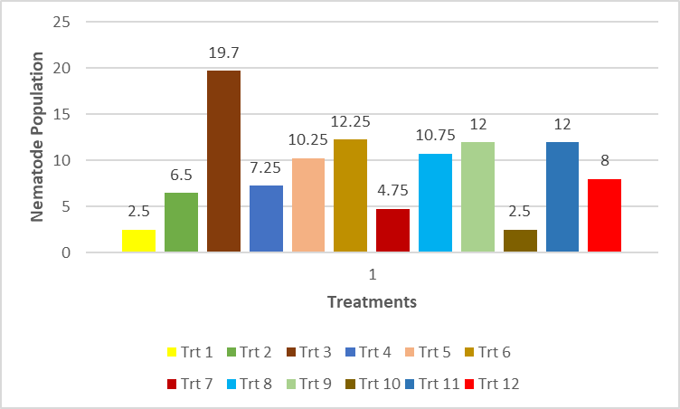

- Work to be Completed:
Work is ongoing on determining the microbial soil population. It is expected that some preliminary data will be presented at the December 14 presentation.
Soil analysis for nutrients, organic matter content and carbon is also ongoing and data will be analyzed after testing is done by AGVISE.
DNA extraction and PCR (Polymerase Chain Reaction) are expected to be done to identify the cyst nematodes and pathogenicity test in the greenhouse would further provide information about the virulence of these nematodes to crops in the rotation including sugarbeet, soybean and corn.

