Determining the current Phytophthora sojae population and the status of variety resistance in Minnesota using improved methods

Cooperators: Megan McCaghey, Dean Malvick, Kathleen K. Markham, Jane Fenske-Newbart, Cathy Johnson, Senyu Chen

Funding provided by: Minnesota Soybean Research and Promotion Council

Project year: May 1, 2023 – April 30, 2024

PURPOSE OF STUDY:
The purpose of this work is to determine the current population of Phytophthora sojae that is causing root and stem rot in Minnesota soybeans. Root and stem rot can be caused by Phytophthora sojae, a water mold (oomycete) that thrives in cool and wet conditions like poorly-drained soils (as found in northwestern Minnesota). P. sojae can infect soybeans at all growth stages, causing anything from early damping off of seedlings to late root and stem rot of mature plants, which can lead to impactful yield losses. To avoid Phytophthora root and stem rot, growers commonly plant soybean varieties that carry resistance genes. However, unless the resistance genes in the variety align with the specific P. sojae pathotype in the field, resistant varieties will remain ineffective against P. sojae. It is therefore crucial to first determine the specific P. sojae pathotype present around Minnesota so that the most effective soybean varieties can be deployed. Our goal is to survey the current Minnesota P. sojae population because the last survey was performed 10 years ago and because P. sojae’s adaptation to resistance shifts over time. To survey more efficiently, we aim to use a recently-developed molecular assay designed to quickly and accurately pathotype P. sojae.

OBJECTIVE 1: Validate the efficiency and accuracy of a recently-developed molecular pathotyping assay

RESULTS
Classic pathotyping methods that involve inoculating plants with P. sojae isolates are time consuming and are known to produce intermediate and ambiguous results. Theoretically, this could have led to the inaccurate pathotyping of P. sojae and hence the possible deployment of unsuitable soybean varieties. In Objective 1, we are validating the efficiency and accuracy of a recently-developed multiplex Polymerase Chain Reaction (PCR) method that is able to simultaneously detect several P. sojae genes that contribute to non-virulence. By detecting which non-virulent genes are present in the P. sojae isolate, we can determine the specific pathotype of that P. sojae isolate.

As a first test, we performed multiplex PCR on six, blinded P. sojae isolates (Cd20, Hn9, WI16, Pe1, Sc2, and As11) that were previously pathotyped via the classic plant inoculation method in 2013 (Dean Malvick). The multiplex PCR was capable of simultaneously detecting Avr1a-indel, -snp1, -snp2, Avr1b, Avr1d, Avr1k, Avr3a, and Avr6 genes (Fig. 1a). Faint bands in the multiplex PCR (ie. Avr1d, Avr6, Avr1a-indel, -snp1, -snp2) were confirmed by performing uniplex PCR (Fig. 1b-f). The Avr1c gene was detected in one of the isolates in a uniplex PCR (Fig. 1g). We repeated the same process for three isolates that had unknown pathotypes (Fig. 1h-n).

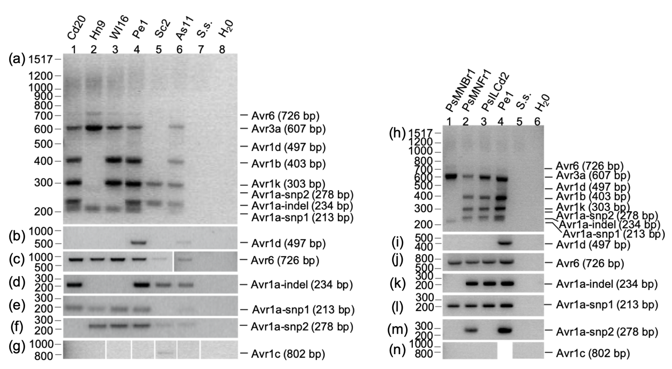
Figure 1. P. sojae pathotyping via a molecular PCR method. (a-n) Multiplex PCR of previously pathotyped (a-g) and non-pathotyped (h-n) isolates. (b-f, i-m) Uniplex PCR to confirm presence of unclear bands from (a) and (h). (g, n). Avr1c uniplex PCR. (a-n) S. sclerotiorum (S.s.) and H₂O are negative controls.

Isolate | Avr1a-indel | Avr1a-snp1 | Avr1a-snp2 | Avr1b | Avr1c | Avr1d | Avr1k | Avr3a | Avr6
Cd20 | + | + |  | + |  |  | + | + | +
Hn9 |  | + | + |  |  |  |  | + | +
WI16 |  | + | + | + |  |  | + | + | +
Pe1 | + | + | + | + |  | + | + | + | +
Sc2 | + |  | + |  | + |  | + |  | +
As11 | + | + | + | + |  | + | + | + | +
PsMNBr1 |  | + |  |  |  |  |  | + | +
PsMNFr1 | + | + | + | + |  |  | + | + | +
PsILCd2 | + | + |  | + |  |  | + | + | +
Table 1. Summary of P. sojae Avr genes detected from multiplex and uniplex PCRs. Plus (+) sign denotes that we detected a band at the expected size. Blank denotes we did not detect a band.

The Avr genes we detected from all isolates tested are summarized in Table 1. We were then able to determine the pathotype of these isolates (Table 2). A comparison of the pathotypes determined by the molecular method and by Dean Malvick’s 2013 plant inoculation are also in Table 2. There were inconsistent pathotypes between the two methods (e.g. WI16 isolate), underscoring the need to resolve which method will provide the most accurate pathotype.

Since pathotypes may have changed after the 10-year storage of these isolates, we re-performed Dean Malvick’s classic plant inoculation method on select isolates (Cd20, WI16, and As11). Table 2 shows the pathotypes determined and Figure 2 shows the morphological results from this recent plant re-pathotyping effort. Again, the determined pathotypes were inconsistent between the 2013 and 2023 plant inoculations.

All together, these tests revealed that there are inconsistencies between classic pathotyping methods and the recently-developed molecular pathotyping method. This warrants further testing and validation of the molecular pathotyping method. Other groups have shown a 98% accuracy rate in molecular pathotyping when compared to a modified plant inoculation method that involves a hydroponic system. Comparing our molecular pathotypes to hydroponic plant inoculations might be something we consider as we validate further.

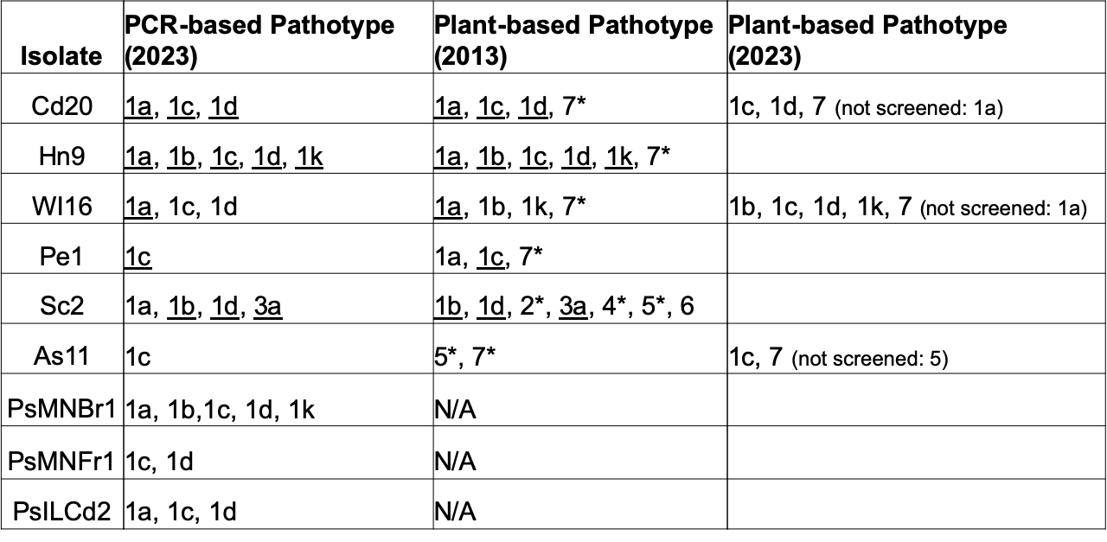
Table 2. PCR-based pathotypes determined in 2023 and plant-based pathotypes determined in 2013 and 2023. *PCR did not screen for corresponding Avr genes. Commonalities between the PCR- and plant-based methods are underlined.

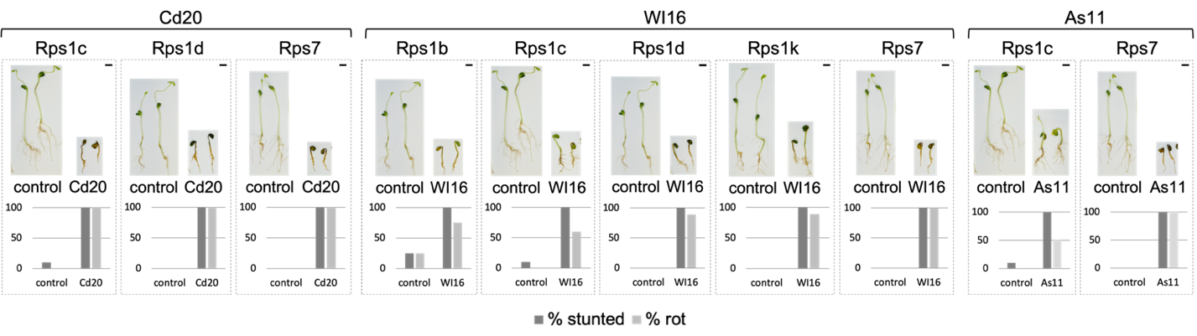Figure 2. P. sojae pathotyping via soybean hypocotyl inoculation. Soybean seedlings harboring single resistance (Rps) genes were inoculated with select P. sojae isolates (Cd20, WI16, or As11). Controls were inoculated with slurry of empty V8 agar media. Percentage of stunted seedlings and percentage of rotting seedlings were quantified (total rot, near total rot, and partial rot of seedlings were combined under % rot). For each soybean line, > 8 seedlings were inoculated with an isolate and > 4 seedlings were inoculated with empty V8 agar. Scale bars = 2 cm.

OBJECTIVE 2: Understand the Phytophthora sojae pathotype diversity in Minnesota that is subject to selection by modern soybean varieties

RESULTS
In Objective 2, we are surveying the P. sojae population around Minnesota. We aim to isolate P. sojae from soil or symptomatic soybean tissue using established methods. To this end, we have requested and received samples from growers through University of Minnesota’s Extension Personnel and the Soybean Cyst Nematode Lab. We have received or anticipate to receive soil samples from counties with pink dots shown in Figure 3. Isolation of P. sojae from soil and tissue is currently in progress.

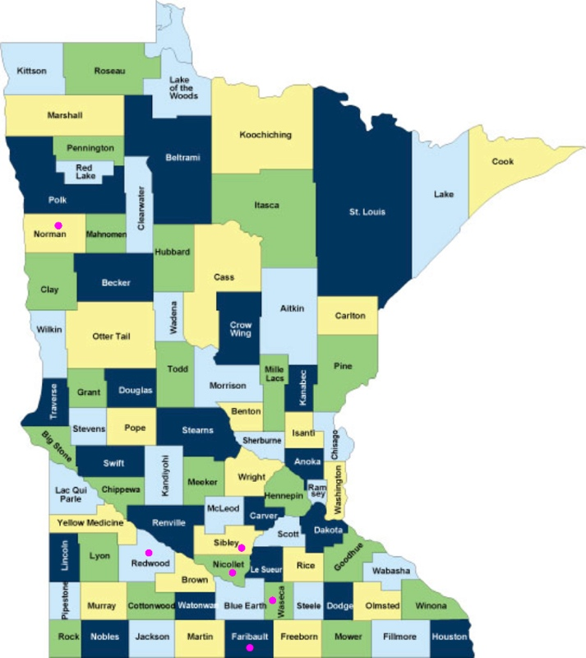

Figure 3. Minnesota county map. Pink dots indicate from which counties we have received or anticipate to receive soil or tissue samples.

