Determination of optimum irrigation amount and timing for enhanced soybean yield, quality, water productivity, and soil health under semiarid western ND
(Mid-Year Report)
Gautam Pradhan, PI; Tyler Tjelde, Co-PI; James Staricka, Co-PI
NDSU Williston Research Extension Center

Overview and Objectives
In irrigated agriculture, the amount and timing of irrigation play a crucial role in obtaining a sustainable higher yield with a minimum adverse effect on the environment. Insufficient irrigation results in lesser crop yield than the genetic potentiality of a given variety, while excessive irrigation escalates pumping costs, hastens the depletion of water resources, induces nutrient leaching, and contributes to environmental pollution. Soybean is the second largest irrigated crop in ND preceded by corn. There is a lack of information on the timing and amount of irrigation needed for soybeans under the semi-arid conditions of Western ND.
The main objective of this project is to determine the optimum amount and timing of irrigation for enhanced soybean yield, quality, and water productivity. The secondary objectives are to assess the effect of irrigation treatments on the soil health manifested by changes in soil physical and chemical properties, and manifestation of soybean diseases including but not limited to white mold.

Completed works
- A roundup-ready soybean variety S01XF25 was seeded at the Nesson Valley Irrigation Site, Ray, ND (Longitude: -103.10511160, Latitude: 48.1639434) on May 29, 2024, under randomized complete block design with four replications. The seeding rate was 188,000 PLS/acre with a Row-to-Row distance of 30 inches and a gross plot size of 59’ X 50’.
- There were 12 irrigation treatments:
- I = Full irrigation
- Wv = Deficit irrigation during vegetative [(VE – V(n)] stage
- Wf = Deficit irrigation during flowering [R1-R2] stage
- Wp= Deficit irrigation during pod development [R3-R4] stage
- Ws = Deficit irrigation during seed filling [R5-R6] stage
- Wm = Deficit irrigation during maturity [R7-R8] stage
- Wvf = Deficit Irrigation during vegetative + flowering stages
- Wvp = Deficit irrigation during vegetative + pod development stages
- Wvs = Deficit irrigation during vegetative + seed filling stages
- Wvm = Deficit irrigation during vegetative + maturity stages
- Wsm = Deficit irrigation during seed filling + maturity stages
- R = rainfed.
- Soil water contents at six different depths (from 6” to 36”) were recorded using a neutron soil moisture meter.
- Unmanned aircraft systems equipped with a visual camera were flown over the experimental field at different dates to assess plant growth.
- At maturity, plant height was measured, biomass was collected, and the crop was harvested using a plot combine.
Progress of Work and Results To Date
Aerial Imageries: Aerial imagery captured on July 26, August 19, and September 10, 2024, reveals noticeable differences in soybean growth across various treatments (Figure 1). Soybeans grown under rainfed conditions (R) displayed consistently poor growth on all three dates. On August 19, the imagery showed clear signs of stress from deficit irrigation during the pod development stage (Wp), with the effects becoming more pronounced by September 10 on both Wp and Wvp. By that date, soybeans under rainfed conditions had already entered senescence.
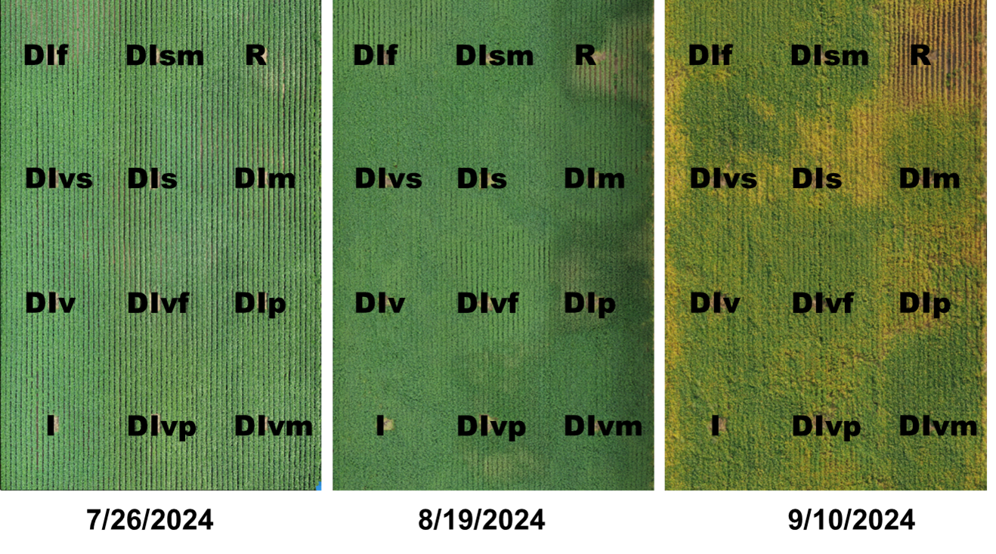
Figure 1. Aerial images illustrate the effect of irrigation treatments on soybeans at different development stages. Since all four replications showed similar conditions, an image from replication one is presented here. For treatment abbreviations, please refer to the Materials and Method section.

Plant Height: Irrigation treatments had a significant impact on soybean plant height (P<0.0001). Deficit irrigation during flowering (Wf) and during both the vegetative and flowering stages (Wvf) reduced plant height by 25% and 21%, respectively, compared to plants under full irrigation (I). Under rainfed conditions, plant height decreased by 31% (Figure 2).
Grain Yield: Irrigation treatments significantly affected soybean grain yield (P<0.0001). Soybeans under full irrigation (I) and deficit irrigation during the flowering stage (Wf) produced 51 and 52 bushels of grains per acre, respectively. Compared to full irrigation deficit irrigation during the pod development stage (Wp) and during both the vegetative and pod development stages (Wvp) resulted in a 21% and 26% reduction in yield, respectively. Rainfed conditions caused a yield decrease of up to 63%. Other irrigation treatments showed a yield decline of 2 to 15% compared to full irrigation, but these differences were not statistically significant (Figure 3).
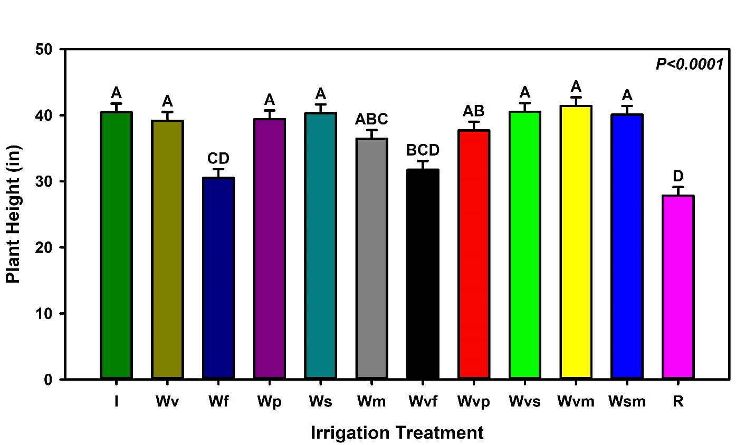
Figure 2. Soybean plant heights under different irrigation treatments. The bars with the same letter on top are statistically not significantly different at P = 0.05.
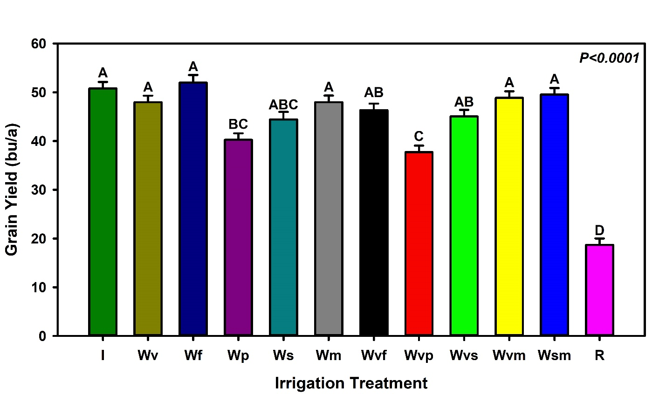
Figure 3. Soybean grain yields under different irrigation treatments. The bars with the same letter on top are statistically not significantly different at P = 0.05.
Works to be Completed
(i) Biomass processing. (ii) Analyses of data on yield components from the processed biomass. (iii) Analyses of more data on growth acquired by the Unmanned Aircraft System. (iv) Analyses of data on soil moisture collected by neutron probes, and data on soil physical and chemical properties from laboratory analyses. (v) Reporting of final outcomes to clientele and North Dakota Soybean Council.

Summary
Preliminary data suggest that irrigation water can be conserved without significantly reducing soybean grain yield, provided that deficit irrigation is avoided during the pod development stage. We are currently analyzing biomass and soil moisture data to further investigate the impact of different irrigation treatments on yield parameters, which will provide more insight into these findings.

