Enhancing Sclerotinia stem rot research capacity and exploring new avenues of disease management through soybean canopy architecture traits
Cooperators: Megan McCaghey, Aaron Lorenz, Suma Sreekanta, Alisha Hershman

For Additional Information: Megan McCaghey

Project Funding Provided by: Minnesota Soybean Research and Promotion Council

Purpose of Study:
The purpose of this work was to develop tools for white mold resistance breeding and research in Minnesota. White mold is caused by the soilborne fungal pathogen, Sclerotinia sclerotiorum and can cause severe yield losses when conditions are suitable for disease development. This project aims to define relationships between canopy architecture and S. sclerotiorum development, to provide another, underexplored consideration for disease resistance breeding for white mold.

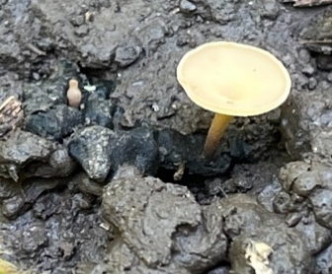
Background and results from 2023: In addition to physiological resistance, plant architecture may be important for avoiding soybean infection by S. sclerotiorum in the field. Apothecia (the mushrooms required for infection of the pathogen) production is influenced by moisture, temperature and light (quality and quantity). In soybean production systems, 50% canopy coverage and greater favors apothecia development, and in a laboratory, UVB light (276-319 nm) are the most important wavelengths needed for apothecia development. Additionally, plant characteristics (leaf area, branch angle, etc.) may impact the plant and soil microenvironments that are important for disease development including UVB light penetration, soil moisture, and soil temperature.
Image 1 Apothecium of S. sclerotiorum

In the spring of 2023, we used UVB light data from three distances to the base of the plant in addition to phenotypic traits and canopy closure data from a shoot architecture panel of soybean lines developed by the Lorenz Lab to select a subpanel of 20 lines for greenhouse and field evaluations in 2023 and 2024 (Figures 1 and 2).

Phenotypic traits used for selection included petiole slope, internode slope, leaf area, and leaf shape (lanceolate or rounded as defined by length: width ratio). A high petiole slope and internode slope meant more light penetration through the plants. Lines were selected to represent variation amongst these traits.

A 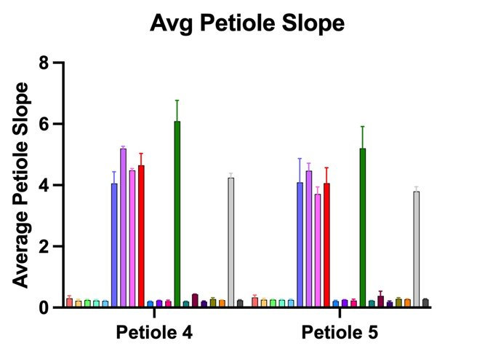 B 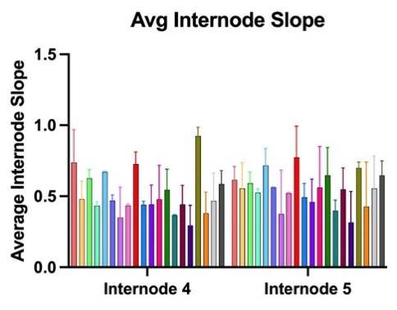 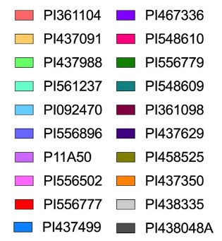
C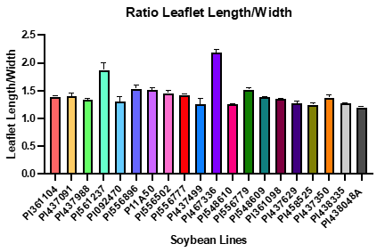 D 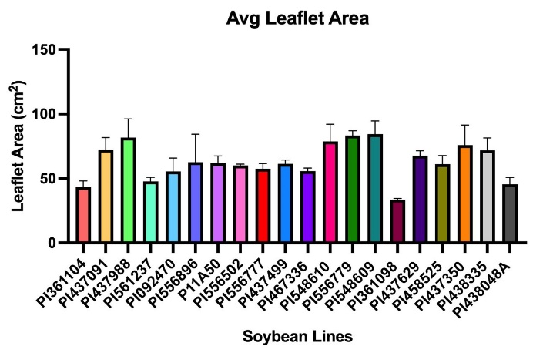

Figure 1. Plant architecture traits of 20 lines selected for 2023 and 2024 evaluations, means of two replicates per line and six replicates per plot . Mean A. slope petiole length between 1st and 4th and 1st and 5th petiole, B. internode slope length between 1st and 4th and 1st and 5th internode, C. leaflet length: width ratio, and D.

Timing of canopy closure is also important for apothecia formation, with white mold development favored by >50% canopy closure. Canopy closure was evaluated in St. Paul using drone flights from the end of the vegetative/ R1 early flowering stage through canopy closure. Drone flyovers took place 1-2 times per week during the 2022 growing season to evaluate the percentage of canopy coverage. 2022 selections were made based on the alignment of canopy closure with flowering time (Figure 2

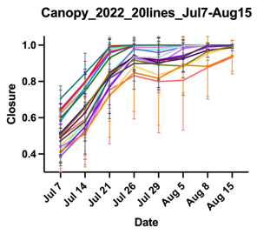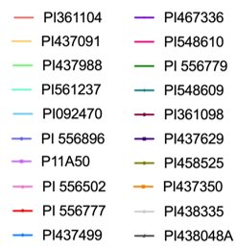

Figure 2. Average date of canopy closure in 2022 for 20 lines selected for 2023-2024 evaluations with 2 replicates per line.

Progress and results for 2024:

Two field trials, one in St. Paul and one in Waseca, are being conducted in 2024 using 20 lines that represent diverse plant architectures and canopy closure dates along with three bushy and three upright industry lines (representing contrasting commercially deployed architectures). Each line is replicated five times. The St. Paul trial was planted on 5/30/24, and the Waseca location was planted on 6/6/24. S. sclerotiorum inoculum, as sclerotia, was added around planting. In Saint Paul, supplemental irrigation was installed during late vegetative stages and irrigation continued through flowering. In Waseca, a field with a history of white mold was used.

Obj. 1) Characterize architectural traits and canopy closure of select lines in the field (continuing)
Imaging for phenotyping of the traits mentioned above took place during the R4 stage and was conducted from four replicates and with six plants per plot. We conducted imaging in St. Paul on 8/12 and 8/14/24. In Waseca, imaging took place on 8/20, 8/22, 8/23, and 8/26. Analysis of the images is in progress. Average leaflet areas from 2023 are summarized in Figure 3. This fall, we will also aim to assess correlations between phenotypic traits and disease and apothecia development.
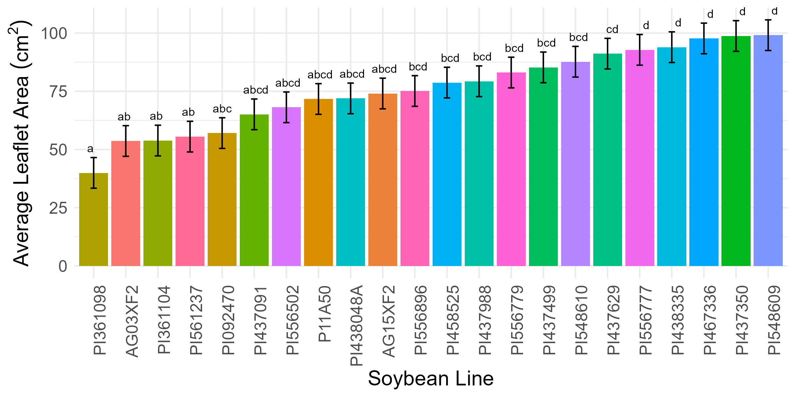
Figure 3. Mean leaflet area of soybean lines from the 2023 field study with each accession replicated four times in an RCBD. Means followed by the same letter(s) are not statistically different at α=0.05 using Tukey's HSD.

Obj. 2) Measure microclimate conditions along with apothecia and SSR development (continuing)
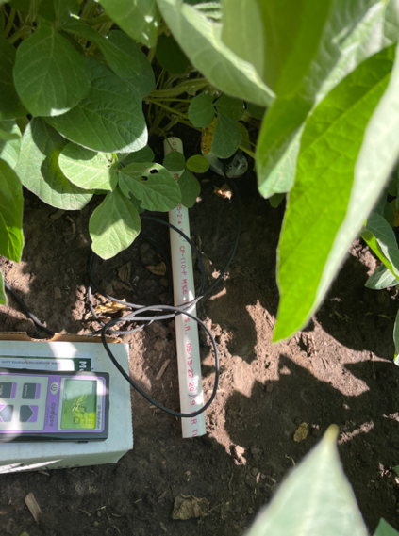
Like in 2022 and 2023, light measurements were taken using a UVB meter at the end of vegetative stages to complete canopy closure. Canopy closure corresponded to R4 for most lines. UVB captures the spectrum of wavelengths considered to be the most important for apothecia production. Measurements were conducted in the morning starting between 9:00 and 10am and ending around 12:30pm on days with little to no cloud cover, waiting if clouds passed over, that might block the UVB penetration to the ground. Measurements were captured in the center of each two rows facing east at 0", 7.5", and 15" from the base of the plant to the center of the row for St. Paul and Waseca due to row spacing being 30”. In St. Paul light measurements were completed on 7/12, 7/25, and several plots were assessed on 8/9 but rating ended early due to cloud cover. In Waseca, UVB light data were collected on 7/17 and the full field on 8/24.
Image 2 Light detection under the soybean canopy with a UVB meter

Spectroradiometer readings to capture a complete light spectrum were collected from lines with very different levels of light interferences: 3 with high light, 3 with low light, 1 with medium light based on 2022 data. Spectra were also captured from the two industry check lines (bushy and upright). The same distances were used for the spectroradiometer measurements. Full spectrum was captured in St. Paul on 7/12 for all plots and on 8/9/24 for some plots.

Soil and canopy moisture are also important for the development of apothecia and white mold. Moisture was measured using a handheld sensor 7.5” from the soybeans in the middle rows. Soil moisture was measured in all blocks in St. Paul on 7/12 and block 5 on 7/25/24. In Waseca soil moisture was measured on 7/24 and 8/2/24 in all plots. Humidity and soil moisture and temperature sensors were established in industry bushy and industry upright lines in St. Paul at the late vegetative, V8 growth stage.

Obj. 3) Assess disease development in current, commercial varieties of varied architectures.
We scouted for apothecia in the middle two rows of each plot from 3–4 1m areas each side of a row prior to flowering and at early flowering stages in St. Paul through canopy closure, when apothecia begin to develop. Scouting in St. Paul took place on 7/8, 7/16, 7/25, and 8/9/24. Many apothecia were found on all dates in St. Paul and data are currently undergoing analysis. Scouting was also completed in Waseca on 7/17, 7/24, and 8/2/24, but unfortunately no apothecia were observed in Waseca.

Bromophenol blue plates were used to detect the presence of ascospores, the spores that infect senescing flowers and lead to disease in soybean. Plates were put into the field at a 45-degree angle upwind for 1-3 hours in the morning (as dew evaporates) and incubated at room temperature for 2-3 days. If spores are present, the blue plates develop a yellow halo around spores due to a change in pH induced by the fungus. In St. Paul, plates were put out in the select lines that spectroradiometer readings were taken from on 7/12 and checked on 7/15 and 7/16. In Waseca plates were put out on 7/17 and checked on 7/20 and 7/22. Ascospores were frequently detected and data will be analyzed this fall.

White mold incidence and severity ratings are planned for the first week of September in St. Paul and the 2nd week of September in Waseca.

Additionally, the subset of 20 soybean lines evaluated in the field, along with commercial lines, and susceptible and moderately resistant lines developed as check lines by Dr. Damon Smith’s Lab were inoculated with S. sclerotiorum in the greenhouse this past winter to assess their genetic resistance. Three MN isolates with a range of aggressiveness were used. A cut petiole method was used to challenge plants and lesion progress was measured for 14 days post inoculation. Differential genetic susceptibility was observed among the lines as indicated by the area under the disease progress curve (a metric of disease progression across time, figure 4).

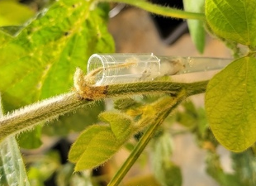
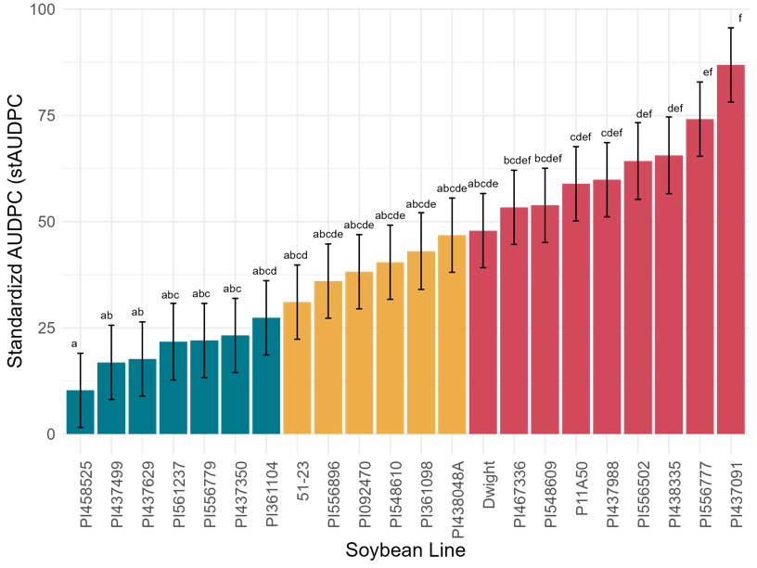

Figure 4. Mean stAUDPC by soybean line challenged by low, medium, and highly aggressive Ss isolates in the greenhouse with four biological replicates and three technical replicates. Means followed by the same letter(s) are not significantly different at α = 0.05 using Tukey's HSD.

This fall, data from 2024 will be analyzed. Correlations and relationships between architecture, disease and apothecia, and soybean microclimates will be assessed.

