Progress Report: Evaluate spray drones in soybean production. FY25
Steve Li. Auburn University

This project funded by National Soybean Checkoff is moving forward as planned. The main objectives listed below will be evaluated in field studies starting August of 2025.
- Compare spray drone to ground sprayer in deposition and canopy penetration using different GPA and nozzles. (4 treatments to be conducted at 2 locations)
- Evaluate how drift reducing agent/deposition aid affect spray deposition and canopy penetration in drone applications (4 treatmnets to be conducted at 2 locations)
- Confirm if spraying soybean desiccant will affect common cover crop germination if seeds are spread before the application (5 cover crop species to be conducted at 2 locations)
- Compare dessication efficacy between spray drones and ground sprayers using 2-5 GPA vs 15 GPA (5 treatments to be conducted at two locations)
The project team has identified two soybean fields on farm in South Alabama for this project that can be seen below. Soybean stand and growth are very uniform in these two fields. Ground sprayer will be provided by the farmer to make all applications required in this project. Project team will use the newest large spray drone model (J100 or HD580) to make the applications. Fluorescent dye will be used to compare deposition and canopy penetration of spray drone and ground sprayer. Dessication chemicals will include Gramoxone, Defol 5, Sharpen and Aim. All applications and data collection are expected to be completed by end of September except for cover crop establishment evaluation.
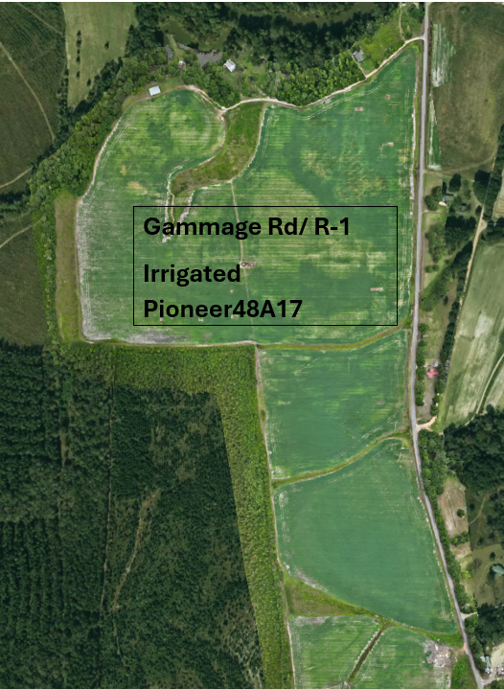
Field 1: 100 acre soybean field in South Alabama
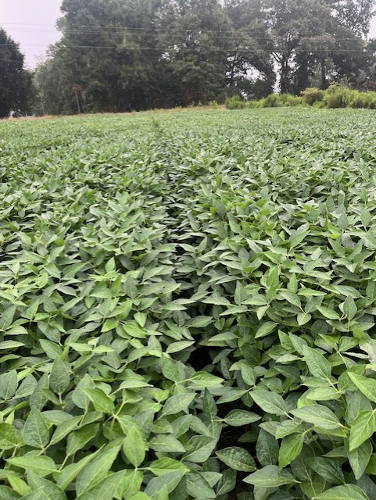
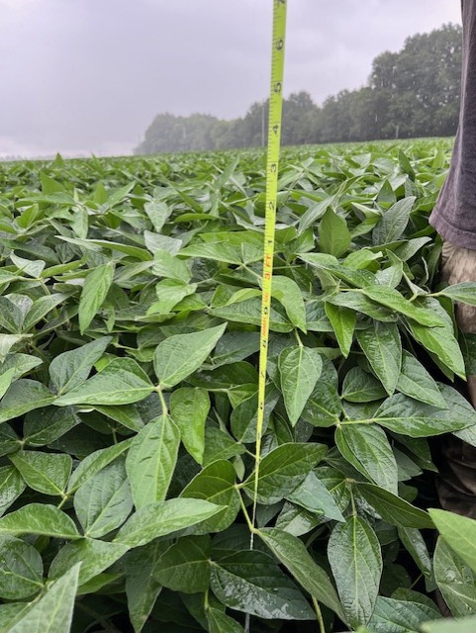
Plants in field one
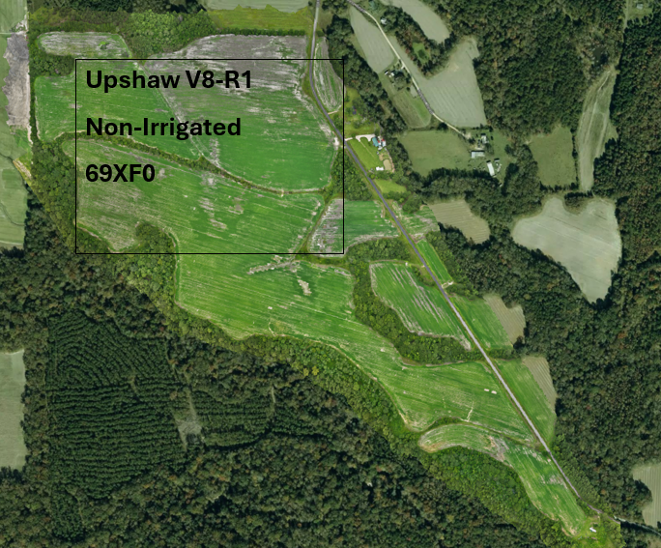
Field 2: 130 acre field in south AL
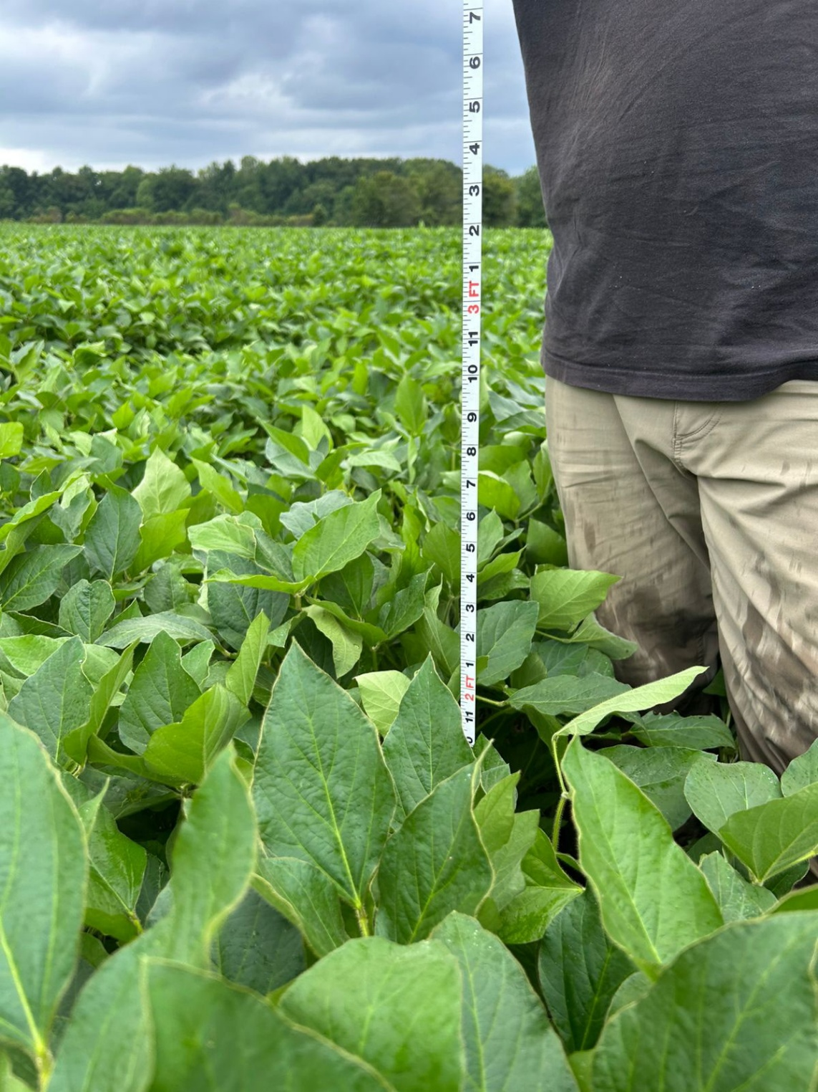
Plants in field 2

