Second quarter progress report FY23 – Kleinjan/Kovacs

Soybean Nitrogen fixation under Nitrogen and Sulfur fertilization

Objectives:

1) Estimate BNF and N budgets in soybean considering N and sulfur (S) fertilization rates.
2) Build a predictive model for BNF in the United States using environmental data.
3) Extend the results to soybean growers using local and national extension networks.

Objective 1: Estimate BNF and N budgets in soybean considering N and sulfur (S) fertilization rates.

In 2022, this study was performed at 30 locations in 14 states with Dr. Ignacio Ciampitti of Kansas State University (KSU) serving as the lead PI. Every effort was made to select a site in each state that was likely to be 1) responsive, and 1) non-responsive to soybean S fertilization. This study is a continuation of an effort begun in the spring of 2021. If all proposed locations are harvested in 2022, there will be 57 site-years of data for the years 2021-2022.

In South Dakota, the studies were planted in Aurora (theoretical responsive environment) and Brookings (theoretical non-responsive environment). Plots were planted at both locations in May. Soil samples were collected prior to planting and N and S fertilizer treatments were surface applied immediately following planting. Plant and soil samples were collected at the R2, R4, and R6 growth stages. The soil samples were frozen and delivered to AgVise Labs in Benson, MN. Soybean whole-plant and stem samples were weighed, dried and course-ground, and sent to Dr. Ciampitti’s laboratory at KSU for analysis. Plots were harvested with a Kincaid plot combine in early October and grain samples will sent to the University of Minnesota (c/o Dr. Seth Naeve) for analysis.

As in 2021, the Aurora location was selected as a ‘responsive’ environment because the soils are ‘lighter’ and considered to be potentially more responsive to fertilizer applications. In 2022, soil sample characterization revealed the Brookings location to have higher OM% and CEC, P and K fertility levels were slightly higher at Aurora (Table 1). A list of fertilizer treatments is summarized in Table 2. A visual representation of the data distribution/yields by treatment for the sulfur study is shown as boxplots in Figure 1. While it appears there may have been a numerical response to sulfur and nitrogen at the Aurora location, statistical analysis showed no differences in any fertilizer treatments at either Aurora (Pr(> F) = 0.518) or Brookings (Pr(>F) = 0.988)). Further analysis combining sites over years will be reported at a future date.

Table 1. Soil test values for 2022 soybean BNF study locations in SD.
Location | Soil texture | OM  (%) | P  (ppm) | K  (ppm) | pH | CEC (meq/100g)
Aurora | silt loam | 3.9 | 13 | 215 | 6.5 | 18.2
Brookings | silty clay loam | 4.3 | 11 | 155 | 7.1 | 24.5

Results of the national study begun in 2021 have not been shared in entirety. In 2021, out of 26 sites, 18 were unresponsive and 8 sites had some response to either S or N+S fertilization. Analysis of plant tissue samples is ongoing and will help to determine how the plant N status and biological N fixation contribute to the response to N-S fertilization across environments. National results from 2022 have not been shared at the time of this report.

Table 2. List of fertilizer treatments in the soybean BNF study (Note: same treatments used in 2021).
Treatment  Number | Planting |  | R3 Growth Stage |  | Total Nutrients Applied
 | N Source  (lb/a) | S Source  (lb/a) | N Source  (lb/a) | S Source  (lb/a) | N Rate  (lb/a) | S Rate  (lb/a)
1 |  |  |  |  | 0 | 0
2 | Urea-N (16) | AMS-S (9) |  |  | 24 | 9
 | AMS-N (8)
3 | Urea-N (0) | AMS-S (27) |  |  | 24 | 27
 | AMS-N (24)
4 | Urea-N (17) | AMS-S (5) | AMS-N (4) | AMS-S (5) | 24 | 10
 | AMS-N (4)
5 | Urea-N (1) | AMS-S (12) | AMS-N (12) | AMS-S (15) | 24 | 27
 | AMS-N (12)
6 | Urea-N (24) |  |  |  | 24 | 0
7 | Urea (135) | AMS-S (13) | Urea (135) | AMS-S (13) | 270 | 26
8 | Unfertilized corn (without nitrogen application)

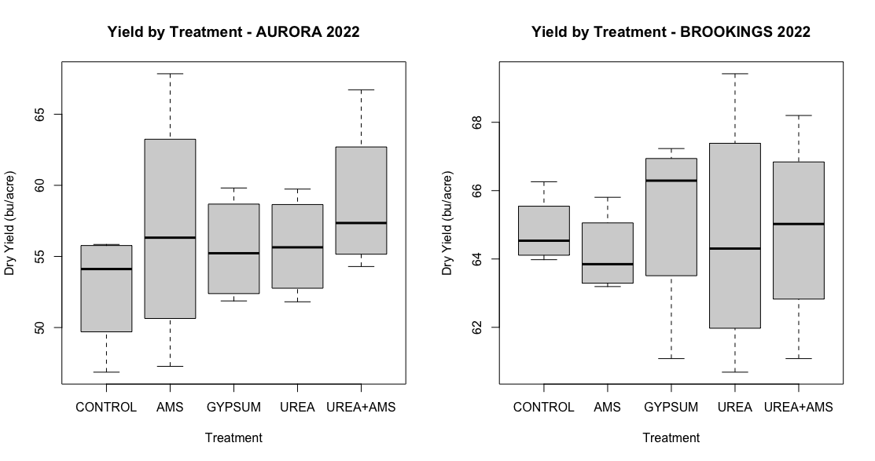
Figure 1. Boxplots showing median soybean yields by fertilizer treatment for Aurora and Brookings, SD in 2022.

Objective 2: Build a predictive model for BNF in the United States using environmental data.
Dr. Ciampitti and his group at KSU will be continuing the process of meta-analysis and attempting to build a predictive model once all the data has been compiled. Prediction models will likely be national in scope with regional considerations. Preliminary observations from 2021 suggest that due to the high uncertainty in treatment response and contribution of N fixation on a deficit of soil N, N fertilization is unlikely to increase yields, leading to non-profitable recommendations. Sulfur deficiency, on the other hand, should be explored under site-specific conditions. National data from 2022 has not been shared at the time of this report.
Objective 3. Extend results to soybean growers through extension networks.

I plan to summarize South Dakota results and share with growers through winter talks (virtual and in-person), radio interviews, SDSU extension website publications, and social media during the January - March 2023 timeframe. I will be discussing the results of the trial during the SDSU extension soybean crop hour on 2/1/2023 and plan to write a brief article/fact sheet discussing the 2021-2022 results on the SDSU extension website. A national summary fact sheet will be published for the study, probably sometime in 2023. A manuscript titled: ‘Soybean yield response to nitrogen and sulfur fertilization in the United States: contribution of soil N and N fixation processes’ was submitted to Field Crops Research for publication in October, 2022 but was not accepted for publication. The manuscript has been edited and submitted to the European Journal of Agronomy in January of 2023.

