Minnesota Soybean Research and Promotion Council

Annual Research Progress Report

Due November 1st

Audience: This information will be utilized to create a research reporting booklet that will be distributed to growers and crop consultants. This is a great opportunity to communi- cate your research directly to growers. Please keep your producer audience in mind when submitting your report. Reports will be printed in COLOR – please include color figures and photos to help explain your results to growers!

Project Title: Determining the current Phytophthora sojae population and the status of variety resistance in Minnesota using improved methods.

Principal Investigator(s): Megan McCaghey and Dean Malvick

Project Period: May 1, 2023 – April 30, 2024
Research Question/Objectives: The purpose of this work is to determine the current population of Phytophthora sojae that is causing root and stem rot in Minnesota soybeans. Root and stem rot can be caused by Phytophthora sojae, a water mold (oomycete) that thrives in poorly-drained soils. P. sojae can infect soybeans at all growth stages, leading to impactful yield losses. To avoid Phytophthora root and stem rot, growers commonly plant soybean varieties that carry resistance genes. However, unless the resistance genes in the variety align with the specific P. sojae variants in the field, resistant varieties will remain ineffective against P. sojae. It is therefore crucial to first determine the specific P. sojae variants present around Minnesota so that the most effective soybean varieties can be deployed. Our goal is to survey the current Minnesota P. sojae population because the last survey was performed 10 years ago and because P. sojae’s adaptation to resistance shifts over time. With this survey, we may develop improved management recommendations for Phytophthora species affecting Minnesota soybeans. The following objectives will help accomplish our goal: (1) Validate the efficiency and accuracy of a recently-developed molecular assay designed to quickly and accurately identify P. sojae variants; (2) Understand the P. sojae diversity in Minnesota that is subject to selection by modern soybean varieties.

Results: Classic identification methods that involve inoculating plants with P. sojae isolates are time consuming and are known to produce inconclusive results. Theoretically, this could have led to the inaccurate identification of P. sojae variants and hence the possible deployment of unsuitable soybean varieties in the past. In Objective 1, we are validating the efficiency and accuracy of a recently-developed molecular assay that uses Polymerase Chain Reaction (PCR) to identify P. sojae variants. With this molecular assay, we can simultaneously detect several P. sojae Avr genes that contribute to non-virulence. By detecting which Avr genes are present in the P. sojae isolate, we can determine the specific variant of that P. sojae isolate.

We performed PCR on 9 P. sojae isolates (Cd20, Hn9, WI16, Pe1, Sc2, As11, PsMNBr1, PsMNFr1, PsILCd2), and we were able to detect 9 out of the 9 P. sojae Avr genes that the PCR can detect (Avr1a-indel, -snp1, -snp2, Avr1b, Avr1c, Avr1d, Avr1k, Avr3a, and Avr6 genes) (Table 1). From here we were able to determine the P. sojae variant (Table 1, last column) based on the Avr genes present.

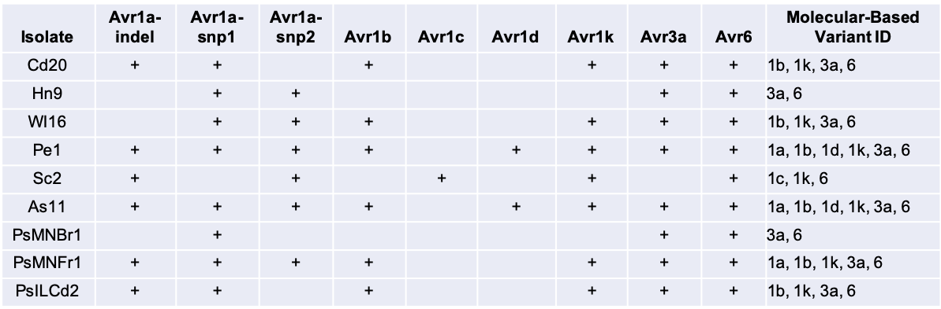
Table 1. Summary of Avr genes detected in P. sojae using a recently-developed PCR molecular assay. Plus (+) sign denotes that we detected an Avr gene in the isolate. Blank denotes we did not detect an Avr gene. The variant identification of the isolate was determined based on which Avr genes were present in the isolate (last column).
In Objective 2, we are surveying the P. sojae population around Minnesota. We aim to isolate P. sojae from soil or symptomatic soybean tissue using established methods, then we will perform the molecular assay (as above) to first confirm it is P. sojae, and then to identify the variant. We have requested and received soil and tissue samples from growers through University of Minnesota’s Extension Personnel and the Soybean Cyst Nematode Lab. We have received soil/tissue samples from counties shaded in pink in Figure 1. Isolation of P. sojae from soil and tissue is currently in progress.
All together thus far, we were able to successfully identify P. sojae variants using the recently-developed molecular assay. Further work is required to confirm its accuracy. We will continue to collect soil and tissue samples so that we may identify the P. sojae variants that may be impacting soybeans in MN. We also aim to submit some of these soil samples to AYOS (a Canadian-based company that can identify P. sojae variants and recommend which soybean varieties to deploy) so that we may validate this service for MN growers.
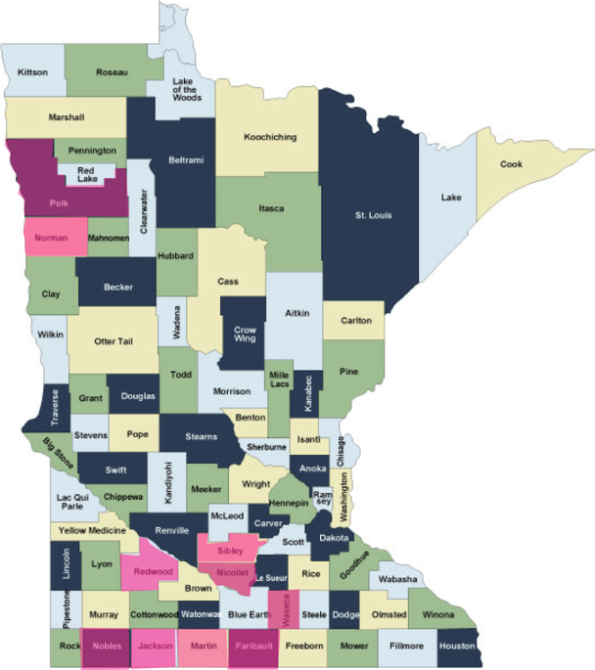
Figure 1. County map of MN showing counties (in pink) from which we have received soil or tissue samples for P. sojae identification.

Application/Use: Results from this work will allow us to develop improved management recommendations for Phytophthora species affecting Minnesota soybeans. We will be able to recommend to growers which P. sojae-resistant varieties of soybean might be most effective in their fields, as well as validate a commercial service that does this for MN growers.

Materials and Methods: P. sojae isolates were grown on clarified V8 agar and incubated at room temperature under ambient light and darkness. DNA to be used for Polymerase chain reaction (PCR) was extracted from P. sojae isolates using established protocols. PCR was performed using DreamTaq Green PCR Master Mix and reactions were ran in a BioRad T100 Thermal Cycler. PCR conditions were same as those in Dussault-Benoit et al. 2020. Gel electrophoresis of PCR was performed using 2% agarose gel.

Economic Benefit to a Typical 500 Acre Soybean Enterprise: Decrease soybean loss due to Phytophthora root and stem rot. Increase soybean yield.

Related Research: Similar work is being performed in Damon Smith’s lab at the University of Wisconsin at Madison and Richard Wade Webster’s lab at North Dakota State University. Our overall goal is to combine our work in order to have a regional survey done of P. sojae population.

Recommended Future Research: We recommend to continue optimizing the molecular PCR assay so that we can further its efficiency and accuracy. We also plan to collect tissue and soil samples from more soybean fields around MN in order to get a better representation of the P. sojae population in the state.

References:
Dorrance, A. E., Kurle, J., Robertson, A. E., Bradley, C. A., Giesler, L., Wise, K., & Concibido, V.
C. (2016). Pathotype diversity of Phytophthora sojae in eleven states in the United States. Plant
Disease, 100(7), 1429-1437.

Dorrance, A.E., D. Mills, A.E. Robertson, M.A. Draper, L. Giesler, and A.Tenuta, 2007.
Phytophthora root and stem rot of soybean. The Plant Health Instructor. DOI: 10.1094/PHI-I-2007-
0830-07 Reviewed 2012.

Dorrance, A.E., Berry, S. A., Anderson, T.R., and Meharg, C. 2008. Isolation, storage, pathotype
characterization, and evaluation of resistance for Phytophthora sojae in soybean. Plant Health Prog.
9. https://doi.org/10.1094/PHP-2008-0118-01-D.G.

Dussault‐Benoit, C., Arsenault‐Labrecque, G., Sonah, H., Belzile, F., & Bélanger, R. R. 2020.
Discriminant haplotypes of avirulence genes of Phytophthora sojae lead to a molecular assay to
predict phenotypes. Molecular plant pathology, 21(3), 318-329.

Matthiesen, R.L., Schmidt, C., Garnica, C.C., Giesler, L.J., and Robertson, A.E. 2021. Comparison
of Phytophthora sojae populations in Iowa and Nebraska to identify effective Rps genes for
Phytophthora stem and root rot management. Plant Health Prog. https://doi.org/10.1094/PHP-02-21-
0016-FI.

Publications:

