ISA Semi-annual report – February 2025
Project title: Investigating the use of nano-encapsulated seed treatments for improved management of soybean sudden death syndrome
PI’s: Leandro and Liu
Report timeline: Apr 1 2024 – Jan 31 2025

Objective 1. Develop nano-encapsulated essential oil seed treatments using nanocellulose derived from soybean residues
Dr. Liu’s lab has prepared nanocellulose from corn stover for use in the formulation of nano-encapsulated essential oils. Results from Fig. 1 show that corn stover derived nanocellulose has a width of 4 nm, and length of 353 nm. Corn stover derived nanocellulose has a crystallinity value of 69.5% according to X-ray diffraction analysis. Corn stover derived nanocellulose has a zeta potential value of −65 ± 3 mV, indicating its good colloidal stability.
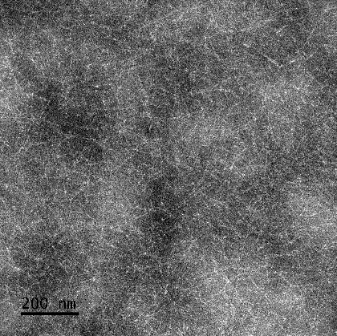
Fig. 1. Transmission electron microscopy (TEM) images of nanocellulose prepared from corn stover.
Dr. Liu’s group worked on using corn stover derived nanocellulose to encapsulate three types of essential oils, including cassia oil, cinnamon bark oil, and lemongrass oil. All nanoemulsions with nanocellulose exhibited droplet sizes between 40 to 280 nm. All nanoemulsions without nanocellulose exhibited smaller droplet sizes (22-129nm) than nanoemulsions prepared with nanocellulose.
Table 1. The diameter of particle sizes and Zeta Potential results of cassia, lemongrass, and cinnamon bark oil nanoemulsion with corn stover-derived nanocellulose.
Sample Oil | Mean Diameter of particle sizes (nm) | Mean Zeta Potential (mv)
Cassia Oil | 198.6 | -12.8
Lemongrass Oil | 40.2 | -24.8
Cinnamon Bark Oil | 285.3 | -6.7

Table 2. The diameter of particle sizes and zeta potential results of cassia, lemongrass, and cinnamon bark oil nanoemulsion without corn stover-derived nanocellulose.
Sample Oil | Mean Diameter of particle sizes (nm) | Mean Zeta Potential (mv)
Cassia Oil | 128.8 | -8.2
Lemongrass Oil | 22.3 | -14.7
Cinnamon Bark Oil | 88.0 | -9.4

For cassia oil and cinnamon bark oil, the essential oil loaded nanoemulsion stabilized by nanocellulose were physically stable at room temperature for storage for at least 30 days, while the nanoemulsion without the presence of nanocellulose was not physically stable. For lemongrass oil, the essential oil loaded nanoemulsion with and without nanocellulose was both physically stable. For all three essential oils, the essential oil loaded nanoemulsion stabilized by nanocellulose was also physically stable against freeze-thaw cycles, while the nanoemulsion without the presence of nanocellulose was not. These findings suggest that nanocellulose can enhance the stability of essential oils, making them more suitable for various applications.

2. Test the effectiveness of the essential oils in suppressing growth of the SDS pathogen, F. virguliforme, in-vitro
Dr. Leandro’s lab conducted phytotoxicity tests with the 16 essential oils previously screened for in-vitro activity against four pathogens of soybean. These tests are necessary to obtain baseline information about the potential for the EO seed treatments to affect seed germination and vigor of the seedlings. Soybean seeds were treated with three coats of the essential oils, planted in pasteurized soil, and evaluated for seed germination, seed emergence, and root length after 7 days. We have completed two runs screening the first set of essential oils and will complete the runs for the second set in early February. To date results suggest that some of oils with the most potent anti-microbial activity cause light phytotoxicity to seeds. We expect that the nanoencapsulation of the oils with corn or soybean cellulose prepared by Dr. Liu will reduce the phytotoxicity, while maintaining or enhancing anti-fungal activity.
We have also conducted a growth chamber assay as a preliminary test of the nanoencapsulated treatments and to fine-time the experimental protocol. This assay showed promising results with a significant reduction of root rot and no significant phytotoxicity on plants treated with nanoencapsulated cassia oil.

