Information needed:
- Name of Project: Development of Best Management Guidelines for White Mold in Pennsylvania
- Principal Researcher: Paul Esker (Extension Field Crops Plant Pathologist and Associate Professor),
Co-Investigators: Alyssa Collins (Associate Research Professor), Beth Gugino (Professor), Karen Luong (Graduate Student), and Tyler McFeaters (Research Technologist)
- Funded amount of $39,167
- None
- None

Research Summary:
Since 1996 in Pennsylvania, white mold has caused soybean yield loss equivalent to an average of $62 per acre. This disease is caused by the fungus Sclerotinia sclerotiorum and thrives in cool, wet conditions. Weather conditions during flowering, soybean variety, row spacing, and soybean management practices influence white mold disease development. S. sclerotiorum infects many other hosts and survives in the soil for five or more years as sclerotia (black overwintering structures). Given the variability of microclimates and production practices across Pennsylvania, targeted risk assessments and management strategies are needed.
Our research aims to improve white mold disease management by studying the diversity of the pathogen at the regional and field scales, determining how widespread white mold is in Pennsylvania, and understanding current effective management practices and their limitations. Our approach will improve the development of targeted management strategies for farmers in the state.
To study the S. sclerotiorum genetic diversity at the field scale, eight fields were divided into 35 plots, and soil was sampled from each section during the spring of 2020 and 2021. To study the genetic diversity at a regional scale, white mold-infested soybeans and soil were collected throughout Pennsylvania during the summer of 2019 through 2022. In addition, we received isolates from New York from our collaborator, Dr. Sarah Pethybridge (Cornell University), to use for a comparison study. In the laboratory, S. sclerotiorum was isolated from samples. DNA was extracted, from which ten different genes were amplified using PCR and sent to the Penn State Huck Genomics Facility to distinguish unique groups (multilocus genotypes).

Isolates from our collection will be screened to capture the current status of the pathogen’s fungicide sensitivity, reduced sensitivity, and resistance. High throughput methods are being designed and tested to increase the time and efficiency of the fungicide sensitivity screening. Lastly, grower discussion meetings and one-on-one interviews have been planned to survey the current effective management practices, limitations of each management tool, and factors that influence the adoption of specific management strategies.

Findings:
Genetic diversity studies at the field and regional level: Across the eight field scale locations, 286 isolates were analyzed, revealing 83 unique multilocus genotypes. Each of the populations within a field showed evidence of clonality. At the regional level, 257 isolates were analyzed, and 41 multilocus genotypes were found, of which 27 were unique to Pennsylvania. While many multilocus genotypes were shared between Pennsylvania and New York, the southcentral Pennsylvania subpopulation was found to be separated from the other regional subpopulations. Compared to other S. sclerotiorum population studies in the literature, the Pennsylvania population was more diverse than observed elsewhere. The diversity studies showed that S. sclerotiorum populations at the field scale were mainly clonal, which means individuals within a field will react similarly to management tools like fungicides. In addition, unique subpopulations may be due to differing management and field histories and may need different management strategies compared to other regions.

High throughput fungicide sensitivity method testing: Five isolates from six different production regions in Pennsylvania and New York (a total of 30 isolates) were selected. A 24-well tissue culture plate was used to test 22 treatments, four fungicides at five different concentrations, negative control (no fungicide and no pathogen), and positive control (pathogen growing in no fungicide). Isolates in the tissue culture plate had comparable growth rates to those on Petri plates. A significant reduction in growth inhibition occurred in two fungicides that have been out on the market longest. This method will undergo more optimization and validation.
Monitoring for white mold: Biweekly throughout the summer, we published articles in the Field Crop News about the current white mold risk (https://extension.psu.edu/white-mold-in-soybeans-sporecaster-forecasts-and-scouting). During the soybean flowering period, there was a high risk of white mold in the northern and central regions of PA. The risk in south-central and southeast regions ranged from 27-40% in mid-July, which is considered moderate. Rainfall during this period was below average, which we hypothesized would reduce likely white mold development.
At the end of the season, seven monitored counties reported white mold: Bedford, Butler, Cambria, Centre, Lawrence, Lebanon, and Northampton. The monitored field in Cambria County showed up to 25% disease incidence in some locations. The Lebanon County field was around 17% disease incidence. Significant yield loss begins to occur at above 40% disease severity index, yet low levels of white mold allow inoculum to build up in the soil. In locations with moderate risk, white mold was present with low incidence and did not significantly impact yields. While the Sporecaster mobile app can be a helpful tool for forecasting risk, other factors should be considered when making fungicide application decisions, especially given the variable results we have seen in the past three years.
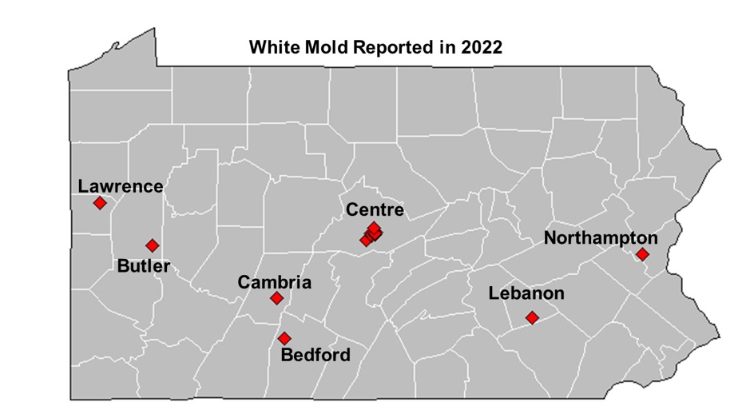
Illustrations:
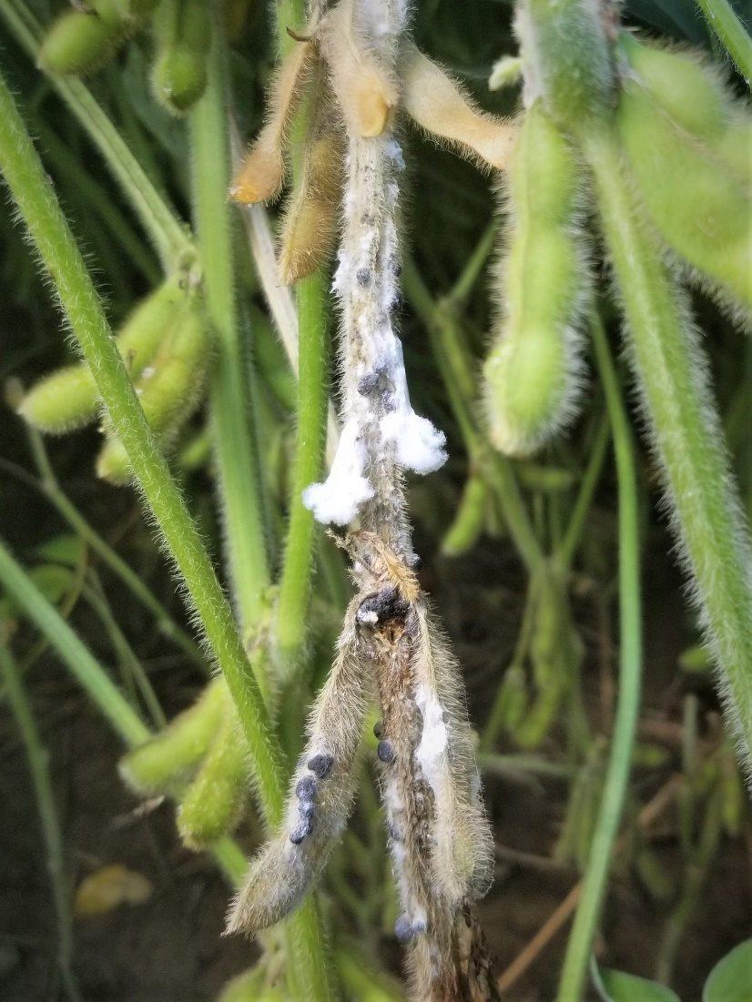
Caption: White mold signs: black sclerotia and white mycelia on soybean stem and pods
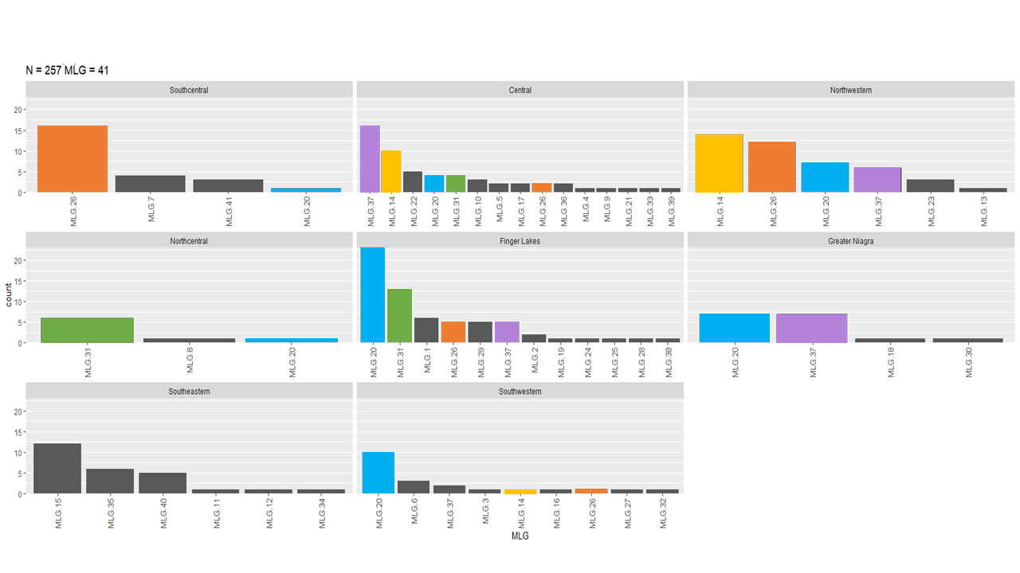
Caption: Multilocus genotype groups (MLGs) found in New York and Pennsylvania regions. MLGs are colored to highlight regions where they are shared.
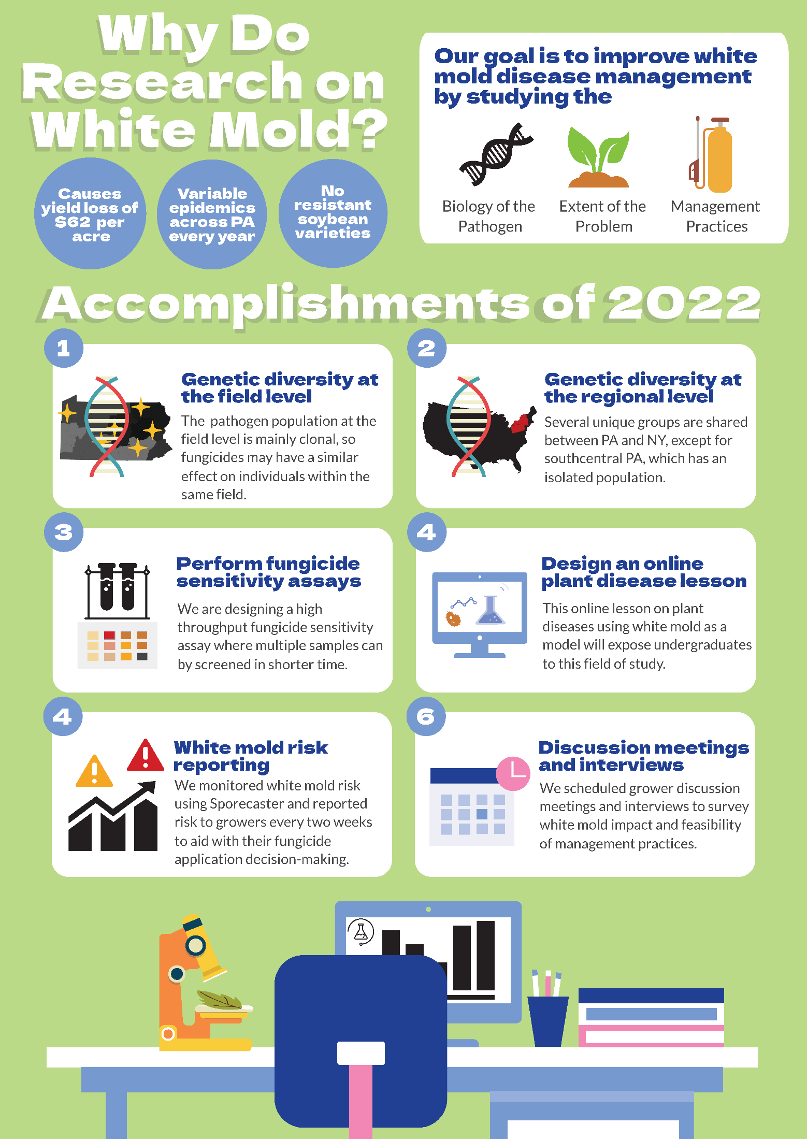
Caption: A summary of this research project and what we have accomplished in the past year.

