Third quarter progress report FY23 – Kleinjan

Evaluating Yield Response and the Return on Investment of Biological Seed Treatments

Objectives:

1) Identify yield response in soybean to biological seed treatments (commonly marketed products).
2) Conduct economic analyses on the value of these products.
3) Extend the results to soybean growers using local and national extension networks.

Objective 1: Identify yield response in soybean to biological seed treatments

In 2022, this study was performed at 50 locations in 17 states with Dr. Laura Lindsey of Ohio State University serving as Principal Investigator. Nine commonly marketed biological seed treatment products from six companies were tested at all locations (Table 1). Products were applied to soybean seed on top of existing seed treatments according to company-supplied protocols.

Table 1. A list of product names and corresponding microorganisms used in the 2022 national soybean study.
Treatment | Company | Product Name | Microorganism
1 | Sunrise | BioBuild™ Soy Bio ST + R | Azospirillum brasiliensi, Bacillus licheniformis, B. amyloliquefaciens, B. subtillis, Pseudomonas fluorescens, Rhizobium
2 | ABM | SabrEx® Soybeans PB | Trichoderma virens
3 | ABM | Graph-Ex® | Rhizobium
4 | BASF | Vault® IP Plus | Bacillus subtillis, Bacillus amyloliquefaciens, Bradyrhizobium japonicum
5 | 3Bar Biologicals | Bio-YIELD® ST | Pantoea agglomerans
6 | 3Bar Biologicals | Bio-YIELD® | Pseudomonas brassicacerum
7 | Lallemand | LAL FIX Proyield + LAL RISE Start SC | Bradyrhizobium elkanii; Delfia acidourarus; Bacillus velenzensis
8 | Lallemand + Agrilead | Rise & Shine | Bacillus velenzensis
9 | Valent | MycoApply EndoFuse | Glomus intraradices, G. mosseae, G. aggregatum, G. etunicatum
10 | Control | Control | None

In South Dakota, the studies were planted at four locations: Bath, Brookings, Miller, and Renner. Plots were planted at all locations at normal planting dates during the month of May. Baseline soil samples were collected at planting time. Stand counts were taken at the ~V3 growth stage. Plots were harvested with a Kincaid plot combine in October and grain samples will sent to Ohio State University (c/o Dr. Laura Lindsey) for analysis. There were no significant differences in stand counts between treatments for 1) individual locations or 2) when analyzed together. The only location in SD that had yield treatment differences was Renner (Figure 1) and, when analysis was done with combined locations, there were no treatment differences (Figure 2). Although Renner had yield differences, none of the treatments were significantly different than the untreated control.

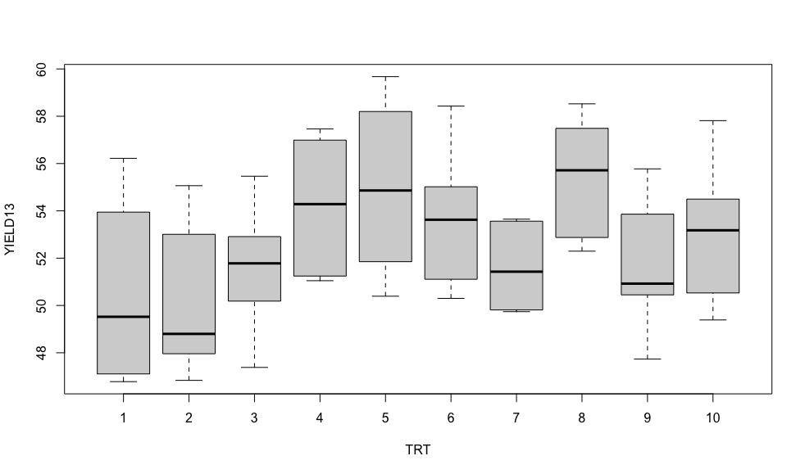Figure 1. A boxplot showing median yields and distributions for biological seed treatments for the Renner location. Note: Treatment 10 is the untreated control.

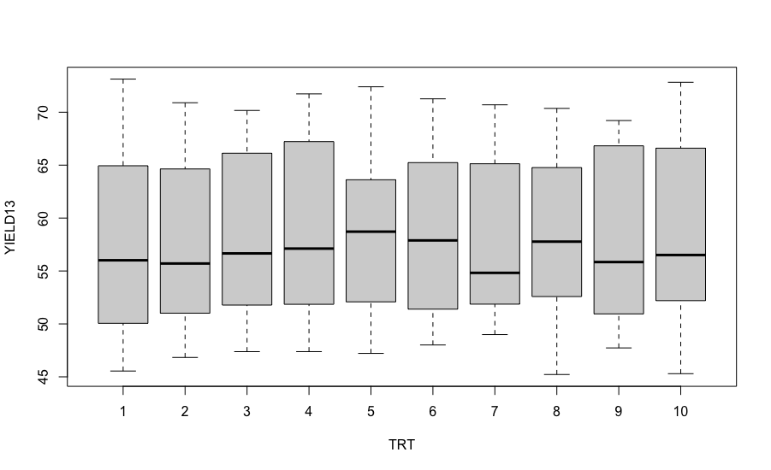
Figure 2. A boxplot showing median yields and distributions for biological seed treatments for combined SD locations (Bath, Brookings, Miller, and Renner). Note: Treatment 10 is the untreated control.

At time of this report, 41 of the 50 locations from 13 states had been analyzed. Only four locations out of the 41 reported (Renner, SD and three sites in Wisconsin) showed significant differences between treatments. While results are preliminary, data suggests that response to biological seed treatments in soybeans is unlikely. Continued research will provide a better understanding of environmental conditions that may contribute to success with biological products.
Objective 2: Conduct economic analyses on the value of these products.

As discussed in the Objective 1 results, preliminary results show that yield response to the biological treatments in this trial are unlikely and, when they do occur, hard to predict. It is therefore highly unlikely that any of the products will be found to be economically viable. If a realistic economic analysis can be performed, it will occur following the national summary.

Objective 3. Extend results to soybean growers through extension networks.

I discussed the results of the trial during the SDSU Extension soybean crop hour on 2/1/2023 (web link) and the SD CCA meeting at McCrory Gardens on 3/24/23. I was also invited to a private seed dealer’s customer meeting to discuss the results of the trial in Milbank, SD on 3/14/23. I will schedule a radio interview to discuss the research with SDSU extension radio during the spring of 2023. I plan to write a brief article/fact sheet discussing the combined 2022-2023 results on the SDSU extension website. A national summary fact sheet and peer-reviewed journal article will be published for the study at a future date (2024).

