Determining the current Phytophthora sojae population and the status of variety resistance in Minnesota using improved methods

Cooperators: Megan McCaghey, Dean Malvick, Kathleen K. Markham, Jane Fenske-Newbart, Cathy Johnson, Senyu Chen, Carol Groves, Damon Smith

Funding provided by: Minnesota Soybean Research and Promotion Council

Project year: May 1, 2023 – April 30, 2024

PURPOSE OF STUDY:
At the start of the last five growing seasons, some parts of Minnesota have been above historic average for soil moisture, promoting the development of Phytophthora sojae, a soil-borne, water mold pathogen that attacks soybeans at all growth stages and causes significant yield losses. P. sojae under these conditions may have contributed to seedling emergence issues, damping off, and higher incidences of root and stem rots that have been observed in Minnesota. Planting soybean varieties with genetic resistance to P. sojae is one of the best management strategies for P. sojae-associated diseases. However, unless the resistance genes (Rps) in the soybean variety align with the specific P. sojae variants (pathotypes) in the field, soybean Rps varieties will remain ineffective against P. sojae. The purpose of this study is to determine the current P. sojae pathotypes present in Minnesota. This will allow us to recommend soybean varieties that could align with the P. sojae pathotypes present in the field so that resistance against P. sojae is achieved. Past P. sojae surveys were performed using inefficient plant inoculation methods, which are resource- and labor-intensive, time-consuming, and possibly erroneous. In this study, we are validating a recently-developed molecular method that was designed to quickly and accurately identify P. sojae pathotypes. We aim to use this molecular method to complete a pathotype survey of P. sojae from soil collected around Minnesota in the 2023 growing season. Here, we show a preliminary comparison between the molecular method and the widely-used plant inoculation method. We will also cross-validate our molecular-based pathotypes with AYOS, a pathotyping service also using similar molecular methods, while at the same time validating this service for growers who opt to use a commercial company for their farm-level soybean recommendations. Overall, this work could improve management recommendations for growers by potentially avoiding the deployment of unsuitable soybean varieties that can further yield losses.

OBJECTIVE 1: Validate a recently-developed molecular method that was designed to identify P. sojae pathotypes

Classic P. sojae pathotyping methods that have been widely-used for decades involve injecting soybeans that carry resistance (Rps) genes with a P. sojae isolate, then evaluating the soybean’s response (susceptible or resistant) to the isolate. Such plant inoculation methods are time-consuming, resource-intensive, and have been known to produce false positives and false negatives. The molecular method recently developed by Dussault-Benoit et al. (2020) uses Polymerase Chain Reaction (PCR) to detect P. sojae Avr genes, which will be used to determine the P. sojae pathotype. This molecular method was shown to have a 97% pathotyping accuracy rate when cross-validated with a modified and more accurate plant pathotyping method that allows P. sojae zoospores to infect soybeans in a hydroponic system. The molecular method generated excitement amongst the community because it showed promise as a potentially new pathotyping method that would deliver faster and more accurate pathotyping results.

RESULTS
The molecular method was designed to simultaneously detect six common Avr genes (Avr1a, Avr1b, Avr1d, Avr1k, Avr3a, and Avr6) in one multiplex PCR reaction, and another Avr gene (Avr1c) in a separate uniplex PCR reaction. We tested the molecular method on nine P. sojae isolates that were previously collected from Illinois by Dean Malvick in 2013. For this objective, we optimized the multiplex PCR to visualize conclusively which Avr genes were detected (Fig. 1b). One of our early multiplex PCRs is shown in Fig. 1a, in which some bands (indicating the presence of a gene) were very faint and not well-separated from other bands (i.e. other genes present). Results like these can lead to ambiguous pathotyping. We have since optimized experimental conditions so that bands are now distinct, clear, and well-separated from other bands (Fig. 1b), allowing us to conclusively ascertain which Avr genes are present and absent. We were then able to successfully determine the pathotypes of the P. sojae isolates (Table 1). Today, we are continuing to test the molecular method on 14 additional P. sojae isolates collected from Illinois by Dean Malvick. At the end of our FY23 funding, we expect to have tested the molecular method on at least 23 total isolates.

Six of the nine isolates tested were previously pathotyped by Dean Malvick in 2013 using the plant inoculation method. We were blind to these previous pathotypes when we tested the molecular method. However, when we compare the molecular-based pathotypes to the plant-based pathotypes, we see that two of the six pathotypes are inconsistent between the two pathotyping methods (Table 1, blue and green column). Based on our communications with other researchers testing the molecular method, many others are also seeing inconsistencies. We are presently re-pathotyping the isolates using the plant inoculation method to determine the current plant-based pathotype, as old isolates could change pathotypes while in culture.

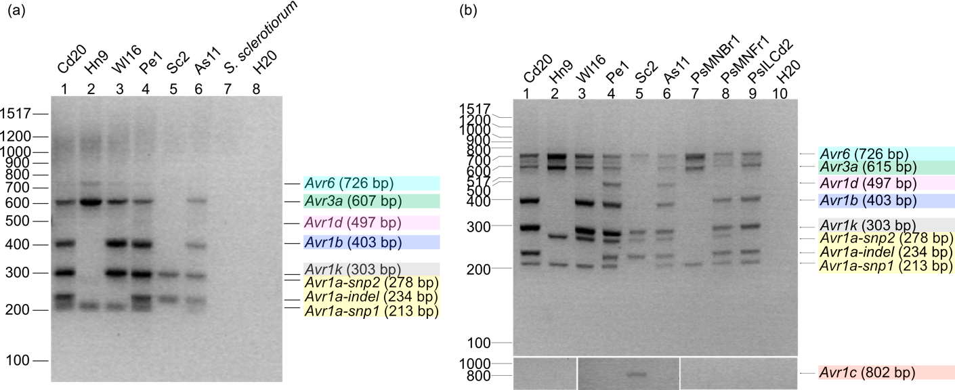

Figure 1. The molecular method developed by Dussault-Benoit et al. (2020) was tested on P. sojae isolates collected in 2013 (Cd20, Hn9, WI16, Pe1, Sc2, As11). Dark bands at the appropriate size indicate presence of a specific Avr gene. S. sclerotiorum and H20 are negative controls. (a) One of our early successful trials of the multiplex PCR suffered from faint and unresolved bands. (b) These issues have been addressed in our latest trial of the multiplex PCR, in which we were able to get distinct and well-resolved bands.

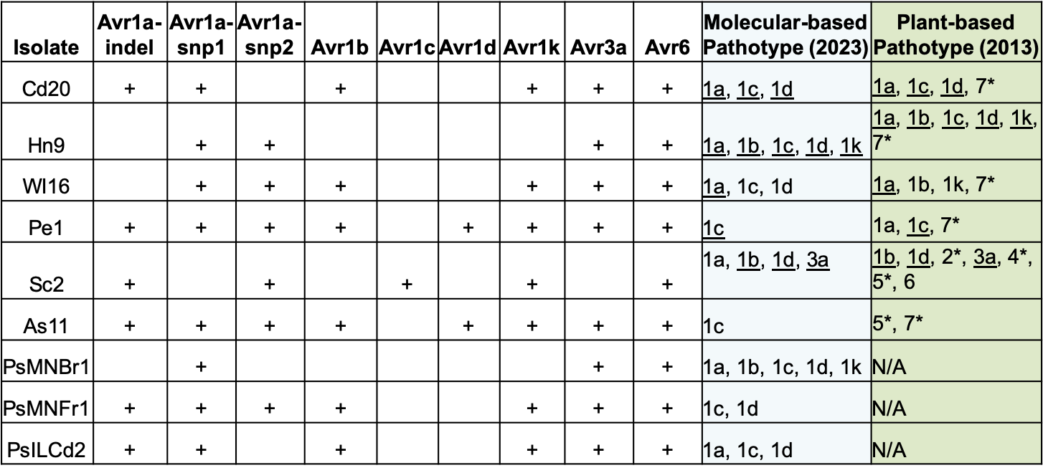

Table 1. Summary of Avr genes detected in 9 P. sojae isolates using the molecular method. Plus (+) sign denotes that we detected an Avr gene in the isolate. Blank denotes we did not detect an Avr gene. For Avr1a, all three genes (Avr1a-indel, Avr1a-snp1, Avr1a-snp2) must be detected in order for Avr1a to be considered present. The pathotype of the isolate can be determined based on which Avr genes were absent in the isolate (blue column). When the molecular-based pathotype is compared to the plant inoculation-based pathotype (performed in 2013 by Dean Malvick) (green column), we see some inconsistencies. * denotes that the molecular method does not screen for these genes. Underlined pathotypes denote consistencies between the two pathotyping methods.

OBJECTIVE 2: Perform hypocotyl inoculations as alternative plant pathotyping method

The plant inoculation method can be done in various ways. A widely-used one involves wounding the hypocotyl and injecting P. sojae at the hypocotyl. Another involves allowing P. sojae zoospores to infect soybean roots in a hydroponic system, which some argue recapitulates a more “natural” infection process. As mentioned above, the hydroponic system is what the molecular method was validated against, exhibiting 97% accuracy. It has been demonstrated and reported that there are inconsistencies between hydroponic system-based pathotypes and hypocotyl inoculation-based pathotypes (Arsenault-Lebrecque et al. 2018). Together, these suggest that soybeans may be highly nuanced in their response to P. sojae. That is, soybean’s response to P. sojae could vary depending on which part of the soybean plant P. sojae gains entry. The wounding process of the hypocotyl inoculation could also contribute to the overall immune response of soybean. The age of the soybean plant could also contribute to differences in response. Any combination of these possibilities could potentially confound pathotype determination. All together, these highlight the potential drawbacks of plant pathotyping methods.

Nevertheless, we will perform hypocotyl inoculations as another means of pathotyping because we seek to understand the differences between the molecular method and the hypocotyl inoculation method. This information is important for the community to know so that we can properly decide how to move forward with the most accurate pathotyping method(s).

RESULTS
In Objective 2, we are using a modified plant inoculation method that involves growing soybeans on germination paper instead of soil, making it is less resource-intensive (Fig. 2a). We inoculated soybean differentials carrying either Rps1a, Rps1b, Rps1c, Rps1d, Rps1k, Rps3a, or Rps6 resistance genes, and a susceptible soybean line as positive control, with P. sojae isolate WI16 (Table 1). We injected the soybeans with either an empty agar (as negative control) or the WI16 isolate at the hypocotyl, then we evaluated the percentage of soybeans that exhibited characteristic rot at the hypocotyl region (Fig. 2b). Our preliminary experiments show that the pathotype based on this method differed from the molecular-based pathotype (Fig. 2c, Table 1). In addition, the pathotype differed based on which cutoff is chosen: 60% of soybeans rotted, 70% of soybeans rotted, or 75% of soybeans rotted. We also observed some rotting in the empty agar controls (e.g. Rps6, Fig. 2b), suggesting that the final pathotype determinations might need to be normalized to the controls.

OBJECTIVE 3: Isolate P. sojae from soils collected around Minnesota to be used for pathotyping survey

PROGRESS
P. sojae is typically isolated from soil using soybean leaf discs or seedlings as bait. We have tested many soil baiting protocols in our FY23 cycle, starting with a positive control that contains mycelia from P. sojae isolates. We have encountered challenges with these soil baiting protocols, particularly in the processing of the leaf discs and seedlings and in the plating of these tissue on selective media. We have been in communication with other researchers who perform soil baiting and have received helpful tips moving forward. While it is taking longer than expected, we are optimistic that we will get the soil baiting working in our lab.

Once we are able to successfully isolate P. sojae from soil and pathotype the isolates using the molecular method in Objective 1 (and possibly our plant inoculation method in Objective 2), we will send a subset of our soil samples to AYOS, a commercial service that uses similar molecular methods as in Objective 1. This will allow us to cross-validate our molecular-based pathotypes with AYOS, while at the same time validating this service for growers who opt to use a commercial company for their farm-level soybean recommendations.

Thus far in our FY23 cycle, we have collected soil and infected tissue samples from 12 counties in the southern and northwestern parts of Minnesota.

OBJECTIVE 4: Communication plan

We are currently working on publishing a manuscript that will discuss the utility of the molecular method in pathotyping P. sojae. In this manuscript, we will demonstrate the efficiency of the multiplex PCR and compare molecular-based pathotypes to pathotypes determined using classic plant inoculation methods. Our goal is to demonstrate to the scientific community any differences between pathotyping methods so that we can decide moving forward on the ideal method to use.

In our FY23 cycle, we have presented or will present our findings at the following events:
- Soybean Research Day, University of Minnesota – Aug. 2023, presented by Kathleen Markham
- American Phytopathological Society Conference – Aug. 2023, presented by Jane Fenske-Newbart
- Fall Extension Crops Team Staff Development Gathering – Sep. 2023, presented by Kathleen Markham
- Fungi: A Global Nexus for Cross-Kingdom Interactions Symposium – Sep. 2023, presented by Jane Fenske-Newbart
- Prairie Grains 2023 Conference – Dec. 2023, presented by Angie Peltier
- P. sojae community meeting – Jan. 2024, presented by Dean Malvick
- Phytophthora root and stem rot Virtual Meeting – Feb. 2024, presented by Kathleen Markham
- College of Food, Agriculture, and Natural Resources Sciences Conference – Mar. 2024, presented by Kathleen Markham

