Determining the current Phytophthora sojae population and the status of variety resistance in Minnesota using improved methods

Cooperators: Megan McCaghey, Dean Malvick, Kathleen K. Markham, Jane Fenske-Newbart, Cathy Johnson, Senyu Chen, Carol Groves, Damon Smith

Funding provided by: Minnesota Soybean Research and Promotion Council

Project year: May 1, 2023 – April 30, 2024

PURPOSE OF STUDY
At the start of the last five growing seasons, some parts of Minnesota have been above historic average for soil moisture, promoting the development of Phytophthora sojae, a soil-borne, water mold pathogen that attacks soybeans at all growth stages and causes significant yield losses. P. sojae under these conditions may have contributed to seedling emergence issues, damping off, and higher incidences of root and stem rots that have been observed in Minnesota. Planting soybean varieties with genetic resistance to P. sojae is one of the best management strategies for P. sojae-associated diseases. However, unless the resistance genes (Rps) in the soybean variety align with the specific P. sojae variants (pathotypes) in the field, soybean Rps varieties will remain ineffective against P. sojae. The purpose of this study was to determine the current P. sojae pathotypes present in Minnesota. This will allow us to recommend soybean varieties that could align with the P. sojae pathotypes present in the field so that resistance against P. sojae is achieved. Past P. sojae surveys were performed using inefficient plant inoculation methods, which are resource- and labor-intensive, time-consuming, and possibly erroneous. In this study, we validated a recently-developed molecular method that was designed to quickly and accurately identify P. sojae pathotypes. We aim to use this molecular method to complete a pathotype survey of P. sojae from soil collected around Minnesota in the 2023 growing season. Here, we show a comparison between the molecular method and the widely-used plant inoculation method. We will also cross-validate our molecular-based pathotypes with AYOS, a pathotyping service also using similar molecular methods, while at the same time validating this service for growers who opt to use a commercial company for their farm-level soybean recommendations. Overall, this work could improve management recommendations for growers by potentially avoiding the deployment of unsuitable soybean varieties that can further yield losses.

RESULTS

Objective 1: To understand the Phytophthora sojae pathotype diversity in Minnesota that is subject to selection by modern soybean varieties.

Objective 2: To understand how widespread Phytophthora sansomeana is in soybean fields in Minnesota.

In Objectives 1 and 2, we aimed to isolate Phytophthora species from MN soil in order to identify the P. sojae variants (pathotypes) in MN fields. We also aimed to identify any soybean-infecting P. sansomeana species to assess how widespread this less well-characterized Phytophthora species is (Hebb et al. 2023, Malvick et al. 2004). In the 2023 planting season, we received 25 soil samples from growers’ or research fields, representing 12 MN counties (Fig. 1). Six of these 12 counties are amongst the top soybean producing counties in MN (USDA, Fig. 1b). In our FY2024 MSRPC grant, we will continue to collect soil from other top soybean producing counties, particularly the western/central western/southeastern regions (Fig. 1b). These additional samples will allow us to capture the representative pathogen profile of the state.

We are currently isolating Phytophthora species from these soil samples using a soil baiting technique (Malvick et al. 2004) that we successfully tested in the lab (Fig. 2). For our soil baiting trials, we artificially infested sterilized soil with known variants of P. sojae, then we allowed P. sojae in the soil to infect a susceptible soybean cultivar (Fig. 2a). After 10 days, we plated the infected soybean tissue onto Phytophthora-selective growth media and allowed Phytophthora to grow on the media (Fig. 2b-c). Finally, we confirmed the Phythophthora species via a molecular method known as Polymerase Chain Reaction (PCR) that can identify P. sojae specifically (Fig. 2d, Bienapfl et al. 2011).

Waiting on results from actual soil baiting. Add here.

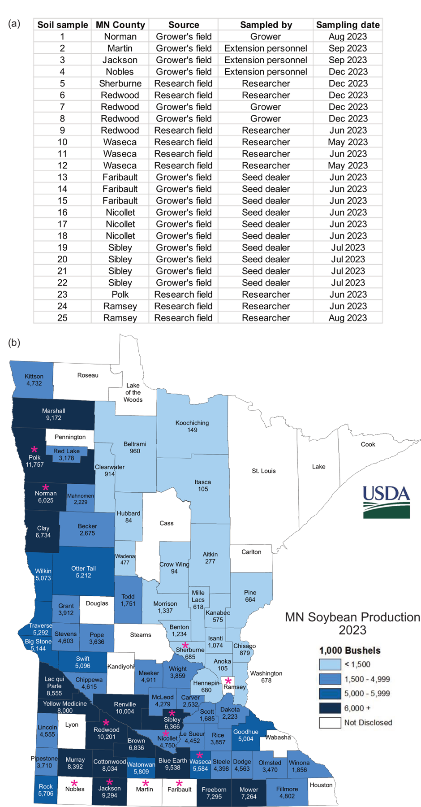

Figure 1. Soil samples collected from various MN fields in 2023 from which Phytophthora species will be isolated. (a) List of soil samples our lab gathered in the 2023 growing season. (b) Map of MN soybean production in 2023, showing number of bushels produced per county (source: USDA). Pink asterisk represents counties from which we have soil samples.

Figure 2. In experimental trials, we successfully isolated P. sojae from soil. (a) Soil that was artificially infested with P. sojae was allowed to infect a susceptible soybean cultivar (Sloan). Infected soybean seedlings (right) versus non-infected seedlings (left) are shown. (b) A piece of infected tissue was plated on Phytophthora-selective media and Phytophthora was allowed to grow. (c) Mycelia from (b) was sub-cultured on new growth media. (d) DNA was extracted from (c) and a molecular method was performed to confirm that the identity was P. sojae (lane 3).

Objective 3: To understand how recent commercial cultivar deployment has affected Phytophthora sojae diversity in Minnesota.
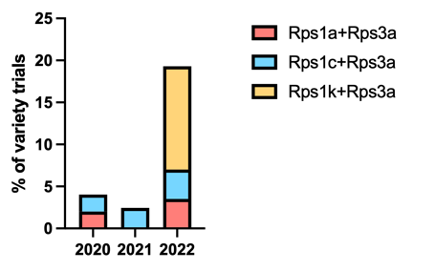
The Soybean Field Crop Variety Trials conducted yearly by Aaron Lorenz at the University of Minnesota saw an increase in soybean varieties carrying ‘stacked’ Rps genes (Fig. 3) (Lorenz et al., 2020; Lorenz et al., 2021; Lorenz et al., 2022). Stacking or combining Rps genes in one soybean line is a strategy used to combat the complex P. sojae pathotypes that could exist in a field. While this could suggest that seed companies plan to introduce more effective varieties, blindly deploying varieties that may not match the pathogen population could put unnecessary pressure on P. sojae to adapt and develop further resistance. Add more years of Variety Trials.

Objective 4: To enhance the efficiency of pathotype identification.
Classic P. sojae pathotyping methods that have been widely-used for decades involve injecting soybeans that carry resistance (Rps) genes with a P. sojae isolate, then evaluating the soybean’s response (susceptible or resistant) to the isolate. Such plant inoculation methods are time-consuming, resource-intensive, and have been known to produce false positives and false negatives. The molecular method recently developed by Dussault-Benoit et al. (2020) uses PCR to detect P. sojae Avr genes, which will be used to determine the P. sojae pathotype. This molecular method was shown to have a 97% pathotyping accuracy rate when cross-validated with a modified and more accurate plant pathotyping method that allows P. sojae zoospores to infect soybeans in a hydroponic system.

We successfully tested Dussault-Benoit et al.’s molecular method on 23 total P. sojae isolates that were previously pathotyped in 2004 by Dean Malvick via a plant inoculation method. After we optimized the molecular pathotyping method on few isolates (Fig. 4a-b), we performed the method on 23 total P. sojae isolates and were able to determine the PCR-based pathotyped based on the Avr genes that were absent (Fig. 4c). However, when we compare the molecular-based pathotypes to the plant incoulation-based pathotypes performed by Dean Malvick in 2004, we see inconsistencies between the two pathotyping methods (Table 1). Based on our communications with other researchers testing the molecular method, many others are also seeing inconsistencies. We are presently re-pathotyping the isolates using a plant inoculation method to determine the current plant-based pathotype, as old isolates could change pathotypes while in culture. Waiting on more results. Add here. Add implications and significance.

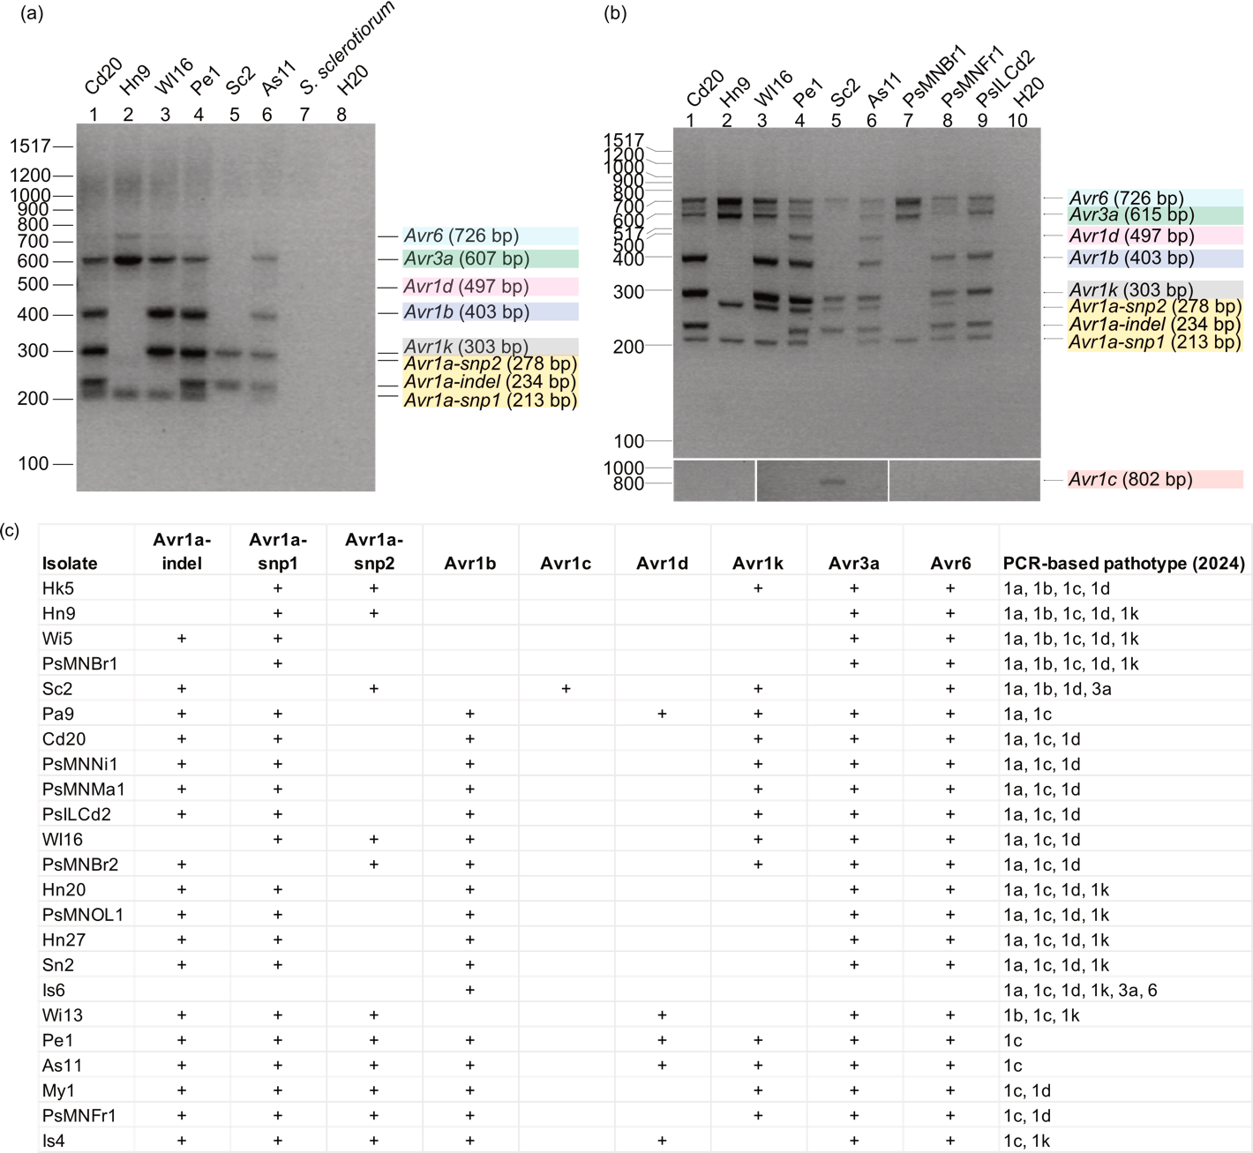
Figure 4. The molecular pathotyping method developed by Dussault-Benoit et al. (2020) was successfully tested on 23 P. sojae isolates collected in 2004 from Illinois by Dean Malvick. Dark bands at the appropriate size indicate presence of a specific Avr gene. S. sclerotiorum and H20 are negative controls. (a) One of our early successful trials of the multiplex PCR suffered from faint and unresolved bands. (b) These issues were addressed in our later iterations of the molecular method, in which we were able to get distinct and well-resolved bands. (c) Summary of Avr genes detected in 23 P. sojae isolates using the molecular pathotyping method. Plus (+) sign denotes that we detected an Avr gene in the isolate. Blank denotes we did not detect an Avr gene. For Avr1a, all three genes (Avr1a-indel, Avr1a-snp1, Avr1a-snp2) must be detected in order for Avr1a to be considered present. We were then able to determine the pathotype of the isolate based on which Avr genes were absent in the isolate.

Table 1. Inconsistencies between PCR-based pathotypes (2024) and plant inoculation-based pathotypes (2004). Waiting on more results. Add here.

Objective 5: To validate a current P. sojae resistant variety recommendation service.
Waiting on soil baiting results.

Objective 6: To develop improved management recommendations for Phytophthora species affecting soybean in Minnesota, including suggested Rps genes that should be deployed.
Waiting on soil baiting results.

