Impact of Road Dust on Soybeans Production
Principal Investigators: Dr. Christina Hargiss, Natural Resources Management Program, NDSU; Dr. Deirdre Prischmann-Voldseth, Department of Entomology, NDSU; Dr. Thomas DeSutter, Department of Soil Science, NDSU; Amy Gnoinsky M.S. Student, Natural Resources Management Program, NDSU

Situation Statement:
In recent years, increased travel and road dust emissions in the Bakken region of western North Dakota have raised concern for farmers and ranchers about the impacts of dust on agricultural production. Considering unpaved roads surround many agricultural fields throughout the state of North Dakota, information on how road dust emissions affect production is beneficial in protecting agricultural yields. Studies that have focused on ambient dust have examined its impacts on crops such as cotton (Zia-Khan et al. 2015), grape (Leghari et al. 2014), wheat and garden pea (Jwan Khidhr Rahman 2015), and cucumber and kidney beans (Hirano 1995).

Physiological impacts on cotton were increased leaf temperature on dusted leaves and an increase in number of blocked stomata (Zia-Khan et al. 2015). In cucumber and kidney beans the same results were discovered, which also increased transpiration rates and altered the photosynthetic rate corresponding to its response curve with leaf temperature (Hirano et al. 1995). Reduced chlorophyll content was found in grapes and in wheat and garden pea, (Leghari et al. 2014; Jwan Khidhr Rahman 2015), along with a decrease in carbohydrate content for both wheat and garden pea but an increase in proline content (Jwan Khidhr Rahman 2015). Production via yield in cotton was reduced by 28% on average in dusted plants and a significant decrease in growth of grape occurred and was apparent through number of leaves, plant length, and plant cover (Zia-Khan et al. 2015; Leghari et al. 2014).

Soybeans are a highly utilized crop and are incorporated into food products (i.e. vegetable oil, margarine, edamame), animal feed (i.e. soybean meal), and industrial applications (i.e. inks, paints, biodiesel fuel, and hydraulic fluids) (Smith 1996; Liu 1996). The quality of soybeans and their derivatives are important, as soybeans are in great demand due to their high protein, oil, and dietary fiber content, along with containing a multitude of vitamins and minerals (Lokuruka 2011). However, it is possible that these factors may be altered due to extenuating circumstances in the field, such as road dust.

Objectives:
In this field study, the objectives were to:
- Determine the impact of road dust on soybean physiology, specifically leaf temperature and chlorophyll/SPAD (an indicator of photosynthetic activity) readings.
- Determine the impact of road dust on soybean production specifically yield quantity and quality (i.e., seed protein, oil components, and amino acids).

Research Conducted:
In the 2015 and 2016 growing season, Roundup Ready soybeans were planted near Prosper, North Dakota. A random complete block design (RCBD) was used in each plot for both years. The plot was divided into eight replications that consisted of four, 9.1 X 9.1 m plots in 2015, and six, 7.62 X 7.62 m plots in 2016. Each replication in 2015 consisted of one control and three treatments and in 2016 a control and five treatments. The three treatments in 2015 were applied dust at the rates of 15.8, 78.8, and 158 g/m²/week. In 2016, the five treatments included applied dust at the rates of 15.8, 78.8, 158, and 315 g/m²/week and 158 g/m² applied twice a week. Dust was applied to 0.75 X 0.75 m treatment areas located in the middle of each plot within a replication.

Dust was obtained from standard class 5 road gravel and standardized with a No. 40 mesh sieve (425 μm) based on Sanders et al. (1997). For ease of application dust was weighed into 37 mL plastic cups, capped, and transported to the field. Application of dust occurred with the use of a 1.2 L stainless steel kitchen flour sifter with a spring action hand trigger and a three layer mesh ≥ 0.425 mm (Figure 1a), modified with a slow release apparatus (Figure 1b) cut from wax paper and attached to the outside of the sifter with tape (Figure 1c) (Hargiss et al. 2017). The slow release apparatus allowed the sifter to hold the dust before dispensing in which aided a more uniform application of dust within the treatment area. To decrease disturbance of wind during application of dust, a spray booth was constructed and placed over the treatment area before each application and removed once application was completed (Figure 2). Dust application rates on plants in treatment areas are shown in Figure 3 after weekly application.

To gauge the impact of dust on plants chlorophyll content readings and leaf temperature readings were taken at the V4, R1, R3, and R6 growth stages. Chlorophyll readings were conducted using a soil plant analysis development (SPAD) meter, while leaf temperatures were collected using an infrared radiometer. Yield and seed composition data were collected for each treatment area after soybeans reached full maturity and were hand harvested.

Findings:
Chlorophyll Content
No significant differences were found in chlorophyll content of treatments within the 2015 growing season and no trends were apparent. The average chlorophyll content was lowest for 0 g/m², increased at the 15.8 g/m², decreased at the 78.8 g/m², but increased at the 158 g/m² (Table 1). In 2016, chlorophyll content at the 15.8 g/m² treatment was significantly different from the chlorophyll content of 315 g/m² and the 2×158 g/m² treatment (Table 2). The highest amount of chlorophyll content belonged to the 2×158 g/m², with 315 g/m² having the second highest chlorophyll content. Chlorophyll content of treatments within each growth stage, were not significantly different for 2015 or 2016. Chlorophyll content among growth stages in 2015 and 2016 were significantly different except for V4 and R3 in 2016. Leaf chlorophyll content is expected to be different at different growth stages as leaf composition and color are functions of leaf age (Gupta and Woolley 1971).

Overall this study only found a significant difference in chlorophyll content in 2016 between the dust treatment of 15.8 g/m² and 315 g/m², as well as, 15.8 g/m² and 2×158 g/m² (Table 2). However, no significant differences were found between dusted treatments and the zero dust treatment. The 15.8 g/m² had an average chlorophyll content just below that of the zero dust treatment and significant differences from the 315, and 2×158 g/m² treatments may be due to the visual observation of chlorosis in the field at the V4 growth stage measurement of chlorophyll readings. Chlorosis in the field affected the 15.8 g/m² treatment in replicate one and two, and affected 78.8, and 158 g/m² in replicate one. Chlorosis was no longer visible at later growth stages (i.e. R1, R3, and R6) for chlorophyll readings.

Leaf Temperature
Average leaf temperatures of treatments for growing season 2015 are in Table 3 and the same data for 2016 are displayed in Table 4. Differences in leaf temperature occurred among treatments but were variable in both years, with treatment differences from ambient air temperatures ranging from 0.46 to 7.72 ˚C and from the zero dust treatment from -1.35 to 1.15 ˚C across growth stages. No significant differences were found in leaf temperatures of treatments within each growth stage for 2015 or 2016. Over the course of the growing season ambient air temperatures ranged from -6 to 34 ˚C (NDAWN 2015; NDAWN 2016). Ambient air temperature fluctuations could have mitigated increases in leaf temperature between dust applications and before leaf temperature readings. Leaf temperature measurements were taken irrespective of wind speed so the reduction in the boundary layer over the leaves due to wind may have normalized leaf temperatures across treatments. Another possibility could be leaf temperatures of dusted soybean leaves could have returned to normal by the time leaf temperature readings were taken a week after dust application. Leaf temperature readings were done right before the weekly dust application and were at a point of maximum dust ‘wear off’. Therefore, by the time leaf temperature readings were taken any spikes in leaf temperature by dust may have been lost, as dust was removed before leaf temperature readings and leaf transpiration could have mitigated any temperature effect caused by dust.

Yield
Analysis of the yield data found no significant differences in treatment yields for either 2015 or 2016 (Table 5). Variation in yield characteristics were observed among treatments, but no significant differences were found in 2015 (Table 6) or in 2016 (Table 7). Plant response to dust contamination level was variable between species and was apparent at higher dust loads. For soybeans, the lack of significant differences in yield could mean that it may take a more frequent application of dust for dust to accumulate and cause negative effects on soybean yield and yield characteristics.

Seed Composition
The non-metric multidimensional scaling (NMS) statistical analysis of the seed composition data set for the 2015 growing season produced a final solution in 59 iterations, and as three dimensional that accounted for 97.2% of the variation in the data, at a final stress of 6.15, and a final instability of 0.00000 (Figure 4). The NMS analysis of seed composition data for the 2016 growing season produced a one dimensional final solution in 62 iterations that explained 98.0% of the variation in the data, with a final stress of 7.23, and a final instability of 0.00000 (Figure 5). Differences observed in ordination of seed composition data may result from genetics in the use of two different varieties between years and from ecological variations between the two growing seasons (Anwar et al. 2016; Bellaloui et al. 2015). In this study, no significantly different responses were observed in soybean seed composition and may be from the experimental dust not containing elements that are harmful to plant processes.

Summary:
Production, as determined by chlorophyll content, leaf temperature, and yield were not significantly different among treatments. Additionally, seed quality via seed composition of treatments were not significantly different among treatments. Overall, road dust had a minimal impact on the physiology and yield of soybeans. The minimal effect found fills a knowledge gap in how increased deposition of road dust may affect soybean production and quality. However, even at the highest road dust amounts, at least 10 to 20 times higher than travel on an average gravel road in North Dakota, this study found no significant differences in those factors. This in part could be attributed to the inert nature of the dust, in that no biologically harmful elements were found in the dust applied. Other studies that have shown negative impacts have typically used non-inert dusts. Future studies should be used to determine the constituents and potential harmful agents found in road dust and determine if those constituents impact soybean production and seed quality. In addition, dust was shown to be removed from leaves after a duration of time. Due to constraints this study was only able to apply dust one or two times per week, thus understanding the daily loads of dust to the plants should be investigated. Also, further investigations into soybean leaf temperature immediately following dust application may better quantify the impacts that dusts have on soybeans.

Acknowledgments:
We would like to thank the North Dakota Soybean Council for funding this study. Thank you to Alexis Steinman, Kayla Graber, and Jesse Riley for assisting with sieving, weighing, and applying dust.

References:
Anwar, F., Kamal, G.M., Nadeem, F. and Shabir, G. (2016) Variations of quality characteristics among oils of different soybean varieties. Journal of King Saud University - Science 28(4), 332-338.
Bellaloui, N., Bruns, H.A., Abbas, H.K., Mengistu, A., Fisher, D.K. and Reddy, K.N. (2015). Agricultural practices altered soybean seed protein, oil, fatty acids, sugars, and minerals in the Midsouth USA. Frontiers in plant science 6: 31.
Gupta, R.K., and Woolley, J.T. (1971). Spectral properties of soybean leaves. Agronomy Journal. 63(1): 123-126.
Hargiss, C.L.M., Graber, K., Prischmann-Voldseth, D., DeSutter, T., Norland, J., and Gnoinsky, A. (2017). Comparison of methodologies for field application of road dust. Water, Air, and Soil Pollution 228:220. DOI 10.1007/s11270-017-3403-8.
Hirano, T., Kiyota, M. and Aiga, I. (1995). Physical effects of dust on leaf physiology of cucumber and kidney bean plants. Environmental Pollution 89(3): 255-261.
Jwan Khidhr Rahman, A.L. (2015). Response of two crop plants to dust deposition. Zanco Journal of Pure and Applied Sciences 27(2): 1-6.
Leghari, S., Zaid, M., Sarangzai, A., Faheem, M., Shawani, G. and Ali, W. (2014). Effect of road side dust pollution on the growth and total chlorophyll contents in Vitis vinifera L. (grape). African Journal of Biotechnology 13(11): 1237-1242.
Liu, K. (1996). Immature soybeans: direct use for food. Inform 7(11): 1217-1223.
Lokuruka, M. (2011). Effects of processing on soybean nutrients and potential impact on consumer health: an overview. African Journal of Food, Agriculture, Nutrition and Development 11(4).
North Dakota Agricultural Weather Network (NDAWN). (2015). Hourly average air temperature for May 18, 2015 to October 16, 2015. Accessed March, 7, 2016 from website: https://ndawn.ndsu.nodak.edu/get-table.html?station=44&variable=hdt&ttype=hourly&quick_pick=&begin_date=2015-05-18&end_date=2015-10-16.
North Dakota Agricultural Weather Network (NDAWN). (2016). Hourly average air temperature for May 18, 2016 to October 16, 2016. Accessed March, 7, 2016 from website: https://ndawn.ndsu.nodak.edu/get-table.html?station=44&variable=hdt&ttype=hourly&quick_pick=&begin_date=2016-05-18&end_date=2016-10-16.
Sanders, T., Addo, J., Ariniello, A. and Heiden, W. (1997). Relative Effectiveness of Road Dust Suppressants. Journal of Transportation Engineering 123(5): 393-397.
Smith, K. (1996). Industrial Uses of Soy Protein: New Ideas. Inform 7(11): 1212-1215.
Zia-Khan, S., Spreer, W., Pengnian, Y., Zhao, X., Othmanli, H., He, X. and Müller, J. (2015). Effect of Dust Deposition on Stomatal Conductance and Leaf Temperature of Cotton in Northwest China. Water 7(1): 116-131.

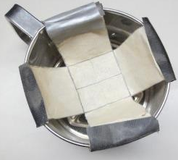
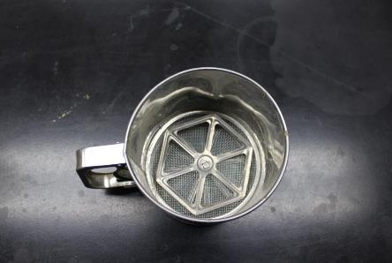

Figure 1. Method used for dust application includes: a) stainless steel flour sifter; b) slow-release apparatus; c) sifter with slow-release apparatus attached.
a)
c)
b)
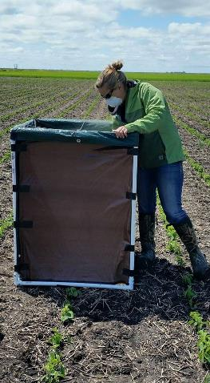
Figure 2. Application of dust to treatment areas.

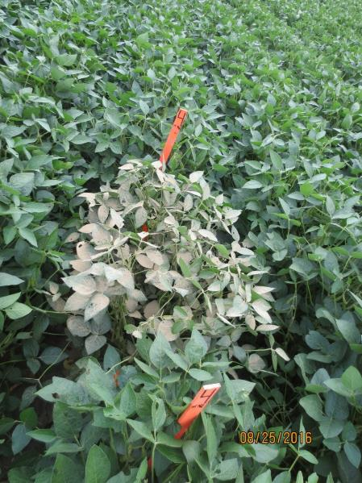
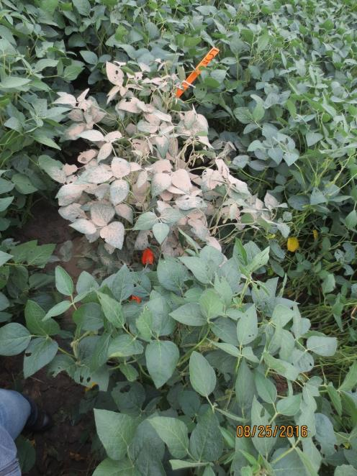
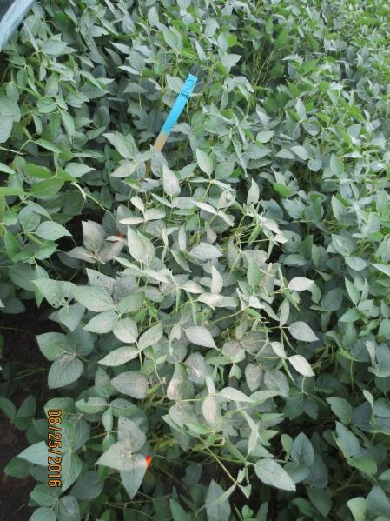
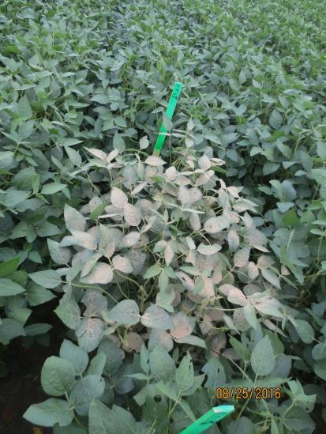
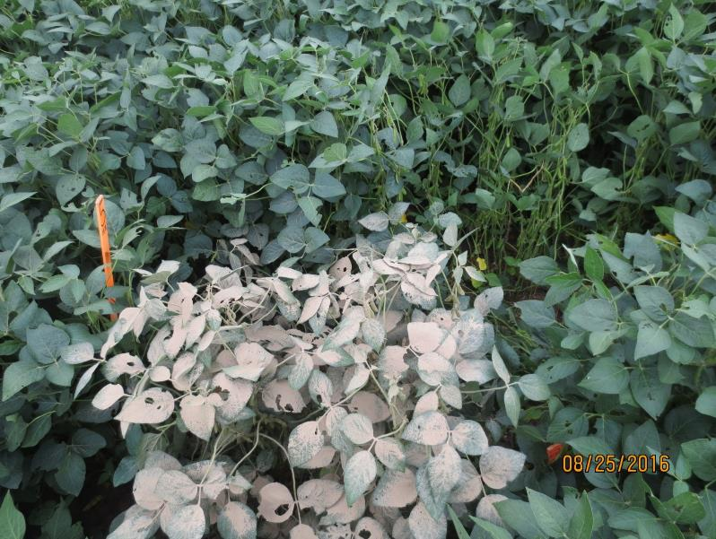
b)
c)
a)
d)
e)
Figure 3. Soybean treatment areas after weekly dust application: a) 0 g/m²; b) 15.8 g/m²; c) 78.8 g/m²; d) 158 g/m²; e) 315 g/m².

Table 1

Average chlorophyll content in SPAD units at each growth stage measured for the 2015 growing season.

Treatment (g/m²) | Measured Growth Stages |  |  |  | Overall Average
Treatment (g/m²) | V4 | R1 | R3 | R6 | Overall Average
0 | 30.8 (3.68) | 33.1 (2.38) | 34.1 (1.59) | 38.3 (2.36) | 34.1
15.8 | 31.3 (3.37) | 33.3 (1.51) | 35.2 (2.51) | 38.4 (2.10) | 34.5
78.8 | 31.2 (2.74) | 32.8 (2.75) | 34.3 (1.96) | 39.0 (1.46) | 34.3
158 | 31.6 (4.11) | 33.7 (2.36) | 35.6 (1.31) | 39.7 (1.30) | 35.2
Average | 31.2ª | 33.2^{b} | 34.8^{c} | 38.8^{d}
Note. Small letters denote significance across row. Different letters in superscript denote significance at p < 0.05. Overall average is the average chlorophyll content across all the measured growth stages. Standard deviations are presented in parentheses.

Table 2

Average chlorophyll content in SPAD units at each growth stage measured for the 2016 growing season.

Treatment (g/m²) | Measured Growth Stages |  |  |  | Overall Average
Treatment (g/m²) | V4 | R1 | R3 | R6 | Overall Average
0 | 34.0 (0.78) | 30.3 (1.30) | 31.9 (2.11) | 42.0 (1.03) | 34.6^{AB}
15.8 | 32.0 (2.09) | 30.1 (1.27) | 33.7 (1.46) | 41.0 (1.10) | 34.2^{A}
78.8 | 33.6 (1.52) | 31.9 (1.02) | 32.2 (2.26) | 41.5 (1.81) | 34.8^{AB}
158 | 33.0 (3.36) | 31.2 (0.87) | 33.3 (1.84) | 41.8 (1.18) | 34.8^{AB}
315 | 34.9 (2.10) | 32.0 (1.02) | 33.1 (1.61) | 41.9 (1.21) | 35.5^{B}
2×158 | 34.7 (1.92) | 32.3 (0.98) | 33.9 (1.38) | 41.4 (1.58) | 35.6^{B}
Average | 33.7ª | 31.3^{b} | 33.0ª | 41.6^{c}
Note. Small letters denote significance across row. Capital letters denote significance down column. Different letters in superscript denote significance at p < 0.05. Overall average is the average chlorophyll content across all the measured growth stages. Standard deviations are presented in parentheses.

Table 3

Average leaf temperature (˚C) of treatments in 2015 growing season.
Treatment (g/m²) | V4 | R1 | R3 | R6
0 | 25.6 (1.15) | 28.7 (2.35) | 24.8 (1.12) | 28.2 (1.28)
15.8 | 25.8 (1.02) | 28.7 (1.68) | 24.7 (0.86) | 28.3 (1.59)
78.8 | 25.9 (1.29) | 29.3 (1.12) | 24.6 (1.42) | 27.7 (0.91)
158 | 25.8 (1.22) | 29.4 (1.14) | 25.2 (1.43) | 28.6 (1.33)

Note. Standard deviations are presented in parentheses.

Table 4

Average leaf temperature (˚C) of treatments in 2016 growing season.
Treatment (g/m²) | V4 | R1 | R3 | R6
0 | 20.1 (1.05) | 28.3 (0.87) | 25.6 (2.06) | 24.0 (0.79)
15.8 | 20.2 (1.30) | 28.7 (0.72) | 24.5 (3.26) | 23.9 (0.73)
78.8 | 20.7 (1.36) | 29.1 (0.90) | 24.8 (3.04) | 24.0 (0.69)
158 | 21.3 (1.66) | 28.7 (1.34) | 24.3 (3.20) | 24.4 (0.60)
315 | 20.7 (1.56) | 29.2 (1.76) | 25.7 (2.42) | 24.5 (0.81)
2×158 | 21.3 (1.31) | 29.0 (1.04) | 26.1 (2.83) | 24.1 (0.70)

Note. Standard deviations are presented in parentheses.

Table 5

Yield of treatments were adjusted to 13% moisture content and are presented in g/m² and bu/ac (adjusted to 13% water content) for growing season 2015 and 2016.
Treatment (g/m²) | 2015 |  | 2016
Treatment (g/m²) | g/m² | bu/ac | g/m² | bu/ac
0 | 288 (46.7) | 42.8 (6.95) | 334 (50.3) | 49.6 (7.47)
15.8 | 286 (37.1) | 42.5 (5.51) | 379 (45.9) | 56.3 (6.82)
78.8 | 291 (66.9) | 43.3 (9.94) | 378 (46.7) | 56.3 (6.95)
158 | 276 (74.3) | 41.1 (11.1) | 335 (31.7) | 49.9 (4.71)
2×158 | - | - | 320 (36.1) | 47.6 (5.36)
315 | - | - | 359 (77.8) | 53.3 (11.6)

Note. Standard deviations are provided in parentheses following averages.

Table 6

Yield characteristics per treatment for 2015 growing season.

Treatment (g/m²) | # pods/plot | # seeds/pod | # seeds/plot | Seed weight (g) | Seed weight (mg)/seed | Seed weight (mg)/pod
0 | 529 (72.2) | 2.47 (0.07) | 1305 (186) | 203 (33.2) | 155 (6.04) | 383 (17.20)
15.8 | 551 (51.7) | 2.42 (0.06) | 1335 (129) | 202 (26.0) | 151 (7.85) | 366 (21.64)
78.8 | 556 (113) | 2.41 (0.07) | 1335 (253) | 206 (47.1) | 153 (9.32) | 369 (24.15)
158 | 542 (149) | 2.43 (0.10) | 1311 (340) | 196 (52.8) | 149 (6.68) | 363 (28.14)
Note. Standard deviations are provided in parentheses following averages.

Table 7

Yield characteristics per treatment for the 2016 growing season.

Treatment (g/m²) | # pods/plot | # seeds/pod | # seeds/plot | Seed weight (g) | Seed weight (mg)/seed | Seed weight (mg)/pod | # seeds/ plant | # pods/plant
0 | 580 (81.4) | 2.61 (0.24) | 1517 (268.6) | 235 (35.5) | 156 (10.1) | 406 (16.4) | 73.9 (9.18) | 28.4 (4.06)
15.8 | 652 (71.0) | 2.47 (0.10) | 1606 (166.6) | 267 (32.5) | 166 (7.05) | 410 (21.7) | 72.9 (16.8) | 29.7 (7.51)
78.8 | 642 (65.0) | 2.57 (0.17) | 1652 (242.9) | 267 (33.7) | 162 (9.22) | 415 (14.6) | 81.9 (12.8) | 32.2 (6.22)
158 | 601 (37.4) | 2.43 (0.11) | 1455 (94.54) | 236 (22.5) | 162 (6.71) | 393 (19.9) | 76.4 (10.8) | 31.5 (3.99)
2×158 | 591 (73.0) | 2.41 (0.14) | 1416 (136.3) | 226 (25.5) | 159 (4.56) | 383 (22.6) | 70.7 (10.1) | 29.4 (4.38)
315 | 611 (95.1) | 2.53 (0.18) | 1554 (305.0) | 253 (55.7) | 162 (5.65) | 411 (39.3) | 73.4 (10.5) | 29.1 (4.29)
Note. Standard deviations are provided in parentheses following averages.

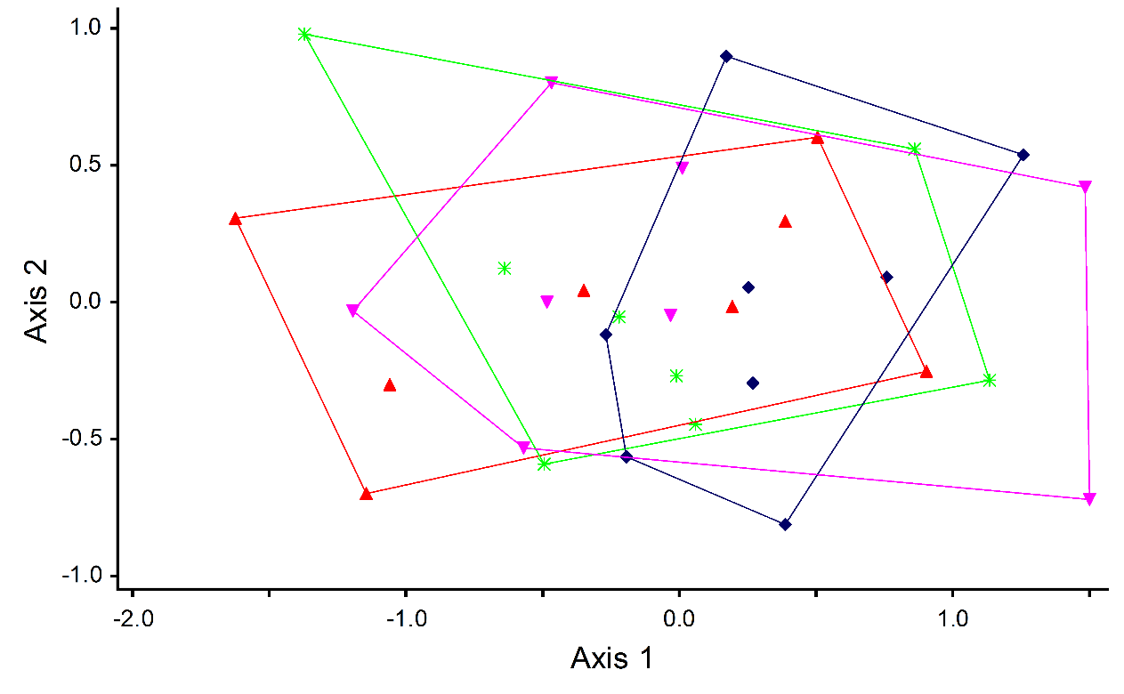
0 g/m²
15.8 g/m²
78.8 g/m²
158 g/m²
Treatment
Figure 4. 2015 growing season Nonmetric Multidimensional Scaling (NMS) ordination of soybean seed composition data for each treatment of 0, 15.8, 78.8, and 158 g/m². Points in ordination space represent a replication of a treatment.
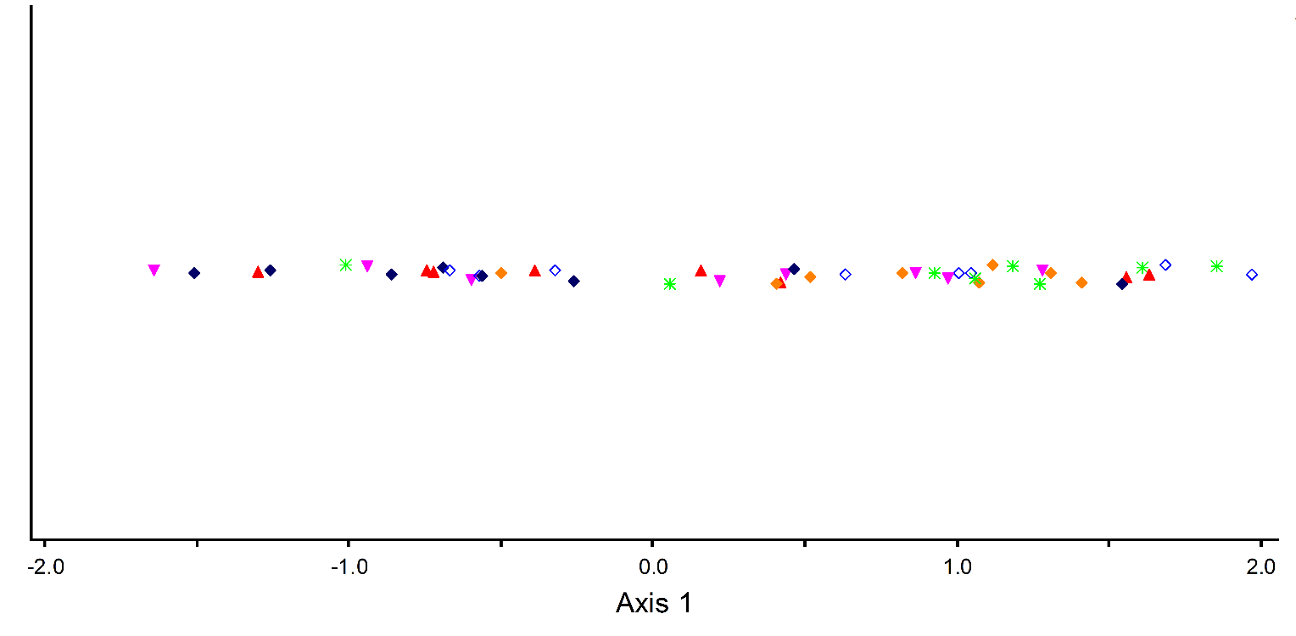
Treatment
0 g/m²
15.8 g/m²
78.8 g/m²
158 g/m²
2×158 g/m²
315 g/m²
Figure 5. 2016 growing season Nonmetric Multidimensional Scaling (NMS) ordination of soybean seed composition data for each treatment of 0, 15.8, 78.8, 158, 2×158, and 315 g/m². Points in ordination space represent a replication of a treatment.

