Field experiments were established in soybean fields in Gilbert, IA and Dayton, IA. The objective of this one-year study was to evaluate the efficacy of the Redekop Seed Destructor (Figure 1) in destroying waterhemp seeds at the time of soybean harvest in 2022 and reducing viable weed seed bank in following year (2023). The Redekop seed destructor unit (currently priced at ~$80,000) was installed at the rear of a John Deer S680 combine.
The success of harvest weed seed control methods relies on the propensity of some weed species like waterhemp and Palmer amaranth to retain most seeds by the time the soybean crop is harvested. Almost 60 to 75% of waterhemp seeds were still retained by the plants at the time of soybean harvest after accounting for shattering losses to the ground. The late harvest can potentially account for greater losses due to seed shattering. Out of those seeds that were retained by the plants at harvest, approximately 30% were lost as the combine head passed through those plants in the field (header loss; Figure 2). Additionally, 10% of the waterhemp seeds entering the combine can be lost at the grain tank (grain tank contamination) or escape through the combine thresher (chopper) during the harvest operation.
To determine the seed-kill efficacy of the Redekop seed destructor, waterhemp seed samples exiting the combine were collected in 1 m² trays placed on the ground with the seed destructor unit turned on vs. off (treatments). Those samples were cleaned and weed seeds were counted. More than 90% of pigweed seeds exiting the seed destructor unit had a moderate to severe physical damage when viewed under a digital microscope (Figure 3). Only a small proportion of seeds escaped with fully intact seeds.
Fifty seeds from each category were germinated at 32/22 C day/night temperatures (14/10 hour periods). Seed germination was observed and recorded for 28 days. At the end of observation period, non-germinated seeds were tested for viability using the imbibed seed crush test. A majority of moderate to severe physically-damaged seeds failed to germinate and tested non-viable. Furthermore, seeds with slight damage are less likely to persist in soil seedbank due to increased seed mortality factors. These results indicated that the Redekop seed destructor was effective in reducing viable weed seed returns to the soil compared to a conventional harvest operation.
The early-season waterhemp density in 2023 season did not differ in the presence or absence of weed seed destructor in 2022 soybean. Further evaluations of waterhemp seedling density, plant height, and biomass/seed production during the summer/fall of 2023 could not be performed as the study was terminated before completion.
Using weed seed destructor over one season is unlikely to have a significant effect in reducing seedling emergence in the following year. No observed differences in weed seedling emergence can most likely be attributed to the residual seed bank from previous years, which could mask the effect of seed destruction. Additionally, seed shattering losses occurred before or at the time of soybean harvest. Those seeds were left on or near the soil surface under no-till until the following growing season. Therefore, the seed destruction efficacy and seed bank needs to be quantified over multiple growing seasons to accurately determine and model the decline in weed seed bank and subsequent reduction in herbicide inputs and costs.
Future efforts need to be focused on minimizing the weed seed inputs to the soil because of the combine header loss (reel contacting the waterhemp plants) to more effectively utilize this harvest weed seed control technology in soybean. Early harvest dates of soybean would also be beneficial to minimize natural shattering of waterhemp seeds with an objective to capture a majority of weed seeds and destroy them with the seed destructor technology.
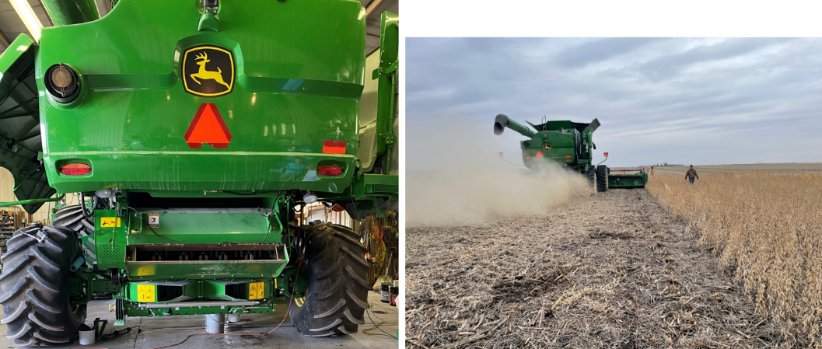

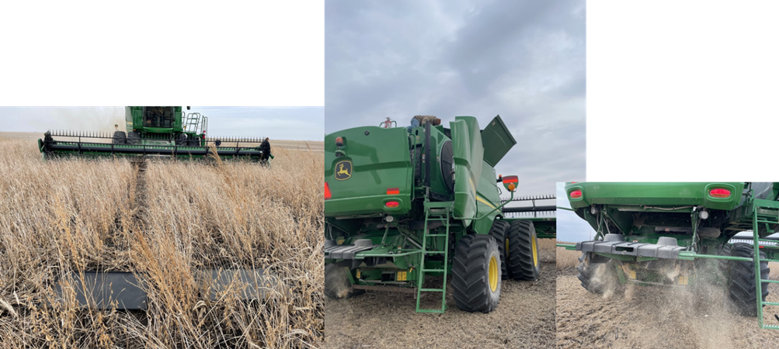
Figure 1. Redekop seed destructor (high-impact mill) attached to a John Deer S680 combine in a soybean field at harvest in Dayton, Iowa, 2022.

Figure 2. Measuring header, grain tank, and thresher losses of waterhemp seeds at harvest in a soybean field in Iowa, 2022.
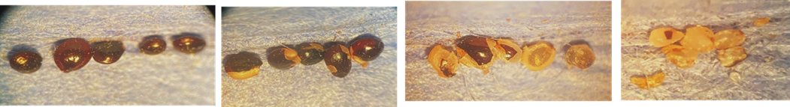
d
c
b
a
Figure 3. Different levels of physical damage of pigweed seeds after passing through the Redekop seed destructor (high-impact mill) compared to conventional harvest (a).

