Evaluation of Phosphorus Needs for Soybean in North Dakota
Principal Investigators and Collaborators:
Lindsay Malone, PI, School of Natural Resource Sciences
David Franzen, co-PI, School of Natural Resource Sciences
Christopher Augustin, collaborator, Dickinson Research and Extension Center
Szilvia Yuja, collaborator, Carrington Research and Extension Center
Greg Endres, collaborator, Carrington Research and Extension Center
Leandro Bortolon, collaborator, North Central Research and Extension Center
Research Overview and Objectives:
There is a need for a reevaluation of phosphorus fertilizer recommendations for soybean production in North Dakota. Current recommendations are focused on P-application on fields with low (3-7 ppm) or very-low (0-3 ppm) soil test phosphorus (STP), but recent research in Minnesota suggests that P-application on fields with medium STP (8-11 ppm) can result in increased seed yield (D. Franzen, 2019). Soybean acres have also increased over the years from 1.06 million acres in 1997 (agcensus, 1997) to 5.7 million acres in 2022 (USDA/NASS 2022 State Agriculture Overview for North Dakota, n.d.) with change in acreage mostly occurring in northcentral and northwestern North Dakota. Current recommendations have been developed from data collected in eastern North Dakota and this project will update recommendations through a statewide effort.
Materials and Methods:
Eight P-trial locations were deployed across ND in 2023 (Figure 1). Sites were screened in the spring to establish experiments in one very low Olsen P field (P < 5 g kg⁻¹) and one low Olsen P field (P <8 g kg⁻¹). Sites were also screened for soil acidity (pH > 5.6). 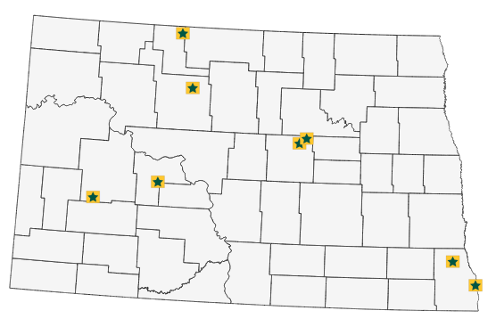
Figure 1. Map of 2023 P-trial sites throughout North Dakota.

Table 1. Location, taxonomic information, and soil test phosphorus (STP) and pH of experiment sites.
Site | Location | Soil Series | Taxonomic Classification | Spring STP | pH
Fairmount | 46.079228°N, 96.9749769° W | Antler-Mustinka complex | Fine-loamy, mixed, superactive, frigid Aeric Calciaquolls | 10 | 7.4
Barney | 46.342315°N, 96.9749769° W | Mantador-Delamere-Wyndmere fine sandy loams, slightly saline, stratified substratum | Coarse-loamy, mixed, superactive, frigid Typic Endoaquolls | 7 | 8.1
Wells Co. 1 | 47.67916°N, 99.3872° W | Fram-Wyard loams | Coarse-loamy, mixed, superactive, frigid Aeric Calciaquolls | 4 | 8.4
Wells Co. 2 | 47.675756°N, 99.391528° W | Heimdal-Esmond loams, very stony | Coarse-loamy, mixed, superactive, frigid Typic Calciudolls | 4 | 7.9
Beulah | 47.110892°N, 101.782228° W | Belfield-Wyola-Daglum complex | Fine, smectitic, frigid Glossic Natrustolls | 5 | 6.9
Dickinson | 46.891861°N, 102.813823° W | Reeder-Farnuf loams, 3 to 6 percent slopes | Fine-loamy, mixed, superactive, frigid Typic Argiustolls | 5 | 6.8
Minot | 48.179652°N, 101.304983° W | Forman-Aastad loams | Fine-loamy, mixed, superactive, frigid Calcic Argiudolls | 5 | 5.5
Mohall | 48.781194°N, 101.522028° W | Hamlet-Souris loams | Fine-loamy, mixed, superactive, frigid Aquic Hapludolls | 5 | 7.2

Experimental units were 8-12 ft wide by 40 ft long. Eight experimental sites were conducted across the state (Figure 1). Experimental sites were managed by farmers or extension specialists, with management factors such as variety, seeding rate, row spacing, maturity group and tillage practice determined individually to improve the relevance of production to the region. The experimental design was a randomized complete block with 5 treatments and 4 replications. The fertilizer treatments were: check, and hand applied as TSP at rates of 23, 46, 69, and 92 lbs. ac⁻¹.
Data collection included soybean seed yield and soil test data. The middle rows of each plot were harvested with a plot-combine for soybean seed yield. Spring soil samples were taken at each site prior to P application. Composite samples across the whole study area were taken at 0-6 in (10-12 cores for P, pH, OM, K, nitrate, EC) and 6-24 in (3-5 cores for nitrate and EC). At most sites, 3-5 cores were taken in each plot at 0-6 in for Olsen STP. Fall soil samples were taken at harvest in each plot at 0-6 in for routine tests (P, pH, OM, K). All soil samples were dried, ground, and sent to Agvise Laboratories Inc in Northwood, ND for analysis.
Statistical differences among P fertilizer levels were determined by an analysis of variance (ANOVA) and Tukey’s test using the aov() and emmeans() functions in R v4.3.3 (R Core Team, 2024). Phosphorus responsiveness was determined to be statistical significance at the 0.05 level for any treatment compared to the no-P check. Relative yields were calculated as follows:
$$Relative yield=\frac{individual plot yield}{maximum yield for site}×100$$
All data were graphed with the ggplot2 package.

Results:
The locations in this study represented a wide diversity of soils. A broad range of textural classes including clay, clay loam, loam, silty loam and sandy loam hosted varying amounts of previous STP (Table 1.). Across all trials, soybean seed yield was determined unresponsive to P fertilization in 6 of the 8 experimental sites at the 0.05 level of significance (Figure 2.).
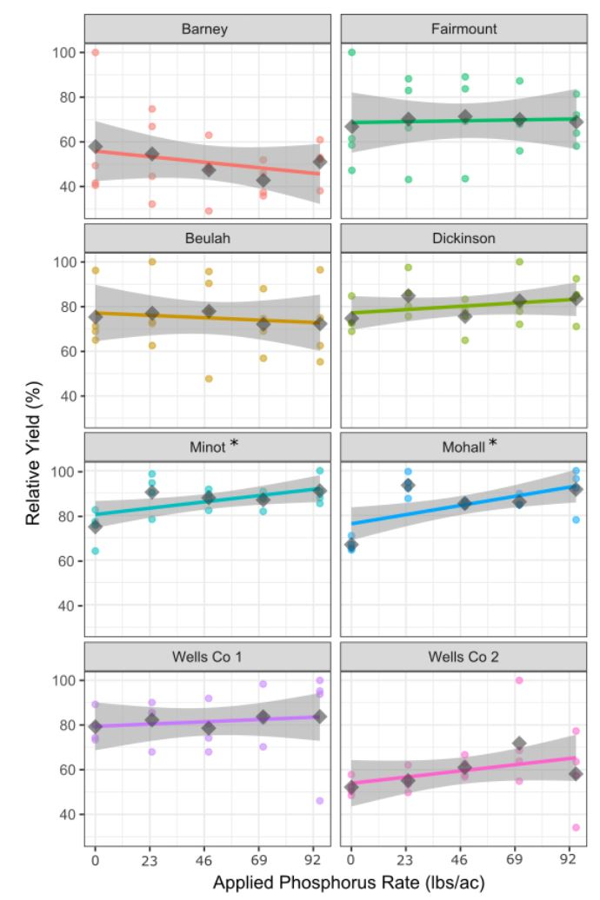
Figure 2. Relationship of applied phosphorus rate (triple super phosphate) and relative yield across all North Dakota experimental sites. Colored points indicate yield from each plot, and colored lines represent the best fit line to these points, with a standard error for this line in light gray. Treatment means are represented by dark gray diamond shaped points. An * indicates significance at the 0.05 level (Minot and Mohall only), all other sites did not respond to P addition.

Phosphorus fertilization increased grain yields in 2 of the 8 trials, Minot and Mohall. In responsive trials, there were increases in seed yield of 5.89 bushels ac⁻¹ and 5.97 bushels ac⁻¹, or a 16.21% and 25.54% yield increase in Minot and Mohall respectively. In both Minot and Mohall, all treatments were significantly different from the control but were not significantly different from each other (Figure 3).
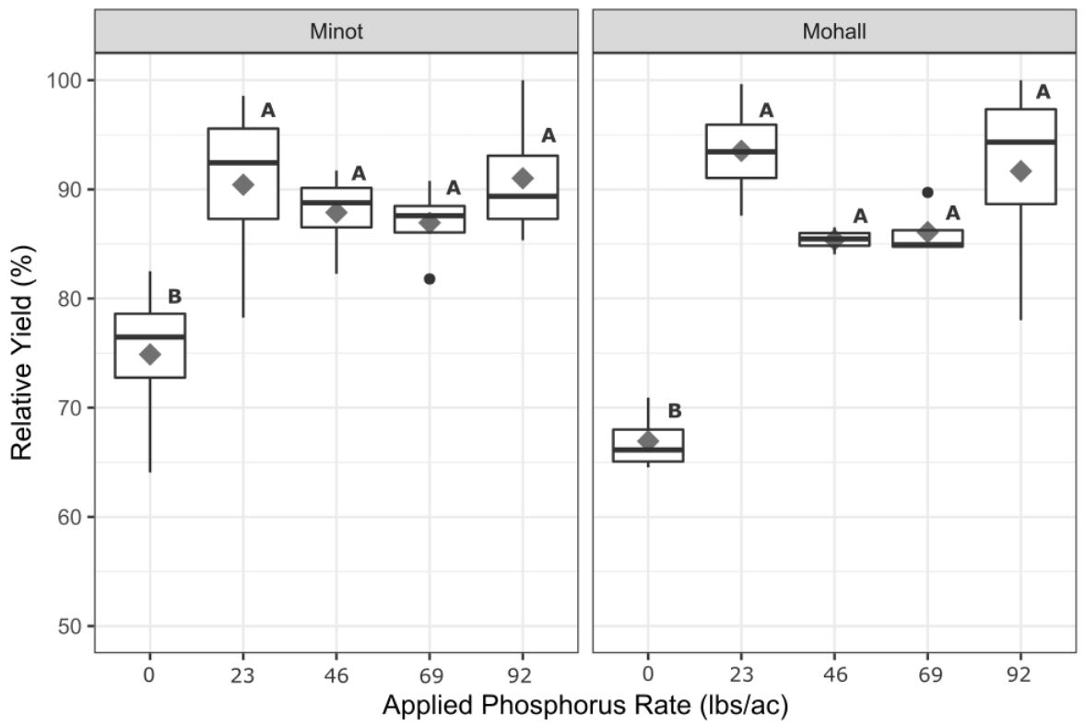
Figure 3. Boxplots of applied phosphorus rate (TSP) and relative yield of the two responsive trials 2023 trials in North Dakota, Minot and Mohall. Treatment means are represented by diamond shaped points. Treatments with the same letter did not result in significantly different relative yield (α = 0.05)
Discussion:
Fertilizer treatments across 6 of the 8 environments did not impact soybean grain yield (Figure 2). This finding aligns with previous studies, where increases in seed yield from P-fertilization can vary tremendously based on environment and previous fertilization history (Augustin & Franzen, 2024; Culman et al., 2023; D. Franzen, 2019; Gaspar et al., 2017; Mallarino et al., 1999).
Soybean is an excellent scavenger of soil P due to its deep root architecture and ability to form mycorrhizal connections that can help “mine” P past the phosphate depletion zone surrounding the root (Smith & Read, 2010; Zhao et al., 2004). Soybean is also not as sensitive to low soil P and does not require as much P-uptake as other crops such as small grains and corn, which might explain the lack of fertilizer P response in our experiments (D. W. Franzen, 2023).
A number of the environments were also alkaline in nature (pH > 7) and were considered chemically susceptible to IDC due to the free carbonates (CO₃²⁻) present in the soil profile. Soybean secretes acids in the rhizosphere to reduce iron from Fe³⁺ to Fe²⁺, which is used in the formation of root nodules. However, carbonates can neutralize these acids as well as form calcium-iron molecules that become tightly bound to soil particles (Kaiser et al., 2014). Soil pH greater than 8 (Table 1) greatly increases the likelihood of IDC (Hansen et al., 2003). Excessive rainfall can also increase IDC by solubilizing more acid neutralizing free carbonates.
Additionally, the lack of precipitation across ND in 2023 could have impacted seed yield and contributed to the lack of fertilizer response as well. Aside from physiological effects that can affect soybean photosynthesis and transpiration, water stress can shorten the period of seed fill, reducing grain yields (Meckel et al., 1984; Ribas-Carbo et al., 2005). Rainfall in our experiments during the 2023 growing season were less than the 9.8 in required by a North Dakota soybean crop (Bauder & Ennen, 1981).
Conclusion:
Phosphorus is one of the three primary macronutrients that plants need in a relatively high abundance to be able to perform physiological processes crucial for life and high yields. Many agricultural soils in North Dakota however, struggle with phosphorus availability and are relatively low in soil P and require fertilizer application of P made from phosphate rock. With global P reserves on the decline and an increase in agricultural demands for P use, smart fertilizer implementation is critical. This is especially true in North Dakota, as soybean has rapidly grown into the highest acreage crop in the state and boasts an average increase in yield of 19.80 lbs. ac⁻¹ per year. Current phosphorus fertilization recommendations however, were created using data obtained from the eastern third of North Dakota. Updating P fertilization recommendations to fit needs across all North Dakota fields allows for a more precise and effective approach to nutrient management, benefiting farmers from both a productivity and economic perspective. This experiment will be repeated in 2024 to develop new recommendations.
References:
Agcensus. (1997). Geographic Area Series, North Dakota [dataset]. https://agcensus.library.cornell.edu/wp-content/uploads/1997-North_Dakota-CHAPTER_1_State_Data-1599-Table-42.pdf
Augustin, C. L., & Franzen, D. W. (2024). Fertilizer Management Strategies of Glycine max L. (Soybean) in Northcentral and North-Western North Dakota. Agronomy, 14(3), Article 3. https://doi.org/10.3390/agronomy14030545
Bauder, J. W., & Ennen, M. J. (1981). Water Use of Field Crops in Eastern North Dakota. North Dakota Farm Research, 32, 3–5.
Culman, S., Fulford, A., LaBarge, G., Watters, H., Lindsey, L. E., Dorrance, A., & Deiss, L. (2023). Probability of crop response to phosphorus and potassium fertilizer: Lessons from 45 years of Ohio trials. Soil Science Society of America Journal, 87(5), 1207–1220. https://doi.org/10.1002/saj2.20564
Franzen, D. (2019). Soybean Soil Fertility. 1–11.
Franzen, D. W. (2023). North Dakota Fertilizer Recommendation Tables. NDSU Extension. https://www.ndsu.edu/agriculture/sites/default/files/2023-10/sf882.pdf
Gaspar, A., Laboski, C., Naeve, S., & Conley, S. (2017). Phosphorus and Potassium Uptake, Partitioning, and Removal across a Wide Range of Soybean Seed Yield Levels. Crop Science, 57, 2193–2204.
Hansen, N. C., Schmitt, M. A., Anderson, J. E., & Strock, J. S. (2003). Iron Deficiency of Soybean in the Upper Midwest and Associated Soil Properties. Agronomy Journal, 95(6), 1595–1601. https://doi.org/10.2134/agronj2003.1595
Kaiser, D. E., Lamb, J. A., Bloom, P. R., & Hernandez, J. A. (2014). Comparison of Field Management Strategies for Preventing Iron Deficiency Chlorosis in Soybean. Agronomy Journal, 106(6), 1963–1974. https://doi.org/10.2134/agronj13.0296
Mallarino, A. P., Wittry, D. J., Dousa, D., & Hinz, P. N. (1999). Variable-Rate Phosphorus Fertilization: On-Farm Research Methods and Evaluation for Corn and Soybean. In Proceedings of the Fourth International Conference on Precision Agriculture (pp. 687–696). John Wiley & Sons, Ltd. https://doi.org/10.2134/1999.precisionagproc4.c66
Meckel, L., Egli, D. B., Phillips, R. E., Radcliffe, D., & Leggett, J. E. (1984, July). Effect of Moisture Stress on Seed Growth in Soybeans1 | Agronomy Journal. https://acsess-onlinelibrary-wiley-com.ezproxy.lib.ndsu.nodak.edu/doi/abs/10.2134/agronj1984.00021962007600040033x
R Core Team. (2024). [Computer software]. R: A Language and Environment for Statistical Computing_. R Foundation for Statistical Computing,. <https://www.R-project.org/>.
Ribas-Carbo, M., Taylor, N. L., Giles, L., Busquets, S., Finnegan, P. M., Day, D. A., Lambers, H., Medrano, H., Berry, J. A., & Flexas, J. (2005). Effects of Water Stress on Respiration in Soybean Leaves. Plant Physiology, 139(1), 466–473. https://doi.org/10.1104/pp.105.065565
Smith, S. E., & Read, D. J. (2010). Mycorrhizal Symbiosis. Academic Press.
USDA/NASS 2022 State Agriculture Overview for North Dakota. (n.d.). Retrieved March 1, 2024, from https://www.nass.usda.gov/Quick_Stats/Ag_Overview/stateOverview.php?state=NORTH%20DAKOTA
Zhao, J., Fu, J., Liao, H., He, Y., Hai, N., Hu, Y., Qiu, L., Dong, Y., & Yan, X. (2004). Characterization of root architecture in an applied core collection for phosphorus efficiency of soybean germplasm. Chinese Science Bulletin, 49, 1611–1620.

