Project Number: | 44220
Project Title: | A nutrigenomic strategy to increase the soybean meal utilization in aquaculture finfish.
Organization: | University of Idaho
Project Lead Name: | Brian Small (PI); Vikas Kumar (coPI); Jie Ma (coPI); Krishna Singha (postdoc)
Report Date: | March 28, 2025

Project Summary:

Overview of project in non-proprietary lay language suitable to be shared publicly.
Aquaculture provides sustainable production of food fish with high protein/low-saturated fat to satisfy increasing demand. Globally, efficient and environmentally sustainable aquaculture production systems are urgently required. Over two decades of selective breeding, our research resulted in development of a rainbow trout strain that grows as well on an all-plant (about 50% soy based products) protein diet as on a fishmeal-based diet, and grows much faster than non-selected trout. In aquaculture, infectious diseases are the primary cause of economic losses, leading to the loss of millions of pounds of cultured product. Disease outbreaks are recognized as a significant constraint on aquaculture production, affecting its economic development. Disease susceptibility in fish is affected by intrinsic (genetic) and extrinsic (water quality, rearing density, feed rate, diet) factors and their interactions. The aquatic environment harbors a complex and dynamic microbial community (microbiota) and is in continuous contact with fish. In addition to selection for growth on replacement diets, families are tested for resistance to infectious hematopoietic necrosis virus (IHNV) and Flavobacterium spp. Each year, controls and crosses are also generated utilizing fish from the selected lines and from non-selected control lines to verify differences related to dietary tolerance and utilization. The ARS/UI fish are likewise being raised commercially under large scale production and evaluations are taking place that compare the survival of our selected fish to other strains under production conditions. Currently, we are using 53% soy protein (35% SBM and 18% SPC) for our selected plant diet for ARS/UI fish (trout). However, we would like to optimize the SBM and SPC level in the diet of selected (ARS/UI) trout and commercial trout by considering growth, gut health and resistance against viral and bacterial disease. Overall, successful completion of this project will have a broad application to commercial fish selective breeding programs, leading to increased profitability for US soy producers and fish farmers. The overall goal for this research project then is to determine the molecular mechanisms behind enhanced non-specific resistance in rainbow trout, while also studying the underlying innate immune changes that occur through disease selection. Again, the price of feed and losses to disease are the highest production costs and, therefore, the ability to reliably convey elevated, persistent non-specific immunity to other strains and/or species would be of great advantage for all aquaculture producers.

Detailed Project Status:
Expand upon the above section. What key activities were undertaken and what were the key accomplishments during this reporting period? List each key deliverable from the proposal and describe progress made (or not made) toward achieving it, including metrics where appropriate.

Background
Aquaculture provides sustainable production of food fish with high protein/low-saturated fat to satisfy increasing demand. Globally, efficient and environmentally sustainable aquaculture production systems are urgently required. Over two decades of selective breeding, our research resulted in development of a rainbow trout strain that grows as well on an all-plant (about 50% soy-based products) protein diet as on a fishmeal-based diet and grows much faster than non-selected trout. In aquaculture, infectious diseases are the primary cause of economic losses, leading to the loss of millions of pounds of cultured product. Disease outbreaks are recognized as a significant constraint on aquaculture production, affecting its economic development. Disease susceptibility in fish is affected by intrinsic (genetic) and extrinsic (water quality, rearing density, feed rate, diet) factors and their interactions. The aquatic environment harbors a complex and dynamic microbial community (microbiota) and is in continuous contact with fish. In addition to selection for growth on replacement diets, families are tested for resistance to infectious hematopoietic necrosis virus (IHNV) and Flavobacterium spp. Each year, controls and crosses are also generated utilizing fish from the selected lines and from non-selected control lines to verify differences related to dietary tolerance and utilization. The ARS/UI fish are likewise being raised commercially under large scale production and evaluations are taking place that compare the survival of our selected fish to other strains under production conditions. Currently, we are using 53% soy protein (35% SBM and 18% SPC) for our selected plant diet for ARS/UI fish (trout). However, we would like to optimize the SBM and SPC level in the diet of selected (ARS/UI) trout and commercial trout by considering growth, gut health and resistance against viral and bacterial disease. Overall, successful completion of this project will have a broad application to commercial fish selective breeding programs, leading to increased profitability for US soy producers and fish farmers. The overall goal for this research project then is to determine the molecular mechanisms behind enhanced non-specific resistance in rainbow trout, while also studying the underlying innate immune changes that occur through disease selection. Again, the price of feed and losses to disease are the highest production costs and, therefore, the ability to reliably convey elevated, persistent non-specific immunity to other strains and/or species would be of great advantage for all aquaculture producers.

Goal and Objectives
The overall goal of our proposed project is threefold: i) increase the usage of soybean meal (SBM) and decrease the soy protein concentrate in feeds for the commercial production of Rainbow trout; and ii) demonstrate how selected trout for soy-based diet can improve their resistance against pathogen; and iii) overall soybean-based feed can improve profits for fish farmers. For this project, we will work toward improving our understanding of fish-disease dynamics, with the long-term goal of reducing losses to the U.S. rainbow trout industry. For this one-year period, we will address this goal with the following objectives:
Objective #1: Define the best feed formulation to incorporate maximum amount of soybean meal (SBM) and decrease the soy protein concentrate (SPC) in two lines (selected and commercial) of rainbow trout diet
Objective #2: Optimize the SBM inclusion level in trout by measuring growth performance, feed utilization, intestinal barrier function, immune related parameters and gut microbiome
Objective #3: Determine the effects of pathogens (viral pathogen, Infectious hematopoietic necrosis virus, IHNV and bacterial pathogen, Flavobacterium psychrophilum (Fp) challenge on survival, immunomodulation, and gut health in rainbow trout.
Objective #4: To examine and genes expression, distal intestinal structure (enteritis), intestinal barrier function and gut microbiome in pre and post challenge study of trout strains with different genetic backgrounds.

Part I:
Evaluation of growth performance, nutrient utilization, and gut health of juvenile rainbow trout fed soy diets
Materials and methods
Ethics statement
The Institutional Animal Care and Use Committee (IACUC) of the University of Idaho (IACUC #2023-44) approved all the experimental protocols, including fish handling and sampling.
Experimental diets formulation and preparation
To achieve the first objective (Objective #1), we defined the best feed formulation in Table 1 to incorporate maximum amount of soybean meal (SBM) and decrease the soy protein concentrate (SPC) in trout diet. Five isonitrogenous and isolipidic diets were formulated to contain 44% crude protein and 13% lipids, respectively. Experimental diets were FM (control), 0% SBM/SPC + 30% fishmeal; M13/C19.5, 13% SBM + 19.5% SPC; M23/C13, 23% SBM + 13% SPC; M34/C6.5, 34% SBM + 6.5% SPC; M45/C0, 45% SBM + 0% SPC.
All the experimental diets were prepared at the USDA-ARS facility in Bozeman, MT, USA. The fry and fingerlings diets were prepared as floating feed using a twin-screw cooking extruder (DNDL- 44, Buhler AG, Uzwil, Switzerland), maintaining the diameter of the pellets at 1.5 mm and 2.5 mm, respectively. All the diets were transferred to the Cold-water lab, ARI, and stored at room temperature until used. The proximate composition of the experimental diets are provided in the Table 1.
Feeding trial
For this trial, fertilized eggs of two different strains of rainbow trout i.e., ARS Hagerman and commercial strains were procured and transferred to the Cold-Water Lab at the Aquaculture Research Institute, University of Idaho (Moscow, ID). A total of 1500 juvenile rainbow trout with initial weight of 4.2 g, were randomly distributed into each of thirty 60 L tanks with a stocking density of 50 fish per tank, maintaining three replicate tanks per diet. Fish were maintained in a recirculating aquaculture system (RAS) at 15.29 ± 0.05 °C with 12 h dark/ 12 h light photoperiod. The feeding trial was conducted for eight weeks, and fish were fed to apparent satiation twice daily (around 09:00 and 14:00).

Sampling
At the end of the feeding trial, the fish were subjected to a 24-h fasting period following their morning feeding (09:00), prior to sampling for the required parameters. Six fish from each tank (18 fish per treatment) were randomly collected and euthanized using methanesulfonate (MS-222 at 300 mg/L, buffered to pH 7.0), and dissected to collect samples after recording their weight. Among these six fish, three fish were used to collect the fecal sample from the distal intestine portion for microbiome analysis in 1 ml screwcap cryotubes (#16466-058, VWR® Micro Centrifuge Tube) and snap-frozen in liquid nitrogen, and then the distal intestine and liver samples were collected in 1 ml screwcap cryotubes (#16466-058, VWR® Micro Centrifuge Tube) using RNA stabilization solution (#AM7021, InvitrogenTM RNAlater™ solution, Thermo Scientific™, USA) for gene expression study. Other three fish were used to collect the distal intestine sections. The distal intestine sections were washed using phosphate-buffered saline (PBS, pH ~ 7.4) and then transferred to Bouin’s fluid for overnight fixation. From Bouin’s fluid, the distal intestine sections were transferred to a 70% ethanol solution for preservation until used to make histological slides. Another two fish from each tank were collected and euthanized with a lethal dose of MS-222 (300 mg/L) and kept at -20ºC for whole-body nutrient composition analysis. Individual weights were recorded for the sampled fish, while bulk weights were measured for the remaining fish after sampling. The weights of both sampled and remaining fish were used to calculate growth and nutrient utilization parameters. Remaining fish from each tank were pooled with respect to diet and strain for further bacterial and viral challenge study.
Calculation of growth, feed utilization, and body indices
The following parameters were calculated using the fish weight and feed consumption data-
Weight gain (g) = Final body weight (g) – Initial body weight (g)
Specific growth rate (%/day) = [{ln(Final weight (g)) – ln(Initial body weight (g))}/Experimental days] × 100
Thermal growth coefficient (TGC) = [{(Final weight (g))^{1/3} – (Initial body weight (g))^{1/3}}/(Temperature × Experimental days)] × 100
Daily feed intake (g.fish⁻¹.day⁻¹) = Total feed given (g)/(Number of fish × Experimental days)
Feed conversion ratio (FCR) = Total feed intake (g)/Weight gain (g)
Protein efficiency ratio (PER) = Weight gain (g)/Protein fed (g)
Apparent net protein utilization (ANPU%) =100 × Protein gain (g)*/Total protein consumed (g)**
*Protein gain (g) = [Final body weight (g) × Final body protein (%)] - [Initial body weight (g) × Initial body protein (%)]
**Total protein consumed (g) = Total feed given (g) × Crude protein of the feed (%)
Energy retention (%) =100 × Energy gain (kcal/g)*/Total energy consumed (kcal/g)**
*Energy gain (kcal/g) = [Final dry body weight (g) × Final body energy (kcal/g)] - [Initial dry body weight (g) × Initial body energy (kcal/g)]
**Total energy consumed (kcal/g) = Total feed given (g) × Gross energy of the feed (kcal/g)
Viscerosomatic index (VSI) = {Visceral weight (g)/ Final body weight (g)} × 100
Hepatosomatic index (HSI) = {Liver weight (g)/ Final body weight (g)} × 100
Fulton’s condition factor (K) = {(Final weight (g)/(Final body length)³} × 100
Survival (%) = 100 × (Total number of fish harvested/Total number of fish stocked)
Proximate composition
The proximate composition of experimental diets and fish was analyzed based on AOAC Official Methods 934.01 (moisture), 990.03 (combustion analyses, LECO, crude protein), 920.39 (A, crude lipids), 978.10 (crude fiber), and 942.05 (total ash) (AOAC, 2006). The total carbohydrate of diets and fish was calculated using the following equation-
Total carbohydrate (%) = 100 – (Moisture + Crude protein + Crude lipids + Total ash)
Distal intestinal histology
The distal intestine samples preserved in 70% ethanol, were cut into longitudinal and cross-sections to place in cassettes and transferred to the Washington Animal Disease Diagnostic Laboratory (WADDL), Washington State University, Pullman, USA, for slide preparation and scanning. Briefly, the cassettes containing distal intestines were placed in 10% neutral buffered formalin and processed overnight on a Leica ASP300S vacuum processor (Leica Biosystems, USA), where the distal intestine tissues were first placed in fresh formalin at 2 h intervals, then dehydrated at increasing concentrations of ethanol (80% ethanol for 1, 95% ethanol for 1 h, 100% ethanol for 1 h thrice) followed by removing ethanol in xylene and then embedded in paraffin wax. Then embedded blocks were cut on a microtome at 4 μ thickness and then stained (H&E, hematoxylin and eosin staining) using an automated slide stainer (Tissue-Tek Prisma®, Sakura Finetek USA, Inc.). The stained slides were then scanned using the Aperio GT 450 Scanner (Leica Biosystems, USA). The scanned slide images were analyzed with the help of two software namely, QuPath (v0.5.0) and Fiji (ImageJ2, v2.14.0/1.54f), for both qualitative and quantitative analysis as discussed below.
Qualitative analysis
The intestinal brush-border morphology was evaluated based on a qualitative scoring system for six histological parameters: lamina propria thickness, connective tissue development, vacuole presence, inflammatory cell infiltration, villi branching, and villi fusion (Table 2). For each treatment group, three slides were prepared. Three non-overlapping fields per slide were selected for observation. The scoring system ranged from 1 to 5 for each parameter, where 1 indicated normal or minimal changes, and 5 represented the most severe alterations (Table 2). The scoring criteria were based on the extent of tissue alteration observed in the lamina propria, connective tissue, vacuoles, inflammatory cell infiltration, villi branching, and villi fusion.
Quantitative analysis
Intestinal brush-border morphology was quantitatively assessed by measuring goblet cell density, villus height, villus width, crypt depth, crypt depth-to-villus height ratio, and muscularis thickness. Three non-overlapping fields per slide were analyzed across three slides per treatment. Goblet cell density was determined within a 500 µm × 500 µm area and normalized to cells per 10,000 µm². Villus height was measured from the crypt-villus junction to the villus tip, and villus width at the midpoint between the junction and the tip. Crypt depth was recorded from the base of the crypt near the muscularis mucosa to its opening at the mucosal surface, with the crypt depth-to-villus height ratio calculated accordingly. Muscularis thickness was measured as the perpendicular distance from the serosa to the mucosa.
Gene expression
Approximately 100 mg of tissue (distal intestine and liver) was put in a screwcap cryotube (#16466-058, VWR® Micro Centrifuge Tube) containing 1 ml of RNA isolation reagent (#TR118, TRI Reagent®, Molecular Research Center, Inc.) and zirconium oxide beads (#E-3396, 1.0 mm diameter, Next Advance, Inc.) used for total RNA isolation following standard protocol. Briefly, muscle tissues were homogenized using a bead homogenizer (Bead Ruptor 96, OMNI International, USA), then 200 μL of chloroform (#MK-4440-1, Macron Fine Chemicals™) was added and shaken for 15 sec. After 3 min incubation at room temperature, the tubes were centrifuged at 12000 × g for 15 min using a refrigerator centrifuge machine. Afterward, the aqueous layer from the top of the tubes was carefully transferred to 1.5 ml Eppendorf tubes containing 500 μL of isopropyl alcohol (#67-63-0, Aqua Solutions, Inc.) and mixed gently. After 10 min of incubation at room temperature, the tubes were centrifuged at 12000 × g for 10 min at 4ºC. The supernatant was discarded and the pellet at the bottom of the tube was washed using 75% ethanol (#64-17-5, Fisher Bioreagents, Thermo Fisher Scientific Inc.) by vortexing and centrifugation at 7500 × g for 5 min thrice. Finally, after removing all the ethanol residue using a micropipette, the pellets were dried at room temperature for 10 min and dissolved using nuclease-free water. The concentration and purity (260/280) of RNA were checked using a Nano-Drop spectrophotometer (NanoDrop One, Thermo Scientific™, USA). The relative quantity and integrity of RNA were confirmed by electrophoresis.
Reverse transcription was carried out using the commercial cDNA synthesis Kit (#E3010L, LunaScript® RT SuperMix Kit, New England Biolabs®, Inc.) following the manufacturer's protocol. The product was stored at −20 °C until the quantitative RT-PCR (qRT-PCR) was performed.
The primers for the housekeeping genes and target genes used are mentioned in Table 3 for both distal intestine and liver tissues. All the primers were purchased from the Integrated DNA Technologies, USA. A high throughput (HT) RT-qPCR system (Wafergen SmartChip Real-time PCR system, Takara Bio USA, Inc.) based on SmartChip MyDesign Kit using SmartChip® TB Green® Gene Expression Master Mix (#640211, Takara Bio USA, Inc.) was used. The same RT-qPCR program was used as the activation at 95°C for 2 min, then 40 cycle reactions, each of which includes denaturation at 95°C for 10 s, annealing at 58°C for 15 s, and extension at 72°C for 10 s) was used for uniformity. Finally, melting curve analysis was done using a temperature gradient to confirm the amplification of the target gene. The relative expression of different myogenic genes was calculated by following the 2^{-ΔΔCT} method (Livak and Schmittgen, 2001). Finally, the 2^{-ΔΔCT} values were converted to Log₂ to get the fold-change.
ΔCT = CT value of target gene – CT value of housekeeping genes*
ΔΔCT = ΔCT of dietary treatment group – ΔCT of control group**
*Geometric mean of CT values of two housekeeping genes
**FM-fed group of Hagerman strain

DNA extraction, 16S rRNA gene amplification, and sequencing
Fecal samples collected from the fish along with RAS water and diets were submitted to Novogene (Sacramento, CA, USA) for microbial community profiling. DNA integrity, purity, and concentration were first assessed using agarose gel electrophoresis. Samples passing quality control were used for library preparation targeting the V4-V5 hypervariable regions of the bacterial 16S rRNA gene, using primers 515F (GTGCCAGCMGCCGCGGTAA) and 907R (CCGTCAATTCCTTTGAGTTT). PCR amplicons were purified, end-repaired, A-tailed, and ligated with Illumina adapters. Libraries were quality checked using AATI for fragment analysis and quantified via qPCR. Qualified libraries were sequenced on the Illumina NovaSeq 6000 platform, generating 2 × 250 bp paired-end reads.
Post-sequencing, raw reads were processed using a standard pipeline. Adapter sequences, primers, and low-quality reads were removed using fastp. Overlapping paired-end reads were merged using FLASH, and chimeric sequences were identified and filtered out with UCHIME, resulting in high-quality, non-chimeric sequences (effective reads) suitable for downstream taxonomic analysis.
Statistical analysis
The normality and homogeneity of variance were assessed by examining the Residual vs Fitted Plot, Q-Q Residual Plot, and Bartlett test. As there was a significant effect of strain on the initial body weight (IBW) (Table 4), we first performed analysis of covariance (ANCOVA) by keeping IBW as covariate for the response variable as mentioned in the following ANCOVA model equation-
Response_{ijk}​ = μ + Strain_{i}​+Diet_{j}​+(Strain × Diet)_{ij}​ + β⋅IBW_{ijk}​ + u_{ij}​+ϵ_{ijk​}
Where:
Response_{ijk}​: Response variable for the k-th replicate within the i-th strain and j-th diet.
μ: Overall mean of the response variable.
Strain_{i}​: Fixed effect of the i-th strain (i=1,2).
Diet_{j}: Fixed effect of the j-th diet (j=1,2,…,5).
(Strain×Diet)_{ij}: Fixed interaction effect between the i-th strain and j-th diet.
β⋅IBW_{ijk} ​: Covariate effect of initial body weight (IBW) for the k-th replicate.
u_{ij}: Random effect associated with the ij-th treatment combination (Strain × Diet), assumed to follow u_{ij}∼N(0, σ_{u}²).
ϵ_{ijk}: Residual error for the k-th replicate within the ij-th treatment combination, assumed to follow ϵ_{ijk}∼N(0, σ²).
However, when IBW was tested as a covariate in the ANCOVA, it was found to have no significant effect on any of the growth, feed utilization, or body indices responses (Table 5). Consequently, a simplified model without IBW as a covariate was applied, using a two-way ANOVA to analyze the effects of strain, diet, and their interaction on response variable to avoid overfitting and ensures interpretability of the results (Azevedo et al., 2004). The simplified model can be written as-
Response_{ij}​ = μ + Strain_{i}​ + Diet_{j} ​+ (Strain × Diet)_{ij} ​+ ϵ_{ij}​
Where:
Response_{ij}​: Response variable for the j-th observation within the i-th combination of strain and diet.
μ: Overall mean of the response variable.
Strain_{i}: Fixed effect of the i-th strain (i = 1,2).
Diet_{j}​: Fixed effect of the j-th diet (j = 1,2,…,5).
(Strain×Diet)_{ij}: Fixed interaction effect between the i-th strain and j-th diet.
ϵ_{ij}​: Residual error, assumed to follow ϵ_{ij} ∼ N (0, σ²).
So, finally two-way analysis of variance (ANOVA) was performed using R-programming (R version 4.4.0) to analyze data for significant variation at a 5% probability level (p < 0.05), followed by Tukey’s pairwise comparison of mean values. Statistical analyses were conducted using the Aligned Rank Transform (ART) ANOVA to evaluate the effects of diet and strain on qualitative intestinal morphology parameters. ART was applied to align and rank the data before performing factorial ANOVA to assess the main effects and interactions. Post hoc pairwise comparisons were conducted using estimated marginal means with Tukey’s adjustment to compare differences between diet groups and strain groups separately after ART ANOVA. A significance level of p < 0.05 was used to determine statistical differences.
Results
Growth performance
Growth performance parameters showed interesting pattern as depicted in Table 6. Although final body weight (FBW) and WG showed no significant difference among the strains, SGR and TGC were found to be significantly (p < 0.05) higher in the commercial strain than the Hagerman strain. In the case of diets, diets with maximum of 34% SBM with 6.5% SPC (i.e., M34/C6.5) showed no significant (p > 0.05) difference with the control FM-based diet in terms of FBW, WG and TGC. Interestingly, all the growth performance parameters showed interaction effect of ‘Strain × Diet’. Based on the interaction effects (Figure 1), best performing SBM/SPC diets for the Hagerman and commercial strains were M13/C19.5 and M23/C13, respectively, however dietary main effects showed no significant difference among SBM/SPC diets and control FM-based diets except M45/C0 with highest SBM.
Feed intake and utilization
Feed intake results showed both main and interaction effects of ‘Strain × Diet’ (Table 7, Figure 2). The Hagerman strain had significantly (p < 0.05) higher feed intake than the commercial strain (Table 7). Highest feed intake was observed in M45/C0, but M23/C13 and M34/C6.5 showed no significant (p > 0.05) difference with the control, FM-based diet (Table 7). In contrast to daily feed intake, the commercial strain showed better feed utilization in terms of FCR and PER than the Hagerman strain (Table 7). However, dietary treatment showed that diets with maximum of 34% SBM with 6.5% SPC (i.e., M34/C6.5) showed no negative impact on the feed utilization parameters. Both ANPU% and energy retention (%) showed similar trend as like PER in terms of both dietary and strain effects (Table 7).
Percent survival and body indices
Although dietary treatments showed no difference in percent survival, the Hagerman strain had significantly (p < 0.05) higher percent survival than the commercial strain (Table 8). The Fulton’s condition factor, K showed both dietary and strain specific effects where only Diet M34/C6.5 showed significantly (p < 0.05) higher value of K than the FM-based diet (Table 8). Additionally, the Hagerman strain showed significantly (p < 0.05) higher value of K than the commercial strain (Table 8). Body indices such as VSI and HSI showed that the commercial strain had significantly (p < 0.05) higher values than the Hagerman strain (Table 8). In the case of diets, significantly (p < 0.05) higher HSI was observed in the control, FM-based diet than the other diets.
Whole-body proximate composition
The strain had a significant (p < 0.05) effect only on the whole-body crude protein levels where the commercial strain had significantly higher crude protein content than the Hagerman strain (Table 9). Except the total carbohydrate content, all other proximate composition components were significantly (p < 0.05) varied due to different diets (Table 9). Interestingly, whole-body moisture and lipid content showed an inverse relation with significantly (p < 0.05) lower moisture and higher crude lipids where observed the FM-based diet compared to SBM/SPC-based diets (Table 9). Moreover, whole-body moisture content showed significant (p < 0.05) interaction of ‘Strain × Diet’ where the FM-based diet showed relatively lowest moisture content in both the strains (Figure 3). Additionally, the high SBM-based diets i.e., M34/C6.5 and M45/C0, and the FM-based diet showed inverse trend where Hagerman strain showed higher moisture content in the high SBM-based diets and lower in FM-based diet, vice-versa is true for the commercial strain (Figure 3). The whole-body crude protein content of the highest SBM-based diet i.e., M45/C0 showed significantly (p < 0.05) values than the FM-based diet (Table 9). Only the M13/C19.5 diet showed significantly (p < 0.05) higher total ash content than the FM-based diet (Table 9). The gross energy (kcal/kg) content followed the similar trend like whole-body crude lipids content where the FM-based diet had significantly (p < 0.05) higher values than the SBM/SPC-based diets (Table 9).
Distal intestinal histology
Qualitative analysis
Among the six qualitative parameters of distal intestinal histology, only the connective tissue score was found to be significantly (p < 0.05) higher in the M13/C19.5 than the FM-based diet; however, all the other SBM/SPC-based diets showed similar connective tissue score like the FM-based diet (Figure 4). Moreover, none of the qualitative scoring showed an interaction effect of ‘Strain × Diet’. Interestingly, the connective tissue, vacuoles, and villi fusion scores were significantly (p < 0.05) higher in the Hagerman strain than the commercial strain (Figure 4b,c,f).
Quantitative analysis
Except the goblet cells density (No./10000 μm²), no other quantitative parameters of distal intestinal histology showed significant (p > 0.05) main or interaction effects (Table 10). Based on the strain effect, the Hagerman strain had significantly (p < 0.05) higher goblet cells density than the commercial strain (Table 10). Based on the dietary effect, although highest SBM-based diet (M45/C0) showed significantly (p < 0.05) higher goblet cells density than the M13/C19.5 and M34/C6.5 diets, none of the SBM/SPC-based diets had significant (p > 0.05) difference with the FM-based diet (Table 10). The interaction plot suggests that the Hagerman strain had more variations in the goblet cells density among different diets than the within the commercial strain (Figure 5). Moreover, the highest SBM-based diet (M45/C0) showed relatively higher goblet cells density than the commercial strain (Figure 5).
Distal intestinal gene expression
Genes related to gut barrier integrity and tight junction
Among the to gut barrier integrity and tight junction related genes, cldn12 and mylk showed significant (p < 0.05) difference between different diets (Figure 6). In the case of cldn12, only M13/C19.5 exhibited significant (p < 0.05) upregulation than the FM-based diet; however, other SBM/SPC-based diets did not show any significant (p > 0.05) difference with the FM-based diet (Figure 6a). Whereas, in the case of mylk, only the M34/C6.5 diet showed significant (p < 0.05) upregulation than the FM-based diet; however, no other SBM/SPC-based diets were significantly (p > 0.05) different from the FM-based diet (Figure 6c). In terms of strain, the Hagerman strain had significantly (p < 0.05) higher expression of both ocln and mylk genes as compared to the commercial strain (Figure 6b,c). The interaction plot of mylk gene showed that diets such as M13/C19.5 and M23/C13 showed relatively higher expression in the Hagerman strain as compared to the commercial strain (Figure 8a).
Genes related to immune response and inflammation
Only the S100I2 gene showed significant (p < 0.05) difference where the Hagerman strain exhibited higher expression of this gene as compared to the commercial strain (Figure 7c). The interaction plot of S100I2 showed that SBM/SPC-based diets such as M13/C19.5, M34/C6.5, and M45/C0 showed higher expression in the Hagerman strain than the commercial strain (Figure 8b). However, other genes related to immune response and inflammation such as il8 (Figure 7a) and nfkb (Figure 7b) showed no significant (p > 0.05) effects of diet, strain, or interaction.
Hepatic gene expression
Genes related growth response
Both IGF1 and IGF2 genes showed significant (p > 0.05) differences due to strain, diet or interaction of ‘Strain × Diet’ (Figure 9a,b).
Genes related to immune response and inflammation
Although both hepatic nfkb and S100V2 expression showed significantly (p < 0.05) higher expression in the Hagerman strain as compared to the commercial strain (Figure 9c,d), only the S100V2 showed significant (p < 0.05) dietary effect (Figure 9d). In the case of dietary effect, the diets with higher SBM inclusion i.e., M34/C6.5 and M45/C0 showed significantly (p < 0.05) higher expression of S100V2 than the FM-based diet (Figure 9d).
Genes related oxidative stress and antioxidant defense
Among the oxidative stress and antioxidant defense genes, the GPx showed significantly (p < 0.05) higher expression in the Hagerman strain than the commercial strain (Figure 10c). However, none of the genes showed significant (p > 0.05) variation due to diet or interaction of ‘Strain × Diet’ (Figure 10).
16S rRNA sequencing output and data quality assessment
All the samples including RAS water, diets and feces were successfully sequenced targeting the V4-V5 region of the 16S rRNA gene. Sequencing yielded between 105,974 and 280,298 raw paired-end reads per sample (Table 11). After quality filtering, merging, and chimera removal, the number of high-quality, non-chimeric sequences (nochime) ranged from 73,600 to 262,084 reads per sample. The average read length across samples was consistent, ranging between 371.68 and 373.57 base pairs, aligning with expectations for the targeted region. GC content remained stable, averaging 54.05%, with minimal variation between samples. Sequencing quality was uniformly high, with Q20 values averaging 99.04% and Q30 values averaging 96.43%, indicating that the vast majority of bases were called with high confidence. These results confirm that the dataset is of high quality and suitable for robust downstream microbial community analyses.
Discussion
Growth and nutrient utilization
The results highlights significant effect of strain and diet interactions on the growth performance and nutrient utilization in rainbow trout. While final body weights were similar between strains, the commercial strain exhibited superior growth rates (SGR, TGC) and feed efficiency (FCR, PER), suggesting a higher metabolic efficiency compared to the Hagerman strain. Diets with up to 34% SBM and 6.5% SPC (M34/C6.5) supported comparable growth and feed utilization to the fishmeal-based control, indicating maximum use of 34% SBM with only 6.5% of SPC in rainbow trout diet (Refstie et al., 2000; Benito, 2023). However, higher SBM levels (M45/C0) negatively impacted growth and feed utilization, likely due to anti-nutritional factors (Benito, 2023). The Hagerman strain performed best on M13/C19.5, while the commercial strain showed optimal growth with M23/C13, emphasizing the need for strain-specific dietary formulations (Smith et al., 1988).
Despite higher feed intake, the Hagerman strain had lower feed efficiency, such as lower apparent net protein utilization (ANPU%) and energy retention (%) compared to the commercial strain. This suggests differences in protein metabolism and nutrient assimilation in the commercial strain compared to the Hagerman strain (Overturf et al., 2013). The more efficient feed utilization in the commercial strain aligns with its better PER and FCR values, suggesting its advantage in practical aquaculture settings while using SBM-based diets.
Survival and biometric parameters
The results for percent survival and body indices further highlight the differences in physiological responses between the two strains. While dietary treatments did not influence survival rates, the Hagerman strain exhibited significantly higher survival than the commercial strain. However, although the difference was significant, but the numerical differences were negligeable between the strains.
The Fulton’s condition factor (K), a measure of overall body robustness, was significantly higher in diet M34/C6.5 compared to the FM-based diet, indicating that moderate SBM inclusion may promote better body condition. This same diet supported optimal growth and feed utilization, reinforcing its suitability as a viable alternative to fishmeal-based diets. Strain-specific effects also showed that the Hagerman strain had a higher K value than the commercial strain, which may reflect its inherently different body composition or growth pattern. For body indices, the commercial strain had significantly higher VSI and HSI, indicating greater visceral fat deposition and liver size, which may be linked to differences in lipid metabolism and energy storage. These although differ from the growth and nutrient utilization, the body indices might be more specific to strain (Barnes et al., 2015). The higher HSI in FM-based diets suggests that fishmeal diets may promote increased liver energy reserves compared to plant-based diets.
Whole-body proximate composition
Whole-body composition results further support differences in nutrient utilization and energy retention between strains and diets. The commercial strain had higher crude protein content, which aligns with better PER, ANPU%, and energy retention, suggesting a more efficient use of dietary protein for growth (Overturf et al., 2013).
Dietary effects showed an inverse relationship between moisture and lipid content, where the FM-based diet led to lower moisture and higher crude lipid content, contributing to its higher energy retention. The gross energy content followed this trend, supporting that FM diets promote greater lipid deposition, which is a key factor in overall energy balance. In contrast, SBM/SPC-based diets resulted in leaner fish with lower lipid storage, indicating differences in nutrient partitioning between protein and fat. A strain × diet interaction in moisture content showed that the Hagerman strain retained more moisture on high SBM diets, while the commercial strain retained more moisture on FM diets. This suggests that the commercial strain may store more energy as lipid when fed fishmeal, while the Hagerman strain exhibits a different metabolic strategy under plant-based diets.
Distal intestinal histology
Only diet M13/C19.5 showed a significantly higher connective tissue score than the FM-based diet, while other SBM diets did not show notable structural differences. However, the Hagerman strain exhibited higher connective tissue, vacuoles, and villi fusion scores, indicating a higher inflammatory or structural response in its distal intestine. These changes suggest that the Hagerman strain is more sensitive to dietary components, which may make it more susceptible to intestinal stress when exposed to high levels of soy-based proteins.
A significant increase in goblet cell density was observed in the Hagerman strain, indicating higher mucus production, a known protective response against potential irritants in plant-based diets. The highest SBM diet (M45/C0) also increased goblet cell density, suggesting that excessive SBM inclusion may stimulate mucus secretion to counteract gut irritation. However, no SBM diets significantly differed from the FM-based diet, indicating that moderate SBM inclusion does not severely impact gut integrity.
These histological observations both qualitative and quantitative suggest that higher SBM levels can induce mild structural and protective changes in the distal intestine, particularly in the Hagerman strain, which appears more sensitive to dietary variations (Barnes et al., 2015). However, moderate SBM/SPC inclusion does not significantly impair gut health, supporting its potential as a fishmeal alternative (Benito, 2023).
Genes related gut-liver axis
The gut and liver responses to SBM-based diets varied significantly between strains, highlighting differences in gut barrier function, immune activation, and oxidative stress regulation. The higher expression of ocln and mylk in the Hagerman strain suggests a stronger gut barrier response, which could be seen as a double-edged sword. While increased ocln expression may indicate efforts to maintain tight junction integrity, the simultaneous upregulation of mylk suggests increased intestinal permeability and gut motility, which could compromise barrier function under dietary stress (Benito, 2023). These observations are supported by the histological results showing higher goblet cell density, connective tissue and vacuoles scores in the Hagerman strain, all of which indicate an active but potentially overstimulated gut response. Similarly, the higher expression of intestinal S100I2 in the Hagerman strain, particularly in SBM diets (M13/C19.5, M34/C6.5, and M45/C0), reflects a heightened immune activation. While S100I2 is involved in mucosal protection, its excessive expression may also signal chronic immune stimulation, which can be detrimental to gut homeostasis if prolonged (Tsai, 2022). This may explain why the Hagerman strain showed higher intestinal histological alterations, despite no significant pro-inflammatory gene activation (il8, nfkb).
At the hepatic level, the higher expression of S100V2 in SBM diets (M34/C6.5, M45/C0) and in the Hagerman strain further suggests a systemic immune response to dietary components. Unlike the intestine, where barrier mechanisms can help regulate exposure, the liver directly processes dietary metabolites, and its immune activation could indicate stress from anti-nutritional factors or metabolic imbalances (Tsai, 2022). The absence of IGF1 and IGF2 differences suggests that this immune activation did not directly affect growth regulation, but it may still influence long-term metabolic efficiency. The upregulation of GPx in the Hagerman strain correlates with higher oxidative stress, likely due to its greater immune activation and intestinal permeability. While antioxidant defenses can help mitigate damage, persistent oxidative stress can negatively impact overall gut-liver function. In contrast, the commercial strain, with its lower immune and oxidative responses, appears better adapted to SBM-based diets, maintaining gut stability without excessive inflammatory or stress responses.
Concluding remarks
This study highlights strain-specific responses to SBM-based diets in rainbow trout. While moderate SBM inclusion (up to 34% SBM, 6.5% SPC) maintained growth and feed efficiency, higher SBM levels (M45/C0) negatively impacted performance, likely due to anti-nutritional factors and gut stress. The commercial strain showed superior nutrient utilization and metabolic efficiency, whereas the Hagerman strain had higher feed intake but lower assimilation, requiring strain-specific diet adjustments. The Hagerman strain exhibited greater intestinal remodeling and immune activation, reflected in higher goblet cell density, connective tissue changes, and gut barrier gene expression. While moderate SBM levels did not impair gut health, excessive SBM induced mild gut stress, particularly in the Hagerman strain. At the hepatic level, higher immune and oxidative stress markers (S100V2, GPx) in the Hagerman strain suggest increased metabolic burden, while the commercial strain maintained stability. Overall, SBM inclusion up to 34% with relatively less SPC (6.5%) is a viable fishmeal alternative, but strain-specific formulations are necessary to optimize growth while minimizing gut and metabolic stress, particularly in the Hagerman strain.
Acknowledgments
We would like to acknowledge Dr. Wendy Sealey (USDA-ARS, Bozeman), Dr. Gibson Gaylord (US Fish and Wildlife Service), and Mr. Jose Ortiz (Research Associate, ARI, Hagerman) for their help to manufacture the diets. Additionally, we would like to thank the ARI-Research facility managers, Mr. Scott R. Williams and Mr. Daniel Korbel, for their support during the feeding trial and sampling.
Financial support
We would like to thank the Soy Aquaculture Alliance (Ankeny, Iowa, USA) for financially supporting this project (Grant Code: CA7052).
References
Azevedo, P.A., Leeson, S., Cho, C.Y., Bureau, D.P., 2004. Growth and feed utilization of large size rainbow trout (Oncorhynchus mykiss) and Atlantic salmon (Salmo salar) reared in freshwater: diet and species effects, and responses over time. Aquaculture Nutrition, 10(6): 401-411.
Benito, M.M.R., 2023. Feed-Based Protocols for Mitigating Soybean Meal-Induced Enteritis (SBMIE) in Rainbow Trout (Oncorhynchus mykiss) (Doctoral dissertation, University of Idaho).
Livak, K.J., Schmittgen, T.D., 2001. Analysis of relative gene expression data using real-time quantitative PCR and the 2^{−ΔΔCT} method. Methods, 25(4): 402-408.
Overturf, K., Barrows, F.T., Hardy, R.W., 2013. Effect and interaction of rainbow trout strain (Oncorhynchus mykiss) and diet type on growth and nutrient retention. Aquaculture Research, 44(4): 604-611.
Refstie, S., Korsøen, Ø.J., Storebakken, T., Baeverfjord, G., Lein, I., Roem, A.J., 2000. Differing nutritional responses to dietary soybean meal in rainbow trout (Oncorhynchus mykiss) and Atlantic salmon (Salmo salar). Aquaculture, 190(1-2): 49-63.
Smith, R.R., Kincaid, H.L., Regenstein, J.M., Rumsey, G.L., 1988. Growth, carcasss composition, and taste of rainbow trout of different strains fed diets containing primarily plant or animal protein. Aquaculture, 70(4): 309-321.
Tsai, T.Y., 2022. The Effects of Soybean Meal on Inflammatory Gene Expression in the Liver and Intestine of Salmonids (Master's thesis, University of Idaho).

Tables
Table 1: Experimental diet formulation and analyzed proximate composition
Ingredients | Experimental diets¹
Ingredients | FM | M13/C19.5 | M23/C13 | M34/C6.5 | M45/C0
Fish meal² | 30.00 | 0.00 | 0.00 | 0.00 | 0.00
Soybean meal (M)³ | 0.00 | 13.00 | 23.00 | 34.00 | 45.00
Soy protein concentrate (C)⁴ | 0.00 | 19.50 | 13.00 | 6.50 | 0.00
Wheat flour⁵ | 26.00 | 18.15 | 14.65 | 10.15 | 5.65
Fish oil⁶ | 13.00 | 14.00 | 14.00 | 14.00 | 14.00
Poultry by-product meal⁷ | 15.00 | 15.00 | 15.00 | 15.00 | 15.00
Corn protein concentrate⁸ | 8.00 | 8.00 | 8.00 | 8.00 | 8.00
Blood meal⁷ | 5.00 | 5.00 | 5.00 | 5.00 | 5.00
Soy lecithin⁹ | 1.00 | 1.50 | 1.50 | 1.50 | 1.50
Vitamin premix¹⁰ | 1.00 | 1.00 | 1.00 | 1.00 | 1.00
Choline chloride⁷ | 0.60 | 0.60 | 0.60 | 0.60 | 0.60
Stay-C 35¹¹ | 0.30 | 0.30 | 0.30 | 0.30 | 0.30
Mineral premix¹² | 0.10 | 0.10 | 0.10 | 0.10 | 0.10
Dicalcium phosphate¹³ | 0.00 | 2.00 | 2.00 | 2.00 | 2.00
L-Lysine¹⁴ | 0.00 | 1.00 | 1.00 | 1.00 | 1.00
DL-Methionine¹⁴ | 0.00 | 0.70 | 0.70 | 0.70 | 0.70
L-Taurine¹⁵ | 0.00 | 0.15 | 0.15 | 0.15 | 0.15
Total | 100.00 | 100.00 | 100.00 | 100.00 | 100.00
Proximate composition
Moisture (%) | 3.44 | 4.82 | 4.87 | 4.88 | 5.21
Crude protein (%) | 45.35 | 43.67 | 43.88 | 44.37 | 44.65
Crude lipids (%) | 14.01 | 11.85 | 11.81 | 12.94 | 12.92
Total ash (%) | 19.21 | 19.83 | 18.85 | 18.41 | 18.11
Total carbohydrate (%) | 17.98 | 19.84 | 20.59 | 19.41 | 19.09
Gross energy (kcal/kg) | 5086.00 | 5014.50 | 5017.50 | 5011.00 | 4975.00
¹Diet: FM, Fishmeal based diet; M13/C19.5, 13% SBM + 19.5% SPC; M23/C13, 23% SBM + 13% SPC; M34/C6.5, 34% SBM + 6.5% SPC; M45/C0, 45% SBM + 0% SPC
²Menhaden fishmeal, special select, Omega Protein (Houston, TX, USA)
³Non-dehulled, 45% crude protein, solvent extracted, Archer Daniels Midland (Decatur, IL, USA)
⁴Archer Daniels Midland (Decatur, IL, USA)
⁵Trigo 30, Indonesia
⁶Menhaden fish oil, Omega Protein (Reedville, VA, USA)
⁷Poultry byproduct meal (feed-grade, 60% crude protein); blood meal (whole, spray-dried); wheat gluten meal (78% crude protein); choline chloride (50% choline) from Rangen Inc. (Buhl, ID, USA)
⁸Empyreal® 75, Cargill Corn Milling, Cargill, Inc. (Blair, NE, USA)
⁹Yelkinol AC dry lecithin, Alliance Nutrition, ADM affiliate (Twin Falls, ID, USA)
¹⁰Contributed per kg of diet: vitamin A (as retinol palmitate), 30,000 IU; vitamin D3, 2160 IU; vitamin E (as DL-α-tocopheryl-acetate), 1590 IU; niacin, 990 mg; calcium pantothenate, 480 mg; riboflavin, 240 mg; thiamin mononitrate, 150 mg; pyridoxine hydrochloride, 135 mg; menadione sodium bisulfate, 75 mg; folacin, 39 mg; biotin, 3 mg; vitamin B12, 90 μg
¹¹Ascorbyl polyphosphate Rovomix Stay-C 35 (DSM Nutritional Products Ltd., Basel, Switzerland)
¹²Contributed in mg per kg of diet: zinc, 37; manganese, 10; iodine, 5; copper, 3; selenium, 0.4
¹³Anhydrous (CaHPO4.H2O), Alliance Nutrition, ADM affiliate (Twin Falls, ID, USA)
¹⁴Ajinomoto U.S.A., Inc.
¹⁵Feed grade taurine (#W381306), Sigma-Aldrich (Burlington, MA, USA)
Table 2: Qualitative scoring of different parameters of distal intestinal brush-border morphology
Morphology | Appearance | Score
Lamina propria | - The lamina propria is a thin and delicate layer of connective tissue. | 1
Lamina propria | - The lamina propria appears slightly more prominent in certain folds. | 2
Lamina propria | - There is a noticeable increase in the lamina propria in most of the simple folds. | 3
Lamina propria | - The lamina propria shows a significant increase in thickness in the majority of the folds. | 4
Lamina propria | - The lamina propria is markedly thickened in many folds. | 5
Connective tissue | - A very thin connective tissue layer present between the base of the folds and the stratum compactum. | 1
Connective tissue | - A slight increase in connective tissue observed beneath some mucosal folds. | 2
Connective tissue | - A distinct increase in connective tissue visible beneath the majority of mucosal folds. | 3
Connective tissue | - A thick layer of connective tissue found beneath numerous folds. | 4
Connective tissue | - An exceptionally thick layer of connective tissue presents beneath certain folds. | 5
Vacuoles | - Large vacuoles fill nearly the entire apical region of the enterocytes. | 1
Vacuoles | - Medium-sized vacuoles occupy less than half of the enterocyte volume. | 2
Vacuoles | - Small vacuoles are located near the apical membrane in the majority of enterocytes. | 3
Vacuoles | - Scattered small vacuoles remain visible in a few enterocytes. | 4
Vacuoles | - No supranuclear vacuoles are observed. | 5
Inflammatory cells | - Lamina propria shows minimal or no inflammatory cells, with normal tissue structure. | 1
Inflammatory cells | - Mild infiltration of inflammatory cells, scattered but without significant disruption. | 2
Inflammatory cells | - Moderate infiltration of inflammatory cells, involving most of the lamina propria with mild tissue alteration. | 3
Inflammatory cells | - Marked infiltration, widespread throughout the lamina propria with noticeable structural changes. | 4
Inflammatory cells | - Severe infiltration, extensive involvement, significant structural distortion, or crypt damage. | 5
Villi branching | - Villi exhibit minimal or no branching, maintaining a normal and organized structure. | 1
Villi branching | - Slight branching is present, with minor irregularities but preserved overall architecture. | 2
Villi branching | - Moderate branching observed, causing moderate distortion of the villous structure. | 3
Villi branching | - Prominent branching with marked disruption and partial loss of normal architecture. | 4
Villi branching | - Excessive branching leads to severe architectural distortion and significant loss of structural integrity. | 5
Villi fusion | - Villi are distinct, well-separated, with normal structure. | 1
Villi fusion | - Mild fusion involving a small number of villi, minimal structural disruption. | 2
Villi fusion | - Moderate fusion affecting multiple villi, reducing surface area. | 3
Villi fusion | - Marked fusion involving most villi, significantly altering architecture. | 4
Villi fusion | - Severe fusion with extensive distortion and loss of normal villous structure. | 5

Table 3: Primers used for gene expression study in real-time PCR for rainbow trout
Target tissue | Gene |  | Primer sequences |  | GenBank accession
Housekeeping genes
Intestine | Ribosomal protein S-15 | RPS-15 | Forward | 5’-ACAGAGGTGTGGACCTGGAC-3’ | NM_001165174.2
Intestine | Ribosomal protein S-15 | RPS-15 | Reverse | 5’-AGGCCACGGTTAAGTCTCCT-3’ | NM_001165174.2
Intestine | Cyclophilin A | CypA | Forward | 5’-GCAAGTCCATCTACGGCAAT-3’ | MN722644.1
Intestine | Cyclophilin A | CypA | Reverse | 5’-TGCTAGCGATGATGTTGAGG-3’ | MN722644.1
Liver | Beta actin | β-actin | Forward | 5’-GGACTTTGAGCAGGAGATGG-3’ | AJ438158.1
Liver | Beta actin | β-actin | Reverse | 5’-ATGATGGAGTTGTAGGTGGTCT-3’ | AJ438158.1
Liver | Elongation factor 1α | Ef1α | Forward | 5’-TGCCCCTGGACACAGAGATT-3’ | NM_001124339.1
Liver | Elongation factor 1α | Ef1α | Reverse | 5’-CCCACACCACCAGCAACAA-3’ | NM_001124339.1
Target genes
Intestine | Claudin 12 | cldn12 | Forward | 5’-AAAACGCCAAGAACATCAGC-3’ | BK007967.1
Intestine | Claudin 12 | cldn12 | Reverse | 5’-GACATGCCTGCCATACACAG-3’ | BK007967.1
Intestine | Occludin | ocln | Forward | 5’-CGGAATCCAATGGCTACG-3’ | GQ476574.1
Intestine | Occludin | ocln | Reverse | 5’-AAGATCCCCACACAGAGCAC-3’ | GQ476574.1
Intestine | Myosin light-chain kinase | mylk | Forward | 5’-GCACTACATGCAGCAGATCG-3’ | XM_021557724.2
Intestine | Myosin light-chain kinase | mylk | Reverse | 5’-AGCCACAAACTCTGGTGTCC-3’ | XM_021557724.2
Intestine | Interleukin 8 | il8 | Forward | 5’-CACAGACAGAGAAGGAAGGAAAG-3’ | AJ279069
Intestine | Interleukin 8 | il8 | Reverse | 5’-TGCTCATCTTGGGGTTACAGA-3’ | AJ279069
Intestine | Nuclear factor kappa B | nfkb | Forward | 5’-GGGAAAGACTGCAAACATGG-3’ | AY163839.1
Intestine | Nuclear factor kappa B | nfkb | Reverse | 5’-AAACTCCTCCTCCCACACCT-3’ | AY163839.1
Intestine | S100 calcium-binding protein I2 | S100I2 | Forward | 5’-GCTTGGAGAGATCATGGGGAAAA-3’ | XM_021598338.1
Intestine | S100 calcium-binding protein I2 | S100I2 | Reverse | 5’-GCCATCTGAGTTAGCGTCCA-3’ | XM_021598338.1
Liver | Insulin-like growth factor 1 | IGF1 | Forward | 5’-GTGGACACGCTGCAGTTTGT-3’ | NM_001124696.1; XM_021577176.2
Liver | Insulin-like growth factor 1 | IGF1 | Reverse | 5’-CGTCCACAATACCACGGTTA-3’ | NM_001124696.1; XM_021577176.2
Liver | Insulin-like growth factor 2 | IGF2 | Forward | 5’-GGCAGAAACGCTATGTGG-3’ | NM_001124697.1
Liver | Insulin-like growth factor 2 | IGF2 | Reverse | 5’-GAAACAACACTCCTCCACG-3’ | NM_001124697.1
Liver | Nuclear factor kappa B | nfkb | Forward | 5’-GGGAAAGACTGCAAACATGG-3’ | AY163839.1
Liver | Nuclear factor kappa B | nfkb | Reverse | 5’-AAACTCCTCCTCCCACACCT-3’ | AY163839.1
Liver | S100 calcium-binding protein V2 | S100V2 | Forward | 5’-TTACGACTGGAGCGTCAGA-3’ | XM_021572132.1
Liver | S100 calcium-binding protein V2 | S100V2 | Reverse | 5’-CCTCCAGAAGTGATTGAAGGTG-3’ | XM_021572132.1
Liver | Superoxide dismutase | SOD | Forward | 5’-GGCACGAGGGCAAGTAGGA-3’ | NM_001124329
Liver | Superoxide dismutase | SOD | Reverse | 5’-GCCTTTGAGCACGCAAACA-3’ | NM_001124329
Liver | Catalase | CAT | Forward | 5’-GGCTTTGCAGTTAAGTTCTAC-3’ | NC_048566.1
Liver | Catalase | CAT | Reverse | 5’-AGCATTGCGTCCCTGATAAA-3’ | NC_048566.1
Liver | Glutathione peroxidase | GPx | Forward | 5’-CGCCCACCCACTGTTTGT-3’ | NC_048571.1
Liver | Glutathione peroxidase | GPx | Reverse | 5’-GCTCGTCGCTTGGGAATG-3’ | NC_048571.1

Table 4: Performing 2-way ANOVA on initial body weight of rainbow trout
Factors¹ | Initial body weight
Strain | <0.001
Diet | 0.36
Strain × Diet | 0.285
¹Strain: Hagerman strain and commercial strain; Diet: FM, Fishmeal based diet; M13/C19.5, 13% SBM + 19.5% SPC; M23/C13, 23% SBM + 13% SPC; M34/C6.5, 34% SBM + 6.5% SPC; M45/C0, 45% SBM + 0% SPC

Table 5: Effect of initial body weight (IBW) as covariate on the response variables
Response variable | p value
Final body weight (g) | 0.572
Weight gain (g) | 0.672
Specific growth rate (SGR) | 0.381
Thermal growth co-efficient | 0.894
Daily feed intake (g.fish⁻¹.day⁻¹) | 0.322
Feed conversion ratio | 0.786
Protein efficiency ratio | 0.886
Fulton’s condition factor | 0.667
Viscerosomatic index | 0.56
Hepatosomatic index | 0.43
Percent survival | 0.374

Table 6: Growth performance of rainbow trout fed with experimental diets for 8 weeks
Factors¹ |  | Response variables²
 |  | FBW  (g) | WG  (g) | SGR  (%.day⁻¹) | TGC
Strain | Hagerman | 40.82 | 36.50 | 4.00a | 0.21a
 | Commercial | 41.73 | 37.71 | 4.25b | 0.22b
 | SEM | 0.678 | 0.676 | 0.031 | 0.002
 | p value | 0.358 | 0.22 | <0.001 | <0.001
Diet | FM | 43.77b | 39.58b | 4.23 | 0.23b
 | M13/C19.5 | 41.76ab | 37.55ab | 4.13 | 0.22ab
 | M23/C13 | 41.54ab | 37.36ab | 4.13 | 0.22ab
 | M34/C6.5 | 40.97ab | 36.82ab | 4.13 | 0.22ab
 | M45/C0 | 38.34a | 34.22a | 4.02 | 0.21a
 | SEM | 1.073 | 1.068 | 0.048 | 0.004
 | p value | 0.031 | 0.033 | 0.095 | 0.048
Strain × Diet | p value | 0.012 | 0.012 | 0.022 | 0.014
All values are expressed as Mean and Standard Error of Mean (SEM); Mean values with different superscripts differ significantly at a 5% probability level (p < 0.05)
¹Strain: Hagerman strain and commercial strain; Diet: FM, Fishmeal based diet; M13/C19.5, 13% SBM + 19.5% SPC; M23/C13, 23% SBM + 13% SPC; M34/C6.5, 34% SBM + 6.5% SPC; M45/C0, 45% SBM + 0% SPC
²Response variables: FBW, final body weight; WG, weight gain; SGR, specific growth rate; TGC, thermal growth coefficient

Table 7: Feed intake and utilization of rainbow trout fed with experimental diets for 8 weeks
Factors¹ |  | Response variables²
 |  | DFI  (g.fish⁻¹.day⁻¹) | FCR | PER | ANPU% | Energy retention (%)
Strain | Hagerman | 0.64b | 0.98b | 2.33a | 35.39a | 33.41a
 | Commercial | 0.60a | 0.88a | 2.60b | 41.39b | 37.64b
 | SEM | 0.007 | 0.01 | 0.025 | 0.51 | 0.513
 | p value | <0.001 | <0.001 | <0.001 | <0.001 | <0.001
Diet | FM | 0.62b | 0.87ab | 2.55b | 37.99b | 41.33c
 | M13/C19.5 | 0.57a | 0.84a | 2.73c | 42.84c | 38.24bc
 | M23/C13 | 0.58ab | 0.87ab | 2.63bc | 41.28bc | 36.55b
 | M34/C6.5 | 0.61ab | 0.91b | 2.48b | 38.51b | 34.00b
 | M45/C0 | 0.71c | 1.15c | 1.96a | 31.31a | 27.52a
 | SEM | 0.011 | 0.016 | 0.039 | 0.807 | 0.811
 | p value | <0.001 | <0.001 | <0.001 | <0.001 | <0.001
Strain × Diet | p value | <0.001 | 0.213 | 0.121 | 0.289 | 0.164
All values are expressed as Mean and Standard Error of Mean (SEM); Mean values with different superscripts differ significantly at a 5% probability level (p < 0.05)
¹Strain: Hagerman strain and commercial strain; Diet: FM, Fishmeal based diet; M13/C19.5, 13% SBM + 19.5% SPC; M23/C13, 23% SBM + 13% SPC; M34/C6.5, 34% SBM + 6.5% SPC; M45/C0, 45% SBM + 0% SPC
²Response variables: DFI, daily feed intake; FCR, feed conversion ratio; PER, protein efficiency ratio; ANPU, apparent net protein utilization

Table 8: Survival and body indices of rainbow trout fed with experimental diets for 8 weeks
Factors¹ |  | Response variables²
 |  | Percent survival (%) | K | VSI | HSI
Strain | Hagerman | 99.73b | 1.38b | 11.30a | 1.26a
 | Commercial | 98.27a | 1.30a | 15.94b | 1.61b
 | SEM | 0.282 | 0.013 | 0.412 | 0.037
 | p value | 0.002 | <0.001 | <0.001 | <0.001
Diet | FM | 98.33 | 1.28a | 11.97 | 1.76c
 | M13/C19.5 | 99.00 | 1.37ab | 14.28 | 1.48b
 | M23/C13 | 100.00 | 1.34ab | 14.15 | 1.37ab
 | M34/C6.5 | 99.33 | 1.40b | 14.28 | 1.42b
 | M45/C0 | 98.35 | 1.33ab | 13.43 | 1.16a
 | SEM | 0.445 | 0.021 | 0.651 | 0.058
 | p value | 0.075 | 0.009 | 0.093 | <0.001
Strain × Diet | p value | 0.123 | 0.406 | 0.086 | 0.203
All values are expressed as Mean and Standard Error of Mean (SEM); Mean values with different superscripts differ significantly at a 5% probability level (p < 0.05)
¹Strain: Hagerman strain and commercial strain; Diet: FM, Fishmeal based diet; M13/C19.5, 13% SBM + 19.5% SPC; M23/C13, 23% SBM + 13% SPC; M34/C6.5, 34% SBM + 6.5% SPC; M45/C0, 45% SBM + 0% SPC
²Response variables: K, Fulton’s condition factor; VSI, viscerosomatic index; HSI, hepatosomatic index

Table 9: Whole-body proximate composition (%) and gross energy (kcal/kg) content of rainbow trout fed with experimental diets for 8 weeks
Factors¹ |  | Moisture (%) | Crude protein (%) | Crude lipids (%) | Total ash  (%) | Total carbohydrates (%) | Gross energy (kcal/kg)
Strain | Hagerman | 74.37 | 15.12a | 7.82 | 2.23 | 0.46 | 6206.07
 | Commercial | 74.08 | 15.60b | 7.52 | 2.17 | 0.63 | 6151.53
 | SEM | 0.112 | 0.12 | 0.109 | 0.022 | 0.082 | 19.14
 | p value | 0.076 | 0.01 | 0.062 | 0.07 | 0.141 | 0.057
Diet | FM | 72.54a | 14.77a | 9.76b | 2.12a | 0.8 | 6447.75b
 | M13/C19.5 | 74.33b | 15.49ab | 7.40a | 2.27b | 0.51 | 6151.42a
 | M23/C13 | 74.61b | 15.48ab | 7.39a | 2.15ab | 0.37 | 6140.33a
 | M34/C6.5 | 75.04b | 15.32ab | 6.77a | 2.20ab | 0.67 | 6140.08a
 | M45/C0 | 74.59b | 15.74b | 7.03a | 2.26ab | 0.37 | 6050.42a
 | SEM | 0.178 | 0.19 | 0.172 | 0.035 | 0.13 | 30.263
 | p value | <0.001 | 0.022 | <0.001 | 0.021 | 0.117 | <0.001
Strain × Diet | p value | 0.035 | 0.426 | 0.437 | 0.211 | 0.262 | 0.251
All values are expressed as Mean and Standard Error of Mean (SEM); Mean values with different superscripts differ significantly at a 5% probability level (p < 0.05)
¹Strain: Hagerman strain and commercial strain; Diet: FM, Fishmeal based diet; M13/C19.5, 13% SBM + 19.5% SPC; M23/C13, 23% SBM + 13% SPC; M34/C6.5, 34% SBM + 6.5% SPC; M45/C0, 45% SBM + 0% SPC

Table 10: Quantitative histological analysis of distal intestine of rainbow trout fed with experimental diets for 8 weeks
Factors¹ |  | Goblet cells (No./10000 μm²) | Villi height (VH)  (μm) | Villi width (μm) | Crypt depth (CD)  (μm) | CD to VH ratio  (CD:VH) | Muscularis thickness  (μm)
Strain | Hagerman | 1.76b | 756.92 | 137.91 | 130.96 | 0.18 | 51.81
 | Commercial | 1.18a | 783.29 | 156.21 | 128.14 | 0.17 | 45.65
 | SEM | 0.082 | 35.077 | 6.219 | 11.642 | 0.014 | 4.716
 | p value | <0.001 | 0.601 | 0.05 | 0.866 | 0.578 | 0.367
Diet | FM | 1.50ab | 846.9 | 156.39 | 151.88 | 0.18 | 44.54
 | M13/C19.5 | 1.26a | 782.76 | 150.54 | 172.33 | 0.22 | 64.39
 | M23/C13 | 1.46ab | 706.43 | 139.64 | 105.43 | 0.16 | 47.4
 | M34/C6.5 | 1.29a | 788.9 | 146.44 | 98.45 | 0.13 | 44.9
 | M45/C0 | 1.85b | 725.54 | 142.3 | 119.66 | 0.17 | 42.4
 | SEM | 0.13 | 55.462 | 9.833 | 18.408 | 0.021 | 7.456
 | p value | 0.03 | 0.425 | 0.766 | 0.046 | 0.103 | 0.259
Strain × Diet | p value | 0.045 | 0.137 | 0.315 | 0.789 | 0.599 | 0.963
All values are expressed as Mean and Standard Error of Mean (SEM); Mean values with different superscripts differ significantly at a 5% probability level (p < 0.05)
¹Strain: Hagerman strain and commercial strain; Diet: FM, Fishmeal based diet; M13/C19.5, 13% SBM + 19.5% SPC; M23/C13, 23% SBM + 13% SPC; M34/C6.5, 34% SBM + 6.5% SPC; M45/C0, 45% SBM + 0% SPC

Table 11: Summary of the 16S-rRNA sequencing data quality
Sample | Diet | Reps | RawPE | Combined | Qualified | Nochime | Base(nt) | Avglen(nt) | GC | Q20 | Q30
RAS water |  | 1 | 202241 | 200898 | 197256 | 131979 | 49053738 | 371.68 | 52.05% | 99.03% | 96.25%
RAS water |  | 2 | 105974 | 105381 | 103206 | 73600 | 27361457 | 371.76 | 51.57% | 98.89% | 95.84%
Diet | FM | 1 | 241047 | 237769 | 233281 | 219343 | 81611891 | 372.07 | 54.83% | 99.11% | 96.74%
Diet | FM | 2 | 205033 | 202102 | 197765 | 181422 | 67453775 | 371.81 | 54.85% | 98.89% | 95.97%
Diet | M13/C19.5 | 1 | 141206 | 138088 | 135463 | 130565 | 48624659 | 372.42 | 54.67% | 99.01% | 96.40%
Diet | M13/C19.5 | 2 | 119659 | 118377 | 116051 | 109348 | 40725936 | 372.44 | 54.65% | 99.02% | 96.39%
Diet | M23/C13 | 1 | 280298 | 278799 | 273761 | 262084 | 97813257 | 373.21 | 54.41% | 99.09% | 96.63%
Diet | M23/C13 | 2 | 206085 | 205220 | 201726 | 193740 | 72321488 | 373.29 | 54.38% | 99.08% | 96.57%
Diet | M34/C6.5 | 1 | 203164 | 202253 | 198541 | 192802 | 72024272 | 373.57 | 54.32% | 99.06% | 96.53%
Diet | M34/C6.5 | 2 | 203926 | 202169 | 198216 | 180761 | 67475499 | 373.29 | 54.18% | 99.06% | 96.46%
Diet | M45/C0 | 1 | 213504 | 212395 | 208413 | 200842 | 74974549 | 373.3 | 54.36% | 99.02% | 96.37%
Diet | M45/C0 | 2 | 106188 | 103051 | 101979 | 95175 | 35520660 | 373.21 | 54.31% | 99.20% | 96.98%
Strain | Diet
Hagerman | FM | 1 | 204874 | 203952 | 200083 | 194102 | 72187732 | 371.91 | 50.28% | 98.89% | 95.89%
Hagerman | FM | 2 | 119647 | 105335 | 103651 | 103424 | 38034965 | 367.76 | 45.31% | 99.17% | 96.76%
Hagerman | FM | 3 | 210510 | 209513 | 204826 | 175276 | 65068335 | 371.23 | 49.73% | 98.71% | 95.18%
Hagerman | FM | 4 | 204446 | 202896 | 199137 | 198815 | 73754689 | 370.97 | 45.01% | 99.01% | 96.18%
Hagerman | FM | 5 | 206200 | 205540 | 201780 | 189992 | 70811734 | 372.71 | 53.97% | 98.80% | 95.65%
Hagerman | FM | 6 | 202092 | 199920 | 196734 | 153617 | 57126039 | 371.87 | 51.50% | 98.76% | 95.40%
Hagerman | M13/C19.5 | 1 | 203756 | 193955 | 190101 | 189326 | 70406383 | 371.88 | 52.40% | 98.81% | 95.66%
Hagerman | M13/C19.5 | 2 | 75306 | 56330 | 55342 | 51462 | 19108552 | 371.31 | 49.89% | 99.02% | 96.30%
Hagerman | M13/C19.5 | 3 | 203862 | 197420 | 193768 | 164908 | 61322756 | 371.86 | 53.10% | 99.01% | 96.27%
Hagerman | M13/C19.5 | 4 | 203516 | 202372 | 198677 | 197597 | 73677948 | 372.87 | 54.46% | 98.89% | 95.94%
Hagerman | M23/C13 | 1 | 58177 | 49643 | 49064 | 47239 | 17594743 | 372.46 | 53.56% | 99.00% | 96.19%
Hagerman | M23/C13 | 2 | 141906 | 139051 | 137288 | 133120 | 49492061 | 371.79 | 52.98% | 99.15% | 96.67%
Hagerman | M23/C13 | 3 | 206252 | 204590 | 200651 | 177615 | 66086701 | 372.08 | 52.63% | 98.88% | 95.86%
Hagerman | M23/C13 | 4 | 95691 | 87756 | 86369 | 66695 | 24783599 | 371.6 | 52.89% | 99.05% | 96.36%
Hagerman | M23/C13 | 5 | 203706 | 201948 | 198502 | 197696 | 73346225 | 371.01 | 45.03% | 99.07% | 96.44%
Hagerman | M34/C6.5 | 1 | 203944 | 202353 | 198278 | 184761 | 68789428 | 372.32 | 53.39% | 98.97% | 96.14%
Hagerman | M34/C6.5 | 2 | 123688 | 78963 | 77841 | 64536 | 23900925 | 370.35 | 52.53% | 99.08% | 96.50%
Hagerman | M34/C6.5 | 3 | 206490 | 195629 | 192302 | 188622 | 69817287 | 370.14 | 45.39% | 99.07% | 96.36%
Hagerman | M45/C0 | 1 | 203883 | 202595 | 198298 | 183324 | 68159968 | 371.8 | 49.87% | 98.84% | 95.80%
Hagerman | M45/C0 | 2 | 203817 | 201050 | 197469 | 133775 | 49745534 | 371.86 | 52.84% | 98.79% | 95.64%
Hagerman | M45/C0 | 3 | 142590 | 137377 | 135399 | 125297 | 46581698 | 371.77 | 52.67% | 99.12% | 96.63%
Hagerman | M45/C0 | 4 | 126148 | 118779 | 116153 | 104353 | 38880806 | 372.59 | 54.46% | 98.64% | 95.15%
Hagerman | M45/C0 | 5 | 266234 | 248748 | 244757 | 238478 | 88155781 | 369.66 | 45.25% | 99.16% | 96.71%
Hagerman | M45/C0 | 6 | 101042 | 97315 | 95865 | 90888 | 33919345 | 373.2 | 53.99% | 99.16% | 96.78%
Commercial | FM | 1 | 204623 | 202852 | 198686 | 162028 | 60460152 | 373.15 | 54.11% | 98.89% | 95.88%
Commercial | FM | 2 | 204018 | 196643 | 192710 | 155247 | 57742800 | 371.94 | 51.26% | 98.86% | 95.74%
Commercial | FM | 3 | 143032 | 142337 | 139487 | 123347 | 46089358 | 373.66 | 54.77% | 98.91% | 95.92%
Commercial | FM | 4 | 213103 | 211956 | 207379 | 166025 | 61760990 | 372 | 52.25% | 98.79% | 95.58%
Commercial | FM | 5 | 202210 | 198325 | 194622 | 181792 | 67624574 | 371.99 | 54.16% | 98.89% | 95.80%
Commercial | FM | 6 | 203753 | 198729 | 195060 | 184010 | 68344097 | 371.42 | 50.84% | 98.97% | 96.13%
Commercial | M13/C19.5 | 1 | 202666 | 201974 | 198656 | 197621 | 73706886 | 372.97 | 56.81% | 98.93% | 96.01%
Commercial | M13/C19.5 | 2 | 95729 | 93507 | 91767 | 76056 | 28252060 | 371.46 | 52.66% | 99.03% | 96.31%
Commercial | M13/C19.5 | 3 | 206709 | 203768 | 199511 | 188423 | 70045569 | 371.75 | 52.67% | 98.97% | 96.02%
Commercial | M13/C19.5 | 4 | 205350 | 204001 | 199922 | 186319 | 69263237 | 371.75 | 52.87% | 98.99% | 96.13%
Commercial | M13/C19.5 | 5 | 120053 | 119300 | 117386 | 115956 | 43184750 | 372.42 | 52.95% | 99.05% | 96.41%
Commercial | M13/C19.5 | 6 | 187662 | 186304 | 183515 | 182622 | 68084092 | 372.81 | 54.54% | 98.98% | 96.18%
Commercial | M23/C13 | 1 | 204470 | 193304 | 189712 | 175933 | 65485125 | 372.22 | 52.95% | 98.91% | 95.94%
Commercial | M23/C13 | 2 | 151462 | 112633 | 110585 | 89150 | 32995949 | 370.12 | 52.71% | 99.08% | 96.50%
Commercial | M23/C13 | 3 | 31058 | 19572 | 19339 | 18539 | 6896920 | 372.02 | 52.71% | 99.08% | 96.46%
Commercial | M23/C13 | 4 | 239866 | 219031 | 215745 | 207819 | 77354071 | 372.22 | 52.90% | 99.08% | 96.47%
Commercial | M23/C13 | 5 | 173870 | 172968 | 169455 | 158315 | 58908697 | 372.1 | 52.91% | 98.92% | 95.88%
Commercial | M34/C6.5 | 1 | 152205 | 148166 | 145806 | 142059 | 52873644 | 372.19 | 52.42% | 98.97% | 96.16%
Commercial | M34/C6.5 | 2 | 213731 | 209741 | 206099 | 201299 | 75067514 | 372.92 | 54.62% | 99.00% | 96.23%
Commercial | M34/C6.5 | 3 | 162837 | 161109 | 157889 | 150825 | 56063555 | 371.71 | 52.69% | 98.77% | 95.55%
Commercial | M34/C6.5 | 4 | 203495 | 202385 | 198571 | 177853 | 66159029 | 371.99 | 52.70% | 98.99% | 96.19%
Commercial | M34/C6.5 | 5 | 203394 | 201661 | 197723 | 194919 | 72480393 | 371.85 | 52.86% | 99.01% | 96.17%
Commercial | M34/C6.5 | 6 | 202879 | 201633 | 197806 | 150345 | 55924005 | 371.97 | 52.76% | 99.02% | 96.30%
Commercial | M45/C0 | 1 | 206217 | 204795 | 201124 | 132136 | 49332754 | 373.35 | 56.43% | 98.97% | 96.21%
Commercial | M45/C0 | 2 | 102178 | 101746 | 99622 | 99229 | 37006211 | 372.94 | 54.24% | 99.06% | 96.38%
Commercial | M45/C0 | 3 | 201571 | 198878 | 194673 | 149641 | 55623015 | 371.71 | 53.92% | 98.86% | 95.84%
Commercial | M45/C0 | 4 | 205403 | 203197 | 199321 | 194852 | 72507470 | 372.12 | 52.78% | 99.01% | 96.27%
Commercial | M45/C0 | 5 | 204149 | 197055 | 193437 | 180901 | 67355584 | 372.33 | 54.20% | 99.04% | 96.44%

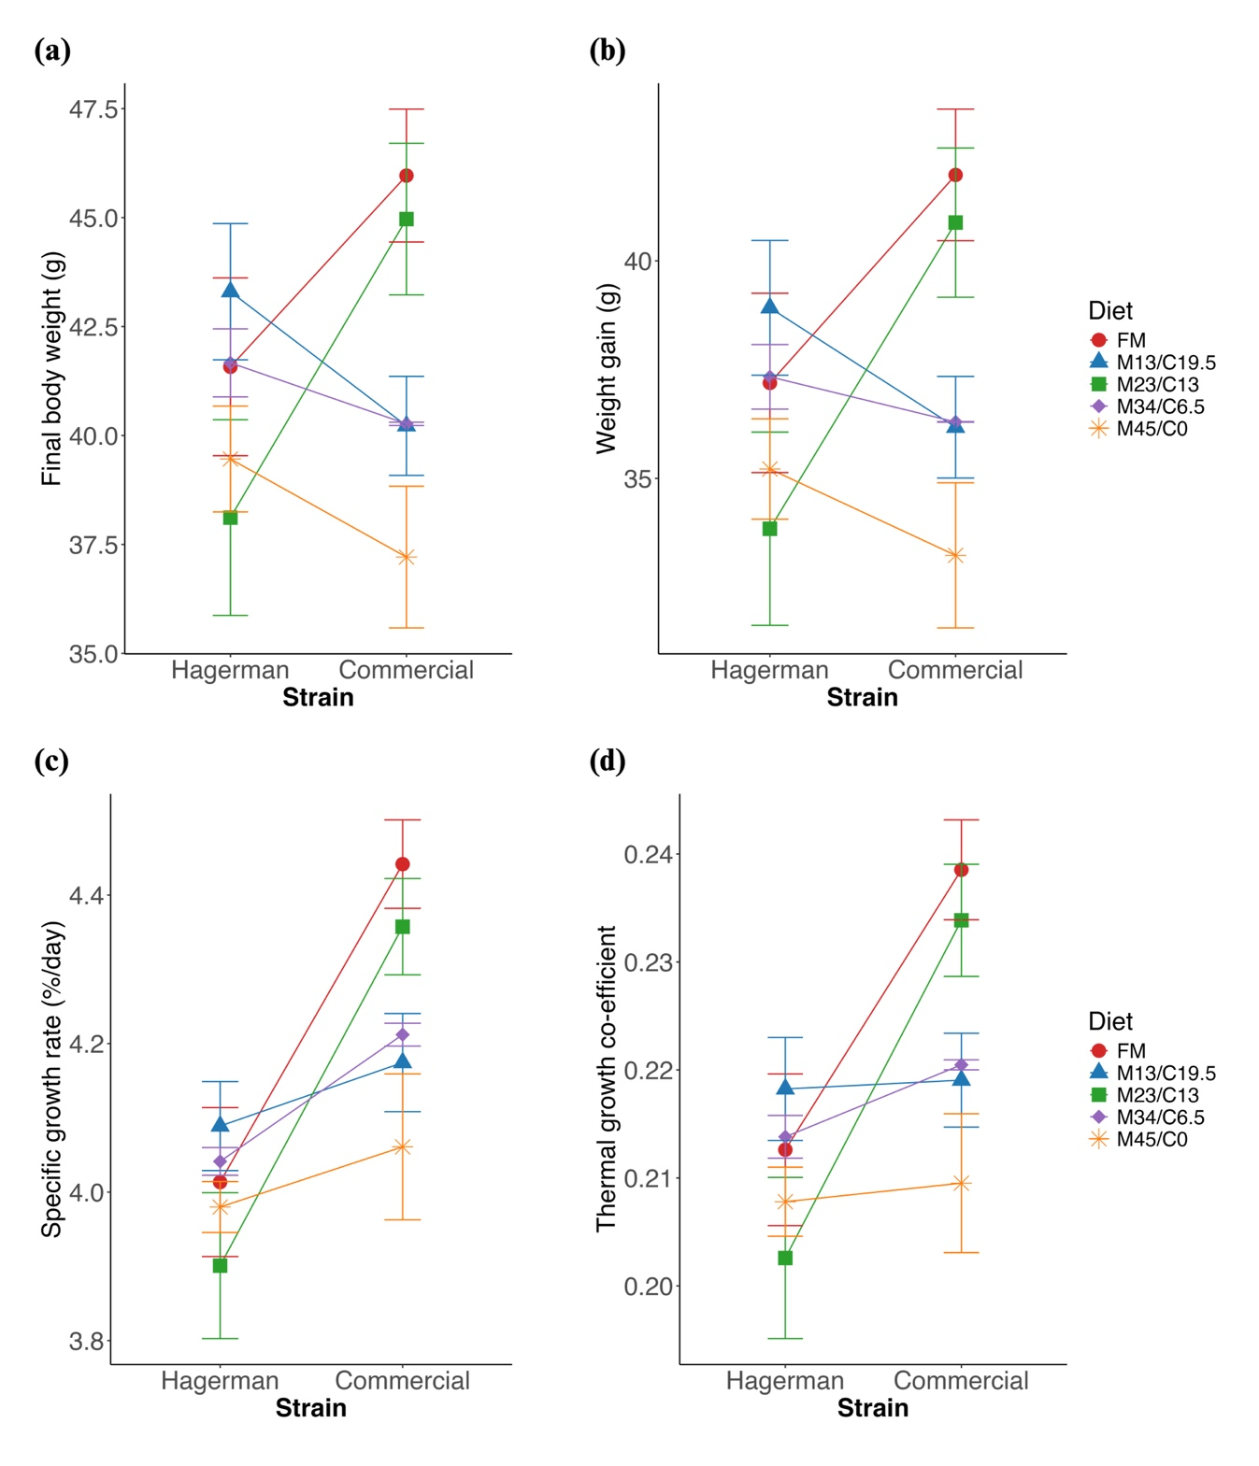
Figure 1: Interaction plot for ‘Strain × Diet’ on (a) final body weight, (b) weight gain, (c) specific growth rate, and (d) thermal growth coefficient of rainbow trout fed experimental diets for 8 weeks
Factors: Strain- Hagerman strain and commercial strain; Diet- FM, Fishmeal based diet; M13/C19.5, 13% SBM + 19.5% SPC; M23/C13, 23% SBM + 13% SPC; M34/C6.5, 34% SBM + 6.5% SPC; M45/C0, 45% SBM + 0% SPC
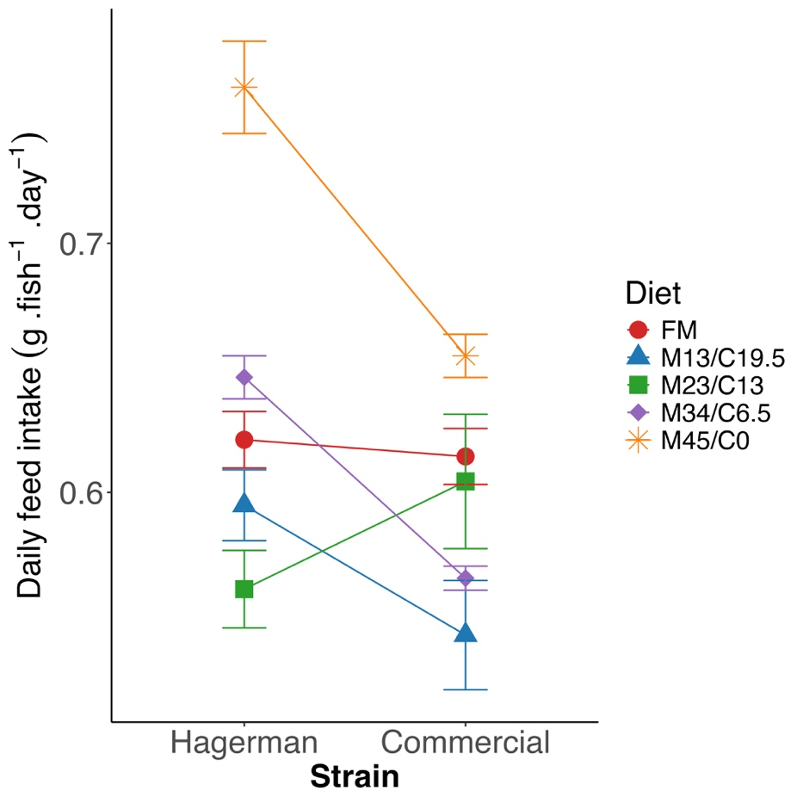
Figure 2: Interaction plot for ‘Strain × Diet’ on daily feed intake (g.feed⁻¹.day⁻¹) of rainbow trout fed experimental diets for 8 weeks
Factors: Strain- Hagerman strain and commercial strain; Diet- FM, Fishmeal based diet; M13/C19.5, 13% SBM + 19.5% SPC; M23/C13, 23% SBM + 13% SPC; M34/C6.5, 34% SBM + 6.5% SPC; M45/C0, 45% SBM + 0% SPC

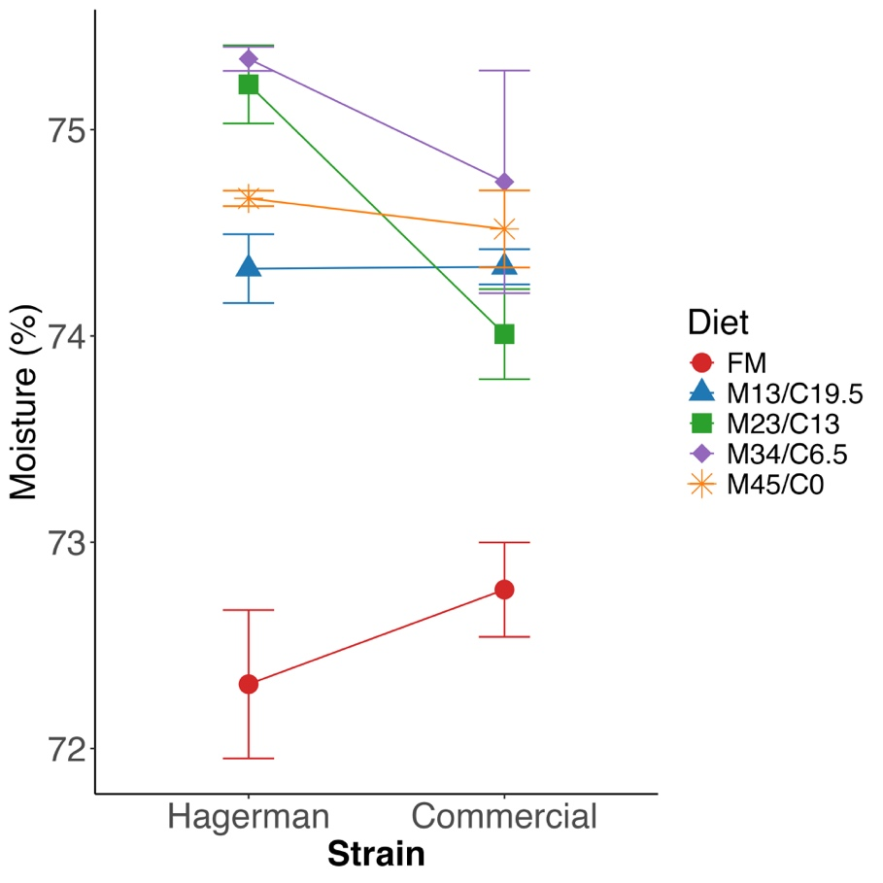
Figure 3: Interaction plot for ‘Strain × Diet’ on whole-body moisture content (%) of rainbow trout fed experimental diets for 8 weeks
Factors: Strain- Hagerman strain and commercial strain; Diet- FM, Fishmeal based diet; M13/C19.5, 13% SBM + 19.5% SPC; M23/C13, 23% SBM + 13% SPC; M34/C6.5, 34% SBM + 6.5% SPC; M45/C0, 45% SBM + 0% SPC

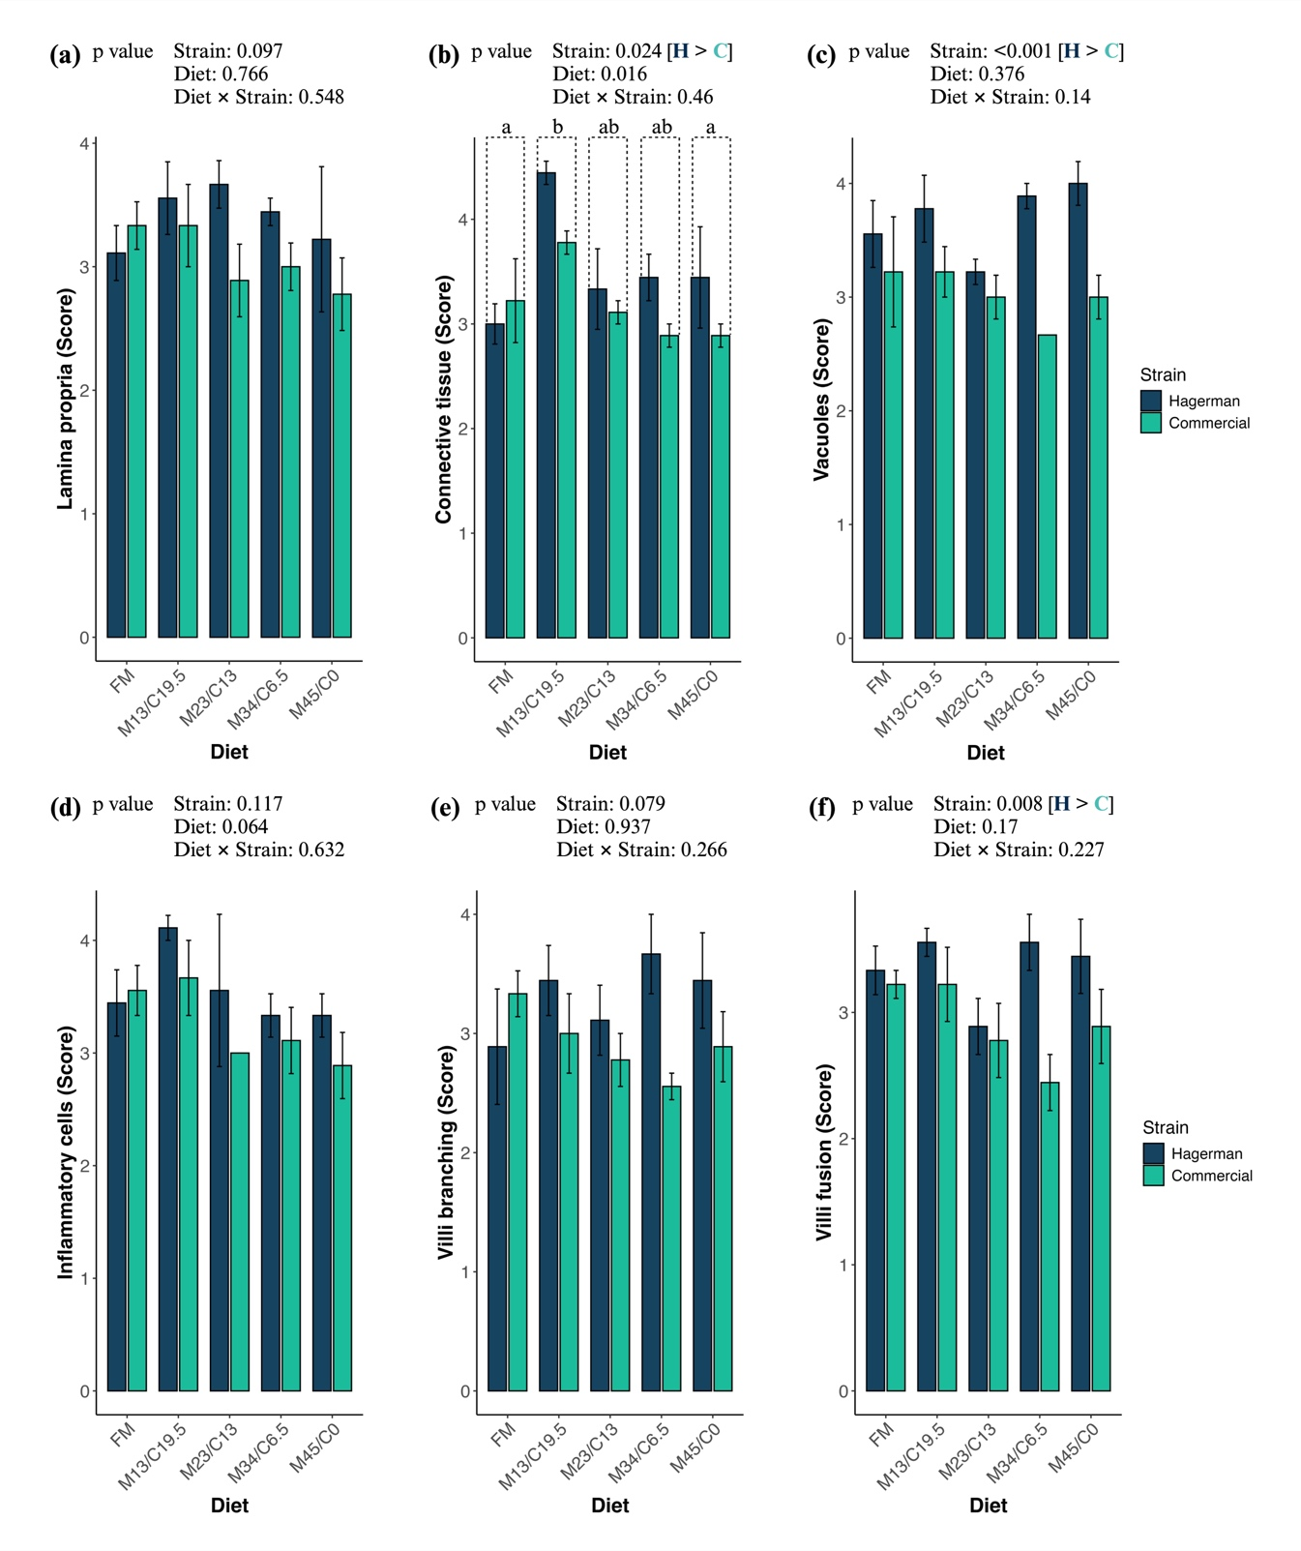
Figure 4: Qualitative analysis of distal intestinal histology- (a) lamina propria, (b) connective tissue, (c) vacuoles, (d) inflammatory cells, (e) villi branching, and (f) villi fusion scores of rainbow trout fed with experimental diets for 8 weeks
Factors: Strain- H, Hagerman strain, and C, commercial strain; Diet- FM, Fishmeal based diet; M13/C19.5, 13% SBM + 19.5% SPC; M23/C13, 23% SBM + 13% SPC; M34/C6.5, 34% SBM + 6.5% SPC; M45/C0, 45% SBM + 0% SPC

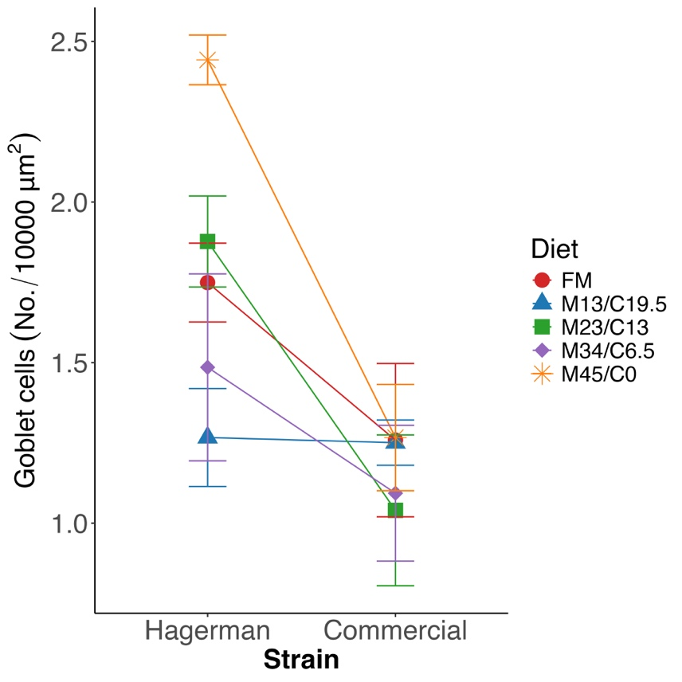
Figure 5: Interaction plot for ‘Strain × Diet’ on goblet cells (No./10000 μm²) of distal intestine of rainbow trout fed experimental diets for 8 weeks
Factors: Strain- Hagerman strain and commercial strain; Diet- FM, Fishmeal based diet; M13/C19.5, 13% SBM + 19.5% SPC; M23/C13, 23% SBM + 13% SPC; M34/C6.5, 34% SBM + 6.5% SPC; M45/C0, 45% SBM + 0% SPC

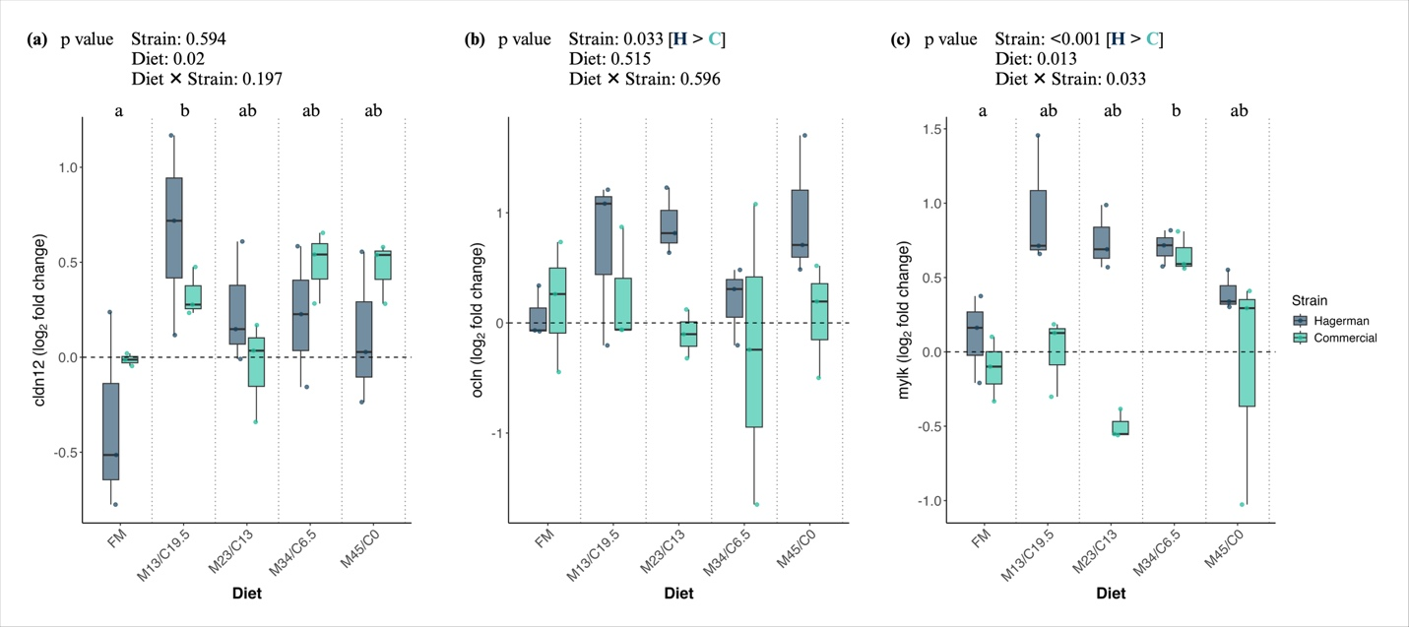
Figure 6: Intestinal gene- (a) claudin 12 (cldn12), (b) occludin (ocln), and (c) myosin light chain kinase (mylk) expression of rainbow trout fed with experimental diets for 8 weeks
Factors: Strain- H, Hagerman strain, and C, commercial strain; Diet- FM, Fishmeal based diet; M13/C19.5, 13% SBM + 19.5% SPC; M23/C13, 23% SBM + 13% SPC; M34/C6.5, 34% SBM + 6.5% SPC; M45/C0, 45% SBM + 0% SPC

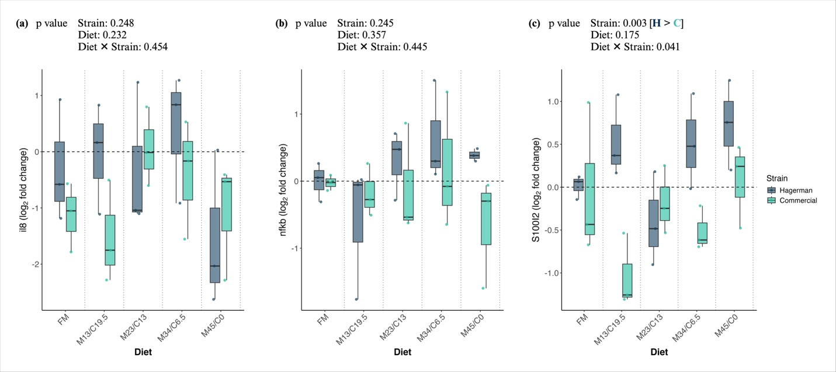
Figure 7: Intestinal gene- (a) interleukin 8 (il8), (b) nuclear factor kappa-B (NF-κB/nfkb), and (c) S100 calcium binding protein I2 (S100I2) expression of rainbow trout fed with experimental diets for 8 weeks
Factors: Strain- H, Hagerman strain, and C, commercial strain; Diet- FM, Fishmeal based diet; M13/C19.5, 13% SBM + 19.5% SPC; M23/C13, 23% SBM + 13% SPC; M34/C6.5, 34% SBM + 6.5% SPC; M45/C0, 45% SBM + 0% SPC

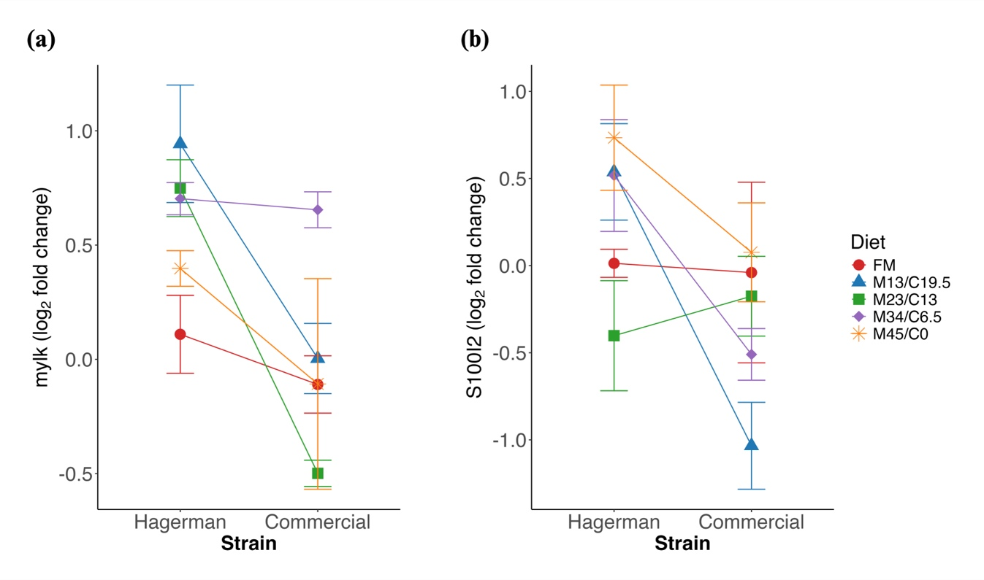
Figure 8: Interaction plot for ‘Strain × Diet’ intestinal gene- (a) myosin light chain kinase (mylk), and (b) S100 calcium binding protein I2 (S100I2) expression of rainbow trout fed experimental diets for 8 weeks
Factors: Strain- Hagerman strain and commercial strain; Diet- FM, Fishmeal based diet; M13/C19.5, 13% SBM + 19.5% SPC; M23/C13, 23% SBM + 13% SPC; M34/C6.5, 34% SBM + 6.5% SPC; M45/C0, 45% SBM + 0% SPC

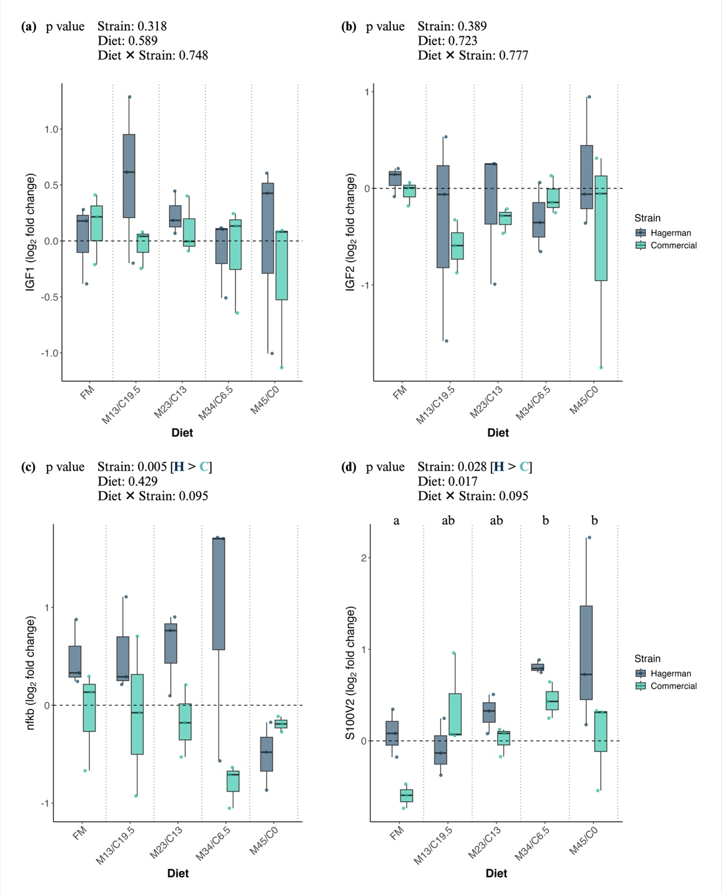
Figure 9: Hepatic gene- (a) insulin-like growth factors (IGF) 1 (b) IGF2, (c) nuclear factor kappa-B (NF-κB/nfkb), and (d) S100 calcium binding protein V2 (S100V2) expression of rainbow trout fed with experimental diets for 8 weeks
Factors: Strain- H, Hagerman strain, and C, commercial strain; Diet- FM, Fishmeal based diet; M13/C19.5, 13% SBM + 19.5% SPC; M23/C13, 23% SBM + 13% SPC; M34/C6.5, 34% SBM + 6.5% SPC; M45/C0, 45% SBM + 0% SPC

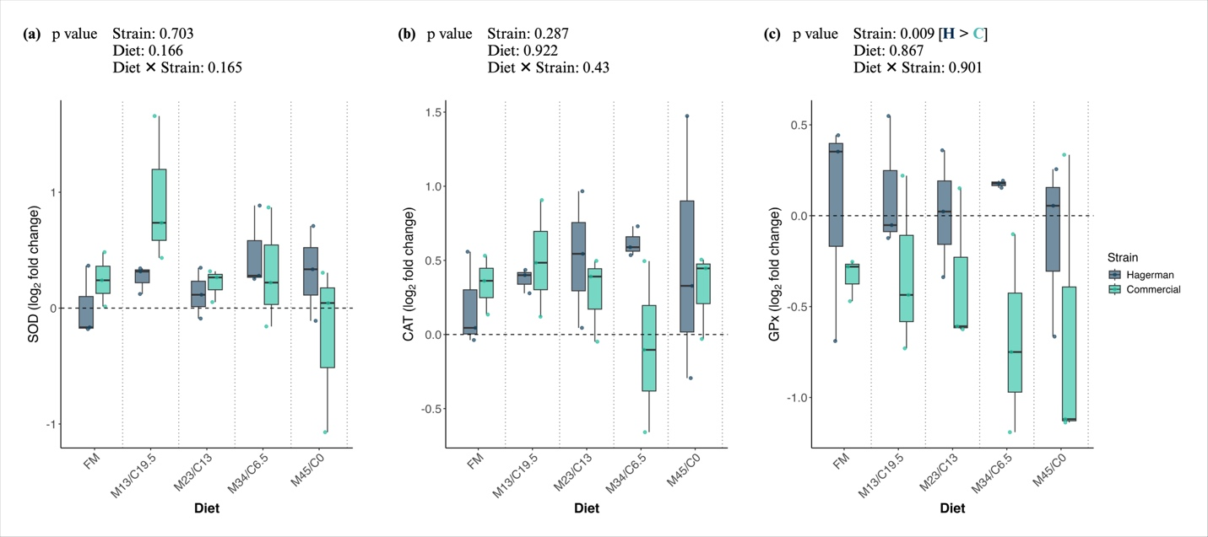
Figure 10: Hepatic gene- (a) superoxide dismutase (SOD), (b) catalase (CAT), and (c) glutathione peroxidase (GPx) expression of rainbow trout fed with experimental diets for 8 weeks
Factors: Strain- H, Hagerman strain, and C, commercial strain; Diet- FM, Fishmeal based diet; M13/C19.5, 13% SBM + 19.5% SPC; M23/C13, 23% SBM + 13% SPC; M34/C6.5, 34% SBM + 6.5% SPC; M45/C0, 45% SBM + 0% SPC

Part II:
Evaluation of immune response and survival of bacterial and viral pathogens in juvenile rainbow trout fed soy diets
Materials and methods
Ethical approval
The Institutional Animal Care and Use Committee (IACUC) of the University of Idaho (IACUC #2023-45) approved all the experimental protocols, including fish handling and sampling.
Experimental fish and pathogenic challenge
The disease challenge trials for two different strains of rainbow trout, the Hagerman strain and the commercial strain, were conducted at the University of Idaho’s CNR Aquatic Animal Laboratory (AAL) in the College of Natural Resources, followed by 8 weeks of feeding trials. For each strain (the Hagerman or commercial), each dietary treatment of fish (5 diets total) was separated into two groups- one group was infected with Flavobacterium psychrophilum (Fp) by intramuscular injection (i.m. at 1.21 x 10⁷ cfu/fish), and the second group was infected with Infectious hematopoietic necrosis virus (IHNV 220-90) by intraperitoneal injection (i.p. at 4000 pfu/fish). The mock challenge fish were injected with PBS. There were three replications for each treatment, i.e., 2 (strains) × 5 (diets) × 3 (replications) × 2 (two different pathogens), which equals to 60 tanks (19 L) in total with a stocking density of 15 fish/tank. Additionally, there was a tank with 10 fish/tank for each group for sampling. The challenge study was carried out for a total of 28 days (4 weeks). Fish were held at temperatures of 16 ± 1˚C throughout the study. Fish were fed with respective diets at maintenance ration throughout the challenge study.
Sampling
All the tanks were examined daily twice to record mortality. Fish blood was collected before the pathogenic challenge for lysozyme activity. Additionally, the blood was collected after 28 days of pathogenic challenge for quantification of Fp and IHNV-specific antibody titer. Tissues (spleen and head kidney) for histology and gene expression were sampled at pre-challenge and 7-days post-challenge. For histology, three tissue samples (from the spleen and head kidney) were preserved in 10% neutral buffered formalin (NBF) until used for histology slide preparation. For the gene expression study, the spleen and head kidney were stored in RNA stabilization solution (#AM7021, InvitrogenTM RNAlater™ solution, Thermo Scientific™, USA).
Survival probability and cumulative percent mortality (CPM)
Each diet-strain combination initially contained 15 fish per replicate, and mortality was recorded daily for 28 days post-challenge. For Kaplan-Meier survival analysis, the dataset was structured so that each fish was represented as an individual entry. If a fish died on a specific day, it was assigned that day as the survival time and given an event status of 1 (indicating mortality). If multiple fish died on the same day within a replicate, separate entries were created for each. To ensure all groups started with 15 fish, the number of censored fish was determined by subtracting the total number of deaths from 15. These censored fish, which survived until the end of the study, were recorded with a survival time of 28 days and an event status of 0 (indicating they were still alive at the final observation).
The cumulative percent mortality (CPM) was calculated using the following equation-
$$CPM \left(\%\right)= \frac{Number of fish stocked at Day 0-Number of fish harvested at Day 0}{Number of fish stocked at Day 0} 100$$
Lysozyme activity
Lysozyme activity was determined by the method of Litwack (1955) as modified by Sankaran and Gurnani (1972). At the end of the growth trial, fish blood was sampled from the caudal vasculature of five anesthetized fish per treatment for lysozyme assays. The assay is based on lysis of lysozyme-sensitive Gram-positive bacterium Micrococcus lysodeikticus (Sigma, St. Louis, MO, USA) by lysozyme present in plasma.
Antibody titers
For the pathogen-specific antibody titers assays in the blood were carried out for pre-challenge (Day 0) and post-challenge on Day 7 and Day 28. For F. psychrophilum-specific antibody test, a standard anti-F. psychrophilum enzyme-linked immunosorbent assay (ELISA) was used, following previously published methods (LaFrentz et al., 2002). For the IHNV-neutralizing antibody test, a similar complement-dependent plaque neutralization assay for IHNV was used as described previously (LaPatra et al., 1993).
Histopathology of spleen and head kidney
The tissue samples, preserved in 10% NBF solution, were placed in cassettes and transferred to the Washington Animal Disease Diagnostic Laboratory (WADDL), Washington State University, Pullman, USA, for slide preparation and scanning. Briefly, the cassettes containing distal intestines were placed in 10% neutral buffered formalin and processed overnight on a Leica ASP300S vacuum processor (Leica Biosystems, USA), where the distal intestine tissues were first placed in fresh formalin at 2 h intervals, then dehydrated at increasing concentrations of ethanol (80% ethanol for 1, 95% ethanol for 1 h, 100% ethanol for 1 h thrice) followed by removing ethanol in xylene and then embedded in paraffin wax. Then embedded blocks were cut on a microtome at 4 μ thickness and then stained (H&E, hematoxylin and eosin staining) using an automated slide stainer (Tissue-Tek Prisma®, Sakura Finetek USA, Inc.). The stained slides were then scanned using the Aperio GT 450 Scanner (Leica Biosystems, USA). The scanned slide images were analyzed with the help of two software namely, QuPath (v0.5.0) and Fiji (ImageJ2, v2.14.0/1.54f), for qualitative analysis as discussed below.
The spleen and head kidney morphology was evaluated based on a qualitative scoring system for three histological parameters: inflammation, necrosis or cell death, and the melanomacrophase centers (MMCs) (Table 1). For each treatment group, three slides were prepared. Five non-overlapping fields (500 μm × 500 μm) per sample were selected for observation. The scoring system ranged from 1 to 5 for each parameter, where 1 indicated normal or minimal changes, and 5 represented the most severe alterations (Table 1). The scoring criteria were based on the extent of tissue alteration observed.
Gene expression
Approximately 100 mg of tissue (spleen and head kidney) was used for RNA extraction using a commercial kit (#R1054, Quick-RNA Miniprep Kit, Zymo Research, USA) following the manufacturer protocol. After the extraction, the concentration and purity (260/280) of RNA were checked using a Nano-Drop spectrophotometer (NanoDrop One, Thermo Scientific™, USA). The relative quantity and integrity of RNA were confirmed by electrophoresis.
Reverse transcription was carried out using the commercial cDNA synthesis Kit (#E3010L, LunaScript® RT SuperMix Kit, New England Biolabs®, Inc.) following the manufacturer's protocol. The product was stored at -20 °C until the quantitative RT-PCR (qRT-PCR) was performed.
The primers for the housekeeping genes and target genes used are mentioned in Table 2 for both the tissues. All the primers were purchased from the Integrated DNA Technologies, USA. A high throughput (HT) RT-qPCR system (Wafergen SmartChip Real-time PCR system, Takara Bio USA, Inc.) based on SmartChip MyDesign Kit using SmartChip® TB Green® Gene Expression Master Mix (#640211, Takara Bio USA, Inc.) was used. The same RT-qPCR program was used as the activation at 95°C for 2 min, then 40 cycle reactions, each of which includes denaturation at 95°C for 10 s, annealing at 58°C for 15 s, and extension at 72°C for 10 s) was used for uniformity. Finally, melting curve analysis was done using a temperature gradient to confirm the amplification of the target gene. The relative expression of different myogenic genes was calculated by following the 2^{-ΔΔCT} method (Livak and Schmittgen, 2001). Finally, the 2^{-ΔΔCT} values were converted to Log₂ to get the fold-change.
ΔCT = CT value of target gene – CT value of housekeeping genes*
ΔΔCT = ΔCT of dietary treatment group – ΔCT of control group**
*Geometric mean of CT values of two housekeeping genes
**FM-fed group of Hagerman strain during pre-challenge (Day 0)
Statistical analysis
The normality and homogeneity of variance were assessed by examining the Residual vs Fitted Plot, Q-Q Residual Plot, and Bartlett test. All the data were subjected to two-way ANOVA to determine the main and interaction effects of strains and diets and Tukey’s HSD for pairwise comparison using R programming (R version 4.4.0). Statistical analyses were conducted using the Aligned Rank Transform (ART) ANOVA to evaluate the effects of diet and strain on qualitative histopathological parameters. ART was applied to align and rank the data before performing factorial ANOVA to assess the main effects and interactions. Post hoc pairwise comparisons were conducted using estimated marginal means with Tukey’s adjustment to compare differences between diet groups and strain groups separately after ART ANOVA. A significance level of p < 0.05 was used to determine statistical differences.
Survival analysis was conducted using the Kaplan-Meier estimator to compare survival probabilities for both strains and dietary treatments. The log-rank test was used to assess differences in survival distributions between groups, with statistical significance set at p < 0.05. To further evaluate the effects of strain and diet on survival, a Cox proportional hazards model was applied. This model estimated hazard ratios (HR) with 95% confidence intervals (CI) to quantify the relative risk of mortality associated with different strains and diets. The likelihood ratio test was performed to assess the overall significance of the model. All statistical analyses were conducted using the “survival” and “survminer” packages in R programming (R version 4.4.0). Results were interpreted based on hazard ratios, log-rank test p-values, and model fit statistics.

Results
Survival probability and cumulative percent mortality (CPM)
In the case of the Fp-challenge, survival probability analysis showed significantly higher mortality in the Hagerman strain compared to the Commercial strain (log-rank test: χ² = 31.5, df = 1, p < 0.05) (Figure 1). Dietary changes had no significant effect on survival probability (χ² = 5.0, df = 4, p > 0.05). Cox proportional hazards analysis confirmed the increased risk in the Hagerman strain (HR = 3.30, 95% CI: 2.17-5.03, p < 0.05). Among diets, only M23/C13 was associated with significantly higher mortality (HR = 2.06, 95% CI: 1.14-3.71, p < 0.05). The overall model was significant (likelihood ratio test: χ² = 38.37, df = 5, p < 0.05), indicating that strain and diet collectively influenced survival (Figure 1).
In the case of the IHNV-challenge, survival probability analysis showed no significant differences in survival probability between strains (χ² = 2.6, df = 1, p > 0.05) or diets (χ² = 4.5, df = 4, p > 0.05), though the commercial strain showed a non-significant trend toward higher mortality (Figure 2). Cox proportional hazards modeling also showed that the commercial strain had a higher but non-significant risk of mortality (HR = 1.51, 95% CI: 0.96–2.36, p > 0.05). No diet significantly affected survival probability (p > 0.05 for all diets), and the overall model was not statistically significant (likelihood ratio test: χ² = 7.5, df = 5, p > 0.05) (Figure 2).
The CPM showed that the Hagerman strain had significantly (p < 0.05) higher mortality than the commercial strain after Fp-challenge (Figure 3A). However, no significant (p > 0.05) difference was observed for different diets or interaction of ‘Diet × Strain’. In the case of the IHNV-challenge, none of the factors had a significant (p > 0.05) effect on CPM (Figure 3B).
Lysozyme activity
The results revealed that there was no significant (p > 0.05) effect of strains, diets, or their interaction on the lysozyme activity (Figure 4).
Antibody titers
Before the challenge, both Fp-specific antibody and IHNV-neutralizing antibody were undetected for all Day 0 samples. Antibody responses to F. psychrophilum or IHNV were detected on Day 7 and Day 28 post-challenge in fish exposed to the respective pathogens. However, there were no significant (p > 0.05) differences among different strains, diets or their interaction (Figure 5).

Histopathology of spleen and head kidney
F. psychrophilum challenged
Although none of the qualitative scoring (inflammation, necrosis, and MMCs) of spleen histopathological parameters showed a significant (p > 0.05) effect of different diets, there were significant (p < 0.05) variations in inflammation and necrosis scores due to strain and interaction of ‘Diet × Strain’ (Figure 6.1). In the case of inflammation, the Hagerman strain had a significantly (p < 0.05) lower score than the commercial strain (Figure 5.1a). However, the necrosis score was significantly (p < 0.05) higher in the Hagerman strain compared to the commercial strain (Figure 5.1b). The interaction plot revealed that in the case of the Hagerman strain, fish fed with the highest SBM (M45/C0) had relatively higher spleen inflammation score than other diets (Figure 7a); however, the commercial strain had higher spleen inflammation for all the diets. In the case of spleen necrosis, the Hagerman strain fed with higher SBM (M34/C6.5 and M45/C0) showed a higher score than the other diets (Figure 7b); however, the commercial strain had an overall lower spleen necrosis score than the Hagerman strain.
In the case of the head kidney histopathology, similar to the spleen inflammation, the Hagerman strain had a significantly (p < 0.05) lower score than the commercial strain (Figure 6.2a). A significantly (p < 0.05) higher head kidney inflammation score was observed in the M23/C13 diet as compared to other dietary groups (Figure 6.2a). The interaction plot showed that although different diets had similar inflammation score in the Hagerman strain, the M23/C13 diet exhibited relatively higher inflammation score in the commercial strain than other diets within the same strain (Figure 7c). The head kidney necrosis score was not significantly (p > 0.05) affected by strain, diet, or their interaction (Figure 6.2b). In the case of the head kidney MMCs score, only the strain showed a significant (p < 0.05) variation, where the Hagerman strain had significantly lower score than the commercial strain (Figure 6.2c).
IHNV challenged
In the case of the spleen, only the inflammation score showed a significant (p < 0.05) variation between strains, where the Hagerman strain had a lower score than the commercial strain (Figure 8.1a). However, the necrosis or MMCs scores in the spleen showed no significant (p > 0.05) changes due to strain, diet, or their interaction (Figure 8.1b,c).
In the case of the head kidney, both inflammation and MMCs scores were significantly (p < 0.05) lower in the Hagerman strain than in the commercial strain (Figure 8.2a,c). Additionally, the inflammation score was significantly (p < 0.05) increased in the higher SBM-fed diets (M34/C6.5 and M45/C0) (Figure 8.2a). The necrosis score in the head kidney showed no significant (p > 0.05) variation due to strain, diet, or their interaction (Figure 8.2b).
Gene expression
Gene expression in the spleen
Immune-related genes in the spleen
The pre-challenge fish showed significant (p < 0.05) variation in complement component 5 (C5) expression due to strain, diet, and their interaction (Figure 9.1A). Although diets showed no clear trend in the C5 expression, the commercial strain showed higher expression of the C5 gene than the Hagerman strain (Figure 9.1A). The interaction plot supports the similar observation where the commercial strain showed relatively higher expression of the C5 in all the dietary treatments (Figure 12a). In the Fp-challenged fish, although the diets showed significant (p < 0.05) variation in the C5 expression, a clear trend was not detected (Figure 9.1B). However, similar to the pre-challenge fish, the commercial strain exhibited significantly (p < 0.05) higher expression of the C5 gene than the Hagerman strain (Figure 9.1B). In contrast, in the IHNV-challenged fish, the Hagerman strain showed a significantly (p < 0.05) higher expression of the C5 gene than the commercial strain (Figure 9.1C).
In the case of the cluster of differentiation 4 (CD4) gene, the pre-challenge fish only showed significant (p < 0.05) interaction of ‘Diet × Strain’ (Figure 9.2A). The interaction plot shows that only in the case of the commercial strain, the SBM/SPC-fed diets had relatively higher expression of CD4 in the spleen than the FM-fed group (Figure 12b). The Fp-challenged fish showed no significant (p > 0.05) differences in CD4 expression due to strain, diet, or their interaction (Figure 9.2B). In contrast, in the IHNV-challenged fish, the commercial strain had significantly (p < 0.05) higher expression of the CD4 gene than the Hagerman strain (Figure 9.2C). Moreover, the highest SBM-fed diet (M45/C0) showed significantly (p < 0.05) higher expression of the CD4 gene than the FM-based diet (Figure 9.2C). The interaction plot for IHNV-challenged CD4 expression showed that the Hagerman strain had more variation in the expression of this gene between the diets, with the lowest and highest expression being recorded in the FM and M45/C0 diet groups (Figure 12f).
In the case of the Immunoglobulin M (IgM) gene, the commercial strain had significantly (p < 0.05) higher expression of IgM than the Hagerman strain, but the diets, although significant (p < 0.05), showed no specific trend (Figure 9.3A). The interaction plot of pre-challenge IgM shows that only in the case of the commercial strain, M13/C19.5 and M45/C0 diets had relatively higher expression of CD4 gene than other diets (Figure 12c).
Inflammatory response genes in the spleen
In the case of interleukin 8 (il8), the pre-challenge fish showed significant (p < 0.05) dietary and interaction effects (Figure 10.1A). The M23/C13 and M43/C6.5 diets showed significantly (p < 0.05) higher expression of il8 than the FM-based diet (Figure 10.1A). The interaction plot for the spleen il8 gene shows that both FM and M45/C0 diets remained at similar expression levels in both strains; however, noticeably, the M13/C19.5 diet showed relative reduced expression in the commercial strain (Figure 12d). In both Fp- and IHNV-challenged fish, only strain showed a significant (p < 0.05) effect on the il8 expression, where the Hagerman strain had significantly (p < 0.05) higher expression of this gene than the commercial strain (Figure 10.1A,B).
In the case of interleukin 10 (il10), although pre-challenge and IHNV-challenged fish showed no significant (p > 0.05) effect of strain, diet, or their interaction, the Fp-challenged fish showed significant (p < 0.05) effect of strain (Figure 10.2). In the Fp-challenged fish, similar to il8 expression, the Hagerman strain showed significantly (p < 0.05) higher expression of il10 than the commercial strain (Figure 10.2B).
In the case of nuclear factor kappa B (nfkb), the pre-challenge and Fp-challenged fish did not show any significant (p > 0.05) effect of strain, diet, or their interaction (Figure 10.3A,B). In the case of IHNV-challenged fish, although all the SBM/SPC-based diets did not show any significant (p > 0.05) variation from the FM-based diet, the commercial strain had significantly (p < 0.05) higher expression of il10 than the Hagerman strain (Figure 10.3C). Interestingly, the interaction plot shows that although all the diets in the commercial strain had relatively higher expression of spleen il10, in the case of the Hagerman strain, the higher SBM-based diets i.e., M34/C6.5 and M45/C0, had relatively higher expression of il10 than other diets within the same strain (Figure 12g).
Autophagy-related genes in the spleen
The autophagy related 12l (Atg12l) gene showed a significantly (p < 0.05) higher expression in the Hagerman strain than the commercial strain (Figure 11.1A). However, both Fp- and IHNV-challenged fish showed no significant (p > 0.05) effect of strain, diet, or their interaction (Figure 11.1B,C).
In the case of microtubule-associated protein 1 light chain beta (MAP1LC3B or simply, LC3B), the pre-challenge fish showed that the Hagerman strain had significantly (p < 0.05) higher expression of LC3B than the commercial strain (Figure 11.2A). In contrast, after the pathogenic challenge, both the Fp-challenged and IHNV-challenged fish showed that the commercial strain had significantly (p < 0.05) higher expression of LC3B than the Hagerman strain (Figure 11.2B,C). However, no significant (p > 0.05) effect of diet or interaction of ‘Diet × Strain’ was observed on the LC3B expression (Figure 11.2).
Gene expression in the head kidney
Immune-related genes in the head kidney
The C5 gene showed no significant (p > 0.05) variation during pre-challenge in the head kidney (Figure 13.1A). During post-challenge for both Fp- and IHNV-challenged, the commercial strain had significantly (p < 0.05) higher expression of C5 gene than the Hagerman strain (Figure 13.B,C). Only in the case of IHNV-challenged fish, the M45/C0 diet showed significantly (p < 0.05) lower expression of head kidney C5 than other diets (Figure 13.C). The interaction plots show that both the Fp- and IHNV-challenged fish showed overall lower expression of C5 gene in the Hagerman strain than the commercial strain except the M45/C0 diet (Figure 17a; Figure 18a).
The CD gene in the head kidney showed significantly (p < 0.05) higher expression in the commercial strain than the Hagerman strain; however, no dietary or interaction of ‘Diet × Strain’ was observed (Figure 12.2A). In the case of the Fp-challenged fish, only a significant (p < 0.05) interaction effect on the head kidney CD4 gene was recorded, where the commercial strain had more variation between diets with higher in the FM-based diet (Figure 12.2B; Figure 17b). In contrast to the pre-challenge, the IHNV-challenged fish showed significantly (p < 0.05) higher expression of head kidney CD4 gene in the Hagerman strain than the commercial strain (Figure 12.2C). Moreover, except the M23/C13 diet, all the SBM/SPC-based diets showed significantly (p < 0.05) higher expression of head kidney CD4 than FM-based diet (Figure 12.2C). The interaction plot shows that there was more variation between diets in the commercial strain with the lowest and highest expression of CD4 was observed in the FM and M45/C5 diets, respectively (Figure 18b).
In the pre-challenge, the head kidney IgM expression was significantly (p < 0.05) higher in the commercial strain than the Hagerman strain, whereas the dietary variation showed no specific trend (Figure 12.3A). The interaction plot of IgM gene during pre-challenge supports that the Hagerman strain had relatively lower expression than the commercial strain in all diets except M13/C19.5 (Figure 16). In contrast to the pre-challenge, both Fp- and IHNV-challenged fish showed significantly (p < 0.05) higher expression of head kidney IgM in the Hagerman strain than the commercial strain (Figure 12.3B,C). In the case of the IHNV-challenged fish, the M13/C19.5 and M45/C0 diets had higher expression of IgM than the FM-based diet (Figure 12.3C). Moreover, the interaction plot shows that the IHNV-challenged commercial strain had more variation in the head kidney IgM expression between the diets (Figure 18c).
Inflammatory response genes in the head kidney
The il8 expression in the head kidney showed an inverse trend in pre- and post-challenge fish in terms of strain effect. During pre-challenge, the Hagerman strain had significantly (p < 0.05) higher expression of il8 than the commercial strain (Figure 14.1). However, during post-challenge for both Fp and IHNV, the commercial strain showed significantly (p < 0.05) higher expression of il8 than the Hagerman strain (Figure 14.1B). Additionally, in the case of Fp-challenged fish, the commercial strain exhibited more variation between diets than the Hagerman strain (Figure 17c).
In the case of il10, the M23/C13 diet had significantly (p < 0.05) lower expression than other diets during pre-challenge (Figure 14.2A). Similar to the il8, both Fp- and IHNV-challenged fish showed that the commercial strain had significantly (p < 0.05) higher expression of head kidney il10 than the Hagerman strain (Figure 14.2B,C). However, dietary effect did not show a clear trend during post-challenge. Moreover, like the il8, the interaction plot shows higher variation of il10 expression between diets in the commercial strain with higher expression in the FM and M34/C6.5 diets (Figure 17d).
The pre-challenge fish showed no significant (p > 0.05) effect of strain, diet or their interaction on the nfkb expression (Figure 14.3A). However, the Fp-challenged fish showed that similar to il8 and il10 genes, the nfkb expression was significantly (p < 0.05) higher in the commercial strain than the Hagerman strain (Figure 14.3B). In the case of the IHNV-challenged fish, in contrast to il8 and il10 genes, the nfkb gene showed significantly (p < 0.05) higher expression in the Hagerman strain than the commercial strain (Figure 14.3C). Additionally, the higher SBM-containing diets (M34/C6.5 and M45/C0) showed significantly (p < 0.05) higher expression of head kidney nfkb than the FM-based diet (Figure 14.3C). Moreover, the interaction plot shows higher variation of nfkb expression between diets (with relatively higher in M34/C6.5 and M45/C0) in the commercial strain (Figure 18d).
Autophagy-related genes in the head kidney
The Atg12l gene in the head kidney showed only significant (p < 0.05) effect of strain during pre- and post-challenge (Figure 15.1). During pre-challenge and Fp-challenged fish, the Hagerman strain showed significantly (p < 0.05) higher expression of Atg12l than the commercial strain (Figure 15.1A,B); whereas, in contrast, the commercial strain had significantly (p < 0.05) higher expression of Atg12l than the Hagerman strain during post IHNV-challenge (Figure 15.1C). Moreover, although the diet showed a significant (p < 0.05) effect on Atg12l in the IHNV-challenged fish, but the post-hoc showed no significant difference between diets (Figure 15.1C).
In the case of the head kidney LC3B gene, although the pre-challenge fish showed no significant (p > 0.05) differences due to strain, diet or their interaction, both Fp- and IHNV-challenged fish exhibited significantly (p < 0.05) higher expression of LC3B in the Hagerman strain than the commercial strain (Figure 15.2). Moreover, in the case of the IHNV-challenged fish, the higher SBM-containing diets (M34/C6.5 and M45/C0) showed significantly (p < 0.05) higher expression of LC3B than the FM-based diet (Figure 15.2C). Additionally, the interaction plot for the IHNV-challenged fish shows that the commercial strain showed more variation of LC3B expression between diets (Figure 18e).
Discussion
Survival probability and cumulative percent mortality (CPM)
The survival analysis showed that strain significantly affected disease resistance mainly in response to the F. psychrophilum (Fp) challenge (Weber et al., 2013). The Hagerman strain exhibited significantly higher mortality than the commercial strain as indicated by both Kaplan-Meier survival analysis and Cox proportional hazards modeling. The increased susceptibility was supported by cumulative percent mortality (CPM) results. Dietary differences did not significantly affect survival as a whole, but Diet M23/C13 had a higher mortality risk. This could imply that the combination of specific SBM/SPCs differed in a way that reduced resistance to the particular pathogens. In addition, after the IHNV challenge, there were no significant differences in survival as a result of strain or diet, though there was a non-significant trend for higher mortality in the commercial strain. The CPM results supported that there were no significant differences in mortality as a result of diet or strain during IHNV challenge. These observations suggest a pathogen-specific response, with strain differences being more pronounced during the Fp-challenge (Overturf et al., 2010), and dietary differences having a minimal effect for both pathogens, with the exception of the stains with M23/C13 formulation indicating vulnerability to the bacterial pathogen.
Lysozyme activity and antibody titers
While there were clear differences in survival outcomes associated with strains and diet treatments, in terms of lysozyme activity and specific antibody titers no significant effects were seen, suggesting that these systemic humoral responses may not explain the differences in resistance to disease observed. We confirmed immune activation during challenge, as Fp-specific antibodies, as well as IHNV-neutralizing antibodies, were detected after challenge (Balfry et al., 2001). However, we did not see any statistically significant differences in titers associated with strain or diet treatment, suggesting a uniform circulating antibody response. Nonetheless, as we will discuss in the next section, the differences in the histopathological and gene expression changes to lymphoid organs (spleen and head kidney) indicates that local immune responses and tissue-level responses may provide a more important and reliable indicator of resistance to strain and diet than systemic indicators like lysozyme activity and antibody titers.
Histopathology of spleen and head kidney
Histopathological examination showed strain-specific and diet-associated tissue responses in lymphoid organs, particularly under F. psychrophilum challenge. The Hagerman strain showed lower inflammation but higher necrosis in the spleen and head kidney, suggesting impaired tissue defense. While diets alone had no significant effects, ‘Diet × Strain’ interactions were present where the Hagerman strain fed with higher SBM diets (M34/C6.5 and M45/C0) exhibited increased spleen necrosis and inflammation. In contrast, the commercial strain displayed higher inflammation overall, with M23/C13 diet elevating head kidney inflammation. Under IHNV-challenge, fewer changes were observed, but inflammation and MMCs remained higher in the commercial strain, particularly in the head kidney, and were elevated in fish fed higher SBM diets. These observations suggests that local immune responses in lymphoid tissues were modulated by both strain and diet in a pathogen-specific manner, supporting the survival trends observed in this study.

Gene expression
Immune-related genes
The two pathogens exhibited distinct immune responses between the strains, with varying innate and adaptive pathways across lymphoid organs. Under F. psychrophilum challenge, the commercial strain displayed stronger innate responses, indicated by higher expression of C5 gene in both spleen and head kidney, along with elevated CD4 and IgM expression in the spleen prior to infection, suggesting enhanced baseline immune readiness against bacterial pathogens (Ma et al., 2025). Conversely, during IHNV challenge, the Hagerman strain exhibited a stronger adaptive response, indicated by higher post-challenge expression of CD4 and IgM in the head kidney, suggesting a pathogen-specific shift toward adaptive immune response (Ma et al., 2023).
Different diets further modulated these responses in a pathogen- and tissue-dependent manner. Compared to the FM-based control, M34/C6.5 consistently enhanced expression of immune genes, particularly CD4 and IgM in the head kidney under IHNV-challenge, suggesting improved adaptive immune activation. M45/C0 also induced strong gene expression but was occasionally linked to elevated inflammation. M13/C19.5 promoted moderate IgM upregulation, while M23/C13 was associated with increased inflammation and higher mortality under bacterial challenge. Overall, M34/C6.5 provided a favorable balance, stimulating immune responses without evidence of excessive immunopathology, supporting its potential as a better SBM/SPC combination as alternative to FM under pathogenic stress.
Inflammatory response genes
Inflammatory gene expression patterns aligned closely with histopathological inflammation scores, showing distinct strain- and pathogen-specific immune response (McCarthy et al., 2013). Post Fp-challenge, the Hagerman strain exhibited higher il8 and il10 expression with lower spleen inflammation scores, suggesting a delayed or subdued inflammatory response that may have contributed to its higher tissue damage and mortality. In contrast, the commercial strain showed both elevated gene expression and inflammation histologically, indicating a more immediate and active response. Under IHNV-challenge, nfkb and il10 were upregulated in the commercial strain, consistent with higher inflammation scores in both spleen and head kidney. Interestingly, in the Hagerman strain, elevated il10 and nfkb expression occurred only with high SBM diets (M34/C6.5 and M45/C0), suggesting a diet-driven modulation of immune activation. In the head kidney, gene expression followed the histological observations, with greater il8, il10, and nfkb expression in the commercial strain during post Fp-challenge. Among diets, M34/C6.5 consistently promoted a balanced inflammatory response, enhancing gene expression without excessive tissue inflammation, especially in the commercial strain- supporting its potential to optimize immune response under pathogenic challenge.
Autophagy-related genes
Expression of autophagy-related genes showed pathogen- and strain-specific regulatory response, which were closely aligned with tissue necrosis patterns observed in the histopathology. During pre-challenge, the Hagerman strain exhibited higher expression of Atg12l and LC3B, indicating a enhanced autophagic state. However, post Fp-challenge, LC3B expression in the spleen was significantly higher in the commercial strain, corresponding with its lower histopathological necrosis scores, suggesting that enhanced autophagy may have contributed to reduced tissue damage. Conversely, the Hagerman strain, despite higher baseline autophagy markers, showed reduced LC3B activation post-challenge, which aligns with its higher necrosis scores in both spleen and head kidney, indicating to a potentially impaired autophagic response under pathogenic stress (Li et al., 2024).
In the head kidney, the Hagerman strain maintained elevated LC3B expression post-challenge, especially under IHNV infection, suggesting a compensatory autophagy response in this tissue. Importantly, higher SBM diets, particularly M34/C6.5 and M45/C0, significantly upregulated LC3B expression in the head kidney under viral stress. Among these, M34/C6.5 supported autophagy activation without excessive necrosis, indicating a more balanced immune-tissue response. These findings suggest that effective autophagic regulation, especially in the commercial strain and with M34/C6.5, may contribute to limiting pathogen-induced tissue damage, particularly in the spleen.
Concluding remarks
This challenge study suggests that strain-specific and pathogen-dependent immune strategies play an important role in disease resistance in rainbow trout. The Hagerman strain was significantly more susceptible to F. psychrophilum, with higher mortality, greater tissue necrosis, and reduced post-challenge autophagic activation, whereas the commercial strain exhibited stronger innate and inflammatory responses, as seen in both gene expression and histopathology. In contrast, under IHNV-challenge, differences between strains were less pronounced, although the Hagerman strain exhibited a more robust adaptive response, particularly in the head kidney.
Although dietary treatments did not significantly affect survival, M34/C6.5 consistently enhanced immune gene expression and maintained a balanced inflammatory and autophagic response without causing excessive tissue damage. Compared to the FM control, SBM/SPC-based diets, particularly M34/C6.5, showed a clear immunomodulatory benefit under pathogenic challenge. In contrast, M23/C13 was linked to increased inflammation and mortality, suggesting the importance of optimizing SBM/SPC ratios.
Acknowledgments
We would like to thank the graduate students- Ryan Maxwell, Veronica Myrsell, and Megan Cox for their incredible help with sampling during the challenge study.
Financial support
We would like to thank the Soy Aquaculture Alliance (Ankeny, Iowa, USA) for financially supporting this project (Grant Code: CA7052).

References
Balfry, S.K., Maule, A.G., Iwama, G.K., 2001. Coho salmon Oncorhynchus kisutch strain differences in disease resistance and non-specific immunity, following immersion challenges with Vibrio anguillarum. Diseases of aquatic organisms, 47(1): 39-48.
LaFrentz, B.R., LaPatra, S.E., Jones, G.R., Congleton, J.L., Sun, B., Cain, K.D., 2002. Characterization of serum and mucosal antibody responses and relative per cent survival in rainbow trout, Oncorhynchus mykiss (Walbaum), following immunization and challenge with Flavobacterium psychrophilum. Journal of Fish Diseases, 25(12): 703-713.
LaPatra, S.E., Turner, T., Lauda, K.A., Jones, G.R., Walker, S., 1993. Characterization of the humoral response of rainbow trout to infectious hematopoietic necrosis virus. Journal of Aquatic Animal Health, 5(3): 165-171.
Li, X., Wang, S., Zhang, M., Li, M., 2024. Enhancement of autophagy can alleviate oxidative stress, inflammation, and apoptosis induced by ammonia stress in yellow catfish Pelteobagrus fulvidraco. Fish & Shellfish Immunology, 149: p.109582.
Litwack, G., 1955. Photometric determination of lysozyme activity. Proceedings of the Society for Experimental Biology and Medicine, 89(3): 401-403.
Livak, K.J., Schmittgen, T.D., 2001. Analysis of relative gene expression data using real-time quantitative PCR and the 2^{−ΔΔCT} method. Methods, 25(4): 402-408.
Ma, J., Singha, K.P., Abanikannda, M.F., Myrsell, V., Romano, N., Koutsos, E., Adams, D., Cain, K.D., Kumar, V., 2025. Insect Larvae Meal as a Complementary Functional Ingredient in High Soybean Meal-Based Diets Improve the Health of Rainbow Trout (Oncorhynchus mykiss). Available at SSRN 4960528.
Ma, J., Trushenski, J.T., Jones, E.M., Bruce, T.J., McKenney, D.G., Kurath, G., Cain, K.D., 2023. Characterization of maternal immunity following vaccination of broodstock against IHNV or Flavobacterium psychrophilum in rainbow trout (Oncorhynchus mykiss). Fish & Shellfish Immunology, 137: p.108749.
McCarthy, U., Casadei, E., Wang, T., Secombes, C.J., 2013. Red mark syndrome in rainbow trout Oncorhynchus mykiss: Investigation of immune responses in lesions using histology, immunohistochemistry and analysis of immune gene expression. Fish & Shellfish Immunology, 34(5): 1119-1130.
Overturf, K., LaPatra, S., Towner, R., Campbell, N., Narum, S., 2010. Relationships between growth and disease resistance in rainbow trout, Oncorhynchus mykiss (Walbaum). Journal of Fish Diseases, 33(4): 321-329.
Sankaran, K., Gurnani, S.H.A.N.T.O.O., 1972. On the variation in the catalytic activity of lysozyme in fishes. Indian Journal of Biochemistry & Biophysics, 9(2): 162-165.
Weber, G.M., Wiens, G.D., Welch, T.J., Hostuttler, M.A., Leeds, T.D., 2013. Comparison of disease resistance between diploid, induced-triploid, and intercross-triploid rainbow trout including trout selected for resistance to Flavobacterium psychrophilum. Aquaculture, 410: 66-71.

Tables
Table 1: Qualitative scoring of the spleen and head kidney histopathological condition of rainbow trout
Morphology | Appearance | Score
Inflammation | - No inflammation, normal tissue | 1
Inflammation | - Very mild, scattered immune cells | 2
Inflammation | - Moderate immune cell infiltration (visible buildup) | 3
Inflammation | - Strong inflammation, cell crowding, some tissue disruption | 4
Inflammation | - Severe inflammation, widespread immune infiltration, major tissue distortion | 5
Necrosis/cell death | - No necrosis, cells healthy | 1
Necrosis/cell death | - Very mild necrosis (occasional dying cells) | 2
Necrosis/cell death | - Focal necrosis (small areas with visible cell death) | 3
Necrosis/cell death | - Moderate necrosis affecting larger parts of tissue | 4
Necrosis/cell death | - Extensive necrosis, tissue structure lost, cell debris widespread | 5
Melanomacrophage centers (MMCs) | - Few MMCs, small in size (normal/low activation) | 1
Melanomacrophage centers (MMCs) | - Slightly increased number or size | 2
Melanomacrophage centers (MMCs) | - Moderate increase in both number and size | 3
Melanomacrophage centers (MMCs) | - Numerous, large MMCs, sometimes merging | 4
Melanomacrophage centers (MMCs) | - Very large or excessive MMCs dominating the tissue area | 5

Table 2: Primers used for gene expression study in real-time PCR for rainbow trout
Gene |  | Primer sequences |  | GenBank accession
Housekeeping genes
Ribosomal protein S-15 | RPS-15 | Forward | 5’-ACAGAGGTGTGGACCTGGAC-3’ | NM_001165174.2
Ribosomal protein S-15 | RPS-15 | Reverse | 5’-AGGCCACGGTTAAGTCTCCT-3’ | NM_001165174.2
Elongation factor 1α | Ef1α | Forward | 5’-TGCCCCTGGACACAGAGATT-3’ | NM_001124339.1
Elongation factor 1α | Ef1α | Reverse | 5’-CCCACACCACCAGCAACAA-3’ | NM_001124339.1
Target genes
Complement component 5 | C5 | Forward | 5’-AACCCTGGATACCTGTGCTCA-3’ | AF349001
Complement component 5 | C5 | Reverse | 5’-CTCAACACGTGCCAAGACATG-3’ | AF349001
Cluster of differentiation 4 | CD4 | Forward | 5’-GAGTACACCTGCGCTGTGGAAT-3’ | DQ867018
Cluster of differentiation 4 | CD4 | Reverse | 5’-GGTTGACCTCCTGACCTACAAAGG-3’ | DQ867018
Immunoglobulin M | IgM | Forward | 5’-AAGAAAGCCTACAAGAGGGAGA-3’ | S63348
Immunoglobulin M | IgM | Reverse | 5’-CGTCAACAAGCCAAGCCACTA-3’ | S63348
Interleukin 8 | il8 | Forward | 5’-CACAGACAGAGAAGGAAGGAAAG-3’ | AJ279069
Interleukin 8 | il8 | Reverse | 5’-TGCTCATCTTGGGGTTACAGA-3’ | AJ279069
Interleukin 10 | il10 | Forward | 5’-CGACTTTAAATCTCCCATCGAC-3’ | AB118099
Interleukin 10 | il10 | Reverse | 5’-GCATTGGACGATCTCTTTCTTC-3’ | AB118099
Nuclear factor kappa B | nfkb | Forward | 5’-GGGAAAGACTGCAAACATGG-3’ | AY163839.1
Nuclear factor kappa B | nfkb | Reverse | 5’-AAACTCCTCCTCCCACACCT-3’ | AY163839.1
Autophagy related 12l | Atg12l | Forward | 5’-GATGGAGGCCAATGAACAGC-3’ | CB490089
Autophagy related 12l | Atg12l | Reverse | 5’-GCGTTTGAACTGAAAAGGGCTAA-3’ | CB490089
Microtubule-associated protein 1 light chain 3 beta | LC3B | Forward | 5’-GAAACAGTTTGACCTGCGTGAA-3’ | CA350545
Microtubule-associated protein 1 light chain 3 beta | LC3B | Reverse | 5’-TCTCTCAATGATGACCGGAATCT-3’ | CA350545

Figures
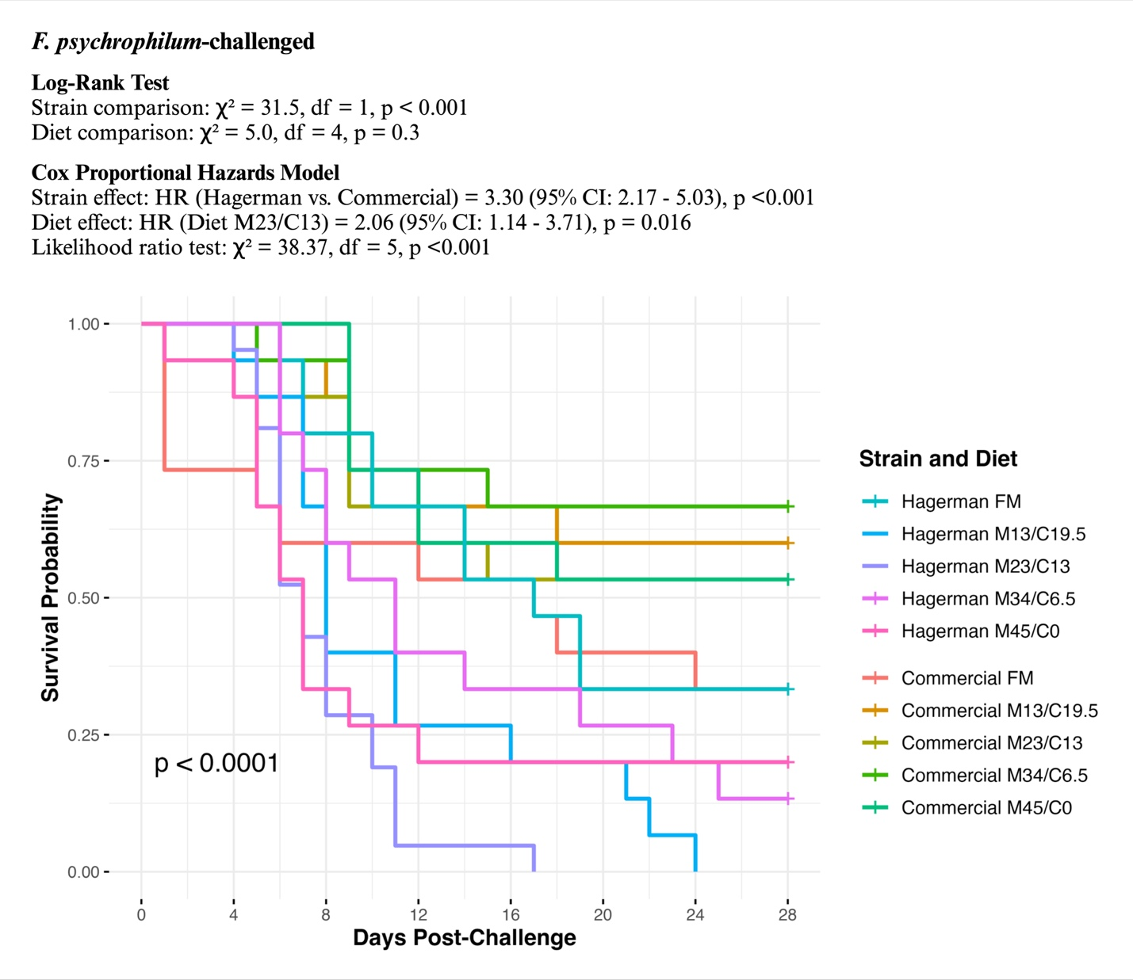
Figure 1: The Kalpan-Meier survival probability of rainbow trout challenged with F. psychrophilum for 28 days
Factors: Strain- Hagerman strain and commercial strain; Diet- FM, Fishmeal based diet; M13/C19.5, 13% SBM + 19.5% SPC; M23/C13, 23% SBM + 13% SPC; M34/C6.5, 34% SBM + 6.5% SPC; M45/C0, 45% SBM + 0% SPC

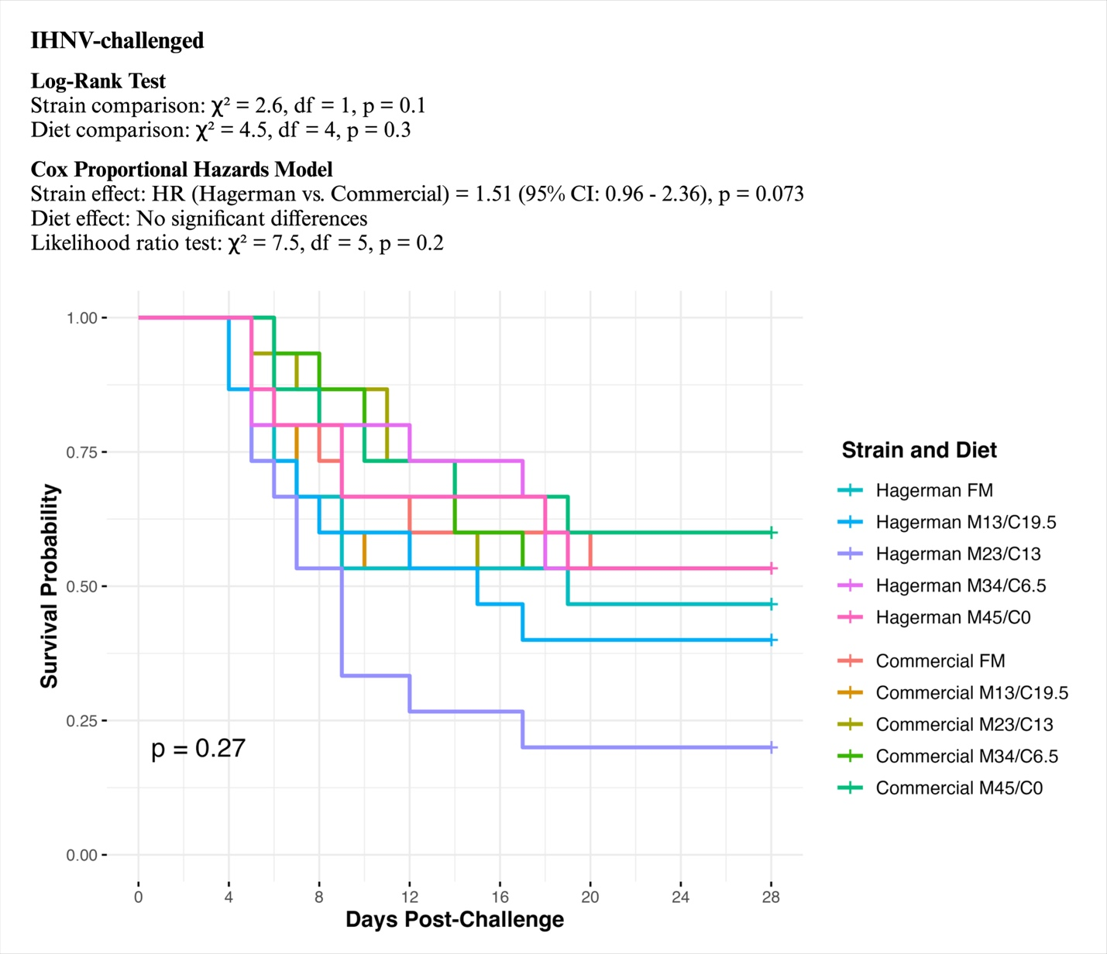
Figure 2: The Kalpan-Meier survival probability of rainbow trout challenged with IHNV for 28 days
Factors: Strain- Hagerman strain and commercial strain; Diet- FM, Fishmeal based diet; M13/C19.5, 13% SBM + 19.5% SPC; M23/C13, 23% SBM + 13% SPC; M34/C6.5, 34% SBM + 6.5% SPC; M45/C0, 45% SBM + 0% SPC

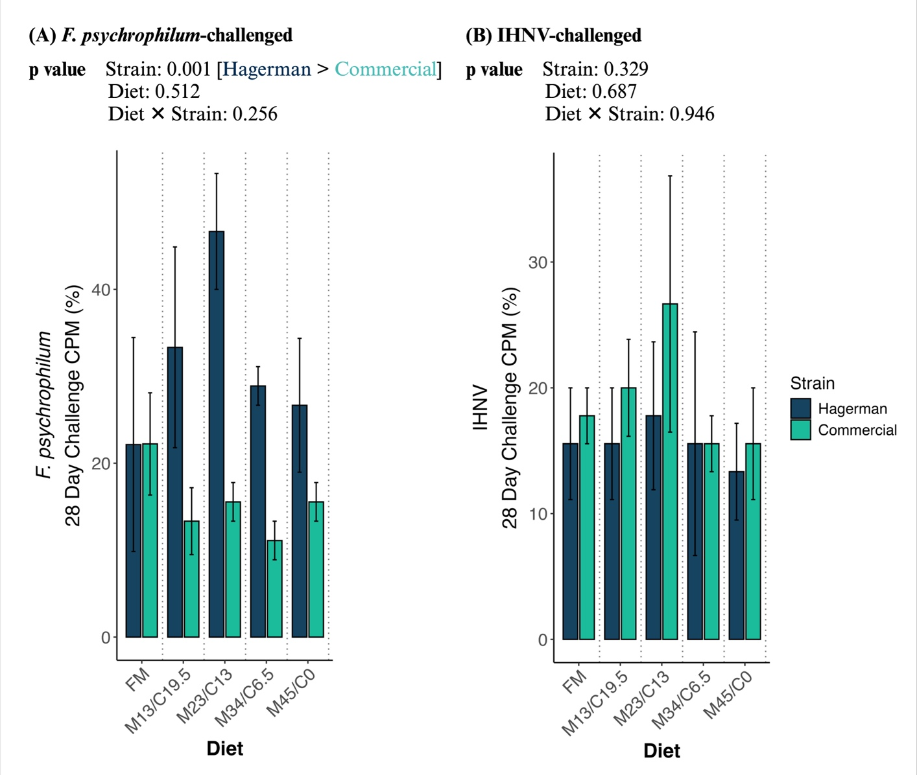
Figure 3: The cumulative percent mortality of rainbow trout challenged with (A) F. psychrophilum and (B) IHNV for 28 days
Factors: Strain- Hagerman strain and commercial strain; Diet- FM, Fishmeal based diet; M13/C19.5, 13% SBM + 19.5% SPC; M23/C13, 23% SBM + 13% SPC; M34/C6.5, 34% SBM + 6.5% SPC; M45/C0, 45% SBM + 0% SPC
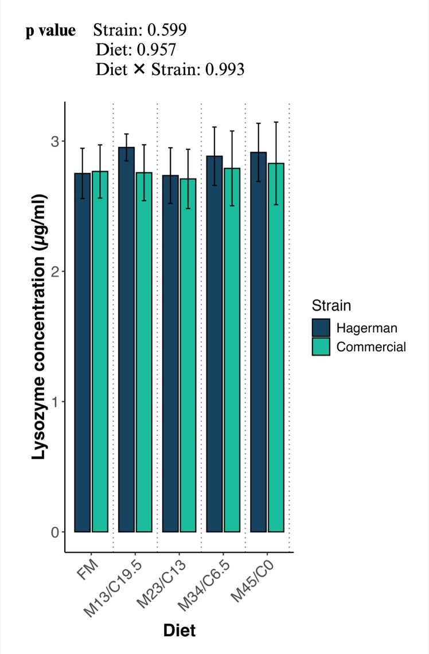
Figure 4: Blood lysozyme assay of rainbow trout before pathogenic challenge
Factors: Strain- Hagerman strain and commercial strain; Diet- FM, Fishmeal based diet; M13/C19.5, 13% SBM + 19.5% SPC; M23/C13, 23% SBM + 13% SPC; M34/C6.5, 34% SBM + 6.5% SPC; M45/C0, 45% SBM + 0% SPC

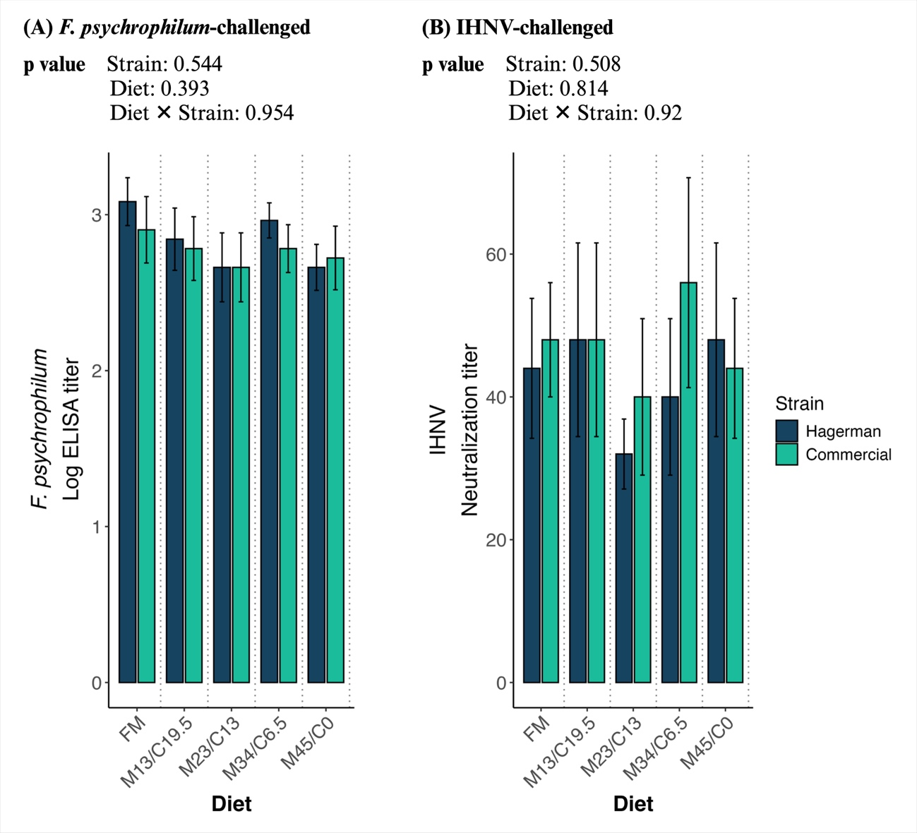
Figure 5: (A) F. psychrophilum specific antibody, and (B) IHNV neutralizing antibody of rainbow trout after pathogenic challenge for 28 days
Factors: Strain- Hagerman strain and commercial strain; Diet- FM, Fishmeal based diet; M13/C19.5, 13% SBM + 19.5% SPC; M23/C13, 23% SBM + 13% SPC; M34/C6.5, 34% SBM + 6.5% SPC; M45/C0, 45% SBM + 0% SPC

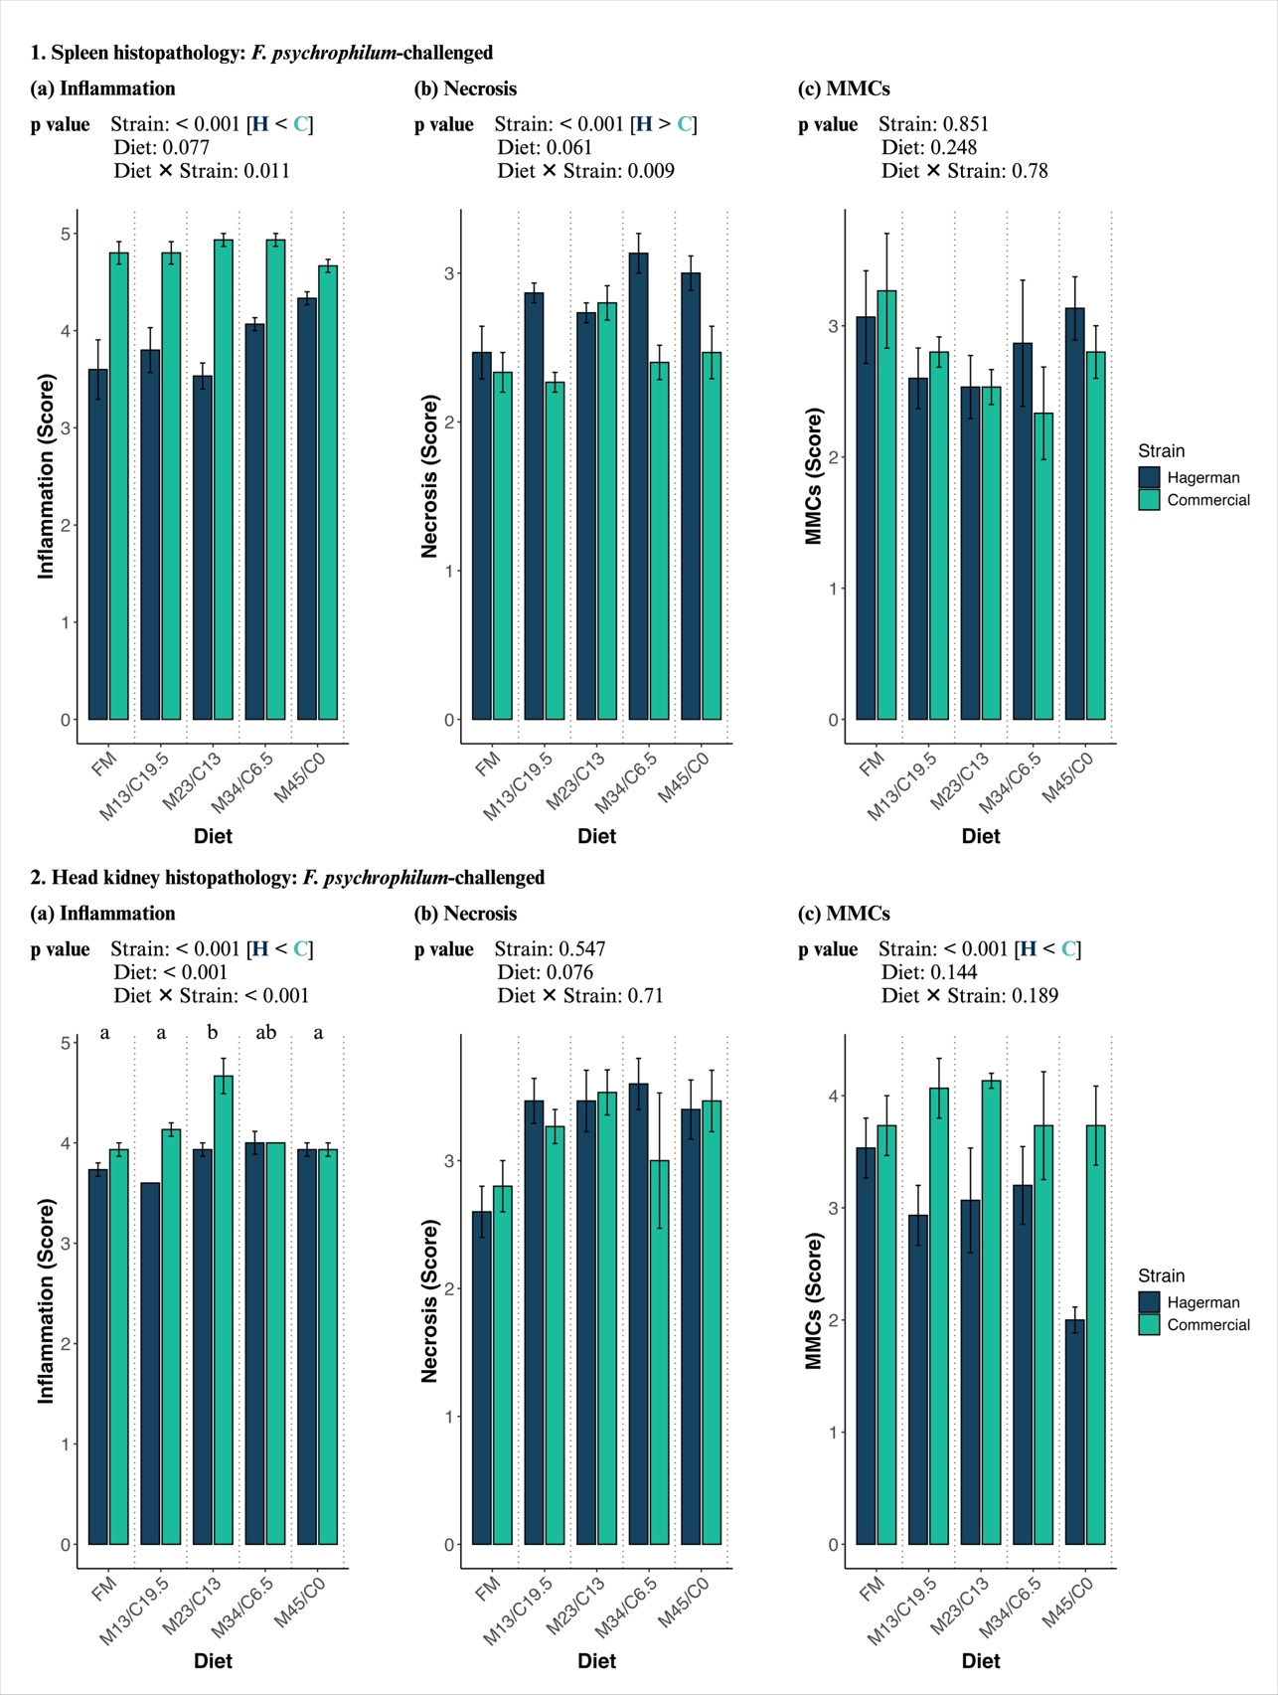
Figure 6: The histopathological qualitative scoring of the spleen (1) and head kidney (2) of rainbow trout challenged with F. psychrophilum for 7 days
Factors: Strain- H, Hagerman strain, and C, commercial strain; Diet- FM, Fishmeal based diet; M13/C19.5, 13% SBM + 19.5% SPC; M23/C13, 23% SBM + 13% SPC; M34/C6.5, 34% SBM + 6.5% SPC; M45/C0, 45% SBM + 0% SPC
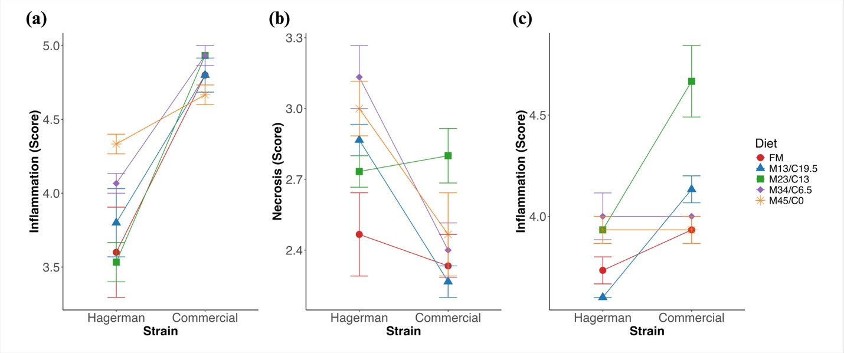
Figure 7: Interaction plot for ‘Strain × Diet’ on the (a) spleen inflammation, (b) spleen necrosis, and (c) head kidney inflammation of rainbow trout challenged with F. psychrophilum for 7 days
Factors: Strain- Hagerman strain, and commercial strain; Diet- FM, Fishmeal based diet; M13/C19.5, 13% SBM + 19.5% SPC; M23/C13, 23% SBM + 13% SPC; M34/C6.5, 34% SBM + 6.5% SPC; M45/C0, 45% SBM + 0% SPC

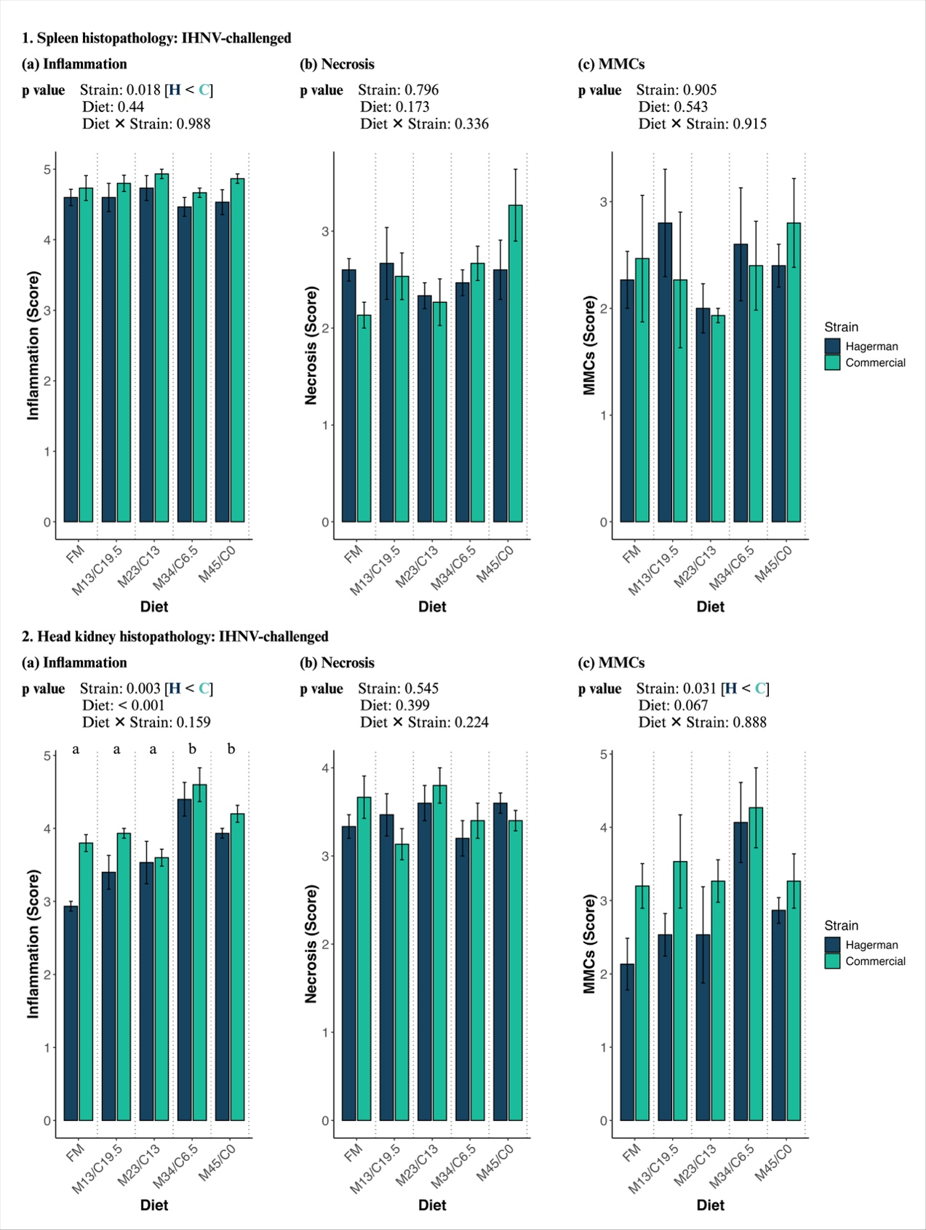
Figure 8: The histopathological qualitative scoring of the spleen (1) and head kidney (2) of rainbow trout challenged with IHNV for 7 days
Factors: Strain- H, Hagerman strain, and C, commercial strain; Diet- FM, Fishmeal based diet; M13/C19.5, 13% SBM + 19.5% SPC; M23/C13, 23% SBM + 13% SPC; M34/C6.5, 34% SBM + 6.5% SPC; M45/C0, 45% SBM + 0% SPC
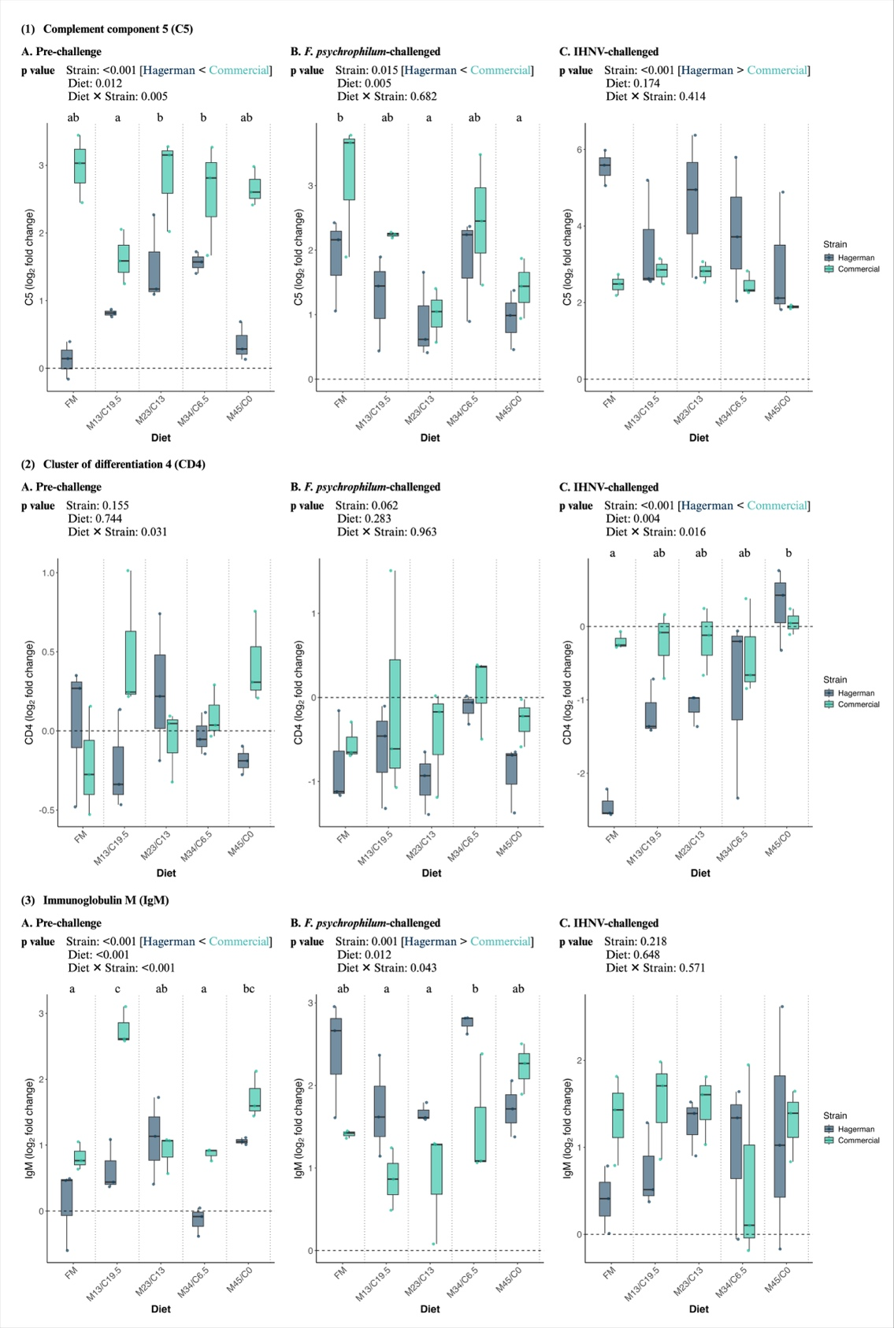
Figure 9: The immune-related gene expression in the spleen of rainbow trout during pre- and post-challenge with F. psychrophilum and IHNV for 7 days
Factors: Strain- Hagerman strain, and commercial strain; Diet- FM, Fishmeal based diet; M13/C19.5, 13% SBM + 19.5% SPC; M23/C13, 23% SBM + 13% SPC; M34/C6.5, 34% SBM + 6.5% SPC; M45/C0, 45% SBM + 0% SPC
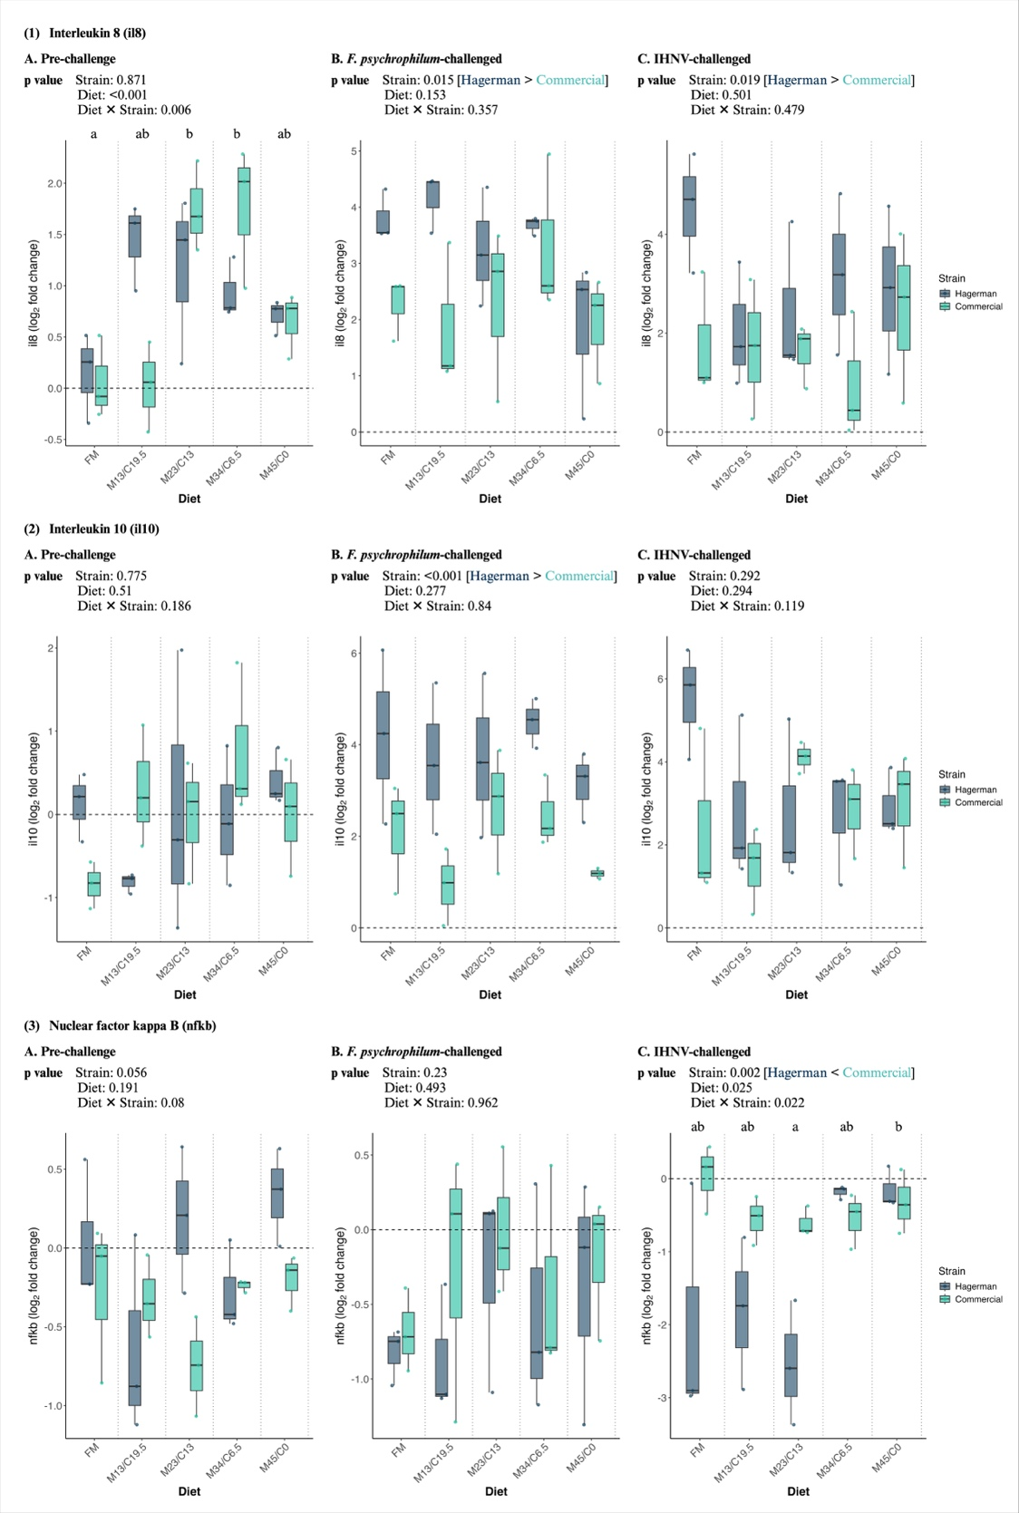
Figure 10: The inflammatory response gene expression in the spleen of rainbow trout during pre- and post-challenge with F. psychrophilum and IHNV for 7 days
Factors: Strain- Hagerman strain, and commercial strain; Diet- FM, Fishmeal based diet; M13/C19.5, 13% SBM + 19.5% SPC; M23/C13, 23% SBM + 13% SPC; M34/C6.5, 34% SBM + 6.5% SPC; M45/C0, 45% SBM + 0% SPC
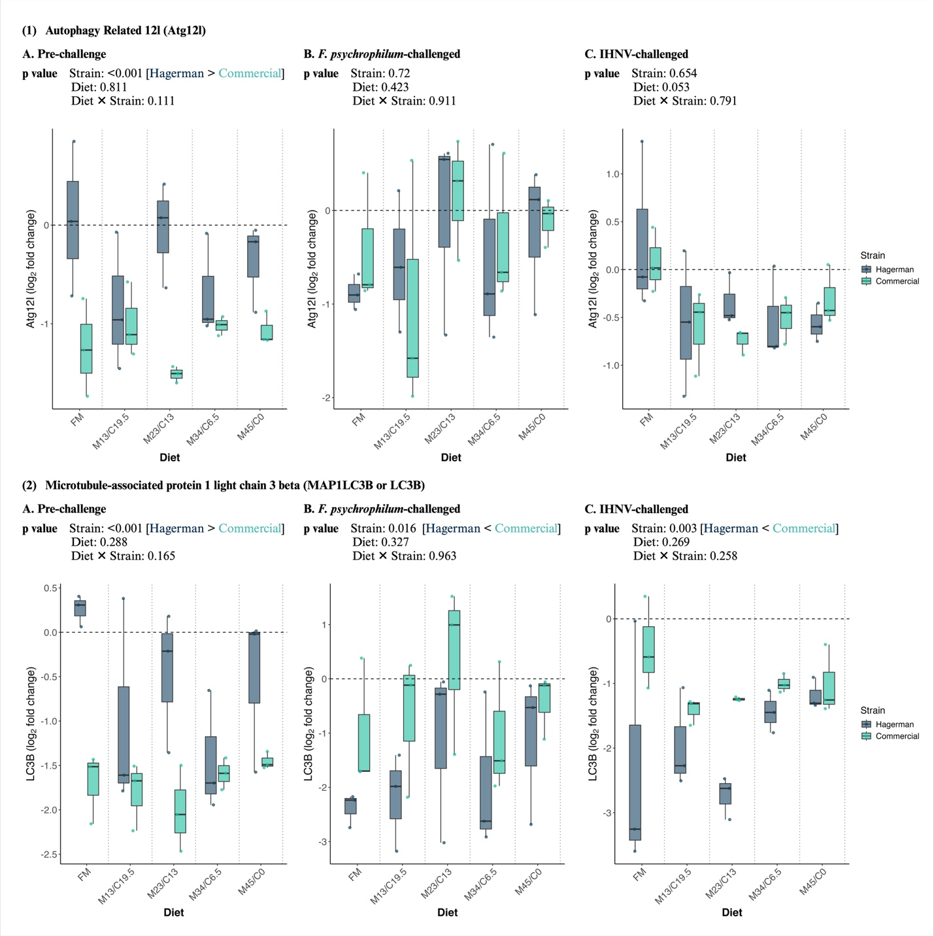
Figure 11: The autophagy-related gene expression in the spleen of rainbow trout during pre- and post-challenge with F. psychrophilum and IHNV for 7 days
Factors: Strain- Hagerman strain, and commercial strain; Diet- FM, Fishmeal based diet; M13/C19.5, 13% SBM + 19.5% SPC; M23/C13, 23% SBM + 13% SPC; M34/C6.5, 34% SBM + 6.5% SPC; M45/C0, 45% SBM + 0% SPC

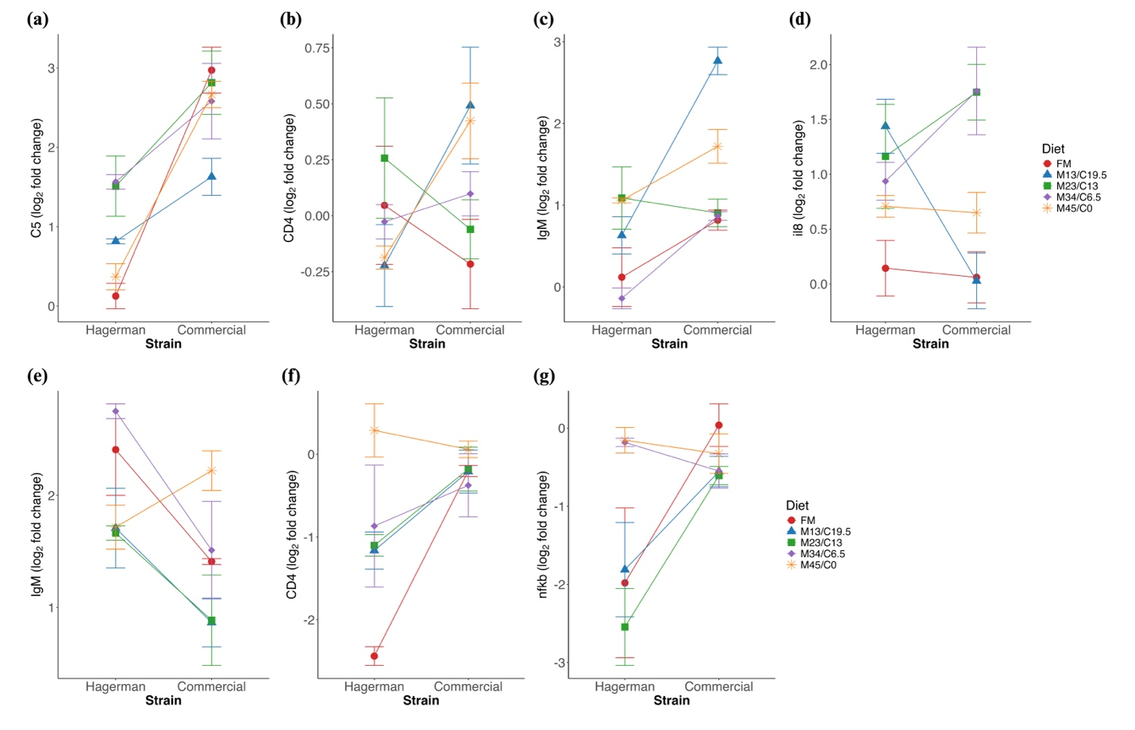
Figure 12: The ‘Strain × Diet’ interaction plot for spleen genes- (a) C5, (b) CD4, (c) IgM and (d) il8 during pre-challenge, (e) IgM on 7-day post-challenge with F. psychrophilum and (f) CD4 and (g) nfkb on 7-day post-challenge with IHNV
Factors: Strain- Hagerman strain, and commercial strain; Diet- FM, Fishmeal based diet; M13/C19.5, 13% SBM + 19.5% SPC; M23/C13, 23% SBM + 13% SPC; M34/C6.5, 34% SBM + 6.5% SPC; M45/C0, 45% SBM + 0% SPC

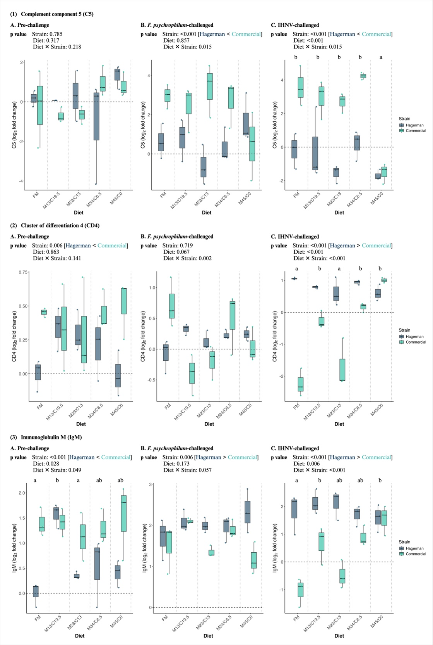
Figure 13: The immune-related gene expression in the head kidney of rainbow trout during pre- and post-challenge with F. psychrophilum and IHNV for 7 days
Factors: Strain- Hagerman strain, and commercial strain; Diet- FM, Fishmeal based diet; M13/C19.5, 13% SBM + 19.5% SPC; M23/C13, 23% SBM + 13% SPC; M34/C6.5, 34% SBM + 6.5% SPC; M45/C0, 45% SBM + 0% SPC
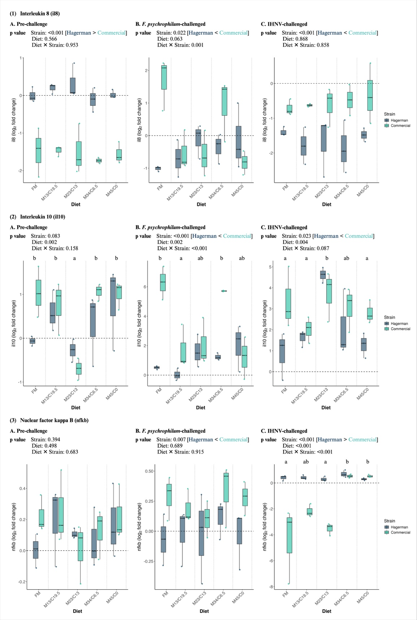
Figure 14: The inflammatory response gene expression in the head kidney of rainbow trout during pre- and post-challenge with F. psychrophilum and IHNV for 7 days
Factors: Strain- Hagerman strain, and commercial strain; Diet- FM, Fishmeal based diet; M13/C19.5, 13% SBM + 19.5% SPC; M23/C13, 23% SBM + 13% SPC; M34/C6.5, 34% SBM + 6.5% SPC; M45/C0, 45% SBM + 0% SPC
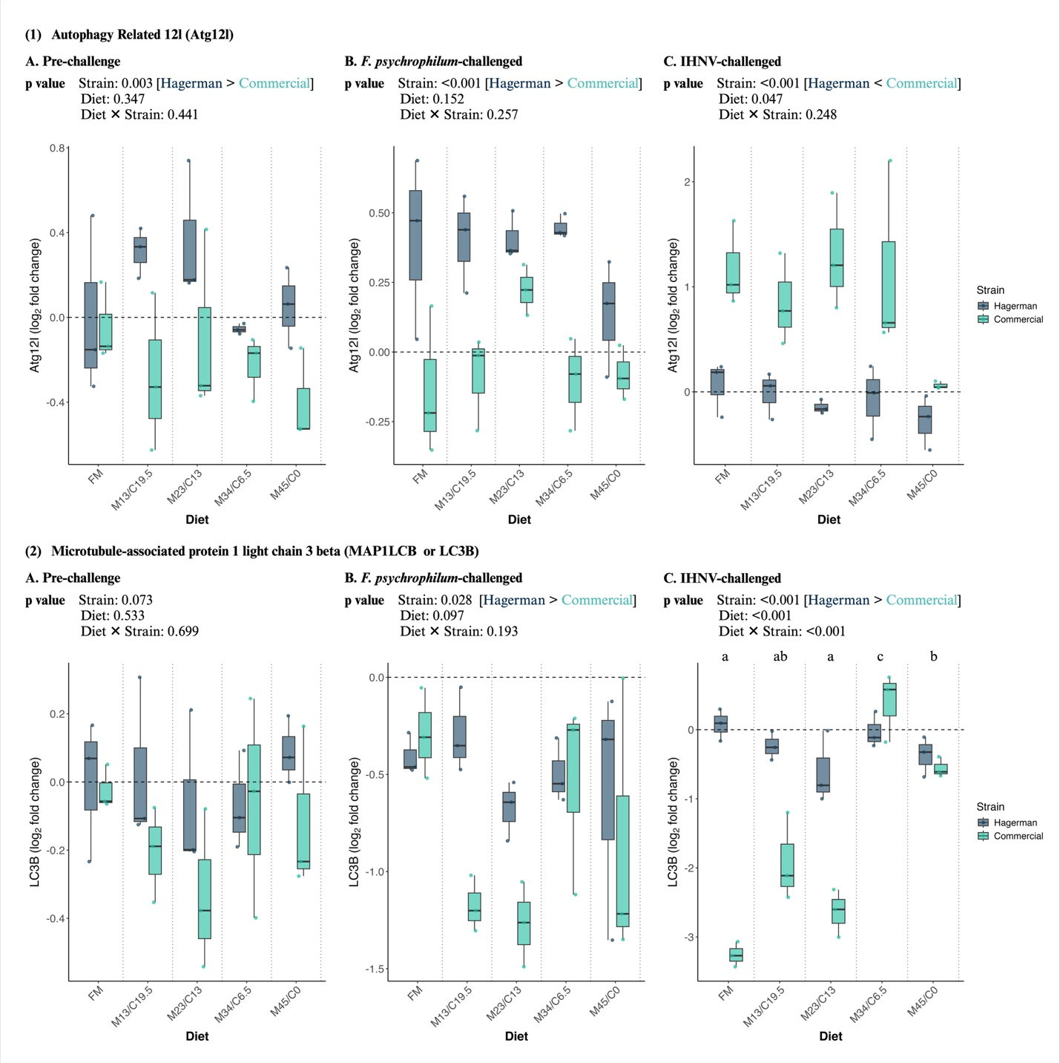
Figure 15: The autophagy-related gene expression in the head kidney of rainbow trout during pre- and post-challenge with F. psychrophilum and IHNV for 7 days
Factors: Strain- Hagerman strain, and commercial strain; Diet- FM, Fishmeal based diet; M13/C19.5, 13% SBM + 19.5% SPC; M23/C13, 23% SBM + 13% SPC; M34/C6.5, 34% SBM + 6.5% SPC; M45/C0, 45% SBM + 0% SPC

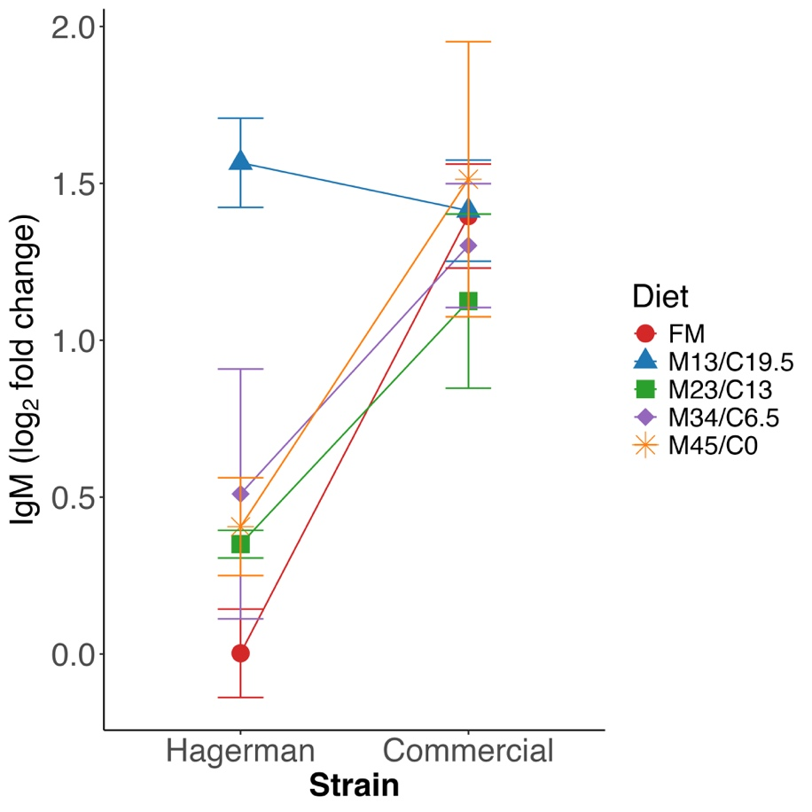
Figure 16: The ‘Strain × Diet’ interaction plot for the head kidney gene, IgM during pre-challenge (Day 0)
Factors: Strain- Hagerman strain, and commercial strain; Diet- FM, Fishmeal based diet; M13/C19.5, 13% SBM + 19.5% SPC; M23/C13, 23% SBM + 13% SPC; M34/C6.5, 34% SBM + 6.5% SPC; M45/C0, 45% SBM + 0% SPC

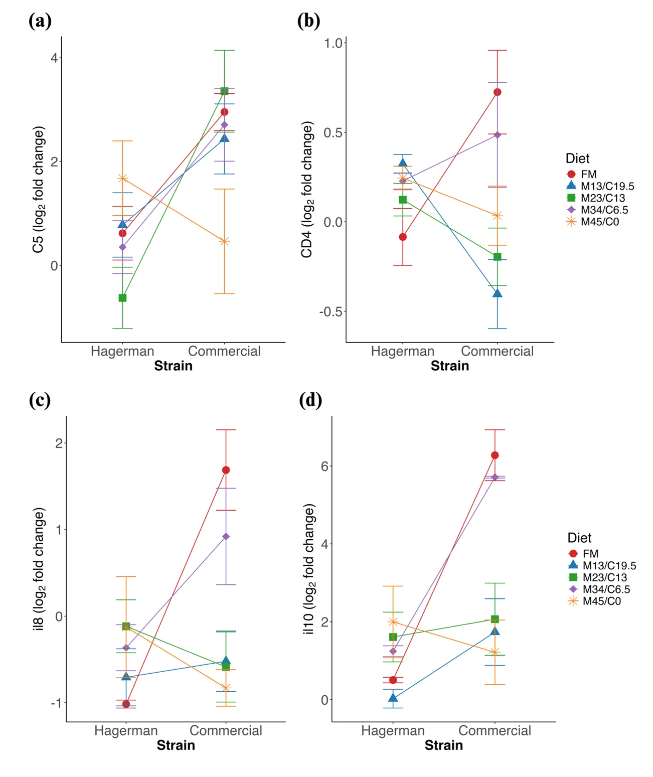
Figure 17: The ‘Strain × Diet’ interaction plot for the head kidney genes- (a) C5, (b) CD4, (c) il8 and (d) il10 on 7-day post-challenge with F. psychrophilum
Factors: Strain- Hagerman strain, and commercial strain; Diet- FM, Fishmeal based diet; M13/C19.5, 13% SBM + 19.5% SPC; M23/C13, 23% SBM + 13% SPC; M34/C6.5, 34% SBM + 6.5% SPC; M45/C0, 45% SBM + 0% SPC

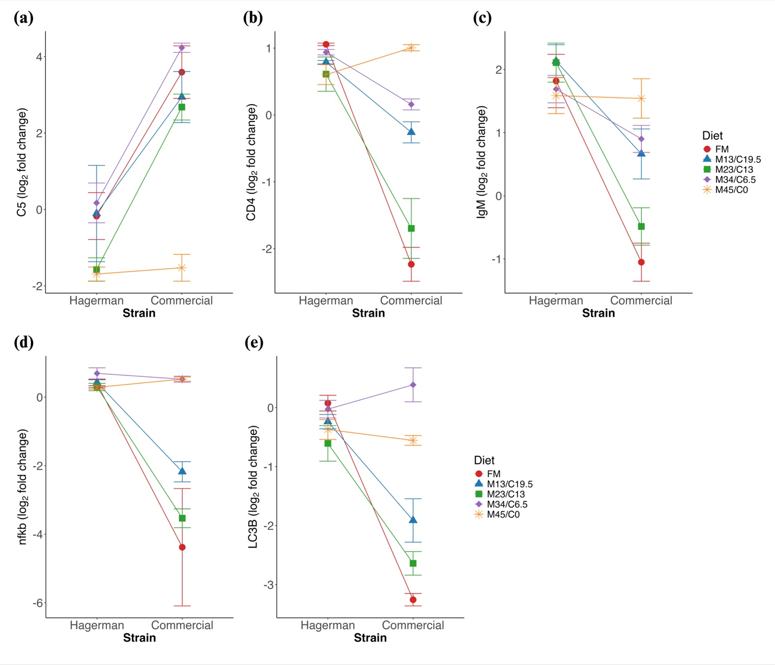
Figure 18: The ‘Strain × Diet’ interaction plot for the head kidney genes- (a) C5, (b) CD4, (c) IgM, (d) nfkb, and (e) LC3A on 7-day post-challenge with IHNV
Factors: Strain- Hagerman strain, and commercial strain; Diet- FM, Fishmeal based diet; M13/C19.5, 13% SBM + 19.5% SPC; M23/C13, 23% SBM + 13% SPC; M34/C6.5, 34% SBM + 6.5% SPC; M45/C0, 45% SBM + 0% SPC

