Soybean extracts as green corrosion inhibiting additives to fluoropolymer coatings

Eugene B. Caldona (Department of Coatings and Polymeric Materials, North Dakota State University)

Research Highlights
- Soybean extract additive enhances both PVDF-HFP's adhesion and corrosion protection.
- Extract was obtained via a low-cost, facile, and eco-friendly method.
- Increasing extract concentration leads to stronger coating adhesion.
- Coating with 0.5 wt% extract displayed the highest corrosion resistance in NaCl solution.
- Adhesion improvement results are supported by finite element analysis.
Project Accomplishments
- NDSU 3-Minute Thesis Competition Champion: Presentation titled “Soy much better: Making non-stick materials stick”.
- Oral presentation at the American Chemical Society Spring 2024 Conference in New Orleans, Louisiana: Titled “Soybean extract as green additive to fluoropolymer coating for enhanced surface adhesion and corrosion protection”
- Final round competitor at the 66th Annual Conference of the Western Association of Graduate Schools (WAGS) 3-Minute Thesis Competition: Presentation titled “Soy much better: Making non-stick materials stick”.
- Poster presentation at the 2024 American Coatings Conference in Indianapolis, Indiana: Presentation titled “Corrosion-resistant soybean extract containing fluoropolymer coatings”.
- Review paper publication: Titled “Toward Enhancing the Surface Adhesion of Fluoropolymer-Based Coating Materials” published in Taylor & Francis’ Polymer Reviews (Impact Factor: 13.1) doi.org/10.1080/15583724.2024.2352360
- Research paper publication: Titled “Interfacially Adhesive Corrosion Protective Fluoropolymer Coatings Modified by Soybean Extract” published in Elsevier’s Chemical Engineering Journal (Impact Factor: 15.1) doi.org/10.1016/j.cej.2024.152616
Research Overview
The use of fluoropolymers, valued by their inherent hydrophobicity and chemical resistance, is hindered by their poor surface adhesion. Despite the research progress, their broad commercial application is constrained by the complexity and costly nature of surface treatments required to modify fluoropolymer-substrate adhesion. Nonetheless, an environmentally friendly and financially promising solution has emerged in the form of plant derivatives, such as soybean extracts (SE). The objective of this study is to integrate SE into poly(vinylidene fluoride-co-hexafluoropropylene) (PVDF-HFP) fluoropolymer coatings and evaluate their adhesion and corrosion protection properties on mild steel. Our findings suggest that integrating SEs increased the affinity between the fluoropolymer coating and metal surface. This enhancement is attributed to the presence of heteroatoms and pi-electrons originating from the isoflavones of the SEs, which foster interactions at the coating-metal interface. Furthermore, the coatings demonstrated an ability to mitigate corrosion in a 3.5 wt% NaCl solution, even with minimal SE dosing. This outcome was corroborated by various investigative techniques, including microscopy, spectroscopy, wettability assessments, surface mechanical evaluations, thermal stability analyses, cyclic corrosion tests, and simulation studies. In summary, this methodical approach highlights the prowess of SE additives in formulating economical, sustainable, and high-efficacy fluoropolymer coatings for various surface protection applications.
Objectives of the Study
The research scope is oriented toward investigating SE's potential role as a corrosion inhibiting additive for PVDF-HFP coatings and their ability to enhance coating adhesion on metallic substrates. The specific aims of this study are to: (1) obtain SE in high concentrations by employing non-toxic solvents through an eco-friendly extraction-distillation procedure, (2) conduct an in-depth electrochemical analysis to understand the influence of varying SE concentrations on the protective properties of the PVDF-HFP coating, and (3) thoroughly assess the impact of SE on the surface adhesion strength of PVDF-HFP coatings when applied to mild steel.
Materials and Methods
The method for obtaining SE is shown in Fig. 1a. Raw soybeans were ground with a laboratory blender and dried to remove excess moisture. Subsequently, the ground soybeans underwent Soxhlet extraction for 8 hours using distilled water. The initial extract was concentrated by heating to evaporate the solvent and then vacuum-dried for 1 day. Carbon steel (CS) substrates were prepared by mechanical grinding with SiC abrasive papers, degreased, and sonicated in acetone. Coating solutions were made by dissolving PVDF-HFP in dimethyl sulfoxide to 25 wt% and adding SE in varying amounts (0, 0.25, 0.50, 1.0 wt%). These solutions were applied to the CS substrates via dip coating. The coated samples (namely, PH, PHSE0.25, PHSE0.5, PHSE1.0) were then oven-dried at 80 °C for 24 hours and the appearance and coating thickness are shown in Fig. 1b.
Spectroscopy was performed using a Fourier Transform Infrared (FTIR) spectrometer in attenuated total reflectance (ATR) mode to identify the chemical structure of the coatings. Matrix-assisted laser desorption/ ionization mass spectrometry (MALDI MS) was utilized to identify the isoflavones present in the SE, while thermal stability was assessed by thermogravimetric analysis (TGA). Sample morphology was examined by scanning electron microscopy (SEM), with elemental composition analyzed by energy-dispersive X-ray (EDX). X-ray photoelectron spectroscopy (XPS) included survey and high-resolution scans to supplement chemical profiling. Static water contact angle (CA) and surface free energy (SFE) were measured with an optical tensiometer, while coating adhesion and hardness were evaluated per ASTM D3359 tape test and ASTM S3363 pencil hardness test methods. Electrochemical measurements were performed on a potentiostat using Ag/AgCl reference, graphite rod counter, and uncoated and coated substrate working electrodes, respectively, at varying immersion times in a 3.5 wt% NaCl test solution. Cyclic corrosion tests were conducted per SAE J2334 on crosscut coated samples in a laboratory humidity test chamber. The cycle is repeated over a period of 7 d, during which qualitative assessment of the coatings was performed. Lastly, the SE swelling within the coating was simulated using a finite element analysis (FEA) 2D model of the composite coatings, while a 2D FE cohesive zone model (CZM) was designed to simulate the peel-off test of the coatings on a CS substrate.
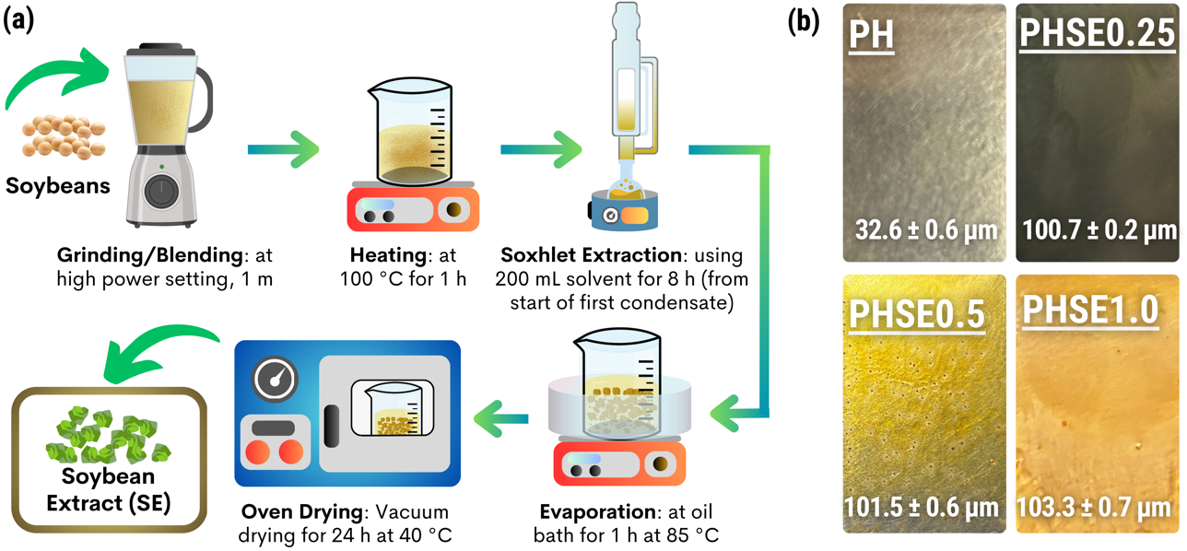
Fig. 1. (a) Experimental scheme for obtaining SE using Soxhlet extraction. (b) Optical image and thickness of the coated samples.
Research Results and Discussion
FTIR spectroscopy confirmed the chemical structure and presence of SE in the fluoropolymer coatings. As shown in Fig. 2a. The spectra of the PHSE coatings revealed combined vibrational bands of PVDF-HFP (circled peaks) and SE (highlighted peaks). The appearance of some of these peaks in the PHSE spectra confirms the presence of SE in the coatings. MALDI MS was performed on the pristine SE to verify the association of these peaks with isoflavones. Mass spectra in Fig. 2b revealed the identities of 6 isoflavones in the SE: genistein, daidzein, glycitein, and their respective glycoside counterparts genistin, daidzin, and glycitin, respectively. This result aligns with the expectation that the use of a polar extracting solvent during the Soxhlet extraction predominantly extracts polar constituents from the soybeans.
The thermal stability of the coating samples was studied by performing TGA. The resulting thermograms and derivative thermogravimetric (DTG) curves under N₂ environment are shown in Fig. 2c and d, respectively, while the extracted TGA parameters are summarized in Table 1. The lower onset temperatures of the PHSE coatings, in comparison to PH, are attributed to the decomposition of small loadings of SE, while the majority is primarily associated with the PVDF-HFP matrix decomposition. The consistent high thermal stabilities of the SE-loaded fluoropolymers still make them well-suited for applications involving elevated temperatures. The water CAs of the coating samples and their corresponding SFE values are summarized in Fig. 2e. These high water CA and low SFE values at the top-side indicate the hydrophobic nature of the PHSE coating surface, essential for minimizing contact with water toward reduced corrosion rates. Interestingly, when the coating films were deliberately peeled off of the substrate to allow CA and SFE measurement on the back side (i.e. coating side facing the substrate) of the coatings, water CA decreased, and SFE increased with increasing SE content. This shift indicates higher SE concentration, particularly of hydrophilic isoflavones, at the bottom layer than at the top surface of the PHSE coatings, suggesting potential altered affinity and interaction at the coating-metal interface. XPS spectra (Fig. 2f) were collected for PH and PHSE1.0 to further investigate the surface chemistry of the bottom layer of the coatings and support the obtained CA results. The difference between the high-resolution O 1s and C 1s scans for PH and PHSE1.0 signals agrees with the findings from FTIR spectroscopy and isoflavone identification via MS, where more SE migrates to the bottom layer.
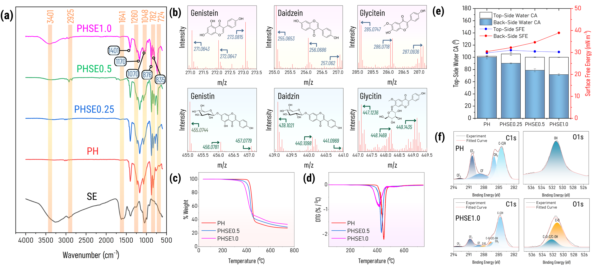
Fig. 2. (a) ATR-FTIR spectra of SE, PH, and PHSE. (b) Mass spectra of isoflavones present in the SE. (c) TGA and (d) DTG curves of selected coating samples under N₂. (e) Top and back side surface properties (CA and SFE) of the coatings. (f) High-resolution O1s and C1s scans of the back side surfaces of PH and PHSE1.0.
Table 1. Thermal parameters extracted from TGA and DTG curves of the coated samples in N₂.
Sample | Onset | Peak | T_{99%} | T_{95%} | Char yield at 750 °C | Offset
Sample | °C | °C | °C | °C | % | °C
PH | 428.70 | 449.35 | 406.84 | 422.78 | 27.47 | 459.98
PHSE0.5 | 417.44 | 432.48 | 352.74 | 395.59 | 29.00 | 446.60
PHSE1.0 | 381.41 | 415.34 | 272.91 | 366.23 | 33.03 | 438.28
Electrochemical impedance spectroscopy (EIS) was performed to investigate charge transfer mechanisms and degradation processes at the coating-metal interface during 3.5 wt.% NaCl solution immersion. The impedance magnitudes and EIS curve shape provided insights into the coatings' protective performance and electrochemical behavior during immersion. The analysis revealed increased resistance from PHSE0.25 to PHSE1.0, with PHSE0.5 showing the highest values and best corrosion protection as evidenced by the (i) larger resistance in the Nyquist plot’s semicircle (Fig. 3a), (ii) high Bode plot’s impedance modulus at low-frequency region, ${\left|Z\right|}_{0.1 Hz}$ (Fig. 3b), (iii) more positive corrosion potential, $E_{CORR}$, (iv) low corrosion current density, $I_{CORR}$, from the extrapolated Tafel curves (Fig. 3c), and (v) the lower diffusion coefficient of PHSE0.5 from the Brasher-Kingsbury equation’s calculated C_{EFF} values plotted against the immersion time (Fig. 3d). This trend is attributed to the distribution and content of SE in the coating. PHSE0.25 showed the lowest protection, likely due to insufficient SE distribution, compromising adhesion. The hydrophilic SE could create areas prone to water infiltration, facilitating corrosion. PHSE0.5 provided the best protection due to well-dispersed SE, with enhanced adhesion. Excessive SE in PHSE1.0 may create hydrophilic channels for water permeation, leading to corrosion. Thus, PHSE1.0 offered better protection than PHSE0.25 but slightly less than PHSE0.5. The balance between adhesion promotion and potential water-induced corrosion is crucial in understanding the performance of different coating formulations.
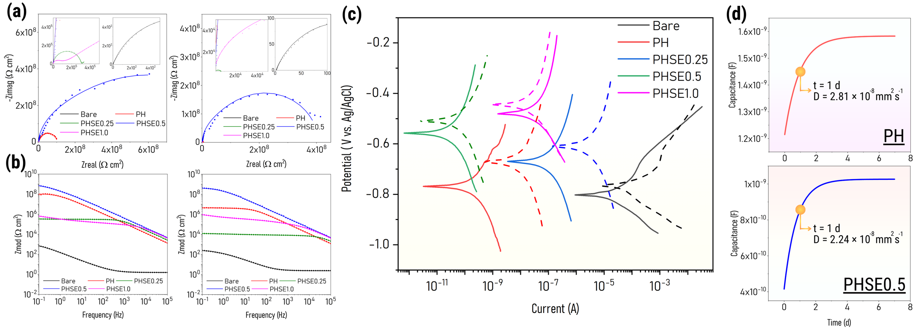
Fig. 3. (a) Nyquist and (b) Bode magnitude diagrams of the uncoated and coated samples after 1- and 7 d of immersion in 3.5 wt% NaCl solution. (c) Tafel curves of the uncoated and coated samples after 1 (solid lines) and 7 d (dashed lines) of immersion in 3.5 wt% aqueous NaCl solution. (d) Effective capacitance (C_{EFF}) of PH and PHSE0.5 obtained at different immersion times.

The ${\left|Z\right|}_{0.1 Hz}$ reduction for PH may further be linked to the water uptake in the void spaces of PVDF-HFP, as revealed in the SEM images (Fig. 4a). The structural morphology of PH shows small clump buildup, likely due to swelling from water absorption, creating pathways for diffusion. The presence of free volumes in the fluoropolymer matrix can lead to pore formation, compromising the protective layer and making it susceptible to oxygen, water, and ions, thus increasing corrosion risk. In contrast, PHSE0.5 exhibited irregularly shaped blobs pre-immersion, due to the presence of SE. Post-immersion, these blobs transformed into a smooth surface, indicating PVDF-HFP matrix swelling and lamellae drainage, forming a protective barrier. This transformation is driven by the hydrophilic SE, promoting water absorption and uniform fluoropolymer swelling, resulting in a robust protective structure. EDX spectra of PHSE coating show increased O peak intensity, supporting the formation of an enhanced protective barrier through the interaction of PVDF-HFP and SE. Results from the cyclic corrosion test (7 cycles of high humidity and corrosive solution per SAE J2334) are shown in Fig. 4b. Significant corrosion was seen at the crosscut of PH, likely due to its uniform film without SE additives. Swelling was also noted after cycle 7, indicating high water uptake. For SE-loaded coatings, corrosion likely began at the coating-metal interface due to SE dispersion issues. PHSE0.25 showed more distinct corrosion gradients in cycle 1, suggesting poor SE dispersion and adhesion. Higher SE loadings in PHSE0.5 and PHSE1.0 resulted in more uniform corrosion and slower progress compared to PH. PHSE0.5 showed reduced corrosion from cycles 3 to 7 due to better SE distribution and SE's inherent corrosion inhibition, enhancing the coating's effectiveness.

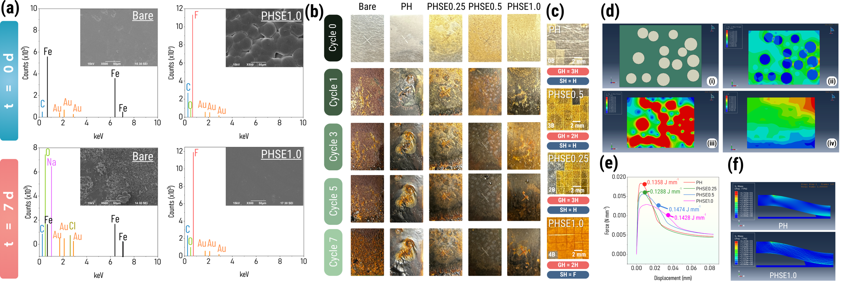
Fig. 4. (a) SEM images and EDX spectra of the bare and coated samples before and after 7 d of immersion in 3.5 wt% aqueous NaCl solution. (b) Optical images of the uncoated and coated samples after performing cyclic corrosion tests. (c) Images of the coated samples after the adhesion test with their respective ASTM D3359 adhesion and ASTM D3363 gouge and scratch hardness ratings. (d) Visual FEA representation of the (i) particle size and distribution, (ii) stress, (iii) strain, and (iv) displacement for the PHSE0.5 swelling. (e) CZM results of the coating systems of simulated force-displacement curves identifying the coatings’ respective interfacial toughness and (f) Visual model of the peeling-off simulation prior to delamination.
The physical properties of the coatings were evaluated for adhesion strength and hardness. The adhesion test, per ASTM D3359, involved applying tape over coating crosscuts and examining the removed areas. Fig. 4c shows post-test images and adhesion ratings. PH had the weakest adhesion at 0B due to PVDF-HFP’s nonstick nature. Adhesion improved with increased SE loading, reaching 4B (<5% removal) for PHSE1.0, attributed to hydrophilic SE at the coating-metal interface. Functional groups in SE (carbonyl, hydroxyl, and aromatic rings) likely promote adhesion through electron transfer and retrodonation with Fe orbitals. Isoflavones' dipoles and H-bonding increase chemical affinity and surface adhesion. PVDF-HFP swelling near the substrate broadens the interface, enhancing interlayer bonding and promoting polymer chain interdiffusion. Coating hardness, per ASTM D3363, was assessed using gouge hardness (GH) and scratch hardness (SH) ratings (Fig. 4c). GH is the hardest pencil that leaves an uncut film, and SH is the pencil that causes no scratch or rupture. PH and PHSE0.25 had identical GH and SH ratings, likely due to low SE loading. Increased SE content slightly decreased hardness for PHSE0.5 and PHSE1.0, attributed to SE providing flexibility and reducing the film’s Young’s modulus, resulting in a softer film. However, the reduction was minor, with PHSE0.5 with an SH rating of H (same as PH).
Evaluation of composite material performance using FEA data provides insights into the behavior of the polymeric matrix and additives under different swelling conditions. Table 3 summarizes the stress, strain, and displacement of the SE additives in the PHSE coatings from the FEA simulations, while the visual representations of the FEA-modeled results for PHSE0.5 as the representative coating sample are depicted in Fig. 4d. An increase in SE concentration correlates with increased stress, strain, and displacement. Higher maximum stress implies enhanced coating resistance to failure (as in the case of PHSE1.0), while increased strain and displacement reflect stronger coating swelling behavior. This increased swelling can facilitate improved adhesion, as in the case of PHSE0.5 and PHSE1.0, by interfacial expansion, strengthening the interlayer bond.
Table 3. FEA simulation results for the PHSE coating systems.
Sample | Maximum Mises stress | Maximum stress | Maximum strain | Displacement in y direction
Sample | MPa | MPa | % | nm
PHSE0.25 | 7.75 | 4.87 | 2.84 | 67.96
PHSE0.5 | 9.88 | 7.71 | 3.61 | 85.13
PHSE1.0 | 11.96 | 10.58 | 4.65 | 105.7
Simulated peeling tests (CZM) assessed SE's impact on PVDF-HFP metal adhesion. Boundary conditions were set on the bonded coating/CS interface, with the bottom plate and one side fixed and a vertical displacement of 0.15 mm simulated peel-off at the top corner. Mechanical durability was measured by interfacial toughness, calculated from the force-distance curve over the detached film area, using pre-simulation properties. The CZM simulated the peeling process, showing elastic loading, damage initiation, and crack propagation. The force-displacement curves (Fig. 4e) showed an initial linear response up to maximum cohesive strength at 1.2 mm displacement (final steps in Fig. 4f). Beyond the peak, the required strength for peeling decreases until full detachment. Higher SE concentrations reduced the cohesive force needed for initial displacement and decreased the curve's slope after peak strength, indicating enhanced adhesion and interfacial toughness. This suggests that a stronger bond requires more force for peeling initiation. Conversely, PH exhibited the lowest toughness, indicating weaker film-substrate bonding and higher delamination risk.
Conclusions and Benefits to the North Dakota Soybean Farmers and the Industry
In conclusion, we systematically investigated the influence of SE additives on the surface adhesion and protective properties of PVDF-HFP coatings on CS. The enhanced coating adhesion with increasing SE loadings can be attributed to the concentration and distribution of the hydrophilic functional-group-containing isoflavones at the coating bottom layer, as evidenced by the XPS, CA, and SFE results, while the governing influence of the hydrophobicity and inertness of PVDF-HFP on the coating top surface remained intact. In addition, the coatings’ thermal stability was maintained, ensuring their suitability for high-temperature applications. Meanwhile, the superior corrosion resistance demonstrated by PHSE0.5 can be associated with the uniform dispersion and content level of SE adequate to reinforce adhesion to the substrate. Beyond this SE threshold concentration, there may be a risk of insufficient surface adhesion or creation of hydrophilic conduits that could facilitate water diffusion within the coating layer. The diminishing corrosion protection of PH coating may have resulted from PVDF-HFP’s inherent porous structure, freely permitting water permeation, while PHSE coatings, in general, swell via lamellae draining, forming a more uniform, robust, and stable film, as corroborated by the obtained SEM images and FEA models. Overall, the inclusion of SEs in PVDF-HFP is a relatively unique and straightforward example of a cost-effective, sustainable, and environment-friendly approach to boosting both the surface adhesion and protection of fluoropolymer coatings.
This research endeavor promises significant advantages to soybean farmers in North Dakota by investigating novel utilization of soybean derivatives in corrosion-resistant coatings. The projected result of this study will broaden the soybean market beyond food production, positioning it as a decisive element in environmentally-friendly industrial commodities. Moreover, the potential knowledge build-up emanating from this investigation could boost both the sustainability and profitability of the soybean industry in North Dakota. This corresponds to the mission of fostering innovation and forging new prospects for soybean farmers, ensuring the vision of the North Dakota Soybean Council of sustained prosperity and involvement in the green building sector.

