Evaluating Late Season Burndown Options for Palmer Amaranth
Ben Beale, Extension Educator, St. Mary’s County
Alan Leslie, Extension Educator, Charles County

A common question asked by farmers dealing with herbicide resistant Palmer amaranth is; What are the most effective burndown options in situations where Palmer amaranth is larger then the ideal 3-4 inch control range?” In addition farmers are often confronted with several weeds species, such as herbicide resistant Palmer amaranth, common ragweed and/or marestail in conjunction with grass or perennial weeds. Often, herbicides effective on one species may not be effective on another- for example, glyphosate may be needed for larger grass control but does little for glyphosate resistant weeds; or glufosinate may control Palmer amaranth but is weaker on larger grasses. Farmers often ask what is the best tank mix for these situations that may allow for a single application, and will tank mixing these products in a single application result in reduced control (antagonism). In the summer of 2022, we undertook a study evaluating eight different treatments for control of larger Palmer amaranth in Southern Maryland. With funding from the Maryland Soybean Board, an expanded study was conducted in the summer of 2023, adding 4 new treatments for a total of 11 treatments. In 2024, trials were conducted looking at best methods to control burndown escapes, often termed rescue treatments

The studies compared the efficacy of burndown options for Palmer amaranth, grass and other weeds with single or tank mix applications of Roundup, Liberty, Enlist and Gramoxone with non-ionic surfactant or crop oil as the adjuvant. It should be noted that other research has shown that separate applications or sequential applications can be effective in controlling larger weeds. The study focused on a single application with a tank-mix of multiple herbicides made at planting. It should be noted that other research has shown that separate applications or sequential applications can be effective in controlling larger weeds.

2023 trial treatments included:
- Glyphosate (Roundup Power Max) 32 fl oz/ac + Amm. Sulfate 48 oz/ac
- Glyphosate (Roundup Power Max) 32 fl oz/ac + Paraquat (Gramoxone SL 2.0) 48 fl oz/ac Amm. Sulfate 48 oz/ac
- Paraquat (Gramoxone SL 2.0) 48 fl oz/ac + Non Ionic Surfactant 6.4 fl oz/ac
- Paraquat (Gramoxone SL 2.0) 48 fl oz/ac + Crop Oil 32 fl oz/ac
- Glufosinate (Liberty 280 SL) 43 fl oz/ac + Amm. Sulfate 48 oz/ac + Crop Oil 32 fl oz/ac
- Glufosinate (Liberty 280 SL) 43 fl oz/ac + Amm. Sulfate 48 oz/ac + Non Ionic Surfactant 6.4 fl oz/ac
- 2,4-D choline (Enlist One) 32 fl oz/ac + Non Ionic Surfactant 6.4 fl oz/ac
- Glufosinate (Liberty 280 SL) 43 fl oz/ac + Glyphosate (Roundup Power Max) 32 fl oz/ac + Amm. Sulfate 48 oz/ac + Non Ionic Surfactant 6.4 fl oz/ac
- Glufosinate (Liberty 280 SL) 43 fl oz/ac + 2,4-D choline (Enlist One) 32 fl oz/ac + Amm. Sulfate 48 oz/ac + Non Ionic Surfactant 6.4 fl oz/ac
- Glyphosate (Roundup Power Max) 32 fl oz/ac + 2,4-D choline (Enlist One) 32 fl oz/ac + Amm. Sulfate 48 oz/ac + Non Ionic Surfactant 6.4 fl oz/ac
- Paraquat (Gramoxone SL 2.0) 48 fl oz/ac + Glufosinate (Liberty 280 SL) 43 fl oz/ac + Amm. Sulfate 48 oz/ac + Non Ionic Surfactant 6.4 fl oz/ac

The trials were conducted at three farm locations during the 2023 growing season. The sites include a double crop wheat to soybean field with ragweed, horse nettle and small grass, a full season soybean field with heavy grass pressure and a full season soybean field with heavy Palmer amaranth pressure. A randomized complete block design with four replications was used at each site. Plot size was 5 ft. by 30 ft., with 5 ft aisles separating plots and running checks on each side of the plots. Treatments were applied using a CO₂ backpack boom sprayer applying 20 gallons per acre of spray solution. Plots were evaluated for percent control of target weeds amaranth and grass weeds at approximately 10, 20, and 30 days after treatment.

Palmer Amaranth Control:
Results in 2023 were very similar to those in the 2022 trial. As depicted in Figure 1, any treatment containing Gramoxone either with crop oil or a non-ionic surfactant provided very good control of Palmer amaranth with over 90% control. The tank mix treatment of Liberty and Enlist One also performed well with 85% control. Roundup by itself provided no control. Liberty applied either with non-ionic surfactant or crop oil, and Liberty with Roundup only achieved around 40-50 % control of Palmer Amaranth. It is notable that all Liberty treatments saw reduction in the level of control as the season progressed. This was evidenced in the field by Palmer amaranth plants suckering out from the base and re-growing approximately 2 weeks after the application. We did not observe suckering with the Gramoxone treatments or Liberty + Enlist treatments. We should also note that new Palmer amaranth seedlings began to emerge just 20 days after the burn down treatments. Palmer amaranth continues to germinate throughout the summer, especially in open areas where sunlight reaches the soil. Controlling this weed takes a season long approach.
Figure 4

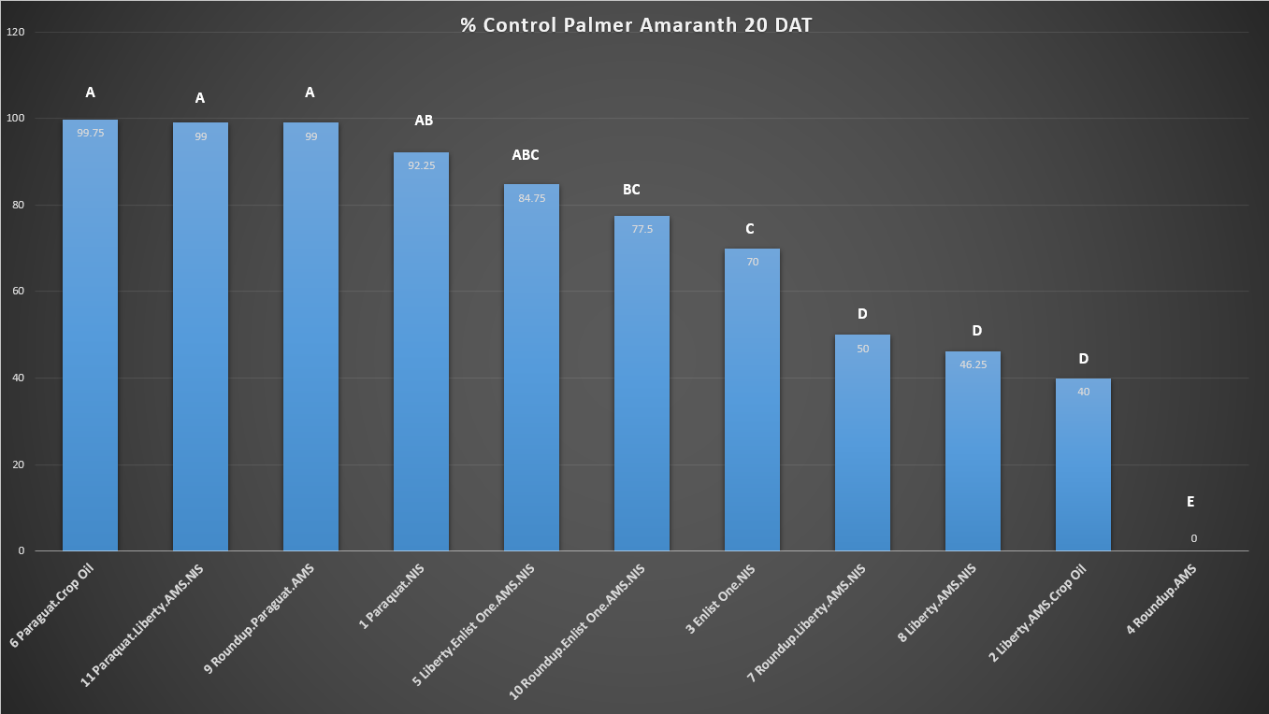
Figure 2:

Grass Control:
Grass control results in 2023 were very similar to those in the 2022 trial. Of note, the study site had large 8-10 inch fall panicum present at time of application which can be challenging to control with best treatments. While Roundup didn’t have any efficacy on resistant Palmer amaranth, the enduring benefit of this product can clearly be seen in control of other tough weeds, such as grasses with 100% control in our study. We saw a slight reduction in control of the grasses present when Roundup was tank mixed with Liberty. The Gramoxone + NIS and Gramoxone + Crop Oil treatments had lower grass control at 69% and 84% respectively and both treatments were significantly lower than Roundup treatments. Tank mixing Roundup with Gramoxone reduced grass control from 100% with Roundup alone to 76% when tank mixed with Gramoxone. The Liberty treatment performed better than expected in this study with grass control around 90%. Enlist only has activity on broadleaf and was omitted in the analysis for grass control.

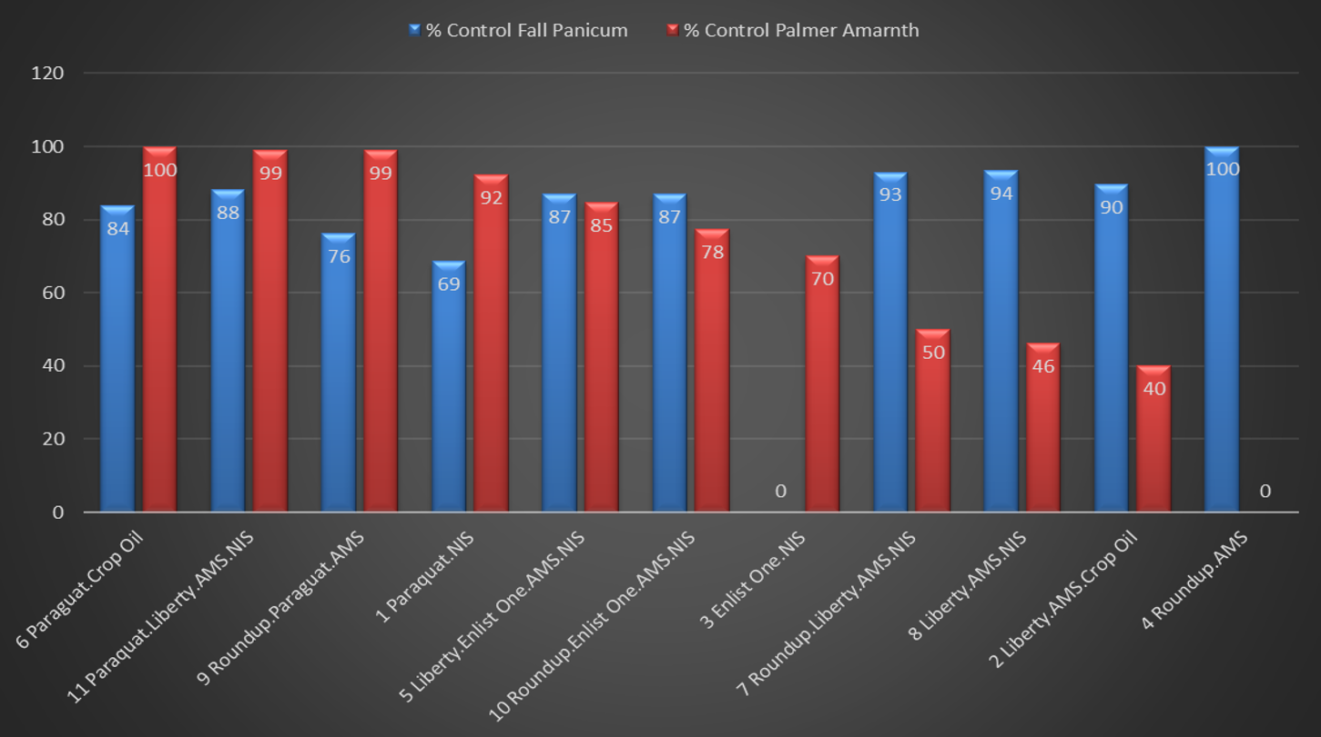
Figure 2:

2024 Trials

Following two years of burndown treatment trials, we next studied 12 rescue treatments for management of palmer amaranth. Rescue treatments typically occur when weed a management plan fails, resulting in weeds that are larger than the preferred application window. Failure can be attributed to weather related conditions that prevent timely sprays such as flooded fields or windy conditions; Initial pre-emergent application failures do to limited activating rainfall, or poor management. Rescue applications are not preferred as they increase the risk of resistance and are often not completely effective. However, situations do arise where a rescue treatment is the only option to achieve control. Farmers often ask the best strategy for control of palmer amaranth in these situations. Farmers should be aware of label restrictions for postemergence applications. For example, Enlist may be applied through R1, Reflex applied up to bloom and at least 45 days form harvest and Liberty up to R1. Growers should always refer to the product label for specific guidance. The treatment protocol included a single application of 12 treatments. The plots were split and a second application of a sequential treatment was applied 15 days later. Plots were rated for percent control and analyzed using the R statistical program.

The first treatment was applied on July 15, 2024 under very sunny and hot (92F) conditions using a CO2 plot sprayer applying 35 gallons per acre. Palmer amaranth was large with an average height of 15 inches. Soybeans were still in the vegetative growth stage. The second treatment was applied on August 1, 2024 under very sunny and hot (93F) conditions using a CO2 plot sprayer applying 35 gallons per acre. Palmer amaranth plants not controlled in the initial application were flowering with some over 36 inches in height. Many plants in these split plots were partially controlled with new growth suckering out. The treatments consisted of:

First Treatment | Second Treatment
1. Roundup | none
2. Liberty + AMS | Liberty + AMS
3. Roundup + Liberty + AMS | Liberty + Enlist One + AMS
4. Enlist One | Enlist One
5. Roundup + Enlist One | Liberty + AMS
6. Roundup + Liberty + Enlist One + AMS | Liberty + AMS
7. Liberty + Enlist One + AMS | Liberty + Enlist One + AMS
8. Enlist One + Reflex + NIS | Liberty + AMS
9. Roundup + Liberty + Enlist One + Reflex + AMS + NIS | Enlist One
10. Liberty + Enlist One + Reflex + AMS + NIS | Liberty + Enlist One + AMS
11. Roundup + Liberty + Enlist One + Dual+ AMS | Liberty + AMS
12. Liberty + Enlist One + Dual+ AMS | Enlist One
Product Rates
Product | Rate in Ounces Per Acre
Glyphosate (Roundup Power Max) | 32
Glufosinate (Liberty) | 43
Reflex | 24
2,4-D (Enlist One) | 32
Dual Magnum | 21
NIS by Winfield (32 per 100 gal) | 6.4
AMS Liguid at 2 qts per 100 gallons | 48

Results and Discussion:

As expected, the glyphosate treatment had no effect on glyphosate resistant Palmer amaranth and was separated from the analysis. All treatments provided significantly higher control than glyphosate applied by itself. As indicated in the below chart, the best single application only achieved 80% percent control. Control tended to decrease over time as Palmer amaranth weeds recovered from the initial application. Plants would often sucker from the bottom of the plant and regrow. The bottom line is no treatment provided an acceptable level of control of large palmer amaranth with a single application. However, applying a sequential treatment 15 days after the initial treatment provided much better control of large Palmer amaranth. As seen in figure 2, control increased significantly with a sequential application, regardless of whether that treatment was based on Enlist, Liberty or a combination of the two. This study shows that farmers who wish to control larger palmer amaranth in a rescue treatment situation should plan on using at least two sequential herbicide applications.

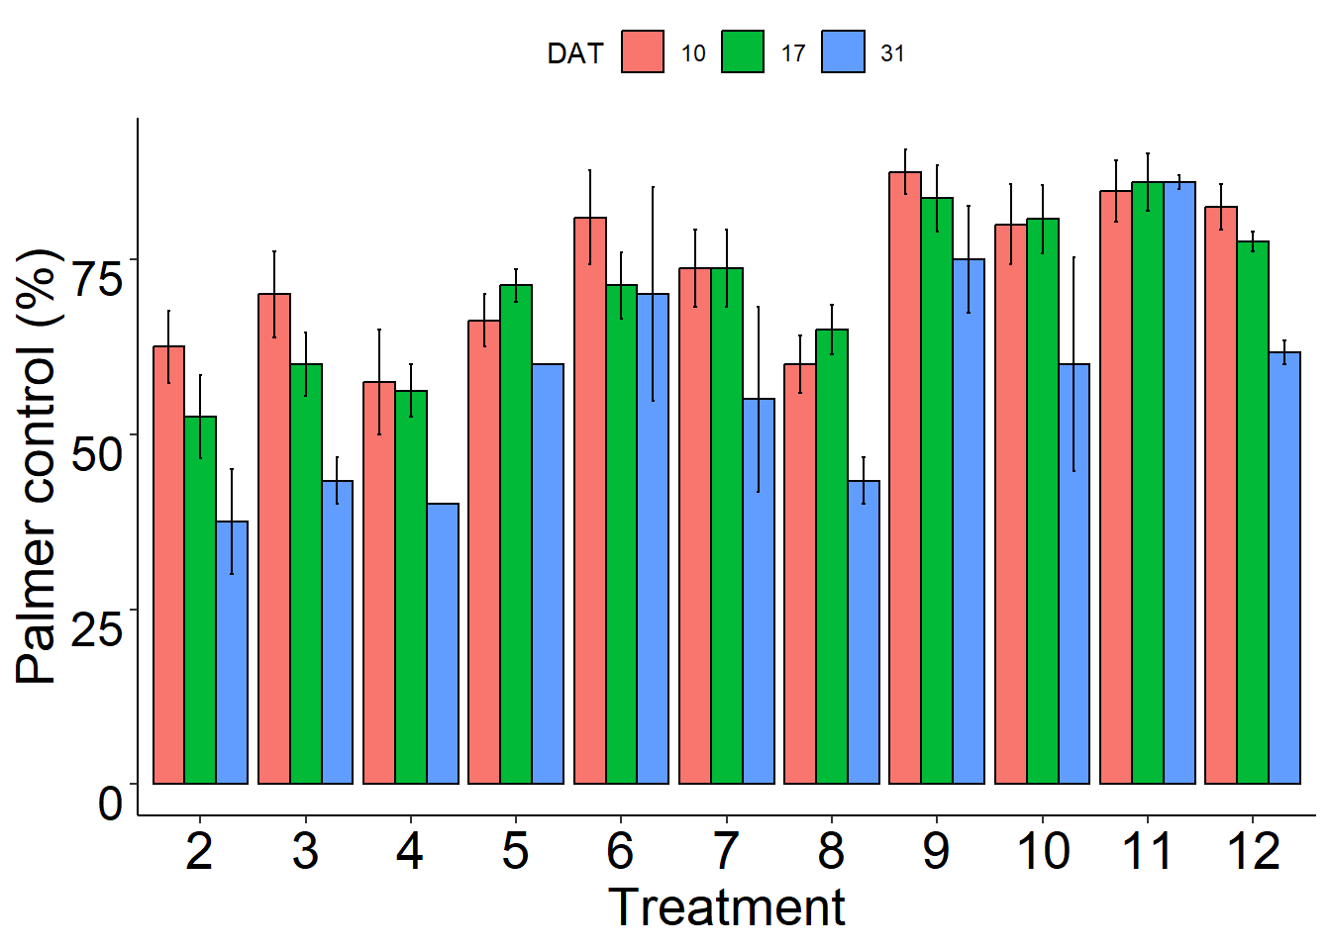
Figure 1. Palmer amaranth control following s single herbicide application

Figure 2. Palmer amaranth control following a single application (1) and a sequential application (2)

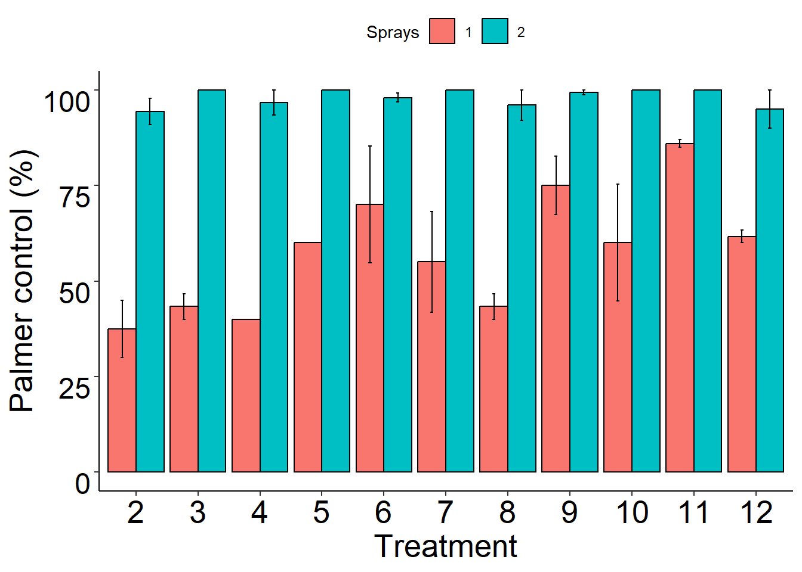




This work is supported by the Crop Protection and Pest Management program [grant no. 2021-70006-35473/project accession no. 1027142], from the U.S. Department of Agriculture’s National Institute of Food and Agriculture. Any opinions, findings, conclusions, or recommendations expressed in this publication are those of the author(s) and should not be construed to represent any official USDA or U.S. Government determination or policy.

