Project Number: | 60065
Project Title: | An integrated approach towards the detection, diagnosis, and response to emerging herbicide-resistant weeds in soybean.
Organization: | Michigan State University
Project Lead Name: | Eric Patterson
Reporting Period:  Please select the appropriate reporting period for this report. | ☐ December ☐ March ☐ June ☐ September ☒ Final

The information included in this detailed report should reflect quantifiable results that can be used to evaluate and measure project success.

If Progress Report – What key activities were undertaken and what were the key accomplishments during this reporting period? List each key deliverable from the proposal and describe progress made (or not made) toward achieving it, including metrics were appropriate.

If Final Report – What were the key accomplishments during the life of the project? List each deliverable from the proposal and describe progress made (or not made) toward achieving it, including metrics where appropriate.
1. Introduction
Over the course of Year 1, the Herbicide Resistance Monitoring Network (HERMON) has made substantial progress across all participating institutions, defined above all by the emergence of a cohesive and collaborative scientific community. Across 11 universities and research labs, the network has simultaneously advanced our understanding of herbicide resistance mechanisms, developed and validated new diagnostic tools, expanded germplasm resources, and engaged thousands of stakeholders through extension and outreach activities. Research efforts have focused on weed species of major agronomic concern in the US, such as Palmer amaranth, waterhemp, Italian ryegrass, giant and common ragweed, among others, addressing resistance to a broad spectrum of herbicide chemistries including PPO inhibitors, ALS inhibitors, glyphosate, glufosinate, 2,4-D, and HPPD inhibitors. The collaborations documented here, both within the network and with external partners in industry and academia, reflect a project that is already functioning as more than the sum of its parts (Figure 1).
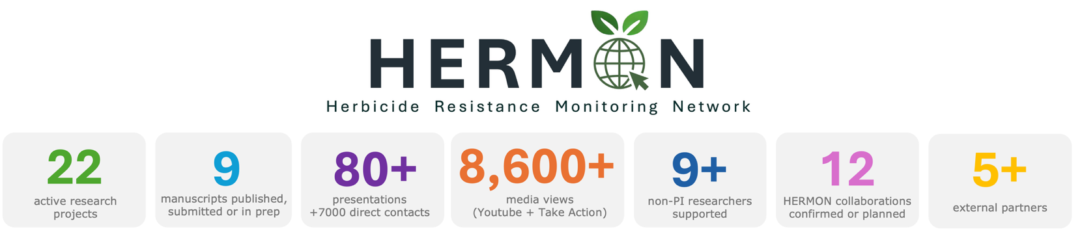
Figure 1. Summary of Year 1 achievements of HERMON project across all universities.

2. Network meetings and coordination

Maintaining regular communication across eleven geographically distributed institutions has been a central priority for HERMON in Year 1. The network established quarterly all-hands meetings for sharing research updates, coordinating germplasm exchanges, and aligning priorities, complemented by two in-person gatherings at the 2025 NCWSS Annual Meeting in Grand Rapids (MI) and the 2026 WSSA Annual Meeting in Raleigh (NC). At WSSA 2026, Dr. Eric Patterson also delivered a dedicated oral presentation introducing the HERMON project to the broader national and international weed science community.

3. Research progress across institutions
In Year 1, HERMON-supported research activities encompassed more than 22 active projects distributed across all participating institutions. The following sections provide a summary of the key research activities and findings at each institution.

Michigan State University – Eric Patterson Lab
- Non-target-site 2,4-D resistance in waterhemp and Palmer amaranth. In collaboration with the Tranel Lab (UIUC), the Patterson Lab has assembled +10 resistant waterhemp and 4 resistant Palmer amaranth populations from across the US to preform transcriptomic and metabolomic analyses to identify resistance responsible genes.
- PPO-inhibitor resistance in common ragweed. Greenhouse screening of Michigan common ragweed populations confirmed resistance to PPO-inhibiting herbicides in multiple accessions, with molecular characterization of both known and novel target-site mutations in the PPO2 gene. The functional significance of these mutations is being evaluated in collaboration with Dr. Aimone Porri at BASF, Germany.
- Germplasm development and database curation. The Patterson Lab maintained and expanded HERMON germplasm resources during Year 1, growing resistant and susceptible waterhemp, horseweed, and common ragweed populations for seed increase. Integration of these resources into the HERMON mapping platform is ongoing in coordination with the Ganske Lab at KSU.

University of Illinois – Pat Tranel Lab
- Glyphosate resistance mechanisms in waterhemp. The Tranel Lab has confirmed glyphosate resistance in multiple waterhemp populations suggesting non-target-site resistance mechanism. Ongoing work is examining uptake, metabolism, and translocation in these populations.
- Transcriptomic atlas of P450s and GSTs. The lab is developing a comprehensive transcriptomic atlas of cytochrome P450s (P450s) and glutathione S-transferases (GSTs) in waterhemp and Palmer amaranth, that is expected to be a widely used reference resource for the weed science community.
- PPO inhibitor resistance in giant ragweed. In collaboration with Dr. Karla Gage at Southern Illinois University, the Tranel Lab confirmed PPO inhibitor resistance in giant ragweed populations in Illinois, with both target-site and non-target site mechanisms.
- Group 15 resistance screening in waterhemp. In collaboration with the Werle Lab at the University of Wisconsin, the Tranel Lab screened several hundred waterhemp populations for resistance to group 15 herbicides. Results revealed a widespread distribution of resistance frequencies, with nearly every population containing some resistant individuals. Screening of archived 2010 populations confirmed the reliability of the methodology.

Purdue University – Bryan Young Lab
- Agar-based leaf disc bioassay for rapid resistance confirmation. The Young Lab is developing a rapid physiological assay for herbicide resistance confirmation that does not rely on molecular markers or greenhouse bioassays, transitioning from a liquid-buffer fluorescence approach to an agar-based system. Leaf discs placed on herbicide-infused agar produced clear visual results within 48 hours, successfully distinguishing susceptible from PPO-resistant waterhemp, with ongoing work to refine the protocol and extend it to additional herbicide classes.

Penn State University – Caio Brunharo Lab
- Field-deployable CRISPR-based molecular diagnostic for ALS resistance. The Brunharo Lab is developing a field-deployable diagnostic platform combining Recombinase Polymerase Amplification (RPA), CRISPR/Cas12a detection, and lateral flow readouts for rapid, on-site identification of herbicide resistance mutations without laboratory infrastructure. During Year 1, the team successfully designed and validated an assay targeting the Trp574Leu mutation in the ALS gene of Palmer amaranth, optimizing all key parameters including primers, amplification conditions, Cas12a concentrations, and a simplified crude DNA extraction protocol.
University of Wisconsin – Rodrigo Werle Lab
- Agar Petri dish assay validation. The Werle lab developed and validated an agar-based Petri dish assay for S-metolachlor, fomesafen, and mesotrione in Wisconsin waterhemp populations. Across a dataset of over 6,000–7,000 Petri dishes and greenhouse bioassays have produced very strong correlations for all three herbicides. The methodology is considered validated and ready for blind testing with partner populations across HERMON.
- Group 15 resistance in Wisconsin waterhemp. In collaboration with the Tranel Lab, 3 waterhemp accessions in Wisconsin have been confirmed as resistant to group 15 herbicides (the first confirmed cases of this resistance type in the state). One PPO-resistant waterhemp population does not carry any known PPO target-site mutation, making the resistance mechanism in this accession unknown and a priority for further investigation.

Mississippi State University – Luis de Avila Lab
- Multi-species resistance screening across Mississippi. The de Avila Lab conducted large-scale resistance screening during the 2025 season, collecting and processing 92 Palmer amaranth, 50 Italian ryegrass, 21 Johnsongrass, and 17 goosegrass populations from soybean and cotton fields across Mississippi. For the 2026 season, 330 additional Italian ryegrass samples have already been collected.
- Italian ryegrass. All 50 populations were fully susceptible to S-metolachlor. Suspected resistance to paraquat was identified in 10 populations, to quizalofop in 22), and to clethodim in 11.
- Palmer amaranth. Pre-emergence screening identified suspected resistance in 17 populations to S-metolachlor, 11 to atrazine, and 5 to isoxaflutole. Post-emergence screening identified 13 populations with suspected dicamba resistance and 9 with suspected glufosinate resistance.
- Johnsongrass and goosegrass. Of the 21 Johnsongrass populations screened for glyphosate, 13 showed control failures. Additional testing for glufosinate, quizalofop, and isoxaflutole is ongoing. For goosegrass, all 17 populations were susceptible to paraquat; evaluations for glyphosate, glufosinate, and clethodim are ongoing.

Kansas State University – Ganske Lab
- HERMON resistance mapping. The Ganske Lab completed the HERMON common ragweed resistance map in February 2026, and efforts are currently underway to extend the mapping platform to the remaining weed species available in the HERMON germplasm database.
- Resistance screening in Kansas waterhemp. Greenhouse screening is underway for 2,4-D, dicamba, and glufosinate resistance in Kansas waterhemp populations. Plans to expand to residual herbicides (mesotrione, flumioxazin, and S-metolachlor) are in place for Year 2.
- Six-way resistant waterhemp characterization. In collaboration with the Jugulam Lab, the Ganske Lab identified and initiated characterization of a unique waterhemp population with resistance to six herbicide modes of action: glufosinate, glyphosate, HPPD inhibitors, PPO inhibitors, atrazine, and ALS inhibitors. PPO resistance has been confirmed as target-site. The glufosinate resistance mechanism is under investigation with radiolabeled studies supported by BASF.

Kansas State University – Jugulam Lab
- Multi-resistance characterization in Texas Palmer amaranth. The Jugulam Lab has characterized five Palmer amaranth populations from Texas for resistance mechanisms. Two populations show resistance to HPPD inhibitors, PSII inhibitors (atrazine), and glyphosate. Reduced sensitivity to mesotrione is also suspected, with ongoing ¹⁴C-mesotrione metabolism studies to confirm a metabolic basis.
- Non-target-site glyphosate resistance in Texas waterhemp. One waterhemp population from Texas showed glyphosate resistance without copy number variation, suggesting a translocation-based or other non-target-site mechanism. This population is also resistant to atrazine and ALS inhibitors.

Michigan State University – Christy Sprague Lab
- Waterhemp screening in the Michigan sugar beet region. The Sprague Lab has collected and initiated screening of more than 50 waterhemp samples from the sugar beet growing region in Michigan. Initial results suggest potential resistance to 2,4-D and possible glufosinate resistance in at least some populations. PPO resistance and additional modes of action are also being evaluated.

University of Arkansas – Jason Norsworthy Lab
- Palmer amaranth germplasm infrastructure and HPPD screening. Year 1 at the Norsworthy Lab was dedicated primarily to completing the organization of Palmer amaranth accessions, developing an inventory system for tracking populations, and cleaning and optimizing cold storage facilities. Additionally, screening of 115 Palmer amaranth accessions (including 52 newly collected 2025 accessions) for resistance to six HPPD-inhibiting herbicides has been completed.
University of Arkansas – Tommy Butts Lab
- The Butts Lab’s primary contribution to HERMON in Year 1 has been through extensive extension activities reaching growers and agronomists across Arkansas and beyond. More than 35 presentations were delivered over the past year, reaching over 3,500 direct contacts on herbicide resistance topics. Several newsletter articles on herbicide resistance were also published. The lab contributed to the HERMON video series, with a video on targeted sprays recently released and a video on drone applications expected imminently.

University of Missouri – Kevin Bradley Lab
- The Bradley Lab has contributed to the HERMON network primarily through seed provision to partner labs upon request, supporting resistance characterization work across the network.

4. Collaborations
A total of 5 active and planned within-network collaborations have been established, covering resistance characterization, germplasm sharing, diagnostic assay development, and resistance mapping (Figure 2, green arrows). The Tranel and Werle labs have also extended open invitations to HERMON partners to contribute populations for transcriptomic analysis and Petri dish assay validation, respectively (Figure 2, blue and orange arrows, respectively). External collaborations include Southern Illinois University, and BASF (Germany).
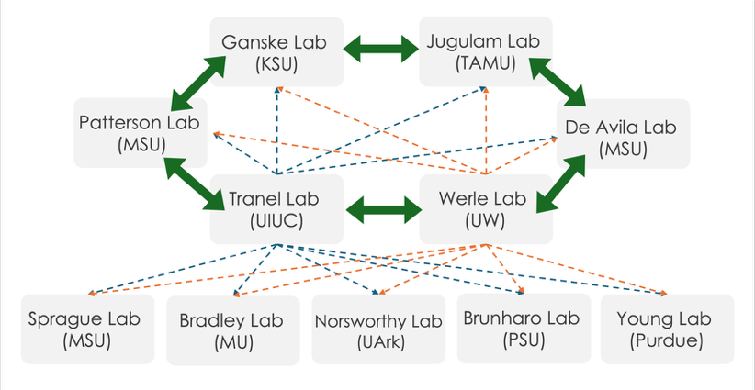
Figure 2. Overview of HERMON network active or planned collaborations.
5. Publications
Year 1 of HERMON has yielded 1 peer-reviewed publication already published in Weed Science, 1 manuscript currently under review also in Weed Science, and a pipeline of 7 manuscripts in preparation or anticipated across multiple labs and institutions, reflecting the strong scientific productivity of the network in its first year.

6. Personnel

In Year 1, HERMON has directly supported more than 13 non-PI researchers across the network, including postdoctoral researchers, master's students, and undergraduate research assistants distributed across six institutions.

7. Extension and outreach

Year 1 extension activities reached thousands of stakeholders across multiple states through three main channels: in-person presentations and media, the HERMON video series, and the War on Weeds podcast.
- In-person presentations and media: A combined total of more than 80 presentations were delivered across the network, reaching an estimated 7,000+ direct contacts. Additional outreach included 10 newsletter articles and 4 radio interviews, covering herbicide resistance topics across Arkansas, Wisconsin, Kansas, and Michigan.
- HERMON video series: Approximately 30 videos are planned or in production, with new releases published monthly. From December 2025 through June 2026, HERMON video content accumulated 8,609 total views and 255 interactions across YouTube and the Take Action promotional platform.
- War on Weeds podcast: Three HERMON-dedicated episodes were released in Year 1, generating a combined 1,196 downloads and featuring Dr. Pat Tranel, Dr. Karla Gage, Dr. Jason Norsworthy, and Dr. Eric Patterson.

8. Looking ahead to Year 2

The first year of the Herbicide Resistance Monitoring Network (HERMON) has demonstrated the value of a coordinated, multi-institutional approach to addressing one of the most significant challenges facing modern soybean production: the evolution and spread of herbicide-resistant weeds. By bringing together expertise from 11 universities and research laboratories across the United States, HERMON has established a collaborative framework that is accelerating the discovery of resistance mechanisms, improving diagnostic capabilities, expanding resistance monitoring efforts, and enhancing communication among researchers, industry partners, extension specialists, and growers.

Year 1 accomplishments include the characterization of resistance mechanisms in major soybean weed species such as Palmer amaranth, waterhemp, ragweeds, and Italian ryegrass; the development and validation of rapid resistance diagnostic tools; the creation and expansion of shared germplasm resources; and the initiation of a national resistance mapping platform. Equally important, HERMON has successfully established an active network of collaborations that leverages the strengths of individual institutions while avoiding duplication of effort and maximizing research impact.

For soybean farmers, the benefits of HERMON are both immediate and long-term. Improved resistance monitoring and mapping efforts will provide earlier detection of emerging resistance issues, allowing growers and advisers to make more informed management decisions before resistance becomes widespread. New diagnostic technologies under development have the potential to dramatically reduce the time required to identify resistant populations, enabling faster implementation of effective control strategies. Research into both target-site and non-target-site resistance mechanisms will support the development of more reliable weed management recommendations and help preserve the effectiveness of existing herbicide technologies.

The extension and outreach activities conducted during Year 1 have already delivered research findings directly to thousands of growers, consultants, retailers, and industry professionals through presentations, newsletters, videos, podcasts, and media engagement. These efforts ensure that scientific discoveries are rapidly translated into practical, field-level solutions that support profitable soybean production.

As HERMON enters Year 2, continued investment in collaborative research, diagnostic innovation, resistance surveillance, and stakeholder engagement will further strengthen the network's ability to address herbicide resistance challenges. Ultimately, HERMON is building the scientific foundation and decision-support resources needed to help soybean farmers maintain effective weed control, protect crop yields, improve production sustainability, and safeguard the long-term viability of herbicide-based weed management programs across the United States. Year 2 priorities include strengthening the collaborations between HERMON groups initiated in Year 1, advancing the germplasm database and resistance mapping platform, and continuing extension and outreach activities through the video series and podcast. A key milestone will be the development of a co-authored HERMON review paper on herbicide resistance diagnostics, bringing together contributions from all participating labs into a unified scientific publication.

