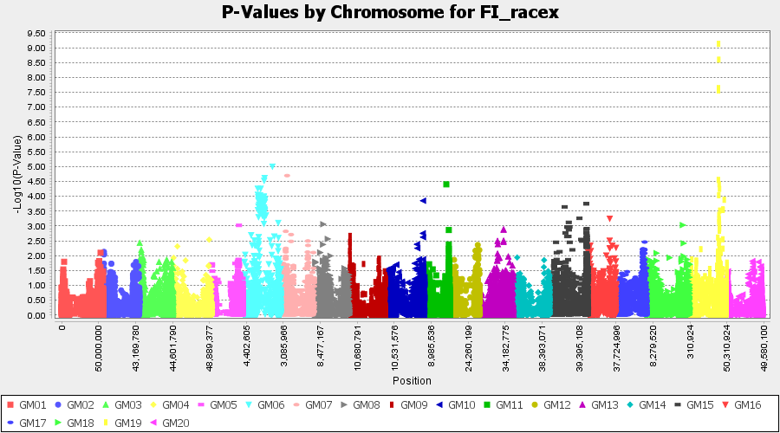

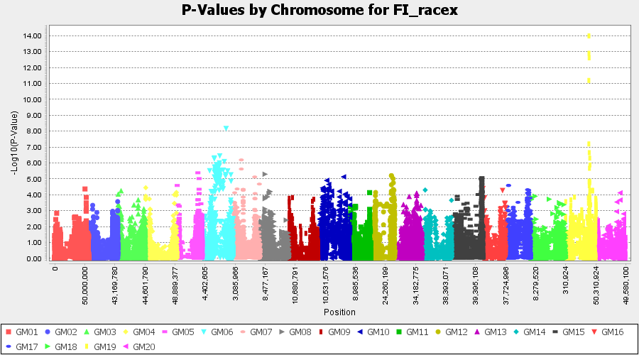

Figure 1. Distributions of Manhattan plot of GWAS for soybean susceptibility to HG Type 2.5.7 (race 5) based on MLM (top graph) in TASSEL 5, and cMLM (bottom graph) in GAPIT where x-axis presents for the soybean 20 chromosomes and y-axis for LOD (-log(P-value)) value. The dots of high values on the chromosome 19 indicate a significant SCN-resistance QTL.

Table 1. Cultivar sequences at Lamberton sites. (In 2018, all plots were planted to corn for weed control purpose).
Sequence | 2008 | 2009 | 2010 | 2011 | 2012 | 2013 | 2014 | 2015 | 2016 | 2017 | 2019 | 2020
1 | S | S | S | S | S | S | S | S | S | S | S | S
2 | R1 | R1 | R1 | R1 | R1 | R1 | R1 | R1 | R1 | R1 | R1 | R1
3 | R2 | R2 | R2 | R2 | R2 | R2 | R2 | R2 | R2 | R2 | R2 | R2
4 | R3 | R3 | R3 | R3 | R3 | R3 | R3 | R3 | R3 | R3 | R3 | R3
5 | R1 | S | R2 | S | R1 | S | R2 | S | R1 | S | R2 | S
6 | R2 | S | R3 | S | R2 | S | R3 | S | R2 | S | R3 | S
7 | R3 | S | R1 | S | R3 | S | R1 | S | R3 | S | R1 | S
8 | R1 | R3 | S | R1 | R3 | S | R1 | R3 | S | R1 | R3 | S
9 | R2 | R1 | S | R2 | R1 | S | R2 | R1 | S | R2 | R1 | S
10 | R3 | R2 | S | R3 | R2 | S | R3 | R2 | S | R3 | R2 | S
11 | R1 | R2 | S | R3 | R1 | S | R2 | R3 | S | R1 | R2 | S
S = Pioneer 92B13, susceptible to SCN; R1 = Latham EX547 RR N (PI 88788 resistance); R2 = Pioneer 91M90 (Peking resistance); R3 = Latham AR5084 (PI 437654 resistance)

