KANSAS SOYBEAN COMMISSION QUARTERLY REPORT OF PROGRESS

Principal Investigators: Sassenrath, G.F. – Southeast Agricultural Research Center
Presley, D. – Agronomy
Little, C. – Plant Pathology
Lin, X. – Agronomy
Shoup, D. – Southeast Area Extension Center

Title: “Soybean production systems to control charcoal rot and other soil-borne diseases”

Amount of Funding: $15,394

Department Heads: Lyle Lomas, Gary Pierzynski, John Leslie, J.D. McNutt

Progress Report: Second Quarter FY2017 (Dec. 1 – Feb. 28, 2017)

This research is designed to compare methods of controlling charcoal rot in soybean cultivars from three maturity groups commonly grown in Southeast Kansas. The control has no biological or chemical treatment. The biological treatment is a mustard plant, Mighty Mustard Pacific Gold (Johnny’s Select Seed). This mustard variety produces high glucosinolate concentrations that are suggested to control soil-borne diseases. Chemical control included seed treatment of fungicide plus in-season fungicide application, if necessary. The fourth treatment included both biological and chemical treatments.

The mustard seed was planted in late March, when soil temperatures were consistently above 50 F. The mustard seed did not germinate well, so the plant stands were much less than last year. We let the mustard grow till after seed set, then disked it under. The ground was worked in all plots in preparation for planting.

The soybean cultivars selected include two early maturity group 4’s, two late group 4’s and a mid- to early- group 5. One cultivar planted last year (AG4933) was not available this year, so was substituted with AG4835. The cultivars include:

- AG4135 RR2Y/SR
- AG4232 RR2Y
- AG4835 RR2Y
- AG4934 RR2Y/SR
- AG5332 RR2Y
- AG5335 RR2Y/SR

We have not had environmental conditions that are conducive to charcoal rot formation in the plants, so we did not see extensive charcoal rot infections in the plants. However, the fungi were present in both years in both soil and plants. To test the charcoal rot infestation in the soil, we took soil samples after disking in the mustard prior to planting the soybeans. Second soil samples were taken in the fall coincident to plant sampling at the R7-8 stage. The numbers of colony forming units (CFU’s) were measured in the soil samples at the Department of Plant Pathology at Kansas State University. Additional samples were used to determine soil microbial activity with the phospholipid fatty acid assay (PLFA). Overall, microbial activity increased substantially from June to October, but no consistent treatment affects were apparent.

There were significantly fewer CFU in the treatments with mustard seed and seed treatment than those without (Figure 1). The number of CFUs increased in all plots from spring to fall (Figure 2). Significantly fewer CFUs were measured in the treated plots than in the control plots in both spring and fall. Those plots with mustard seed cover crop had the lowest CFUs; chemical treatment also reduced total CFUs.

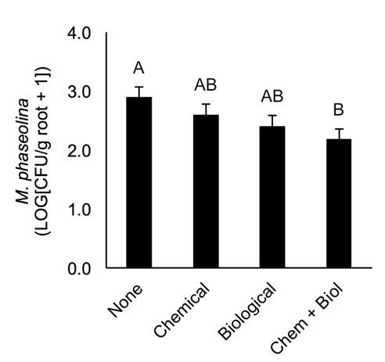
Figure 1. Number of CFUs of M. phaseolina in soil with and without mustard seed cover crop (Biological) at harvest.

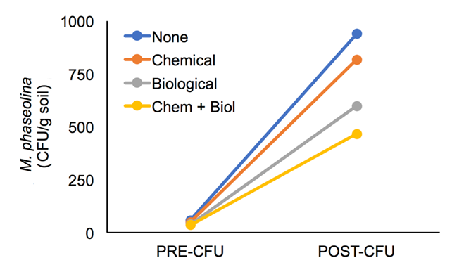

Figure 2. Comparison of CFUs before planting soybean and at harvest for the four treatments.

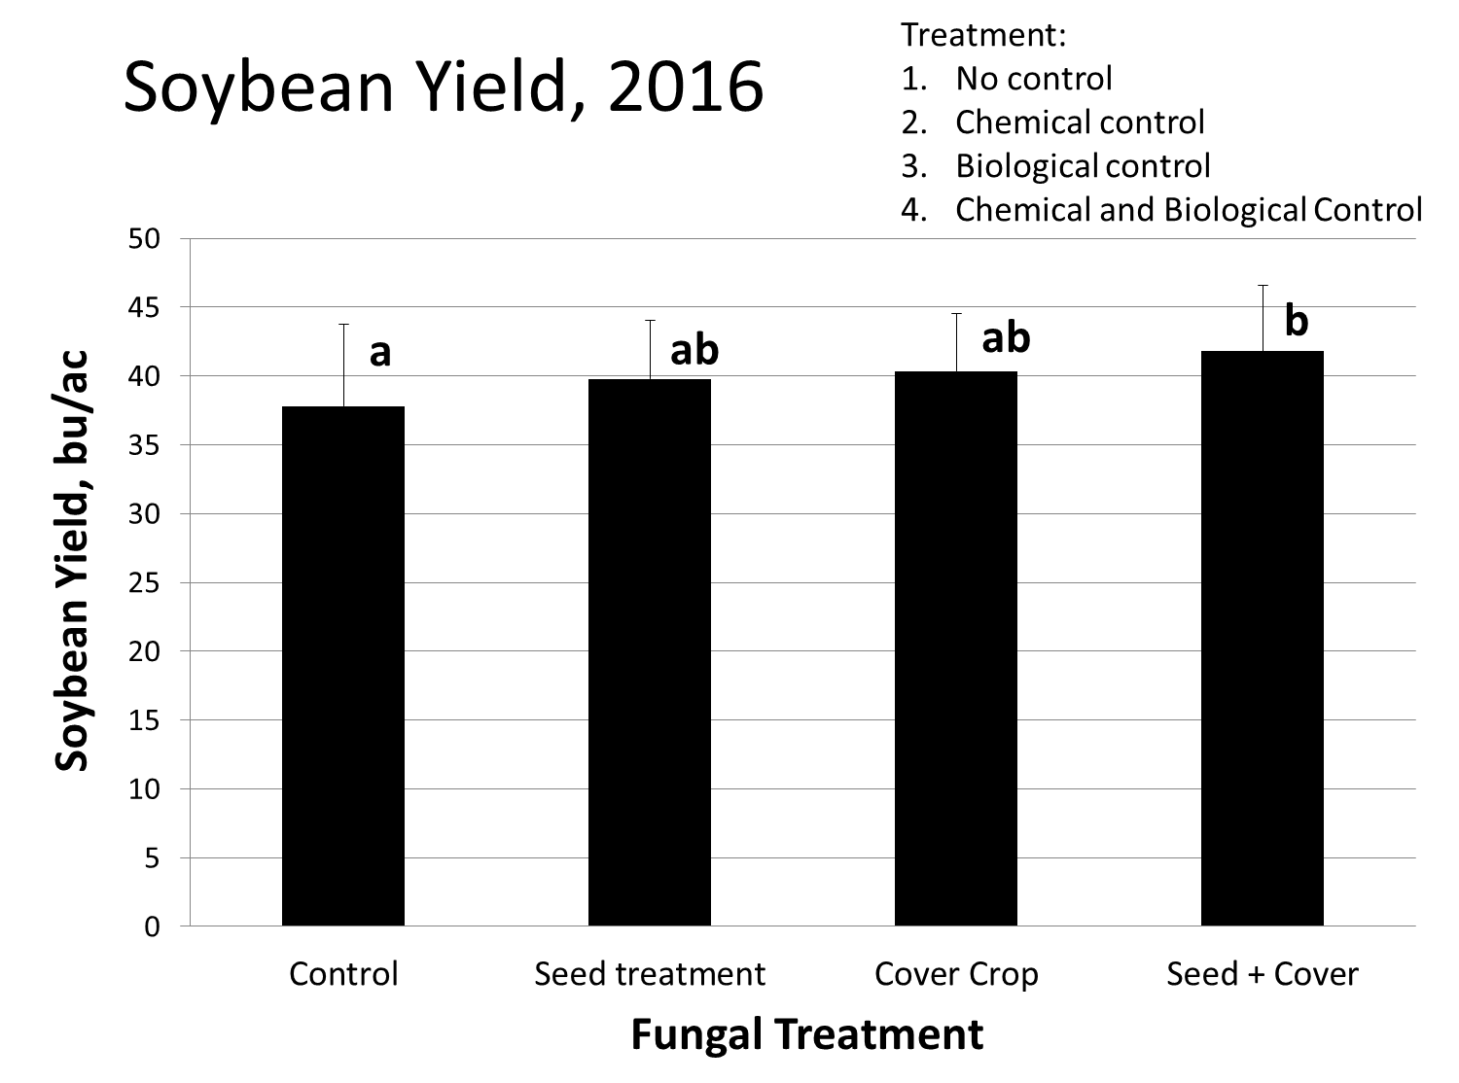
Figure 3. Impact of control method on yield across all cultivars. Different letters indicate statistical significant differences.

Soybeans yielded significantly better with both seed treatment and cover crop treatment than no control in 2016 (Figure 3). The early maturity (4.2) soybean cultivar yielded lower than the later maturity cultivars, with the highest yield reported in the 5.3 MG cultivar (Figure 4). The trend in yield was similar to that seen in number of CFU in the roots with maturity group, with MG5.3 having the lowest number of CFUs (Figure 5). Trends showed improved yield with the cover crop, but the difference between cultivars was not consistently significant. The differences in yield with maturity group were more likely due to differences in timing of flowering, with later maturing cultivars better able to capture fall rains.
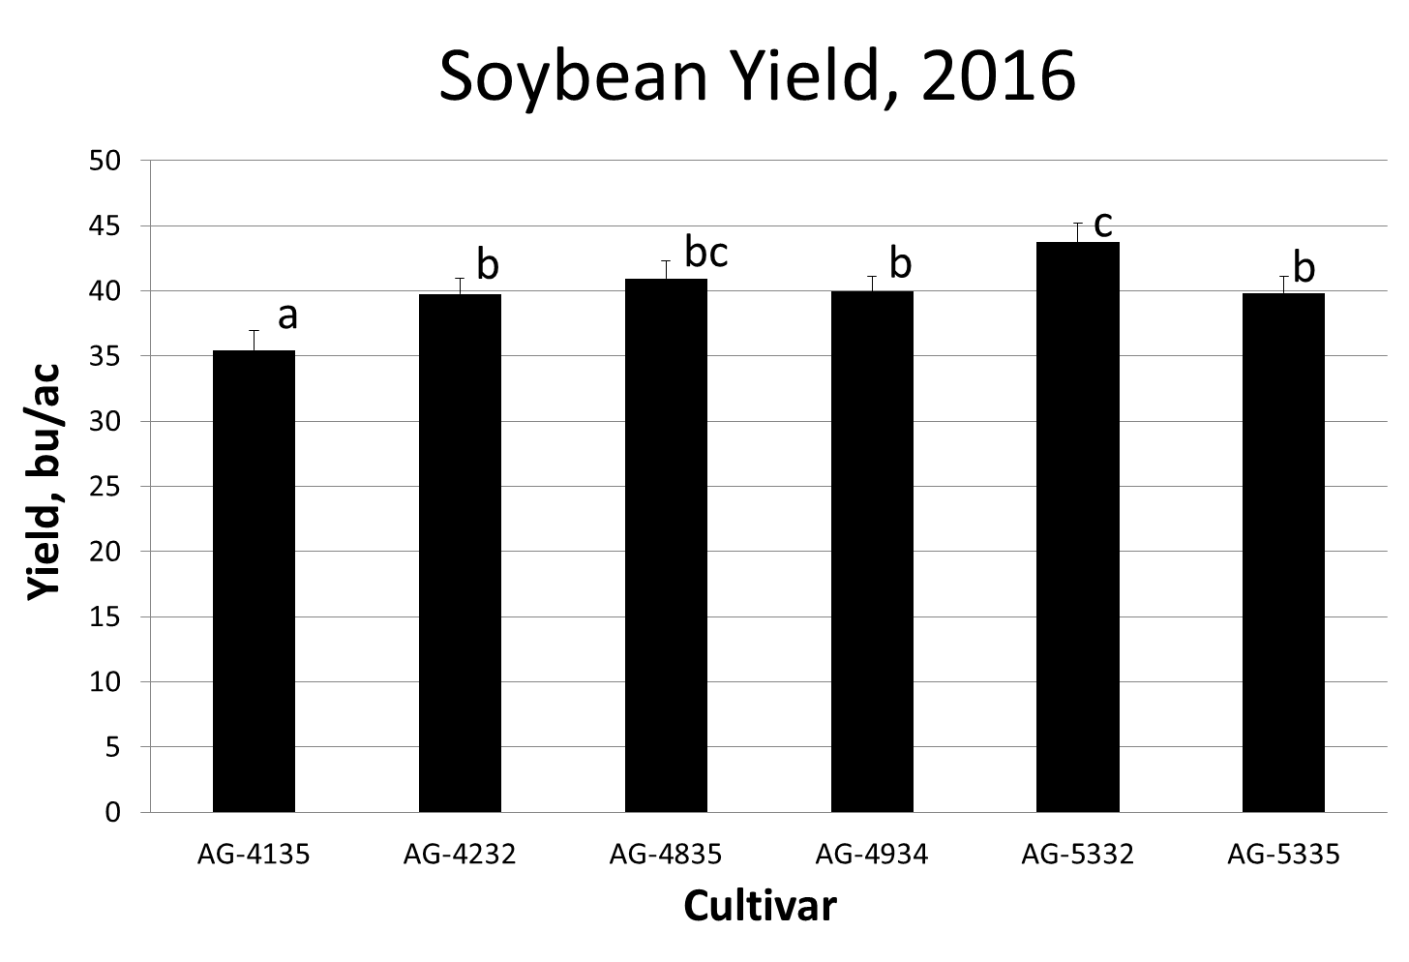
Figure 4. Differences in yield for cultivars across all charcoal rot control treatments.

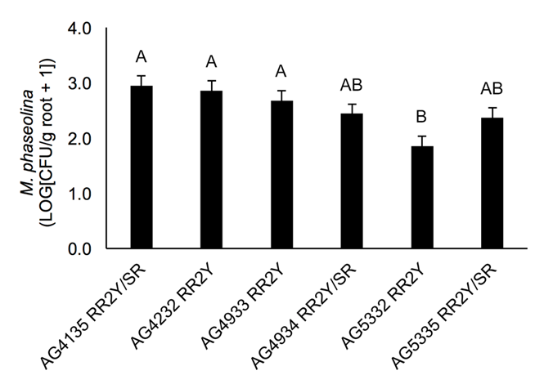

Figure 5. Number of fungal CFUs in root material for different cultivars.

