Summary of experiment conducted for the project “Finding pyrethroid-resistant aphids before it is too late”.

Executive summary-
We were able to complete aspects of Objective 1 and 2. This is due in part to a change in personnel and very low populations of soybean aphids. This project began with a PhD student, Ivair Valmorbida, who completed his degree and took a job with ADAMA US (a crop protection company). After he left, Dr. O’Neal recruited a new MS student to conduct this work with a focus on the first two objectives.
What our results mean for farmers-
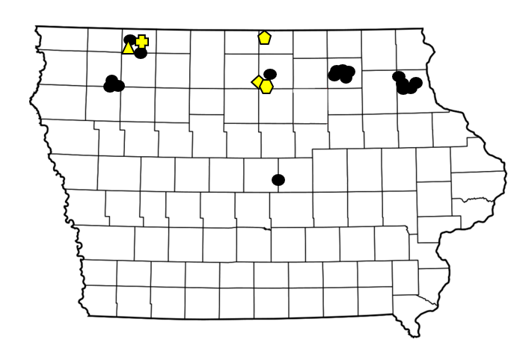
The low populations of aphids suggest that there was a limited risk to farmers from this pest in 2023 for the region we studied (northern third of Iowa). However, we observed some disturbing evidence that soybean aphids were not affected by an insecticide spray. Our observations suggest aphid populations continued to grow after a foliar application of an insecticide. Although this increase occurred, the populations were very low to begin with and did not rise above the economic threshold. Going forward, if farmers continue to spray insecticides prophylactically, there is the risk of the frequency of insecticide-resistant aphids spreading despite their low populations.
Figure 1. We visited a total of 22 locations. Yellow locations received a pyrethroid application. Lambda cyhalothrin was sprayed at four locations and bifenthrin was sprayed at one.

We will share these data in podcasts, newsletters and other extension materials during the 2023 growing season.
Figure 2. Average frequency of plants with at least one aphid at the five sites that had an insecticide applied. The percentage of plants with aphids before and after spray was calculated from our field data.

Regarding objective 1, we visited 22 soybean fields managed by farmers or the ISU Research Farms during the summer of 2022. We visited these fields during late June to early August (Figure 1). Overall the populations were very low, with some fields lacking aphids. No fields reached the economic threshold by August, with an overall seasonal average population of just 6 aphids per plant. This is a very low population that is not expected to affect soybean yield.

Regarding objective 2, we could not convince farmer volunteers to install a ‘check strip’ of untreated soybeans. In fact, very few farmers elected to use insecticides, due in part to very low populations of soybean aphids. Regardless of low populations, five fields were treated with an insecticide. We revisited these fields within seven days of the application. Overall, we noted the average number of plants infested with aphids increased (Figure 2). We are sharing these data with the farmers who participated, noting the repsonse of aphids on their fields if insecticide was sprayed (Figure 3). On all of the fields that were sprayed, the aphid populations increased to 24 per plant after the insecticides were applied. Despite this increase, the populations were still below the economic threshold (250 aphids per plant with increasing populations) and unlikely to affect yield.
Figure 3. Average frequency of plants with at least one aphid at example sites that contributed to the data reported in figure 2. The percentage of plants with aphids before and after spray was calculated from our field data.

In addition to scouting the fields, we collected aphids to determine if they had mutations associated with resistance to pyrethroids. We are looking for the presence of these mutations in fields before applications of pyrethroids and will compare them to the mutation frequencies after applications. Unfortunately, the graduate student who prepared these samples became ill during the fall semester and could not complete the molecular analysis of these samples. We are working with Dr. Brad Coates, USDA scientist located in Ames Iowa, to summarize these data. We are in the process of evaluating those aphids and hope to have those data summarized before the next growing season.

Regarding objective 3, We have completed a subset of the assays outlined in objective 3 before Dr. Valmorbida left ISU in the spring of 2022. During the summer of 2022, we were able to place all of these insecticides into Dr. Erin Hodgson’s insecticide evaluation trial. This field study would have complimented the lab study in an attempt to study the impact of alternative insecticides that are not within the same class as pyrethroids. We conducted this test within the insecticide evaluation trial conducted by Dr. Erin Hodgson. Due to the very low population of aphids experienced at that trial, we do not have a robust set of data to share.

Although we no longer have funding for this project, we are planning to repeat parts of Objective 1 and 2 in 2023. Because of the funding that we received for this one year project, we were able to hire and train a MS candidate (Matthew Pfab) who can complete these tasks beyond the lifetime of this grant. During the winter and spring we are reaching out to the farmers who participated in 2022 to participate again during the 2023 growing season. Dr. O’Neal will supervise Mr. Pfab and undergraduate assistants to visit these field(s). We will collect aphids and assay them for mutations. Our goal is to better understand the risk of pyrethroid-resistant aphids to soybean production in Iowa. Aphid populations were low during 2022, but the response to insecticide suggest we need to keep our eye on them to better inform famers of future risk.

