Technical Report
Determining Rye Safety to Soybeans with Soil Moisture Status
Mike Ostlie, Szilvia Yuja, Jasper Teboh, Greg Endres, Steve Zwinger, Paulo Flores, and Ezra Aberle
From 2018 to 2021 a trial was conducted to measure soil moisture differences between plots with rye that was terminated at different points within a rye/soybean relay system. After rye green-up, rye termination treatments were imposed weekly for 7 weeks. Soil moisture was measured weekly through rye anthesis and every other week thereafter. A hydroprobe was used to measure water content in 1 foot increments down to 4 feet. Soybeans were planted just before the rye boot stage. Winter rye was established in the fall of each year. Soybean emergence, rye growth stages, plant height, and rye and soybean grain yield and quality were other variables measured.
Treatments consisted of a fallow check (to calculate deficit), a rye-only check, a soybean-only check and a no termination (double-crop) check, along with 7 termination dates in-between, beginning in late April and running through early June. This trial was arranged as an RCBD with 4 replicates. This was the concluding year of a four year study. The treatments were designed to be able to differentiate soil moisture differences of varying termination dates and rye growth stages.
This research has been the focus of several workshops including the Advanced Crop Advisor’s Workshop, No-till Support Group, Field Days, and Row Crop Tour, as well as an internal training workshop among researchers. Data were prepared for the CREC annual report and Wild World of Weeds Workshop and distributed on Twitter.
Why the Research is Important to ND Soybean Farmers
Winter rye is growing in popularity as a cover crop prior to soybeans. However, past research at the CREC has documented instances of rye growth reducing soybean yields under dry conditions. During wet seasons the soybeans can be planted ‘green’ (but terminated soon after) into the rye with little change in soybean yield. Other years, rye needs to be terminated several weeks prior to soybean planting to prevent soybean yield reduction. In some instances we saw complete crop failure from terminations occurring after soybean planting and near rye anthesis. This project has aimed to develop a set of guidelines for rye termination timing so that producers can predict when their soybean crop may be at risk from the rye.
Rye has become an important sustainability tool for soybean growers in the Northern Great Plains. It has excellent winter survival and grows late in the fall and early in the spring. It can be planted almost any time before ground freeze in the fall (though earlier is better). Rye provides soybean farmers with 1) reduced weed pressure, 2) a firm seedbed (which is important for saline areas), 3) reduced wind and water erosion, 4) potential livestock grazing/haying. #3 is probably the key reason to consider rye as it not only reduces erosion but also encourages reduced tillage.
Final Findings of the Research
Each year of the study provided its unique set of environmental conditions which cover a wide range of potential outcomes. This is a good thing! The unfortunate part of 2021 specifically was that the rye establishment was very poor as a result of the previous dry fall and lack of germination. Estimated rye stand in the spring of 2021 was only about 5%. This low population made any differences in termination negligible. Data for soil moisture were still collected. This data showed a severe water deficit across the area, even in the early spring of 2021 (Figure 1). Rye biomass was collected at anthesis to determine any potential effect of rye water use on soil moisture. The only difference was between completely fallow ground and any area that had rye (Figure 2). As such, moisture data were combined to a single line for Figure 1. For reference, in 2020 plant available water remained high season long (between 75-100%) except for soybean plots during grain fill, which dropped the level down to 20%, and coincided with the start of the 13 month drought that lasted until September 2021. As a side note, this drop to 20% available water confirmed observations that soybeans (and sunflowers) created the greatest water deficit for the 2021 crops, resulting in poorer crop yields on soybean history.
When separated by whether there was any rye growing at all, the soil held on average about 0.5 inches of soil moisture more under bare ground in the top 2 feet (Figure 2). This was significant at the alpha=0.1 level. The collected biomass averaged 730 lbs per acre. To be clear, this amount of rye, which is very low, depleted the soil of only 0.5 inch of moisture over the course of the study.

Figure 1. Soil moisture and rainfall changes throughout the early 2021 growing season.
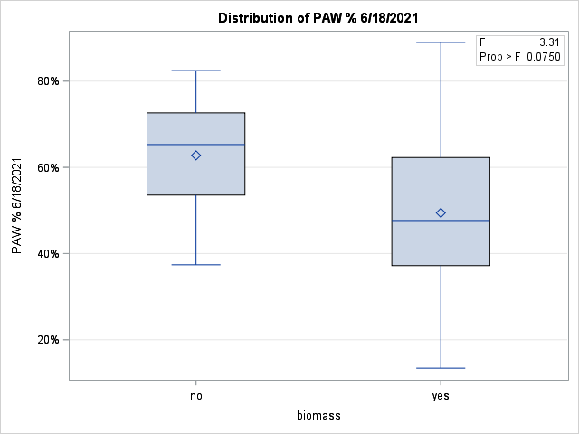
Figure 2. Comparison of Plant Available Water in fallow vs rye plots.

Benefits/Recommendations to North Dakota Soybean Farmers and Industry
This was the final year of the study. We have developed a good database of to use in developing recommendations for growers; both from this study directly, and from similar studies conducted without measuring water content. The safest approach for any year is to terminate rye two weeks prior to planting. In over 20 comparisons conducted since 2013, we have never seen a reduction in soybean yield from terminating at that time. Over the course of this current study, soybean yields were never impacted when terminating the rye at soybean planting. However, in some instances in similar studies (for instance in 2016 and 2017) planting green resulted in a reduction of soybean yields. Soil moisture, and timing of rain events are the best predictors for determining rye safety.
This current study has been instrumental in helping to identify the termination timings that are dangerous to soybean production. We are continuing to work with the data and have begun our collaboration with NDAWN to build a risk prediction tool that can be used to determine optimum rye termination timings. This tool will use a combination of a the rye GDD model and the soil moisture data from the NDAWN stations to estimate soybean risk. While this tool is not available yet, we are moving forward with plans to implement this beyond the end of the project.

