RESISTANCE OF SOYBEAN CULTIVARS AND GERMPLASM TO SOYBEAN CYST NEMATODE

TECHNICAL REPORT

NORTH DAKOTA SOYBEAN COUNCIL
JUNE 2020

Dr. Guiping Yan, Principal Investigator, Dept. Plant Pathology, NDSU
Co-investigators: Dr. Carrie Miranda, Dept. Plant Sciences, NDSU and Dr. Sam Markell, Dept. Plant Pathology, NDSU

Soybean cyst nematode (SCN; Heterodera glycines) and sudden death syndrome (SDS; Fusarium virguliforme) are two economically important disease affecting soybean production worldwide. SCN was first found in North Dakota (ND) in Richland county in 2003 and has spread to more than 26 soybean-producing counties, while SDS was first reported in the same county in 2018 and have been reported in two counties in ND so far. Planting resistant cultivars is often considered the best management strategy to manage SCN and SDS. But only few cultivars are found to be completely resistant to SCN and SDS. The continued use of the limited source of resistance has resulted in high selection pressure and a shift in the SCN virulence populations is capable of breaking the resistance. As a result, the need to find novel sources of resistance and broaden the genetic basis of resistance is increasing.
SDS has a synergistic relationship with SCN. SDS is most likely to occur in areas where SCN is a problem and the disease complex of SCN and SDS causes the most yield losses of soybean. Therefore, soybean lines that have resistance to both SCN and SDS should be identified to manage the disease complex. The major goal of this research is to manage SCN and SDS by identifying new resistance sources for breeding programs and by identifying and utilizing resistant soybean cultivars. The specific objectives of this research were to screen 80 soybean cultivars, germplasms and breeding lines for resistance to HG type 0 and HG type 2.5.7 detected in North Dakota, and to screen 20 soybean cultivars, germplasm and breeding lines for their resistance reactions to SDS detected in North Dakota.
101 soybean lines (29 soybean accessions of early maturity group ranging from 0-I from USDA-ARS Soybean Germplasm Collection in Urbana, IL and 72 commercial cultivars from growers) were screened for their resistance reactions to HG type 2.5.7. 110 soybean lines (21 soybean accessions of early maturity group ranging from 0-I from USDA-ARS Soybean Germplasm Collection in Urbana, IL, 75 commercial cultivars from growers, and 14 breeding lines from the NDSU soybean breeding program) were screened for their resistance responses to HG type 0.
Pregerminated seedlings of each soybean line were planted into a cone container each containing 100 cm³ of pasteurized river sand soil replicated four times. Each plant was inoculated with 2000-2500 eggs at the time of planting and kept in a controlled growth chamber maintained at 27 °C and daylight of 16 hours for 30 days. After 30 days, the plants were harvested and SCN white females were extracted from the roots and soil of individual plants and counted on a lined petri-plate under a microscope. The number of white females in the four replicates was averaged to calculate the mean number of white females which was used to calculate the female index (FI) as, FI = mean no. of white females produced on a tested soybean line/mean no. of white females on the susceptible check Barnes x 100 %. Soybean lines were classified for their resistance reactions based on the female index as described by Schmitt and Shannon (1992) as resistant (R) (FI < 10%), moderately resistant (MR) (10% ≤ FI < 30%), moderately susceptible (MS) (30% ≤ FI < 60%), and susceptible (S) (FI ≥ 60%).
Based on the previous SCN screening experiments, 21 soybean accessions from USDA-ARS Soybean Germplasm Collection in Urbana, IL, that were resistant to either HG type 0 or HG type 2.5.7 were selected and tested for their resistance reactions to the SDS pathogen found in North Dakota. Fusarium virguliforme, the causal agent of SDS, was grown in half strength PDA media and used to infect autoclaved sorghum seed in a conical flask with 10 plugs (8mm diameter) of actively growing fungal hyphae. Sorghum seeds were incubated at room temperature for 2 weeks and air dried before use.
Two experiments were conducted to screen the soybeans for resistance to the SDS pathogen (Figure 1). 500 ml plastic cups were filled with 350 gram of pasteurized river sand soil and inoculated by a layered method with 3-5 gm of fungus-infested sorghum seeds. Six seeds of each line were planted per pot and covered with a top layer of soil. Each line was replicated 5 times. Cultivar Barnes with autoclaved sorghum seeds was used as a control. Only four healthy plants were allowed to grow per pot after germination, and kept in the greenhouse for 40 days. The disease was evaluated based on foliar disease severity and root rot severity. Foliar disease severity was estimated based on the percentage of chlorotic or necrotic leaf area in total leaf area and root rot severity was estimated according to the percentage of root area showing brown lesions or discoloration in total area of tap root.
Among the 110 soybean cultivars, breeding lines and germplasm tested for HG type 0, 16% were resistant, 29 % were moderately resistant, 32% were moderately susceptible, and 23% were susceptible. Among the 101 soybean cultivars and germplasm tested for HG type 2.5.7, 15% were resistant, 5% were moderately resistant, 24% were moderately susceptible, and 56% were susceptible. Multiple lines were resistant to both HG type 0 and 2.5.7. The testing results for selected soybean cultivars, breeding lines and germplasm are shown in Tables 1 and 2.
In addition, 149 soybean germplasm lines from the USDA-ARS Soybean Germplasm Collection were tested for SCN HG type 2.5.7. The results have been summarized and presented in a manuscript which is now published in the journal, Plant Health Progress (Acharya, K. and Yan, G. P. 2022. Screening of early maturing soybean accessions for resistance against HG Type 2.5.7 of soybean cyst nematode, Heterodera glycines. Plant Health Progress 23:166-173). Briefly, 13 of the accessions were resistant, 17 of the accessions were moderately resistant, 81 were moderately susceptible, and 38 were susceptible. Out of the 13 resistant accessions, three originated from China, four from Canada, four from Japan, one from North Korea, and one from Ukraine.
Significant difference in root rot severity was observed among the 21 lines screened for SDS (Figure 2). PI 603151A and PI 603424A showed the maximum root rot severity (28.3%) and foliar disease severity (10.9%), respectively, in Experiment 1 while PI 6031148 showed the maximum root rot severity (38.5%) and foliar disease severity (8.4%) in Experiment 2. Among the lines that had root rot severity of less than 10%, PI 548642 had the lowest root rot severity (2.5%) followed by PI 603426B, PI 594314, and PI 603438A in Experiment 1. In Experiment 2, among the lines having root rot severity less than 10%, PI603169 and PI603426B had the lowest root rot severity (7.5%) followed by PI603153. In both trials, PI 603426B (7.8% and 7.5%) had root rot severity less than 10%. Foliar symptoms were not common in both the trials and therefore the disease was mainly evaluated based on the root rot severity.
The data have been communicated to the crop consultants, farmers, and breeder who provided the seed. The results will be further validated to confirm the resistance reactions of the soybean lines to SCN and SDS. Molecular techniques will be used to further elucidate the resistance genes or loci in the germplasm before using them in breeding programs to develop cultivars resistant to SCN. This research will be useful for the farmers to select resistant soybean cultivars in infested fields and for the breeder to develop new cultivars with improved resistance to manage SCN and SDS.

Table 1. Resistance responses of selected soybean germplasm from USDA-ARS Soybean Germplasm Collection to two SCN populations (HG type 0 and HG type 2.5.7) collected from soybean fields in North Dakota, tested in controlled greenhouse conditions.
Accession ID | Cultivar/Line | Country | MG | HG type 2.5.7 |  | HG type 0
 |  |  |  | Female Index | Resistance label | Female Index | Resistance label
PI603151A | - | North Korea | I | 74.2 | S | - | -
PI603153 | - | North Korea | 0 | 79.0 | S | - | -
PI603169 | - | North Korea | 0 | 82.5 | S | - | -
PI612707B | (Bei 8709) | China | 0 | 62.9 | S | 86.7 | S
PI603426B | (Ben di yuan huang dou) | China | 0 | 49.7 | MS | - | -
PI603438B | (Da hei qi) | China | I | 89.4 | S | - | -
PI675764B | (dau tuong vang) | Vietnam | I | 32.9 | MS | - | -
PI612708C | (K 89-9081) | China | I | 70.4 | S | 121.3 | S
PI597391C | (Kievskaya 27) | Ukraine | 0 | 3.7 | R | 8.5 | R
PI594245B | (Okuhara 1-B) | Japan | 0 | 1.6 | R | 6.4 | R
PI597405C | (Zaporozhie 46-96) | Ukraine | I | 79.9 | S | 171.8 | S
PI603439 | 74-2 | China | I | 76.5 | S | 28.7 | MR
PI603424A | Ben di huang dou | China | 0 | 62.8 | S | - | -
PI612745 | Bonwand | China | 0 | 3.4 | R | 5.3 | R
PI603438A | Da hei qi | China | I | 40.0 | MS | 9.0 | R
PI612715 | Hei nong 40 | China | I | 79.3 | S | 183.0 | S
PI603447 | Ka qi mao yan dou | China | I | 77.6 | S | 81.9 | S
PI603443A | Ke qi xiao hei dou | China | I | 0.8 | R | 4.3 | R
PI548642 | Maple Donovan | Canada | 0 | 4.2 | R | 23.4 | MR
PI548650 | Nattosan | Canada | 0 | 3.0 | R | 12.2 | MR
PI567782 | OAC Dorado | Canada | I | 3.8 | R | 7.4 | R
PI567783 | OAC Eclipse | Canada | 0 | - | - | 6.9 | R
PI603148 | Oh won No. 1 | North Korea | I | 4.5 | R | 6.9 | R
PI594245A | Okuhara 1-B | Japan | 0 | 4.4 | R | 18.6 | MR
PI594279 | Shinsei | Japan | 0 | 2.7 | R | 8.5 | R
PI594296 | Tokachi kuro | Japan | I | 88.2 | S | 63.1 | S
PI594301 | Toyomusume | Japan | I | 1.9 | R | 6.9 | R
PI594314 | Wase suzunari | Japan | I | 68.9 | S | - | -
PI597399 | Yug 30 | Ukraine | 0 | 88.2 | S | - | -
PI597405A | Zaporozhie 46-96 | Ukraine | 0 | 96.1 | S | 127.7 | S
- not available
MG - maturity group

Table 2. Resistance responses of selected soybean seed samples (cultivars) from growers in North Dakota and NDSU soybean breeding lines to two SCN populations (HG type 0 and HG type 2.5.7) collected from soybean fields of North Dakota, tested in controlled greenhouse conditions.

Cultivars/Breeding lines | Brand | HG type 2.5.7 |  | HG type 0
Cultivars/Breeding lines | Brand | Female Index (%) | Resistance label | Female Index (%) | Resistance label
05E256N | Impact | 99.5 | S | 63.1 | S
05LGT265N | Impact | 67.5 | S | 28.7 | MR
07E165N | Impact | 74.5 | S | 67.8 | S
08E127N | Impact | 73.9 | S | 86.6 | S
08LGT065N | Impact | 94.7 | S | 101.0 | S
10C153N | Legend | 68.8 | S | 47.2 | MS
10E125N | Impact | 44.6 | MS | 23.1 | MR
12E157N | Impact | 75.2 | S | 65.9 | S
13E245N | Impact | 87.4 | S | 42.2 | MS
13LGT132N | Impact | 61.8 | S | 28.7 | MR
GL0632E | DO SEED | 66.6 | S | 30.8 | MS
GL0968E | DO SEED | 71.3 | S | 105.7 | S
GL1057E | DO SEED | 51.5 | MS | 20.8 | MR
GL1294E | DO SEED | 59.5 | MS | 7.1 | R
GL1347E | DO SEED | 44.1 | MS | 24.2 | MR
GL1481E | DO SEED | 52.5 | MS | 39.0 | MS
GL1605E | DO SEED | 60.8 | S | 21.5 | MR
GL1658E | DO SEED | 67.0 | S | 29.5 | MR
GL1721L | DO SEED | 64.1 | S | 40.3 | MS
GL7610X | DO SEED | 104.1 | S | 41.9 | MS
GL924E | DO SEED | 58.9 | MS | 22.5 | MR
Natto MK0603 | RICHLAND | 150.0 | S | 110.3 | S
XF07722 | MUSTANG | 113.3 | S | 29.2 | MR
XF10522 | MUSTANG | 97.0 | S | 56.3 | MS
XF12422 | MUSTANG | 106.0 | S | 45.2 | MS
KP 0611 | - | 67.8 | S | 36.9 | MS
KP 0720 | - | 36.8 | MS | 23.9 | MR
KP 1010 | - | 38.9 | MS | 27.6 | MR
ND18-20092(GT) | NDSU | - | - | 10.8 | MR
ND18-20161(GT) | NDSU | - | - | 14.2 | MR
ND18-22422(GT) | NDSU | - | - | 18.8 | MR
ND18-22776(GT) | NDSU | - | - | 28.7 | MR
ND18-22814(GT) | NDSU | - | - | 45.3 | MS
ND18-22817(GT) | NDSU | - | - | 39.6 | MS
ND18-22829(GT) | NDSU | - | - | 42.9 | MS
ND18-22862(GT) | NDSU | - | - | 18.7 | MR
ND18-22883(GT) | NDSU | - | - | 20.7 | MR
ND18-22885(GT) | NDSU | - | - | 9.7 | R
ND18-25222(GT) | NDSU | - | - | 16.0 | MR
ND18-25228(GT) | NDSU | - | - | 38.0 | MS
ND18-25245(GT) | NDSU | - | - | 11.3 | MR
ND18-25274(GT) | NDSU | - | - | 44.0 | MS
- not available

Figure 1. Soybean plants maintained under greenhouse conditions for 40 days before assessment of the SDS disease severity (A), brown discoloration of the tap root caused by Fusarium virguliforme in a susceptible soybean accession PI603424A (B), and foliar symptom of SDS showing typical interveinal chlorosis in the plants infected by F. virguliforme in a susceptible soybean accession PI 603148 (C).

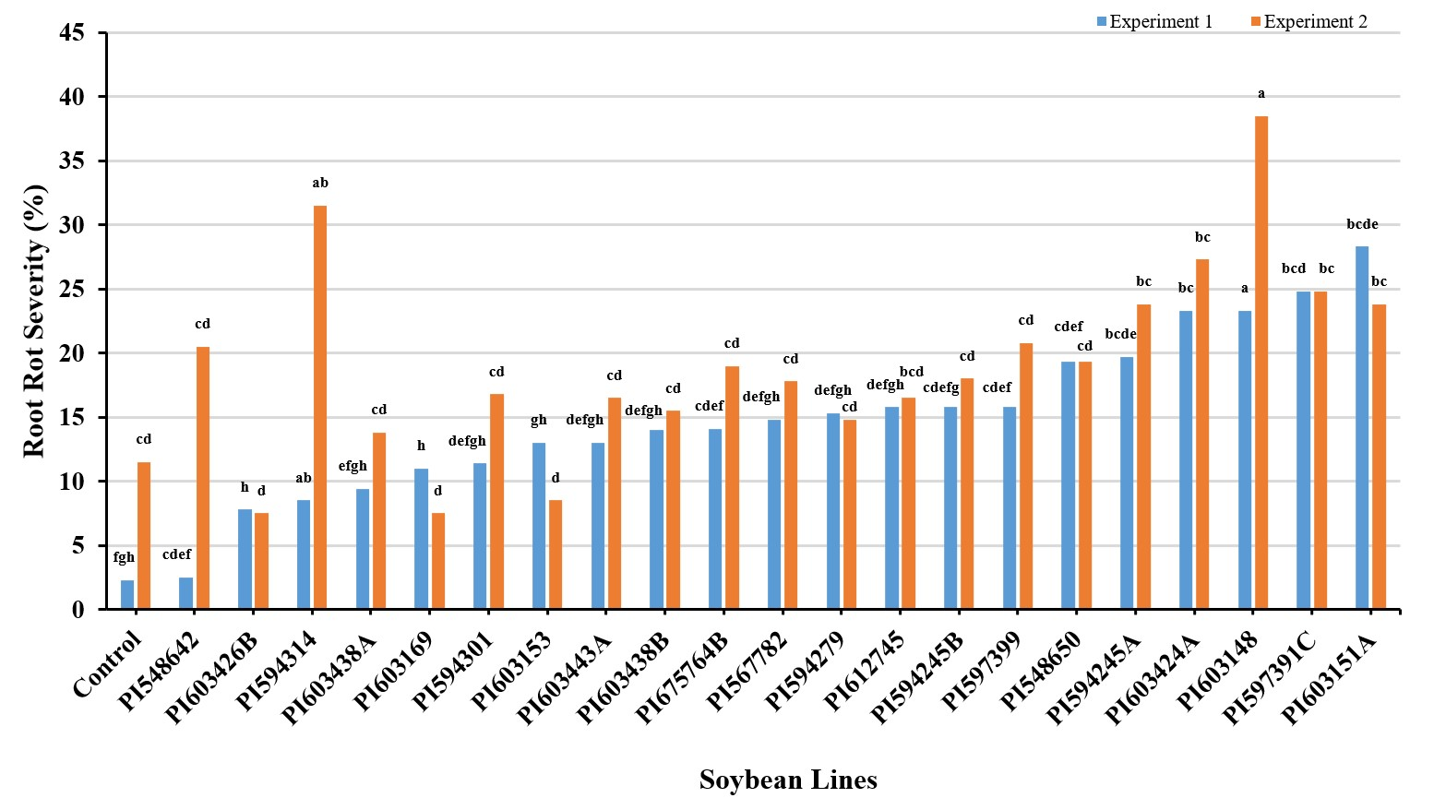
Figure 2. Root rot severity of 21 soybean lines and one control 40 days after inoculation of the fungal pathogen Fusarium virguliforme causing SDS in the greenhouse. Means followed by the same letters are not significantly different at α = 0.05.

