FY 2022 Final Report to the Minnesota Soybean Research and Promotion Council

UofMN/MSR&PC Drainage and Tillage Research Site: Enhancing Soybean Production with Residue Management and Cover Crops

Seth Naeve & Carlos Sanchez

Summary

The long-term research project near Wells, MN, is being conducted to examine the effects of artificial soil drainage, soil tillage, and corn residue on soybean nutrient content, physiology measurements, and soil chemical and physical parameters. The study features eight blocks with corn-soybean rotation, distinguished by drained or undrained soil conditions and three tillage systems (conventional, strip-tillage, and no-tillage). Starting in the fall of 2021, three levels of residue management were implemented, involving the removal of corn residue, the planting and terminating a cover crop in the fall and spring, or the traditional approach of leaving residue on the field.

The goals and objectives of the study include monitoring soil temperature and moisture profiles, evaluating yield and quality impacts, examining interactions on soybean yield and seed quality, and analyzing nitrogen availability, soil carbon effects, and soil health parameters. The ultimate goal is to understand how these factors impact soybean growth, development, yield, and seed quality. After completing the study description, statistical graphics were compiled visually, representing the observed trends and patterns within the various treatment combinations. These graphics showcase the effects of drainage conditions, tillage practices, residue management, seed treatments, and seeding rates on both corn and soybean crops. They serve as valuable tools for analyzing and interpreting the research findings.

One of the study's findings pertains to the 2022 corn-growing season, considering different tillage treatments. It reveals no notable distinction between the two drainage conditions employed. However, it is worth noting that conventional tillage demonstrates a slightly higher yield at harvest compared to the no-tillage approach. Overall, the long-term research project provides valuable insights into the effects of various factors on soybean growth, development, yield, and seed quality using temporal crop management methods.

Findings
Soybean is a competitive and resilient crop, but early-season growth is critical for maximizing yields. Planting dates have little effect on yields, but emergence dates and early-season vigor do. Heavy rainfall events are becoming more frequent, making drainage, tillage, and residue/cover crop research critical. Various crop management scenarios were used to examine the effects of temperature, water, and nutrient availability on early-planted soybeans. A first-of-a-kind experiment that evaluates the effects of drainage, tillage, and residue on soil temperatures, moisture, and nutrient availability. Results will improve recommendations for fall tillage, cover crop management, and planting management in well-drained and poorly-drained soils.

The goals and objectives aim to examine the effects of drainage, tillage, and corn residue or cover crops on soil conditions, soybean measures, and soil chemical and physical parameters. This includes monitoring soil temperature and moisture profiles, evaluating yield and quality impacts, examining interactions on soybean yield and seed quality, and analyzing nitrogen availability, soil carbon effects, and soil health parameters. The ultimate goal is to understand how these factors impact soybean growth, development, yield, and seed quality.

The study is being conducted at a long-term research site near Wells in south-central Minnesota. The site was established on a farmer's field and divided into eight blocks. Each block has been randomly assigned to either drained or undrained conditions. The drainage structures in the drained blocks are fully open, while the undrained blocks have their drainage structures completely closed. The blocks have further subdivisions to accommodate corn and soybean crops, with a rotation taking place every year. In 2017, three tillage treatments were introduced: conventional, strip-till, and no-till.

Additionally, starting in the fall of 2021, three levels of residue management were implemented, involving the removal of corn residue, the planting and terminating of a cover crop in the fall and spring, and the traditional approach of leaving residue on the field. Each level consists of five plots measuring 10x30 ft, with varying nitrogen (N) rates applied during the corn phase (0, 130, or 260 lbs N/ac), while no nitrogen is provided during the soybean phase. The objective is to assess soil N supply, N use efficiency, and the effects of different factors such as drainage, tillage, and residue on the treatments. The study encompasses a total of 720 plots, with 360 plots dedicated to corn and 360 plots to soybean, replicated across multiple factors and treatment combinations.

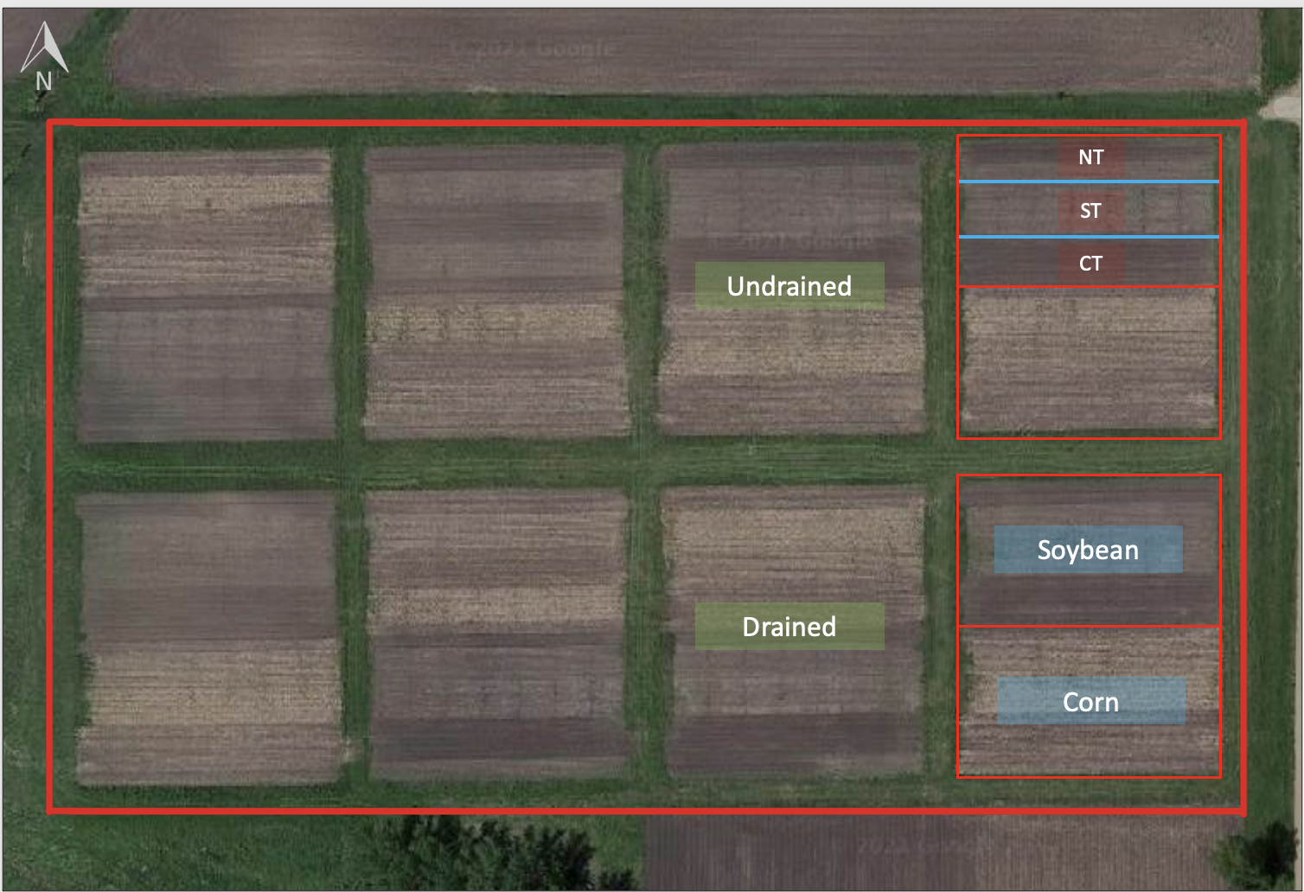

The aerial view showcases an experimental design at the research site near Wells, MN. It features eight blocks with corn-soybean rotation, distinguished by drained or undrained soil conditions. Additionally, three tillage systems are implemented.

The treatment structure enables the inclusion of a control treatment involving 130 lbs of nitrogen applied to corn, with no treatment applied to soybean. This allows for two additional soybean treatments to be compared against the control. The research team's primary focus is investigating the interactions between seed treatments, seeding rates, drainage conditions, tillage practices, and residue management. Specifically, they plan to examine the effects of different seed treatments and seeding rates across various factors. In one example, three seed treatments are applied to corn plots receiving 130 lbs of nitrogen, with varying population rates. Treatment 1 involves no seed treatment and a population of 125,000 seeds per acre. Treatment 2 includes a seed treatment and a population of 140,000 seeds per acre. Treatment 3 consists of no seed treatment and a population of 140,000 seeds per acre. Each of these treatment combinations is replicated within three residue levels, three tillage treatments, and two drainage levels, resulting in a total of 16 blocks in the experiment when considering both corn and soybean crops, two drainage levels, and four replications.

After completing the study, we compiled a series of statistical graphics that depict the data collected over the past two summer seasons. These graphics visually represent the observed trends and patterns within the various treatment combinations. The graphics showcase the effects of drainage conditions, tillage practices, residue management, seed treatments, and seeding rates on both corn and soybean crops. They serve as valuable tools for analyzing and interpreting our research findings.

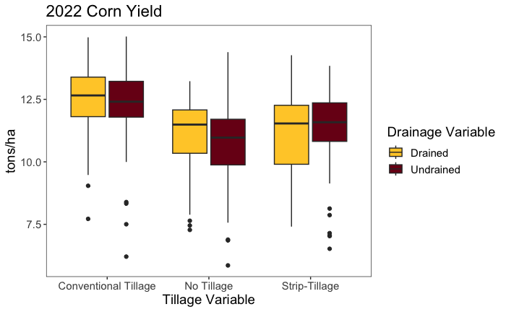

The chart above presents data about the 2022 corn-growing season, considering different tillage treatments. It reveals no notable distinction between the two drainage conditions employed. However, it is worth noting that conventional tillage demonstrates a slightly higher yield at harvest compared to the no-tillage approach.

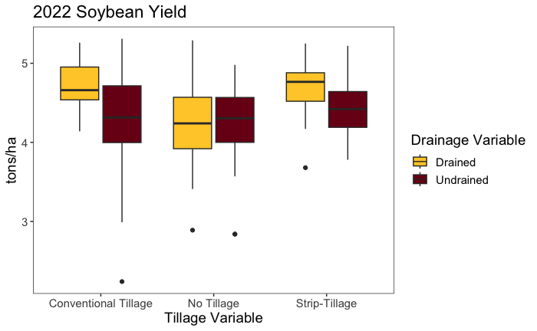

Slight disparities among drainage conditions and tillage systems for the soybean crop during the 2022 growing season. Nevertheless, it is crucial to note that these effects were overshadowed by the fluctuations in weather conditions experienced during this growing season. Specifically, there was a significant pronounced variation from the average rainfall recorded in the previous ten growing seasons, with precipitation levels falling far below average. As a result, the discernible influence of these factors on soybean crop outcomes was obscured.
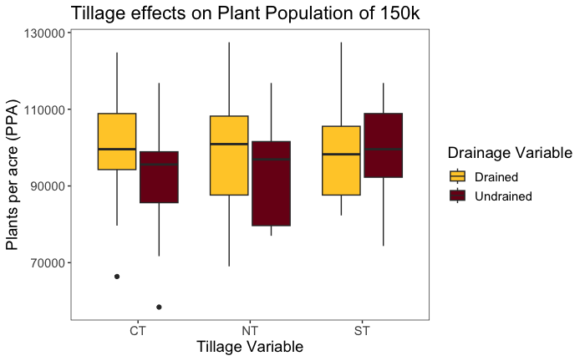

Here is a comparison of the stand count between three distinct tillage systems and two drainage conditions. The data reveals that the final number of plants per acre is relatively consistent across the different conditions, with only minor variations observed, suggesting that the tillage system and drainage condition have a limited impact on the final stand count in this study.

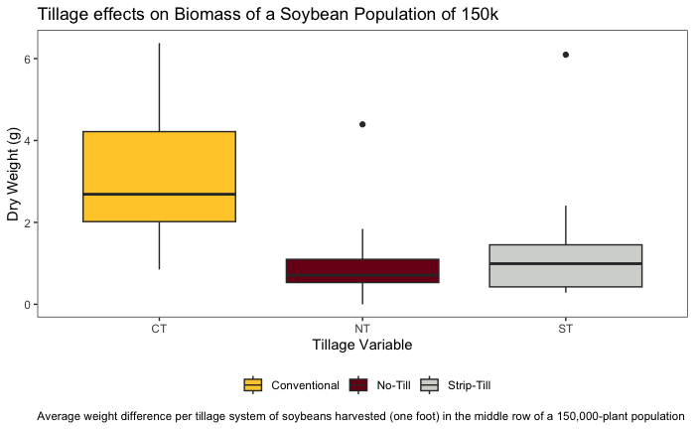

This chart illustrates the impact of the tillage methods on the biomass of soybeans. The samples were collected from soybean plants within one foot of the middle row of a plot with a target population density of 150k plants per acre at V2. The results indicate that soybeans in the conventional tillage section had a higher weight than those in the no-tillage and strip-tillage sections, suggesting that conventional tillage may be more beneficial for soybean biomass. Biomass was similar at the R1 stage (data not shown).

Another important factor to consider when planting soybeans is soil compaction. It is caused by field traffic and heavy machinery use, especially under wet conditions, and can be a significant issue for soybean production. Compacted soil can restrict root growth and nutrient and water uptake. In severe cases, soil compaction can cause stunted plants. If the roots hit a hardpan layer caused by soil compaction from the use of heavy machinery, vertical root growth may be inhibited, and lateral root growth may occur. Therefore, it is important to manage soil compaction to ensure healthy root growth and optimal nutrient and water uptake for soybean plants.
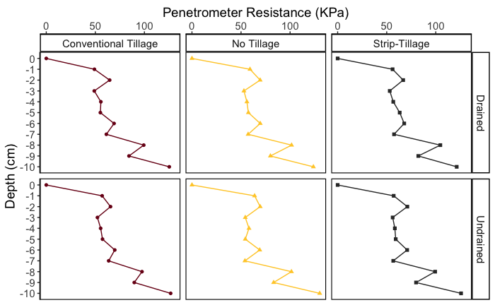

The chart above displays the soil compaction measurements taken using a penetrometer across the different tillage treatments and soil drainage conditions, showing the soil resistance at various depths within the plot. Measurements were taken across the eight blocks with three other tillage systems and under the two varying drainage conditions. We assume the lack of difference in soil compaction is consistent throughout the study. We attribute this lack of difference to the unusually low rainfall recorded during the growing season, which may have affected the soil moisture conditions across the experiment station. Supporting this claim, the Minnesota Department of Natural Resources reported that small pockets of southern, western, and central Minnesota had below-normal precipitation for the first five months of 2022, including the region where this station is located.

The following series of charts illustrate the availability of various nutrients in the soil of soybean plots during the 2022 growing season. These measurements were taken using PRS probes, with retrieval periods of three weeks throughout the season.

PRS (Plant Root Simulator) probes are a convenient and economical tool used to quantify spatial and temporal variations in nutrient supply rates for all soil ions simultaneously. They use specially charged ion exchange membranes that adsorb nutrients directly from the soil, mimicking how a plant root takes nutrients. PRS probes are essential in agronomic, forestry, and ecological research.

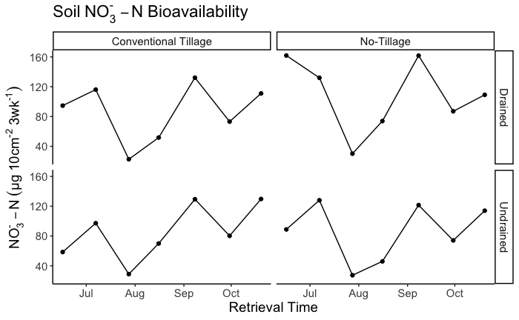

Nitrate (NO3-N) is a key nutrient for soybean and corn crops. Soybeans can produce some of their required nitrogen through a symbiotic relationship with Rhizobium bacteria but also obtain inorganic nitrogen from the soil as nitrate. Nitrogen is also the most yield-limiting nutrient for corn production. Accurately estimating the economically optimum nitrogen rate (EONR) is essential to maximize profit potential while minimizing the risk of over-application and nitrogen loss. Monitoring and managing nitrate availability in the soil is crucial for both crops' optimal growth and yield. In this dataset, plots under soil-drained conditions and no-tillage reported higher amounts of nitrate during the establishment of the crop (planting) and early in September.

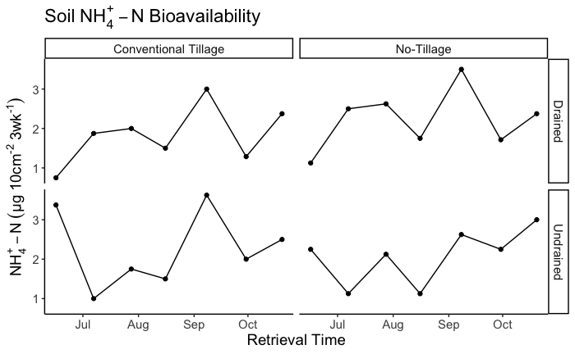

Ammonium (NH4-N) is another important form of nitrogen for both soybean and corn crops. Organic nitrogen is contained in organic matter in the soil, crop residues, and microbial community within the soil. While organic nitrogen may make up most of the nitrogen in the soil, it is only available to plants once microorganisms convert it through mineralization. Mineralization converts organic nitrogen to ammonium or nitrate ions that can take up by the plant. During the growing season, ammonium is quickly converted to nitrate, called nitrification. Nitrate is the main form of nitrogen taken up by plants. Soybean can also obtain inorganic nitrogen from the soil as ammonium or nitrate. In the charts shown above, it is reported that in the first stages of the crop after planting, the amount of ammonium is higher in those plots under undrained soil conditions compared to those under well-drained conditions. This may be because ammonium is held on the soil exchange complex and does not move with water.

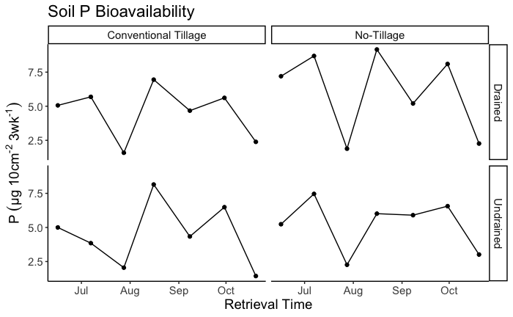

Phosphorus (P) is another important nutrient for soybean and corn crops. Phosphorus is a macronutrient for corn, along with nitrogen (N) and potassium (K). Phosphorus is essential for photosynthesis as it is a component of the green pigment in plants, chlorophyll. Adequate phosphorus availability in corn allows the plant to reach its genetic yield potential. In soybean, phosphorus is also an important nutrient for growth and yield. High phosphorus rates are generally applied to corn before soybean in rotation. During the early stages of soybean, phosphorus availability was similar across the field, with slightly higher values in the plots with no-tillage.

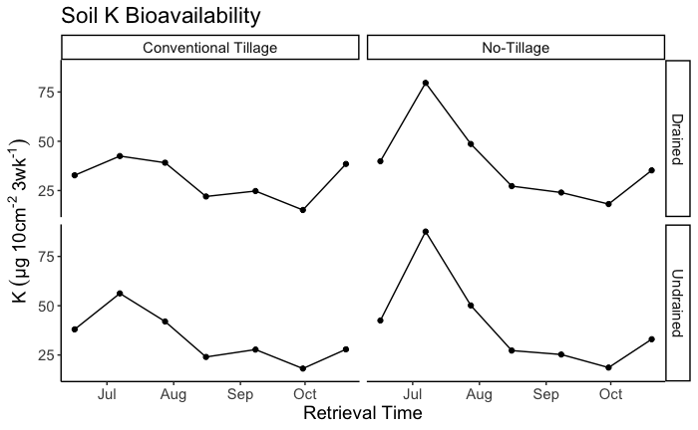

The bioavailability of K in the soil was almost linear for the plots under conventional tillage. However, the plots with no tillage reported a peak between the end of June and late August. Potassium deficiency symptoms occur when plants cannot extract potassium from the surface soil. Symptoms for both corn and soybean are yellowing of the leaf margins, and in severe cases, leaf edges may become brown. An average-to-high-yielding soybean crop will remove more potassium annually than an average-to-above-average corn crop.

Acknowledgments

We thank the Minnesota Soybean Research and Promotion Council and the University of Minnesota for funding this research. Their support has been instrumental in advancing our understanding of soybean production and management.

