Project Title: 2022 Continued Evaluation of Waterhemp Control and Crop Injury
Private Investigator (P.I.): Next Gen Ag, LLC/Andrew Lueck
Quarter Report: #3 November 2022 thru January 2023
Objectives: (List project objectives as submitted in final proposal. Describe activity for each during this reporting period.)
- Renew a 2021 grant with modifications to repeat study to capture a second environment;
  - Goal #1: Resubmit 2022 grant with modifications (Done)
  - Goal #2: Industry partners contribute chemistry [BASF, Bayer, Corteva, FMC, Syngenta, Valent, Winfield] (Done).
- Develop more diverse one- and two-pass combinations of residual herbicides and maintain 95% waterhemp control 56 DAA (canopy).
  - Goal #1: Successfully apply chemistry (Done).
  - Goal #2: Next Gen Ag based variable tank mix treatments and timing combinations (Done).
  - Goal #3: Collect data from a second environment (2022) (Done).
- Develop array of treatment costs to provide competitive considerations.
  - Goal #1: The average cost of all five variable tank mix rates tested was $30.63 and ranged from $21.43 to $39.05. (Done).
- Run ratio and crop safety evaluations on the most successful combination from the 2020 variable rate tank mix combo trial;
  - Goal #1: 1X rate of Blanket + Valor SX + Warrant + Flexstar at 8 + 2* + 40 + 10 (Done).
  - Goal #2: Ratios ranged from 0.62 of base rate to 1.37 (Done).
  - Goal #3: No crop injury recorded (Done).
  - Goal #4: Double number of varieties evaluated (Done).
- Institute expansive outreach opportunities through;
  - Goal #1: Industry collaborators 8/8; 8 in attendance (Done).
  - Goal #3: One field plot tour held August 11th; 9 AM to Noon (Done).
  - Goal #4: Publications; will be attached with report (Done).
  - Goal #4: Create a virtual tour to disperse via social media (Done).
  - Goal #5: Ag Expo Posters/Appearance (January, not done).
    - Presentation and article for Prairie Grains/Small Grains (Done).
Achievements: (Specific project achievements during this reporting period.)
- Trial was successfully planted in an area of intense waterhemp pressure.
- Every plot was planted and sprayed according to plans, NO MISTAKES!
- Some crop injury noted from treatments, but no lasting evidence.
- 14, 28, 42, and 56 DAA waterhemp control notes taken.
- 19 field day attendees. 10 surveys taken; “Quality of tour” was rated 4.30/5.00; “Transfer of Info” rated 4.6/5.00; 10/10 would return for another tour next year however 3 individuals wonder if field tours are the “way” anymore….want to see the virtual tour concept; Survey participants wanted to see more plant health and possible corn demos in the future.
- All 8 industry partners were on site to present and a LOT of great conversation and networking!
Challenges: (Challenges encountered. Specific request for assistance from Production AT on any challenges listed above.)
- Erratic soybean and weed emergence due to dry conditions.
- Less representation of farmers then expected at tour (6).
- Less representation of local co-op staff then expected at plot tour (none).
- Really need additional support and resources to be provided by the MSRPC board in the future for promotion. May consider moving away from field days or abandoning the work altogether in 2023…..will depend on virtual tour outcome.
Publications/Symposium:
- All publications complete.
- Plot tours complete with 19 attendees; virtual tour concept and impact (30 views, 13 min avg).
- Publications posted to Next Gen Ag website that can be accessed through or FB page “Next Gen Ag LLC” in Quarter #2 (Done).
Tech Transfer: (General audience identification and approximate number attending.)
- Plot tour attendees 19.
- Facebook page followers 123; posts have reached up to 1,200 individuals.
- Anticipate ag expo this winter (Done).
- Virtual tour build and dispersion via social media this winter (Done).
Drone images taken 7-10-21.
Image 1. Large Industry Trial Renville, MN.
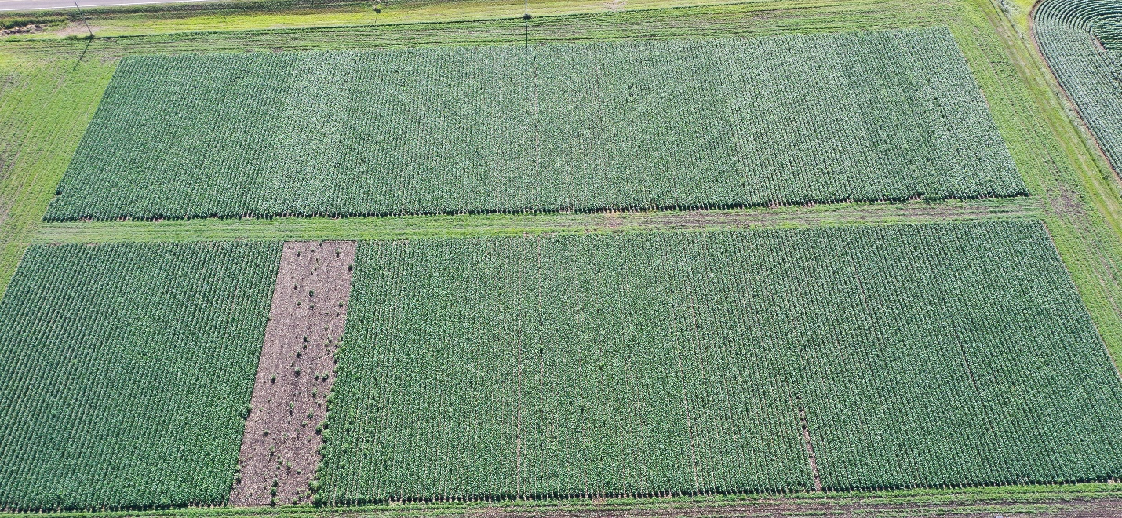

Image 2. Varietal Crop Safety Trial.
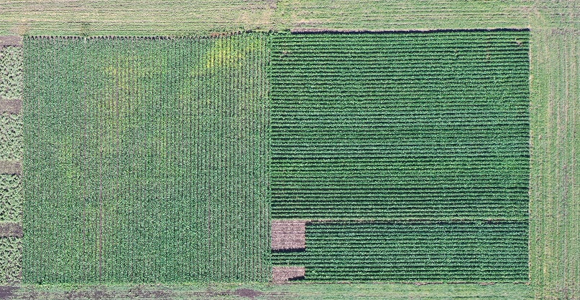

Image 3. PRE Vs. PRE fb EPOST Micro-Rate Combinations.
