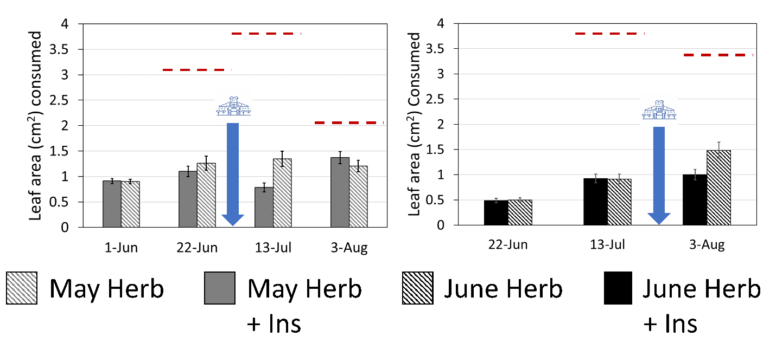
Figure 1. Mean defoliation damage (in square centimeters of leaf area consumed) for the earlier planting (left) and the later planting treatment (right) pooled across both sites for each week of sampling. The blue arrow denotes the timing of the pesticide application. The red dotted line represents the amount of leaf area consumed that would approximately correspond to 10% defoliation (the lowest economic threshold for any growth stage/pest), based on average total leaf size on that date.

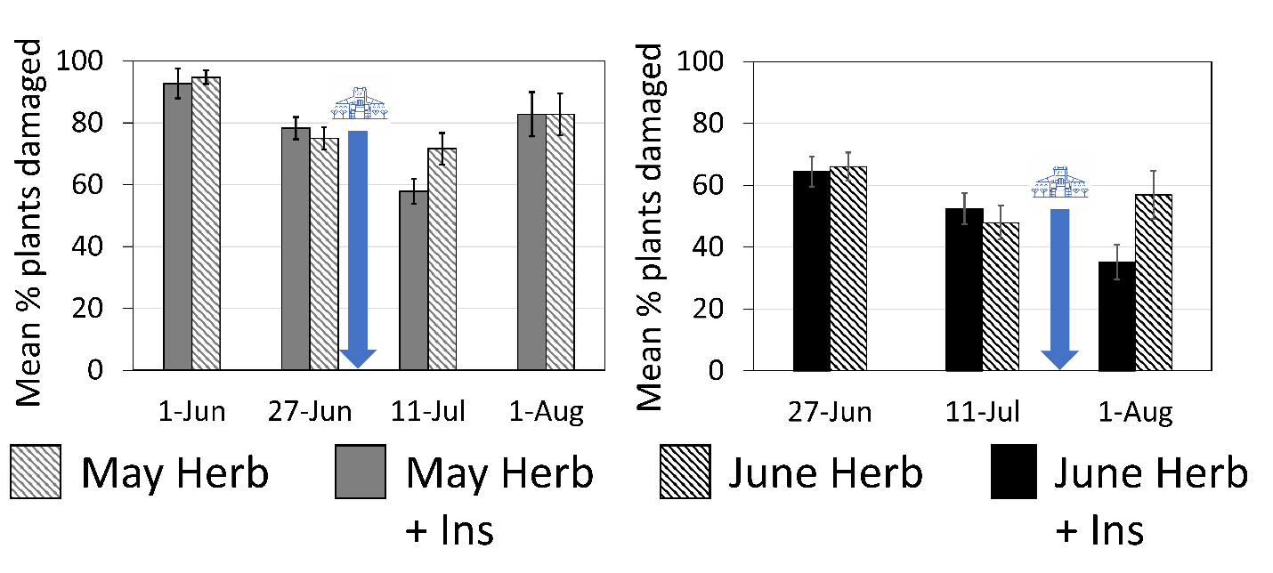
Figure 2. Mean percent of plants damaged for the earlier planting (left) and the later planting treatment (right) pooled across both sites for each week of sampling. The blue arrow denotes the timing of the pesticide application.

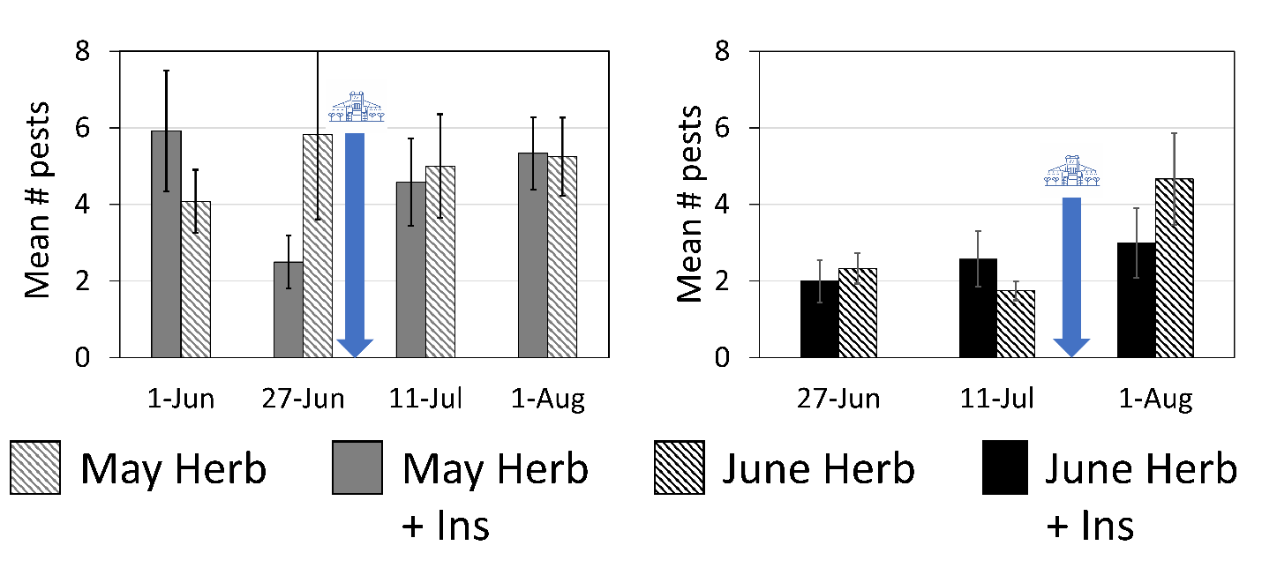
Figure 3. Mean number of pest organisms detected during visual sampling for the earlier planting (left) and the later planting treatment (right) pooled across both sites for each week of sampling. The blue arrow denotes the timing of the pesticide application.

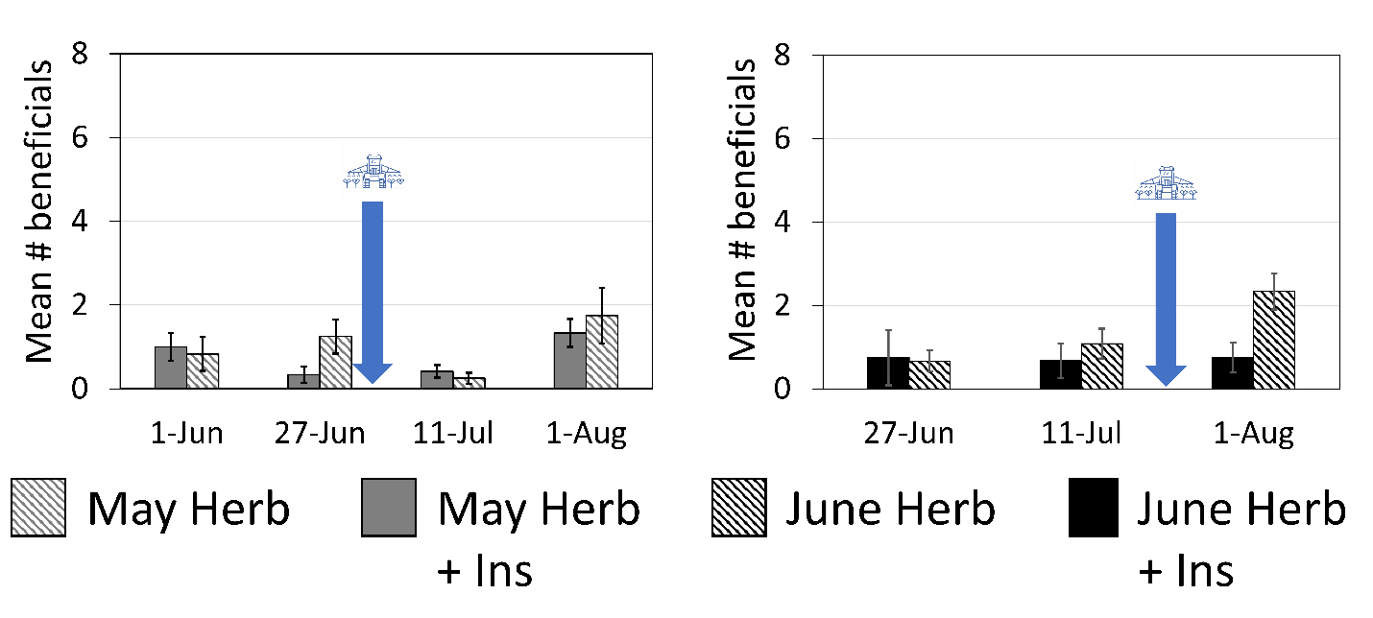
Figure 4. Mean number of beneficial organisms detected during visual sampling for the earlier planting (left) and the later planting treatment (right) pooled across both sites for each week of sampling. The blue arrow denotes the timing of the pesticide application.

