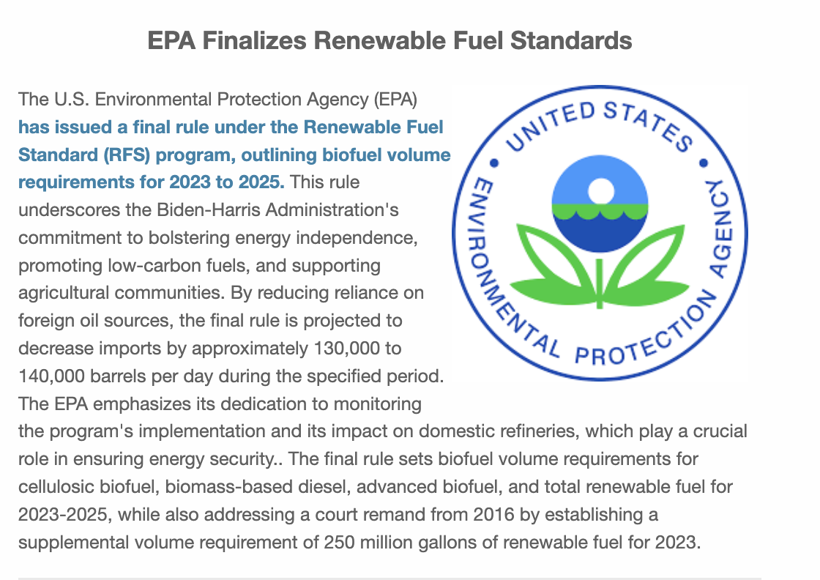
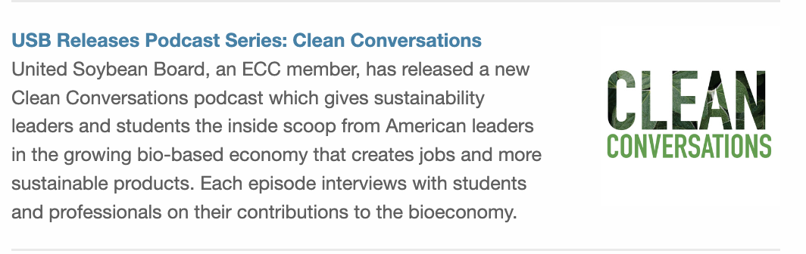
NYSCGA Grant Progress of Work 1 August 2023 Newsletter

June 20th

July 4th

