Evaluating soybean varieties to identify genetic and sources of resistance and escape against white mold, 8/30/2023
Cooperators: Megan McCaghey, Aaron Lorenz, Suma Sreekanta, Hsuan-Fu Wang, Alisha Hershman

Purpose of Study:
The purpose of this work was to develop tools for white mold resistance breeding and research in Minnesota. White mold is caused by the soilborne fungal pathogen, Sclerotinia sclerotiorum and can cause severe yield losses when conditions are suitable for disease development. One of the most effective means to control white mold is the use of resistant cultivars. This work aimed to characterize Sclerotinia sclerotiorum isolates, collected throughout Minnesota, that can be used to comprehensively screen soybean lines and study fungal biology. We are also working to compare field techniques for infesting research fields to conduct research on white mold management under more consistent disease pressure. Lastly, this project aims to define relationships between canopy architecture and S. sclerotiorum development, to provide another, underexplored consideration for disease resistance breeding for white mold. The goals of this work will set the stage for my soilborne fungi pathology lab to conduct biologically relevant white mold research in soybean and will open new, creative avenues to improve resistance to this challenging fungal disease.

Results:
PROJECT OBJECTIVES:
- GOAL: Characterize the aggressiveness of S. sclerotiorum isolates for use in future pathogen biology and resistance screening assays

This study aims to characterize Minnesota isolates in soybean to establish a range of native, biologically relevant isolates for germplasm screening and fungal biology assays in Minnesota. So far, we have developed an isolate collection of 34 isolates. Isolates were surface sterilized using 10% bleach and 70% ethanol solutions. They were then plated, bulked on carrots and stored.

Isolates of S. sclerotiorum were evaluated for their aggressiveness as indicated by lesion size on soybean over time. An “empty plug” of agar with no fungus was used as a control to show that lesions were caused by the fungus, not cutting of the petiole. Three plants were inoculated in a single pot and five pots were inoculated per isolate (15 plants per isolate) at the V4 growth stage. The treatments were arranged in a randomized complete block design in the growth chamber. Lesions were measured at 24, 96, and 120 hours post inoculation (HPI). Consistent lesions formed on plants and allowed the isolates to be compared for aggressiveness. Results of the initial screening indicated differing levels of lesion sizes and disease progression with each isolate (Figures 1 and 2). For example, MNSS4 appears to be less aggressive than MNSS6 as indicated by the lesion size (Figure 1, lavender and purple respectively) and disease progress (Figure 2, brown and green respectively).

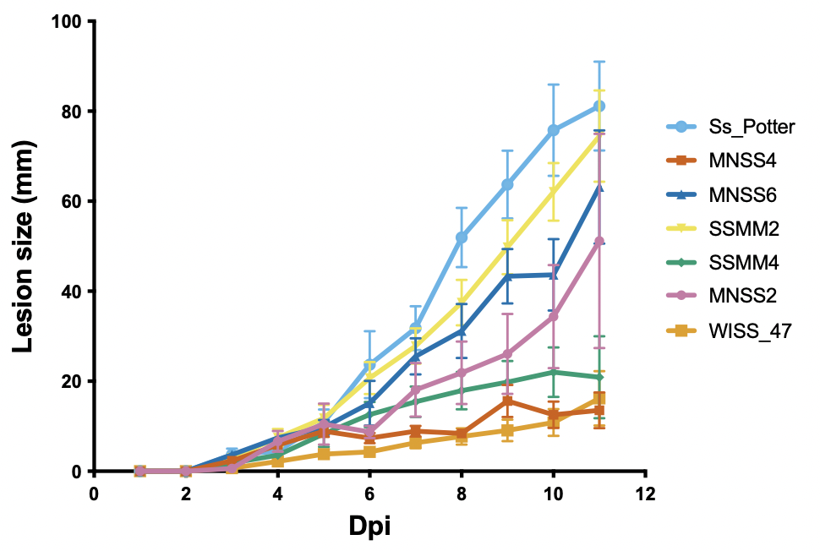
Figure 1. Lesion size on soybean from 0 to 14 days after being inoculated (DPI) with seven isolates of S. sclerotiorum with three biological and three experimental replicates.

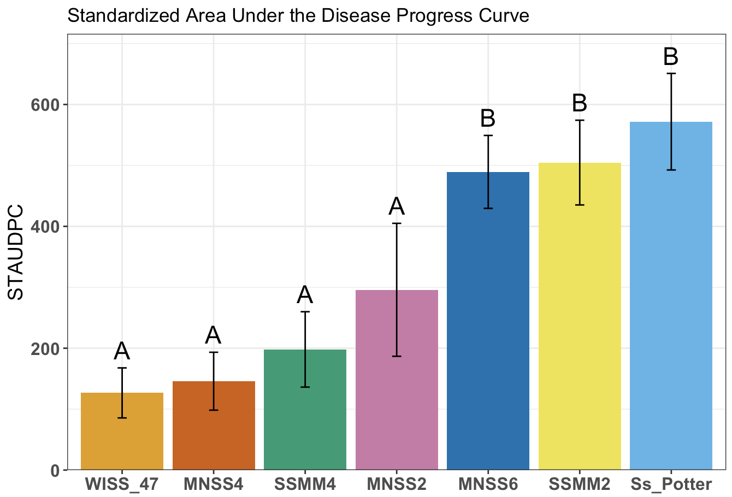
Figure 2. STAUDPC on soybean from 0 to 14 days after being inoculated (DPI) with seven isolates of S. sclerotiorum with three biological and three experimental replicates.
Graph provided by new graduate student, Hsuan-Fu Wang.

Once we identify a panel of isolates with different levels of aggressiveness, we can test whether isolates will distinguish the resistance ranking of cultivars. Using three representative isolates, this fall we will inoculate soybean check lines developed by Dr. Damon Smith’s Lab at University of Wisconsin, Madison with known low, moderate, and high levels of resistance (compared to susceptible controls) to see if resistance rankings are similar when challenged with the new, UMN isolates and whether our isolate panel can differentiate putative resistant from susceptible lines.

Additionally, graduate student Hsuan Fu has been evaluating the inoculum potential of isolates- to compare how isolates may differ in their ability to spread the disease in the next season on soybean. He has completed this for nine isolates in three experiments (5 plants each, 15 replications).

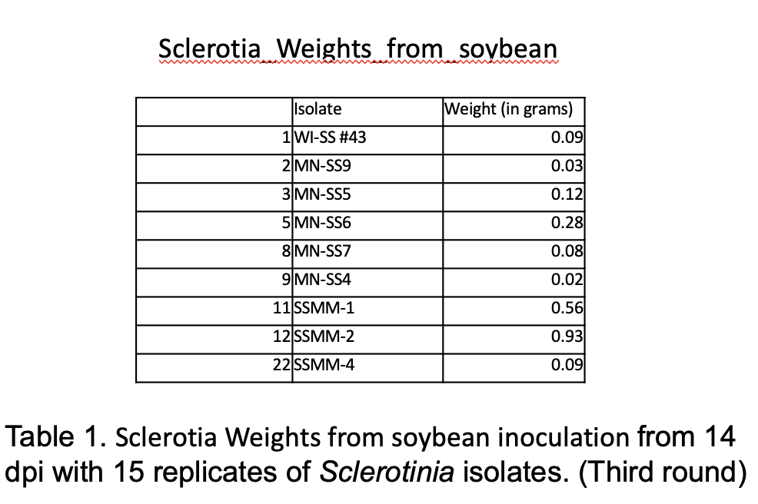

- GOAL : Define relationship between canopy architecture and white mold development
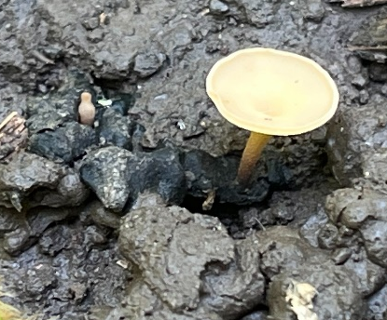
Apothecium
In addition to physiological resistance, plant architecture may be important for avoiding soybean infection by S. sclerotiorum in the field. Apothecia (the mushrooms required for infection of the pathogen) production is influenced by moisture and light (quality, specific spectra and quantity, intensity).

This spring, we used differential light data in addition to phenotypic traits including branching angle, canopy closure, and leaf area to select lines for greenhouse screenings and for field evaluations in 2023. UVB ratings from three distances from the base of the plant to the center of the row are shown in the graphs below from three different dates in 2022 for the 20 lines selected. Note that on the first two dates not all lines are represented due to cloud cover ending data collection early.

Figure 3. UVB intensity (µmolm-2s-1) in 2022 at 3 distances from base of plant for 20 lines with 2 replicates per line. On 7/22 and 7/28 not all lines or only one replicate were evaluated due to cloud cover ending data collection early.

Timing of canopy closure is also important for apothecia formation. According to literature 50% canopy closure is when peak apothecia formation is observed. Selections were also made based on timing of canopy closure and how that aligned with flowering time.

Figure 5. Average date of canopy closure in 2022 for 20 lines with 2 replicates per line

Additional selections were made based on phenotypic data from the 2022 field season. Traits including petiole slope, internode slope, leaf area, and leaf shape (lanceolate or rounded as defined by length: width ratio). A high petiole slope and internode slope meant more light penetration through the plants. Lines were chosen based on having variation amongst these traits. The below graphs show phenotypic traits for the the final 20 lines which have been selected.

B
A
C
D

Figure 6. Plant architecture traits. Mean A. slope petiole length between 1st and 4th and 1st and 5th petiole, B. internode slope length between 1st and 4th and 1st and 5th internode, C. leaflet length: width ratio, and D. leaflet area for 20 lines with 2 replicates per line and 6 plants per replicate.
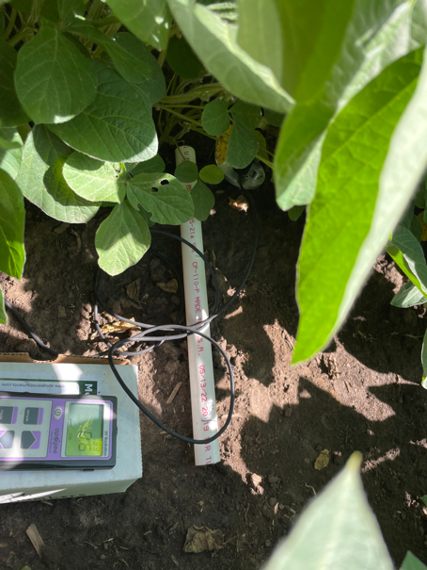
Light detection under the soybean canopy with a UVB meter
Two field trials are taking place in 2023 using the selected lines in the above figures and industry bushy and upright check lines. In St. Paul the trial was planted on 5/19/23 and sclerotia were applied on 5/16/23. Crookston field trials were planted on 5/25/23 and sclerotia were applied on 6/14/23. Both trials were irrigated during flowering to encourage disease.

Canopy closure data in St. Paul was collected using drone flights from the end of the vegetative/beginning R1 early flowering stage through canopy closure. This was completed by Suma Sreekanta, the postdoctoral researcher in the Lorenz Lab.

We scouted for apothecia in each row of soybeans using a t-shaped PVC push pole prior to flowering and at early flowering stages in St. Paul through canopy closure, when apothecia begin to develop.

UVB intensity and spectra were collected on three dates throughout canopy closure (6/30, 7/11, and 8/1).

Lines were phenotyped for architectural characteristics when most lines were at the R4 growth stage, and plants were scouted for white mold severity ~30 plants and disease incidence within plots, from the two center rows of each plot at the full pod stage (R6) on 8/23/23.

Lodging scores and yield measurements will be collected at harvest.

In Crookston, plots were severely affected with IDC this season, despite iron chelate at planting. An alternative site will be proposed for 2024.

Apothecia are being produced in the growth chamber using the Pethybridge protocol published on the American Phytopathological Society Website (apsnet.org). Light conditions in the field will be simulated in the lab to further assess light conditions that are optimal for production of apothecia.

- GOAL: Develop reliable S. sclerotiorum nurseries for future white mold field trials

Currently, researchers do not have field sites with reliable and uniform inoculum where we can conduct white mold experiments (personal communication). High disease pressure, across plots is often required to observe the impact of experimental treatments (such as variety resistance differences or fungicide efficacy).

In 2022, we initiated a trial comparing three methods to encourage uniform disease pressure for trials in 2023. These include 1) growing sunflowers, which are susceptible to white mold, inoculating them the back of the head with a slurry of S. sclerotiorum, and then incorporating residue into the soil in the fall of 2022. We also added 2) sclerotia inoculum generated in the lab on carrot seed into the field during the fall before 2023 trials. Cold conditioning over the winter should allow the inoculum to produce apothecia in the following field season. In the third method, 3) we are growing sclerotia in the lab, cold conditioning them in the fridge, and then will spring apply the sclerotia to the field. 4) Untreated, naturally infested plots will be left as controls to compare with plots treated with the described infestation methods.

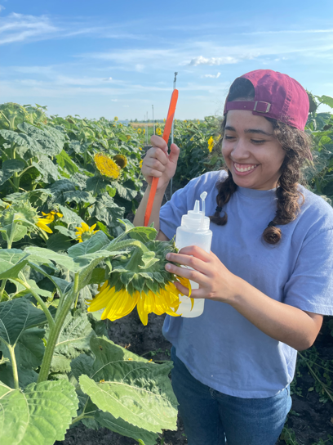
Towards this objective, plots were planted on 6/3/2022 at The Northwest Research and Outreach Center (NROC) in Crookston, MN. The variety used was an early, Phomopsis and SSR susceptible Nuseed variety, N4HM354. The trial is a randomized complete block design and each treatment is repeated six times. It was planted on 22” row spacing. Rows are 20 feet long and each treatment plot contained six rows. There is a four-foot buffer of untreated buffer between plots to prevent unintended inoculum spread. Five-foot alleys were left on the front and back of rows. These trials are misted during early flowering until beginning dry down to encourage disease development.
Sunflower Sclerotinia slurry inoculations in disease nurseries

We inoculated plots with a slurry of Sclerotinia at full flowering on 8/22/2022. Slurry was a prepared with a mixture of cultures from three isolates. We chose isolates with a range of aggressiveness. We also bulked sclerotia on autoclaved carrots will applied sclerotia in field plots in the fall, to cold condition in the field and applied ~30 ml of mixed sclerotia to plots in the spring after cold conditioning in the lab refrigerator.

In 2023 thew plots were planted in soybean, These plots will be evaluated during the R6, full pod growth stage and the incidence and severity of SSR infections will be compared. Plots were evaluated for apothecia during canopy closure. It is expected that this work will allow for more uniform, consistent disease pressure in which to compare the performance of soybean lines and treatments for white mold.

One page summary:

The purpose of this work was to develop tools for white mold resistance breeding and research in Minnesota. White mold is caused by the soilborne fungal pathogen, Sclerotinia sclerotiorum and can cause severe yield losses when conditions are suitable for disease development. One of the most effective means to control white mold is the use of resistant cultivars. This work aimed to characterize Sclerotinia sclerotiorum isolates, collected throughout Minnesota, that can be used to comprehensively screen soybean lines and study fungal biology. We are also working to compare field techniques for infesting research fields to conduct research on white mold management under more consistent disease pressure. Lastly, this project aims to define relationships between canopy architecture and S. sclerotiorum development, to provide another, underexplored consideration for disease resistance breeding for white mold. The goals of this work will set the stage for my soilborne fungi pathology lab to conduct biologically relevant white mold research in soybean and will open new, creative avenues to improve resistance to this challenging fungal disease.
So far, we have developed an isolate collection of 34 isolates. Results of the initial screening indicated differing levels of lesion sizes and disease progression with each isolate. Once we identify a panel of isolates with different levels of aggressiveness, we can test whether isolates will distinguish the resistance ranking of cultivars. Using three representative isolates, we will inoculate soybean check lines developed by Dr. Damon Smith’s Lab at University of Wisconsin, Madison with known low, moderate, and high levels of resistance (compared to susceptible controls) to see if resistance rankings are similar when challenged with the new, UMN isolates and whether our isolate panel can differentiate putative resistant from susceptible lines.
In addition to physiological resistance, plant architecture may be an important for avoiding soybean infection by S. sclerotiorum in the field. Apothecia (the mushrooms required for infection of the pathogen) production is influenced by moisture and light (quality and quantity). This spring, we used differential light data in addition to phenotypic traits including branching angle, canopy closure, and leaf area from over 150 lines (measured in 2022) to select 20 lines for greenhouse resistance screenings and for field evaluations for white mold infection in 2023. This season, we aim to better understand the interaction between light and plant architecture so that it might be used as a breeding consideration to reduce infection.
Currently, researchers do not have field sites with reliable and uniform inoculum where we can conduct white mold experiments. High disease pressure, across plots is often required to observe the impact of experimental treatments. In 2022, we initiated a trial comparing three methods to encourage uniform disease pressure for trials in 2023. These include 1) growing sunflowers, which are susceptible to white mold, inoculating them the back of the head with a slurry of S. sclerotiorum, and then incorporating residue into the soil in the fall of 2022. We also added 2) sclerotia inoculum generated in the lab on carrot seed into the field during the fall before 2023 trials. Cold conditioning over the winter allowed the inoculum to produce apothecia in the following field season. In the third method, 3) we grew sclerotia in the lab, cold conditioned them in the fridge, and then spring applied the sclerotia to the field. 4) Untreated, naturally infested plots were left as controls to compare with plots treated with the described infestation methods. In September, soybean will be evaluated in the plots and the incidence and severity of white mold infections will be compared. Apothecia density was also monitored. It is expected that this work will allow for more uniform, consistent disease pressure in which to compare the performance of soybean lines and treatments for white mold.

