Enhancing Sclerotinia stem rot research capacity and exploring new avenues of disease management through soybean canopy architecture traits
Cooperators: Megan McCaghey, Aaron Lorenz, Suma Sreekanta, Hsuan-Fu Wang, Alisha Hershman

For Additional Information: Megan McCaghey

Project Funding Provided by: Minnesota Soybean Research and Promotion Council

Purpose of Study:
The purpose of this work was to develop tools for white mold resistance breeding and research in Minnesota. White mold is caused by the soilborne fungal pathogen, Sclerotinia sclerotiorum and can cause severe yield losses when conditions are suitable for disease development. One of the most effective means to control white mold is the use of resistant cultivars. This work aimed to characterize Sclerotinia sclerotiorum isolates, collected throughout Minnesota, that can be used to comprehensively screen soybean lines and study fungal biology. We are also working to compare field techniques for infesting research fields to conduct research on white mold management under more consistent disease pressure. Lastly, this project aims to define relationships between canopy architecture and S. sclerotiorum development, to provide another, underexplored consideration for disease resistance breeding for white mold. The goals of this work will set the stage for my soilborne fungi pathology lab to conduct biologically relevant SSR research in soybean and will open new, creative avenues to improve resistance to this challenging fungal disease.

Results:
PROJECT OBJECTIVES:
- GOAL: Characterize the aggressiveness of S. sclerotiorum isolates for use in future pathogen biology and resistance screening assays

This study aims to characterize Minnesota isolates in soybean to establish a range of native, biologically relevant isolates for germplasm screening and fungal biology assays in Minnesota. So far, we have developed an isolate collection of 34 isolates. Isolates were surface sterilized using 10% bleach and 70% ethanol solutions. They were then plated, bulked on carrots and stored.

Isolates of S. sclerotiorum were evaluated for their aggressiveness as indicated by lesion size on soybean over time. An “empty plug” of agar with no fungus was used as a control to show that lesions were caused by the fungus, not cutting of the petiole. Three plants were inoculated in a single pot and five pots were inoculated per isolate (15 plants per isolate) at the V4 growth stage. The treatments were arranged in a randomized complete block design in the growth chamber. Lesions were measured at 24, 96, and 120 hours post inoculation (HPI). Consistent lesions formed on plants and allowed the isolates to be compared for aggressiveness. Results of the initial screening indicated differing levels of lesion sizes and disease progression with each isolate (Figures 1, 2 and 3). For example, MNSS4 and WISS47 appears to be less aggressive than MNSS6, SSMM2 and SSPotter as indicated by the lesion size and disease progress (Figure 2).

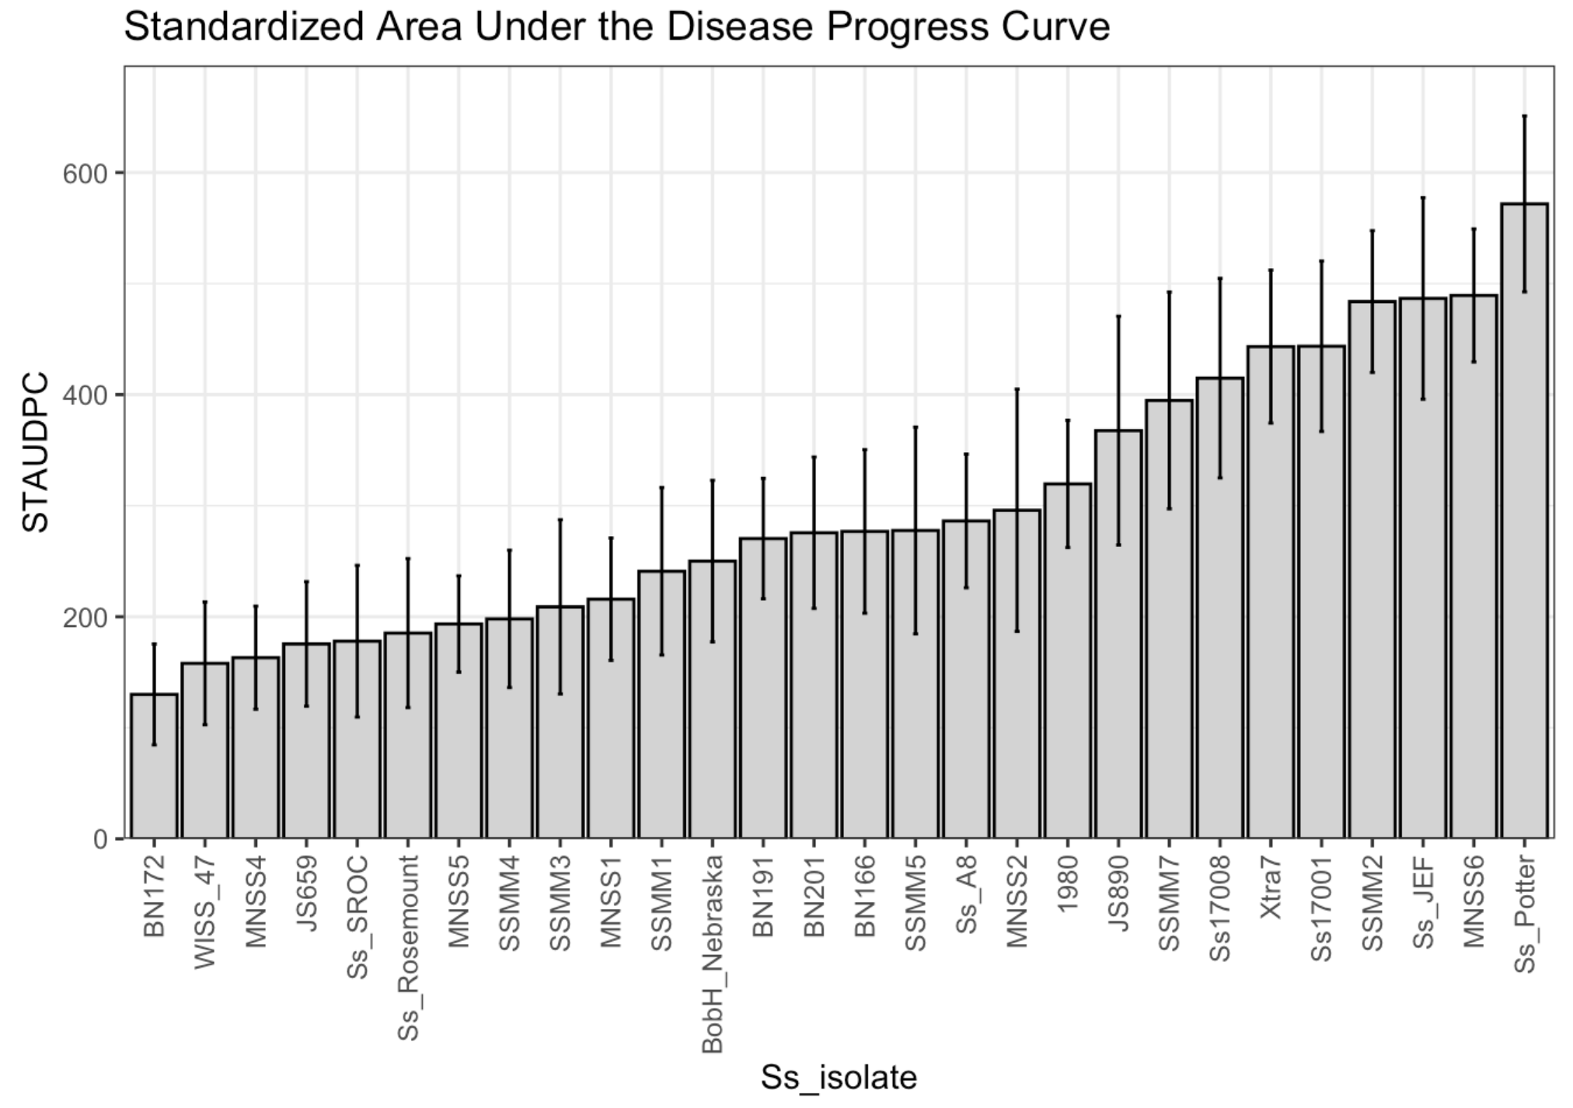
Figure 1. STAUDPC on soybean from 0 to 14 days after being inoculated (DPI) with 28 isolates of S. sclerotiorum with 5 biological replicates per isolate treatment. The experiment was performed twice.

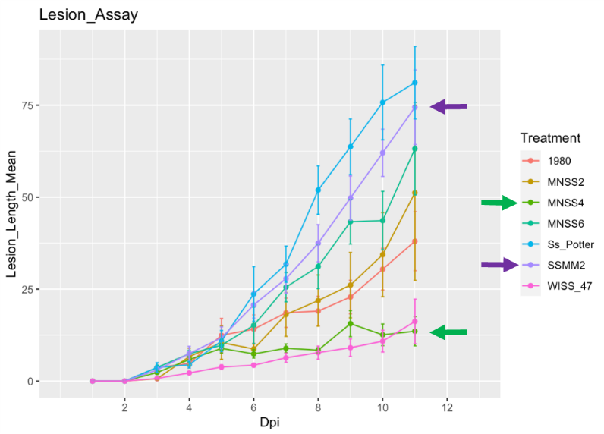

Figure 2. Lesion size on soybean from 0 to 14 days after being inoculated (DPI) with 6 isolates from MN with 5 biological replicates per isolate treatment. The experiment was performed twice.

After we identified a panel of isolates from MN with different levels of aggressiveness, we tested whether isolates distinguished the resistance ranking of cultivars. Using five representative isolates, we inoculated 4 soybean check lines developed by Dr. Damon Smith’s Lab at University of Wisconsin, Madison with known low, moderate, and high levels of resistance (compared to susceptible controls) to see if our isolates can similarly differentiate putative resistance. The experiment was conducted at the University of Minnesota, Saint Paul Campus. Two replicate trials were conducted. Six-inch pots were filled with SunGro potting media. Each trial included five pots per soybean line, arranged in a random complete block design. Plants were inoculated with a cut petiole method at the V4 growth stage in the growth chamber. μmol Observations were recorded at 1, 2, 3, 4, 7, 11, and 14 day-post-inoculation (DPI).

Stem lesions were measuredusing calipers.Significant differences in infection AUDPC were observed between soybean cultivars SSR51-23, SSR51-70, SSR52-82B, and Dwight when challenged with S. sclerotiorum isolates SSMM2, SsPotter, MNSS6, MNSS4, and WISS47 (as indicated in the table, p<0.05, Type III ANOVA and Scheffe's method). The susceptible check line, Dwight, consistently displayed the most severe infections (617 ± 7.93) when inoculated with the five S. sclerotiorum isolates (p<0.05), while the resistant check line, SSR52-82B, consistently exhibited the most resistance (104 ± 12.03;p<0.05). SSR51-23, SSR51-70, and SSR52-82B showed significantly lower infection levels compared to Dwight (p<0.05), although there were no significant differences in infection severity between SSR51-70 and SSR52-82B (p<0.05, ). Notably, isolates from SSMM2, SsPotter, and MNSS6 were consistently highly aggressive across all soybean check lines, while the S. sclerotiorum isolate from WISS47 was consistently the least aggressive on all soybean check lines.

Objectives from this goal are complete. A subpanel of S. sclerotiorum isolates has been identified and can differentiate resistance rankings of cultivars. This will provide a valuable tool for breeders and researchers in MN to screen for resistance to Sclerotinia stem rot/white mold. Because these isolates are native to MN, they can also be used to infest field soil for field-based resistance screening. The results of the work will be submitted for publication this summer Hsuan Fu, presented results of this work at Plant Health 2023 (annual professional society meeting) and at the UMN Soybean Research Field Day (poster).
Table 1. Sclerotinia sclerotiorum isolate aggressiveness screening panel applied on soybean resistance check line, 2024

Soybean variety | Screened Ss. isolate | Time pinot of observation (DPI ^{z}) | STAUDPC ^{y} | Average STAUDPC
Dwight |  |  |  | $617±7.93$^{A}
 | SSMM2 | 1, 2, 3, 4, 7, 11, 14 | $967.2±15.2$^{A}
 | SsPotter | 1, 2, 3, 4, 7, 11, 14 | $952.2±15.1$^{AB}
 | MNSS6 | 1, 2, 3, 4, 7, 11, 14 | $873.3±19.8$^{B}
 | MNSS4 | 1, 2, 3, 4, 7, 11, 14 | $663±16.2$^{C}
 | WISS47 | 1, 2, 3, 4, 7, 11, 14 | $249±17$^{E}
SSR51-23 |  |  |  | $322±9.64$^{B}
 | SSMM2 | 1, 2, 3, 4, 7, 11, 14 | $610.7±19$^{CD}
 | SsPotter | 1, 2, 3, 4, 7, 11, 14 | $508.3±22.2$^{D}
 | MNSS6 | 1, 2, 3, 4, 7, 11, 14 | $659.4±22.3$^{C}
 | MNSS4 | 1, 2, 3, 4, 7, 11, 14 | $94.2±25.2$^{GHI}
 | WISS47 | 1, 2, 3, 4, 7, 11, 14 | $62.1±19.5$^{HI}
SSR51-70 |  |  |  | $120±13.62$^{C}
 | SSMM2 | 1, 2, 3, 4, 7, 11, 14 | $215.5±25.3$^{EFG}
 | SsPotter | 1, 2, 3, 4, 7, 11, 14 | $111±47.9$^{EFGHI}
 | MNSS6 | 1, 2, 3, 4, 7, 11, 14 | $235.7±27.6$^{EF}
 | MNSS4 | 1, 2, 3, 4, 7, 11, 14 | $145.7±22.3$^{FGH}
 | WISS47 | 1, 2, 3, 4, 7, 11, 14 | $13±27.6$^{I}
SSR52-82B |  |  |  | $104±12.03$^{C}
 | SSMM2 | 1, 2, 3, 4, 7, 11, 14 | $208.2±28.1$^{EFG}
 | SsPotter | 1, 2, 3, 4, 7, 11, 14 | $67.4±34.7$^{GHI}
 | MNSS6 | 1, 2, 3, 4, 7, 11, 14 | $189.5±25.3$^{EFG}
 | MNSS4 | 1, 2, 3, 4, 7, 11, 14 | $112±24.1$^{FGHI}
 | WISS47 | 1, 2, 3, 4, 7, 11, 14 | $44.1±23.1$^{HI}
MSE ^{v} |  |  | 66667.9182

z Days Post Inoculation
y Standard Area Under the Disease Progress Curve.
x First inoculation date in first trial was 9/21/2023. First inoculation date in second trial was 11/15/2023.
w Column numbers followed by the same letter are not significantly different at P=0.05 as determined by Scheffe's method.
v Mean Square of Error are determined by Type III ANOVA in general linear mixed model

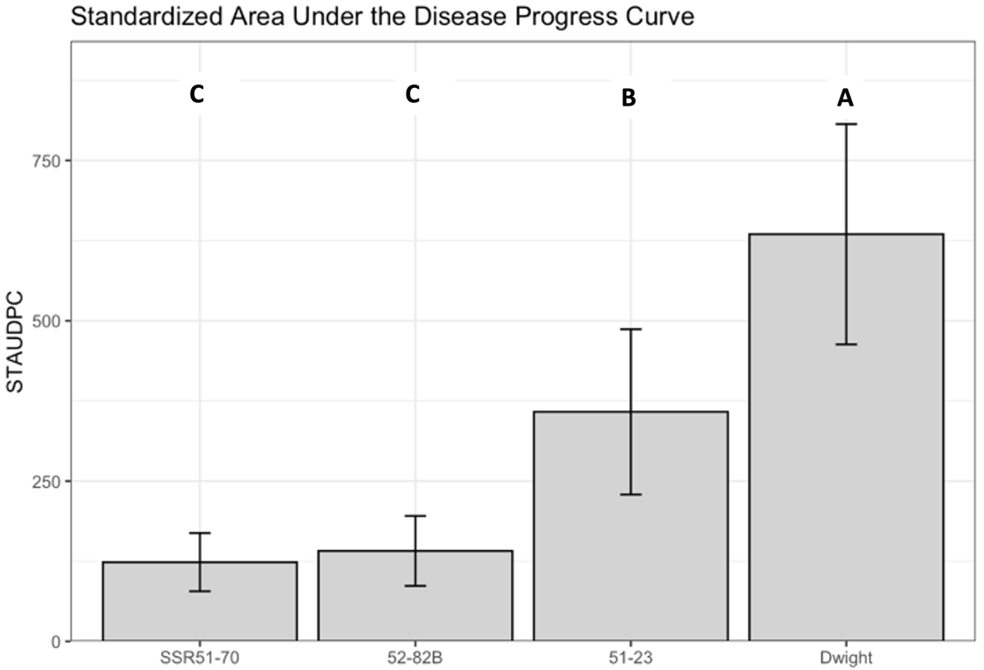

Figure 3. Area under the disease progress curve, measured 7-11 days post inoculation of soybean with S. sclerotiorum. 5 low (MNSS4, WISS47), medium (SSPotter), and highly aggressive (SSMM2, MNSS6)) isolates were used for inoculations. Five biological replicates were used per isolate treatment. The experiment was performed twice.
- GOAL: Define relationship between canopy architecture and SSR development

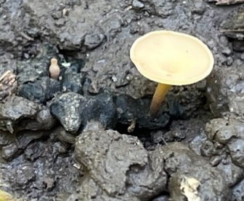
In addition to physiological resistance, plant architecture may be important for avoiding soybean infection by S. sclerotiorum in the field. Apothecia (the mushrooms required for infection of the pathogen) production is influenced by moisture, temperature and light (quality and quantity). In soybean production systems, 50% canopy coverage and greater favors apothecia development, and in a laboratory, UVB light (276-319 nm) are the most important wavelengths needed for apothecia development.
In the spring of 2023, we used differential UVB light data from three distances to the base of the plant in addition to phenotypic traits including branching angle, and leaf area collected in 2022 on an architecture panel of soybean lines to select a subpanel of lines for greenhouse screenings and field evaluations in 2023 (Figures 4 and 5).

Phenotypic traits used for selection included petiole slope, internode slope, leaf area, and leaf shape (lanceolate or rounded as defined by length: width ratio). A high petiole slope and internode slope meant more light penetration through the plants. Lines were selected to represent variation amongst these traits. The below graphs show phenotypic traits for the final 20 lines which have been selected.

A 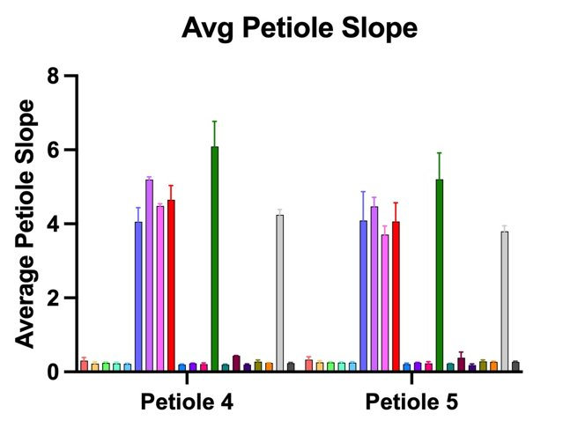 B 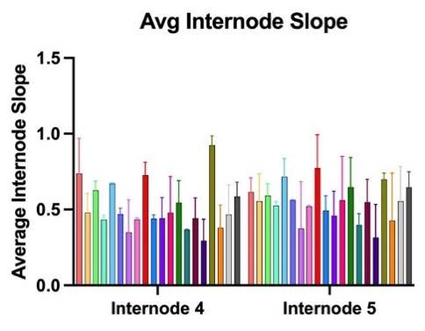 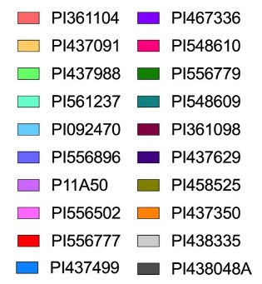
C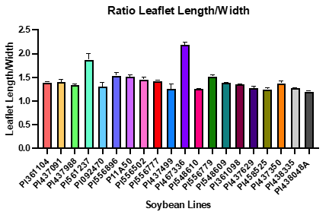 D 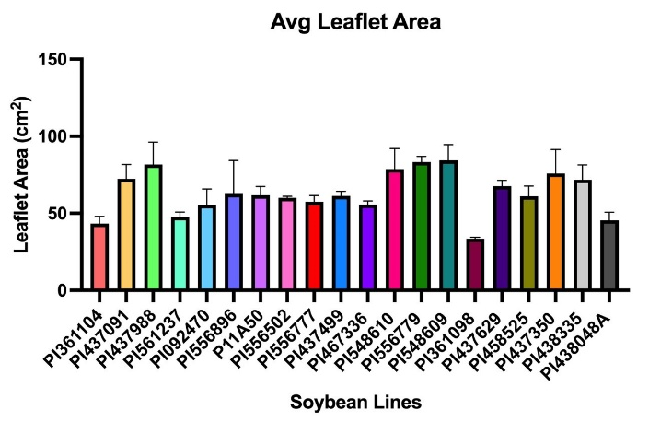

Figure 4. Plant architecture traits. Mean A. slope petiole length between 1st and 4th and 1st and 5th petiole, B. internode slope length between 1st and 4th and 1st and 5th internode, C. leaflet length: width ratio, and D. leaflet area for 20 lines with 2 replicates per line and 6 plants per replicate.

Timing of canopy closure is also important for apothecia formation, with white mold development favored by >50% canopy closure. Canopy closure was evaluated in St. Paul using drone flights from the end of the vegetative/ R1 early flowering stage through canopy closure. Drone flyovers took place 1-2 times per week to evaluate the percentage of canopy coverage. 2022 selections were made based on the alignment of canopy closure with flowering time (Figure 5).

Figure 5. Average date of canopy closure in 2022 for 20 lines with 2 replicates per line.

Two field trials were conducted in 2023 using the selected lines in the above figures and representative industry bushy and upright lines.The fields were established in a randomized complete block design. In St. Paul the trial was planted on 5/19/23 and sclerotia inoculum were applied on 5/16/23. Crookston field trials were planted on 5/25/23 and sclerotia inoculum were applied on 6/14/23.

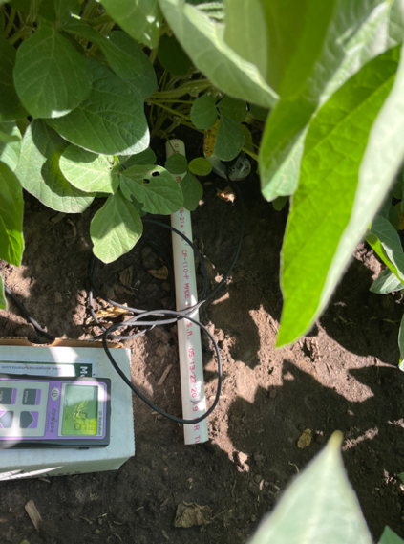
Like in 2022, light measurements were taken using a UVB meter at the end of vegetative stages to complete canopy closure (Figure 6). Canopy closure corresponded to R4 for most lines. UVB captures that spectrum of wavelengths considered to be the most important for apothecia production. Measurements were conducted in the morning starting between 9:30 and 10am and ending around 12:30pm on days with no cloud cover that might block the UVB penetration to the ground. Measurements were captured in the center of each two rows facing east at 0", 7.5", and 15" from the base of the plant for St. Paul and 0, 6”, and 12” in Crookston due to row spacing being 30” in St. Paul while it is 24” in Crookston plots. In St. Paul light measurements were completed on 6/30, 7/11, and 8/1. Spectroradiometer readings to capture a complete light spectrum were collected from lines with very different levels of light interferences: 3 with high light, 3 with low light, 1 with medium light based on 2022 data. Spectra were also captured from the two industry check lines (bushy and upright). The same distances were used for the spectroradiometer measurements. One replicate full spectrum measurement under these lines was completed on 7/1 and five replicates were completed on 7/28. Both UVB and spectroradiometer readings were collected on 7/6 in Crookston, with this being the only date for data collection due to severe IDC.
Light detection under the soybean canopy with a UVB meter
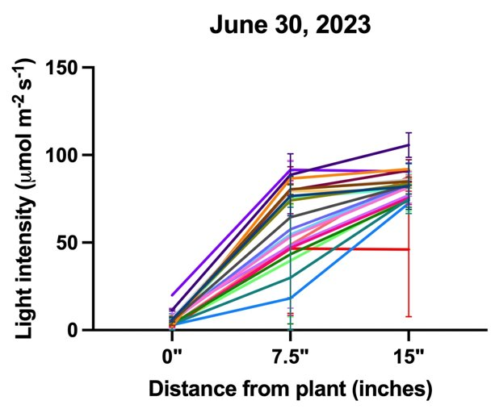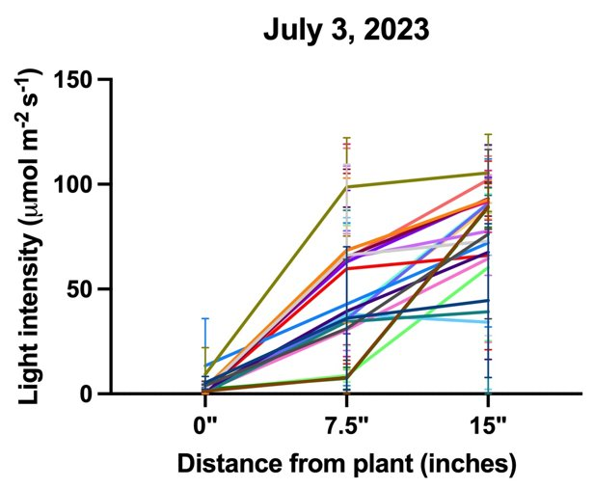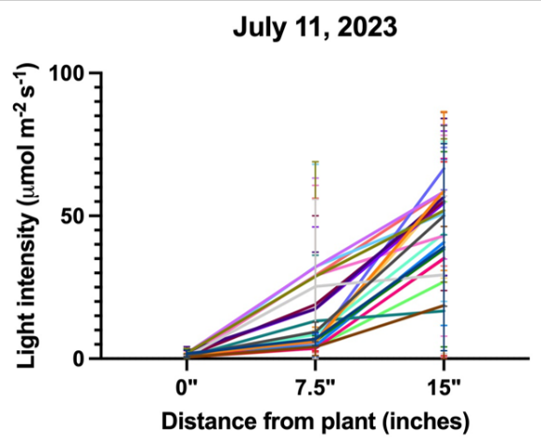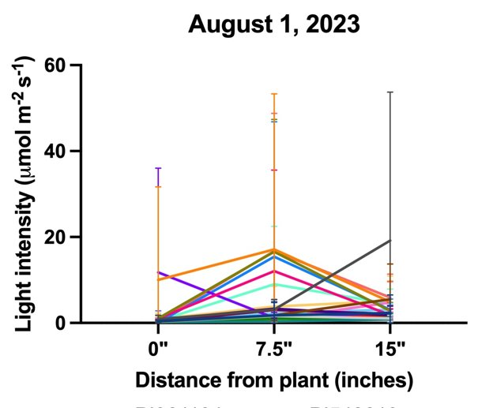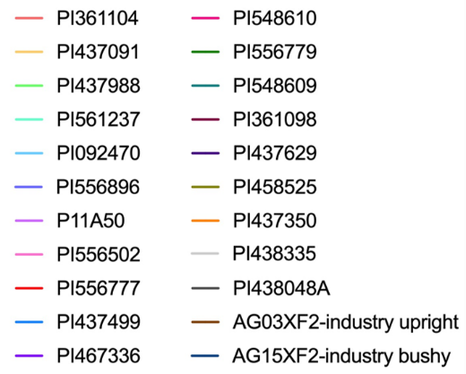
Figure 6. UVB intensity (µmol/m²s) in 2023 at 3 distances from base of plant for 20 lines chosen and 2 industry checks with 5 replicates per line.

Soil moisture is also important for the development of apothecia. Irrigation was established during the first full week of July to encourage apothecia formation. In 2024, we will establish irrigation by June vegetative stages, prior to canopy closure. Soil moisture was measured in 3 blocks on 7/20 and all blocks on 7/28 in St. Paul (figure 6) and was similar beneath lines. A mist irrigation system was established in Crookston during the first full week of July which is when flowering is estimated to have begun.

Figure 6. Average soil moisture percentage (%) on 07.20.23 and 07.28.23 by genotype

Imaging for phenotyping of the traits mentioned above took place around the R4 stage. Phenotyping in St. Paul took place 8/2-8/4 on 4 blocks. Analysis of the images is in progress.

We scouted for apothecia in the middle two rows of soybeans using a t-shaped PVC push pole and square, 3’ quadrats on each side prior to flowering and at early flowering stages in St. Paul through canopy closure, when apothecia begin to develop. Scouting in St. Paul took place on 6/29, 7/10, 7/17, and 7/31. No apothecia were found on these dates. One apothecium was found on 8/3 when most plots were at R4. This growth stage is past when infection typically occurs (R1-R3). One scouting was completed in Crookston on 7/5. Unfortunately, the field in Crookston was severely impacted by iron deficiency chlorosis (IDC) and symptoms were already apparent on this date. We suspect high temperatures and drought conditions early in the summer may have delayed or inhibited apothecia formation.

Bromophenol blue plates were used to detect the presence of ascospores, the spores that infect senescing flowers. Plates were put into the field at a 45-degree angle upwind for 1-3 hours in the morning (as dew evaporates) and incubated at room temperature for 2-3 days. If spores are present, the blue plates develop a yellow halo around spores due to a change in pH induced by the fungus. In St. Paul, plates were put out in the select lines that spectroradiometer readings were taken from on 8/2 and checked on 8/4 and 8/5. Distinct halos were observed on 8/5 (Figure 7).
Figure 7. Average number of yellow colonies by genotype observed on bromophenol blue plates

Finally, disease rating was conducted at R6, the growth stage where infections are known to be correlated to yield loss (Figure 8). Disease incidence and severity was completed on 8/23 with majority of lines at R6. The disease severity index by taking the number of diseased plants per plot times the disease severity score divided by the number of plants in the middle rows of the plot where plants were evaluated.

Figure 8. Disease Severity Index by genotype in 2023

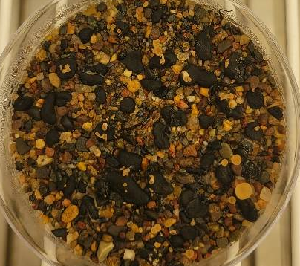
Apothecia are being produced in the growth chamber using the Pethybridge protocol published on the American Phytopathological Society Website (apsnet.org). Optimization of this protocol is in progress testing fluorescent lights on wire racks in the lab and using a bucket in a cold-room for cold conditioning. Once a protocol is well-established to form consistent apothecia, filters will be used on top of petri dishes to modify light quality and quantity to the sclerotia simulating field conditions to help understand light requirements for apothecia formation.
Apothecia in the growth chamber grown in sand
Additionally, the subset of 20 soybean lines used in the field were challenged along with a susceptible check line, Dwight, and a moderately resistant with S. sclerotiorum in the greenhouse this winter to assess their genetic resistance. Three MN isolates, from Goal 1, with a range of aggressiveness were used. A cut petiole method was used to challenge plants as was done for Goal 1. The first round was completed in December and a final round was initiated and completed in April The standardized area under the disease progress curve for the two experimental runsis presented in figure 9.

Figure 9. Lesion progress in mm from 4-16 days post inoculation (dpi) and standardized area under the disease progress curve (SAUDPC), two experimental replications.

- GOAL: Develop reliable S. sclerotiorum nurseries for future SSR field trials

Currently, researchers do not have field sites with reliable and uniform inoculum where we can conduct white mold experiments (personal communication). High disease pressure, across plots is often required to observe the impact of experimental treatments (such as variety resistance differences or fungicide efficacy).

In 2022, we initiated a trial comparing three methods to encourage uniform disease pressure for trials in 2023. These include 1) growing sunflowers, which are susceptible to white mold, inoculating them the back of the head with a slurry of S. sclerotiorum, and then incorporating residue into the soil in the fall of 2022. We also added 2) sclerotia inoculum generated in the lab on carrot seed into the field during the fall before 2023 trials. Cold conditioning over the winter should allow the inoculum to produce apothecia in the following field season. In the third method, 3) sclerotia produced in the lab were cold conditioned in the fridge and applied in the spring to the field. 4) Untreated, naturally infested plots will be left as controls to compare with plots treated with the described infestation methods.

Towards this objective, sunflower plots were grown in 2022 at The Northwest Research and Outreach Center (NWROC) in Crookston, MN. The variety used was an early, Phomopsis and SSR susceptible Nuseed variety, N4HM354. The trial is a randomized complete block design and each treatment is repeated six times. It was planted on 22” row spacing. Rows are 20 feet long and each treatment plot contained six rows. There is a four-foot buffer of untreated buffer between plots to prevent unintended inoculum spread. Five-foot alleys were left on the front and back of rows. These trials are misted during early flowering until beginning dry down to encourage disease development. Treatments with sunflower incorporation were inoculated near the end of August 2022 at full flowering using a slurry mixture of culture from 3 isolates chosen with a range of aggressiveness, based on the results displayed in Table 1. Sclerotia bulked on autoclaved carrots in the lab were sprinkled by hand in field plots in the fall, to cold condition in the field. Spring applied sclerotia also bulked on carrots were cold conditioned in the lab refrigerator over fall and winter. We used 30 ml of sclerotia per plot.

In 2023, Soybean variety NKS008-E3 was planted in all plots including buffer rows on 5/23/23. Spring applied sclerotia were sprinkled by hand on 6/23/23 as described above with 30ml of sclerotia per plot. A walkthrough for apothecia took place on 7/5 and 7/18 but no apothecia were observed. On 7/5 some iron deficiency chlorosis (IDC) was observed on 7/18 the plants appeared to be recovering from the previously observed iron deficiency. No disease was observed when rated on 9/8/23. A lackof canopy closure from stunted plants likely contributed to lack of disease. Spring application of inoculum successfully created disease pressure in St. Paul field for architecture portion of this project. This year, our research white mold plots will be replicated in Waseca instead of Crookston to achieve better agronomics.
