Maryland Soybean Board Final Report 2019
Title: Improving Detection of Dectes Stem Borer for Developing Spray Recommendations in Soybeans

Principal Investigator: Alan Leslie
Co-Principal Investigators: Kelly Hamby
Emily Zobel
Edwin Afful
Cerruti Hooks

Introduction
Dectes stem borer (DSB; Dectes texanus) is a native species of long-horned beetle that can be a sporadic pest of soybeans. Damage to soybean plants is caused by the larvae, which feed internally on soybean stems. As the plant reaches maturity, the larvae girdle the main stem at the base of the plant, which can cause lodging before soybeans are harvested, resulting in heavy yield losses. Recently, Maryland soybean producers have reported increased incidences of DSB infestation, and resulting yield loss from plant lodging prior to harvest. Management options for this pest are limited, as the eggs, larvae, and pupae are protected from insecticides by tunneling inside of the soybean plant. The main objective of our research was to learn more about the biology of DSB to improve our knowledge of the timing for insecticide sprays and quantify the damage caused by larval feeding to develop management options for soybean farmers. Results of this work will allow us to estimate yield increases that would be possible under different management options.
Objective 1
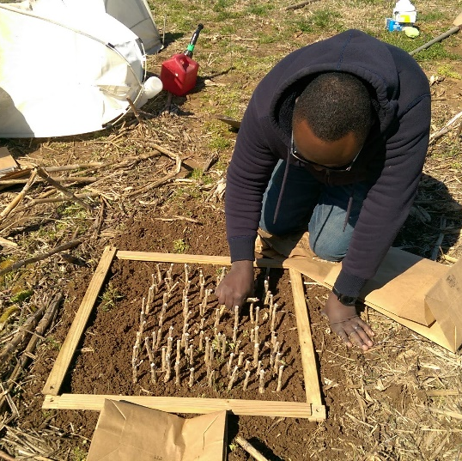
Our first objective was to determine periods of peak DSB adult emergence as a way to inform soybean farmers of the best time to best apply insecticides to control the adult beetles. To this end, we monitored emergence of adult beetles using emergence cages. We collected soybean stems from the previous year’s soybean crop at two university research farms in February and placed them in the field at three research farms across the state to monitor emergence of adults through the season (Fig. 1). Locations of emergence cages were chosen to represent a gradient of temperatures in Maryland to determine whether there is a correlation between adult emergence and daily mean temperatures. At each site, two emergence cages were placed in fields that were planted in corn the previous year. The soil was tilled to incorporate residues, and 100 soybean root crowns with evidence of DSB infestation were buried to approximately the same depth they were in the field prior to collection. Soybean stubble originating from each collection site were kept separate to test for differences between site of origin.
Figure 1 DSB infested soybean stubble being planted in tilled ground to be covered with emergence cage to monitor adult emergence
Emergence cages were monitored on a weekly basis through the spring and summer until no further adult beetles were captured for at least 3 straight weeks. From monitoring adult emergence, we found that adults emerge over an extended period of time with a single peak in adult emergence in mid to late July (Fig. 2). Monitoring infested stems also showed that adults emerge from overwintering sites over an extended period of time, with emergence occurring over five to six weeks at different sites, which contributes to the prolonged presence of adults in soybean fields as measured in previous years. In addition, emergence of adult beetles seems to be correlated with temperatures at the respective sites, with beetles beginning and completing their emergence earlier when placed in warmer areas (Fig. 3). Digital temperature monitors placed in each of the cages quantified the difference in temperatures experienced at each of the farm locations. The earliest adult emergence from stubble was measured on July 4 at the research farm in Salisbury on the lower Eastern Shore, and the final emergence was observed on August 11 at the Keedysville farm in western MD.
Figure 2 Adult dectes emergence over time from emergence cages, dashed lines are soybeans collected from WyeREC, solid lines collected from LESREC
Objective 2
Our second objective was to determine whether putative sex pheromones produced by the adult beetles could be effectively used as lures in monitoring programs at the field scale. We collaborated with Dr. Jocelyn Millar at the University of California Riverside to determine whether chemicals produced by adult DSB function as a long-distance pheromone to attract mates, as they do in other species within this beetle family. We deployed a range of different types of insect traps baited with either the putative pheromone or a solvent control. Since we have had only low captures of DSB adults in baited traps tested in the past, we wanted to test a range of trap architectures to maximize chances of success. We tested universal traps, Japanese beetle traps, panel traps, sticky card traps, and Lindgren funnel traps. We found some support for the attractiveness of the pheromone compared to the control, however overall captures were again low, with only 9 beetles captured. Of the 9 beetles captured, 7 were captured in pheromone baited traps, and 2 in control traps. Males represented 7 of the 9 beetles captured in traps, including 2 in the control baited traps and 7 in pheromone-baited traps. Sticky card traps and panel traps were the only trap types to successfully collect beetles, with 4 in the panel traps and 5 in sticky traps. These results indicate that the synthetic pheromone is not extremely attractive to adult beetles at the field scale. Further lab-based studies are needed to clarify the behavioral response of male and female beetles to the putative sex pheromone before it can be used at the field scale as a monitoring tool. In addition, these results indicate that the cheapest trap type shows promise as an effective monitoring tool for DSB, which may eventually lead to a cost-effective monitoring tool for this insect.
Figure 3 Percent emergence of adult dectes over time from emergence cages, dashed lines: WyeREC, solid lines: LESREC
Objective 3
Our third objective was to update and disseminate educational materials on this insect pest, including recommendations for management. To this end, we measured infested and un-infested soybean plants from six different farms across the Eastern Shore to determine the amount of yield loss incurred from feeding by DSB larvae in the absence of soybean plant lodging. To do this, we sampled approximately 250 soybean plants from six different farms with varying levels of DSB infestation. For each plant, we measured total height, maximum stem diameter, and number of main branches of each plant, and then counted and weighed pods and seeds. We then split the stems of each plant to determine whether that plant contained a DSB larva. Analysis showed that, within a field, larger diameter soybean plants are more likely to be infested with DSB than smaller diameter plants, and that on average these larger diameter plants have higher yield than other plants. After correcting for differing plant size, our analysis determined that feeding by DSB larvae had lower yield than predicted for individual soybean plants, however this difference was not statistically significant. In the previous two years of data, we were able to show a 10% reduction in yield when plants were infested with DSB in 2017, and no significant effect of DSB in 2018. Differences in findings from the two years are likely due to major differences in growing conditions between the two field seasons. The 2017 field season represented more or less typical growing conditions for the area, 2018 was an abnormally wet year, and 2019 was an abnormally dry year. When the three years are analyzed together, there is a significant effect of DSB infestation, with a 6% reduction in yield, on average, across years in plants infested with DSB. By analyzing the patterns from the three years of data, our current hypothesis is that abnormally wet years (2018) compensate for any potential disruption of vascular functions in soybean plants caused by larvae feeding (Fig. 4). This effect has also been seen in irrigated soybean fields, where losses to DSB are generally lower. In abnormally dry years (2019), yield was consistently low across all plants because of drought stress, so feeding damage by DSB did not further reduce yield by a significant margin. In normal growing years (2017), DSB feeding seems to have a greater impact on larger plants with higher yield potential.
Conclusions
Given the results of the three years of study, we conclude that spraying to reduce feeding pressure by DSB will not result in economic returns if lodging losses can be minimized by timely harvest. Yield loss from feeding alone averaged approximately 6% over the three years of study, and the highest recorded infestation rates were still less than 50% across entire fields. Given that adults emerge over a period of 5-6 weeks from overwintering sites protected from insecticidal sprays, repeated insecticide application is not warranted for at best a 3% yield increase. Priority should be given to scouting fields during the growing season for infestation levels, and scheduling harvest of heavily infested fields first to prevent lodging losses. Previous years sampling has shown that sweep net captures do not accurately predict infestation levels, so sampling larvae should be performed, either in-season by splitting stems of living plants or between seasons by examining stubble from the previous crop.
Figure 4 Predicted versus actual yield for individual soybean plants infested with DSB larvae. Points above the line have greater than expected yield, while points below the line have lower than expected yield, given plant architecture
Although not an explicit objective of this study, several anecdotal observations suggest that even a single season of rotation to other grain crops can dramatically reduce infestation levels during the following cropping season. For example, the field with the highest levels of infestation during the first year of study (~38%) reduced infestation levels to ~11% after a single year of rotation to corn. In 2019 sampling, the highest infestation rates were measured from fields that have been in continuous soybean for decades. Corn and sorghum are non-hosts for DSB, which would force existing populations to move out fields to find suitable hosts if those crops are planted in rotation. Many of the fields sampled in this study that have been planted in continuous soybeans were done so for economic reasons; either farmers did not have equipment to plant and harvest corn, or the fertility of those specific fields would not result in a profitable crop of corn or other summer grains. Although not measured in this study, multiple stressors acting on soybean plants are likely contributing to yield loss in these fields, including overall low fertility/yield potential, build-up of disease and other pest species, as well as the buildup of DSB populations. Maximum infestation levels measured in soybean fields across Maryland’s Eastern Shore (28-47%) are well below levels reported from other areas of the country (80-100%). Lodging losses from DSB infestation may simply be a more drastic visual representation of other underlying problems in these fields. This hypothesis is supported by observations made at the university research farms. The research farms had no history of major losses to lodging from DSB, even though they had fields with infestation levels comparable to other fields where DSB was reported as a problem. Given these results, rotation and timely harvest of infested fields are more likely to reduce losses to DSB feeding than insecticide application.

