December 3, 2018
Impact of Storage Environments on Green and Semi-Green Soybeans
Kenneth Hellevang, Ph.D., P.E.
North Dakota State University
Email: kenneth.hellevang@ndsu.edu

Co-Investigators: Ewumbua Monono, Research Specialist; Jasper Teboh, Soil Scientist; and Ibukunoluwa Ajayi-Banji, Ph.D. Student
- Objectives of the research
- Evaluate the physical appearance, primarily the color of green and partially green soybean over time stored at different storage conditions (40°F and 70˚F, about 12% and 17% moisture content, with and without light, and with and without aeration)
- Evaluate the effect of these storage conditions on oil quality, including free fatty acid and peroxide content.
- Completed work
The Soybeans were grown and harvested from fields at the Carrington Research Extension Center at three different maturity stages (R6, R7, and R8) which are fully developed soybeans that are green beans, semi-green beans (approximately 25% to 50% yellow), and yellow seeds (control). Harvesting was done on August 31 for R6, September 5 for R7, and September 27 for R8 samples. The soybeans were grown by Jasper Teboh and he provided guidance on when to harvest to obtain the different maturity stages.
A plot harvester could not combine the soybean at the R6 and R7 maturity stages. Therefore, R6 and R7 samples were harvested with a forage harvester and the pods were manually removed from the plants. The samples were refrigerated at 40 F during the pods removal process which took approximately 4 weeks and lots of man hours.
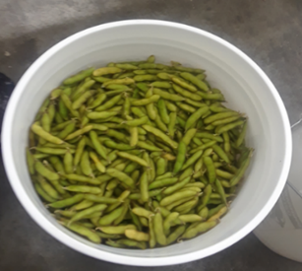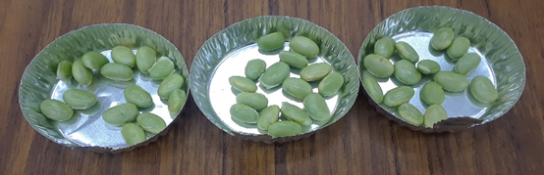
R6 green soybean pods removed from plant prior to drying

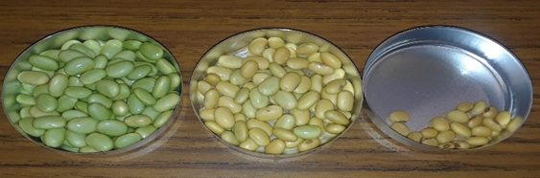
R7 green/semi-green soybean pods removed from plant prior to drying plant prior to drying

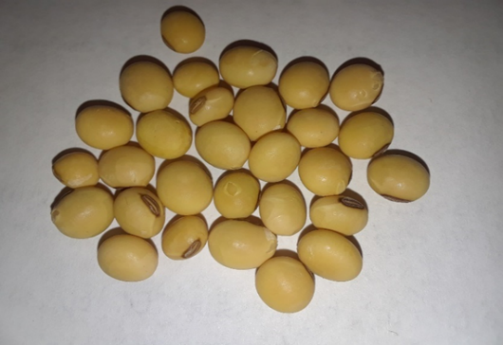
R8 sample was fully matured; therefore, it was harvested with a combine harvester.

The green beans could not be removed from the pods using a normal soybean sheller at the harvest moisture content. A green pea sheller was purchased, but it was only marginally successful and it required feeding individual pods through the unit. The soybeans were partially dried in a laboratory dryer that moved dry warm air through trays of beans. After drying, the bean sheller in the Plant Sciences Department was used to remove the soybeans from the pods.

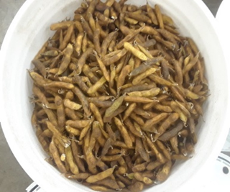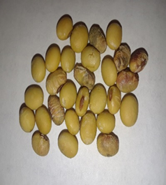

Storage environment boxes were designed and built to permit storing the beans at the desired storage conditions. 1) No aeration and no light, 2) No aeration and light, 3) Aeration and no light, 4) Aeration and light (florescent light), and at 5) 40°F and 70˚F. Soybeans that are not being aerated are stored in sealed plastic bags and the aerated beans are stored in mesh bags. The soybeans were conditioned to about 12% and 17% moisture content.
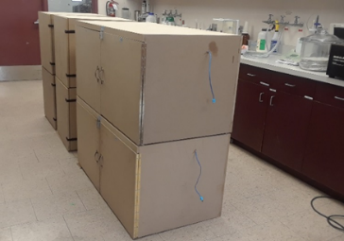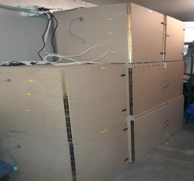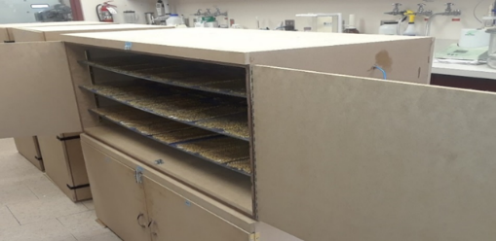
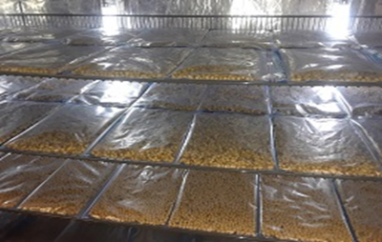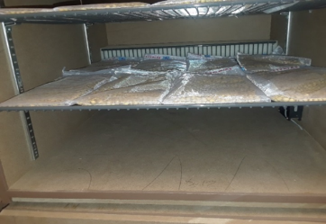
Soybean storage period started on October 22, 2018. Samples will be collected and analyses completed every two weeks for 2 months, thereafter monthly for the next 4 months. One month data has been collected so far.

- Preliminary results
The storage period is just beginning, but much has be learned already.
High moisture soybeans developed a dark brownish color coating on the beans while being stored at harvest moisture in the cooler at 40°F before starting the storage period. This indicates that very wet soybeans can only be stored for a short duration even at cool temperatures. The moisture content of the R6 beans was about 60% w.b.
The soybeans changed color in the dryer during drying even when using relatively cool drying air temperatures of approximately 90˚F. Even though much of the green color changed to a golden color, there was still a green tone to the color. This was very apparent in comparing the dried beans color to the golden color of field matured beans.
R6 soybeans stored in a freezer show a major amount of green color.

- Work to be completed
Samples will be collected at six time intervals 0, 2, 4, 8, 16, and 24 weeks. The samples will be analyzed for moisture content, color, and oil quality. The color will be measure using a Konika Minolta Colorimeter. The oil quality analysis will be acid and peroxide values based on AOCS Official titration Method Ca 5a-40 and Cd8-53, respectively. A statistical software, Minitab will be used to analyze results.

