Liming Impacts of Soybean Yield and Quality
Chris Augustin, Brian Jenks, Gary Willoughby, Tiffany Walter
Introduction
Soil pH is the activity of the hydrogen ion (H⁺) and measure by the negative log concentration of H⁺. That is why as pH decreases, acidity increases. North Dakota soil pH has historically been alkaline. However, several fields west of highway 83 now have a soil pH less than 5.5. The cause of the soil acidification is believed to be caused by nitrogen fertilizers. As nitrogen fertilizers convert into plant available nitrate, H⁺ is released and acidifies the soil. Over time, H⁺ accumulates and can turn the soil acidic which reduces yields. Soil acidity is rarely found throughout an entire field. Soil acidity tends to be found in depressional or summit areas. Precision agriculture can help pinpoint acidic areas.
Acidic soils reduce yields because of reduced soil microbial activity, aluminum toxicity that stunts root growth, and reduced nutrient availability such as phosphorus tie-up. Acidic soils can be managed by the application of lime. Lime is calcium-carbonate. Lime raises soil pH because carbonates react with H⁺. This produces free calcium, carbon-dioxide, and water. Many states have developed lime recommendations based on their clay type, parent materials, and climate. Acidic soils in North Dakota are a new issue and consequently, lime recommendations have not been developed here. Commercial ag lime is not readily available in North Dakota. However, sugarbeet waste lime (beet lime) is readily available from sugarbeet processing factories. Beet lime is a by-product of the sugar refining process. Beet lime was used as the liming agent for this project.
Materials and Methods
Experimental plots were treated with 0 (check), two, four, and eight tons of sugarbeet waste lime (beet lime) by hand application in 2018. Beet lime was soil incorporated shortly after the application with a field cultivator. Beet lime is made up of more than just the acid neutralizing carbonates and has nitrogen, phosphorus, various micro-nutrients, and organic matter. The beet lime used for this project contained 73% calcium carbonate, 3% nitrate, 3% phosphorus, and trace amounts of zinc, copper, and manganese. The actual amount of calcium carbonate applied was 0, 1.5, 2.9, and 5.8 tons/ac.
Results
Each beet lime treatment increased soil pH (Figure 1) and decreased extractable aluminum (Figure 2). Aluminum toxicity becomes an issue when the soil pH is less than 5.5 and extractable aluminum is greater than 25 ppm. Aluminum toxic plant root growth tends to be malformed and reduced.
Aluminum toxicity was possible with the beet lime applications of zero and two tons/ac. However, aluminum toxic symptoms were not observed. The beet lime applications of four and eight tons reduced soil extractable levels to less than two ppm (Figure 2). Soil pH was greater at the eight tons/ac beet lime treatment than the four tons/ac beet lime (Figure 1). However, the data suggests that beet lime applications of four and eight tons/ac reduced soil extractable aluminum to similar levels.
The average soil calcium carbonate content was 0.29% and similar across all lime treatments (p-value 0.556). This indicates that within two years, the lime treatments reacted with the soil acidity. Future use of nitrogen fertilizer will likely re-acidify the lime applied soil. This study site will be monitored annually to gather important information on the frequency of re-liming.
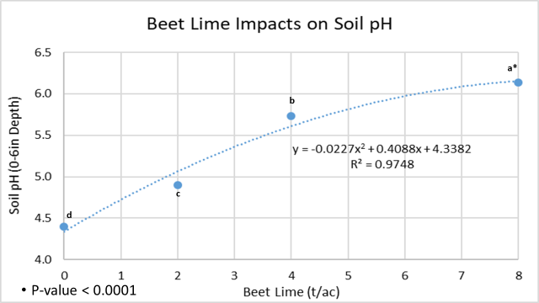 Figure 1. The relationship of hand applied and incorporated beet lime on soil pH at the 0-6 inch depth. *Different letters indicate statistical differences at the 0.05 level.
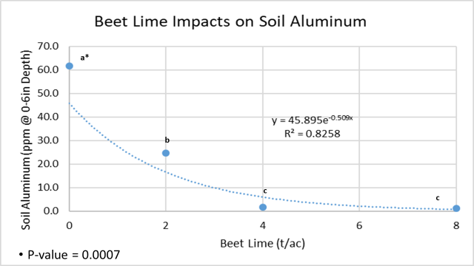 Figure 2. The relationship of hand applied and incorporated beet lime on soil extrable aluminum at the 0-6 inch depth. *Different letters indicate statistical differences at the 0.05 level.
Beet lime applications improved soil pH and soil extractable aluminum. However, lime did not impact yield or quality of soybean grain. The analysis of variance determined that the average soybean yield was 23 bu/ac with a variance of 87.5 and a p-value of 0.586. Beet lime treatments did not impact soybean oil or protein content at the 0.05 level. The 2020 growing season was droughty and likely caused the lack of no plant response from the beet lime treatments.

Conclusions
All beet lime treatments increased soil pH, and decreased soil extractable aluminum. This data suggests that four tons beet lime/ac (2.9 tons calcium carbonate/ac) is an effective rate to improve soil pH and soil extractable aluminum. Yield and quality of soybeans were not impacted by beet lime treatments. However, the droughty conditions from the past few growing seasons likely caused a lack of soybean response from the treatments.

