Characterization of Phytophthora sojae and Phytophthora sansomeana Populations in the North Central Region AND an Assessment of Management Strategies
Dr. Anne Dorrance (OSU, Principle Investigator), Loren Giesler (Univ of Nebraska), Alison Robertson (Iowa State), Santiago Mideros Mora (Univ. of Illinois), Martin Chilvers (Michigan State), Emmanuel Byamukama (South Dakota), Dean Malvick & Jim Kurle (Univ of Minnesota), Doug Jardine (Kansas State), and Guohong Cai (USDA-ARS, Purdue)
Progress on Proposed Research – Year 2
The team and their students and staff are tentatively scheduled to meet in Chicago on December 6th, following the Corn Disease Working Group and in conjunction with ASTA
1. Recover P. sojae from fields within each state and characterize for pathotype and genetic diversity.
Soil collection and baiting of 25 to 50 locations is mostly complete for those states that were going to participate. In addition, we have 17 locations from Kentucky. With close to a total of 1450 isolates we have completed the isolation process and are moving into characterizing these isolates. The fall and winter will be spent working on this part of the project.
- In Minnesota sampling is complete. Samples were collected from 66 locations in 57 counties. All P. sojae isolates (113) have been pathotyped. The Minnesota P. sojae isolates consisted of 19 pathotypes. Pythium spp. were present in 43 of the 66 Minnesota samples.

2. Evaluate the new sources of resistance to these regional populations.
Seed was increased again in 2018 as the quality due to weather conditions and total amount was low for some lines from 2017. We did spray with fungicides in the hopes of improving quality but we have had ~5” of rain in the last 2 weeks. An agreement to share this germplasm is in place and has been signed by some states. However, we are unable to obtain the new material for Rps11 from Purdue. We may have access to the plant introduction for this one.
- Minnesota has obtained seed with potentially novel R-genes RpsUN1 and RpsUN2. These sources of resistance will be tested for resistance to pathotypes found in Minnesota.

3. Recover P. sansomeana from fields within each state and characterize for host range, genetic diversity.
Almost 100 isolates of P. sansomeana have been collected in total throughout the region and they will be characterized this fall and winter. Host range studies, sources of resistance, and efficacy of seed treatments are all in progress.
- In Minnesota all isolates that appeared to be P. sansomeana on basis of cultural and morphological characteristics were genotyped. None of the isolates were P. sansomeana. P. sansomeana was not found In fields sampled in this survey.

4. Establish sensitivities (EC₅₀) values for P. sojae and P. sansomeana isolates recovered from fields towards the new active ingredients ethaboxam, strobilurin, and oxathiapiprolin fungicides.
- EC₅₀ values for oxathiapiprolin were completed from isolates collected in Ohio during 2015-2016
- Two manuscripts are in development for long term studies of ethaboxam and oxathiopiprolin in Ohio
- One set of isolates is complete, published from Minnesota – Radmer et al., 2017, Plant Disease 101:62-72.
- MI has initiated fungicide sensitivity for their isolates to ethaboxam, mefenoxam, azoxystrobin, pyraclostrobin and oxathiapiprolin

5. Comparison of new seed treatments on varieties with different resistance packages (Rps gene(s)/partial resistance) in field trials.

Santiago Mideros Mora evaluated a number of lines from Brian Diers program to include in this study. Both Rps gene and partial resistance were characterized to evaluate which set of varieties would work best.
Data to be collected of the seed treatment will be stand and canopy closure. We did identify a need in establishing these field protocols as well as situations where inoculations maybe necessary.
A field trial was planted at Boone (IA) that compared varieties with different resistance to P. sojae and seed treatments. The site was inoculated with P sojae. 2 row plots. Early stand counts across all plots ranged from 80 to 85%. Seedlings were sampled from the plot and evaluated for Phytophthora root rot symptoms. The incidence of root rot among plots ranged from 20 to 25% with severities ranging from 15 to 30%. Data have yet to be analyzed for treatment effects on root rot. Two hailstorms one week apart occurred at approximately V2-V3 and severely damaged plants in the plots. No PSR developed during the growing season. The trial will likely be harvested in early October.

6. Evaluation of potential herbicide interactions with the development seed rot and stand loss. This section from University of Nebraska-Lincoln graduate student – Vinicius Garnicia
The incidence of seedling diseases can vary greatly from season-to-season but prolonged periods of saturated soil conditions associated with cooler soil temperatures seems to favor outbreaks. Such conditions have also been reported to enhance herbicide injury caused by PPO inhibitors (flumioxazin, sulfentrazone, saflufenacil; Group 14), commonly adopted pre-emergent herbicides for early-season weed control in soybeans. To this date, only few studies delineating field effects of soil-applied pre-emergent herbicides on soybeans have been carried out.
- Effect of soil-applied pre-emergent herbicides on soybean seedling diseases incidence.
Field trials were conducted at two locations near Mead and Lincoln (East Central Nebraska) in 2017. In 2018, four locations near Tekamah, Arizona (Northeast Nebraska), Mead and Bruno (East Central Nebraska) are being currently evaluated. Treatments, applied at recommended rates, consisted of (i) no pre-emergent herbicide; (ii) Classic at 2.5 oz.A⁻¹; (iii) Sencor at 2/3 lbs.A⁻¹; (iv) Sharpen at 1 fl oz.A⁻¹; (v) Spartan at 10 fl oz.A⁻¹; and (vi) Valor at 2.5 oz.A⁻¹. Disease incidence was collected by measuring root rot from six seedlings at VC-V1 growth stage collected from non-harvestable rows. Fungal and Oomycete frequency at each location was estimated by surface disinfesting rated roots and following by plating them onto four different semi-selective media. Plant stands were estimated at VE-V1, V1-V3 growth stages and at maturity.
In 2017, no considerable rain events were observed between 12 days after planting (DAP) in both locations studied. Soil temperatures at a raise during this period averaged 24.5°C and 27.1°C at Mead and Lincoln, respectively, which were favorable to crop emergence and development. Such conditions have been reported to minimize the impact of pre-emergent herbicides and incidence of seedling diseases on soybeans. Overall disease incidence (pre and post-damping-off, root rot) was low across both environments with root rot scores varying from 25 to 37% with the grading scale utilized. Fusarium spp. were the majority of species isolated from symptomatic roots in both sites in 2017. No effect of application of pre-emergent herbicides was observed on root rot, plant stand and yield in 2017.
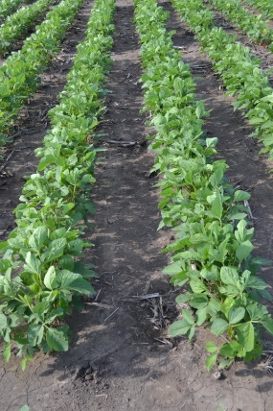
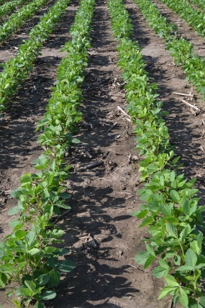
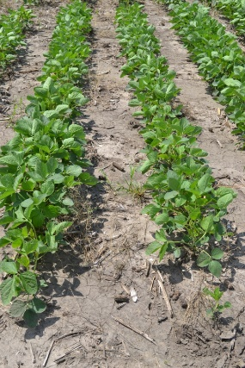
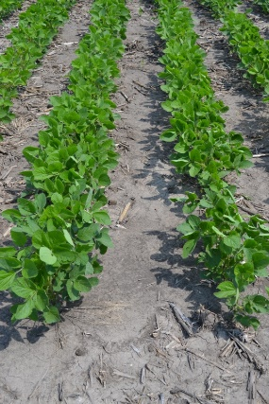
In 2018, site-specific characteristics and environmental conditions occurring shortly after planting likely contributed to the range in responses observed across four locations studied, which varied from 15% to 61% on root rot scores across experimental units. Preliminary data analysis of root rot showed a negative effect on plant health status when pre-emergent PPO herbicides (orthogonal contrast comparison between flumioxazin + sulfentrazone + saflufenacil versus chlorimuron-ethyl + metribuzin + non-treated control), in only one of four locations studied, which also happened to have the highest averaged root rot scores, pre-emergence damping-off and recovery of oomycetes from symptomatic roots, compared to other locations. At this location planted in mid-May, early-season plant stand counts were not significantly different between treatments, possibly due to high variability in plant emergence, as usually observed under seedling diseases outbreaks (Figure 2). Our results still need to be carefully interpreted but our study may be demonstrating increasing severity on soybean root rot symptoms when PPO pre-emergent herbicide injury occurs in association with high seedling diseases pressure environments. Remaining three locations, planted mid-May and early-June did not show differences on root rot or early-season plant stand from application of pre-emergent herbicides. Detrimental effects of pre-emergent herbicides have been extensively reported on soybeans but few studies investigating interaction of newer pre-emergent herbicide molecules and seedling diseases in soybeans are available for Nebraska growers. Late-season plant stand and yield data for 2018 locations are to be collected in mid- and late-October.
Figure 1. Detail of harvestable rows from few experimental units at V6 growth stage depicting the pre-emergent herbicide experiment carried out in Lincoln and Mead-NE in 2017. No differences in plan height collected at V6 growth stage. From left to right: non pre-emergent herbicide; Shapen at1 fl oz.A⁻¹; Valor at 2.5 oz.A⁻¹ in sensitive cultivar and Valor at 2.5 oz.A⁻¹ in tolerant cultivar.

Figure 2. Detail of harvestable rows from few experimental units at V4 growth stage depicting the pre-emergent herbicide experiment carried out in Tekamah-NE in 2018. From right to left: non pre-emergent herbicide; Sharpen at 1 fl oz.A⁻¹; Classic at at 2.5 oz.A⁻¹; and Valor at 2.5 oz.A⁻¹.

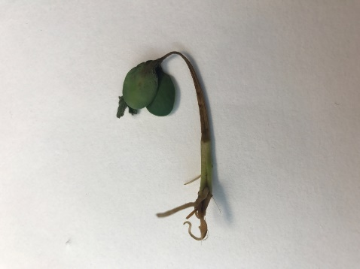
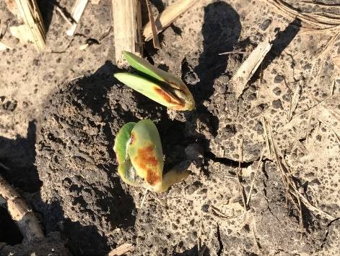
Figure 3. Right picture showing post-emergence damping-off caused by Phytophthora sojae. Figure on the left showing cotyledonar symptoms of PPO pre-emergent herbicide injury to emerging soybean seedling. Both abnormalities are favorable by cool and wet soil conditions.

NOTE – 2 locations were also planted in Ohio
In Iowa, one trial was planted just north of Ames the first week of May. The trial was inoculated with P. sojae and irrigated as the hypocotyls emerged (~1” water). Emergence was rapid due to unseasonably warm temperatures (~4 days after planting). Stand counts were low (~70%) across all treatments. No herbicide injury was observed on the seedlings. Canopeo was used to assess plant canopy but weed pressure at the site was high and appeared to affect data. Root rot incidence was low and severity ranged from 10 to 20%. No Phytophthothra stem and root symptoms developed during the season. All data will be analyzed once yield data are received.

