NCSPR "Boots on the Ground: Validation of Benchmarking Process Through an Integrated On-Farm Partnership" Project Report
We had an annual kick-off meeting with project collaborators in November 10, 2019. At this meeting we discussed project objectives, outputs and logistics, and we agreed on minor protocol changes to enhance the experimental design and resulting output. Project PIs Grassini (NE) and Conley (WI), along with Dr. Juan Ignacio Rattalino Edreira (NE), Dr. Jose Andrade (NE), Dr. Spyridon Mourtzinis (WI), Mr. Adam Roth (WI) and Mr. John Gaska (WI) continue to supervise data collection and are responsible to quality control the data and input them into a digital database. The NE-WI core team has had bi-monthly Skype calls to discuss and monitor project progress. The core team has also developed and distributed detailed field protocols and data collection methods to ensure consistency in the experiments conducted across states. State collaborators were requested to identify fields before April 15, 2020. The number of collected fields as of May 14 are shown in the table below.
The NE-WI core team actively promotes and distributes output from this project. In-season live Twitter interviews with participating growers occurred in the 2019 growing season with farmers in IA, WI, IL, and OH. The core team also developed an Extension publication with year 1 results that was widely distributed and is housed on SRII and www.coolbean.info. In short, the “Improved system” increased yield by 5.5 bu/a and profit by $51/a (Figures 3 & 4). Protein, oil, and AA data were also collected. For more information, please see the full publication entitled: Boots on the Ground 2019 On-Farm Trials Report:
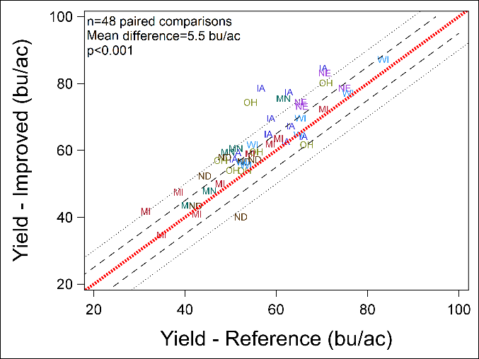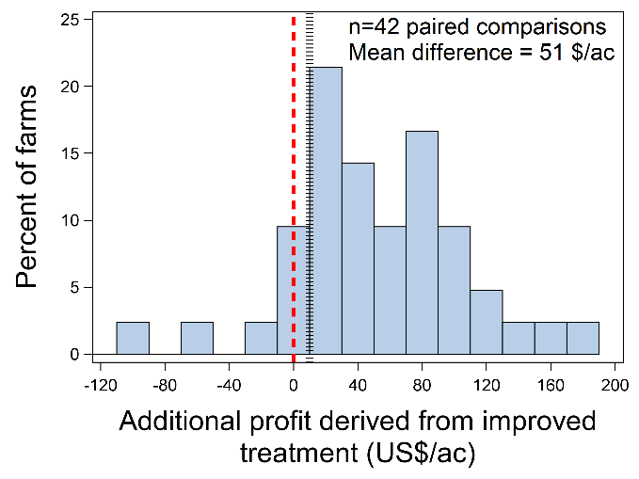
The NE-WI core team has been actively utilizing the legacy data from the initial NCSRP project and other on-farm networks across the NC US region. To date, we have published four manuscripts from these legacy data (listed below) two in review and two in preparation. We have also synthesized all of the data from the original Benchmarking project into an Extension publication entitled: Benchmarking Soybean Production Systems in the North Central US. This publication has been shared with all collaborators and published through multiple venues.
- Azzari, G. et al. 2019. SATELLITE MAPPING OF TILLAGE PRACTICES IN THE NORTH CENTRAL US REGION FROM 2005-2016. Remote Sensing of Environment 229: 417-429. https://doi.org/10.1016/j.rse.2018.11.010
- Andrade, J.F. et al, 2019. Assessing the influence of row spacing on US soybean yield using experimental and producer survey data. Field Crops Research 230: 98-106. https://doi.org/10.1016/j.fcr.2018.10.014
- Rattalino Edreira, IR et al. 2020. From sunlight to seed: assessing limits to solar radiation capture and conversion in agro-ecosystems. Agricultural and Forest Meteorology. https://doi.org/10.1016/j.agrformet.2019.107775
- Mourtzinis, S et al. 2020. Assessing approaches for stratifying producer fields based on biophysical attributes for regional yield-gap analysis. Field Crops Research. Accepted 4/20/20.

By the end of this 3-year project, we will have validated a novel research approach that utilizes self-reported on-farm production practices, together with on-farm validation, to identify management practices with greatest impact on farm yield and profit. Consequently, we will strengthen state-to-state research collaboration through the managed coordination of the on-farm partnership, build farmer-to-farmer networks and identify and communicate key management practices that increase soybean productivity and return of investment. We will also build a framework through our farmer-to-farmer networks, farmer video profiles, and field labs to communicate findings directly to farmers from farmers.

