REQUEST FOR FUNDING OF RESEARCH
2019-2020 FUNDING CYCLE

TITLE: Screening soybean germplasm and breeding soybeans for flood tolerance

INVESTIGATORS:

Pengyin Chen  Professor and Soybean Breeder  University of Missouri – Delta Center  (573)-379-6958  Chenpe@missouri.edu | Tessie Wilkerson  Assistant Research Professor  Mississippi State University  662-820-0549  twilkerson@drec.msstate.edu
Leandro A. Mozzoni  Associate Professor  University of Arkansas  (479) 575-7564  lmozzon@uark.edu | Daryl Chastain  Assistant Research Professor  Mississippi State University  662-686-3245  drc373@msstate.edu
Blair Buckley  Soybean Breeder  LSU AgCenter  (318) 741-7430  bbuckley@agcenter.lsu.edu | M.O. (Mo) Way  Professor  Texas AgriLife Research and Extension Center  409-239-4265  moway@aesrg.tamu.edu

PROGRAM AREA (check all that apply):

___ Management of weeds, to include resistance management and economics
_x_ Irrigation/water management
___ Quality of harvested seed—Phomopsis/Seed rot
___ Disease Management/Control
___ Fertility needs (especially P and K) for optimum and economical yield
___ Insect management/Control, especially late-season populations
___ Harvest aids
___ Iron Chlorosis
___ Nematode management/control
___ Rotations using soybeans
_x_ Research Validation or Demonstration
___ Producer Communications
_x_ Variety Trials
___ Economics
___ Other (Identify)

PROJECT STATUS:

New ____ (1 of 3)

Renewal __x__ (Year 2 of 3)

Stand alone _x__ or cross-commodity

2019 FUNDING REQUEST ___$160,000___

CATEGORY |  |  |  |  | MO | AR | MS | LA | TX | T
A. | Personnel |  |  |  |  |  |  |  |  | Total
 | Salaries (Research Specialist ¾ time) |  |  |  | $37,500
 | Wages (hourly workers)
 | GRA (include tuition)
B. | Fringe Benefits (36.69%) |  |  |  | $13,760
C. | Travel |  |  |  | $2,500
D. | Contractual Services (GC)
E. | Subcontracts
F. | Commodities (plot fees) |  |  |  | $3,500
G. | Publication Costs
H. | Other Costs (Materials & supplies) |  |  |  | $2,740
TOTAL COST |  |  |  |  | $60,000 | $40,000 | $25,000 | $25,000 | $10,000 | $160,000

Chen – A) ¾-time research specialist for field tests and breeding activities; B) Fringe benefit calculated on 36.69%; C) Mileage for travel to plots in MO and adjacent states; F) Plot fees on research farm and winter nursery H) field and lab supplies.

Buckley – A) Hourly Labor for field tests; B) Fringe Benefit rate of 7.65%; C) travel to research plots in Louisiana and adjacent states; H) field and lab supplies.

TECHNICAL SUMMARY

Waterlogging or flooding can be caused by inadequate drainage of soils after intense rainfall or excessive irrigation or from a rising water table. Yield losses up to 50% due to waterlogging are common because of heavy clay soils, poor surface and internal drainage, occasional high rainfall amounts, and cropping practices (especially the rice-soybean rotation system). Breeding for waterlogging tolerance in soybean is a relatively new goal of breeders. There has been no report on releasing a soybean cultivar possessing flood tolerance. Using a tolerant variety to maintain a greater percentage of the yield under stress is the most feasible alternative. When dealing with potential losses to stresses, many growers have to decide whether or not to grow the highest-yielding cultivars or to grow cultivars that are the most stable when stresses are encountered. This project will identify cultivars with flood tolerance so that specific recommendations can be made to producers. This project will also identify new sources of flood tolerance from diverse germplasm and incorporate such tolerance into high yielding background.

OUTLINE OF RESEARCH

RATIONALE/JUSTIFICATION FOR RESEARCH:

Waterlogged or saturated soil conditions are problematic to soybean production systems in heavy clay and poorly drained soils, typical of flat land in the mid-south. A previous USB funded flood project has led to several research findings including: most commercial cultivars are sensitive to flooding; plants are more sensitive at R1 stage than V5 stage; there are genetic variations among soybean germplasm in response to flooding; 5-10 flooding would differentiate soybean genotypes for flood tolerance; wild soybeans tend to be more tolerant than cultivated soybeans; use flood tolerance in breeding can increase yield under flooding. This project is designed to continue our research effort on flood tolerance research and build on the previous USB funded flood project. The goal of this project is to differentiate tolerant and sensitive cultivars, germplasm lines, and plant introductions in a waterlogged or flooded environment and incorporate the identified tolerance in elite background. Once the tolerant commercial cultivars are identified and new and improved varieties are developed, recommendations will be provided to farmers in the mid-south for their variety choices.

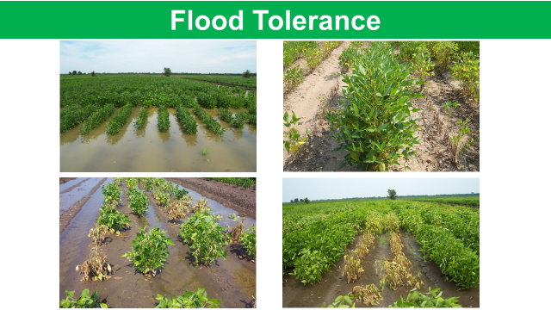

OBJECTIVE(S):

- Screen soybean germplasm and commercial cultivars for genetic tolerance to flooding.
- Incorporate flood tolerance from identified source(s) into elite cultivars and lines.

APPROACH AND EXPERIMENT CONDUCT:

Seed of currently available soybean cultivars (MG-4 and MG-5) will be obtained from the State Variety Testing programs in MO, AR, MS, LA, and TX. Advanced breeding lines will be selected from breeding programs in AR, MO, MS, and LA. PI’s and wild soybean accessions will be obtained from the USDA germplasm collections. Single 7-10 ft row plots or hill plots with 3-4 replications will be planted in a Randomized Complete Block design. Plants will be subjected to 3-5 inches of water above the soil surface for 5-7 days R1 (blooming) growth stage (see photo below). Lines will be rated for visual injury based on the presence and frequency of foliar chlorosis and plant death a week after the water is removed. The ratings will be based on a 0 to 9 scale, with 0 being no damage and 9 having more than 90% dead plants. Lines will be evaluated within their respective maturity group (MG) classifications (early 4, late 4, early 5 and late 5) to determine the most tolerant and most sensitive genotypes. In addition, we will screen a group of diverse germplasm including exotic plant introductions, varieties and breeding lines from other programs, and lines with drought tolerance or genetic diversity. The experiment will be repeated in the 2nd and 3rd year using the selected extreme genotypes to determine the effects of waterlogging/flooding at different growth stages for different period of flooding durations. The same selected set will be evaluated for yield response under R-1flooding and non-flooding conditions. Previous tests have shown GxE interaction effect on flood tolerance, which could be due to locations, soil types, and temperature. In this proposal, we will use the selected extreme sets in a multi-state and multi-location test to confirm flood tolerance and stability across diverse environments.

In a preliminary flood screening in AR, PI 471931, RA 452, and N94-7440 showed excellent tolerance to waterlogging conditions. Other flood tolerant lines include Anand, Manokin, NC Roy, Ozark, Osage, Young, R01-2731F, R08-2496, PI 587619, R05-374, R07-6669, R09-5088, R07-2001, R07-129, UARK-5798, Walters, R05-235, R07-7775, R07-190, and R09-4010, BoggsRR, N01-11136, Walters, Dillon, N02-7002, PI471938, Caviness, and PI567436. In a field flooding screen of commercial varieties using hill plots in MO, varieties with the best tolerance scores included Delta Grow DG4860RR2, Dyna Gro 31RY45, S12-3791, Progeny 4757, Syngenta 39-T3, Syngenta 45-R7, Armor 48D24, Morsoy LL4524, Bayer CZ5225LL, S11-20124 and Dynagro S52RY75. Also tolerant are exotic germplasm lines PI 567343, PI 408105A, PI 567651, PI 479740, PI 603155, PI 407038, and PI 603910B and wild soybean accessions PI 407729, PI 407195, and PI 424116. Crosses have been made using some of these lines and other southern elite cultivars and lines. We have developed plant populations from these crosses, some of which will be used for gene mapping purposes. In Missouri, we have completed two cycles of breeding for flood tolerance using PI 408105A as the original trait source. Significant yield improvement has been achieved under flooding conditions (see table below). However, the tolerant lines are not competitive to the best commercial check varieties under non-flooding conditions. The next step is to incorporate new sources of flood tolerance identified into our current breeding program in attempt to combine high yield potential with high levels of flood tolerance. We will also use lines derived from flood tolerant sources in AR and MO as bridge material in the next cycle of breeding for flood tolerance and high yield This is achieved through our cyclic breeding scheme: making different crosses, growing and identifying hybrids, advancing segregating populations via bulk pod method with mass selection for three generations (F2-F4), selecting desired individual plants, evaluating progeny rows and selecting pure lines, and testing selected lines in preliminary and advanced trials for flood tolerance and yield potential.
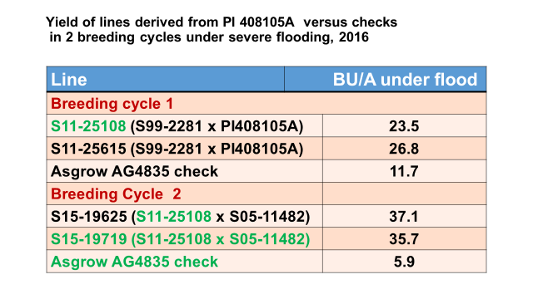
PROJECTED IMPACT OF RESULTS ON MID-SOUTH SOYBEAN PRODUCTION

This research will provide flooding-tolerant germplasm and cultivars. The germplasm and cultivars developed in this project will not only improve on-farm profit for soybean production, but also will serve as valuable genetic sources for future breeding programs in both public and private sectors to improve yield and stress tolerance.

EXPECTED END PRODUCT(S)

The expected end products from this project will include 1) a publically available and unbiased data set for the commercial varieties tested in state variety testing programs in MO, AR, MS, LA, and TX; 2) a list of high yielding, stable, and locally adapted soybean lines with flood tolerance recommended to the Mid-south farmers; and 3) new and improved breeding lines with flood tolerance to share with other public and private breeding programs for variety development.

