**Progress Report for On-farm Soybean Poultry Litter Project**

**Project Title:** Calculating the Fertilizer Value of Poultry Litter

**Principal Investigator (PI):** Dr. Bhupinder Farmaha

**Report Due Date: 10/15/21**

**Reporting Period: SA3**

**Summary:**

Poultry litter has the potential to improve crop productivity and soil health (Lin et al., 2016). Around 1.5 kg of litter per broiler is produced annually accounting for about 12.8 million metric tons of poultry litter from around 8.5 billion of birds produced across the United State of America (Mitchell and Tu, 2005; USDA-NASS, 2015). However, the under-utilization of poultry litters as a potential substitute for chemical fertilizers in modern agriculture as against the conventional systems resulted in stockpiling of poultry litter especially in the Southeastern States of America (Georgia, Mississippi, Alabama, Arkansas, and North Carolina) where two-third of broiler production in the United States comes from (Lin et al., 2016). In the same vein, poultry litter were said to have contained all essential mineral nutrients needed for plant growth in the ratio of 3:3:2 (N:P2O5:K2O) fertilizer grade equivalent (Mitchell and Donald, 1995) but are made available to plant in varying quantities or forms due to many factors ranging from litter type droppings (cake versus the whole house) in relation to bedding proportion, birds’ growth phase/stage, and litter handling system (Kulesza and Sharara, 2020).

Application of poultry litter in crop improvement programs such as growth enhancement (yield and nutrient uptake) and increase in soil organic matter is a function of its nutrient composition and availability (Watts et al., 2010). In the same vein, continuous application of poultry litter or litter can increase the availability of soil C, N, P, K, Ca, and Mg content (Ginting et al., 2003; Watts et al., 2010), thereby creating a reservoir of soil nutrients for several years after application. On the other hand, excessive application of poultry litter can create an accumulation of P in the soil which will, in turn, decreases the rate of P absorption thereby promoting leaching of soil nutrients to subsurface waters owing to the availability of malic and oxalic acid in organic litter (Gebrim et al., 2008).

Therefore, understanding the nutrient content of a litter prior to its application through excellent sampling and contents analysis in any cropping season (in-season and off-season) will not only bring about enhancement of crop yield and productivity but also preserve the organic matter in the soil and its environment. It is on this note that this research seeks to evaluate the Integration of Poultry litter/Poultry litter on Soybean and Corn Production.

**Objectives:**

The objectives of this research are to;

* Investigate the use of poultry litter as a potential source of low-cost nutrients to enhance yield and productivity of soybean production through on-farm trials.
* Evaluate different rates of poultry litter, time of application, and its effects on plant nutrient uptake as well as accumulations of nutrient in soil and soybean.

**Hypothesis:**

For this research, the proposed hypotheses are:

* Application of poultry litter will enhance soybean yield.
* Change in soybean yield with poultry litter application is a function of the litter application rate.
* Multi-year application of poultry litter will improve the soil health

**Activities:**

A group of potential soybean farmers were identified and selected from among the South Carolina Soybean Board for the purpose of this research owing to their previous experience and expertise in soybean production. A stakeholder meeting was organized between our research team from Clemson University and the selected farmers, and a presentation was made in which the research details were itemized for the farmers to see the potentials benefits of incorporating poultry litter into soybean production. The purpose of this stakeholder meeting was to gain the trust of those selected farmers as well as their support towards establishing our field trials in their existing facilities while maintaining the status quo. We believe that with this approach, it will be a lot easier to convince other farmers to adopt and emulate agricultural revolution of improving and managing soil fertility and/or conservation for higher yield and productivity of soybean through green technology which will in turn brings about greater productivity or profitability.

Our effort to establish contact with other two board members prove abortive thus prompting us to make alternative arrangement of increasing the number of sites used for this project. The selected sites were then flagged for collection of baseline information such as previous management history, crop selection and fertilization history etc.

This research was designed to run for three (3) years consecutively (2021 - 2023) and a total of seven (7) research sites was identified and established in the year 2021. The poultry litter intended for this research were purchased from a local poultry farmer in Barnwell and stored at the tractor storage facilities of Edisto Research and Education Center in Blackville, South Carolina.

**Sample Collection and Analysis of Nutrient Composition**

Worthy to notes is that poultry litter have varying nutrient composition based on many factors including types and life stages of bird, feed ration, proportion of bedding to droppings, systems handling the litter as well as litter type (cake versus whole house). It is therefore imperative to sampled and analyzed all poultry litter to determine the actual nutrient constituents and composition before application. As importance as the analysis of poultry litter are before application, understanding the soil organic matter or constituents also plays an important role in determining quality and quantity of soil fertilizer application requirement.

**Soil Sample Collection:**

Following the baseline information which comprises of previous crop histories, management practices including fertilizer application history etc. collected on all the selected sites, we collected sample the soil using soil auger, residue of the cover crop previously cultivated on the soil etc. from all the selected sites. The sample collected were then taking to the laboratory for further screening and analysis as shown in the table 2 below.

The analysis of poultry litter nutrient and composition was performed, and the results were as stated in figure 1 below. In order to avoid study variation and biased result in this research, we ensure that we used same source of poultry litter across all our selected sites.

**Figure 1: Showing the analyzed results of the Poultry Litter nutrient and composition.**

Part of the activities conducted during the planning stage of this research consist of meeting and discussing the results of the analyzed litter as well as the application rates with extension agents from NC and SC. Part of the outcome of our discussion was to test 0, 1.5, 3, 4.5, and 6 tons/ac poultry litter application rate. We applied these rates in three replicates at all sites and we plan to continue this study for two more years to evaluate the direct, residual, and cumulative effects of the litter application on soil and crops. In order to achieve our set goals, we established three or four sets of plots in all the selected sites with which the first and third set will receive liter application in year one (1) while the second and fourth set will not. However, in the year two (2) of this research, second and third sets will receive litter application, but first and fourth set will not. meanwhile, in the year three (3) of this research the cumulative effects of poultry litter applications will be evaluated on the three sets as none of the sets will receive litter application. We will evaluate the residual effect of poultry litter application in year two (2) and three (3) on all the sets and directs effects of poultry litter application will be evaluated in year one (1), year two (2) and three (3) respectively.

**Table 1: Date-wise management information for all the sites**

|  |  |  |  |  |
| --- | --- | --- | --- | --- |
| **Date** | **Producer** | **County** | **Cropping system** | **Operations carried out** |
| 20-May | Joe Alvin | Johnston | Soybean-Soybean PL trial, No cover crop | Flagging, Soil sampling, Residue sampling, 3 Rep with 3 sets-each trial |
| 20-May | EREC | Barnwell | Soybean-Soybean PL trial, No cover crop | Soil sampling, Residue sampling, 1 Rep with 3 sets |
| 26-May | Pee Dee Station | Florence | Soybean PL Trial | Flagging, Soil sampling, Residue sampling, 3 Rep with 4 sets each trial |
| 27-May | Dean Hutto | Orangeburg | Soybean PL Trial | Flagging, Soil sampling, Residue sampling, 3 Rep with 4 sets each trial |
| 7-Jun | Rachel Sharp | Allendale | Dryland-Cotton-Wheat-Soybean (No cover crop) PL trial- 3 Reps with 4 sets | Flagging, Soil sampling, Residue sampling, 3 Rep each trial |
| 7-Jun | Irrigated land- Soybean PL trial- 3 Reps with 4 sets | Flagging, Soil sampling, Residue sampling, 3 Rep each trial |
| 28-Jun | Dean Hutto | Orangeburg | Soybean PL Trial | PL applied |
| 6-Jul | Joe Alvin | Johnston | Soybean-Soybean PL trial, No cover crop | PL applied |
| 7-Jul | Pee Dee Station | Florence | Soybean PL Trial | PL applied |
| 8-Jul | Rachel Sharp | Allendale | Irrigated land- Soybean PL trial- 3 Reps with 4 sets | Flagging for PL |
| 9-Jul | Rachel Sharp | Allendale | Irrigated land- Soybean PL trial- 3 Reps with 4 sets | PL applied |
| 12-Jul | Rachel Sharp | Allendale | Dryland-Cotton-Wheat-Soybean (No cover crop) PL trial- 3 Reps with 4 sets | PL applied |
| 13-Jul | Rachel Sharp | Allendale | Dryland-Cotton-Wheat-Soybean (No cover crop) PL trial- 3 Reps with 4 sets | PL applied |
| 27-Jul | Wes Woodard | Darlington | Soybean PL Trial, 1 Rep with 4 sets | Soil sampling, Residue sampling, 1 Rep with 4 sets each trial |
| 2-Aug | Wes Woodard | Darlington | Soybean PL Trial, 1 Rep with 4 sets | PL applied, Plant height and stand count |

**Completed Tasks:**

Following the successful discussion and engagement of potential farmers that were purposefully identified and selected from the South Carolina Soybean Board, we established on-farm field trials in all the selected sites/locations stated in the above table and in their sequential order (Joe Alvin, Pee Dee, Dean Hutto, Rachael Sharp, EREC and Wes Woodard). We take the GPS coordinate for future reference as shown in below figures.

A total of 9 soil samples with a sample depth of 0 – 4 inches, 4 – 12 inches, and 12 – 24 inches were randomly collected and analyzed for baseline information on the soil organic content from all the selected sites. The information on the soil organic matter contents coupled with the results of the nutrients analysis of the Poultry litter informed us of the application rate (0, 1.5, 3, 4.5, and 6 tons/ac) for year one project.

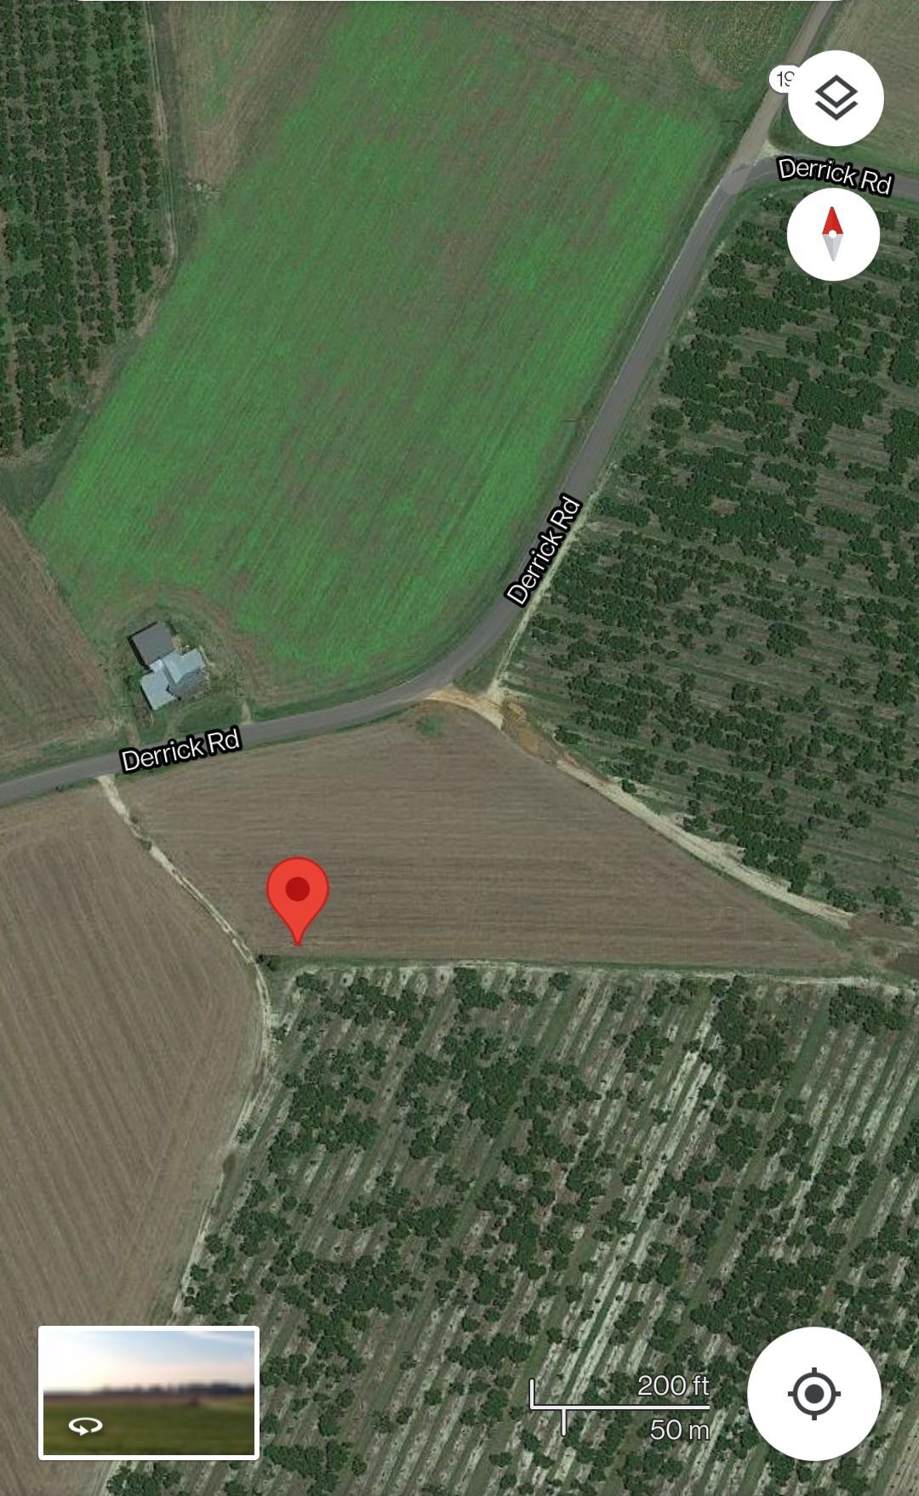

**Joe Alvin 05/20/21**

Soil sampling: 05:20:21

Fertilizer application: 07:06:21

Growth stages: V2 and V3

R1, R2 and R3 Poultry litter trial

R4, R5 and R6 K rate Trial

1 rep = 3 sets

1 set = 20 rows

length = 60 rows

width of one rep = 30 ft

25 ft border in the front

6 rows left and Right

Row to row spacing = 30 inches

Spacing left from front left 160 right 23

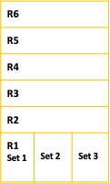

**Figure 1: Showing GPS coordinate of Joe Alvin and the activities carried out on the sites.**

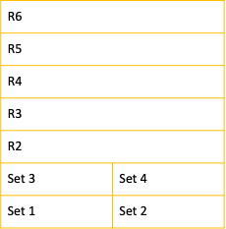

**Dean Hutto 05/27/21**

Soil sampling: 05:27:21

Fertilizer application: 06:28/29:21

Growth stages: V3 and V4

R1, R2 and R3 PL trial

R4, R5 and R6 K trial

20 rows within one set

204 ft length of trial

Length of 48 rows with 4 rows left and right as border

Width of one rep = 34 ft

Growth stages: V3 and V4

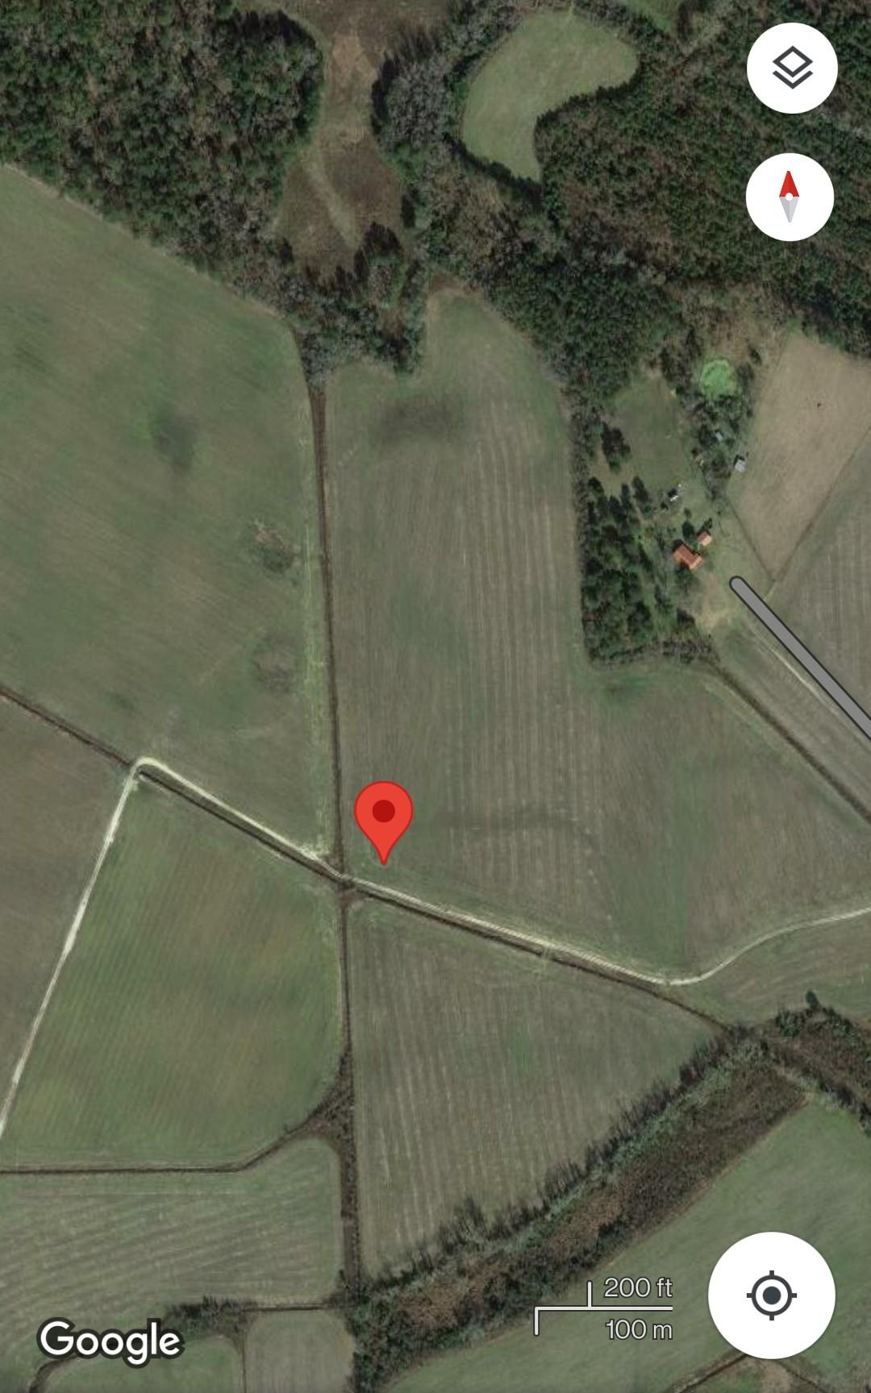

**Figure 2: Showing GPS coordinate of Dean Hutto and the activities carried out on the sites.**

For Racheal Sharp, two sites were selected, and two GPS coordinate was taken (Dryland and Irrigated land) due to our inability to reach the other two (2) board member of the South Carolina Soybean Farmers Cooperative. Our decision to increase the number of sites in Racheal Sharp was as a result of our interest in evaluating the effect of poultry litter in on-farm irrigated land versus on-farm dryland soybean production.

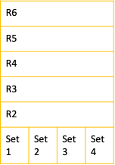

**Rachael Sharp 06/07/21**

R1, R2 and R3 PL trial

R4, R5 and R6 K trial

30 ft border within both the trial

length of one rep = 30 ft

36 inches within rows

width of one rep = 80 rows

20 rows within one set

15 ft border top and bottom

25 ft left and right

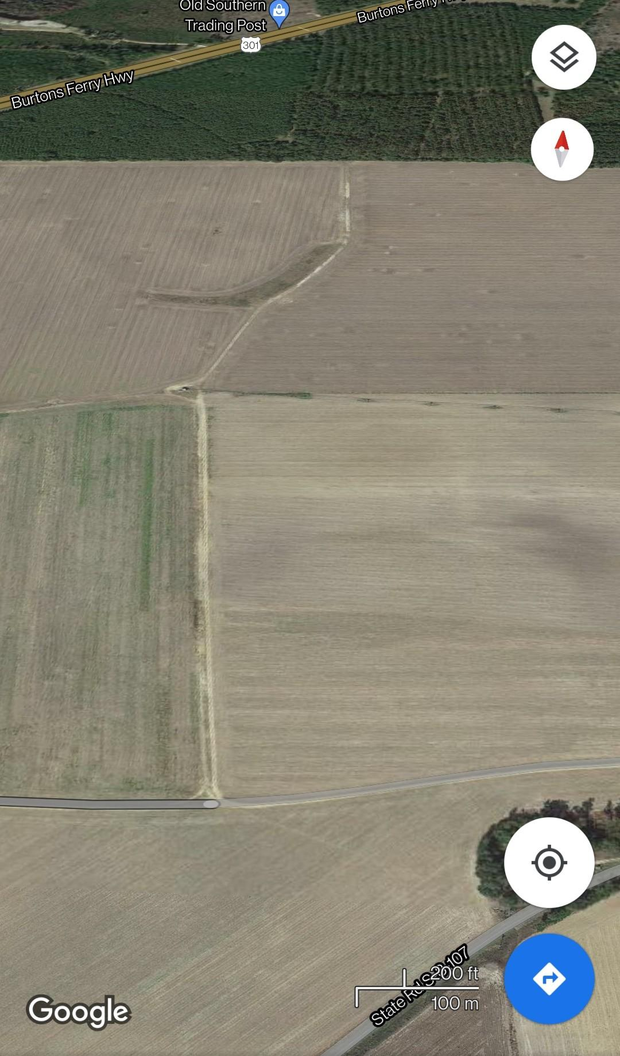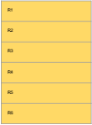

Field 2(Irrigated) Rachael Sharp

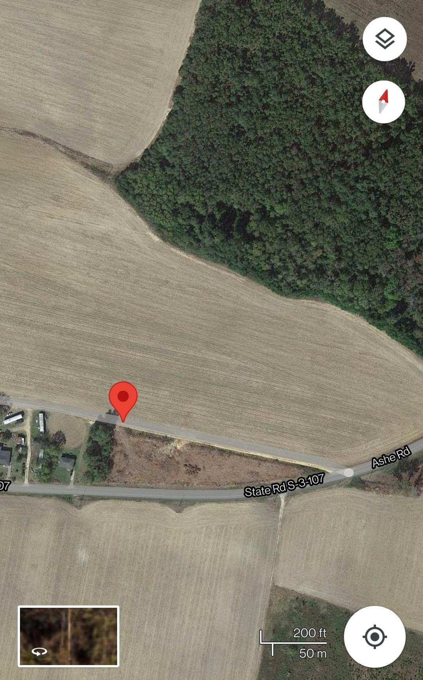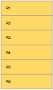

Field 1(Dryland) Rachael Sharp

**Figure 3: Showing GPS coordinate of both Dryland and Irrigated land of Rachael Sharp.**

We could not get the image of the GPS coordinates of both Pee Dee and Edisto REC stations on google map but using the available GPS data, we were able to establish the field layout as shown in the figure below. Also, we were to established other baseline information like every other site. Meanwhile, owing to the pre-existing field mapping and layout at Edisto REC, it was easier to establish field trials in one of the soybean field plots.

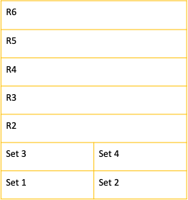

**Pee Dee station 05/26/21**

Soil sampling: 05:26:21

Fertilizer application: 07:07:21

Growth stages: V5 and V6

R1, R2 and R3 PL trial

R4, R5 and R6 K trial

50 ft border within both the trial

30 inches within the rows

length of one rep = 100 ft

width of one rep = 40 rows

20 rows within one set

25 ft border top and bottom

**Seed rate**: 120,000

**Herbicides**: Valor 30 oz/acre, Roundup 1quart/acre, and Prowl 2pints/acre

**Coordinates**:

34◦17’21” N

-79◦44’30” W

**Figure 4: Showing no image GPS coordinate of Pee Dee REC station.**

**Wes Woodard**

Soil sampling: 07:28:21

Fertilizer application: 08:02:21

Plant height and stand count: 08/02/21

R1, R2 and R3 Poultry litter trial

R4, R5 and R6 K rate Trial

1 rep = 4 sets

1 set = 20 rows

Row to row spacing = 30 inches

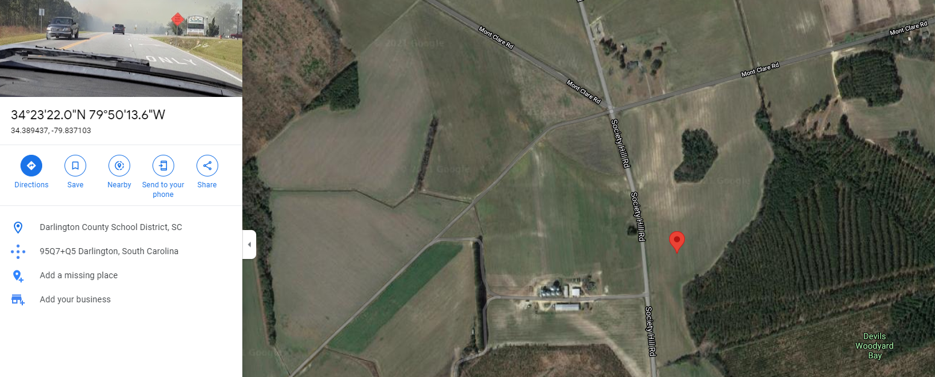

**Figure 5: Showing GPS coordinate of Wes Woodward and the activities carried out on the sites.**

Four sets of soybean on-farm trials with our proposed treatment were established in six plots of land (R1 – R6) across all the selected sites/locations for this project. This research was carried out in three replicates per treatment and per set in each of the sites/locations.

**Rate of Poultry Litter Application:**

Due to the availability of land space in Rachael Sharp and Wes Woodward, we adopt similar poultry litter application pattern for the two (2) sites while different application pattern was used in other sites as shown in below pictures.



**Figure 6: Showing Poultry litter application pattern for Rachael Sharp and Wes Woodward Sites.**

**Figure 7: Showing Poultry litter application pattern for Joe Alvin Sites.**



**Figure 8: Showing Poultry litter application pattern for Pee Dee REC station.**

Upon the completion of field layout, designation of poultry litter application pattern, and plant establishment, we planned to collect data on several growth parameters like the Days of planting, plant stand counts and leaf area, plants heights per set and per plot at reproductive growth phase (R2 –R4).

Trifoliate leave samples from all the selected fields have been collected, dried, and stored in the laboratory for further screening/analysis of the plants' nutrients contents.

**Challenges and Steps taken:**

Farmers response to our inquiries regarding information on soybean varieties, proposed time of harvesting etc. have been coming so slow. However, owing to the small plots size from all the on-farm location where we could only apply poultry litter/poultry litter manually using hand and not mechanically, collection of trifoliate leave samples were somewhat difficult.

We were unable to collect data on growth parameters particularly on number of plant stand, plant girth, and plants heights per set and per plots as proposed in all the selected sites except from Wes Woodard due to the canopy formation of the varieties used in this research couple with the fact that the plants were already in the middle of their reproductive stage)

**Plan for Next Quarter:**

The collected trifoliate leave samples will be analyzed to determine the total nitrogen content, nutrients uptake and nutrient use efficiency, total nutrients removed from the soil and other parameters relating to evaluation of plant-soil nutrient analysis which will be used to evaluate the effect of poultry litter application on the yield and productivity of on-farm soybean in our selected location.

We will compare the results from all the location after the analysis and draw our inferences on the effects of Poultry litter/Poultry litters for on-farm to on-station yield and productivity of Soybean. We plan to repeat this research experiment using the same approach and materials to ascertain the previous results obtained and to evaluate the seasonal variability of on-farm soybean production in relation to fertilizer application. Activities and progress reports will be prepared and circulated among the stakeholders involved in the projects.