- Name of Project: Pennsylvania Soybean On-Farm Network
- Principal Research and Co-Investigators
  - Dr. Paul Esker, PSU Extension Plant Pathologist, and Associate Professor
  - Dr. Terrance Bell, Assistant Professor
  - Dr. Liz Bosak, PSU Extension Field and Forage Crops Educator
  - Dr. Daniela Carrijo, PSU Extension Agronomist, and Assistant Professor
  - Dr. Alyssa Collins, PSU Extension Plant Pathologist, and Associate Research Professor
  - Andrew Frankenfield, PSU Extension Field and Forage Crops Educator
  - Anna Hodgson, PSU Extension Field and Forage Crops Educator
  - Dwane Miller, PSU Extension Field and Forage Crops Educator
  - Dr. Adriana Murillo-Williams, PSU Extension Field and Forage Crops Educator
  - Dr. Heidi Reed, PSU Extension Field and Forage Crops Educator
  - Dr. John Tooker, PSU Extension Entomologist, and Professor
  - Dr. John Wallace, PSU Extension Weed Scientist, and Assistant Professor
- Funded amount: $255,490
- Co-funders: NA
Articles as part of the Pennsylvania Soybean On-Farm Network:
1. Return on investment for saved seed in a full season and double crop environment
2. Refining 2-pass herbicide programs for horseweed management
3. Updating Pennsylvania soybean maturity zones
4. Ilevo seed treatment trials and microbiome/soilborne research
5. Broadcasting cover crops into standing soybeans
6. Sentinel plot program for detection of insect pests and diseases
7. Pennsylvania slug monitoring project
8. Proactive monitoring and management of soybean cyst nematode

Project Summary
Since 2009, the Pennsylvania Soybean On-Farm Network has conducted on-farm research to address important questions that drive soybean production in the Commonwealth. The importance of these trials and educational efforts is evident. Since 2017, 85% to 90+ % of participants in trials and workshops have indicated that there has been a moderate to high (“a lot”) amount of knowledge gained from the program.

Also, approximately 75% to 90+% of the workshop participants indicated that they would adopt a new practice on their farm during the next one to two growing seasons. Interviews with farmer cooperators also show the value of the network. Comments range from indicating the importance of testing ideas at the farm scale since there are always new issues to figuring out what works and doesn’t work under production situations.

Thank You! We thank our grower cooperators who participated in the 2022 On-Farm Network trials. We also thank the entire Penn State Extension Field and Forage Crops Extension Team for making this research possible. Conducting on-farm research requires additional time and effort from our growers. We value your participation in testing new and novel ideas under production situations.
We look forward to continued collaborations in 2023.

Pennsylvania Slug Monitoring Project
Anna Hodgson and John Tooker

Slugs can be a problematic pest when they occur in large numbers during spring and fall planting seasons. Replanting fields due to slug damage is often unsuccessful and results in multiple re-plantings. Managing slugs with molluscicides can be challenging because slug damage typically occurs during cool, wet weather, and finding a dry gap in the weather for application can be difficult. Since 2018, Extension Educators across Pennsylvania have assessed slug populations and crop damage each week at 20 to 30 sites. Each site is a problem slug field identified by the farmer cooperator. Educators scout for slug eggs in each field at the beginning of the season. Ten shingle traps are installed randomly over the field. The traps are installed prior to planting, removed during planting, and replaced after planting. Each week, or more frequently after crop emergence, the traps are checked for slugs. Crop damage is measured for 21 days after emergence.

Findings.
Each week during the planting season, a report is published in Penn State’s Field Crop News. Scouting for slug eggs in the springs of 2018 to 2022 did not predict the juvenile and adult slug population. The two most abundant slug species were marsh and gray garden slugs. From 2018 to 2020 and 2022, most sites reported low slug numbers and minimal crop damage. In 2021, higher slug numbers and significant crop damage were reported at some sites. We have learned that scouting for slug eggs is not a good way to assess slug populations. Slug populations vary each year, and in the first five years of the monitoring project, we have built a good base of data that can be used to establish whether slug populations follow a predictable pattern.

Sentinel Plot Program for Detection of Insect Pests and Diseases
John Tooker

Project Summary
This project involved establishing in 16 Pennsylvania counties sentinel soybean plots that were scouted weekly for insects, slugs, and diseases by Penn State Extension Educators. The project was run collaboratively between Penn State’s Department of Entomology and Penn State Extension to provide soybean growers with regional assessments of insects and diseases active in soybean fields. We expected that an unbiased view of insect and disease populations in typical fields would reveal to soybean growers that pest populations in most soybean fields tend to be mild, and do not threaten yield, therefore they do not usually require management with insecticides and fungicides. The ultimate goal of our project is to demonstrate the value of scouting and encourage growers to adopt Integrated Pest Management

Findings
In 2022, like past years, our scouting efforts discovered a narrow range of insects, slugs, and only a few diseases infesting soybean fields. The main pests we encountered were bean leaf beetles, Japanese beetles, grasshoppers, Septoria brown spot, and frogeye leaf spot. Importantly, however, none of the pest populations exceeded economic thresholds, thus they did not require rescue treatments of insecticides or fungicides. This outcome has been common over the past 13 years that we have conducted this program, and it is an important message for growers to hear: insect, slug, and disease populations in Pennsylvania soybean fields are not pervasive and always threatening yield. In fact, most field in most years do not develop economically damaging pest populations; thus, insecticide and fungicide use should provide no advantage.

Return on investment for saved seed in a full season and double crop environment
Delbert Voight, Andrew Frankenfield, Dwane Miller, Daniela Carrijo, Adriana Murillo Williams, Tyler McFeaters, and Dr. Paul Esker

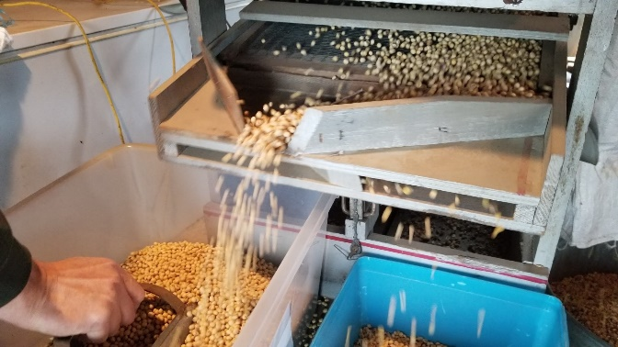
Off-patent Roundup Ready One soybean seed was purchased in 2019. In 2019, the seed was used as part of the “good inoculation practices” trials at $26 per unit. In 2020, 2021, and 2022 a residual herbicide followed by an in-season application of glyphosate was utilized to manage weeds, adding costs to the saved seed practice. Seeds were saved from the original lot, cleaned, and bagged at $4 per unit, then used for planting in 2020, 2021, and 2022. The maturity groups 2.9, 3.1, and 4.0 were compared with the original seed lot (2019) at the end of 2021. In addition, the saved seed was entered into the Pennsylvania Soybean Variety Trials to determine performance compared to current releases Farms in Schuylkill, Lebanon, and Lancaster counties. Centre and Montgomery counties were provided cleaned saved seed. They were asked to compare to their commercial offering to see if any yield differential existed between the saved seed and their selections.

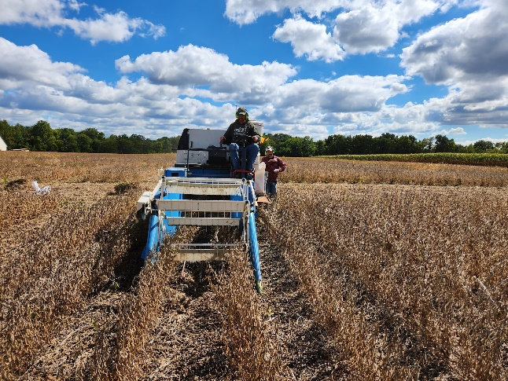
FINDINGS The 2019 original lot showed no differences in yield between commercial offerings. However, the results of the Pennsylvania Soybean Variety Trials placed this material in the middle of the current releases for that year. Farmers that used the seed to compare with their typical variety reported no differences in performance to accept at one location in Lebanon, where the grower felt he lost approximately 5 bushels per acre compared to his selection.

In 2020, yields for saved seeds were compared to the original lots. No statistical differences were noted, with the average yield for the saved seed at 86 bushels per acre.

In 2021, results showed that the saved seed performed as well as the original and new seed lots. Yields averaged 82 bushels per acre. Growers conducting on-farm trials reported no differences between their selections in yield but noted having to apply an additional herbicide to control weeds.

In the 2022 growing season, all three maturities and saved seed lots performed similarly. It was also found that the longest saved seed lot appeared to outperform the original lot of seed and have the best germination. Growers in the four counties reported similar yields in full and double-crop scenarios to their seed selections. A marked difference in seed germination was observed, with the saved seed lots having a 95% germination test prior to planting.

When considering the return on investment, the saved seed lot performed well and can be viewed as a viable option for marginal fields that are not prone to high yields or for production in a double-crop soybean scenario. Preliminary results suggested a $60 savings per acre in seed savings. Our data indicate that newer releases will need at least a difference of 5 bushels per acre to compete with saved seed methods economically.

Looking forward to the 2023 growing season, we have 2.9, 3.1, and 4.0 maturities (20 acres each) available for additional comparisons. Please get in touch with Del Voight (dgv1@psu.edu) for more information.

Updating Pennsylvania soybean maturity zones
Daniela Carrijo

Research summary:
The purpose of this project is to provide farmers with an updated map of soybean maturity zones in Pennsylvania. As the climate changes over time, maturity groups that used to be adequate for a region may not perform so well anymore. Also, as cropping systems have become more complex and diverse (e.g., cover crops, double cropping, no-till), a wider range of planting dates have been practiced, and producers want to know the best combination of planting date and maturity group for their region.
To answer this question, we set up replicated, randomized trials at four on-farm locations (Cambria, Snyder, Mercer, and Tioga counties) and one on-station (Lancaster County) trial. The Tioga location had severe deer damage and was discarded. We planted 4-7 soybean varieties of different maturities in each location. In Cambria and Lancaster only, we planted the same varieties at two planting dates (one trial planted early and another trial planted late). Therefore, a total of six trials are reported here.

Findings:
As expected, the vegetative (emergence to flowering) and reproductive (flowering to senescence) phases were generally shorter in the earlier maturing varieties. While this trend was always consistent within seed companies, there were slight inconsistencies when comparing varieties from different seed companies. For example, in one trial, the varieties 2721RFX (maturity group 2.7) and C3255XF (maturity group 3.2) flowered on the same day and senesced practically on the same day. These slight inconsistencies in maturity group ratings across varieties from different seed companies were expected and reinforced the importance of local variety testing when switching to a new seed brand.

There was not a significant trend between yield and maturity group, except at the Cambria location when planted late (Cambria-late, planted on June 1), where yield decreased approximately linearly with the maturity group. In this trial, the yield was 40% lower with a maturity group 3.7, compared to a maturity group 2.3. This trend was not observed in an adjacent trial planted early (Cambria-early, planted on May 17). The Cambria location experienced high white mold pressure, and there is strong evidence that the lower yields observed with the later maturing varieties in Cambria-late were due to white mold infection, which was a result of high disease risk (see Sporecaster App: https://ipcm.wisc.edu/apps/sporecaster/) coinciding with flowering time for these later maturing varieties planted late. Because there are no clear seasonal patterns of white mold risk, likely, this relationship between yield and maturity group in the Cambria-late trial is an exception rather than the rule.

Average yields for each trial were: 69 (Cambria-early), 55 (Cambria-late), 74 (Lancaster-early, planted on April 25), 73 (Lancaster-late, planted on May 11), 56 (Mercer), and 63 bushels per acre (Snyder). The lack of a significant trend between yield and maturity group in five out of six trials could indicate that the maturity ranges tested in these trials were near optimal. Data from more years are needed to confirm this. These results suggest that wider maturity ranges are possible in these locations. We plan to continue this work in 2023 to account for year-to-year variability and include a larger range of maturity groups within each trial.

Illustrations:
Varieties tested at each location
Variety | Maturity group | Cambria (early and late) | Lancaster (early and late) | Mercer | Snyder
2321RXF | 2.3 | x
C2355XF | 2.4 | x
2721RFX | 2.7 | x
XO 2832E | 2.8 |  | x | x | x
XO 3131E | 3.1 |  | x | x | x
C3255XF | 3.2 | x
XO 3341E | 3.3 |  | x | x | x
XO 3651E | 3.6 |  | x | x | x
C3755XF | 3.7 | x
XO 3861E | 3.8 |  | x
XO 3922E | 3.9 |  | x
XO 4132E | 4.1 |  | x |  | x

Relative yield (% of maximum yield at each location) across the maturity groups tested
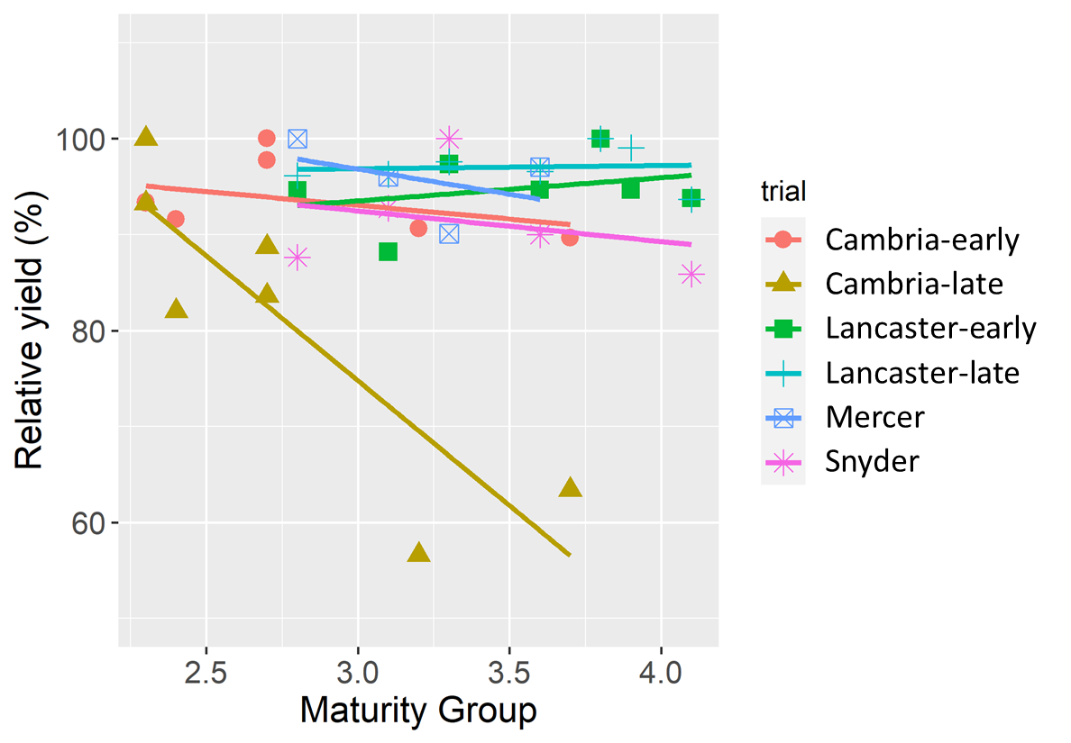

Proactive monitoring and management of soybean cyst nematode

Paul Esker, Alyssa Collins, Adriana Murillo-Williams, Dilooshi Weerasooriya, and Mariah Kidd,
Link to further information online: https://www.thescncoalition.com/

Research Summary:
Soybean cyst nematode (SCN, Heterodera glycines) is North America's most damaging soybean pathogen. Yield losses associated with SCN damage can be greater than 50%. The nematode was first detected in 1954 in North Carolina and is currently found in almost every county where soybean is grown. In Pennsylvania, SCN was first detected in Lancaster County in 2002. Subsequent surveys did not report further findings of SCN.

Nonetheless, our initial stakeholder survey found a need to know the importance of SCN and soil sampling. As such, and considering increases seen in surrounding states, we created a free SCN testing program for farmers across the Commonwealth. Pre-labeled soil bags with soil sampling instructions and a field history form were sent to all extension offices. They were also made available to participants at the PSU Ag Analytical Laboratory and were sent to farmers, industry representatives, and ag consultants when requested. Nematode identification and quantification were performed at the North Carolina Department of Agriculture and Consumer Services.

Findings:
Approximately 700 soil samples from 46 counties have been tested for SCN. Soybean cyst nematode has been detected in at least one field in seven counties, in addition to Lancaster County (Figure 1). We have officially confirmed York County as SCN positive based on follow-up sampling of the original positive field. Based on our free testing program, we found that only 3% of the total samples tested positive for SCN. In the fields where SCN has been detected, infestation levels remain low (below 200 eggs per 100 cc).

For each sample, we also receive information about other plant parasitic nematodes. Two important ones include root-knot and lesion nematodes (Figures 2 and 3). Root-knot nematodes have been found in 7 counties, with test positivity of 2% across all samples. Root lesion nematodes have been found in 85% of samples and most counties sampled.

Recommendations: It is essential to sample for nematodes. Best management recommendations incorporate knowledge of PPN. Our current results suggest that we are doing many things correctly to limit the increase in PPN. But, we also receive reports from farmers that they have seen decreases in yield in time that they cannot easily explain. We need sampling and testing for nematodes to determine which factors explain the reduced yield. SCN is known to reduce yields without causing any symptoms in the above-ground part of the plant. In the meantime, SCN populations continue to grow below ground until they reach levels that cause stunting or yellowing and, finally, plant death. By the time symptoms are noticeable, SCN populations can far exceed the damage threshold for yield, and management becomes more challenging.

Those who detect SCN in their fields early have the greatest chance of deploying the most effective strategies to protect their yield (including crop rotation and genetic resistance) at the lowest cost to the grower.

Contact Paul Esker (pde6@psu.edu), Alyssa Collins (acc18@psu.edu), or Adriana Murillo-Williams (axm1119@psu.edu, office phone: 355-4897, txt 814-360-5517) if you have any questions about our free SCN testing program or would like to participate.

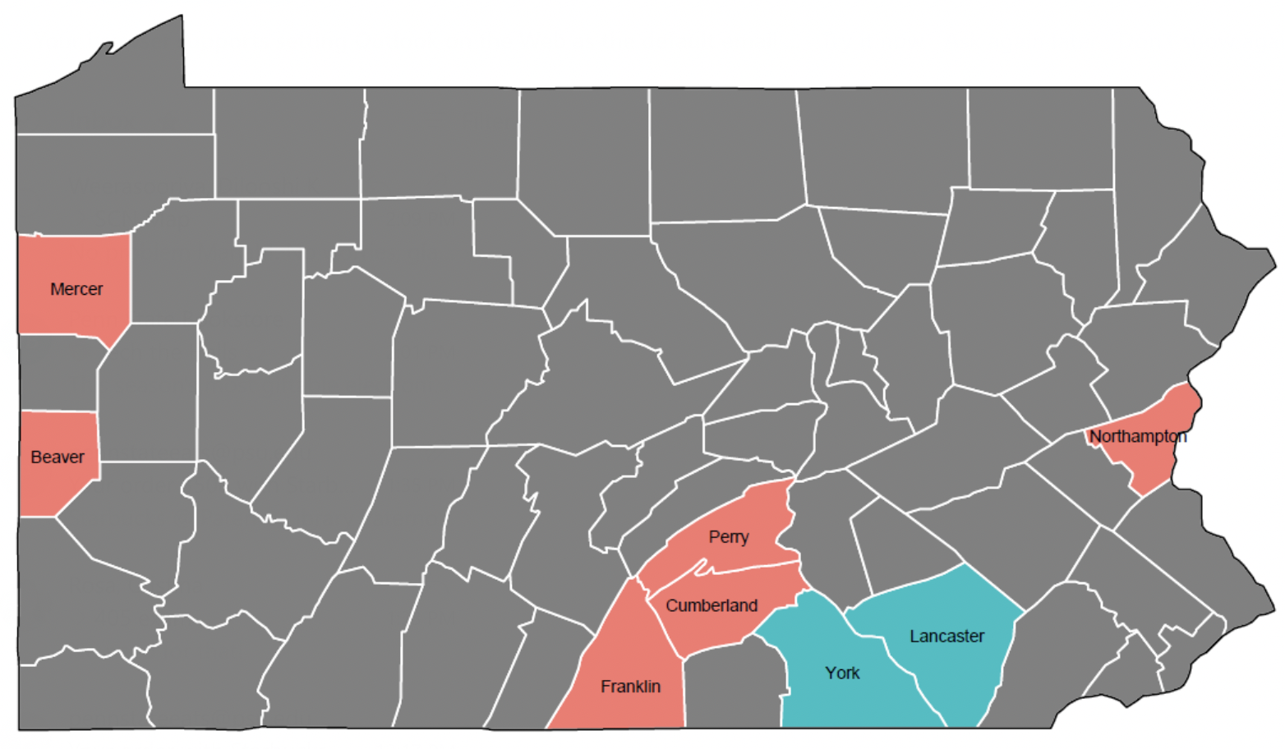
Figure 1. Current counties where soybean cyst nematode has been found. The light blue counties (York and Lancaster) are confirmed officially, while those in red require follow-up sampling in coordination with the Pennsylvania Department of Agriculture.
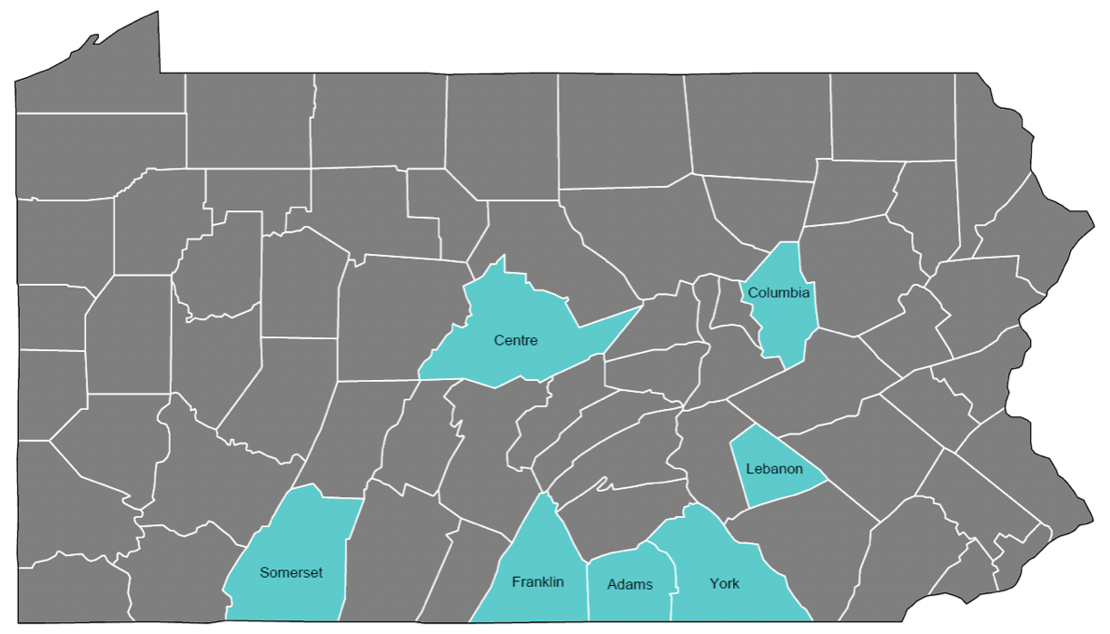
Figure 2. The current prevalence of root knot nematode from samples collected in Pennsylvania.

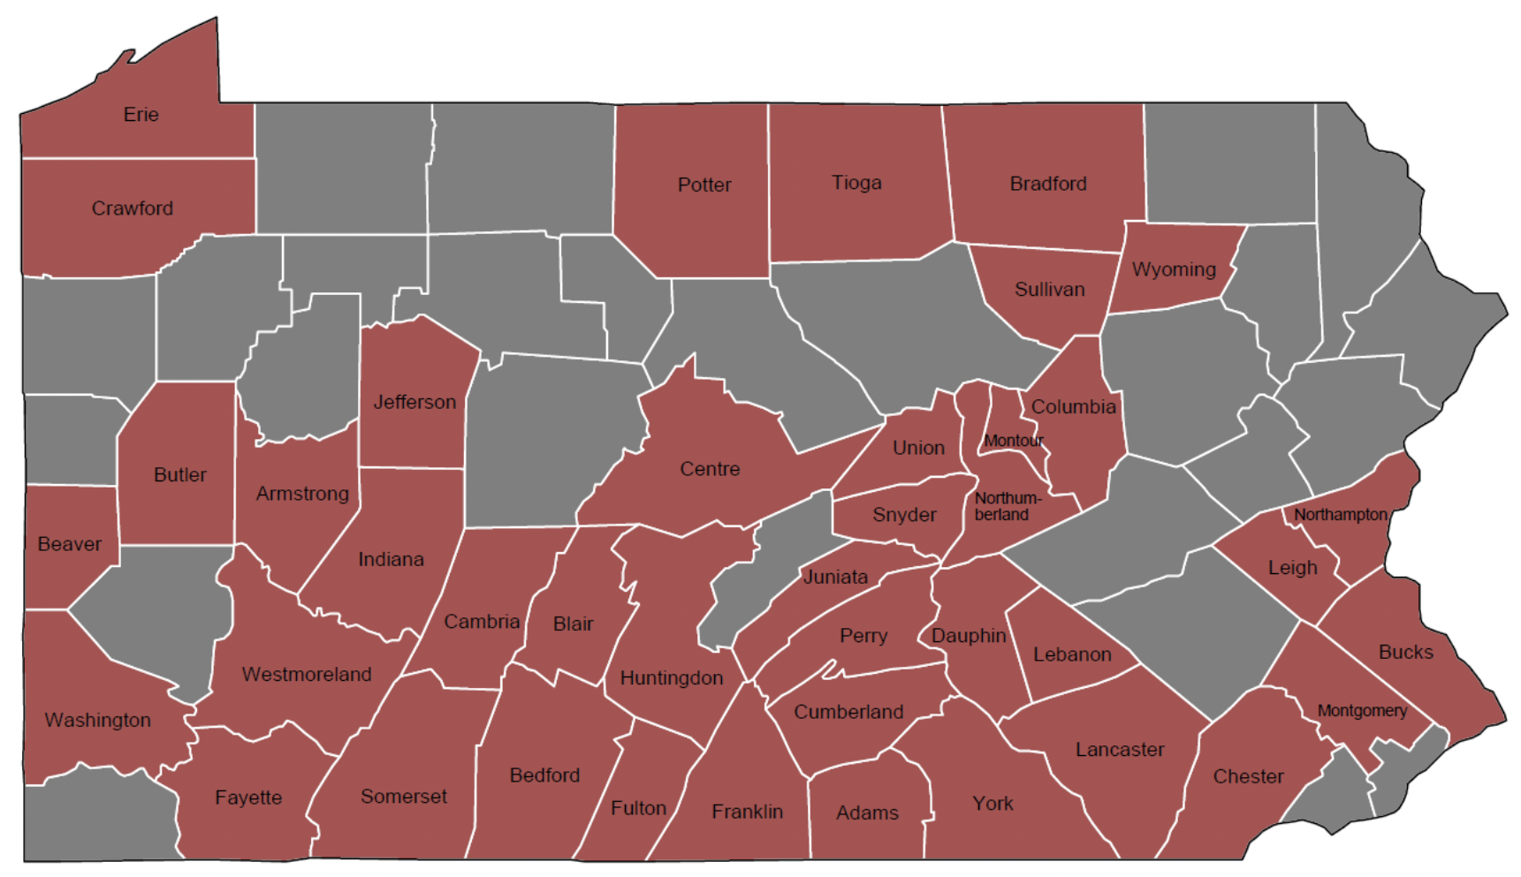
Figure 3. The current prevalence of lesion nematode from samples collected in Pennsylvania.
For decoration (if wanting to use this):
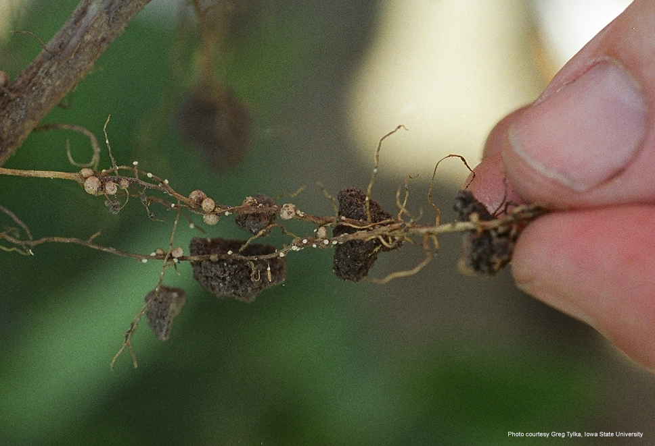
Soybean root infected with soybean cyst nematode. White, lemon-shaped females can be observed protruding out of the root about 6 weeks after planting. Photo credit: Greg Tylka, Iowa State University.

Refining 2-pass herbicide programs for horseweed management.
John Wallace and Cody Smith

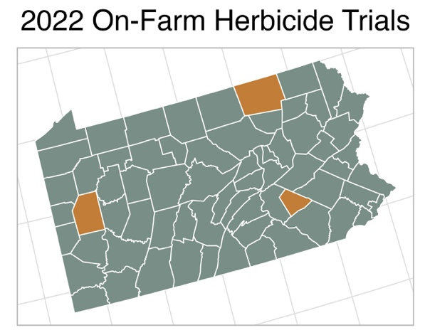
PROJECT SUMMARY
Glyphosate-resistant horseweed populations are becoming more widespread in the state and are now a significant management issue in western PA and the Northern Tier. In addition to varying levels of resistance throughout the state, including glyphosate- or glyphosate and ALS resistant biotypes, horseweed is challenging to control because of variable emergence patterns. Understanding regional (i.e., environmental) or management-driven trends in emergence patterns is the first step at designing more effective herbicide programs for horseweed control.

The objective of this project is to conduct coordinated on-farm trials across distinct PA production regions to (1) describe horseweed emergence patterns relative to soybean planting dates; (2) evaluate preemergence herbicide programs for horseweed control, including single- and multiple- active ingredient programs; and (3) quantify the length of residual activity across production regions of soil applied herbicides for control of small-seeded annual weeds (e.g., horseweed, waterhemp, Palmer amaranth) using bioassays from field-trial soils. In 2022, we conducted trials in Butler County (n = 2), Bradford County (n = 1) and Lebanon County (n = 2).

Table 1. Growth stage of horseweed population prior to pre-plant burndown application (listed below).
 |  | % of horseweed population
Location (burndown) |  | cotyledon | rosette | bolting
Bradford Co. | (5/14) | 42 | 31 | 21
Butler Co. I | (5/06) | 0 | 87 | 13
Butler Co. II | (5/26) | 0 | 9 | 91
Lebanon Co. I | (4/26) | 0 | 99 | 1
Lebanon Co. II | (none)ª | 0 | 0 | 0
ª soybean planted (5/25) into cereal rye and then roll-crimped at anthesis; no horseweed observed
FINDINGS (2022)

A key management goal for effective control of horseweed is to target populations with pre-plant herbicide applications prior to the bolting stage because the efficacy of commonly used burndown products [saflufenacil (i.e., Sharpen), 2,4-D, dicamba or paraquat] decreases after horseweed bolts. Horseweed populations were characterized by growth stage just prior to the time of pre-plant burndown applications by growers (Table 1). As expected, later planted soybean fields (mid- to late- May) were more likely to have horseweed plants that had already bolted. One noteworthy finding was that the Northern Tier location was the only population that appeared to have a significant early-spring flush of horseweed.

Table 2. Emergence timing of horseweed relative to soybean planting (pre- or post- plant).
 |  | % of total emerged
Location (plant date) |  | pre-plant | post-plant
Bradford Co. | (5/20) | 53 | 47
Butler Co. I | (5/31) | 27 | 73
Butler Co. II | (5/25) | 70 | 30
Lebanon Co. I | (5/3) | 92 | 8
Lebanon Co. II | (5/25)ª | 0 | 0
ª soybean planted into cereal rye and then roll-crimped at anthesis; no horseweed observed
Additional horseweed emergence occurring after typical soybean planting dates is becoming more common and understanding this pattern can help design effective tactics for managing horseweed in crop. Monitoring results showed significant horseweed emergence after planting (Table 2). Though additional sites will be needed, our first-year results suggest that the Northern Tier and western locations were more likely to have significant flushes of horseweed after planting. This finding suggests that soil-applied herbicide programs will be a key component of horseweed management in these regions.

Herbicide trials consisted of single- and multiple- active ingredient preemergence programs, including two ALS Inhibitors (Group 2; chlorimuron and cloransulam), metribuzin (Group 5) and flumioxazin (Group 14). Effective burndown applications were applied at each location but varied depending on the soybean trait. Treatment varied at each location to include each grower's program that was applied in the rest of the field. Horseweed control 35 days after planting is reported in Table 3. The efficacy of single active ingredients varied across locations. The lack of control from Group 2 herbicides may be an indicator of ALS-resistant populations, though additional studies will be needed to verify. In general, Group 2/5 mixtures provided the most consistent control.

Table 3. Horseweed control (% population reduction) 30-35 d after application.
PRE application | Bradford  (35 DAP) | Butler I  (35 DAP) | Butler II  (30 DAP) | Lebanon I  (35 DAP) | Avg. | Range
S-metolachlor + | ------------- % reduction in horseweed population -------------
chlorimuron (0.03 lb ai; Classic) | -- | 87 | 70 | 95 | 84 | 70-95
cloransulam (0.04 lb ai; FirstRate) | 66 | 99 | 99 | 95 | 90 | 66-99
metribuzin (0.2 lb ai; Tricor) | 99 | 99 | 91 | 70 | 90 | 70-99
flumioxazin (0.06 lb ai; Valor) | 96 | 94 | -- | 75 | 86 | 75-96
chlorimuron + metribuzin | -- | -- | 99 | 95 | 97 | 95-99
cloransulam + metribuzin | -- | 98 | 99 | 95 | 97 | 95-99
cloransulam + flumioxazin | 85 | 89 | -- | 90 | 88 | 85-90
metribuzin + flumioxazin | 99 | 99 | -- | 70 | 89 | 70-99

If you have questions or would like to participate in 2023 field trials (horseweed, waterhemp, or Palmer amaranth infestations), please contact: John Wallace, jmw309@psu.edu, phone: 814-863-1014, text: 208-874-2887

Ilevo seed treatment trials and microbiome/soilborne research
Paul Esker, Mariah Kidd, Tyler McFeaters, and Dilooshi Weerasooriya

Sudden death syndrome (SDS) is one of the significant yield-limiting soil-borne diseases of soybean in North America. For example, in 2020 and 2021, SDS caused approximately $11.6 million in economic losses in the Northeastern USA.

Ilevo seed treatment has emerged in other parts of the US as a promising control for SDS. However, before recommendations could be made for Pennsylvania, it is essential to conduct multi-year, multi-location trials to quantify the efficacy of Ilevo.
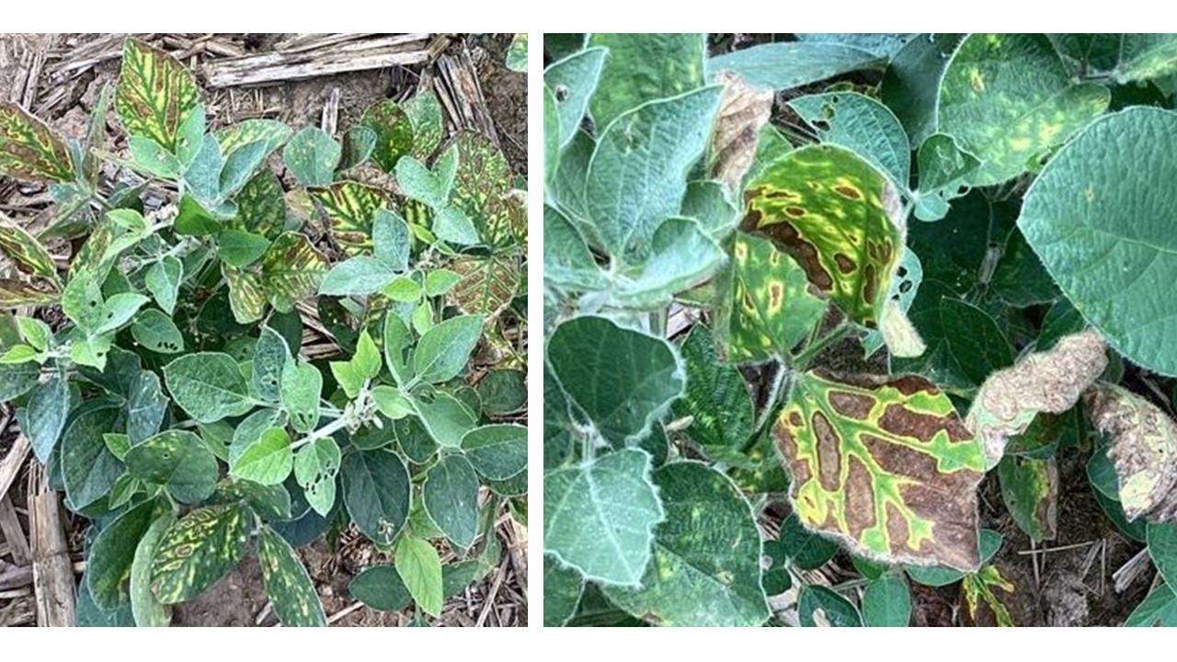
Figure 1. Sudden death syndrome symptoms observed in farmer fields during 2022.

The study design was based on an on-farm methodology that we used in trials that started in 2021. The 2022 trials were established in farmer fields with a history of SDS in six counties of Pennsylvania: (1) Cambria County, (2) Centre County, (3) Lancaster County, (4) Lawrence County, (5) Lebanon County, and (6) Lycoming County. The variety P2721RXF with and without the Ilevo seed treatment was used for the treated and control plots. Farms followed used seeding rates that ranged from 140,000 to 180,000 and row spacings of 15 or 30 inches. Any standard farm-specific crop production practices, such as fertilizer and herbicide use, were recorded.

Prior to planting, bulk soil samples were collected from each site to determine the density of four important soilborne fungal pathogens, Pythium spp., Phytophthora spp., Fusarium spp., and Rhizoctonia spp. Plant parasitic nematode density and soil nutrient profile for each site were also determined. The normalized difference vegetation index (NDVI) was recorded at the R2 growth stage using the “GreenSeeker” handheld crop sensor to measure crop health. The initial plant stand of each plot was recorded at the same growth stage, and fifteen plants per plot were collected for destructive measurements. Collected plants were evaluated in the laboratory to quantify disease incidence for any noticeable disease and crop growth parameters. At harvest, the yield from each plot was collected separately for yield comparison between the two treatments.

We also collected root ball samples at emergence (VE), unrolled unifoliolate leaves (VC), and first trifoliolate (V1) growth stages for the microbiome portion of this study. Sampling was done for Ilevo treated and control plots within a selected block. The reason for choosing these three sampling stages was to determine if Ilevo seed treatment has contributed to any noticeable changes in the soil microbial profile and composition.
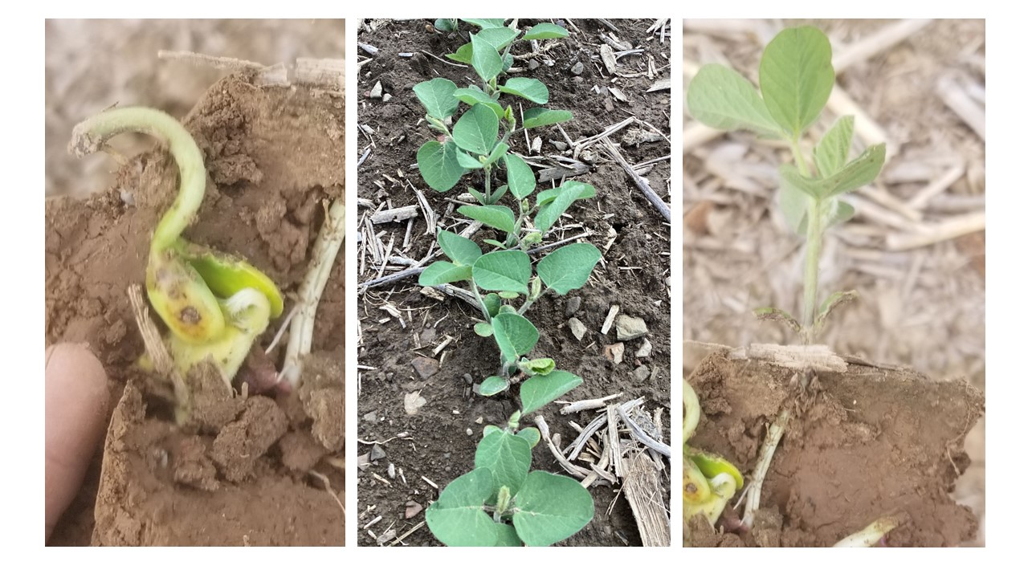
Figure 2. Root ball samples for microbiome analysis were taken at three different growth stages: VE (left), VC (middle), and V1 (right).

Current Findings
Across trial locations and years, we have not observed any differences between the Ilevo and the Control treatments for any of the parameters measured. Given the late harvest in 2022, we are still receiving the yield data from several Ilevo trial sites. However, similar to 2021, the yield data obtained has not indicated any significant differences between the Ilevo treated and Control plots. Though many different types of nematodes were found in the soil samples collected from these trial fields, none of the sites were positive for soybean cyst nematodes or root rot nematodes. Soil nutrient profiles for the sites did not show any significant nutrient deficiencies.

Soil pathogen density determination and the microbiome portion of this study are in progress. We expect those results to help guide our understanding of the potential efficacy of using Ilevo seed treatment in protecting soybean seed against SDS and other soilborne pathogens in Pennsylvania.

Broadcasting Cover Crops into Standing Soybeans
Heidi Reed

This project aims to compare how several different cover crop species perform when broadcast seeded into soybeans just before soybean leaf drop. We measured soil nitrate in the fall and spring to see if cover crops tie up or supply nitrogen for the next crop. Additionally, plants were counted, ground cover was measured in the fall, and repeated measurements were made in the spring. Lastly, dry matter for each cover was estimated, along with how well the cover crops were established. This research is important to farmers because many struggle to get cover crops planted after soybean harvest. The results from this study will help farmers decide whether broadcasting into standing soybeans might be a worthwhile practice on their farms. Broadcasting cover crops can open the planting window to species other than winter cereals or allow a farmer who usually doesn’t have enough time to plant cover crops in the fall to grow a winter cereal.

Potential economic impacts
• Lowered cost of cover crop establishment by broadcasting into standing soybeans instead of drill seeding after harvest
• Reduced herbicide cost with improved weed control from earlier-seeded, higher biomass cover crops
• Reduced N fertilizer cost if legume cover crops can supply some N for the next crop.

FINDINGS
As in year one of the experiment (2020-2021), dry matter production was low (<1,000 lb/ac) in this experiment in 2021-2022. Clovers did not establish at any of the three sites where it was planted, producing a maximum of 200 lb/ac biomass only when termination was delayed into June at SEAREC. Small grains were once again the most productive species at all four sites but grew less than 700 lb/ac everywhere except at SEAREC, where wheat reached 4,805 lb/ac., likely due to the late cover crop termination. Hairy vetch performed marginally well at SEAREC and the Lancaster County cooperator site, producing an average of 462 lb/ac; however, the establishment was very patchy, and weeds outweighed the vetch in most plots. The NRCS recommends at least 2,700 lb/A of cover crop dry matter to see cover crop benefits, so we likely did not see significant benefits from the cover crops at most sites.
Groundcover and plant density counts followed similar trends to spring biomass, and even the highest spring density was less than half the plants/A recommended by NRCS. Soil nitrate was not significantly impacted by the cover crops, likely due to the very low biomass produced.
These data add evidence to what we learned last year—that broadcasting cover crops into standing soybeans provides inconsistent establishment. It is best suited for fields where cover crop termination is delayed into late May or June. After two years and nine site-years of data, we can recommend small grains or annual ryegrass with some confidence, hairy vetch and rapeseed in the southeast especially, and avoiding clover species for this practice. Planting should be done as soon as possible when leaf yellowing begins, and success depends significantly on timely rainfall.

The next phase of this trial, established at five sites in Fall 2022, compares broadcasting the most successful species into soybeans (cereal rye, winter wheat, annual ryegrass, hairy vetch, and rapeseed) with drill-seeding the same species after soybean harvest.

