ON-FARM RESEARCH: Utilization of On-Farm Data on Soybean Production

Summary:
Nowadays good agronomical practices demand the adoption of new technologies that deliver better resource efficiency. The objective of this study was to identify and work closely with high-yielding soybean farmers in order to implement Ag precision tools, in this case: satellite imagery. Fields were selected for the 2017 growing season. The study is based on working with the field variation and the selection of three productivity zones outlined according to normalized difference vegetation index (NDVI) values.

Introduction
Vast information about crop health and development can be obtained via characterization of the temporal and spatial variability in the field, for example with the utilization of satellite imagery. Satellite imagery may provide crucial information that could potentially influence the decision-making process related to all farming inputs such as fertilizer, seeding rate, genotype selection, and pesticide application, among others.
The main objectives of this study are to: 1) explore the potential use of satellite imagery to identify productivity zones and evaluate soybean development across the growing season at the on-farm scale, and 2) explore relationships between satellite imagery data and ground-truth based plant traits such as plant growth and final yield.

Procedure
Sites Description
Field sites were established for 2017. Agronomical practices were those suitable per site.
Determination of Productivity Zones
A map defining productivity zones will be elaborated with previous year data for NDVI obtained from satellite imagery. See, Example of previous season productivity map.
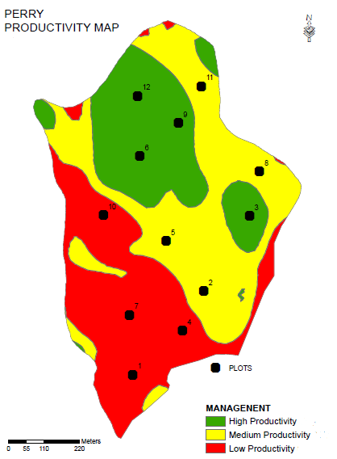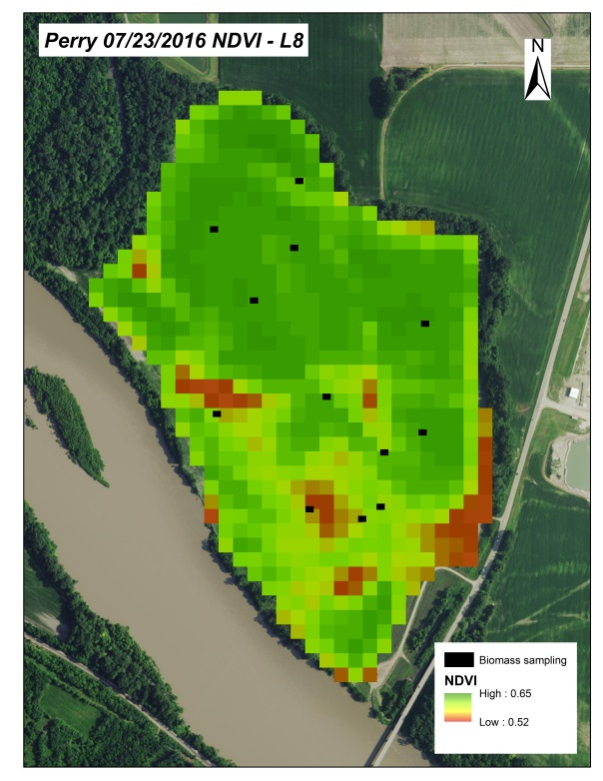
Fig. 1. Productivity zone map (left) and mid-season (R2 phenological stage) NDVI map of 2016 (right) soybean season at Perry site (KS). Black spot indicate the sampled plots.

