Q4 Final Progress Report – Feb-Apr
Cover Crop Management in a Wheat-Soybean System in Northwest Minnesota

Objectives:
- Identify the optimum timing of rye termination prior to soybean planting in a wheat-cover crop-soybean, no-till system.
- Identify the best species of cover crops to be used after wheat harvest and before soybean planting. Experiments were planted in two locations in September to address this objective.
- Evaluate the sowing method on the establishment and rooting depth of cover crops. Nothing has been done with this objective. It will be addressed in the spring.
Achievements:
During this quarter there were very limited activities due to cold weather and therefore limited cover crop growth. The plan is to harvest biomass from the four experiments prior to planting soybeans, which should occur around the third week of May. Initial observations suggest that the winter annual crops, camelina and winter rye, survived the winter well.

Challenges:
Cover crop growth has been slow this spring due to an unusually cold spring.
Publication(s)/Symposium:
None during this quarter.

Tech Transfer:
None during this quarter.

Summary of Trial Data for 2019 Growing Season

Research Question: There is increasing interest in the use of cover crops, primarily for their benefits in protecting the soil from erosion and improving soil health. Given the limited time between the harvest of a crop and the end of the growing season in northern Minnesota, the establishment of cover crops into most farming systems can be challenging. Within the rotation sequences in northwestern Minnesota, cover crops will most likely establish best and provide the greatest environmental benefits when planted after harvesting wheat in fields where soybeans will be grown the following spring. When incorporated into the current wheat-soybean cropping system in NW Minnesota, cover crops have the potential of protecting the soil for several weeks, grow sufficiently to scavenge much of the residual soil nitrate, thereby reducing its loss through leaching and runoff and establish enough biomass to reduce soil blowing in the winter. This project will seek to answer questions related to how to manage cover crops after wheat to maximize their environmental benefits while minimizing any detrimental impacts on the productivity of the cash crops grown. Specifically, we hope to answer the questions of what cover crops are the most effective to plant after wheat if soybean is planted the following spring, and if planting rye after wheat, when is the best time to terminate it, relative to when soybean is planted the following spring.

Results: We are still early the research process. In the rye termination timing experiments, we found that delaying the termination of rye (with glyphosate) until 2 weeks after planting (the latest termination date in the experiment) did not significantly reduce soybean emergence or soybean yield at harvest when compared to earlier termination timings (the earliest timing was two weeks before planting which was about as early as one could enter the field this year due to the late spring. The later termination dates resulted in greater rye biomass at the time of termination, greater weed suppression, and more ground cover during the early stages of soybean development. Rye terminated before planting soybeans had developed little biomass and this biomass was largely gone with a week or two of planting soybeans (Table 1).

Application/Use: The data collected so far are from a single year, one which was abnormally wet in the spring and fall. Therefore, the results should be viewed in the context of a wet spring and fall. They do suggest that when rye is planted as a cover crop after wheat that delaying its termination beyond the planting of the soybean crop will not have a detrimental impact on soybean establishment and yield, and will provide very good cover while the soybean crop is developing. This can reduce weed pressure, in addition to reducing the potential for erosion during the time that soybean is still developing.

Materials and Methods: We established the rye termination trial in fields of rye that had been planted the fall before, one east of RLF in Red Lake County Minnesota and the other in Steele County in North Dakota. We superimposed the following treatments in a uniform area of the field (time of termination of rye in the spring): a) early spring (2 weeks before planting), b) 1 week prior to planting; c) at planting, d) 1 week after planting; and e) 2 weeks after planting. Rye was terminated by applying glyphosate at the recommended rate. Soybeans were planted with a no-till drill about May 20th. Rye biomass at the time of termination, stand establishment of soybeans; observations on early weed suppression, vigor and iron chlorosis scores on soybeans, and yield were obtained from these plots. This experiment will be repeated in 2019/20.
A second experiment was established in two locations in September. In this experiment, a range of commonly recommended cover crops were planted in September (largely due to the wet fall, which precluded earlier planting). Cover crop biomass, in both the fall and spring will be measured and the effect of cover crops on the yield of soybeans in 2020 will be quantified. There are no data from this experiment yet as it was just established. Measurements that will be taken include: cover and biomass in the fall (at freeze-up and at the time of termination in the spring); nitrogen content of cover crops; stand establishment of soybeans; observations on early weed suppression, yield of the soybeans, vigor and iron chlorosis scores on soybeans as well as soil moisture and observations on soil tilth. Check plots where no cover crops will be planted will be included.

Economic Benefit to a Typical 500 Acre Wheat Enterprise: Potential economic benefits are unknown at this time but will hopefully become clear as we explore and analyze the data moving forward. Preliminary data suggests that there will be weed suppression when rye is terminated after planting soybeans. This could potentially translate into an economic benefit for farmers, particularly if there are weeds in the field that are difficult to control due to herbicide resistance.

Table 1. Effect of rye termination timing on weed numbers, rye biomass (at time of termination) soybean stands and yield, average of two locations in 2019.
Rye termination time | Weed count |  | Rye Biomass | Soybean population | Yield
 | (#/ft²) |  | (gm/ft²) | (#/acre) | (bu/acre)
2 wks before plant | 7.3 |  | 0.0 | 106,286 | 40.3
1 wk before plant | 5.4 |  | 23.9 | 108,610 | 41.6
At planting |  | 5 .2 | 31.4 | 114,998 | 42.2
1 wk post plant | 1.8 |  | 47.3 | 104,544 | 39.5
2 wks post plant | 0.9 |  | 78.0 | 105,125 | 40.4

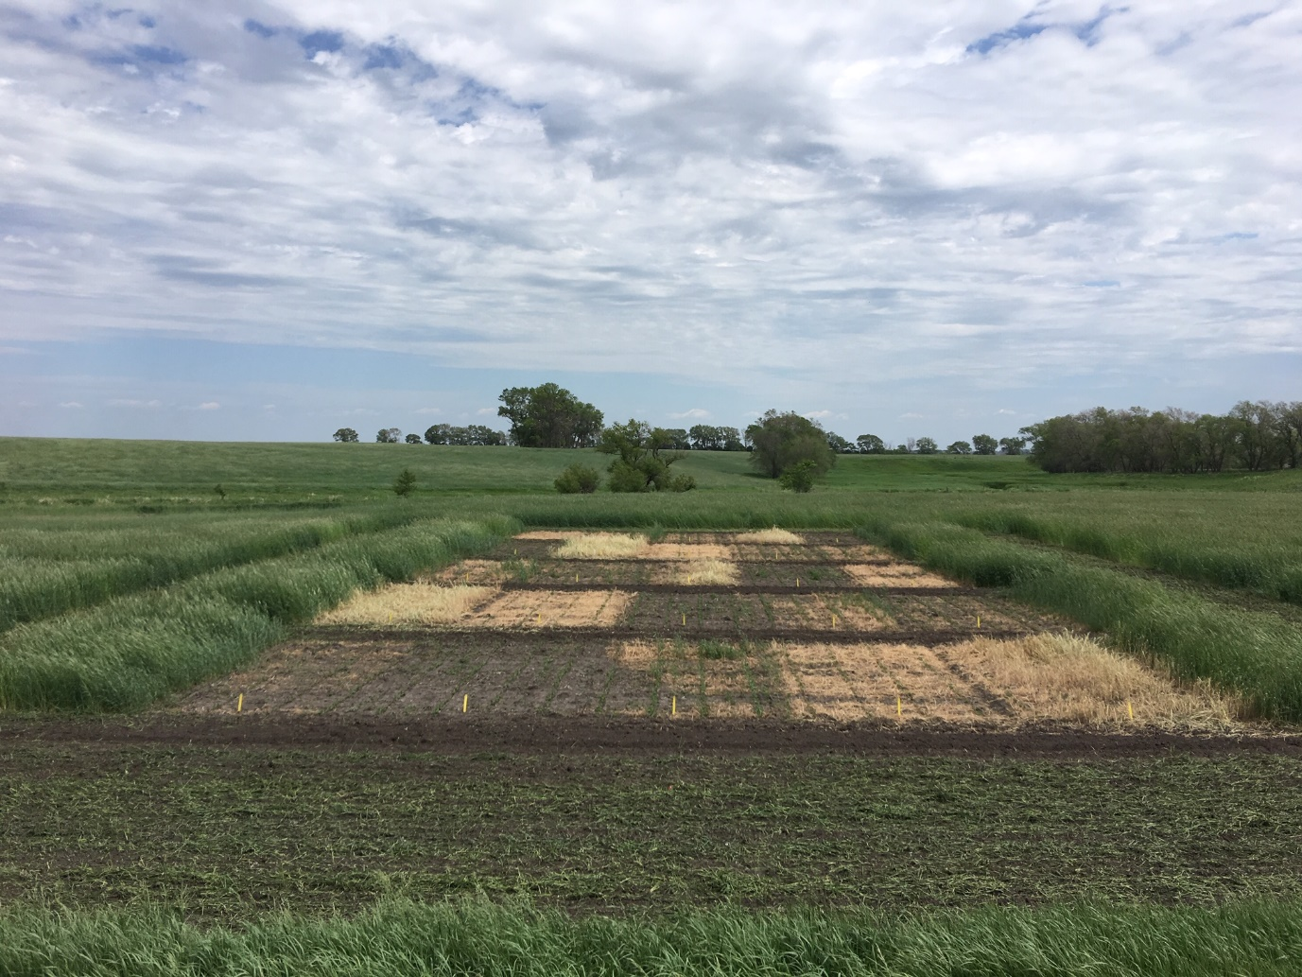
Figure 1. Rye biomass and weed suppression, Steele County, ND about two weeks after last rye termination timing in 2019.

