Spring planting conditions throughout Iowa were excellent and ahead of historical planting records. In general, drought conditions were evident and field in western Iowa, in particular, were stressed. Abnormally dry or moderate drought conditions persisted throughout the entire growing season.
Population fluctuations between locations and years is typical soybean aphid dynamics for Iowa. Soybean aphids arrived on soybean in July, which is average for Iowa. Soybean aphid colonization was initially patchy and continued to grow at a slow pace.
I was able to complete proposed work, including research and extension related to soybean aphid management. I established a foliar insecticide efficacy evaluation at one location in 2021 (ISU Northwest Research Farm). I had 25+ treatments at this location; however, aphids did not approach the economic threshold.
Soybean gall midge continues to emerge as an economic pest in Iowa. Three new counties were confirmed with infestations (total of 31 counties), and expanded to over 120 total counties in five states (IA, MN, MO, NE, SD). I dedicated many extension programs to soybean gall midge and spoke about the limited information on biology, life cycle and management. Overall, severity of commercial fields was less than in 2019 and infestations tended to be more scattered within fields. I established efficacy evaluations at two locations in 2021. Multiple chemistries and sites of application were used, but emphasis was placed on suppressing overwintering adult establishment. Our 25+ treatments did not appear to delay or effectively suppress larval feeding.
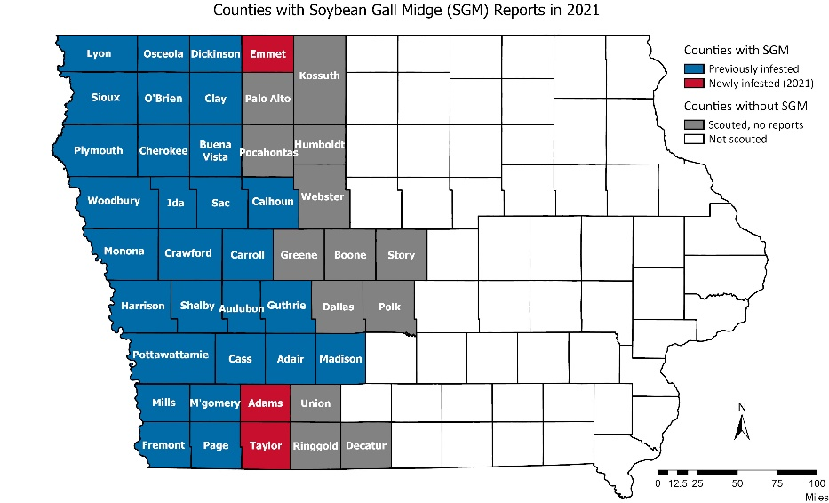

My extension efforts are summarized here:
Peer-Reviewed and Peer-Edited Extension Publications and Proceedings: 5
Huseth, A. S., R. L. Koch, D. Reisig, J. A. Davis, S. V. Paula-Moraes, and E. W. Hodgson. 2021. Current distribution and population persistence of five caterpillars in U.S. soybean. Journal of Integrated Pest Management. DOI: 10.1093/jipm/pmab004.
Hodgson, E. W., R. L. Koch, J. A. Davis, D. Reisig, and S. V. Paula-Moraes. 2021. Identification and biology of common caterpillars in U.S. soybean. Journal of Integrated Pest Management. DOI: 10.1093/jipm/pmab006.
McMechan, A. J., E. W. Hodgson, A. Varenhorst, T. Hunt, R. Wright, and B. Potter. 2021. Soybean gall midge (Diptera: Cecidomyiidae), a new species causing injury to soybean in the United States. Journal of Integrated Pest Management. DOI: 10.1093.jipm/pmab001.
Hodgson, E. W., and M. Helton. 2021. Soybean gall midge efficacy screening program, 2020. Entomological Society of America Arthropod Management Tests. DOI: 10.1093/amt/tsab010.
Hodgson, E. W., and G. VanNostrand. 2021. Soybean aphid efficacy screening program, 2020. Entomological Society of America Arthropod Management Tests. DOI: 10.1093/amt/tsaa053.

Other Extension Publications: 15
Sisson, A. J., D. S. Mueller, S. P. Conley, C. K. Gerber, S. H. Graham, E. W. Hodgson, T. R. Leglieter, P. P. Price, K. J. Schaefer, E. J. Sikora, T. H. Wilkerson, and K. L. Wise. 2021. Crop scouting basics for corn and soybean. Crop Protection Network CPN 4007. DOI: 10.31274/cpn-20201214-0.
Hodgson, E., and A. Dean. “Fall armyworm is a 2021 late-season pest.” In ICM News. 2 September 2021.
Hodgson, E. “Twospotted spider mite scouting reminders.” In ICM News. 28 July 2021.
Hodgson, E. “Corn silks (and feeders) are out - assess pollination in fields.” In ICM News. 14 July 2021.
Hodgson, E. “Alfalfa weevils active in northern Iowa” In ICM News. 7 July 2021.
Hodgson, E. “Soybean gall midge emergence beginning in Iowa.” In ICM News. 17 June 2021.
Dean, A., and E. Hodgson. “Corn rootworm egg hatch peaking in Iowa.” In ICM News. 14 June 2021.
Dean, A., and E. Hodgson. “Japanese beetle adult emergence beginning in southern Iowa.” In ICM News. 11 June 2021.
Dean, A., and E. Hodgson. “Stalk borers are on the move across Iowa.” In ICM News. 8 June 2021.
Dean, A., and E. Hodgson. “Soybean aphid egg hatch complete.” In ICM News. 13 May 2021.
Dean, A., and E. Hodgson. “Begin scouting for black cutworm in corn.” In ICM News. 11 May 2021.
Dean, A., and E. Hodgson. “High mortality rates for bean leaf beetle in northern Iowa.” In ICM News. 20 April 2021.
Dean, A., and E. Hodgson. “Seedcorn maggots get an early start.” In ICM News. 12 April 2021.
Dean, A., and E. Hodgson. “Alfalfa weevils active throughout southern Iowa.” In ICM News. 12 April 2021.
Dean, A., and E. Hodgson. “Summary of 2020 insecticide evaluations for soybean pests.” In ICM News. 10 January 2021.

Extension Presentations: 8
Hodgson, E. W. Soybean gall midge and soybean aphid management update. Stine Annual Summer Meeting, Adele, IA. [75 people] 21 July 2021
Hodgson, E. Management updates for corn and soybean pests. Stine Field Day, Field Extension Education Laboratory, Iowa State University, Ames, IA. [3 sessions; 55 people] 30 July 2021
Hodgson, E. Corn pest management. Management Clinic, Field Extension Education Laboratory, Iowa State University, Ames, IA. [25 people] 22 July 2021
Hodgson, E. Corn rootworm and soybean gall midge updates. Northwest Research Farm, Iowa State University, Sutherland, IA. [125 people] 7 July 2021
Dean, A., M. O’Neal, and E. W. Hodgson. Developing a decision-making framework for pest management. Soybean Breeders’ Workshop, Virtual Delivery [23 February 2021]
Hodgson, E. W., M. Helton, and J. McMechan. Soybean gall midge efficacy evaluations. Soybean gall midge discussion series, Virtual Delivery. [175 live views] 19 January 2021
McMechan, J., E. W. Hodgson, and Vilma Montenegro. Soybean gall midge ecology and plant injury. Soybean gall midge discussion series, Virtual Delivery. [180 live views] 12 January 2021
McMechan, J., T. Hunt, E. W. Hodgson, B. Koch, and B. Potter. Soybean gall midge biology, distribution, sampling tips, and look-alikes. Soybean gall midge discussion series, Virtual Delivery. [210 live views] 5 January 2021

