Achieving 100 Bu/A soybean yields: developing, testing, and sharing high yield protocols with South Dakota soybean producers
Prepared by David Clay
Team members: David Clay, Sharon Clay, Connie Strunk, Anthony Bly, Peter Sexton, Thandi Nleya, Cheryl Reese, Stephanie Bruggeman, Graig Reicks, John Kleinjan, and Rocky Dailey

Advisory board: David Iverson, David Wright, Craig Converse, Gregg Carlson, Gordon Anderson, Kyle Gustafson

Executive summary of project: Increasing yields in a highly variable environment requires the development of adaptable systems that link advances in crop genetics with an improved understanding of ecosystem functioning. The proposed project will build the infrastructure where locally-led production and management questions are identified and tested. During the past year, research was conducted that investigated the impact of planting data and row spacing on soybean yields, how to achieve high yield soybeans, the impact of in season cover crops on soybean yields, as well as facilitated on over 80 on-farm studies. Two advisory board meetings where held and we had several meetings on developing a web-page. In addition, team members help integrate research into Ag-outlook and planning for the 2016 Soy100 meeting was conducted.

Objective 1: Targeted research used to increase soybean yields

Task 1a: Determine the influence of planting date, seeding rate, and variety on soybean growth, yield, and nutrient uptake characteristics.
Report prepared by Thandiwe Nleya and Matthew Schutte,
- Row Spacing/Seeding Rate /Variety for Maximizing Yield
Introduction
This research builds on the project conducted from 2009 to 2013 on soybean seeding rates in a range of soybean maturity zones (South Shore, Volga, Beresford) in South Dakota. Data from this research revealed that narrow row yields were equal to or greater than yields in 30-inch row spacing and that higher seeding rates also increased yield. Additionally, variety performance was affected by row spacing in some instances. Unfortunately, there has been a 24% shift in acres planted back to wider rows (20-inch to 30-inch) from 2009 to 2013 in South Dakota according to USDA-NASS. Some important changes in the treatment structure are needed to address current producer trends and concerns on variety selection for narrow versus wider row spacing.
Materials and Methods
In 2015 research was conducted at the SDSU Southeast experimental farm (Beresford), Volga, and Aberdeen. Treatments included two soybean varieties, one variety adapted to narrow rows and white mold resistance and the other, adapted to wide rows and susceptible to white mold. The varieties were Beresford: 2306R2 (resistant) and 2408R2 (susceptible) ; Volga: 2108R2 (resistant) and 2207R2 (susceptible); Aberdeen: 0906R2 (resistant) and 1108R2 (susceptible). At each location the soybean varieties were planted at two row spacings (8 and 30-inch), and four seeding rates (100K, 135K, 170K, and 205K). The experiments were planted on 2 June, June 4, and 3 June at Volga, Southeast Farm, and Aberdeen, respectively.

Results
When data was combined over the three locations, white mold susceptible varieties yielded slightly better than resistant varieties. This can most likely be attributed to the varying maturity ratings of the varieties that were chosen to be the resistant and susceptible varieties (Table 1). Soybean yields were greatest at Beresford (65.8 bu/ac) and lowest at Volga (56.7 bu/ac). Overall soybean yield was maximized at the highest seeding rate of 205k across all plots.

The effect of row spacing had the same results at all three locations with greater yield with 8” rows than with 30” rows. The differences in yield were greater at Beresford and Aberdeen with yield increases of 2.9 and 2.3 bu/ac respectively than at Volga (0.8 bu/ac) (Table 2).

Table 1. Mean effects of location, row spacing, soybean variety, and seeding rate on yield, seed protein and seed oil content for soybean in 2015.
 | Yield (bu/ac) | Seed Protein (%) | Seed Oil (%)
Location
Aberdeen | 61.0 | 32.6 | 19.7
Beresford | 65.8 | 33.0 | 19.5
Volga | 56.7 | 34.3 | 18.7
Mean | 61.2 | 33.3 | 19.3
Spacing (inches)
8 | 62.2 | 33.3 | 19.2
30 | 60.1 | 33.3 | 19.4
Mean | 61.2 | 33.3 | 19.3
White Mold
Resistant | 60.3 | 33.1 | 19.3
Susceptible | 62.0 | 33.5 | 19.3
Mean | 61.2 | 33.3 | 19.3
Seeding rate
100K | 60.6 | 33.4 | 19.3
135K | 60.3 | 33.7 | 19.3
170 K | 61.0 | 33.6 | 19.3
205 K | 62.7 | 33.3 | 19.3
Mean | 61.2 | 33.5 | 19.3

Table 2. Influence of location on yield and seed protein content for two soybean varieties grown with two row spacings, variety, and at four seeding rates in 2015.
 | Aberdeen | Beresford | Volga
 | Yield (bu/ac)
Spacing (inches)
8 | 62.1 | 67.3 | 57.1
30 | 59.8 | 64.4 | 56.3
Mean | 61.0 | 65.9 | 56.7
Variety
Resistant | 60.4 | 64.3 | 56.3
Susceptible | 61.5 | 67.4 | 57.1
Mean | 61.0 | 65.9 | 56.7
Seeding rate
100K | 60.5 | 65.3 | 55.8
135K | 60.2 | 65.4 | 55.4
170 K | 60.8 | 65.4 | 56.9
205 K | 62.3 | 67.1 | 58.8
Mean | 61.0 | 65.9 | 56.7

- Planting Date/Seeding Rate/Variety for Maximizing Yield

Introduction
Climate change trends and simple year-to-year variability in weather often pushes the limits of crop insurance coverage for early (April 26) and late planting (June 10 with reduced coverage until July 5). Risk Management Agency (RMA) reviews planting dates for insurance coverage and data from long-term planting date studies have been used to make revisions. As a result, it is important to initiate a long-term date of planting study for soybeans to assess the yield response curve and appropriate reductions in insurance coverage.

Materials and Methods
In 2015 this research was conducted at Volga. The treatments included:
- Four planting dates: May 4, May 20, June 2 and June 16.
- Two seed treatments (with and without fungicide),
- Two soybean variety two maturities (1.4 -1405R2) and 2.4-2402R2)
- Four seeding rates (100K, 135K, 170K, and 205K) using 30 inch row spacing.

Results
Stand counts showed little variation among planting dates. Overall there was a significant decline in yield and seed protein content as planting date was delayed (Table 3). Compared to the first year, the decline was more linear and less exponential. This was most likely caused by having no frost before the soybeans reached full maturity in all planting dates. Overall, the 1.4 maturity variety yielded 1.1 bu/ac more than the 2.4 maturity variety. Overall, there was a small increase in yield with increase in seeding rate. Seeding rate had significant effect on oil and protein content with protein increasing with increase in seeding rate while oil content decreased.

Conclusions
The second year results of the row spacing trial show that location is still important when considering row spacing for soybeans but with all three locations showing a greater yield in narrow rows, it seems that year-to-year variability has more of an impact on the effectiveness of different row spacings. Row spacing effects are more consistent in northern South Dakota (Aberdeen) but a positive or at least a neutral impact on yield can be seen on narrower row spacings throughout South Dakota. Increasing seeding rate for soybeans resulted in increased yield but the yield increase may not be economical for most farmers since all locations had on average of 2 bu/ac increase in yield after more than doubling the seeding rate from 100k to 205k. Also since this is a white mold study it was noted that there was not any significant infections of white mold. Susceptible varieties yielded greater than resistant varieties in all three locations reinforcing the fact that white mold was not an influencing factor in yield.
The second year of the date of planting study only reinforced that earlier planting is better, but year-to-year variability has a profound impact on how well later planting dates and maturities perform. With no frost during plant growth, soybean yield loss was more linear with delays in planting compared to last year’s exponential drop in yield for planting dates hit with frost. Increasing seeding rate had a positive effect on yield but because the yield increase was small, it’s likely not economic for a farmer to increase seeding rate. Seed fungicide treatment had a negative effect on seed yield, oil, and protein content. The losses were very small but since the point of seed treatment is to increase yield, the results were disappointing.
Table 3. Mean effects of planting date, variety maturity group, plant population and fungicide on yield, seed protein and seed oil content for soybean grown at Volga, SD in 2015.

Task 2: High yield soybeans: Intensive early and late season management impact on soybean yields
David Clay, Sharon Clay, Graig Reicks, Michael Devens
Introduction
There are many products on the market that may increase soybean yields when either applied solo or in combination. A trial was initiated in 2013 that has continued through 2015. Sites for the 2015 trials were near Beresford, Aurora, and Pierre.
Methods
The previous crop was tilled corn. The trial was a split-plot on a randomized complete block design with four replications. Planting date or irrigation was the main plot effect, while product or combination of products was the subplot (Table 1). Plot sizes were 10 ft wide and anywhere from 20 to 30 ft long, depending on available space. All trials were planted in 30 in. wide rows.

Spraying was performed with a 4-nozzle CO₂ backpack sprayer at approximately 15 gal. per acre. A plot combine was used to harvest the middle two rows of each plot.

Table 1. Characteristics of each site in the 2014 South Dakota High-Input Soybean Trials.
Site | Variety | MG | Planting Date(s) | Irrigation
Aurora | AG1431 | 1.4 | May 22 | No
Pierre |  |  |  | No
 |  |  |  | Yes
Beresford | AG2933 | 2.9 | May 22 | No
 |  |  | June 11 | No

Table 2. Products applied in the 2014 South Dakota High-Input Soybean Trials.
Product | Purpose | Growth Stage | Rate ac⁻¹
Cobra | Herbicide | V4 | 12 oz
Urea | N Fert | V4 | 75 lbs N
ESN Urea | Slow release N Fert | V4 | 75 lbs N
Task Force 2 | Foliar Fert Blend | R1 | 64 oz
Ascend | Plant Growth Regulator | R3 | 6.4 oz
Bio-Forge | Ethylene Inhibitor | R3 | 16 oz
Quilt Xcel | Strob + Prop Fungicide | R3 | 21 oz
Domark | Prop Fungicide | R5 | 5 oz

Table 3. Soybean yields from high-input studies in 2015. Values are expressed as bu ac⁻¹ differences from the control at each of the eight sites.
TRT | Aurora  Dryland | Aurora Irrigated | Pierre Irrigated | Pierre Dryland | SE Farm Norm PD | SE Farm Late PD
 | ---------------------------------------bu ac⁻¹---------------------------------------
Control | 57.8 | 59.2 | 79.2 | 42.4 | 73.3 | 74.3
All (but Cobra) | 3.5 | 10.6 | 4.2 | 1.3 | 2.6 | 4.1
 | p=0.08 | p=0.02 | p=0.23 | p=0.78 | p=0.43 | p=0.29
Ascend | -0.4 | 3.5 | 2.4 | -2.8 | 4.3 | 3.3
 | p=0.85 | p=0.06 | p=0.49 | p=0.35 | p=0.02 | p=0.03
Bio-Forge | 1.2 | -1.4 | 1.5 | 1.6 | -2.3 | -1.8
 | p=0.12 | p=0.55 | p=0.61 | p=0.60 | p=0.43 | p=0.6
Cobra | -3.9 | -4.0 | -2.2 | -2.4 | 3.1 | -2.5
 | p=0.06 | p=0.16 | p=0.47 | p=0.17 | p=0.26 | p=0.47
Full N | 4.2 | 1.1 | 0.4 | -0.9 | 2.3 | 4.7
 | p=0.08 | p=0.74 | p=0.95 | p=0.40 | p=0.54 | p=0.05
Full N + Asc + 2 Fung | 4.0 | 4.4 | 3.4 | 2.1 | -7.5 | 1.5
 | p=0.32 | p=0.22 | p=0.33 | p=0.18 | p=0.04 | p=0.76
Full N + Asc | 1.9 | 6.8 | 3.8 | 5.1 | 5.0 | -0.2
 | p=0.18 | p=0.22 | p=0.23 | p=0.29 | p=0.29 | p=0.96
QuiltXcel | 1.1 | 5.8 | 4.1 | -5.1 | 0.6 | -0.2
 | p=0.37 | p=0.08 | p=0.24 | p=0.22 | p=0.84 | p=0.97
TaskForce 2 | 0.1 | 3.9 | 3.4 | -1.1 | 3.7 | 2.4
 | p=0.96 | p=0.35 | p=0.32 | p=0.50 | p=0.09 | p=0.58
Urea | 0.1 | 6.2 | 3.7 | 0.4 | 1.3 | 3.3
 | p=0.98 | p=0.16 | p=0.42 | p=0.90 | p=0.71 | p=0.17
2 Fungicides | 4.4 | 9.8 | 1.4 | -4.0 | 3.2 | 2.8
 | p=0.01 | p=0.04 | p=0.70 | p=0.03 | p=0.44 | p=0.29

Key Finding
Ascend was the most consistent performer in 2015, significantly increasing yields (p<0.06) in three of the six environments tested. The two fungicide application proved beneficial at Aurora with and without irrigation. N application significantly increased yields in the Aurora dryland and Beresford late-planted plots. At Aurora, the yield benefit appeared to come from the ESN component, whereas at Beresford, the urea component appeared to contribute.

Objective 2: On-farm research
Task 3. Education for producer identified research on-your-farm projects
Soybean Investigations: Research On Your Farm Update for FY16.

Connie Strunk and Anthony Bly
Harvest has been completed for the following research on your farm projects:
- Late Season Nitrogen – Madison, SD
- B-sure amino acid late season foliar application – Valley Springs, SD
- Early Season ESN in Furrow – Brandon, SD
- Soybean Variety Comparison – Armour, SD
- Nutri-pack Foliar Application – Garretson, SD
- Soybean Inoculum Comparison – Pierre, SD
- Late Season Nitrogen – Pierre, SD
- Micro-nutrient Study – Crooks, SD
- Micro-nutrient Study – Sinai, SD
- Micro-nutrient Study – Garretson, SD #1
- Micro-nutrient Study – Garretson, SD # 2
- Micro-nutrient Study – South Shore, SD
- Late Season Fungicide – Crooks, SD
- Late Season Fungicide – Sinai, SD
- Late Season Fungicide – Garretson, SD # 1
- Late Season Fungicide – Garretson, SD # 2
- Late Season Fungicide – South Shore, SD
- Coron with Pod Filler

Educational Outreach:
Three crop clinics have been held so far in South Dakota with one more planned. The fertility information has been presented to 160 people so far at the crop clinics. The late season fungicide information has been shared at two of the crop clinics and at three commercial applicator trainings so far with six more planned commercial applicator trainings to be held. The late season fungicide information has already been presented to 577 people.

Future Plans:
Data analysis is still occurring for the B-Sure project, the late season Nitrogen study in Madison, and the Coron with pod filler study. The late season fungicide information will be presented at 25 upcoming private applicator trainings, six commercial applicator trainings, and the fertility information will be presented at one more upcoming crop clinic. We have started to take names and make plans for the next growing season.

2016 Soybean Investigations: Research On Your Farm Results so far:

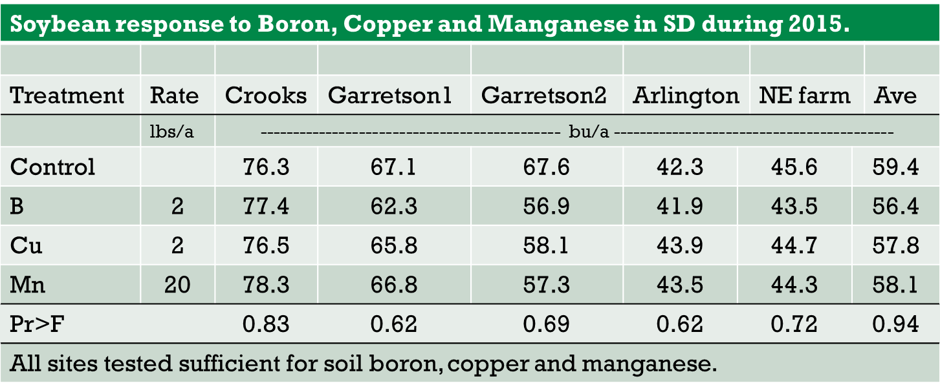
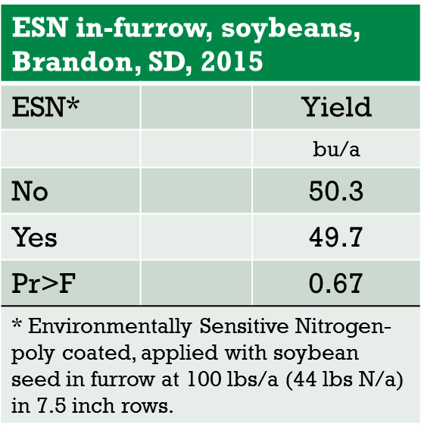
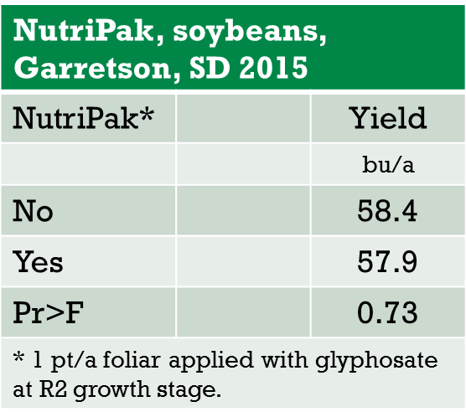

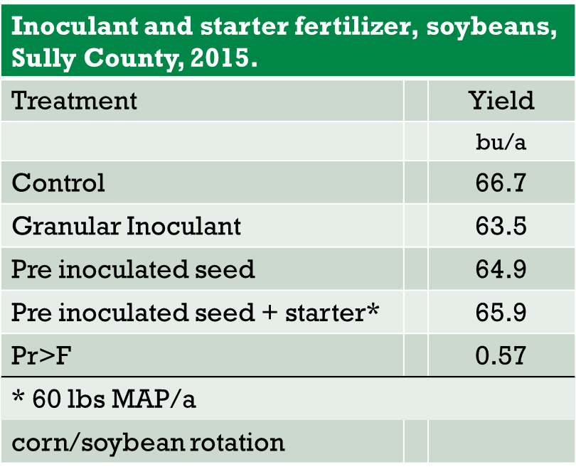

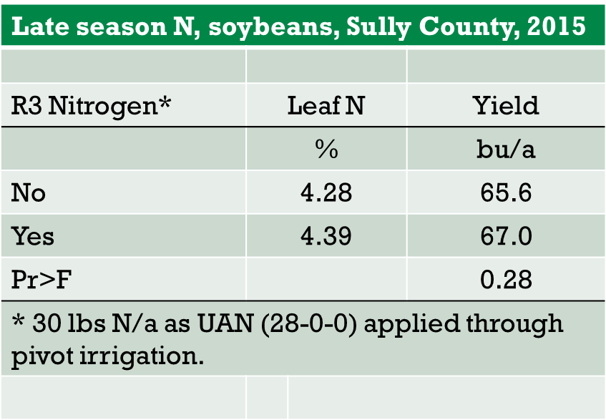
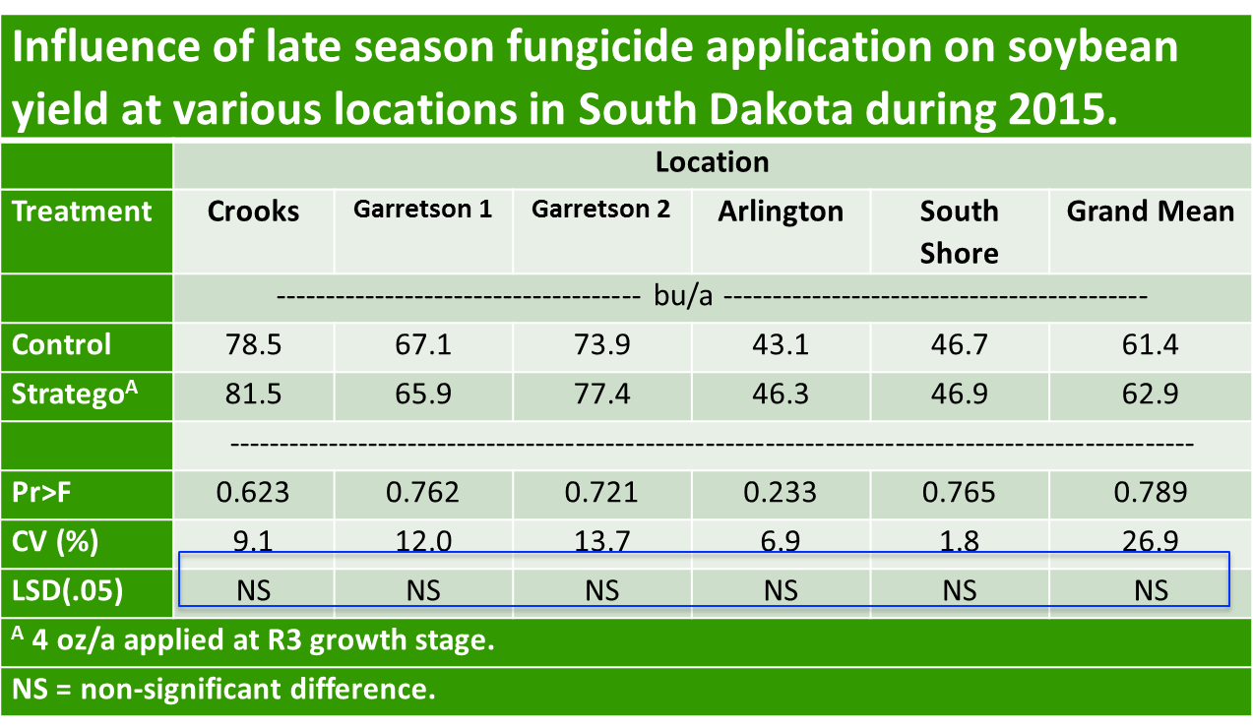

Task 4. Evaluation of Multi-Line Seeding for Soybeans in South Dakota Peter Sexton^{1/}, Douglas Prairie, Barry Anderson, and Doug Johnson.
INTRODUCTION
This report reviews our third season of trials looking at variable-line seeding of soybeans using a “multi-hybrid” planter. Where previously we had used a smaller 6-row prototype unit developed in collaboration with Raven Industries and Pioneer Hi-Bred, in 2015 Kinze Manufacturing kindly provided a 16-row planter which they have made commercially available (Kinze model 4900 MH Planter). In the first season (2013) at the Tripp and Beresford sites we found on average a 5 bushel per acre yield gain with variable line planting in corn and a 3 bushel per acre yield gain in soybeans. In the second year of the study, we again found a 6 bushel yield advantage with corn with the right pairing of lines, but no advantage with corn or soybeans if the lines didn’t fit well. In this third year of the study we conducted we had three sets of trials soybeans (two on-farm, and one at the research station).
The basic logic behind this approach is that given our rainfall distribution (which peaks in May and June) versus the water requirements of corn and soybean crops (which peak in August) there is a good chance that in the same field in the same season the lowland parts of the field may be yield limited by excess moisture early in the season, while the upland positions on the landscape will be yield limited by drought stress in late July and August. It seems logical that gains in productivity within a field might be achieved by using lines with a more horizontal root profile and tolerance to wet conditions in lowland portions of the landscape, and switching to lines with a more vertical root profile and resistance to drought conditions in the upland portions of the landscape. The primary objective of this effort was to make an initial evaluation of improvements in soybean yield grown with a variable-genotype planting system versus planting a single line across the landscape

METHODS
This project was partially supported by the South Dakota Soybean Research and Promotion Council. Pioneer Hi-Bred provided materials to test, and Raven Industries and Kinze Manufacturing provided equipment. Field maps were developed for each test site by personnel from SDSU. Agronomists from Pioneer Hi-Bred selected the lines to be used in the upper and lower landscape positions for the study. The project looked at two pairs of soybean lines with only one given pair being tested at each site (Table 1). At each site treatments were upland line, lowland line, variable-line seeding according to landscape position, and variable-rate with variable line seeding. For soybeans, the standard and variable seed rates were 150,000 and 120/180,000, respectively, at all locations. All individual treatments were planted in field-length plots, a minimum of 40’ wide. The number of replications at each site is given in Table 1. Initially our plans called for several on-farm trials in the Wilmot area to look at utilizing this technology in fields with iron-chlorosis problems (seeding lines resistant to iron chlorosis in problem areas and then seeding lines selected solely for yield potential on the remainder of the field). However, the way weather conditions worked out this spring, our cooperators in the Wilmot area were ready to plant soybeans in early May, and since we were still not done planting around Beresford we had to tell them to go ahead on their own.

Table 1. List of sites, lines used, number of replications per site, and method of collecting yield data for trials conducted in southeast South Dakota to evaluate use of a multi-hybrid planter for these crops in the 2015 growing season. All plots were seeded with a Kinze 4900 Multi-hybrid planter.
Crop | Cooperator Location | Upland Line | Lowland Line | Number of Replications | Yield Data
Soybean | Lennox | 92Y51 | 92Y70 | 3 | yield monitor
Soybean | Beresford | 92Y51 | 92Y70 | 3 | yield monitor
Soybean | SDSU Southeast Farm | P22T69 | 92Y70 | 4 | weigh wagon

Yield data were subjected to analysis of variance using SAS statistical software using Proc GLM with all factors considered as fixed effects for each site. There were no significant site by treatment interaction for sites that shared the same lines, so data was pooled across sites where the lines were the same.

RESULTS AND DISCUSSION
In 2015 we did not observe an impact of variable-line seeding with soybeans at Lennox or Beresford in the on-farm studies with ‘92Y51’ and ‘92Y70’ as the upland and lowland lines, respectively (Table 2). The trial at the research farm which used ‘P22T69’ as an upland line also did not show a yield response to variable line seeding (Table 3). Therefore, looking across seasons we have some mixed results as some of these same two lines (‘92Y51’ and ‘92Y70’) showed a significant 3 bu/ac benefit from variable-line seeding in the 2013 season, but did not show an advantage in 2015. The environment during seed-filling was remarkably good in our area in 2015, with adequate moisture and mild temperatures. Most years late-July and August are marked by more days with higher maximum temperatures and also some period of drought stress. That was not the case in 2015; rainfall in July and August was more than 6.8” above average this past year, and the rains were fairly well spaced. The relatively ideal conditions in our area may have equally benefited all the lines, lessening the differences between them across the field.
Table 4. Average soybean yields from trials conducted at Lennox and Beresford, SD in 2015 using a variable line planting of ‘92Y70’ (lowland) and ‘92Y51’ (upland) lines of soybean. The ‘VLR’ treatment was “variable-line and rate” seeded with a seedrate of 180,000 seeds per acre in the upland portions of the plot and 120,000 seeds per acre in the lowland portions of the plot. Each plot was 40’ wide and ran the length of the field. There was no site by treatment interaction, so data was pooled across sites.

Treatment | Yield
VLR |  | 62.7
Lowland |  | 62.3
Upland |  | 61.9
Variable-Line |  | 60.7
Mean |  | 61.9
CV (%) |  | 2.9
LSD (0.05) |  | NS
Site x Treatment Interaction |  | NS

Table 5. Average soybean yields from a trial conducted at the SDSU Southeast Research Farm in Beresford, SD in 2015 using a variable line planting of ‘92Y70’ (lowland) and ‘P22T69’ (upland) lines of soybean. The ‘VLR’ treatment was “variable-line and rate” seeded with a seedrate of 180,000 seeds per acre in the upland portions of the plot and 120,000 seeds per acre in the lowland portions of the plot. The ‘VLRR’ treatment was the reverse of this for population. Each plot was 40’ wide and ran the length of the field (approximately 1700’).
Treatment | Stand | 100 Seed-Wt | Moisture | Test Wt. | Yield
 |  | (g) | (%) | (lb/bu) | (bu/ac)
VLR | 130680 | 15.3 | 10.1 | 57.1 | 63.5
Upland | 137940 | 14.8 | 10.2 | 57.7 | 63.1
VLRR | 122694 | 15.8 | 10.3 | 56.9 | 62.4
Variable-Line | 133584 | 15.6 | 10.2 | 57.0 | 60.9
Lowland | 118338 | 17.0 | 10.1 | 56.6 | 60.0
Mean | 128647 | 15.7 | 10.2 | 57.1 | 62.0
CV (%) | 18.0 | 3.5 | 3.2 | 1.0 | 2.5
LSD (0.05) | NS | 0.8 | NS | 0.6 | 2.2
ACKNOWLEDGEMENTS
The authors would like to recognize Mr. Gordon Anderson, and Mr. Matt Loewe for being willing to put trials on their operations and for their work in implementing these trials. The efforts of the crew at the SDSU Southeast Research Farm, particularly Mr. Doug Johnson, were critical for the successful completion of this project.

Task 5. On-farm testing of soybean K responses.
In the on farm study, research was conducted in two soybean fields in 2015. During the growing season soil samples were collected and analyzed for soil test K. Once the sampling was complete fertilizer was then applied and mixed into the soil. Plant populations, transpiration, and yield was measured. In addition, whole plants were taken from each treatment strip in all 3 plots with a field and then separated into 6 different parts. The parts consisted of newest fully developed petioles and trifoliates, remaining petioles, old leaves, new leaves, and stems. Analysis of this experiment is being conducted.

Task 6. Interseeding covercrops into soybeans, G. Reicks, S.A. Clay, D. E. Clay, and J. Chang
Planting cover crops after corn or soybean harvest does not provide enough time for establishment or growth. If cover crops could be used in corn/soybean rotation, seeding will need to take place prior to harvest. There have been several timings, species, and methods proposed for this interseeding. Our objective is to seed cover crops during the main crop growth to establish them. Several areas of concern must be accounted for in this interseeding. First, the crop yield must not be harmed by the growth of the cover crop. Second, the amount of biomass for the cover crop must be great enough at the end of the season to provide benefit to the following crop. Third, the cover crop must not interfer with harvest (i.e. too tall to be picked up during combining). We have tried broadcast at several times of crop growth over several years and the establishment at best is poor. In this study, we drilled several species of cover crop seeds into soybean at several growth stages to determine if, and when, cover crops grow well and still meet the criteria described above. A broadcast treatment at one date was used for comparison. This study was conducted at two locations, Aurora and Beresford in 2014 and 2015.
Methods
The previous crop was corn with conventional tillage. The trial was a randomized complete block design with four replications. Each plot had 4 rows, each 2.5 ft. wide and 25 ft. long. A soybean variety with 2.2 maturity rating was planted at approximately 160,000 seeds ac⁻¹ on June 10. Cover crops were interseeded on the following dates and growth stages: July 13 at R1 when the crop was 12 in. tall, August 7 at R3 when the crop was 35 in tall, and late-R6 on Sept. 13 just prior to leaf drop. A broadcast treatment was also performed on Sept. 13 to examine the effectiveness of soybean leaf cover on germinating cover crop species. One of two cool season cover crop blends or a warm season species (cowpea) or both were chosen for the experiment. One cool season mix contained forage radish (4.2 lbs ac⁻¹) and crimson clover (14.7 lbs ac⁻¹). The other contained annual rye (20 lbs ac⁻¹) and dwarf essex canola (1.67 lbs ac⁻¹). If seeded as either a cool season mix or cowpea alone, the mix was seeded in a single row half-way between two soybean rows with a hand push drill. In the treatment that received a cool season mix and cowpea, these two were seeded in separate rows, each 7.5” apart. Cover crop biomass sampling was performed on Oct. 11, the day before soybean harvest. Cover crop sampling was performed again in November to determine the amount of growth following soybean harvest.
Results
Cowpea was the greatest biomass yielding cover crop treatment, at 181.2 lbs ac⁻¹ when seeded into R1 soybeans near Beresford (Table 1). Despite the late frost, which occurred after soybean harvest, the cowpea at both sites remained in the vegetative stage and did not set seed. It’s also important to note that the fresh cowpea biomass did not affect soybean harvesting. Like cowpea, forage radish also yielded higher amounts of biomass when interseeded earlier in the growing season (Tables 1 and 2). Broadcast treatments just prior to leaf drop had minimal cover crop establishment and growth.
When the 2014 and 2015 soybean yield data were analyzed together for both of these sites (4 site-years), there was 6% soybean yield increase when cover crops were interseeded at R1 (data not shown) compared to a no cover crop control. This yield response however, was not significantly different (0.05 probability level) when 2015 data was analyzed alone. However, the three highest yielding treatments recorded at Aurora in 2015 contained a cowpea cover crop
interseeded at R1 or R2.
Table 1. Soybean yields and interseeded cover crop biomass production near Beresford, SD in 2015.
Species | Seeding Method | Timing | Soybean Yield | Cowpea | Forage Radish | Crimson Clover | Annual Rye | Dwarf Essex | Total Biomass
 |  |  |  | (CP) | (RD) | (CC) | (RY) | (DE)
 |  |  | bu ac⁻¹ | -----------------------------lbs biomass ac-1-------------------------------
RD+CC | Drilled | R1 | 60.1 |  | 41.4 a | 7.0 b |  |  | 48.4 cd
RY+DE | Drilled | R1 | 59.9 |  |  |  |  | 0.3 bc | 0.3 e
CP | Drilled | R1 | 59.5 | 181.2 a† |  |  |  |  | 181.2 a
CP+RD+CC | Drilled | R1 | 61.9 | 69.9 b | 38.2 a | 6.3 bc |  |  | 114.4 b
CP+RY+DE | Drilled | R1 | 60.1 | 9.4 cd |  |  | 2.7 ab | 0.5 abc | 12.6 e
RD+CC | Drilled | R2 | 56.7 |  | 1.0 b | 0.2 d |  |  | 1.2 e
RY+DE | Drilled | R2 | 55.6 |  |  |  | 0.2 b | ‡ | 0.2 e
CP | Drilled | R2 | 57.1 | 56.7 b |  |  |  |  | 56.7 c
CP+RD+CC | Drilled | R2 | 59.7 | 47.2 bc | 1.4 b | 0.6 d |  |  | 49.2 cd
CP+RY+DE | Drilled | R2 | 58.1 | 11.4 d |  |  | 5.8 ab | 0.1 c | 17.3 de
CP+RD+CC | Drilled | R7 | 59.8 | 11.1 d | 26.4 ab | 26.6 a |  |  | 64.1 bc
CP+RD+CC | Broadcast | R7 | 58.8 | 10.3 d | 4.5 b | 0.9 cd |  |  | 15.7 de
CP+RY+DE | Drilled | R7 | 60.7 | 10.1 d |  |  | 6.9 a | 3.2 ab | 19.9 de
CP+RY+DE | Broadcast | R7 | 57.4 | 0.4 d |  |  | 3.2 ab | 3.5 a | 7.1 e
None |  |  | 58.0
† Values followed by the same letter within the same column are significant at the 0.05 probability level.
Table 2. Soybean yields and interseeded cover crop biomass production near Aurora, SD in 2015.
Species | Seeding Method | Timing | Soybean Yield | Cowpea | Forage Radish | Crimson Clover | Annual Rye | Dwarf Essex | Total Biomass
 |  |  |  | (CP) | (RD) | (CC) | (RY) | (DE)
 |  |  | bu ac⁻¹ | -----------------------------lbs biomass ac-1-------------------------------
RD+CC | Drilled | R1 | 61.2 |  | 58.6 a | 2.5 cd |  |  | 61.1 bcde
RY+DE | Drilled | R1 | 64.8 |  |  |  | 1.6 b | 2.7 ab | 4.3 e
CP | Drilled | R1 | 66.5 | 74.8 a† |  |  |  |  | 74.8 abcd
CP+RD+CC | Drilled | R1 | 67.1 | 79.7 a | 28.0 b | 1.4 d |  |  | 109.1 ab
CP+RY+DE | Drilled | R1 | 58.8 | 19.1 b |  |  | 1.4 b | 0.8 b | 21.3 de
RD+CC | Drilled | R2 | 62.8 |  | 4.4 b | 7.1 bc |  |  | 11.5 de
RY+DE | Drilled | R2 | 59.2 |  |  |  | 134 b | 3.6 ab | 137.6 a
CP | Drilled | R2 | 63.6 | 84.0 a |  |  |  |  | 84.0 abc
CP+RD+CC | Drilled | R2 | 63.6 | 86.5 a | 4.3 b | 10.0 b |  |  | 100.8 ab
CP+RY+DE | Drilled | R2 | 66.6 | 14.5 b |  |  | 6.3 b | 4.3 ab | 25.1 de
CP+RD+CC | Drilled | R7 | 57.6 | 6.0 b | 24.4 b | 20.5 a |  |  | 50.9 bcde
CP+RD+CC | Broadcast | R7 | 62.0 | 0.1 b | 28.7 b | 1.7 cd |  |  | 30.5 cde
CP+RY+DE | Drilled | R7 | 59.9 | 4.3 b |  |  | 12.0 b | 4.6 ab | 20.9 de
CP+RY+DE | Broadcast | R7 | 63.9 | 2.4 b |  |  | 11.5 b | 11.2 a | 25.1 cde
None |  |  | 62.8
† Values followed by the same letter within the same column are significant at the 0.05 probability level.

Task 7. On farm testing of producer identified treatments (Clay and Graig Reicks).
On-Farm Soybean Research Projects in 2015.
Name | Location | Project | Yield Diff Map Made | Draft | Report to Adam
Alverson, | Chester | ESN Broadcast | x | x
Keith |  | Anhydrous Ammonia | x | x
Anderson, | Beresford | Quilt Xcel Fungicide@R4 | x | x
Gordon |  | ESN Slow-Release N Early | x | x
 |  | ESN Slow-Release N Late | x | x
 |  | K2O Early | x | x
 |  | ESN + K2O Early | x | x
Carlson, | Badger | Row Spacing Project (also USB Project) #1 | x | x
Scott |  | Row Spacing Project (also USB Project) #2
 |  | Ascend Foliar | x | x
Converse, | Arlington | Optimize Seed Trt | x | x | x
Craig |  | TagTeam LCO Seed Trt | x | x | x
 |  | Vitazyme In-Furrow | x | x | x
 |  | Vitazyme In-Furrow +TagTeam LCO Seed Trt | x | x | x
 |  | Vitazyme In-Furrow + Optimize Seed Trt | x | x | x
Beyers, | Ipswich | Foliar N (Super72) – R3 App | x | x
Drew |  | Foliar N+K (Super72 + K24) – R3 App | x | x
 |  | Foliar N+K (2x rate Super72 + K24) – R3 App | x | x
 |  | Foliar N (Super72) – R5 App | x | x
 |  | Foliar N+K (Super72 + K24) – R5 App | x | x
 |  | Foliar N+K (2x rate Super72 + K24) – R5 App | x | x
Ellefson, | Flandreau | Foliar N (Super72) - Field 1 | x | x
Jerry |  | Foliar N+K (Super72 + K24) – Field 1 | x | x
 |  | Foliar N (Super72) - Field 2 | x | x
 |  | Foliar N+K (Super72 + K24) - Field 2 | x | x
Elliot, | Lake Co. | Coron + Podfiller | x | x
Stuart |  | Urea | x | x
Fischbach, | Mansfield | TagTeam LCO SeedTrt | x | x
Chris |  | TagTeam LCO SeedTrt+ Vitazyme Foliar (F) | x | x
 |  | TagTeam LCO SeedTrt + Vitazyme In-Furrow | x | x
 |  | TagTeam LCO SeedTrt + Vitazyme In-Furrow + Vitazyme Foliar | x | x
Hanten, | Goodwin | Fly-on ESN | x | x
Todd |  | ESN In-Furrow | x | x
 |  | Vault HP Seed Treatment
On-Farm Soybean Research Projects in 2015 (continued).
Name | Location | Project | Yield Diff Map Made | Draft | Report to Adam
Hefty, | Baltic | UAN Injection
D&B
Henricks, | Watertown | ESN Broadcast
Jon
Hoitsma,  Lynn | Castlewood | ESN Fly-On | x | x
Holler, | Pierpont | Urea Broadcast May
Morgan |  | ESN Broadcast early-June
 |  | ESN Broadcast early-July
 |  | Foliar Fungicide
Kleinjan, | Volga | Interseeded Cool Season Cov. Crop
Jon |  | Interseeded Cowpea + Cool Season Cov. Crop
McHenry, | Pierre
Jason |  | 10-34-0 @ 5 GPA Starter
 |  | 10-34-0 Starter @ 7 GPA Starter
 |  | Aventine Complete + 10-34-0 + Ascend Starter
 |  | Aventine Complete + 10-34-0 + Ascend Starter
 |  | 10-34-0 + Ascend Starter
 |  | Aventine Complete Foliar
 |  | Aventine Complete + Ascend Foliar
 |  | Ascend Foliar
 |  | Ascend + Max-In ZMB Foliar
 |  | Max-In ZMB Foliar
Miron, Al | Crooks | Seed Treatment
Overskei, | Nunda | Foliar Ascend
Clint |  | Foliar BioForge
Raap, | Bristol | Interseeded Cool Season Cov. Crop | x | x
Jon |  | Interseeded Cowpea + Cool Season Cov Crop | x | x
Scott, | Minnehaha | N | x | x
Kevin
Strom, | Kimball | Foliar Fungicide | x | x
Corey
Totals |  | 61 | 37 | 37 | 5

Objective 3: Communication and outreach strategy (S. Bruggeman)
Soy100 was held on March 10th, at a new venue, the SDSU Performing Arts Center. Approximately 140 were in attendance. Graduate students presented posters associated with soybean research, and the Plant Diagnostic Clinic was in attendance. Topics covered in morning sessions included “Finding Your Financial Footing” by Brent Gloy, Fighting Weeds by Dr. Sharon Clay, Fighting Fertilizer Costs without Sacrificing Yield by Dr. David Clay, Yield Contest Results, and a producer Panel with Dr. Gregg Carlson and Adam Kask moderating. Breakout sessions included a dual Agronomist panel discussion with Dr. Carlson and Ryan Wolf from Winfield, a presentation on biodiesel from Hoon Ge of MEG Corp Fuel Consulting, and seed treatments by John Kleinjan, Adam Varenhorst, and Connie Strunk.

In June, discussion was initiated for the planning of Soy100 2017. Location is tentatively set for SDSU’s Performing Arts Center. Further topics for discussion include theme/speaker suggestions, incorporating a big data handling workshop before or after Soy100, including student presenters from Ag Outlook, and time of meeting. We no longer have to be concerned about parking availability on campus with the new venue, and would have access to more student help if the meeting was not held during spring break.

- Advisory board group had two meetings.
- David Iverson (iverfarm@gmail.com)
- David Wright (david.wright@sdstate.edu)
- Craig Converse, 1953 Spyglass Hill Dr., Brookings, SD 57006 (cconverse@sdsoybean.org)
- Gregg Carlson, gregg.carlson@sdstate.edu
- Kyle Gustafson, 1509 Breckenridge Ln., Brookings, SD 57006 KRGustafson@landolakes.com

