Soybean report 4-30-2020
South Dakota Soybean Research and Promotion Council
Achieving 100 Bu/A soybean yields: on-farm research and sharing high yield protocols with South Dakota soybean producers
Principal investigators: David Clay, 688-5081, david.clay@sdstate.edu, Agronomy, Horticulture, and Plant Science Department, SDSU, Brookings SD; Sharon Clay, Sharon.clay@sdstate.edu, Connie Strunk, connie.strunk@sdstate.edu; and Anthony Bly, Anthony.bly@sdstate.edu; Stephanie Bruggeman, Stephanie.bruggeman@sdstate.edu

Additional Co-investigators: Peter Sexton, Thandi Nleya, Cheryl Reese, Graig Reicks, Jon Kleinjan, David Karki, Ruth Beck, Sara Berg, Dwayne Beck, Jiyul Chang, Gared Shaffer, and Peter Kovacs

Advisory board: David Iverson, David Wright, Craig Converse, Gordon Andersen,
Gregg Carlson, and Kyle Gustafson (Winfield Solutions)

Executive summary of project
Increasing soybean profitability in a highly variable environment requires the development of adaptable systems that links advances in crop genetics with an improved understanding of ecosystem functioning and soil health. The proposed project will build the infrastructure where locally-led production and management questions are identified and tested.
Due to poor weather conditions, we were requested to reduce the project funding. Based on this request, we reduced our funding by over 10%. In addition, due to low projected soybean sales, the funding for Soy100 was eliminated. After a meeting with soybean staff members, we decided to continue this meeting.
Related projects are investigating marketing opportunities energy related projects. This last year, team members had several meetings with The Great Plains Institute that are investigating techniques to increase the production of energy produced from plant materials such as soybeans. This team included partners from many different environmental and commodity groups.

Objective 1. Due to poor weather, we had 35 projects cancel. The name and location of these projects are below. In spite of the adverse climatic conditions, 55 projects were conducted in 2019. Many of these projects were associated with collecting information with a UAV. In addition, several projects were associated with prevent plant seeding in fields where soybean seeding was prevented by flooding.
Cancelled projects due to poor weather
Name | Location | Treatment | Total Number
Drew Beyers | Flandreau | Normal vs. High/Low Population | 2
Darren Fechner | Delmont | Normal vs. High/Low Population | 2
Arne Harstad | Wilmont | Foliar Inoculant | 1
Morgan Holler | Pierpont | Prescription Seeding | 1
Nick Lorang | Davison | Normal vs. High/Low Population | 1
Tyson Martinmaas | Polo | Normal vs. High/Low Population | 2
BJ McNeil | Wessington | Normal vs. High/Low Population | 2
Bud Metz | Peever | Normal vs. High/Low Population | 2
Colin Nachtigal | Hughes | Starter Fertilizer | 1
John Schubeck |  | Treated vs Untreated Seed | 1
Derrick Scott | Geddes | Foliar Fertilizer | 1
Paul Westhoff | Salem | Foliar Inoculant | 1
Pat & Dawn Scheier | Salem | Normal vs. High/Low Population | 2
Pat & Dawn Scheier | Salem | Foliar Inoculant | 1
Brent Greenway | Mitchell | Normal vs. High/Low Population | 2
Josh Kayser | Emery | Normal vs. High/Low Population | 2
Josh Kayser | Emery | Fungicide | 1
Kevin Deinert | Mt. Vernon | Normal vs. High/Low Population | 2
Clint Overseki |  | Normal vs. High/Low Population | 2
Jamie Johnson | Frankfort | Normal vs. High/Low Population | 2
John Schaeffer | Viborg | Fungicide | 1
Craig Converse | Arlington | Normal vs. High/Low Population | 2
Ron Kohls | Roberts | Rye cover crop | 1
Total |  |  | 35

Current projects
Name | Location | Treatment | Total Number
Drew Beyers | Flandreau | Foliar inoculant | 1 | Drone | 1 fly
Drew Beyers | Flandreau | Starter | 1
Scott Carlson | Badger | foliar product, Ignite | 1
Dave Claussen | Miner | fungicide | 2 | Drone | 1 fly x 2
Dave Claussen | Miner | Population | 1 | Drone | 1 fly
Craig Converse | Arlington | Emergence | 2 | Drone | 1 fly x 2
Craig Stehly |  | Prevent Plant | 1
Karl Crymmek | Chamberlain | fungicide | 1 | Drone | 1 fly
Karl Crymmek | Chamberlain | Vitazyme | 1
Karl Crymmek | Chamberlain | Foliar Inoculant | 1
Chris Fischbach | Warner | Population | 2
Jim Kettlehut | Chamberlain | Prevent Plant | 1
Ryan Larson | Garretson | Interseeded Rapeseed | 2
Mike McCranie | Claremont | fungicide | 1 | Drone | 3 fly
Ryan Patterson | Claremont | fungicide | 1 | Drone | 2 fly
Cassius Pond | Aberdeen | Population 115,000 vs 145,000 | 1
Cassius Pond | Aberdeen | Population 145,000 vs 175,000 | 1
Rich Vande Weerd | Brookings | fungicide | 1 | Drone | 4 fly
Paul Westhoff | McCook | norm vs high pop | 1 | Drone | 2 fly
Paul Westhoff | McCook | starter fertilizer | 1 | Drone | 2 fly
Paul Westhoff | McCook | treated vs. untreated seed | 1 | Drone | 2 fly
Paul Westhoff | McCook | rye cover crop | 1 | Drone
Matt Loewe | Linkin | Variety | 1 | Drone | 1 fly
Mike Traxinger | Claremont | fungicide | 1 | Drone | 3 fly
Tom Bialas | Mitchel | fungicide | 3 | Drone | 1 fly x 3
Martin Proudy | Hamlin | fungicide | 1 | Drone | 1 fly
Blair Arne | Robert | Enlist vs. Enlist + rhizobia | 1
Blair Arne | Robert | Enlist + Liberty vs Enlist + Liberty + rhizobia | 1
Blair Arne | Robert | Xtendimax vs Xtendimax + rhizobia | 1
Blair Arne | Robert | Acifluorfen vs. aciflurofen + rhizobia | 1
Blair Arne | Robert | Xtendimax vs aciflurofen | 1
Blair Arne | Robert | Enlist vs. Enlist + Liberty | 1
Gary Bothe | Brookings | Small plot 30 lbs N vs none - lower landscape | 1
Gary Bothe | Brookings | Small plot sulfur vs none - lower landscape | 1
Gary Bothe | Brookings | Small plot 30 lbs vs none - upper landscape | 1
Gary Bothe | Brookings | Small plot sulfur vs none - upper landscape | 1
Ross Hanson | Minnehaha | Small plot 30 lbs N vs none - lower landscape | 1
Ross Hanson | Minnehaha | Small plot sulfur vs none - lower landscape | 1
Ross Hanson | Minnehaha | Small plot 30 lbs vs none - upper landscape | 1
Ross Hanson | Minnehaha | Small plot sulfur vs none - upper landscape | 1
Todd Hanten | Deuel | Small plot 30 lbs N vs none - lower landscape | 1
Todd Hanten | Deuel | Small plot sulfur vs none - lower landscape | 1
Todd Hanten | Deuel | Small plot 30 lbs vs none - upper landscape | 1
Todd Hanten | Deuel | Small plot sulfur vs none - upper landscape | 1
Bob Speck | Hand | Cover Crop | 1
Marina Johnson | Milbank | Foliar Inoculant | 1
Matt Bainbridge | Ethan | Cover Crop w/wo Inoculant | 1
Todd Hanten | Goodwin | In-Furrow Inoculant | 1
Total |  |  | 54 |  | 30 fly

On-farm undergraduate student problems
In PS475 students are required to conduct a special problems. This last year, undergraduate students enrolled in PS 475 used on-farm studies for these problems. Individual groups conducted processed the on-farm data and conduct an economic analysis of the different treatments. They are working with SDSU staff and the farmers associated with these projects.

Students | Topic | Farmer | Location |  | Students | Topic | Farmer/ | Location
 |  |  |  |  |  |  | contact
Mitchen Moritz | cover crops | Larson | Garretson |  | Kyla Dendinger | Fungicide | Deepak | Volga
Tyler Vogel | and |  |  |  | Taylor Schultz | treatments | Joshi
Brennan Lewis | soil health |  |  |  | Tye Kost
Bradley Berg |  |  |  |  | Tayler Gravos
William Brolin |  |  |  |  | Nathan Oberembt

Objective 2: Soil health research reducing costs and increasing yields
For this objective research is being conducted to assess how to document changes in soil microbial community structure. Over the last 6 months, we have developed a method for determining soil microbial community structure, using the PLFA approach. To reduce costs, most of this research is being funded by NREC. In addition to research being conducted on corn fields to assess N, P, and K recommendations we have several prevent plant experiments. A summary of these experiments are below.

In long-term North Dakota no-tillage fields, research shows fertilizer recommendation should be modified by tillage practices. Our research will determine if similar guidelines are appropriate for South Dakota. Many long-term South Dakota no-tillage farmers report that their fertilizer recommendations have decreased. A common perception is that these practices are linked to improved soil health resulting from the adoption of cover-crops and the adoption of reduced or no-tillage systems. In response to this perception, some soil testing laboratories are conducting soil health assessments, the NRCS and the SD Soil Health coalition has been demonstrating the impact of tillage on soil health and resiliency using the rainfall simulator and the buried underwear tests (http://igrow.org/agronomy/corn/tighty-whities/), and commercial products have been created that allows farmers to estimate N mineralization (https://solvita.com/soil/).
The impacts of cover crops, tillage, and plant diversity on soil and plant health is well documented in the scientific literature. For example, research in South Dakota shows that cover crop management affects the soil biology, and that changes in this biology could affect the surface residue decomposition and fertilizer use efficiency. Changes in the microbial composition are important because different organisms have different responsibilities in the soil. For example, bacteria decompose soil organic materials and release organic acids and siderophores that increase the availability of many nutrients, whereas fungi enhance the transport of nutrients to the plant roots.
Benefits from a diverse microbial community can be integrated into fertilizer recommendations through multiple mechanisms including basing the recommendation on changes in a measured soil property. We will explore if nutrient recommendations should be modified based on the rotational sequence or tillage. We believe that integrating soil health into nutrient recommendations will reduce production costs. In year 1, experiments were initiated at seven South Dakota sites. At this point, all sites have been harvested and the soil sample analysis for water infiltration, microbial community structure, microbial respiration, and initial inorganic N have been completed. We are in the process of analyzing the soil and plant results from year 1. Funds for this on-farm study are primarily provided by NREC and NRCS.

Objective 3: Continue on-farm research designed to assess the impact increasing salt concentration and drainage on yields.

This research was handicapped due to extensive flooding in 2019. To reduce the costs to soybean, additional support was provided by NRCS and USDA-AFRI. In one farmers field, flooding in the spring of 2018 and 2019 prevented access into the field. At this site, the producer asked us to assess why the tile lines did not work. In this study deep soil samples were collected in 2018 and 2019 from three landscape positions at the third study site. These samples were analyzed for the soils physical and chemical characteristics. Data from this analysis showed that at all sites the effectiveness of the drainage systems was poor, however in the footslope area drainage did not occur.

Summary of preliminary findings
- Reseeding these areas was very difficult
- The microbial community structure is in “good” and salt effected soils are very different,
- Subsurface soils can have very high bulk densities which influences remediation success,
- Tile drainage may not be successful in remediating these sites,
- Grasses were more successful than native broadleaves.
‘
On-farm project reports.
We are in the process of analyzing data from 2019. Several reports are provided below. This last year many farmers were interested in the effectiveness of different fungicides and if drones could be used to assess problem areas. Currently 60 reports have been entered into the system. Topics investigated include seeding rate, fungicide, new products, and fertilizers. Several draft reports are provided below.

Methods: Soybean was planted 160,000 seeds/ac in 30-inch rows. Miravis neo fungicide was applied on 120 feet wide strip at the middle of field. Drone image was collected at 3 different time: 8/9/2019, 9/06/2019 and 9/18/2019
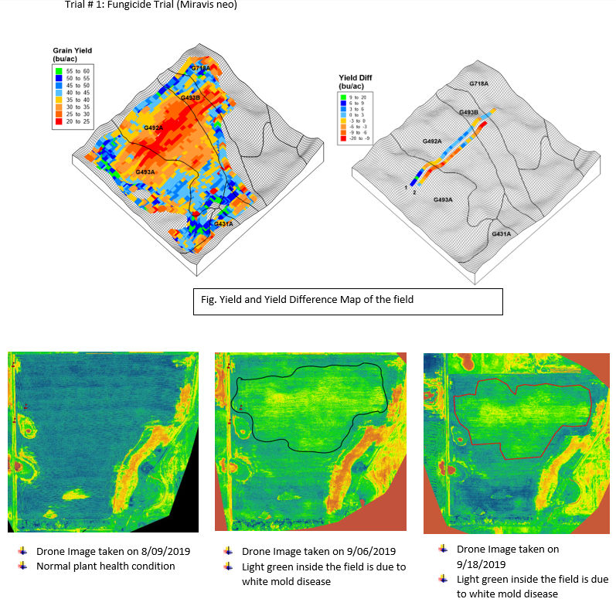
Results: In this trial, Miravis neo did not increase yield (Table 1). There was overall decrease in yield by -3.25 bu/ac. This decrease in yield was due to the white mold disease. From the drone pictures at different time, we can see the plant health condition of the field. Drone image shows that most of the center part of the field is affected by the white mold disease. However, this decrease in yield was not significantly different than the check. More future fungicide trials are needed to better understand their role in SD Soybean production.
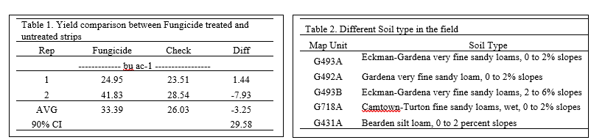

Methods: Soybean was planted on May 14, 2019 at 160,000 Seeds/acre in 30-inch rows. Miravis neo fungicide was applied on July 30 at the rate of 8 oz in 90 feet wide strips which was replicated three times. Drone image was collected at four different times: 6/14/2019, 7/30/2019, 9/04/2019 and 9/23/2019.
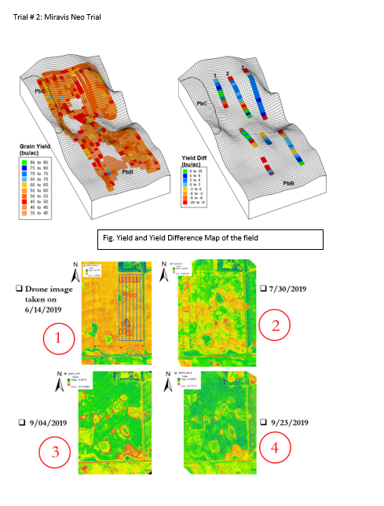

Results: Overall there was increase in yield by 0.34 bu/ac. Rep 2 and Rep 3 had increase in yield by 2.10 and 2.69 bu/ac, however Rep 3 had decrease in yield by 3.76 (Table 1). Drone images at different time does not show any white mold incidences however we can see the seed emergence and plant coverage variability along the different landscape of field. More future fungicide trials are needed to better understand their role in SD soybean production.

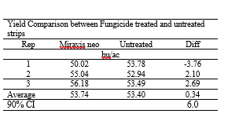
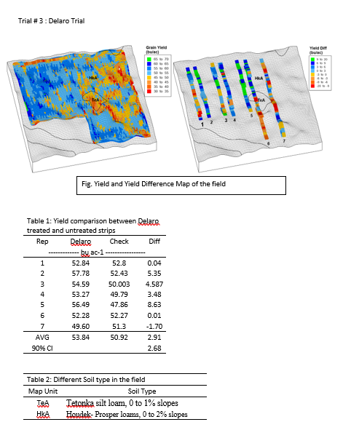
Methodology: Soybean was planted on June 16, 2019 at 180,000 Seeds/acre in 30-inch rows. Delaro fungicide was applied on August 3 at the rate of 8 oz in 100 feet wide strips having seven replications. Asgrow 26x8 variety was planted in field.

Results: Overall there was increase in yield by 2.91 bu/ac. Except for Rep 7, all 6 remaining replications showed increase in yield. More future fungicide trials are needed to better understand their role in SD soybean production.

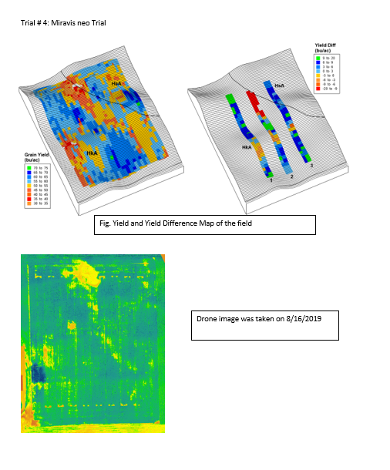

Methods: Soybean was planted on June 18, 2019 at 180,000 Seeds/acre in 30-inch rows. Delaro fungicide was applied on August 5 at the rate of 8 oz in 100 feet wide strips having three replications. Asgrow 26x8 variety was planted in field. Done image was taken once on 8/16/2019.
Results: Overall there was increase in yield by 2.8 bu/ac. Rep 1 and 3 had increase in yield by 5.2 and 6.9 bu/ac, however Rep 3 had decrease in yield by 2.73 bu/ac. More future fungicide trials are needed to better understand their role in SD soybean production
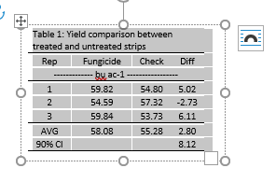
Soy100 Planning meeting

After extensive planting for 2020 soy100 the meeting was cancelled. Planning for the 2021 will start soon. The planning committee consists of David Clay (SDSU), Sharon Clay (SDSU), Adam Kask (SD Soy), Craig Converse (SD Soy Board), Stephanie Bruggeman (Augustana), Anthony Bly (SDSU Extension), David Karki (SDSU Extension), Connie Strunk (SDSU Extension), and Shaina Westhoff (SDSU). The proposed agenda is shown below.

