**Digital Imaging Technique to Detect and Rate Iron Deficiency chlorosis (IDC) in Soybeans**

Oveis Hassanijalilian, Hans Kandel, Sreekala G. Bajwa, John Nowatzki, Saravanan Sivarajan, Ted Helms

Based on USDA statistics, 5.75 million acres of soybeans were planted in the state of North Dakota in 2015. Soybean yield in the state of North Dakota was almost 185.9 million bushels. One of the factors that reduces soybean yield is lack of useable iron which causes Iron Deficiency Chlorosis (IDC). In 2013 at The North Central U.S., total land area where soybean was grown was approximately 4.7 million acres, where IDC caused 375,000 ton loss in soybean grain production at a value of $120 million per year.

The most effective step to manage this problem is to select an IDC tolerant variety suitable to a specific area as IDC occurrence varies widely under different environment conditions. Tolerance of different varieties to IDC can be determined through IDC visual rating by experts in variety research trials. Some scientists suggest that visual ratings at an early stage could help farmers identify its severity and apply iron chelates to prevent yield loss. But visual rating is too subjective, and requires experts. Leaf color can be used to identify chlorosis in soybean leaves, so digital imaging technique can detect its presence when the crop is growing. Digital imaging technique is used in this study for rating IDC in soybeans with a camera which does not require expertise.

The digital image captured has different bands of Red, Green and Blue (RGB). Research studies at the University of Arkansas showed that the amount of red and blue color scheme indicates how green an image or a plant looks. Therefore, they suggested a vegetation index called Dark Green Color Index (DGCI) based on the color scheme or values of Hue, Saturation and Intensity (HSI). It has been used on corn to detect the nitrogen deficiency.

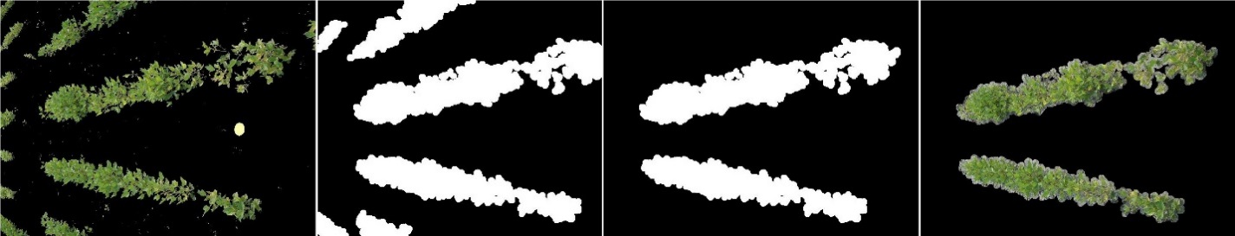The research experiments were conducted in soybean variety trial close to Leonard, North Dakota, USA (Latitude 46.671998 N, Longitude 97.243805 W). 40 different varieties were planted in 4 rows. Each plot was 11 feet long. IDC rating was done based on 2 middle rows by an expert. To compare digital images with IDC scores, images were imported to Matlab. Soil was removed from background by setting a criteria for new matrix which was a product of subtraction between Green and Blue matrices. For each plot, a digital image was taken by placing a color standard board in middle of the plots to help to compensate for different cameras and different lighting conditions. Two middle rows were extracted automatically for DGCI calculation.

Variations in DGCI were studied on all images from variety trials. An algorithm was developed based on both DGCI values and how an expert rate IDC. IDC scores are from 1 to 5 with 0.5 point increments which 1 is no chlorosis, and 5 is severe chlorosis and dead tissues. The output of processed images such as minimum and mean DGCI values were compared to IDC scores to find out the different ranges of DGCI to rate IDC.

The greener soybean plots are, the higher the value of DGCI will get. The average value of DGCI for the whole plot was used as a base value to rate IDC. Then by segmenting the image and detecting the low DGCI values for chlorosis, the rating was increased. The amount of increment were dependent to the values of DGCI on chlorosis spots.

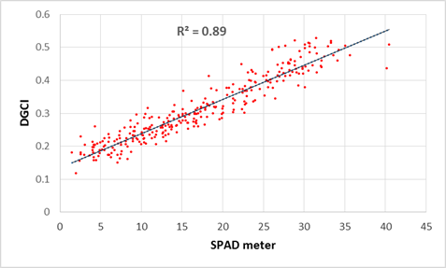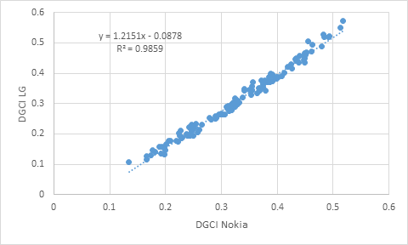 On the other study, SPAD meter values for individual leaflets were also measured. Digital images also were captured from the same leaflets with two different smartphones to determine the ability of the technique to estimate the chlorophyll amount. The DGCI values determined by digital image processing technique was significantly correlated (r2 = 0.89) to SPAD meter reading of the same leaflets. Moreover, the correlation between DGCI values of two different smartphones was significantly high (r2 = 0.98) which means DGCI can be accountable for differences of different cameras.

After calculating DGCI at V4 growth stage, yield was correlated with DGCI to study if there is any significant relationship exists between these parameters. The correlation between DGCI and yield was low (r2=0.33). Therefore, we are planning to monitor soybean plots more frequent in the next growing season by using UAVs to see if the duration of IDC affect yield. Also we can study the relationship of the yield with different growth stages.

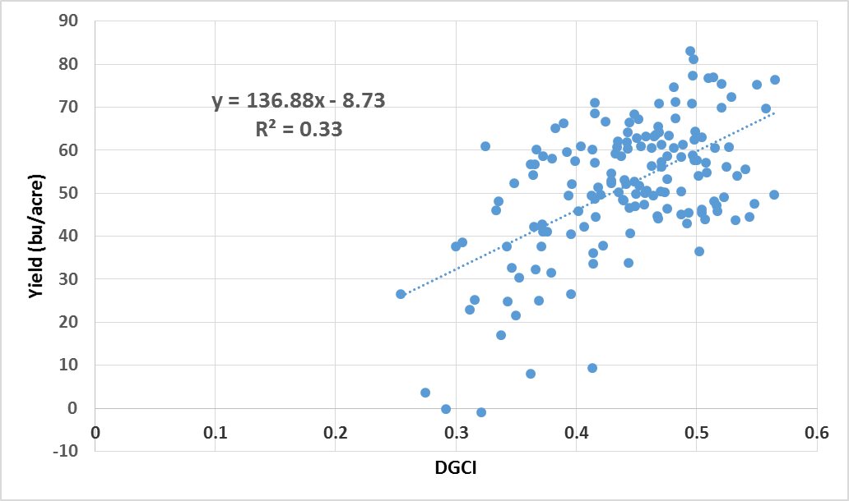

In summary, these days a lot of people carrying smartphones. They can be used to rate IDC in soybean using DGCI. We are planning to use DGCI accompanied by Unmanned Aerial Vehicle (UAV) to delineate IDC and to detect the growing pattern of IDC in the field. As a result, susceptible regions of the fields can be detected for future management.