Iowa Soybean Association
Mapping and introgression of Rps12 for resistance to Phytophthora root rot into elite soybean lines
10/1/2012 – 3/31/2016
Alison Robertson¹, Madan Bhattacharyya² and Silvia Cianzio²
¹Department of Plant Pathology and Microbiology, Iowa State University
²Department of Agronomy, Iowa State University

Accomplishments
- Identified a new locus for resistance to P. sojae, Rps12
- Mapped the locus to a genomic region of Chromosome 18 that harbors several Phytophthora resistance genes
- Identified markers that soybean breeders can use when incorporating the gene into new varieties.
- Backcrossing Rps12 into elite soybean germplasm lines is in progress

Project Goal: The long-term goal of our research is to develop elite soybean lines with improved resistance to Phytophthora sojae, the causal organism of Phytophthora root rot

Objectives
- Generate molecular markers linked to Rps12.
- Backcross Rps12 into elite soybean germplasm lines.
- Identify candidate Rps12 genes.

Objective 1. Generate molecular markers linked to Rps12.
A previous report by Gordon et al. (2007) [62] indicated that PI399036 contained multiple Rps genes including at least one novel Rps gene. Our recent mapping study (Abeysekara et al. 2016) [63] using a mixture of three P. sojae isolates suggested an Rps gene located on the lower arm of Chromosome 18 (ISA Proposal Identification of quantitative trait loci for partial resistance
to Phytophthora sojae in soybean).
The AX20925 recombinant inbred line (RIL) population was developed by crossing PI399036 (National Germplasm Collection) with the germplasm line AR2, released by Iowa State University (Cianzio et al., ISURF Docket # 03381). A cup assay was used to assess susceptibility or resistance of the RIL population to P. sojae and 120 RILs consisting of homozygous lines for either resistance or susceptibility were used to analyze the inheritance of the Rps12 gene. Eleven plants of each RIL were inoculated with P. sojae using the hypocotyl inoculation method. Fifty-nine homozygous resistant and 61 homozygous susceptible F_{5:7} families were used for the mapping experiments. Eleven plants from each resistant or susceptible homozygous F₇ family were scored for responses to the P. sojae isolates in each experiment, which was repeated two more times.
In this study, to further characterize the novel Rps gene, 25 F₂ plants obtained from the cross between PI399036 X AR2 were inoculated with the mixture of the Val 12-11 and R17 isolates. These two isolates together were shown to be virulent on soybean lines carrying all genes that were previously mapped to the Chromosome 18, except the RpsJS gene. It is unknown if the RpsJS gene can encode resistance against the mixture of P. sojae R17 and Val12-11 isolates. Of the 25 F₂ plants, 19 were resistant: 6 susceptible to the P. sojae R17 and Val12-11 isolate mixture. The segregation ratio fits to the expected 3:1 (R:S) ratio for a single gene with dominance of resistance over susceptibility (χ2 with df 1 = 0.013, P=0.908). Screening of the 120 RILs of the AX20925 population with an inoculum mixture of P. sojae R17 and Val12-11 or P7074 alone resulted in 59:61 (R:S) lines indicating again single gene action for Phytophthora resistance (χ²_{df=1} 0.03 , P=0.855) in the novel Rps locus. P. sojae P7074 isolate is virulent on soybean lines with Rps8, but PI399036 was not susceptible to infection suggesting this line does not have Rps8.
In our previous study, preliminary data suggested that a novel Rps gene could be present in the Rps4/6 region. We therefore evaluated 33 SSR markers mapped to the Rps4/6 region for polymorphisms between the PI399036 and AR2 parents considered in this study. The SSR markers selected for this study encompass the genomic region that includes RpsJS, 4 and 6 genes. Of these 33 SSR markers, only 14 were polymorphic between PI399036 and AR2 parents and were considered for bulked segregation analyses (BSA). BSA analyses of the markers suggested that the novel Rps gene is mapped to the Rps4/6 region (Figure 1).
In addition to the 14 polymorphic SSR markers, we designed primers and amplified two PCR products of 130 and 533 bp in length using Rps4-NBS-LRR-specific primers, from both PI399036 and the resistant bulked DNA sample, but not from either AR2 or the susceptible bulked DNA sample. BSA analysis suggested that the amplified Rps4-NBS-LRR-type sequences co-segregate with the putative novel Rps gene. Moreover, the sequenced 130 bp and 533 bp PCR fragments showed 100% and 99% nucleic acid sequence identity to the Rps4-NBS-LRR sequence identified by Sandhu et al. (2004) [44]. The 130 and 533 bp NBS-LRR-type fragments were named as NBSLRR130 and NBSLRR533, respectively.
The two dominant markers, NBSLRR130 and NBSLRR533, and nine co-dominant SSR markers were used to map the putative novel Rps gene. The gene mapped in between SSR markers, BARCSOYSSR_18_1840 and Sat_064 (BARCSOYSSR_18_1858) (Figure 1). Both NBSLRR130 and NBSLRR533 markers were mapped at 2.2 cM distal to the locus suggesting that the novel Rps gene is unlikely allelic to Rps4 (Figure 1).
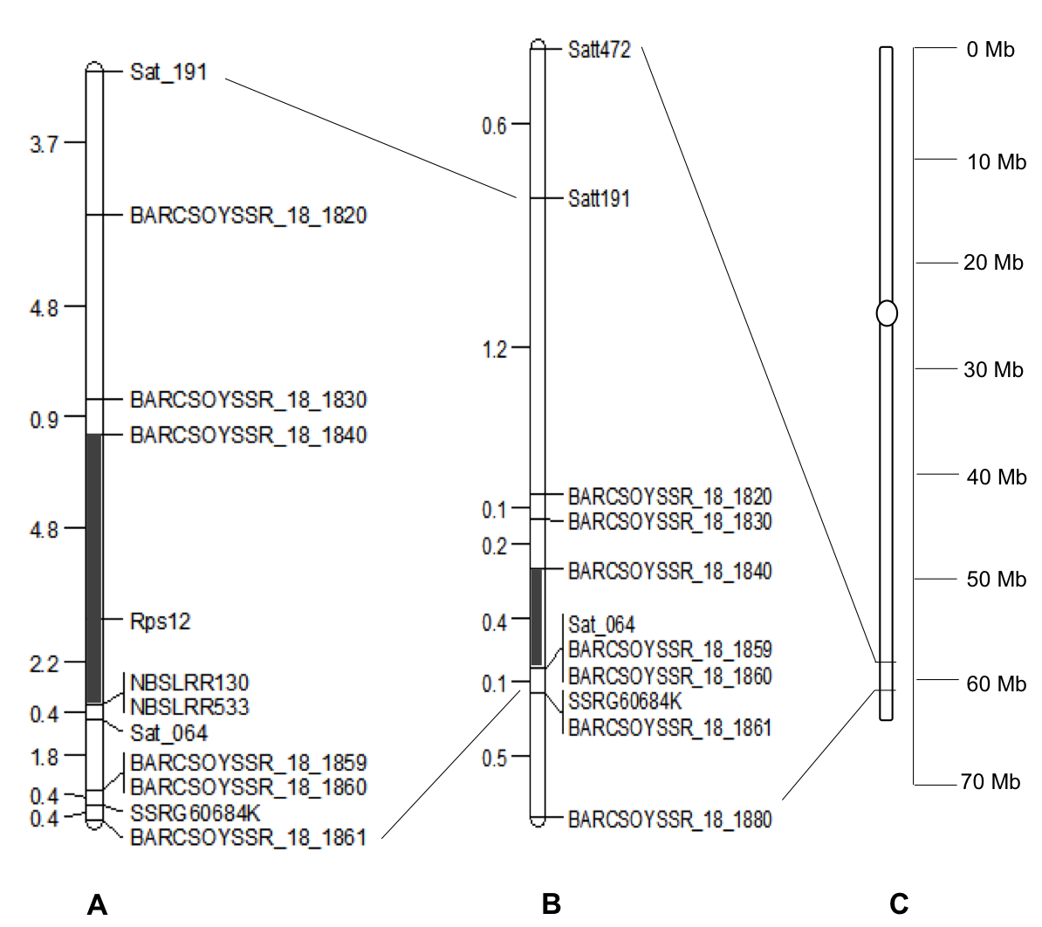
Figure 1. Genetic map of chromosome 18 showing location of Rps12

The RpsJS gene has been mapped also to the Rps4/6 genomic region [45]. We therefore included the molecular markers BARCSOYSSR_18_1859 and SSRG60752K that flanked the RpsJS gene. Both these markers mapped distal to Sat_064, which co-segregated with the Rps4/6 locus. Rps5 is very loosely linked to Rps4 and mapped closely to XXX [77], which proximal to the novel Rps locus. Our mapping data suggest that the novel Rps gene is located in region distal to Rps5 and proximal to Rps4, 6 and JS. We named this novel Phytophthora resistance gene as Rps12.

Objective 2: Backcross Rps12 into elite soybean germplasm lines.
Backcrossing Rps12 into elite soybean germplasm was delayed but will start in Fall 2016.

Objective 3: Identify candidate Rps12 genes
This work is in progress.

Publications and presentations
- Sahoo, D.K., Abeysekara, N.S., Cianzio, S., Robertson, A.E., and Bhattacharrya, M.K. XXXX. A novel Phytophthora resistance gene mapped tightly to the Rps4/6 region in soybean. PLoS ONE.

