Title:
Increasing awareness of Soybean Cyst Nematode in North Dakota: 2015.
PI:
Sam Markell, Extension Plant Pathologist, NDSU

Co-PI’s:
Guiping Yan, Ph.D. and Ted Helms, Ph.D.

Collaborators and Cooperators:
Richard Jenny, Agvise
Michael Knudson, Grand Forks County Agent, NDSU
John Kringler, Cass County Agent, NDSU
Berlin Nelson, Soybean pathologist, NDSU
Alyssa Scheve, Traill County Agent, NDSU
Brock Shouldis, Richland County Agent, NDSU

Acknowledgements of other contributors:
We thank the people and organizations who contributed to this project, including; Arthur Companies, Peterson Farms Seed, Syngenta Crop Protection, Bayer Crop Science, each county crop improvement association from Cass, Richland and Traill counties, the growers who allowed us to utilize their land and the Extension agents who distributed SCN bags, hosted field days, and helped with map creation.

Situation Statement and Background:
Soybean cyst nematode (Heterodera glycines) is a plant parasitic nematode originating from Asia. The pathogen can cause approximately 15-30% yield loss without above ground symptoms. When SCN egg levels become high, the disease is very difficult to manage and yield loss can be devastating. However, management strategies for SCN are available and if growers are proactive, egg levels can be kept low and yield loss can be minimized.
Since its identification in North Carolina in 1954, SCN has spread across the United States into states with significant soybean acres. In 2003, soybean cyst nematode (SCN) was first identified in North Dakota in Richland County. After its confirmation in Cass (2007) and Traill (2009) Counties, a concerted effort to identify locations with SCN was begun by NDSU and funded through the North Dakota Soybean Council.
In 2013 and 2014, an Extension/research project was funded by NDSU designed to increase SCN awareness among growers by; encouraging them to sample themselves, attend field days, and providing an in-depth training to trainers (County Agents, Crop Consultants, etc…). The current Extension/Research project is a continuation and expansion of this effort.
Goals and Objectives:
The goal and objective of the proposal is to increase awareness of Soybean Cyst Nematode in North Dakota by using multiple strategies; 1) Provide incentive for growers to sample for SCN by providing cost reimbursement for up to three bags per grower (Up to 2,000 bags total), 2) Create a map of SCN distribution and density from grower submitted samples in ND, 3) Evaluate SCN seed treatments, and 4) Increase grower awareness by hosting three ‘SCN field days’.
Description of the Research/Extension Conducted:
SCN sample bags. SCN sample bags were acquired from Agvise (Richard Jenny) and coded with a specific NDSU/NDSC identifier. A separate submitter form accompanied each bag so growers could provide geographic information about the sample. SCN sample bags and forms were sent to every Extension County office in North Dakota and distributed at SCN field days and other grower events (NDSU and company field days.)
SCN map creation. Data from the SCN samples was sent to the P.I., and with cooperation from Grand Forks County Agent Michael Knudson, whole state and southeastern ND maps were generated using ArcView. For greater resolution, data was combined with 2013 and 2014 samples.
Evaluate SCN Seed Treatments. Four seed treatment nematicide trials were established in infested fields near Absaraka, Arthur, Galesburg and Hankinson. Trials were arranged in a randomized complete block design with four replications. Due to delays in receiving treated seed from Bayer, only the Syngenta products could be evaluated. Treatments included a 1) fungicide insecticide base (CruiserMaxx Vibrance) which is used as a control for the nematicide treatments, 2) CruiserMaxx Vibrance + Clariva pn, and 3) Avicta Complete Beans 500 Vibrance. Treatment two was a test of Clariva while treatment three was a test of Avicta. Evaluations included early and late SCN egg counts, phytotoxicity, vigor, number of cysts per root, stand counts, evaluation for Brown Stem Rot (BSR), evaluation for Sudden Death Syndrome (SDS) and yield. Soil sampling was done by taking ten cores per plot (inner two rows only) immediately after planting and prior to harvest.
Field days. Three SCN field days were held in Absaraka (September 4th), Galesburg (September 9th) and Hankinson (September 11th). Demonstrations included SCN resistant varieties, SCN nematicide seed treatments, SCN root-digging, and a SCN soil-sampling demonstration. After each field day, a 14-question survey was given to participants (handouts or email, depending on location).
Findings:
SCN sample bags and map creation. By January 1st, 943 SCN sample bags were sent in for analysis by growers and stakeholders. Due to incomplete geographic data and location information, only 869 were incorporated into the map and other data generated. Of the samples with known geography, 232 were positive. Whole state (Figure 1) and southeastern ND (Figure 2) maps were generated for 2015, and data was combined with 2013 and 2014 samples (Figures 3 and 4) for the same regions. Since the program began, a total increase in SCN sample bags submitted by ND constituents has been observed every year (Figure 5). Similarly, an increase in positive samples has also been observed (Figure 5).
SCN nematicide field trials. Field locations were selected because of high SCN counts in the previous fall. Statistical differences in an evaluation were not observed. Statistical yield differences were not observed either. However, the seed treated with Avicta Complete Beans 500 + Vibrance was higher than then other two treatments in all four trials (Tables 1-4). Averaged across trials, Avicta Complete Beans 500 + Vibrance yielded 38.2 bu/a while CruiserMaxx Virbrance + Clariva pn yield 36.0 bu/a, and CruiserMaxx Vibrance yielded 36.7 bu/a. Although this may represent a trend, given that no differences were observed with any SCN evaluations, it is likely this is unrelated to SCN.
Field days. Attendance at the SCN field days was approximately 100-120 people. Areas surrounding field day locations were the most heavily sampled in the state, suggesting that those attending the field days had a greater understanding and appreciation for the damage that SCN can do to soybean fields. A 14 question survey (Figure 6) was distributed. Results of the survey suggested that grower’s information increased on all topics taught, including; biology, detection, resistance, rotation and seed treatments (Appendix 1).

Figure 1. 2015 distribution of SCN (eggs/100cc) in North Dakota from samples submitted by growers.
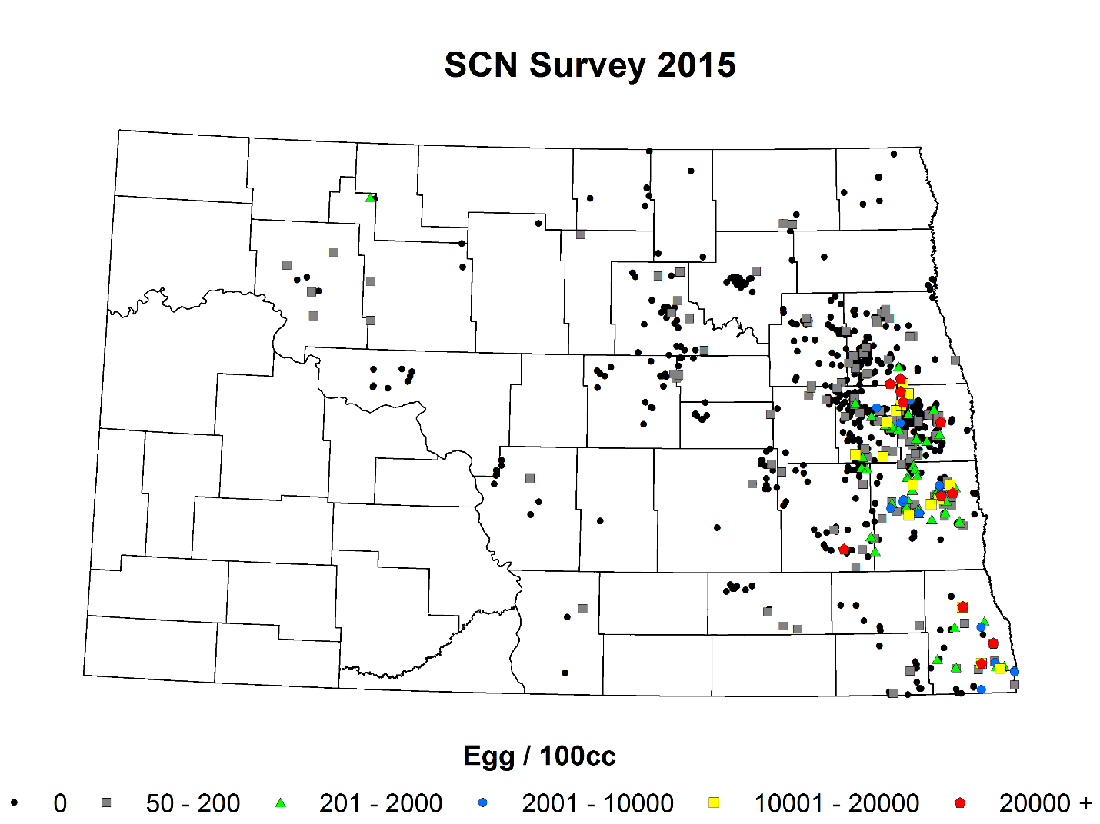
Figure 2. 2015 distribution of SCN (eggs/100cc) in Southeast North Dakota from sample submitted by growers.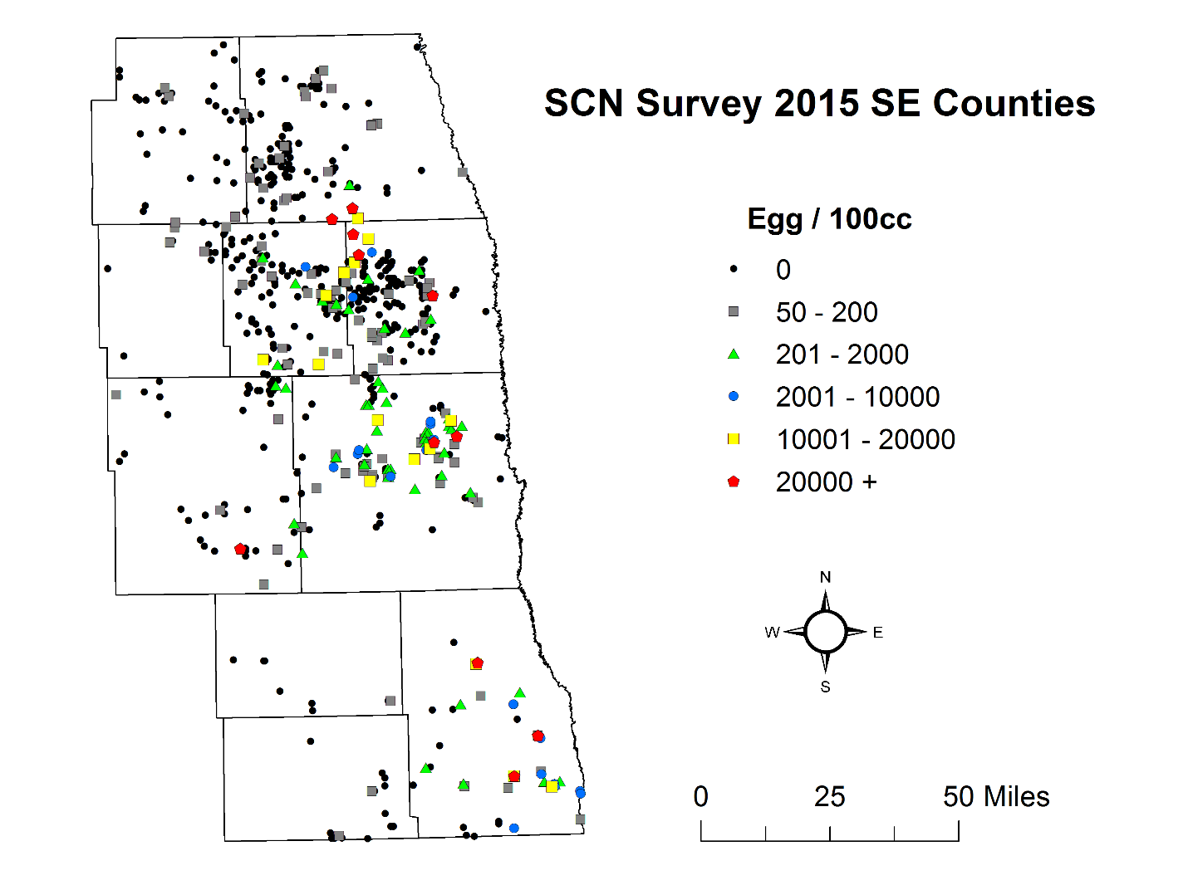
Figure 3. Combined 2013 - 2015 distribution of SCN (eggs/100cc) in North Dakota from samples submitted by growers.
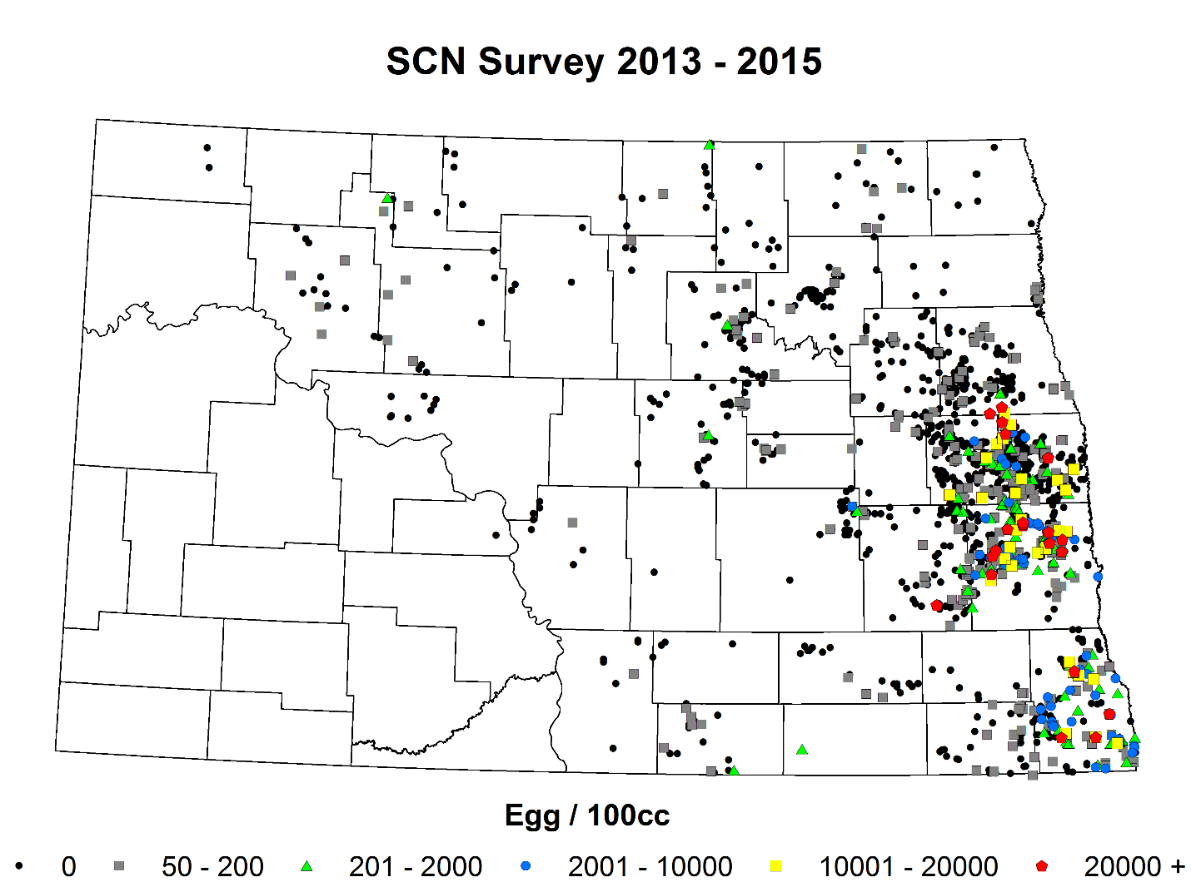
Figure 4. Combined 2013 to 2015 distribution of SCN (eggs/100cc) in Southeast North Dakota from sample submitted by growers.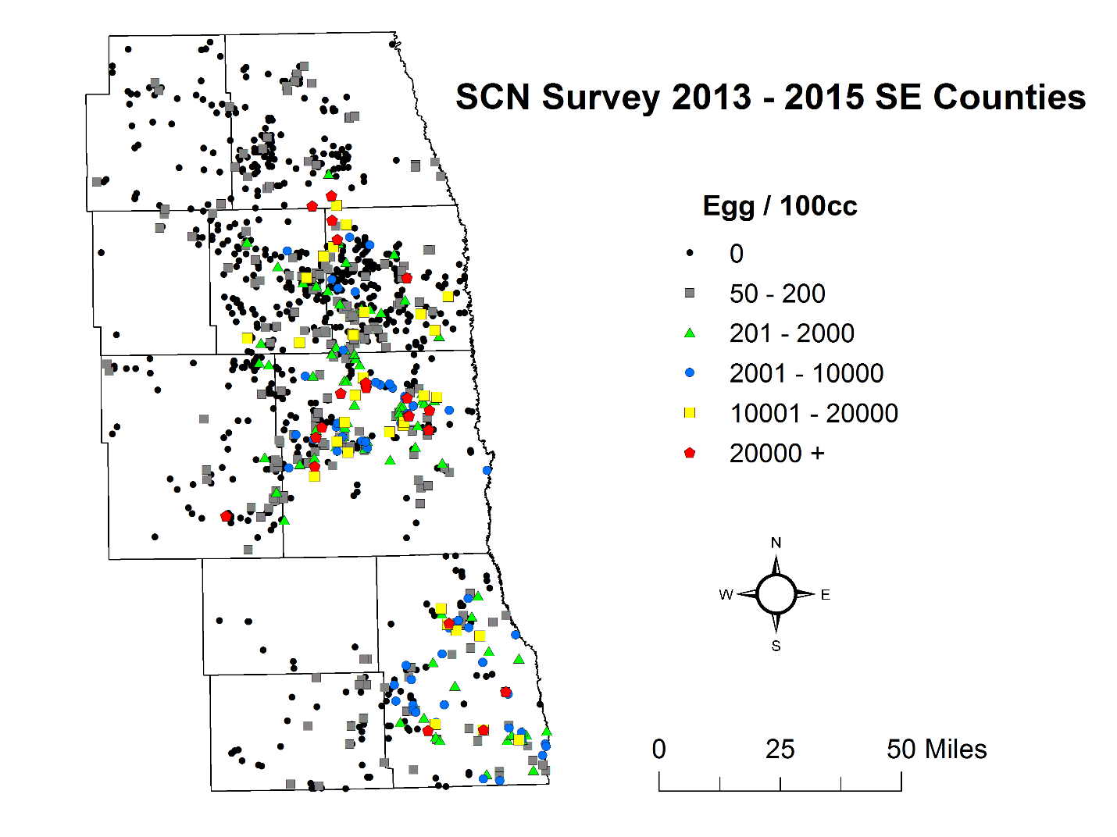
Figure 5. Total SCN sample bags and total positive samples (> 0 eggs/100cc soil) from 2013 – 2015.
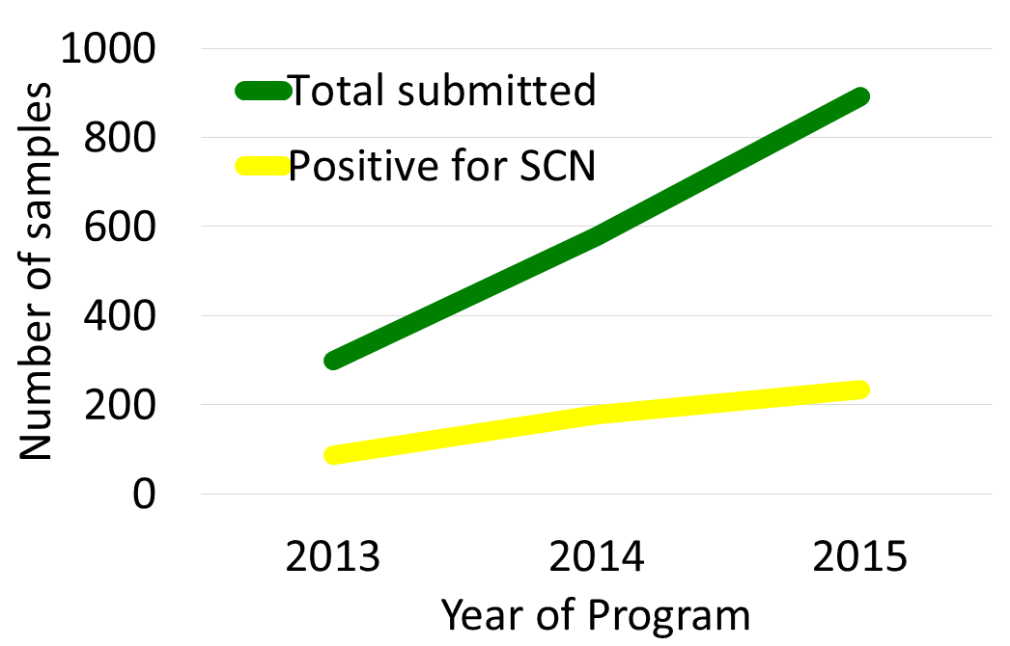

Table 1. Evaluation of seed treatments for nematode management in Absaraka, ND, 2015.
Treatment | Egg Countª  (Eggs & J2/100 cc soil) |  | Phytotoxicity  (% incidence) |  | Stand Count  (plants/25 ft²) |  | Root Cyst Count^{b}  (cyst/plant on 10 plants/plot) | BSR^{c} Incidence | SDS^{c}  Incidence | Yield  (bu/A)
 | 6/17 | 9/15 | 6/17 | 8/17 | 6/17 | 6/30 | 7/16 | 8/17 | 8/17 | 9/15
CruiserMaxx Vibrance | 141.3 | 2.7 | 0 | 0 | 174.3 | 177.7 | 0.2 | 0 | 0 | 40.85
CruiserMaxx Vibrance + Clariva pn | 149.3 | 2.7 | 0 | 0 | 176.5 | 177.7 | 0 | 0 | 0 | 40.90
Avicta Complete Beans 500 + Vibrance | 226.7 | 13.3 | 0 | 0 | 188.8 | 186.2 | 0 | 0 | 0 | 41.11
LSD P=.05 | 210.56 | 18.66 | 0 | 0 | 19.21 | 21.73 | 0.3 | 0 | 0 | 2.4907
Stand Dev | 163.68 | 14.51 | 0 | 0 | 14.94 | 16.89 | 0.24 | 0 | 0 | 1.9361
CV | 94.92 | 233.17 | 0 | 0 | 8.3 | 9.36 | 424.26 | 0 | 0 | 4.73
ª10 soil cores were taken from the center two rows of each soybean plot using a one inch soil probe, approximately two inches from the plant stems. Samples were mixed, bagged, kept cool and brought to the NDSU diagnostic laboratory for assessment.
^{b}Ten plants per plot were arbitrarily extracted, cleaned gently with water, and cysts were visually counted.
^{c}Sudden Death Syndrome (SDS) and Brown Stem Rot (BSR) were visually assessed in each plot at approximately growth stages R5-R6

Table 2. Evaluation of seed treatments for nematode management in Arthur, ND, 2015.
Treatment | Egg Countª  (Eggs & J2/100 cc soil) |  | Phytotoxicity  (% incidence) |  | Stand Count  (plants/25 ft²) |  | Root Cyst Count^{b}  (cyst/plant on 10 plants/plot) | BSR^{c} Incidence | SDS^{c}  Incidence | Yield  (bu/A)
 | 6/17 | 9/15 | 6/17 | 6/30 | 6/17 | 6/30 | 7/20 | 8/17 | 8/17 | 9/13
CruiserMaxx Vibrance | 1629.3 | 2640 | 0 | 0 | 157.5 | 152.7 | 8.2 | 0 | 0 | 40.85
CruiserMaxx Vibrance + Clariva pn | 1877.3 | 3200 | 0 | 0 | 146 | 153 | 1.7 | 0 | 0 | 40.90
Avicta Complete Beans 500 + Vibrance | 1877.3 | 3094 | 0 | 0 | 152.3 | 154.8 | 4.2 | 0 | 0 | 41.11
LSD P=.05 | 1723.12 | 2079.68 | 0 | 0 | 24.71 | 24.54 | 7.74 | 0 | 0 | 2.2643
Standard Deviation | 1339.48 | 1616.65 | 0 | 0 | 19.21 | 19.08 | 6.01 | 0 | 0 | 1.7602
CV | 74.64 | 54.29 | 0 | 0 | 12.64 | 12.43 | 128.87 | 0 | 0 | 10.02
ª10 soil cores were taken from the center two rows of each soybean plot using a one inch soil probe, approximately two inches from the plant stems. Samples were mixed, bagged, kept cool and brought to the NDSU diagnostic laboratory for assessment.
^{b}Ten plants per plot were arbitrarily extracted, cleaned gently with water, and cysts were visually counted.
^{c}Sudden Death Syndrome (SDS) and Brown Stem Rot (BSR) were visually assessed in each plot at approximately growth stages R5-R6

Table 3. Evaluation of seed treatments for nematode management in Galesburg, ND, 2015.
Treatment | Egg Countª  (Eggs & J2/100 cc soil) |  | Phytotoxicity  (% incidence) |  | Stand Count  (plants/25 ft²) |  | Root Cyst Count^{b}  (cyst/plant on 10 plants/plot) | BSR^{c} Incidence | SDS^{c}  Incidence | Yield  (bu/A)
 | 6/24 | 9/9 | 6/24 | 7/6 | 6/24 | 7/6 | 7/20 | 8/17 | 8/17 | 9/15
CruiserMaxx Vibrance | 1530.7 | 1210.7 | 0 | 0 | 142.2 | 157.8 | 4.5 | 0 | 0 | 51.228
CruiserMaxx Vibrance + Clariva pn | 1896 | 725.3 | 0 | 0 | 144.2 | 162.5 | 5.3 | 0 | 0 | 51.127
Avicta Complete Beans 500 + Vibrance | 1613.3 | 829.3 | 0 | 0 | 148.5 | 161.8 | 5.8 | 0 | 0 | 54.828
LSD P=.05 | 857.28 | 828.48 | 0 | 0 | 12.63 | 11.61 | 4.91 | 0 | 0 | 7.6452
Standard Deviation | 666.41 | 644.03 | 0 | 0 | 9.82 | 9.03 | 3.82 | 0 | 0 | 5.943
CV | 39.67 | 69.87 | 0 | 0 | 6.77 | 5.62 | 73.14 | 0 | 0 | 11.34
ª10 soil cores were taken from the center two rows of each soybean plot using a one inch soil probe, approximately two inches from the plant stems. Samples were mixed, bagged, kept cool and brought to the NDSU diagnostic laboratory for assessment.
^{b}Ten plants per plot were arbitrarily extracted, cleaned gently with water, and cysts were visually counted.
^{c}Sudden Death Syndrome (SDS) and Brown Stem Rot (BSR) were visually assessed in each plot at approximately growth stages R5-R6

Table 4. Evaluation of seed treatments for nematode management in Hankinson, ND, 2015.
Treatment | Egg Countª  (Eggs & J2/100 cc soil) |  | Phytotoxicity  (% incidence) |  | Stand Count  (plants/25 ft²) |  | Root Cyst Count^{b}  (cyst/plant on 10 plants/plot) | BSR^{c} Incidence | SDS^{c}  Incidence | Yield  (bu/A)
 | 6/24 | 9/9 | 6/24 | 7/6 | 6/24 | 7/6 | 7/20 | 8/17 | 8/17 | 9/15
CruiserMaxx Vibrance | 498.7 | 682.7 | 0 | 0 | 140.5 | 152.5 | 13.3 | 0 | 0 | 37.467
CruiserMaxx Vibrance + Clariva pn | 416 | 1067.5 | 0 | 0 | 138.2 | 151.8 | 7.2 | 0 | 0 | 34.8
Avicta Complete Beans 500 + Vibrance | 453.3 | 941.7 | 0 | 0 | 150.2 | 159.8 | 10.3 | 0 | 0 | 38.595
LSD P=.05 | 328.83 | 313.07 | 0 | 0 | 15.58 | 15.7 | 4.91 | 0 | 0 | 5.07
Standard Deviation | 255.62 | 243.37 | 0 | 0 | 12.11 | 12.2 | 3.82 | 0 | 0 | 3.9412
CV | 56.06 | 27.12 | 0 | 0 | 8.47 | 7.89 | 73.14 | 0 | 0 | 10.67
ª10 soil cores were taken from the center two rows of each soybean plot using a one inch soil probe, approximately two inches from the plant stems. Samples were mixed, bagged, kept cool and brought to the NDSU diagnostic laboratory for assessment.
^{b}Ten plants per plot were arbitrarily extracted, cleaned gently with water, and cysts were visually counted.
^{c}Sudden Death Syndrome (SDS) and Brown Stem Rot (BSR) were visually assessed in each plot at approximately growth stages R5-R6

Figure 6. The post-field day survey distributed to growers after each of the three 2015 field days.

Appendix 1. Post-field day survey results.
Demographics
32 total respondants
30 male - 2 female
Where respondants were from: 5 = Cass Co., 3 = Grand Forks Co., 4 = Traill Co., 13 = Richland Co., 2 = Roberts Co. SD, 5 = Not Responding
Please answer Yes or No | Yes | No
Have you tested for SCN before? | 13 | 18
Do you have SCN on your farm as confirmed by a soil test | 12 | 18
Please rate your understand using a 1 (low) to 5 (high) scale | Pre- Field Day | Post- Field Day
My understanding of how the soybean cyst nematode spreads. | 3.1 | 4.16
My understanding of how important it is to soil sample to detect SCN early | 3.48 | 4.53
My understanding of how SCN can be managed with resistance | 3.16 | 4.25
My understanding of how SCN can be managed with rotation | 3.53 | 4.44
My understanding of how SCN can be managed with seed treatments | 2.72 | 4.06
1 = low: 5= high
As a result of what you learned, how likely are you to do the following, where 1 = not at all, 2 = unlikely, 3 = undecided, 4 = somehwat likely, 5 = likely and 6 = likely? | Mean | Range
Soil Sample | 5.2 | 4 to 6
Impliment specific management practices that will help manage SCN | 5.19 | 1 to 6
Using a 1 to 5 scale, where 1 = not at all, 2 = slightly, 3 = somewhat, 4 = significantly, and 5 = very much, please rate your agreement with the following statement. | Mean | Range
I feel the session on SCN was worthwhile for me | 4.34 | 3 to 5
Please provide what you might do differently on your farm as a result of what you learned today.
as an agronomist I will push for more testing and more rotation
Try a nematicide seed treatment on a few acres.
Use seed treatments as needed
More rotation
Test
soil test
Look for Most Resistant Variety
Make sure to plant resistant varieties
Maybe use seed treatment if needed
Start Soil Testing
Soil test to continue to search for it
Every year we do 2-3 samples per farmer. Last year we detected low numbers in 10% of samples. We will continue sampling.
Rotate crops and also rotate genetics
Learn more about seed treatment options
What else can the NDSU Extension Service and the North Dakota Soybean Council do to help you manage SCN?
Continued research on the resistant genes and keep us educated on the topic
Provide data on different nematicides.
Provide test info on nematicides
more plots
Keep me informed on changes
Update Producers on future research
Continue research and education material for growers and consultants.
Keep up the good work!

