Optimizing the use of irrigation, row spacing, partial host resistance, and fungicides for management of Sclerotinia in soybeans

Principal Investigator:
Michael Wunsch, plant pathologist
NDSU Carrington Research Extension Center
PO Box 219 / Carrington, ND 58421-0219
Tel: 701-652-2951 / Fax: 701-652-2055 / michael.wunsch@ndsu.edu
Co-Investigators:
Tyler Tjelde, irrigation agronomist, NDSU Williston Research Extension Center, Nesson Valley Irrigation Research Site; tyler.tjelde@ndsu.edu
Venkat Chapara, plant pathologist, NDSU Langdon Research Extension Center; venkata.chapara@ndsu.edu
Leonard Besemann, research specialist, NDSU Carrington Research Extension Center, Oakes Irrigation Research Site; leonard.besemann@ndsu.edu

Situation statement:
Management of Sclerotinia stem rot (white mold), an important, recurrent disease of irrigated soybeans and sporadic disease of dryland soybeans in North Dakota, is limited by a lack of knowledge of how to optimize variety selection, row spacing, fungicide usage, and irrigation to maximize soybean yields under Sclerotinia disease pressure. Fungicide timing recommendations for Sclerotinia management were developed from research conducted on solid-seeded soybeans, and optimal fungicide timing is likely to differ when soybeans are planted in wider rows, where the canopy is generally open at early bloom and delayed disease onset is likely. Use of a soybean variety partially resistant to Sclerotinia can be a very effective disease management tool, but selecting a variety that performs well under Sclerotinia pressure is difficult; resistance ratings provided by seed companies are only approximate, and the plant architecture traits that help confer disease escape and their utility in predicting Sclerotinia resistance are poorly understood. Irrigation intensity is known to impact Sclerotinia disease pressure, but the implications of modifying irrigation frequency – especially in sandy soils where water retention and drought stress are concerns – on Sclerotinia severity, soybean yields, and the optimal deployment of other disease management tools (row spacing, resistant varieties, foliar fungicides) are poorly understood.

Objectives:
- Identify the optimal fungicide application timing for controlling Sclerotinia in soybeans planted to narrow, medium, and wide rows.
- Quantify the impact of irrigation intensity on Sclerotinia disease development, soybean yield, and net economic returns in irrigated soybeans.
- Identify optimal fungicide application strategies (fungicide application rate and frequency) for managing Sclerotinia in susceptible and partially resistant soybean varieties relative to precipitation patterns (rainfall and/or irrigation) and other environmental conditions.
- Identify physical soybean growth characteristics that can be used to predict the susceptibility of soybean varieties to Sclerotinia and quantify how rainfall and irrigation patterns influence the relative importance of these growth characteristics in determining Sclerotinia resistance.
- Evaluate whether the expression of partial resistance to Sclerotinia by soybean varieties is dependent on row spacing, which row spacing optimizes yields under high Sclerotinia

Description of the research conducted:
Field trials were established at the NDSU Robert Titus Research Farm 3 miles south of Oakes, at the NDSU Carrington Research Extension Center 3 miles north of Carrington, at the NDSU Langdon Research Extension Center 1 mile southeast of Langdon, and at the NDSU Nesson Valley Irrigation Research Site 26 miles east of Williston.
Field trials to assess the impact of fungicide application timing on white mold control and soybean yield were established at Oakes and Carrington. In Carrington, testing was conducted on the 0.3- and 0.4-maturity soybean varieties Dairyland ‘DSR-0305’ and ‘DSR-0404’ seeded to 14-inch rows and to Dairyland ‘DSR-0404’ seeded to 28-inch rows. In Oakes, testing was conducted on the 0.7-maturity soybean variety Dairyland ‘DSR-0711’ seeded to 14-inch rows and on ‘DSR-0305’ seeded to 28-inch rows. The fungicide Endura (boscalid; BASF Corp.) was applied at 5.5 oz/ac at bloom initiation (60 to 90% of plants with an open blossom), early R2 growth stage (80 to 98% of plants at the R2 growth stage, full R2 growth stage (100% of plants at the R2 growth stage), and at the early R3 growth stage. Applications were made with Spraying Systems TeeJet XR8001VS flat-fan nozzles in a spray volume of 19 gal/ac at 45 psi (Oakes) and XR8001VS flat-fan nozzles in a spray volume of 15 gal/ac at 35 psi (Carrington). The trials were conducted under irrigation. Sclerotinia incidence and severity was assessed shortly before maturity, and seed yield and quality (including contamination of harvested grain with sclerotia) were assessed at harvest. These trials were also utilized to test the impact of fungicide application rate in a ‘rescue’ fungicide treatment applied at R2/R3 growth stage (Carrington) and the impact of one vs. two fungicide applications (Oakes) in soybeans seeded to narrow and wide rows.
Field trials to assess the impact of irrigation intensity on Sclerotinia disease development were conducted at Carrington and Nesson Valley. The soybean varieties Dairyland ‘DSR-0305’ and ‘DSR-0404’ were evaluated at three seeding rates (132,000; 165,000; and 198,000 pure live seeds/ac) and in two row spacings (14- and 28-inch rows) in Carrington; the soybean variety Pioneer ‘P01T23R’ was evaluated at the same seeding rates in 7.5-inch rows. Due to timely spring rains, soil moisture did not drop below 50% available water until the R3 growth stage in Carrington. From the R3 to R6 growth stage, sufficient irrigation was applied to bring the soil to 100% available water every time soil moisture reached 50%, 65%, or 80% available water. At Nesson Valley, 1.25 inches of water were applied every time soil moisture reached 50% available water throughout the season; when soil moisture reached 30% available water prior to R3 and then at 50% available water thereafter; and when soil moisture reached 30% available water prior to R3 and then 70% available water thereafter. Both experiments included a fungicide component (Endura at 5.5 oz/ac applied at the early R2 growth stage).
Field trials to assess the impact of soybean row spacing and seeding rate on Sclerotinia disease development were conducted at Carrington, Langdon, Nesson Valley, and Oakes. Varieties from four companies were included in the tests: Dairyland, Mycogen, ProSeed, and Pioneer. Three varieties (0.05 to 0.09 maturity) were evaluated in Langdon, four varieties (0.1 to 0.2 maturity) were evaluated at Nesson Valley, five varieties (0.5 to 0.6 maturity) were evaluated in Carrington, and five varieties (0.4 to 0.7 maturity) were evaluated in Oakes. All varieties were evaluated at three seeding rates (132,000; 165,000; and 198,000 pure live seeds/ac) seeded to each of four row spacings (7 or 7.5 inches, 14 or 15 inches, 21 or 22.5 inches; and 28 or 30 inches). Trials were conducted under irrigation and physical growth characteristics of the soybean varieties that would be expected to influence white mold development, including the timing of canopy closure and plant height, were recorded.

Findings:
- Fungicide application timing: Applying 5.5 oz/ac of the fungicide Endura when 80 to 100% of the plants reached the R2 growth stage (an open blossom in one of the top two nodes of the plant) optimized Sclerotinia disease control and soybean yield across all four field trials conducted in Carrington. The impact of fungicide application timing on white mold management could not be rigorously assessed in Oakes; due to hot weather, disease levels were very low in Oakes (2% incidence in the non-treated controls). The findings from Carrington closely parallel results from field trials conducted in 2014 (Figures 1, 2) and suggest that the current recommendation of applying fungicides at the R1 growth stage (at least one open blossom) may not be optimal. Averaged across seven field trials conducted on soybeans seeded to 14-inch rows in 2014 and 2015, delaying fungicide applications from the R1 to the early R2 growth stage improved disease control from 21% to 44% and increased yield gains from 5.3 to 8.1 bu/ac. Averaged across four trials conducted on soybeans seeded to 28-inch rows in 2014 and 2015, delaying fungicide applications from the R1 to the R2 growth stage improved disease control from 28% to 45% and increased the yield response from 5.3 to 8.0 bu/ac.
- Irrigation intensity: In the field trial conducted in Carrington, conditions were relatively dry, but timely rains prevented soil available water from dropping below 50% until the R3 growth stage. From the R3 to R6 growth stage, supplemental irrigation was applied every time soil available water reached 50%, 65%, or 80%, with sufficient water applied to bring the soil to water-holding capacity. Irrigation was applied once, three times, and five times, respectively, from the R3 to R6 growth stage in each of these irrigation regimes. Apothecia, the fruiting structures of the Sclerotinia fungus, were not present above trace levels during the R2 and R3 growth stages when soybeans are at maximum susceptibility to Sclerotinia, and disease levels remained low. Sclerotinia disease levels were very low in all irrigation treatments. Increasing the frequency of irrigation was associated with a trend towards increased Sclerotinia and reduced soybean yield, but differences were very modest (Table 1). The field trial conducted in Williston had poor stand establishment and developed severe bacterial blight and was not assessed.
- Fungicide application strategies: Economic returns to fungicide applications were observed only when apothecia were present above trace levels during the R2 and R3 growth stages and environmental conditions favored white mold infection during that period. When apothecia did not develop until later growth stages, disease remained very low and fungicide applications were not economic. When conditions were favorable for disease development during the R2 and R3 growth stages, applying the fungicide Endura at a high application rate did not increase the efficacy of a “rescue” fungicide application at the R3 growth stage.
- Row spacing: Reducing row spacing was associated with an increase in Sclerotinia incidence and an increase in sclerotia in harvested grain but also increased soybean yields even under high white mold disease pressure (Figures 3, 4, and 5).
- Seeding rate: Increasing seeding rate was associated with very modest changes in Sclerotinia incidence, sclerotia in harvested grain, and yield. Increasing the seeding rate from 132,000 to 198,000 viable seeds/ac was associated with modest increases in sclerotia in harvested grain (Figure 7). Increasing the seeding rate from 132,000 to 198,000 viable seeds/ac was associated with increased soybean yields under low white mold disease pressure but not high white mold disease pressure (Figure 8). Making smaller changes in the seeding rate (132,000 to 165,000 viable seeds/ac or 165,000 to 198,000 viable seeds/ac) did not result in any consistent impact on white mold incidence, sclerotia in harvested grain, or soybean yield across the varieties tested.
- Plant architecture traits associated with reduced white mold: The bushiness of soybean varieties, as measured by the number of days between bloom initiation and canopy closure, was strongly correlated to relative susceptibility to Sclerotinia (Figures 9, 10), suggesting that this measure could be useful for predicting the relative susceptibility to white mold of soybean varieties.

-----------------------------------------------------------------------------------------------------------------
Figure 1. Impact on Sclerotinia disease control and soybean yield of applying the fungicide Endura at bloom initiation (60 to 90% of plants with at least one open blossom), early R2 growth stage (80 to 98% of plants with at least one blossom at one of the top two nodes of the plant), and full R2 growth stage (100% of plants with at least one blossom at one of the top two nodes of the plant) to soybeans seeded to narrow (7- to 15-inch) rows. Bars shaded in pink are significantly different from the non-treated control (P < 0.05; Tukey multiple comparison procedure).
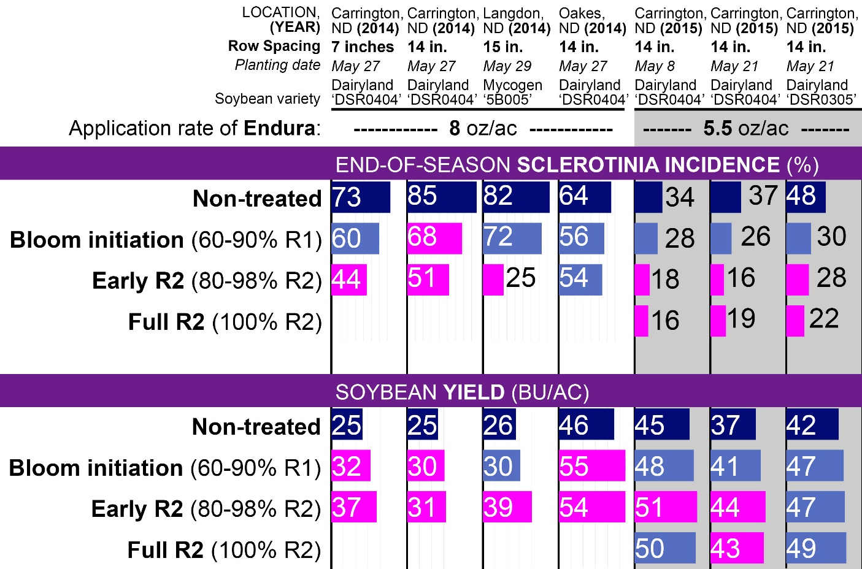

-----------------------------------------------------------------------------------------------------------------
Figure 2. Impact on Sclerotinia disease control and soybean yield of applying the fungicide Endura at bloom initiation (60 to 90% of plants with at least one open blossom), early R2 growth stage (80 to 98% of plants with at least one blossom at one of the top two nodes of the plant), and full R2 growth stage (100% of plants with at least one blossom at one of the top two nodes of the plant) to soybeans seeded to wide (21- to 28-inch) rows. Bars shaded in pink are significantly different from the non-treated control (P < 0.05; Tukey multiple comparison procedure).
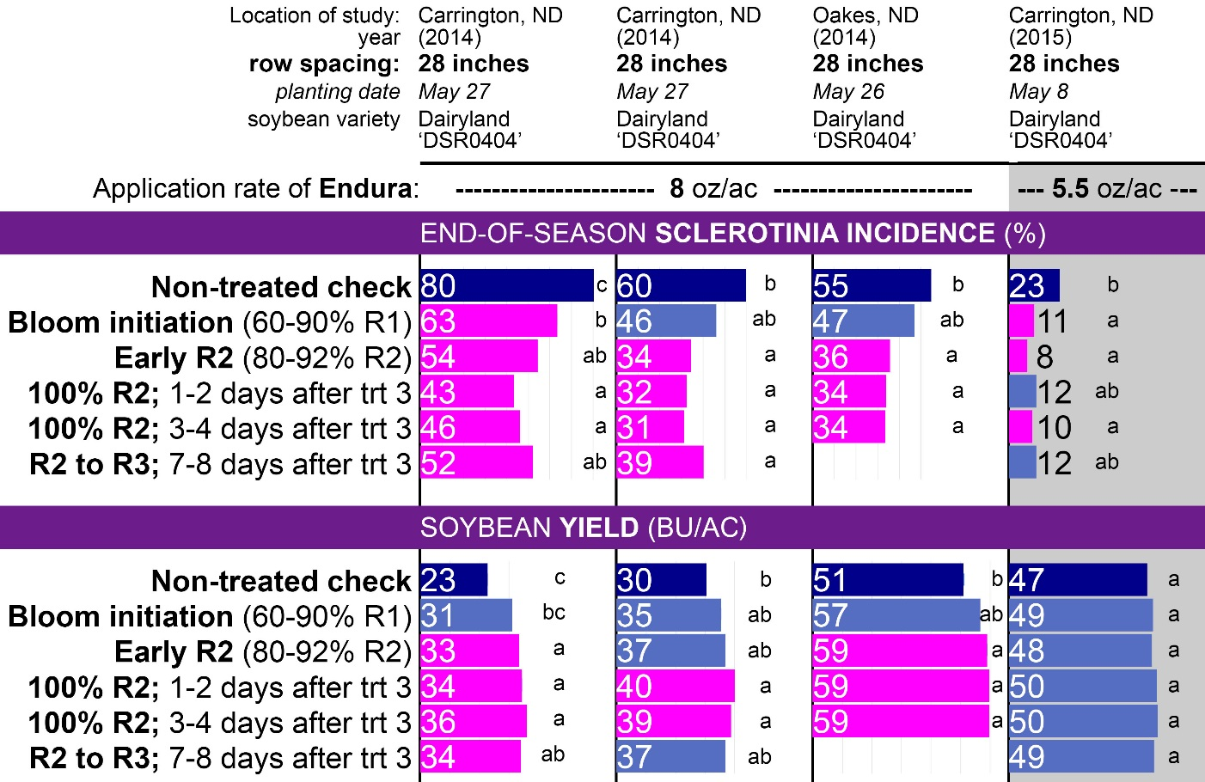

Table 1. Impact of increasing the frequency of supplemental irrigation during pod-fill. Irrigation was applied every time soil available water reached 50%, 65%, or 80%, with sufficient water applied to bring the soil to water-holding capacity, resulting in one, three, or five applications, respectively, from the R3 to R6 growth stage in each of these irrigation regimes. | 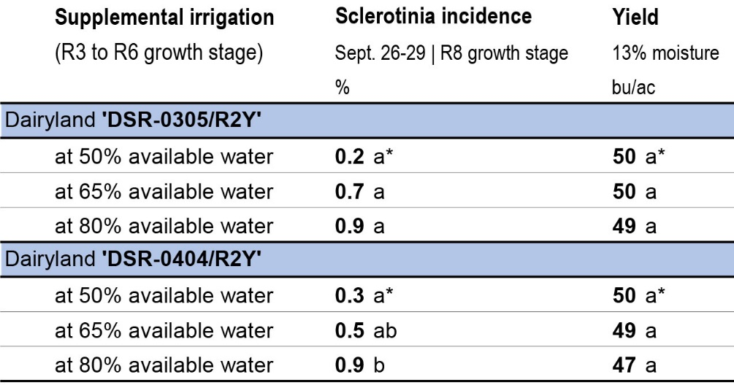
Figures 3, 4, and 5. Changes in white mold incidence, sclerotia in harvested grain, and soybean yield as row spacing was narrowed. Each dot represents results from one of 15 soybean varieties evaluated at one of three locations in North Dakota in 2015.

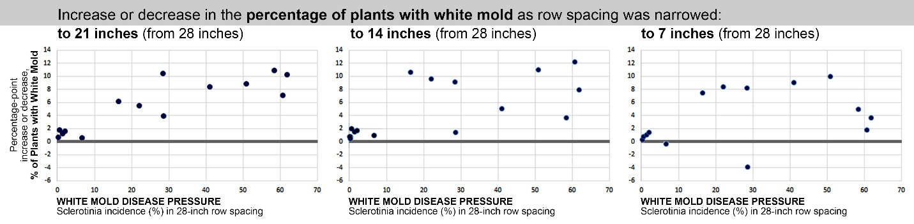

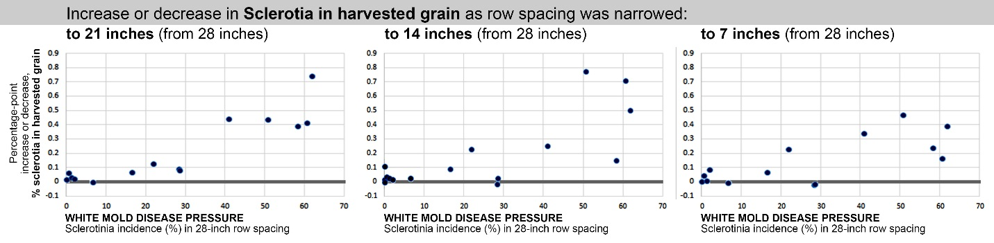

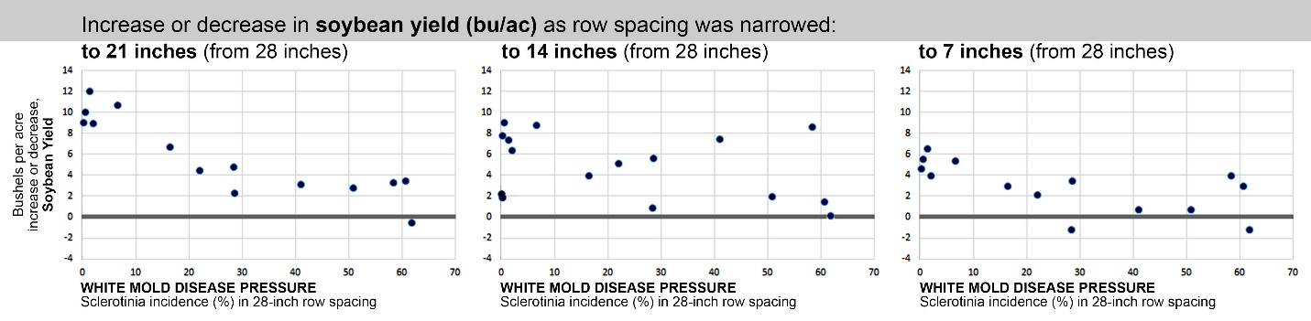

Figures 6, 7, and 8. Changes in white mold incidence, sclerotia in harvested grain, and soybean yield seeding rate increased. Each dot represents results from one of 15 soybean varieties evaluated at one of three locations in North Dakota in 2015.

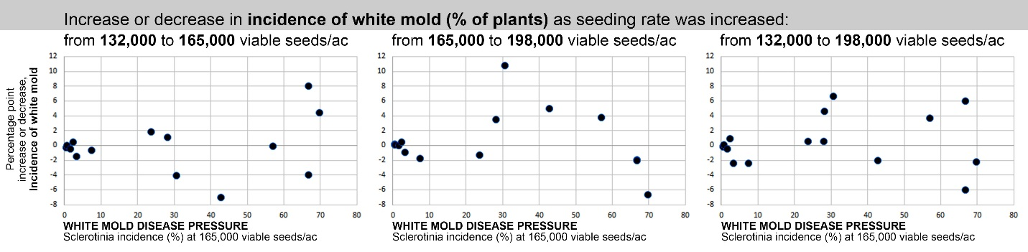

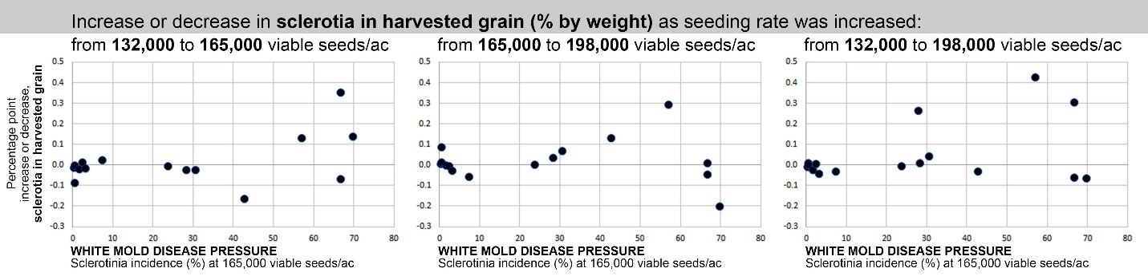

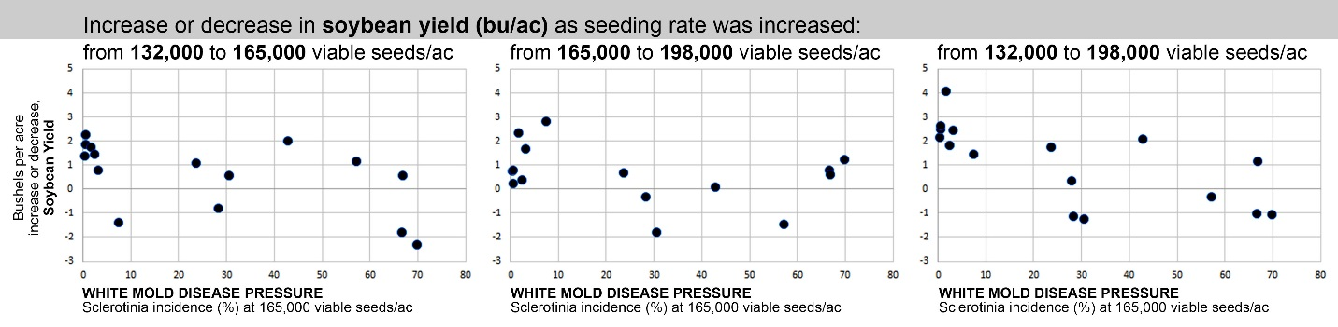

Figures 9 and 10. Relationship between bushiness of soybean varieties and susceptibity to Sclerotinia. Bushiness was assessed as the number of days between bloom initiation (80% of plants with at least one open blossom), and canopy closure. Each dot represents a different soybean variety.
--------------------------------------------------------------------------------------------------------------
Figure 9: Figure 10:
Carrington  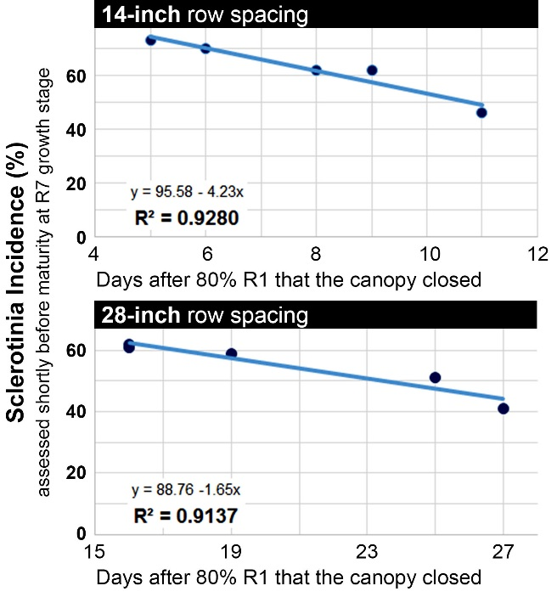 | Oakes  