From the ground up: How Salinity Gradients Damage Soybeans, Contribute to Arthropod Pest Infestations, and Impact Soil Nitrogen Reserves

Principal Investigators:
Abbey Wick, Dept. of Soil Science; Tom DeSutter, Dept. of Soil Science; Jason Harmon, Dept. of Entomology; Deirdre Prischmann-Voldseth, Dept. of Entomology, NDSU

Technical Support:
Kirsten Butcher, Graduate Student, Dept. of Soil Science
Jackie Eichele, Graduate Student, Dept. of Entomology
Chandra Langseth, Extension Research Technician, Dept. of Soil Science

FY Year End Report: June 30, 2016; Technical Report

Situation Statement:
Soil salinization is a global issue affecting 2 billion acres of arable land and resulting in approximately US$ 27.3 billion in costs annually (Martinez-Beltran and Manzur, 2005; Qadir, et al. 2014). It has been estimated that approximately 400,000 acres in the Red River Valley alone are subject to saline soils (Benz, et al. 1961). Given the extent of soil salinity, it is imperative to obtain a better understanding of the changes in agro-ecosystem functions in response to increasing levels of soil salinity under field conditions. Coupled with results from greenhouse studies performed in North Dakota, this field study aims to determine patterns of soybean yield response and pest pressures across natural gradients in soil salinity in a sandy loam soil native to North Dakota. This research is will provide more pertinent recommendations for producer management of saline soils.

Objectives:
There were two main objectives of this research. Firstly, both plant and insect data obtained from this field study were compared with results generated from similar studies performed in the greenhouse (FY2014 Technical Report) to determine the ability of the greenhouse predictions to accurately depict soybean and pest responses to salinity under field conditions. Secondly, results of this study were intended to establish crop tolerance thresholds, as well as yield prediction curves that could be used by soybean producers in the Red River Valley managing saline soils. Soybean aphid and spider mite infestations along the same salinity gradients were also assessed to determine the effect of salinity on pest pressure under field conditions. Ultimately, results from this field study will be incorporated into an economic model to estimate the costs associated with soil salinization in an effort to encourage preventative and reclamation management of saline soils.

Research Conducted:
Field Conditions
Preliminary salinity gradients were established using the Geonics EM 38 electromagnetic meter across each of the three sandy loam soil fields (Wyndmere loam) and three silty clay loam (Antler-Mustinka complex) in Richland County, North Dakota. Interpolated maps were created in ESRI ArcMap 10.1 to produce field-scale salinity maps for each field in the study. These maps were used to determine the most pronounced salinity gradients in which to construct transects for sampling. Soil series and field management were constant across each field to ensure that only the effect of salinity was examined. However, while attempts to control both soil series and field management were of high priority, it is important to acknowledge the inherent variability in natural agro-ecosystems. Consequently, even though soil chemical and physical properties are constantly fluxing in nature, these conditions were assumed to be fluxing equally across the salinity gradients used in this study.

Field Sampling Methods
Soybean response and pest infestations were assessed across five, 100-m transects on each field. Soybean crop parameters-plant height, leaf area index (LAI), and nitrogen (N) content- were measured twice across the growing season at a vegetative (V6) and reproductive (R6) life stage of soybean, with the exception of LAI, which was only measured at the reproductive stage. Yield was hand-harvested in a 2.3 m² area at each sample point along the transects. Arthropod sampling and cage experiments were also performed around the same sampling points used for soybean crop parameters and yield. However, insect sampling was constricted to a 1.4 m² plot immediately surrounding the plant sampling area to avoid influencing the crop parameter and harvest data.

Soybean Yield and Crop Parameters
Four composite soil samples were extracted using a Giddings hydraulic probe at each sample point following harvest. Samples were collected from five depths: 0-15 cm, 15-30 cm, 30-60 cm, 60-90 cm, and 90-120 cm. Both saturated paste extracts (EC_{e}) and 1:1 soil to water slurries (EC_{1:1}) were used to determine the EC of each sample according to methods by Whitney (1998). One additional core was taken at each sample point, centered above a soybean stalk, to determine root length at each of the five depths using an EPSON Perfection V700 Photo scanner and WinRHIZO software (Regent, 2011).

Yield (kg ha⁻¹) was analysed using threshold slope (Maas, 1993) and modified discount response function (MDRF; Steppuhn et al., 2005) to determine the relationship between yield decline and the depth weighted average electrical conductivity (EC_{DWA} in dS m⁻¹) from 0 to 30 cm, calculated as follows:
EC_{DWA} = $\frac{\left(E{C_{e}}_{0-15}*15 cm\right)+(E{C_{e}}_{15-30}*15 cm)}{30 cm}$

where EC_{DWA} is the depth weighted average from 0 to 30 cm, EC_{e0-15} is the salinity determined by a saturated paste extract at the 0 to 15 cm depth, and EC_{e15-30} is the salinity determined by a saturated paste extract at the 15 to 30 cm depth. The depths used for the depth weighted average were based on the distribution of soybean roots observed under field conditions according to Gao et al. (2010).

Crop parameter measurements taken at the two life stages were also analysed using linear and threshold slope regression models. The vegetative stage was analysed against the EC_{e} from 0 to 15 cm. Reproductive stage crop parameters were compared against the EC_{DWA}. The EC_{e} of the depth roots were collected from was used to assess root length response to salinity. The best fit curves for explaining soybean responses to salinity reported were based on statistical significance (p-value < 0.05) and the degree of variation explained by the regression model (R²).

Arthropod Greenhouse Experiments
In the past couple of years we have made tremendous progress and done a great deal of work investigating how soybean pests respond to soil salinity in the greenhouse. In previous experiments (described in FY2014 & FY2015 Technical Reports) we detailed how we established methods to experimentally manipulate soil salinity for use in controlled greenhouse experiments. These greenhouse experiments increase the degree of control we have so that we can limit the impact of confounding variables that may influence the results. For the greenhouse experiments, all soil factors were held constant, with the exception of soil salinity. This allowed for the analysis of only salinity’s effect on plant growth. We have used two different soils in these experiments. First, we used a soil native to North Dakota (Glyndon Aeric Calciaquoll collected from Hunter, ND). Secondly, we used a prepacked soil that is commercially available. The first gives us important insights about a regional soil type while the second helps complement and generalize our results. With both methodologies we used salts relevant to the Red River Valley (Na₂SO₄ and MgSO₄·7H₂O), and we added those salts across a range of concentrations so that we would be able to test for effects along a gradient of values relevant to North Dakota soybean fields. Specifically, we attempted to emulate salinity concentrations of ECs 0, 2.0, 4.0, and 6.0 dS m⁻¹, with our second set of experiments expanding to 8.0 dS m⁻¹. This last value was added to match observations we were seeing for saline conditions in the fields we were studying.

We used different methods to assess pest performance on the soybean plants across our manipulated gradient of soil salinity. The results thus far have been remarkably consistent: both spider mites and soybean aphids produce more babies and have larger populations as soil salinity increases.

In the greenhouse this past year we have been expanding our results to understand how salinity affects the movement and distribution of both pests as well as additional studies into the lifetime demographic changes in one of the pests.

We performed two different types of movement experiments in the greenhouse. Both of them address the movement of either two spotted spider mites or soybean aphids, but they do so at two different scales: movement between individual leaves and movement between plants. The first experiment used two soybean plants, one grown in high concentrations of salinity and one grown in a control soil without any added salts. An enclosed clip cage allowed adults to move between leaves of the two plants. If they can distinguish between the two leaves, we would expect they would accumulate on the leaf from the saline soil where they will have a fitness advantage. The second experiment was at a larger scale and used three different plants. A middle “source” plant had an established pest colony and then two additional plants were added to the large cage. One of those cages was grown in a high salinity soil (8.0 dS m⁻¹) and the other was grown in control soil with no added salts. Bridges were made between leaves so that either mites or aphids could easily walk among the plants. Again, if the pest could tell the difference between the high and low salinity plants we would expect them to become more abundant on the high salinity plant so they could take advantage of the fitness boost they would likely gain.

Finally, we also performed a lifetime longitudinal study with soybean aphid. The impetus for this work was to cover a longer time scale than previous experiments allowed. Our previous work showed how populations responded over 7 days but the experiments with individuals only ran for 3 days. Thus it is possible that there are some sorts of trade-offs that exist when feeding on saline plants. For example, perhaps females have more babies but they don’t live as long. To test this experiment we caged new (<24h) soybean aphids in individual cages on to soybean plants. The plants were growing in either control conditions or in soil where salts had been added to mimic fairly high salinity conditions. We then kept the individual in the cage for its entire life and regularly checked on it. This allowed us to look at the aphids’ development time, fecundity through time, longevity, and similar demographic parameters.

Arthropod Field Sampling and Experiments
A large cage experiment was performed to examine the response of spider mites on soybean plants grown at different levels of salinity under field conditions. This experiment was intended to test the predictions established by previous experiments in the greenhouse. For this field experiment, small enclosures called clip cages were used to contain adult female spider mites to one small area of a soybean plant. Three adult females were placed in each cage and given three days to lay eggs. Female spider mites can choose the number of eggs to lay based on the quality and suitability of the plant for her offspring. More eggs indicate a greater chance for pest problems to develop. After three days, the clip cages were removed to avoid spreading pests in the field. Leaves from the soybean plants with clip cages were collected and analysed using a stereomicroscope to count the number of eggs laid and the number of female spider mites still present. We performed this experiment multiple times in commercial soybean fields that had an established gradient of salinity that had been measured.

Results:
Soybean Yield and Crop Parameters in Sandy Loam Soils
In sandy loam soils, N-content was the only crop parameter at the V6 growth stage to significantly decline in response to increasing EC_{e} down to 15 cm. Nitrogen content declined linearly by 2.1% (0.77 SPAD units) per unit increase in EC_{e} of the 0-15 cm depth (p-value < 0.05; R² = 5.6%; Table 1). Declines occurred after the lowest observed salinity of 0.30 dS m⁻¹. At the R6 growth stage, soybean height and N-content significantly declined in response to increasing EC_{DWA} down to 30 cm. Height declined linearly by 12.8% (7.0 cm) per unit increase in EC_{DWA} after a threshold EC_{DWA} (EC_{T}) of 2.96 dS m⁻¹ (Table 1). The threshold-slope model was significant (p-value < 0.05) and explained 8.8% of the variation in soybean height. The threshold-slope model indicated that EC_{T} was within an interval of 1.60 and 4.31 dS m⁻¹ with 95% confidence. Nitrogen content at the R6 life stage declined linearly after an EC_{DWA} of 0.36 dS m⁻¹ by 1.3% (0.59 SPAD units) per unit increase in EC_{DWA} down to 30 cm (Table 1) The linear model was significant (p-value < 0.01), and EC_{DWA} explained 10.7% of the variation in N-content. Root length was distributed equally between 0-15 and 15-30 cm depths in sandy loam soils. No significant models explaining root length and EC_{e} were found at any of the depths sampled. However, while not significant, distribution of roots in the 0-15
cm depth increased as EC_{e} of the 15-30 cm depth increased.

The threshold-slope model was highly significant (p-value < 0.0001) for predicting
soybean yield in response to increasing EC_{DWA} down to 30 cm in sandy loam soils (Figure
1). The EC_{DWA} of the root zone explained 27.2% of the variation in soybean yield. The model intercept corresponded to 1.8 Mg ha⁻¹, and a significantly different (p-value < 0.0001) slope of yield decline was predicted after an EC_{T} of 2.98 dS m⁻¹. At values below EC_{T}, soybean yield declined by 1.8% (32.0 kg ha⁻¹) per unit increase in EC_{DWA}. At values greater than or equal to EC_{T}, soybean yield declined by 21.0% (384 kg ha⁻¹) per unit increase in EC_{DWA}. The threshold-slope model indicated that EC_{T} was within an interval of 1.80 and 4.17 dS m⁻¹ with 95% confidence. The 95% upper and lower confidence bounds for the slope of decline after EC_{T} were -38.3 and -3.7% per dS m⁻¹ increase, respectively.

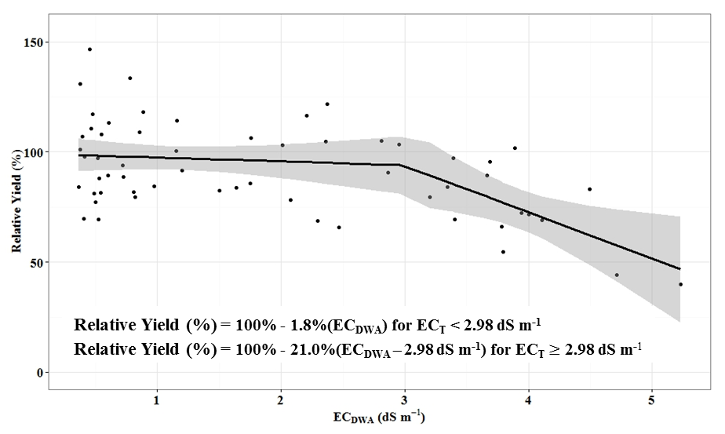

Figure 1: Threshold-slope model of hand-harvested soybean yield in sandy loam soils in Richland County, ND as a function of the depth weighted average EC_{e} (EC_{DWA}) of the root zone. Best fit line fitted with 95% upper and lower confidence bounds. Change in slope occurred after a threshold EC_{e} (EC_{T}) of 2.98 dS m⁻¹.

Soybean yield in sandy loam soil was also significantly predicted by the MDRF
model (Figure 2). The model intercept corresponded to 1.8 Mg soybeans ha⁻¹. The estimated value for the steepness parameter (s) was 0.33 as determined by non-linear fitting of the MDRF model. The EC₅₀ was estimated from the threshold-slope model at 5.00 dS m⁻¹. The value of p was calculated at 5.21. The MDRF model parameters were highly significant (p-value < 0.001), and the model explained more variation in yield with increasing salinity of the root zone (R² = 30.8%). The model intercept corresponded to 1.8 Mg ha⁻¹, and yield declined exponentially by a factor of 1.66% per unit increase in EC_{DWA}. The steepest declines were observed after an EC_{DWA} of 3.00 dS m⁻¹.
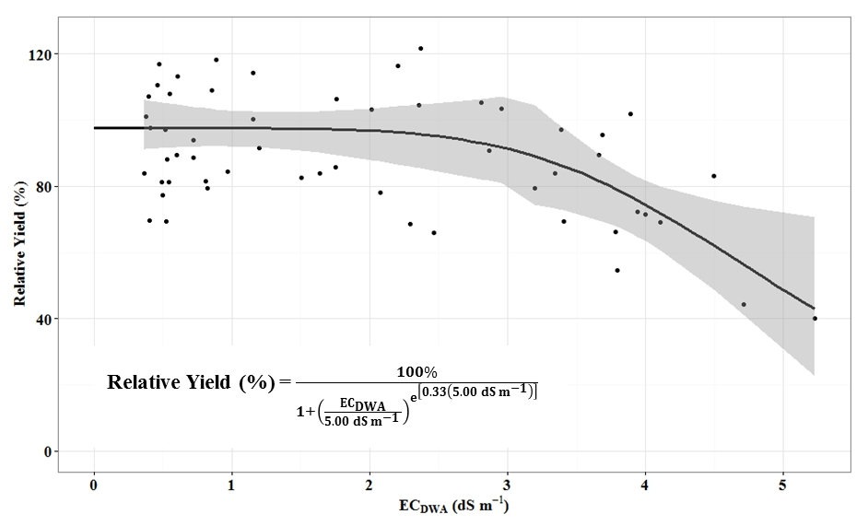

Figure 2: Modified discount response function of hand-harvested soybean yield in sandy loam soils in Richland County, ND as a function of the depth weighted average EC_{e} (EC_{DWA}) of the root zone. Steepest declines occurred after an EC_{DWA} of approximately 3.00 dS m⁻¹. Confidence intervals derived from threshold-slope model.

Residual analysis detected significant heteroskedasticity in both threshold-slope and MDRF models explaining yield response to EC_{DWA}. Further analysis indicated that residuals of both yield models were significantly correlated (p-value < 0.05) to clay content (r = 0.30) and approached a significant correlation (p-value < 0.10) to sand content (r = -0.22). Incorporation of clay content and EC_{DWA} into a multiple linear regression generated a highly significant model (p-value < 0.0001) explaining 35.5% of the variation in yield. In the multiple linear regression, soybean yield declined by 10.0% per unit increase in EC_{DWA} when clay content was constant. When EC_{DWA} was constant, soybean yield increased by 1.5% per g clay soil kg⁻¹ increase.

Soybean Yield and Crop Parameters in Silty Clay Loam Soils
In silty clay loam soils, no significant declines in soybean height or N-content at the V6 stage were observed (Table 1). Soybean height at the R6 stage was best predicted by a threshold-slope model. The model was significant (p-value < 0.01) and explained 10.4% of the variation in soybean height (Table 1). Significantly different slopes in height were observed after an EC_{T} of 2.76 dS m⁻¹. The 95% upper and lower confidence bounds for EC_{T} were +1.15 and -4.38 dS m⁻¹, respectively. Soybean height declined by 11.6% (10.6 cm) per unit increase in EC_{DWA} at values of EC_{DWA} greater than or equal to EC_{T}. Nitrogen content at the R6 stage of soybeans declined linearly by 1.8% (0.81 SPAD units) per unit increase in EC_{DWA} (Table 1). The linear model was significant (p-value < 0.05) and explained 8.7% of the variation in N-content. Highly significant declines (p-value < 0.0001) in LAI were also observed at the R6 stage of soybeans grown in silty clay loam soils (Table 1). Leaf area index declined by 13.4% (0.24 LAI units) per unit increase in EC_{DWA}. The model explained 23.6% of the variation in LAI.

Similar to root distribution in sandy loam soils, root length in silty clay loam soils was equally distributed between the 0-15 and 15-30 cm depths. Root length in both the 0-15 and 15-30 cm depths could not be explained by increasing EC_{e} of the respective depths. However, root length distribution in the 0-15 cm depth was significant correlated to EC_{e} of the 15-30 cm depth below (r = +0.34). No significant declines in soybean yield were observed in silty clay loam soils up to an EC_{DWA} of 5.76 dS m⁻¹ (Figure 3).

Table 1: Responses of measured soybean parameters to soil salinity in the root zone for both textures.

Texture† | Growth Stage | Crop Parameter | Model‡ | Threshold (EC_{T})§ | Slope
 |  |  |  | dS m⁻¹ | % per dS m⁻¹
SL | V6 | Height | -- | -- | --
 | V6 | N-Content | Linear | -- | 2.1
 | R6 | Height | Threshold-Slope | 2.96 | 12.8
 | R6 | N-Content | Linear | -- | 1.3
 | R6 | LAI | -- | -- | --
 | Harvest | Root Length | -- | -- | --
 | Harvest | Yield | Threshold-Slope | 2.98 | 21.0
SCL | V6 | Height | -- | -- | --
 | V6 | N-Content | -- | -- | --
 | R6 | Height | Threshold-Slope | 2.76 | 11.6
 | R6 | N-Content | Linear | -- | 1.8
 | R6 | LAI | Linear |  | 13.4
 | Harvest | Root Length | -- | -- | --
 | Harvest | Yield | -- | -- | --
† Soil texture of field. SL is sandy loam (Wyndmere loam), and SCL is silty clay loam (Antler-Mustinka complex).
‡ Best fit model describing soybean response to salinity. Significant threshold-slope model also indicatives significant MDRF model.
§ Threshold before decline in crop parameter. No significant decreases in crop parameter for electrical conductivity of the root zone (EC_{DWA}) up to this threshold.

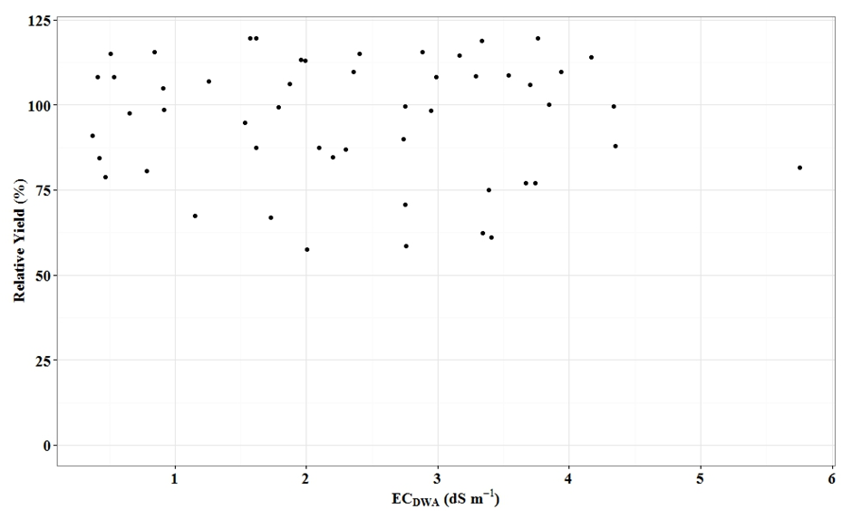

Figure 3: Hand-harvested soybean yield in silty clay loam soils in Richland County, ND as a function of the depth weighted average EC_{e} (EC_{DWA}) of the root zone.

Arthropod Response in Greenhouse Experiments
Spider mite movement
Despite the very strong, positive relationship we previously observed between salinity and the offspring produced by spider mites we did not see any effect of salinity on the movement behaviour of the pest. In all runs of our experiments we were just as likely to find mites on the plant grown in high salinity soil as we were on the control soil with no salts added. Most of the movement we observed in our experiments were done by adult mites. Perhaps these adults are unable to distinguish between the two plants when they are choosing a host to feed on. Alternatively, even if they can tell the difference, they may rely on other cues such as where other mites are to decide where to feed.

Besides adults walking among plants, spider mite movement is also carried out by juveniles who use long silk threads to “balloon” to other places. This movement is also unlikely to be affected by salinity as where the mites end up is primarily determined by the wind. This might mean that spider mites might be more likely to move to the edges of fields or other such location, but they do not appear likely to be basing that decision only on the concentration of salts in the soil. It is important to point out, however, that the mites that do make it to saline areas will be able to reproduce faster and could become a problem sooner than those mites in other areas.

Aphid movement
Soybean aphids on the other hand did respond to salinity by changing their aggregation patterns. At the small scale, we did not see differences in which leaf an aphid chose. However, at the larger scale more adult aphids were found on the plants grown in more saline soils. These aphids went on to have more babies so that the plants grown in saline conditions ended up with many more aphids than the other plants. This may mean that soybean aphids will preferentially segregate to areas of higher salinity where they will get a boost in their reproduction and create “hot spots” of high aphid density.

Aphid lifetime demography
Aphids kept on plants in high salinity developed at the same rate as the aphids in the control plants. Almost all other measured metrics, however, showed a benefit of being on the high salinity plants. Aphids on high salinity plants produced more babies and they lived longer while producing babies for a longer period. Such lifetime advantages to reproduction are likely to have very strong effects on the population level and make it that much easier for pest populations to become a problem.

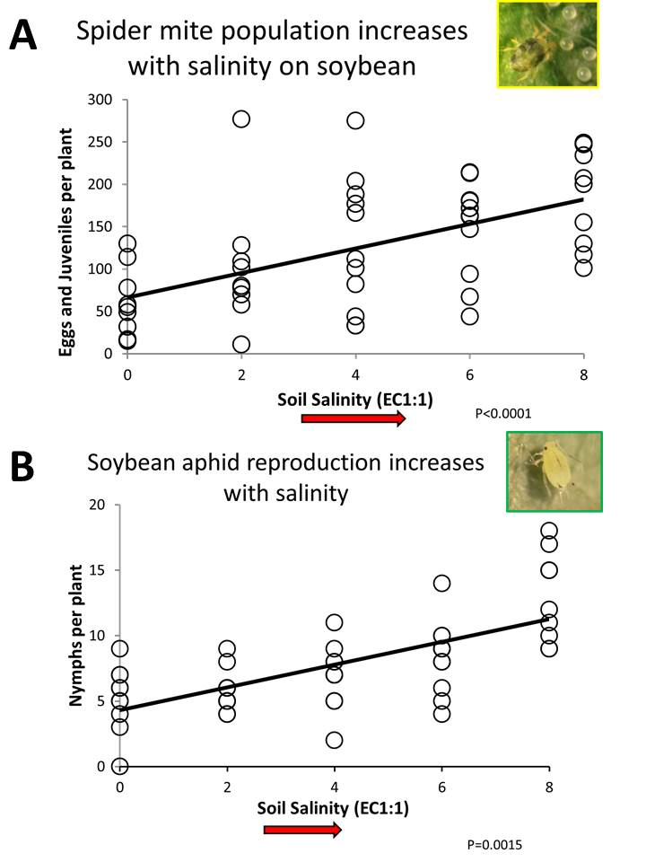
Figure 4: Reproductive output of individual aphids per day for the entire lifetime for aphids raised their entire life on a soybean plant grown in high salinity soil vs a control soil with no salts added.

Arthropod Response in Field Experiments
Overall, our clip cage experiments in the field showed the same positive correlations between salinity and the number of eggs produced per adult alive at the end of the experiment. This matches all of the greenhouse work we performed. However, not all fields showed the same positive response to salinity. This may indicate that there are additional factors, perhaps some of them that are specific to certain fields, that can modify the relationship between salinity and pest performance. Future work will need to investigate what those factors might be and when they may be important.

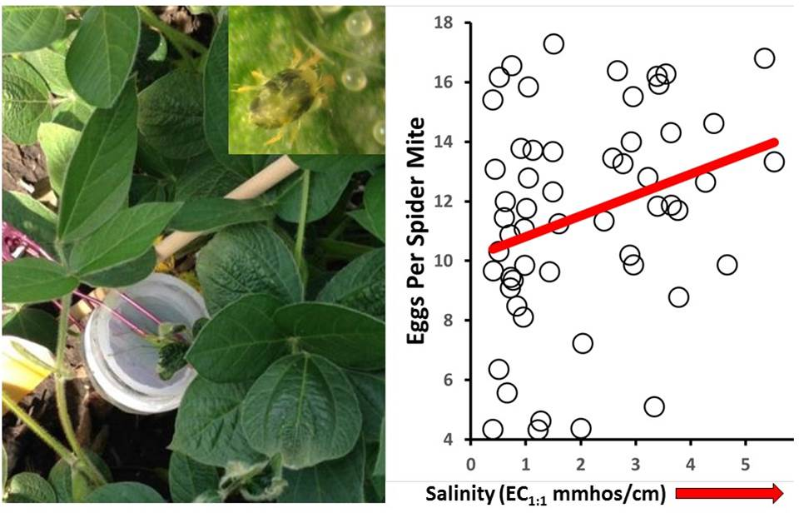
Figure 5: Spider mites in field cages have more offspring on plants grown in increasingly saline soils.

Discussion:
Soybean Yield in Sandy Loam Soils
Yield declines in this study were observed at substantially lower salinities than previously established by crop tolerance studies performed in greenhouses. Previous results by Abel and MacKenzie (1964), Bernstein and Ogata (1966), and Maas and Hoffman (1977) indicated soybean yields declined at an EC_{e} of 5.0 dS m⁻¹. The results of this study thus have immense repercussions for producers in the Red River Valley opting to plant soybeans based on previous studies indicating their higher tolerances. In effect, results of this study determined that soybean yields begin to decline at a maximum of 3 ds m⁻¹. A comparison of previous thresholds (A) and thresholds observed in this study (B) are depicted in Figure 6. The increase in red areas on Figure 5B indicates that more areas on the same field are now predicted to have lower yields given that these regions exceed the threshold salinity observed in this study. Consequently, the new thresholds for soybean yield declines predict substantially higher losses in yield profits attributed to soil salinity.

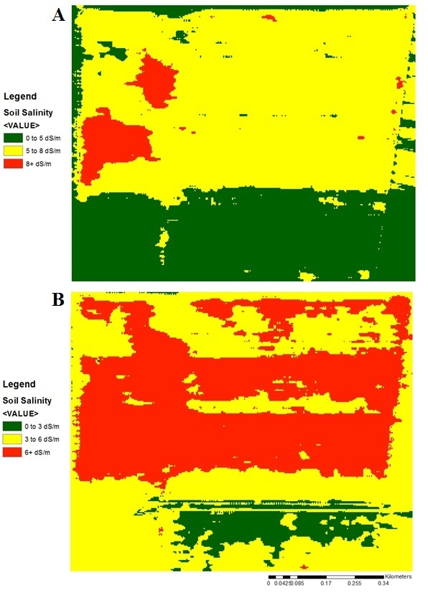
Figure 6: Field-scale salinity maps generated by EM 38 measurements. Green represents low salinity (regions of high yield), red is high salinity (regions of low yield), and yellow is an intermediate soil salinity (regions of intermediate yield). A) Previously established tolerance indices for soybeans. B) Soybean tolerance in the Red River Valley observed in this study. The increase in red areas on B indicate that more areas on the same field are now predicted to have lower yields given that these regions exceed the threshold salinity observed in this study.

It is uncertain why the threshold tolerance for soybeans observed in this study was lower than previous studies suggested. It is possible that differences in tolerance thresholds are the result of differences in soybean varieties tested. Typically, soybean variety has an important influence on the tolerance of the crop to soil salinity (Phang et al., 2008). However, there are no known studies assessing response of varieties used in this study. Consequently, it is difficult to validate this conclusion.

Another potential factor contributing to the lower threshold tolerance of soybeans grown in sandy loam soils in Richland County could be the result of cation nutrition imbalances induced by saline conditions in the soil. High levels of Mg²⁺ can induce Ca²⁺ deficiencies (Nukaya et al., 1982). Soybeans salinized by both MgSO4 and MgCl₂ had lower leaf Ca²⁺ concentrations (Nukaya et al., 1982). Consequently, the presence of salinity with excessive amounts of Mg²⁺ in Richland County could be contributing to Ca²⁺ deficiencies in soybeans observed in this study.

The presence of SO₄²⁻ could also be causing the lower the threshold salinity as a result of ion pairing with Ca²⁺ and Mg²⁺. Ion pairing removes these cations from solution, which allows Na+ to dominant in the soil solution and adsorb onto the particles surface (Springer et al., 1999). As Na⁺ displaces Ca²⁺ and Mg²⁺ on soil particle surfaces, dispersion can occur (Springer et al., 1999). Dispersion ultimately impacts soil water movement. As a result, osmotic stress could become more pronounced in saline soils dominated by SO₄²⁻.

While there are many potential factors that could be contributing to the significant soybean yield declines with increasing salinity, it becomes difficult to tease apart these factors. Cation analysis of plant tissue was not performed in this study so it is difficult to differentiate the effects of salinity on soybean yield with other factors associated with increasing levels of salinity in the soil.

Even despite the relatively low r² values generated by the bioindicator models, it is important to remember that these models can still be accepted given that this was a field study. Even more, lower correlation coefficients should be expected because of the extreme variation inherent in natural agro-ecosystems. The heteroskedasticity in the threshold slope and MDRF models indicate that there are likely more factors contributing to the yield declines observed when soybeans were grown in sandy loam soils. For example, residual analysis depicted significant positive correlations between yield and clay content of the soil. While other factors influencing yield should likely be included into the models for a more complete understanding of salinity’s impact on soybeans under field conditions, the addition of more model parameters becomes problematic to the original objectives of the study. Incorporation of factors like clay content, as well as other factors that influence salinity like water content and aggregate stability, reduces the applicability of the results from this study to producers managing saline soils because producers may not have the detailed information required for the models.

Between the threshold slope and MDRF models, the MDRF may be more ecologically relevant to soybean yield response to salinity under field conditions (van Genuchten and Gupta, 1993). The MDRF model is potentially more relevant because of the cumulative effects of soil salinity on plant growth. For example, salinity increases cation concentrations in the soil solution contributing to both osmotic stress and specific ion toxicities (Maas and Niemen, 1978). Cation salinity in Richland County is dominated by Ca²⁺. If Ca²⁺ is available in solution, it can complex with phosphorus (Jackman and Black, 1951). Precipitation of calcium phosphate removes plant available phosphorus from the soil, which could lead to phosphorus deficiencies (Curtin et al., 1993). Coupled with pest pressures (Maas, 1993) and an increased risk for iron deficiency chlorosis (Franzen and Richardson, 2000), salinity may cumulatively intensify plant decline after some threshold from several secondary factors attributed to increasing salinization.

Soybean Yield in Silty Clay Loam Soils
Soybeans grown in silty clay loam soils in Richland County did not have significant yield declines with increasing salinity of the root zone. Typically, finer textured soils contain more water, which may effectively dilute the soil solution (Bernstein, 1975). This dilution effect would reduce the salinity experienced by the plant. Consequently, plants grown in finer textured soils require a higher EC of the soil solution to impair biological growth and development (Richards, 1954).

While the increased water holding capacity does potentially explain why no yield declines were observed for soybeans grown in silty clay loam soils, it seems contradictory to the results of crop parameter measurements recorded during reproductive (R6) growth of soybeans. In effect, it is uncertain why no declines were observed in soybean yield with increasing salinity, despite significant declines in the vegetative components of the crop during reproductive growth. One potential explanation is that the observed declines during the R6 growth stage are adaptive responses to increasing salinity. For example, declines in LAI are a possible mechanism to reduce water lost to the atmosphere through transpiration (Cutler et al., 1977). Consequently, it is possible that the declines in plant parameters like height and LAI observed during the R6 stage of soybean growth were an attempt for the plant to acclimate to the increasing salinity.

The decline in R6 stage crop parameters of soybeans grown in silty clay loam soils as a means of adaptation to salt stress contradicts the results of crop parameters of soybeans grown in sandy loam soils. For example, if soybeans were able to use these mechanisms for adaptation in silty clay loam soils, why did they not allow for acclimation in sandy loam soils? One potential explanation is that salt stress in silty clay loam soils is “moderate” drought stress, whereas salinity stress in sandy loam soils is “severe” drought stress. These classifications are attributed to the water holding capacities of these two soil textures. Again, finer textured soils hold more water (Bernstein, 1975). At the same salt content on a dry soil basis, the EC of the soil solution in a coarser textured soil is approximately five times higher than the EC of the solution in a finer textured soil (Bernstein, 1975). Consequently, the salinity stress in sandy loam soils may have been too severe for soybean growth and development to recover, despite significant declines in crop parameters during vegetative and reproductive growth. The ability of a plant to overcome moderate drought stress has been observed in Arabidopsis. During moderate drought stress (gravimetric water content at 40-50% of field capacity), height of Arabidopsis significantly declined, but flower production was maintained at levels of the well-watered control (Ma et al., 2014). Conversely, Arabidopsis growth under severe drought stress (gravimetric water content less than 40% of field capacity) demonstrated significant declines in both growth and flower production (Ma et al., 2014). Increased plant mortality was also observed (Ma et al., 2014).

Arthropod Infestations
Increasing evidence suggests that arthropod pests of soybeans are affected by salinity, often in ways that could exacerbate pest problems in soils with high salt contents. Through our greenhouse and field work we have been finding fairly consistent patterns of increased pest response as salinity increases. Our recent field results suggest that there may be some mitigating factors that future research will have to investigate. Overall, however, it is clear that the probability of greater pest problems will occur in areas with higher saline concentrations. This may be helpful for scouting and determining “hot spots” in the field, but it also suggests more potential risks that come from not treating problems with saline soil.

Conclusions:
The previously established crop tolerance threshold for soybean yield was substantially higher (5.0 dS m⁻¹; Maas and Hoffman, 1977) than the threshold observed in this study (2.98 dS m⁻¹). However, after the observed threshold of 2.98 dS m⁻¹, soybean yield declined by 21%, which is similar to the previously observed declines of 20% per unit increase in salinity (Maas and Hoffman, 1977). The results of soybean yield in sandy loam soils indicates that soybeans respond differently to SO₄²⁻-dominated salinity than NaCl or CaCl₂-induced salinity. The lack of decline in soybean yield in silty clay loam soils indicates a potential ameliorative effect of salinity in soils that hold more water because of the dilution effect. However, both of these interpretations are still hypotheses that require further testing. For example, given different weather conditions, crop variety, or soil conditions, the observed threshold and slope of decline is subject to change. Despite this variability, the results of this study can still be used by producers to improve management of saline soils.

The results of this study indicate the possible repercussions of soil salinity that is not effectively managed. As these results are translated into economic terms, it becomes obvious that there are not only profit losses associated with lower yields, but also additional fertilizer and pesticide costs necessary to reduce secondary environmental stressors attributed to soil salinity. The substantially lower threshold for soybean tolerance in sandy loam soils observed in this study only intensifies the high costs associated with soil salinity. It is thus vital for the well-being and sustainability of soybean production in the Red River Valley to employ preventative strategies to mitigate and reclaim the effects of soil salinity on North Dakota agriculture.

Acknowledgements:
We would like to thank the North Dakota Soybean Council for funding this research, as well as the participating producers for their cooperation. Additionally, a special thanks goes to the tireless efforts of the students and technicians in the Soil Science and Entomology departments at North Dakota State University for their hard work in both field sampling and laboratory analysis.

References
Abel, G.H. and A.J. Mackenzie. 1964. Salt tolerance of soybean varieties during germination and later growth. Crop Sci. p. 157-161.
Benz, L.C., R.H. Mickelson, F.M. Sandoval, and C.W. Carlson. 1961. Groundwater investigations in a saline area of the Red River Valley, North Dakota. J. Geophys. Res. p. 2435-2443.
Bernstein, L. and G. Ogata. 1966. Effects of salinity on nodulation, nitrogen fixation, and growth of soybeans and alfalfa. Agron. J. p. 201-203.
Bernstein, L. 1975. Effects of salinity and sodicity on plant growth. Annu. Rev. Phytopathol. 13:295- 312.
Curtin, D., H. Steppuhn, and F. Selles. 1993. Plant responses to sulfate and chloride salinity: Growth and ionic relations. Soil Sci. Soc. Am. J. 57:1304-1310.
Franzen, D.W., and J.L. Richardson. 2000. Soil factors affecting iron chlorosis of soybean in the Red River Valley of North Dakota and Minnesota. J. Plant Nut. 23:67-78.
Gao, Y., A. Duan, X. Qui, Z. Liu, J. Sun, J. Zhang, and H. Wang. 2010. Distribution of roots and root length density in a maize/soybean strip intercropping system. Agric. Water Man. p. 199-212.
Jackman, R.H., and C.A. Black. 1951. Solubility of iron, aluminum, calcium, and magnesium inositol phosphates at different pH values. Soil Sci. 72:179-186.
Ma, X., N.L., Sukiran, H. Ma, and Z. Su. 2014. Moderate drought stress causes floral transcriptomic reprogramming to ensure successful reproductive development in Arabidopsis. BMC Plant Bio. 14:164-179.
Maas, E.V. 1993. Testing crops for salinity tolerance. In: Maranville et al. Proc. Workshop on Adapt. Plants Salt Stresses. 94:234-247.
Maas, E.V. and G.J. Hoffman. 1977. Crop salt tolerance: Current assessment. Irr. Drain. p. 187-198.
Maas, E.V., and R.H. Nieman. 1978. Physiology of plant tolerance to salinity. In: G.A. Jung. Crop Tolerance to Suboptimal Land Conditions. Am. Soc. Ag., Crop Sci. Soc. Am. Soil Sci. Soc. Am., Madison. 32:277-299.
Martinez-Beltran, J. and C.L. Manzur. 2005. Overview of salinity problems in the world and FAO strategies to address the problem. In: Proceedings of the International Salinity Forum. Riverside. p. 311-313.
Nukaya, A., M. Masui, and A. Ishida. 1982. Salt tolerance of green soybeans as affected by various salinities in sand culture. J. Jap. Soc. Hort. Sci. 50:487-496.
Phang, T.H., G. Shao, and H.M. Lam. 2008. Salt tolerance in soybean. J. Int. Plant. Bio. 50:1196- 1212.
Qadir, M., E. Quillerou, V. Nangia, G. Murtaza, M.Singh, R.J. Thomas, P. Dreschel, and A.D. Noble. 2014. Economics of salt-induced land degradation and restoration. Nat. Res. Forum. p. 282- 295.
Regent Instruments and Software. 2011. WinRHIZO 2012b. Basic, Reg, Prod and Arabidopsis for Root Measurement. Canada.
Richards, L. A. (ed.). 1954. Diagnosis and Improvement of Saline and Alkali Soils. USDA Agric. Handbook No. 60, U.S. Government Printing Office, Washington, DC.
Springer, G., B.J. Wienhold, J.L. Richardson, and L.A. Disrud. 1999. Salinity and sodicity induced changes in dispersible clay and saturated hydraulic conductivity in sulfatic soils. Comm. Soil Sci. Plant Anal. 30:2211-2220.
Steppuhn, H., M.Th. van Genuchten, and C.M. Grieve. 2005. Root-zone salinity: II. Indices for tolerance in agricultural crops. Crop Sci. 45:221-232.
van Genuchten, M.Th. and S.K. Gupta. 1993. A reassessment of the crop tolerance response function. J. Indian Soc. Soil Sci. 41:730-737.
Whitney, D. A.1998. Soil Salinity. North Central Regional Research Publication No. 221 (Revised)
Recommended Chemical Soil Test Procedures for the North Central Region. MO Agric. Exp. Station SB 1001, University of Missouri, Columbia, MO. 59-60.

