Research and Extension Efforts at the Soil Health and Agriculture Research Extension (SHARE) Farm (Year 3)

Principal Investigators:
Dr. Abbey Wick, Extension Soil Health Specialist, NDSU Soil Science, Dept. 7680, P.O. Box 6050, Fargo, ND 58108; phone: 701-231-8973; fax: 701-231-7861; email: abbey.wick@ndsu.edu

Dr. Frank Casey, Director of the School of Natural Resource Sciences, NDSU, P.O. Box 5638, Fargo, ND 58108; phone: 701-231-8557; fax: 701-231-7861; email: francis.casey@ndsu.edu

Dr. David Ripplinger, Assistant Professor, NDSU Dept. of Agribusiness and Applied Economics, Dept. 7610, P.O. Box 6050, Fargo, ND 58108; phone: 701-231-5265; fax: 701-231-7400; email: david.ripplinger@ndsu.edu

Technical Support:
Chandra Langseth, Extension Research Technician
Rebecca Schewe, Masters level graduate student

FY Year End Report:
June 30, 2016; Technical Report

Situation Statement for the SHARE Farm
The soil health research program in North Dakota focuses on management options for salt-affected soils, effective use of conservation tillage and cover crops, evaluation of soil health and its relation to crop disease, pest pressures and economic parameters. All projects are directly linked to the Soil Health and Agriculture Research Extension (SHARE) Farm in Mooreton, ND. This project is funded primarily with commodity dollars with the goal of conducting field-scale research and developing extension programming driven by farmer input.

On this quarter of land, owned by cooperating farmer Ken Johnson, we extensively soil sampled and established groundwater monitoring wells (spring, 2013). Tile drainage was installed on the northern half of the field (fall, 2014). An NDAWN station was installed (summer, 2015; Figure 1). We set up conservation tillage plots (fall, 2015) in partnership with University of Minnesota Extension, Minnesota Corn Growers Association, Minnesota Soybean Council and numerous companies providing the tillage equipment used on-site. The SHARE Farm has also recently been linked with the National Corn Growers Association Soil Health Partnership to evaluate soil health properties with the use of cover crops in rotation over tiled and non-tiled parts of the field. Through the NCGA Soil Health Partnership, we inter-seeded 90 acres of cover crops (40 lbs cereal rye; 5 lbs radish) into corn at 6 leaf stage (Summer 2016). This will initiate a five-year agreement with the NCGA to evaluate cover crops in rotation over tiled and non-tiled ground.

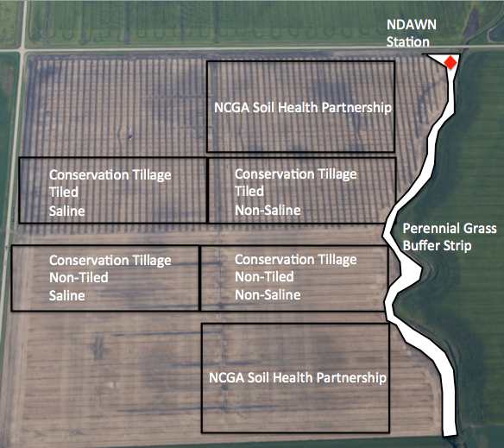
Figure 1. SHARE Farm plot layout. Activities for 2015-2016: Perennial grass buffer strip seeded Spring 2015, NDAWN Station installed summer 2015, Conservation tillage plots added fall 2015, NCGA Soil Health Partnership plots added spring 2016.

Goals/Objectives
The primary goal of the SHARE farm is create a platform for farmer-driven research and extension programming related to soil health. This goal is accomplished through communication among farmers, commodity councils, NDSU research faculty and extension specialists. With this unique approach, soil health can stay relevant and timely. Here are a couple of examples of research questions that have influenced the SHARE Farm based on farmer input – (1) how fast do tiled drained fields build soil health versus fields that aren’t tile drained? (2) how do I fit cover crops into corn and soybean phases of the rotation? and (3) what type of conservation tillage should I use on tiled and non-tiled fields?

Farmers are also very interested in a whole system approach. This is why there are so many different specialists and two universities involved in research and extension associated with the SHARE Farm (Figure 2). It has led to interactions amongst specialists to determine the best management approaches to recommend to farmers.

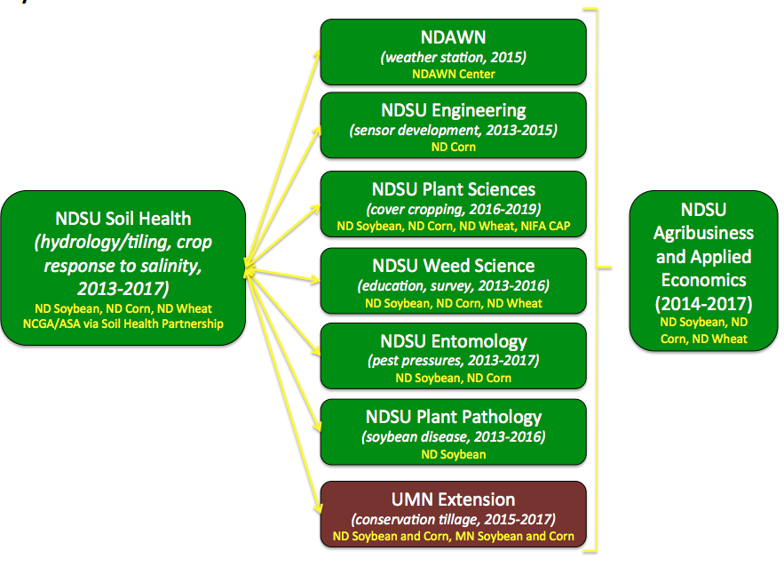

Figure 2. Fourteen scientists in eight disciplines with two universities are conducting on-going research and extension efforts on-site.

Research Projects
Project 1: Quantifying Salt Removal from Tile Drainage in the Red River Valley

Since 1993, North Dakota has been experiencing a wet cycle, which has caused groundwater tables to rise (Euliss and Muschet, 2011). Soil salts dissolved within the groundwater have been transported to the soil surface by capillary rise, increasing soil salinity levels within the crop root zone (Brown et al., 1982; Franzen, 2003). Soil salinity induces drought stress upon the crop, effectively decreasing crop yield (Provin and Pitt, 2001). A popular management strategy to compensate for excess water and soil salinity in the Red River Valley (RRV) is tile drainage.

Water movement is critical for understanding salt transport. Tile drainage lowers the groundwater table by intercepting water from both above and below the tile line. Soil salts will dissolve into soil water and move with the soil water. Thus, tile drainage will remove dissolved soil salts from the field when water is intercepted by the tile drain. Without the presence of a tile drain, soil salts are not removed and are able accumulate near the soil surface. Soil properties, such as texture and structure, influence the ability of water to move through the soil. The research site has a unique soil type classified as a fine, smectitic, frigid Typic Epiaquert (Natural Resources Conservation Service; NRCS, 2013). Smectitic soil shrinks upon drying and swells upon wetting. When dry, large fractures form that are able to transfer water quickly through the soil profile. As the soil is wetted, the soil swells and the fractures begin to close, impeding water movement. Thus, the initial moisture status of the soil will influence how water infiltrates through the soil.

This research investigates the quantity of salt removed from above the tile drain during a leaching event. A leaching event is when water is passed from the soil surface to the tile drain. In the field, this water would come from weather events such as rain or snowmelt during the spring. Since North Dakota has a semi-arid climate, weather events that provide enough water for a leaching event to occur are limited.

Six large, undisturbed soil cores (20 cm dia, 121 cm length) were harvested from the Soil Health and Agriculture Research Extension (SHARE) farm located near Mooreton, ND. Electrical conductivity (EC) values from a Veris map were used to select appropriate sampling areas (Figure 3), average electrical conductivity saturated paste values (EC_{SPE}) were then determined for each sampling location. A total of six cores were collected, three from an area of relative high salinity (EC_{SPE}=5.36 dS m⁻¹) and three from an area of relative low salinity (EC_{SPE}=0.84 dS m⁻¹). These cores were then transported to the laboratory and prepared for a greenhouse study (Figure 4). All cores were then dried, indicating that the soil was fractured from the shrinking effect. Once dry, 6 in. of water was applied to each core. Infiltration and soil water movement was recorded as water passed through the soil cores. Water collected from the drainage was analyzed for cations (Ca²⁺, Mg²⁺, Na⁺, and K⁺) to represent salt content as well as anions (SO₄²⁻, Cl⁻). After all the water passed through the soil, the soil cores were dried once again. A total of four leaching events were completed on the soil cores.

Six small cores (5.4 cm dia, 121 cm in length) were also harvested from the sample locations to establish initial conditions of the soil. Measurements of the small cores included particle density, saturated hydraulic conductivity, particle size, water retention curve characteristics, electrical conductivity 1:1 (EC_{1:1}), saturated paste electrical conductivity (EC_{SPE}), calcium carbonate equivalent (CCE), and cations (Ca²⁺, Mg²⁺, Na⁺, and K⁺).
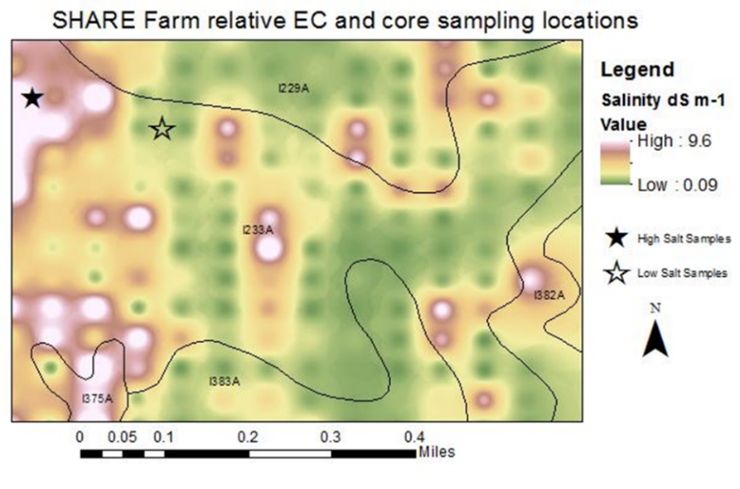
Figure 3. Veris relative electrical conductivity (EC) map of the SHARE farm and selected sampling locations for the large soil cores.
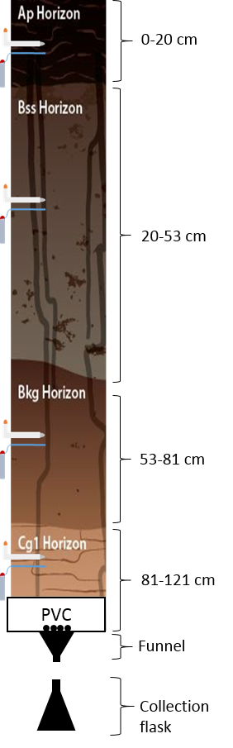
Figure 4. Experimental set-up for each large soil core. Water was applied to the soil surface of each core, monitored as it moved through the soil, and collected at the bottom with a collection flask. The drainage water was then analyzed for salt content.

Monitoring soil water movement indicated that bulk water movement occurred through the fractures of the soil. This means that water moved quickly through the fractures formed from the shrinking effect of the soil. This quick movement of water influenced overall salt removal during the leaching event. The dissolution of salt into water is not instantaneous, and the quick movement of water limited how much salt was able to dissolve into the water before draining from the core.

Salt removal from the high salt cores was limited (Figure 5). The whole circle represents the amount of salt that needs to be removed from the high salt cores to establish the salt levels of the low salt cores. Slices of the circle are indicative of salt removal from high salt cores for each leaching event. Overall, from this experiment a total of 94 leaching events would be required to remove excess salt from the high salt cores to establish low salt levels in the soil.
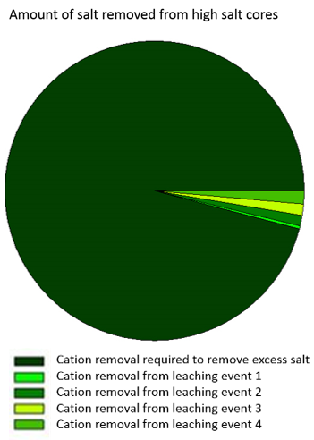
Figure 5. Cation (salt) removal from the high salt cores for each leaching event are represented by the slices of the circle. The whole circle is indicative of how much salt needs to be removed from the high salt cores to reach salt levels of the low salt cores.

Implementation of tile drainage in the RRV will remove a fraction of salt with each leaching event. However, leaching events in the RRV are limited and management practices to improve soil structure and water transfer to the tile drain may increase leaching events (Oster et al., 1996). Management efforts to improve infiltration may maximize the efficiency of salt removal by tile drainage (Callaghan et al., 2014). Cover cropping can improve infiltrability of precipitation and break confining layers that impede water movement (Chen et al., 2014). No-till techniques can reduce compaction layers obstructing water flow towards the tile drain (Okada et al., 2014). Although management practices can improve water transfer, leaching events that occur in the field are weather dependent (Wiekenkamp et al., 2016). Thus, subsequent salt removal per season is difficult to predict; however, salt removal will occur with each leaching event and improve the soil salinity status.

Literature Cited:

Brown, P.L., A.D. Halvorson, H.F. Siddoway, H.F. Mayland, and M.R. Miller. 1982. Saline-seep diagnosis, control, and reclamation. U.S. Department of Agriculture Conservation Research Rep. 30. U.S. Gov. Print. Office, Washington, D.C

Callaghan, M.V., E.E. Cey, and L.R. Bentley. 2014. Hydraulic conductivity dynamics during salt leaching of a sodic, structured subsoil. Soil Sci. Soc. Am. J. 78:1563-1574.

Chen, G., R.R. Weil, and R.L. Hill. 2014. Effects of compaction and cover crops on soil least limiting water range and air permeability. Soil Tillage Res. 136:61-69.

Cover photo: Agassiz Drain Tile. 2008-206. Installation. Agassiz Drain Tile, LLC, Buxton, ND. http://www.agassizdraintile.com/?method=cSiteManager.showInstallation (accessed 8 May, 2016).

Euliss, N.H., and Mushet, D.M. 2011. A multi-year comparison of IPCI scores for prairie pothole wetlands: Implications of temporal and spatial variation. Wetlands. 31:713.

Franzen, David. 2007. Managing saline soils in North Dakota. Bull. SF1087. North Dakota State University Extension Service, Fargo, ND.

Natural Resources Conservation Service. 2013. Map unit description: Fargo silty clay. Richland County, North Dakota. Version 23: Dec 31, 2013.

Okada, E., J.L. Costa, F. Bedmar, P. Barbagelata, A. Irizar, and E.A. Rampoldi. 2014. Effect of conventional and no-till practices on solute transport in long term field trials. Soil Tillage Res. 142:8-14.

Oster, J.D., I. Shainberg, and I.P. Abrol. 1996. Reclamation of salt-affected soil. In: Soil erosion, conservation and rehabilitation. ASA and SSSA, Madison, WI. p. 315-352.

Provin, T., and J.L. Pitt. 2001. Managing soil salinity. Bull. E-60 3-12. Texas Agrilife Extension Service.

Wiekenkamp, I., J.A. Huisman, H.R. Bogena, H.S. Lin, and H. Vereecken. 2016. Spatial and temporal occurrence of preferential flow in a forested headwater catchment. J. Hydrol. 534:139-149.

Project 2: NDSU Soil Salinity Economics Decision-Making Tool

Soil salinity impacts crop growth, resulting in reduction in plant yields. This has significant impacts on revenue, input costs, profitability and land values. Yields of common North Dakota crops are impacted differently by varying levels of salinity – some crops are more tolerant than others. Knowing which crop to plant on different levels of soil salinity is an important part of on-farm decision making. Previous studies conducted in other regions identified thresholds where yields would decline; however, recent studies (2013-2016) at NDSU have redefined thresholds and slopes/declines to make the information more regionally relevant (Table 1).

Table 1. Previous and re-defined crop salinity response thresholds and declines.
 | Previous Studies |  | NDSU Studies (2013-2016)
 | Threshold (mmhos/cm) | Slope (% decline) | Threshold (mmhos/cm) | Slope (% decline)
Corn | 1.3 | 12 | 2.0 | 12
Soybean | 1.9 | 20 | 1.1 | 21
Wheat | 3.4 | 14 | 4.5 | 23

The NDSU Soil Salinity Economics Decision-Making Tool allows users to enter salinity levels to visualize impacts on yields, revenue, input costs and returns. On moderately saline soil (5 mmhos/cm), soybean yields are 16%, corn yields are 65% and wheat yields are 80% of relative yield (figure 6).

Figure 6. Salinity yield response for corn, soybean and wheat. Example salinity level of 5 mmhos/cm identified with vertical line.

The tool includes baseline market prices and expected yields from 2016 Crop Budgets for the Southern Red River Valley prepared by NDSU Extension. Using these numbers, expected per acre soybean revenues fall from $276 to $50 per acre, corn revenues fall from $472 to $305 per acre and wheat production falls from $314 to $278 per acre when soil salinity is 5 mmhos/cm (Figure 7).

Figure 7. Salinity revenue response for corn, soybean and wheat based on yield response to soluble salts.

A lower yield goal resulting from high salinity should cause farmers to revisit input application rates. This includes optimal seeding rates and fertiliizer application rates. A reduction in inputs to optimal levels will increase profitability. Corn cash returns, before fixed costs and returns to management and labor, are $161 per acre at the salinity threshold (where relative yields are 100%) and $60 at a salinity level of 5 mmhos/cm where relative yields are 65%.

Figure 8. Revenue, cash costs and cash returns for corn example using the NDSU Soil Salinity Economics Decision Making Tool.

The impact of salinity on profitability varies greatly by crop as it impacts revenue and costs. In fields with moderately or strongly saline soils, salt sensitive crops may no longer be viable as profitability is dramatically reduced. High levels of salinity limit a farmer’s flexibility in responding to changing market conditions as they may not profitably grow salt sensitive crops even during periods of high prices. Ultimately, the lower productivity of saline soils is capitalized in the price of land. With fields with higher saline soils having lower prices than those with lower saline soils. Cropping practices that impact salinity may have significant impacts on the profitability of crop production and land value.

Extension Programming
A large extension program developed around the SHARE Farm. Since 2013, 53 workshops and field days have been held reaching over 3,200 people. In 2015-2016, extension efforts focused on three areas: (1) soil health café talks, (2) field days and a two-day soil health bus tour and (3) web-based information.

Soil health café talks have been one of the most successful ways to reach farmers with customized information and to encourage conversations among farmers. Café talks were held in Sargent, Stutsman, Cass, and Grand Forks counties. Each café talk had between 15 and 35 attendees, which made for great discussion and new connections.

In 2015, the Annual Soil Health Field Day was held at the Langseth farm where one set of conservation tillage plots are located. Over 100 attended and the typical format of breaking into small discussion groups to cover topics related to whole systems management was used. Topics covered included: conservation tillage, dynamic rotations, erosion, crop disease and weed management. In 2016 (June 29-30) the first soil health bus tour will be held in Richland and Sargent Counties to highlight commodity funded projects. This will be joint with UMN Extension, ND Corn Council, ND Wheat Commission, MN Corn Growers and MN Soybean Council. This is a regional tour as indicated by the zipcode map in Figure 9.
Figure 9. Zipcode map for attendees on the 2016 Soil Health Bus Tour.

Thirty videos have been produced (8 of those videos in 2015-2016) since 2013, receiving over 15,800 views. Most of the views are from the US and Canada; however, we are reaching a wider audience with views from other locations around the world. In July 2015, a twitter account was developed (@NDSUsoilhealth) to reach additional growers. The Soybean Council tag (and other commodities) are used when highlighting projects. The webpage continues to be updated and serve as a resource for farmers.

